Hashim Izzidien
2203506
History & Theory 2 (ACAA5003)
A Critical Essay About A Piece of Welsh Contemporary Architecture.
Canolfan S4C Yr Egin, Carmarthen, Wales.

Introduction
The S4C Yr Egin building (1.1) in Carmarthen stands as a testament to the intersection of culture, design, and functionality in today's Welsh architectural landscape. This architectural landmark not only houses the Welsh-language broadcasting channel, S4C, but also serves as a vibrant hub for creative industries and Welsh-language media. This critical writing delves into the many facets of the Yr Egin building, illuminating its significance within the Welsh cultural and architectural context. Key terms such as cultural identity, architectural symbolism, and functional adaptability will be explored throughout the analysis, providing a comprehensive understanding of the complex interplay between the physical structure and its cultural implications. Examining the design elements, spatial dynamics, and the role of the building in fostering linguistic and creative pursuits.
The purpose of this writing is to reveal the intricate layers of meaning embedded in the Yr Egin building, as well as to shed light on its broader implications for the Welsh cultural landscape. The essay's goal with this exploration is to contribute to a more nuanced understanding of how architectural spaces can shape and reflect cultural identities, with the S4C Yr Egin building serving as a compelling case study.
The Background of Yr Egin
Opened on the 8th of November 2018 after four years of planning and development, the S4C’s Egin building was constructed after the University of Wales Trinity Saint David successfully acquired the bid to relocate the S4C headquarters to the town of Carmarthen. The purpose of this move was to allow the broadcaster to expand Its reach in terms of employment opportunities for those residing outside Cardiff and to also dig in its heels on its Welsh background and connect with its rural audience (S4C Press, 2018).
The design was a product of a collaboration between Rural Office Architects (2.1), a local Welsh architectural practice and the national scale practice, Building Design Partnership (2.2)(BDP)(Yr Egin, 2018). The brief presented was to “provide a fantastic opportunity for academia, industry and the Welsh language community to come together in this rural heartland” (BDP, 2018). Which resulted in a development that has become a landmark of the town and has labelled the county as an area that embraces the creative industries with open arms. The name “Yr Egin” is a Welsh wordplay referring to a spark of energy and birth (Fotohaus, 2018)

The Function
The Yr Egin building is the central hub for a few businesses, the most prominent being S4C (3.1) (Sianel Pedwar Cymru, Channel Four Wales), one of Wales’s largest broadcasting and communications companies with some of its programmes being produced by BBC Cymru Wales (S4C, 2019). The building is also the main headquarters for Rural Office, the architectural practice that collaborated with BDP to design Yr Egin. This is a testament to the quality of the design and the confidence of the designers.
The ground floor of Yr Egin is also the host to several state-of-the-art audio recording facilities, with an auditorium, postproduction facilities or editing suites, a green screen room and a sizeable performance area. These facilities have hosted numerous events for the creative and digital industry of Wales (businesswales, 2023).
The Site
Nestled at the top of a hill overlooking vast Carmarthen fields (4.1), Yr Egin may seem initially out of context, however, a multitude of landscaping efforts and techniques such as flat even grass allow the building to sit flush with its hilly backdrop. The building is opposite the University of Wales Trinity Saint David Carmarthen campus (4.2), which architecturally, adopts a much older style of architecture, which gives Yr Egin a much more streamlined look to it at the cost of being dwarfed by the sheer size of the UWTSD building.
The Design Philosophy
As mentioned previously, the design was a joint effort between Rural Office Architecture and BDP (Yr Egin, 2018), two architectural practices with two very different backgrounds in architecture. Prior to this project Rural Office Architecture specialised in quaint boutique home installations primarily utilizing timber constriction (5.1). This is a stark comparison to BDP’s cutting edge modernist architecture that incorporates glass, steel and other industry level materials for their designs. This merge in two wholly different architectural “styles” equated into a design with a very striking appearance.
The exterior assumes a simple triangle shape on first impression which seems to become more complex the more one looks at it without being too harsh on the eyes unlike other triangle plan buildings such as the Triangle School Building by NAMELESS architecture (6.1). In comparison with the previously mentioned building Yr Egin appears softer due to its rounder vertexes (6.2) and its use of glass and cladding. Yr Egin’s exterior can be divided into 2 parts, the lower plinth section that includes the first two floors which holds up the upper main structure of the third floor, this can be interpreted as a statue, or an art piece being showcased on a pedestal (6.3).
The interior of Yr Egin is centred around the entrance alongside a main atrium (6.4) that connects the 3 storeys. The building’s entrance is divided into 3 areas, the reception area, a café area and an aptly named “S4C Welcome Zone”, where all three of these spaces merge inro becoming a “Multifunctional Heart Space” (6.5) (Fotohaus, 2018). This gives a welcoming sense to the building and encourages social interaction between the hundreds of people that use the building daily.

The Plans
The Yr Egin building is part of a three-building cluster away from the main UWTSD campus, this creates a so called “Media Village”. This is made clear in the site plan (7.1) where each of the 3 buildings are visible clearly (Carmarthenshire.gov, 2018). The site is accessed via a newly constructed side road that connects the A40 with the site, this improvement in accessibility allows easy access to the employees of Yr Egin to the shared parking between the buildings in this Media Village.
The ground floor plan of Yr Egin (7.2) all the public access facilities such as a café, an auditorium and the aforementioned Heart Space, due to the triangular nature of the building, all the facilities are placed on the sides of the building. This allows for adequate space in the centre of the building which allows for ample breathing space for the building users. The secondary utility facilities such as the stairs, lifts and bathrooms are located in one cluster on the north side of the building by the reception and main entrance, this is a memorable location for these vital amenities for first time building users.
The first floor (7.3) of Yr Egin is fully owned by the S4C broadcasting company (Carmarthenshire.gov, 2018). The layout of the plan provides areas of informal meeting, this breeds ideas and creativity via freedom of movement throughout the building. Despite being fully owned by S4C this floor is fully accessible to all tenants of the building. This floor is packed with all the necessary equipment for a broadcasting company to operate, such as an IT server room.
The second floor (7.4) is divided into ten tenant units of varying size, this caters to the requirements of each unique tenant that may be interested in occupying a unit whether it be a large office practice such as Rural Office architecture or a small two-man project. The largest unit being up to 180m² and the smallest being 39.5m². The southern area of the floor is dominated by an incubator room, which in essence is a temporary office space for freelance workers looking for medium to short term office space. Additionally, there are two small meeting rooms on the floor. With all these elements combined together this floor allows for a mix of private working and public meeting spaces all whilst maintaining a consistent circulation.
The Economic Impact
In the period of 2022-2023 alone, Yr Egin has produced and economic growth of £21.6 million, £7.6 million of which was into the economy of Carmarthen (Businesswales, 2023). For a small town like Carmarthen with a population of 14,636 in 2021 (Citypopulation.de, 2021) this large sum of money is a vital piece of cashflow into the local economy. As of 2023 a total of 176 staff are employed in Yr Egin, which for a singular building is a sizeable amount. The total number of people who have interacted with Yr Egin in events, such as workshops, meetings, conferences or performances has exceeded 12,000 people in the 2022-2023 season.

Conclusion
In summary, the S4C Yr Egin building in Carmarthen epitomizes the fusion of culture, design, and functionality. Its relocation by the University of Wales Trinity Saint David expanded employment opportunities and strengthened S4C's Welsh ties. Collaborating architects, Rural Office Architecture and Building Design Partnership, seamlessly blended traditional Welsh elements with modern aesthetics, creating an inviting exterior and a multifunctional heart space within.
Functionally, Yr Egin serves as a vibrant hub for the creative and digital industry, offering state-of-the-art facilities and fostering collaboration. The Media Village concept and thoughtful site planning enhance accessibility and user interaction. The economic impact extends beyond broadcasting, catalyzing the creative industries in Carmarthen and contributing to local economic development.
Yr Egin transcends its utilitarian purpose, becoming a cultural icon that reflects Welsh identity. It demonstrates how architecture can harmonize tradition and modernity, shaping spaces that resonate with the spirit of a community.

Reading List
BDP, Canolfan S4C Yr Egin, 2018
https://www.bdp.com/en/projects/a-e/canolfan-s4c-yr-egin/
Businesswales.com, Celebrating 5 Years of Canolfan S4C Yr Egin, 26th October 2023.
https://businessnewswales.com/celebrating-5-years-of-canolfan-s4c-yr-egin/
Carmarthenshire.gov, Canolfan S4C Yr Egin Tenant Brochure, 2018
http://www.carmarthenshire.gov.wales/media/1213185/067-9403d-tenant-brochure-hr-final-081217.pdf
Citypopulation.de, Carmarthen Population, 2021
https://citypopulation.de/en/uk/wales/admin/carmarthenshire/W04000494__carmarthen/
Fotohaus, “Canolfan S4C Yr Egin, Carmarthen”, 2018
https://portfolio.fotohaus.co.uk/canolfan-s4c-yr-egin-carmarthen
S4C, “Introducing S4C”, 2019
https://www.s4c.cymru/en/about-us/introducing-s4c/page/17280/introducing-s4c/
S4C Press, “Official Opening of New S4C Headquarters”, 2018
https://www.s4c.cymru/en/press/post/29526/official-opening-of-new-s4c-headquarters/
Yregin.cymru “Our Story”, 2018
https://yregin.cymru/en/our-story/

Appendix
Word Count: 1549 words.
1 meter = 3.3 feet.
Figures:
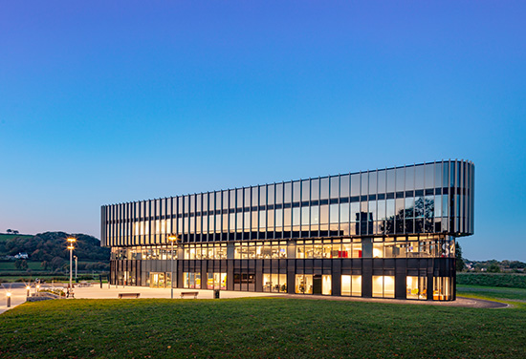
(1.1) The Yr Egin building at dawn (Image: BDP, 2018)

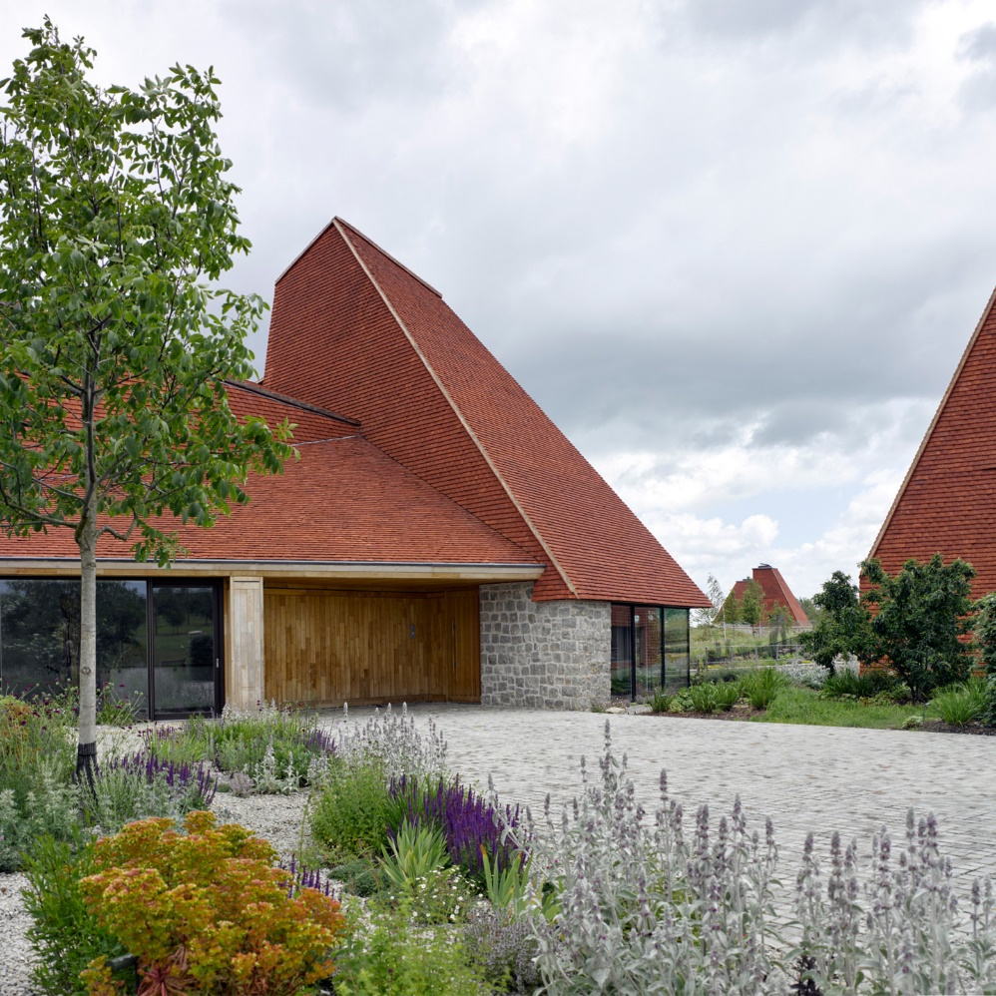
(2.1) RIBA House of the year 2017 winner, Caring Wood house by Rural Office Architects. (Image: Rural Office, 2018)

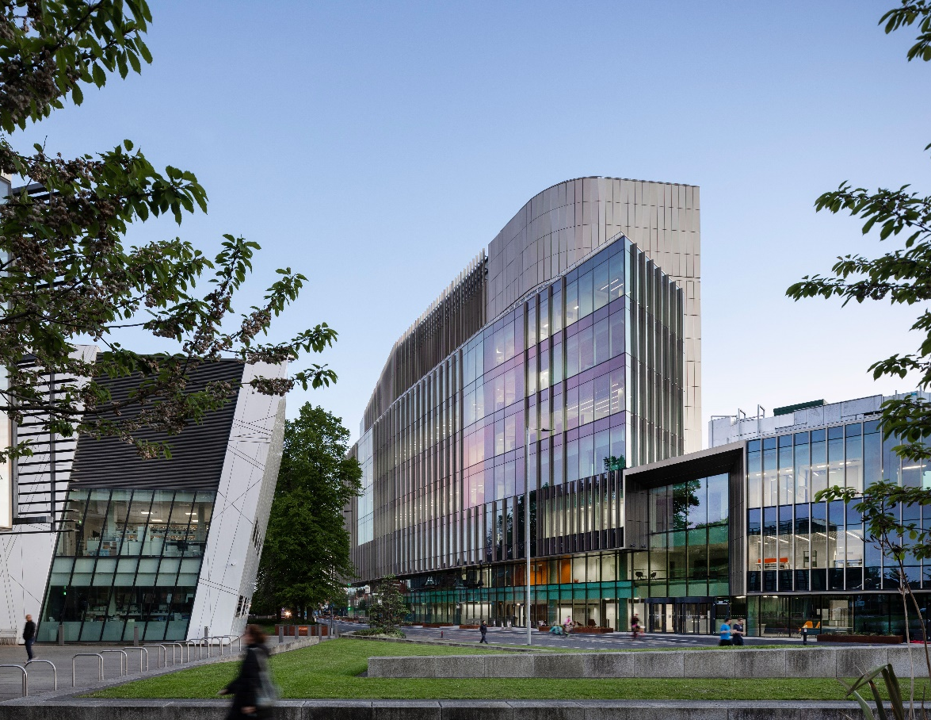
(2.2) Christie Paterson Cancer Research Centre by BDP Architects. (Image: BDP, 2019)

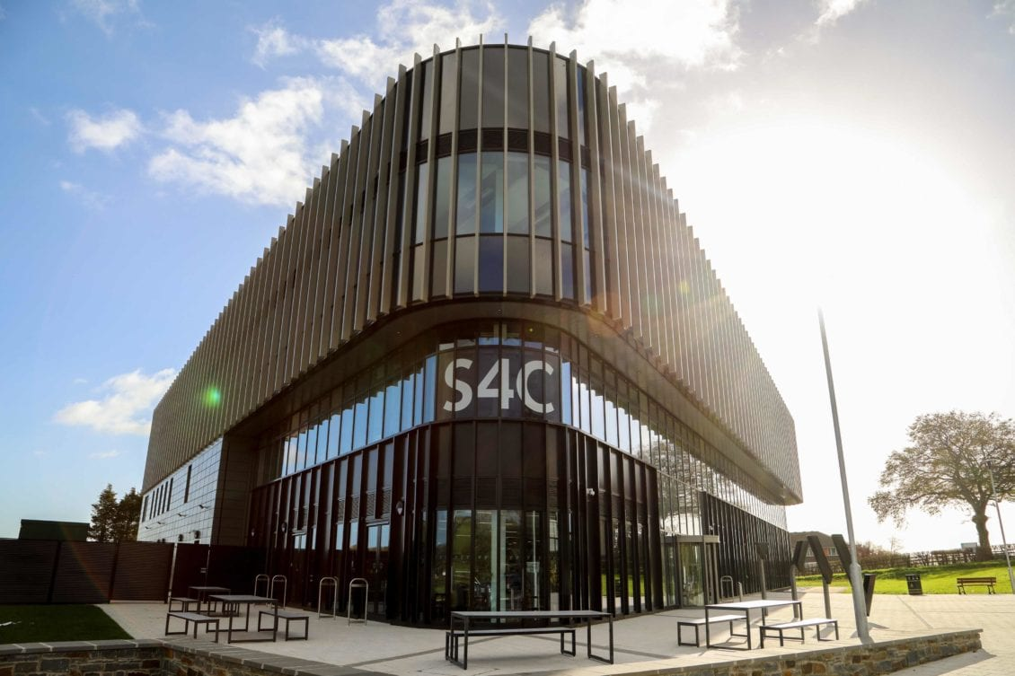
(3.1) The S4C logo put clearly on display on the main entrance of the Yr Egin building.
(Image: Gregory R, 2021)

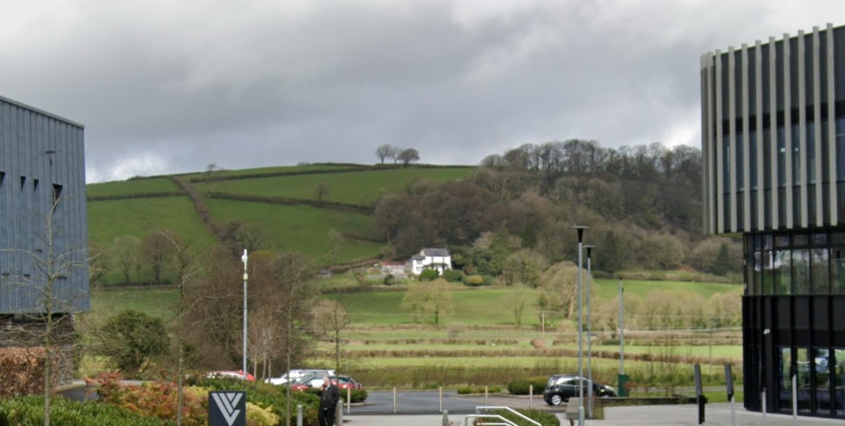
(4.1) The hilly Carmarthen landscape behind the Yr Egin building (right). (Image: Google Maps, 2022)

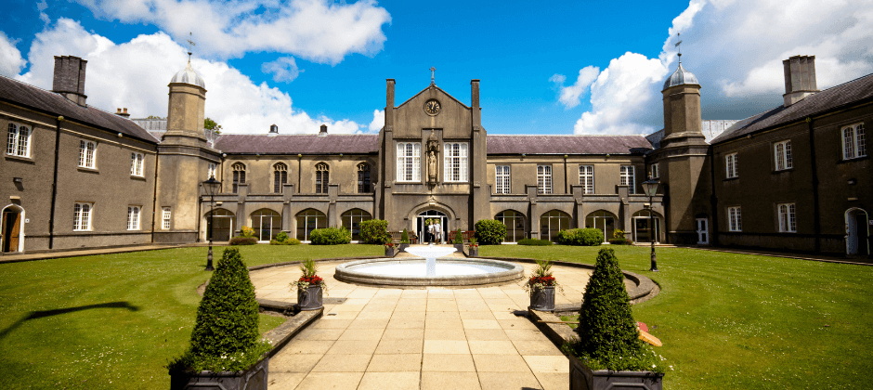
(4.2) The University Of Wales Trinity Saint David main building. (Image: UWTSD, no date)

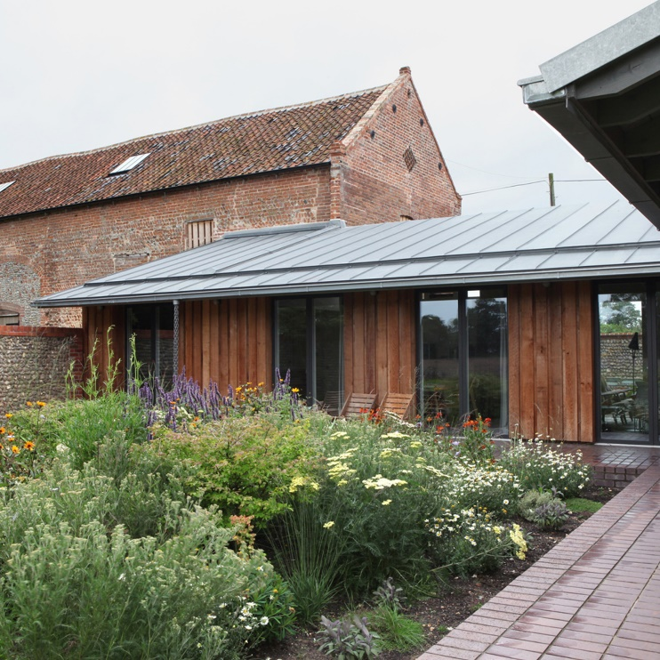
(5.1) Old Barn by Rural Office Architects, a conversion of a grade 2 listed barn in Northfolk with its timber construction. (Image: Rural Office, 2015)

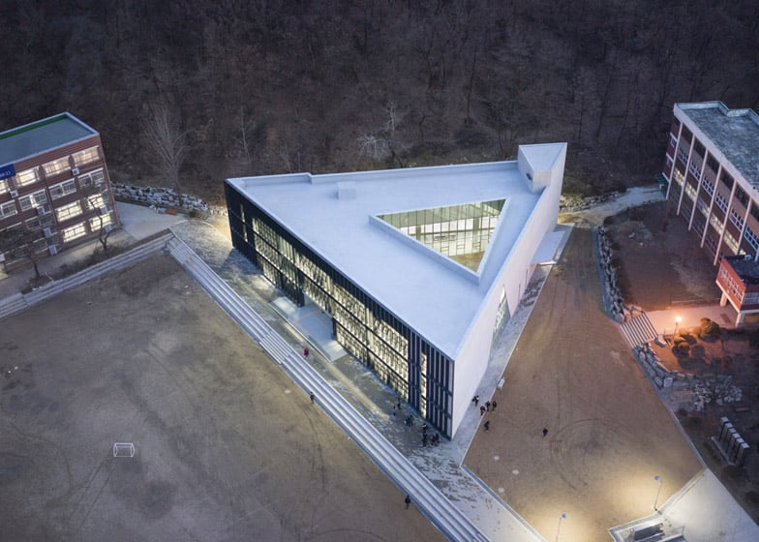
(6.1) The Triangle School building by the Korean practice, NAMELESS. (Image: Mairs J, 2015)

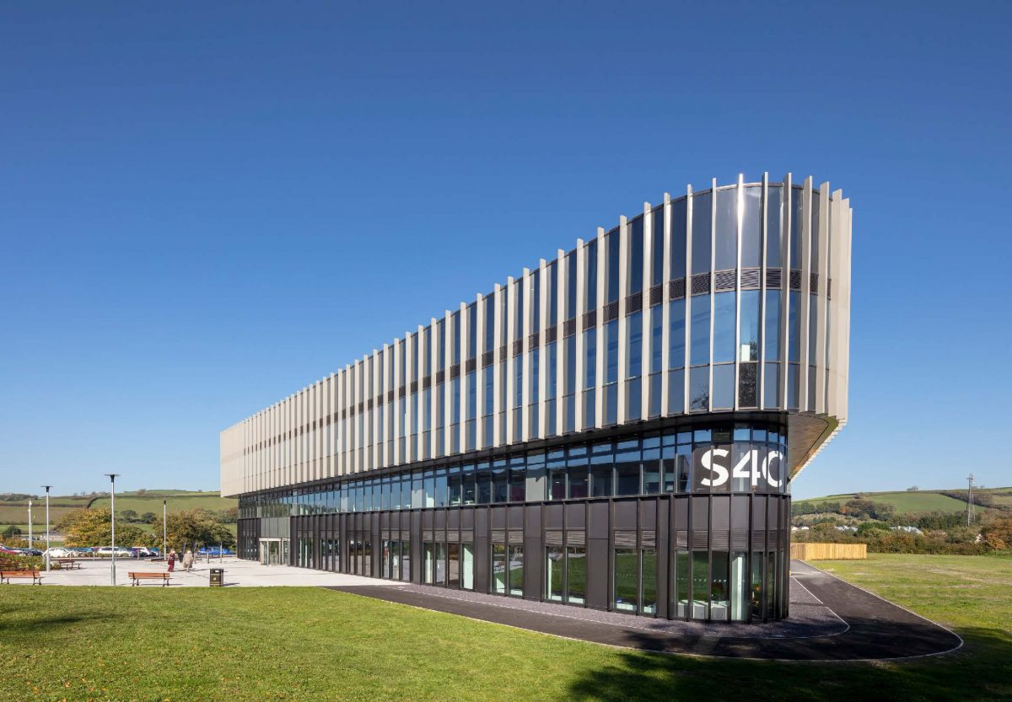
(6.2) The round vertex of Yr Egin on display. (Image: DCFW, 2018)

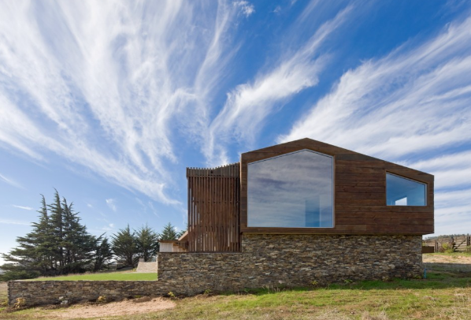
(6.3) The Plinth House by LAND Arquitectos in Chile, displaying what a raised plinth can do to a building in terms of raising its level and form. (Image: LAND, 2008)

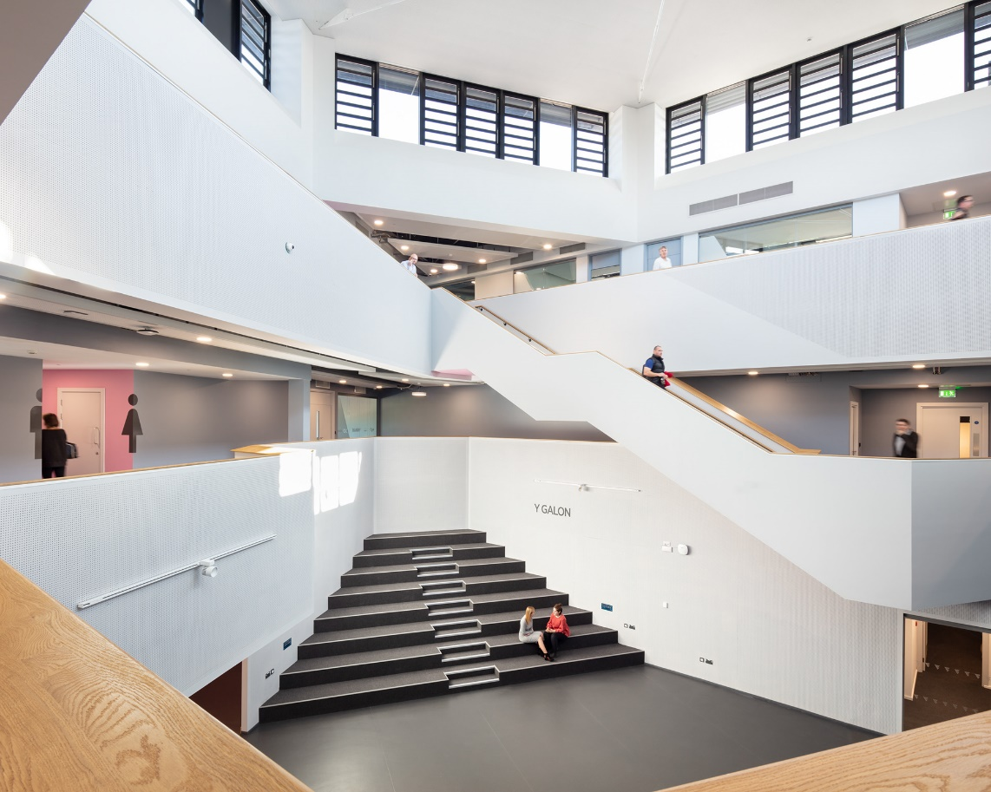
(6.4) The main atrium of Yr Egin. (Image: BDP, 2018)

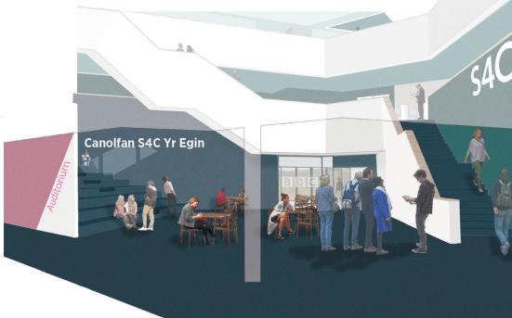
(6.5) A graphic representation of Yr Egin’s “Heart Space”. (Image Carmarthen.gov, 2018)

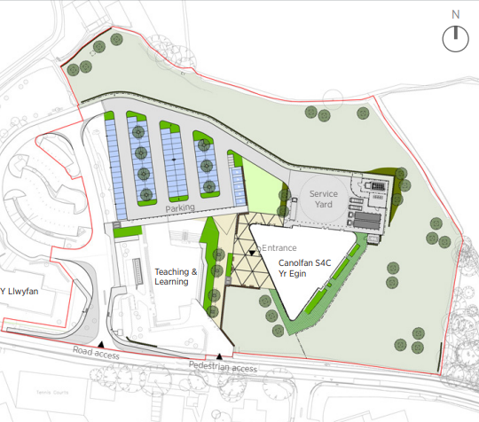
(7.1) The Yr Egin site and its surrounding buildings. (Image: Carmarthenshire.gov, 2018)

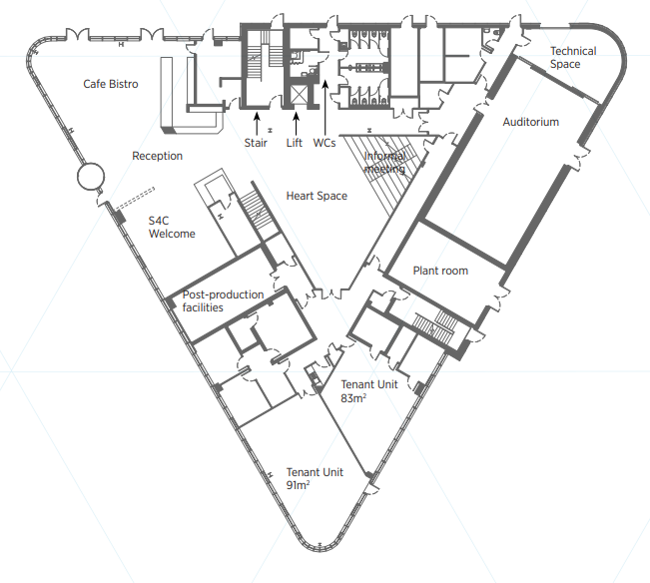
(7.2) The ground floor plan of Yr Egin. (Image: Carmarthenshire.gov, 2018)

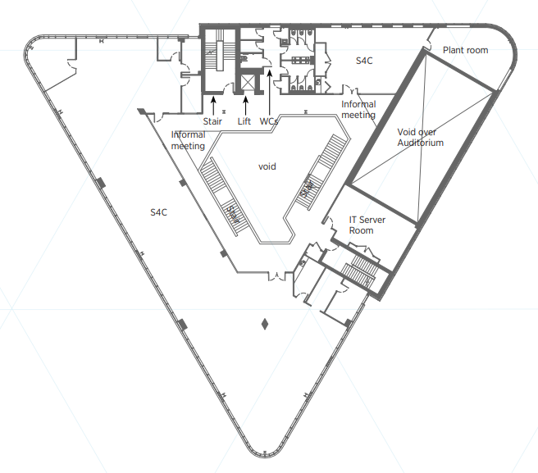
(7.3) The first-floor plan of Yr Egin (Image: Carmarthenshire.gov, 2018)

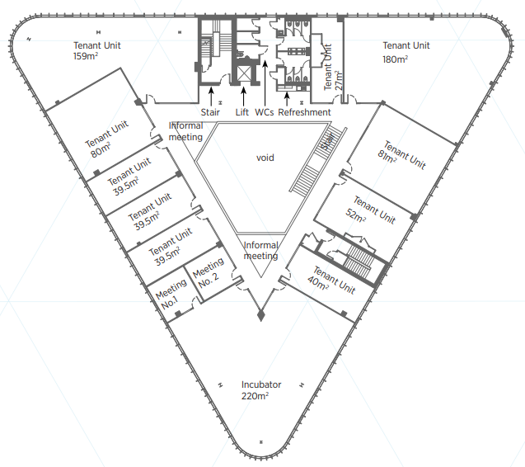
(7.4) The second-floor plan of Yr Egin (Image: Carmarthenshire.gov, 2018)

