Software Development
Level 4 – Assignment 2 – Section 2

Iuliana Maria Gherasim
Student ID: 1919760

Table of Contents
Section 2 2
Part A (Understanding) 2
Arrays 2
OOP – Objects Oriented Programming 4
Part B(testing) 8
Essay 8
Part C (Implementation) 9
Source code: 10
Output: 13
References 13

Section 2

Part A (Understanding)

Arrays

Basically, array is used to store multiple values of the data of the same type in only single or one variable. It defines or displays a range of similar things. It can be called as a type of data structure. It has a prototype list like objects and the prototype is the reason for performing traversal as well as mutation process. The length of the array to store the data can be changed anytime in the program. Arrays are the most commonly used in the programming. Are very useful in organising data, sorting, and searching more easily. They are just like a big container that is used for data sorting. (Techterms, 2007)

Arrays terms:
- Data type – this defines the type of the data or the value the array is going to be stored, as char.
- Array name – the word by which the array can be identified.
- Array size – defines the quantity or the number that the array is holding.

Example:
Data type array name = [dimension];
For declaration of and array of size 10 for the characters – char str[10];
Declaring the away of size 10 of the float – float myarray[10];

Storing data in Array:
The index in the arrays always starts from 0 to N number of the index. All the elements in array are represent in the form of arr[index]. All the data is stored in these places or the address.

Measuring Length of the Array:
The following is an example of researching the array while finding the elements in the given system using the length method:
String[] royalty cars = {“Audi”, “Royal Enfield”};
System.out.println(royalty cars.Length);

Applications of Arrays:
- Arrays are used to store the data or the elements but of same data type.
- Arrays are used for the scheduling of the CPU.
- Arrays are usually used in records of the databases.

Types of Arrays:
There are mainly two types of arrays:
- One dimensional array – these types of arrays are used to store as well as the access the data in the linear form. It is also called Matrix array.
- Two-dimensional array – it is used for representing the element of the arrays in a Matrix form , but in row and columns.

Array Operations:
- Traverse
- Insertion
- Deletion
- Search
- Update

Advantages of the Array:
- It is very easy to store the data of the same type.
- The elements from the array cannot be stored.
- The index of the first element of an array is 0.
- It can be used in the implementation of the matrices.
- It is easier to access data structures like linked list by using the array.

Importance of Arrays in programming:
As arrays are used for storing many elements of the same data type, it is easier to store or declare by using it. The efforts of declaring or initializing data types one by one are decreasing. It is more convenient to store, delete and update the data.
- Array is a type of the data structure that is used to store fixed-sized sequential collections of elements of the same data.
- Are used for storing the collection of the same data, but sometimes it is more useful for think that the array is the collection of the same type of the variables.
- Can be used for representing multiple data or the items of same data type by using of only single name.
- Are more efficient and beneficial when compared to linked lists and hash tables.
- Are faster and they can be utilised in the code anywhere.
- Can be used to store the data of same data type together anywhere in the code.

OOP – Objects Oriented Programming

OOP it is known as Objects Oriented Programming. It is a language that is used in programming in various languages such as JAVA, C++ and many more. The main idea behind the OOPs programming is the implementation of the entities of real world like hiding, polymorphism, inheritance, etc. In OOP programming all the data and function are banded together so that other part of the program has no permission to access it. (w3schools, 2020)

Concepts used in OOP:
- Polymorphism – it is the ability of the OOP in which two entities of the same name can be distinguished.
- Inheritance – it is the ability in which the sub class gets the behaviour and the properties of a supper class.
- Encapsulation – it is the ability in which the code or the program written in encapsulation syntax cannot be accessed by other part of the code.
- Methods – are the variable and functions used in the program.
- Class – is a user defined data type who can be used in the program and can create objects.
- Objects – are created by classes and can be a cumulus included.
- Abstraction – make only the important details visible to the user.

Inheritance in OOP
Inheritance it is a very important pillar in OOPs programming. It can be called as the mechanism by which the super class allows the sub class to get the behaviour and the properties of the similar class. It is just like a parent – child relationship, as the child get the properties of their parent. The super class is considered as parent class and the sub classes are considered the child classes. What also need to be mentioned, is that in one super class can be identified many sub classes. (w3school, 2020)
- Super class (Base Class) – it is the parent class whose properties or features are being taken or to be inherited.
- Sub class(Derived Class) – it is the child class who takes the feature and is the one who inherits from the super class.
- Reusability – in inheritance it is available to reuse the classes.

Type of inheritance
- Hybrid inheritance – it is the combination of more types of inheritances.
- Single inheritance – a derived class is formed from one base class.
- Multi-level inheritance – a derived class is formed from another derived class.
- Multiple inheritance – a derived class in formed from more than just one base class.
- Multipath inheritance – a derived class is formed from another derived class, plus one more base class.
- Hierarchical inheritance – more derived classes are formed from single base classes.
Some of the advantages of inheritance are the reducing of code redundancy, it provides code reusability, also it reduces the source code size and split it in parent and child classes.
The disadvantages of the inheritance can be considered the following. Due to the link between the parent and child, any change between one of them, can affect the other. Another disadvantage is that sometime not all the memory is utilised. (Print, 2019)

Example:

//the base class
Class Bicycles
{
//the class bicycles have two fields
publicint gears and publicint speeds.
//the class bicycles has only one constructor
public Bicycles (Int gears, int speeds)
{
this.gears = gears;
this.speeds = speeds;
}
//the class bicycles has three method
public void applyBrakes (int decrement)
{
speeds -=decrement;
}
public void speedsUp(int increment)
{
speeds += increment;
}
//to String() the method for printing the information of the Bicycles
Public String toString()
{
Return(“No of gears are” +gears
+”\n”
+”speeds of bicycles is”+speeds);
}
}
//the derived class
Class MoutainBikes extends Bicycles.
{
//the MountaiBikes subclass will add one more filed
publicintseatHeights;
//the MountainBikes subclass has one more constructor
publicMontainBike(intgear, intspeeds, intstarsHeights)
{
// invoking the base-class(Bicycles) constructors
Super(gears, speeds);
seatHeights = startHeights;
}
//the MoutainBikes subclass will add one more methods
public void setHeights(intnewValue)
{
seatHeight = newValue;
}
//overriding the toString() method
//of Bicycles for printing more information
@Override
public String toString()
{
return(super.toString()+
“\nseat heights is”+seatHeights);
}
}

Part B(testing)

Essay

Software testing is defined as testing the software by entering all the possible inputs in order to find the defects in the software. The people who are implementing this are the test engineers. The software testing can also be defined as verifying the functionality of an application against the customers requirement specifications.
Software testing can also classify into the functional and non-functional test. Functional testing mainly deals with testing the actual functionality of an application whereas non-functional testing deals with the verification process. (TestBytes, 2017)

Types of testing models:
- Waterfall Model – is the basic development life cycle. It represents multiple stages or a process which is a sequence. This model has step by step process to follow.
- V Model – in this model the execution of the code or the program takes place in a V shape sequence. This model has three phases which are the verification phase, coding phase and validation phase.
- Agile Model – in this model the approach towards the product is divided into parts. The steps can be as the following: plan, requirements, analysis, designing, coding, testing, etc.
- Spiral Models – similar to Agile Model, but with only 4 phases – planning, risk analysis, engineering, and evaluation.
- Rational Unified Process – the model has 4 phases, organized in a number of more iteration.
- Rapid application development – the components are developed parallel to each other.

Part C (Implementation)

Source code:

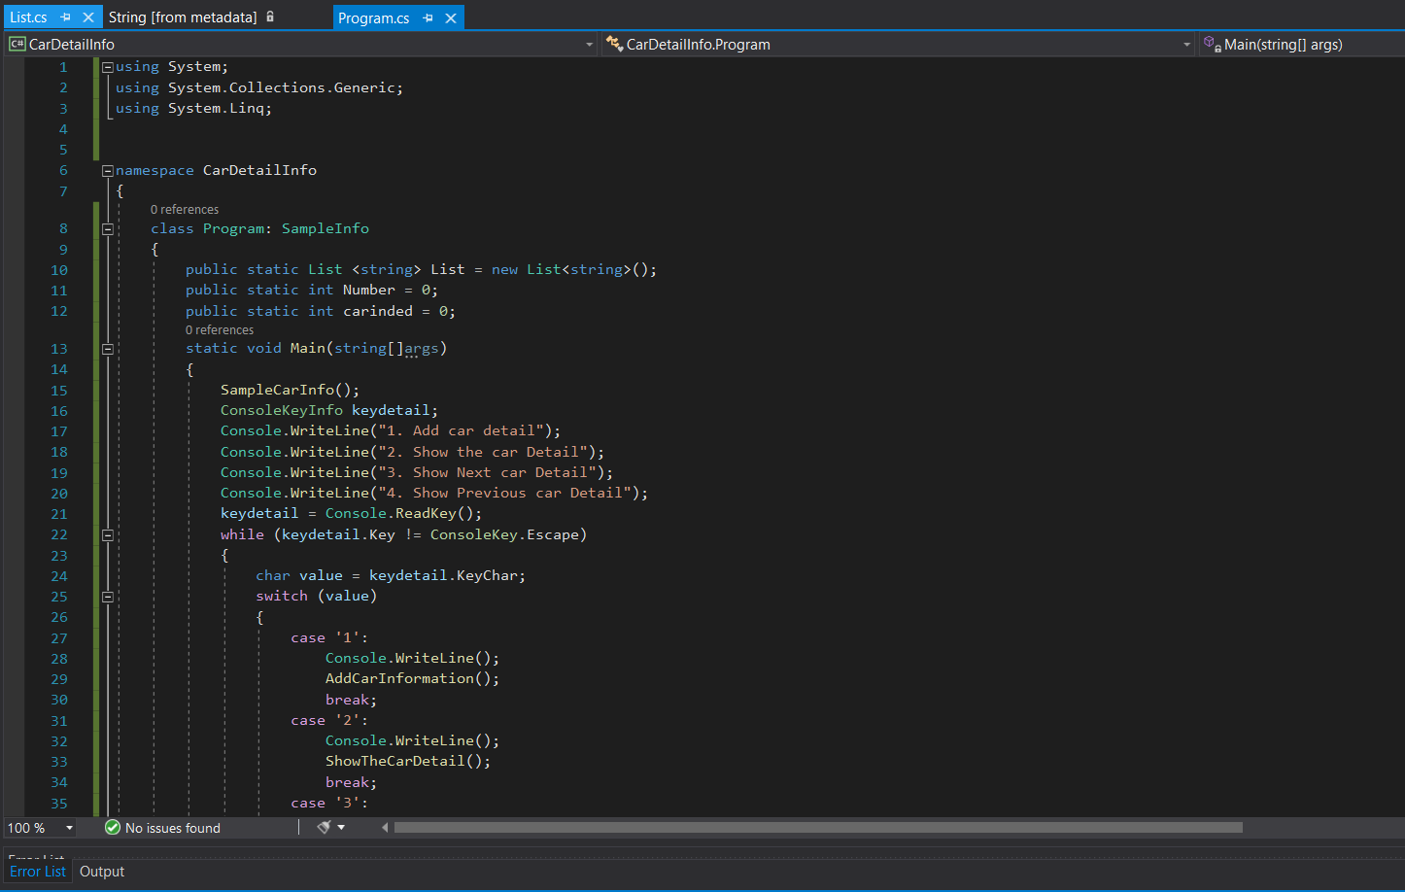

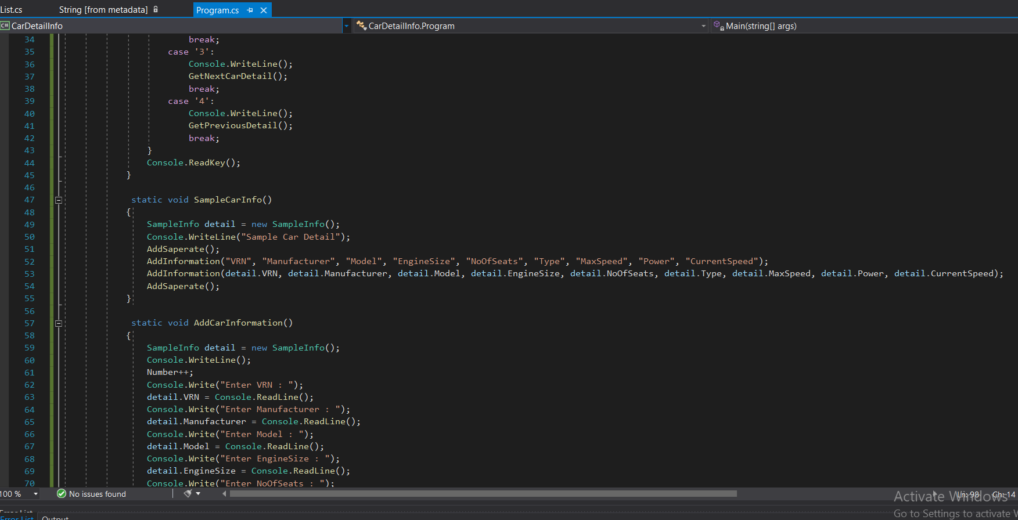

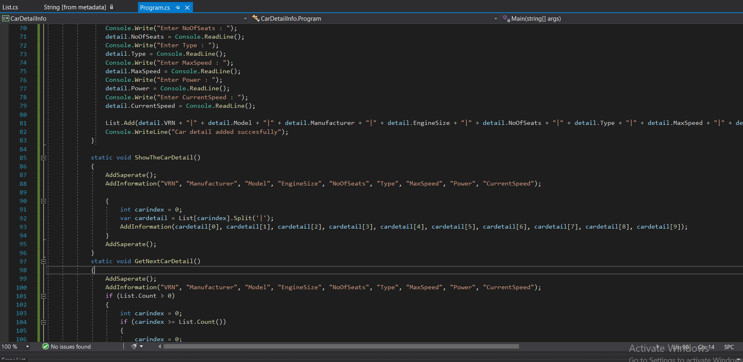

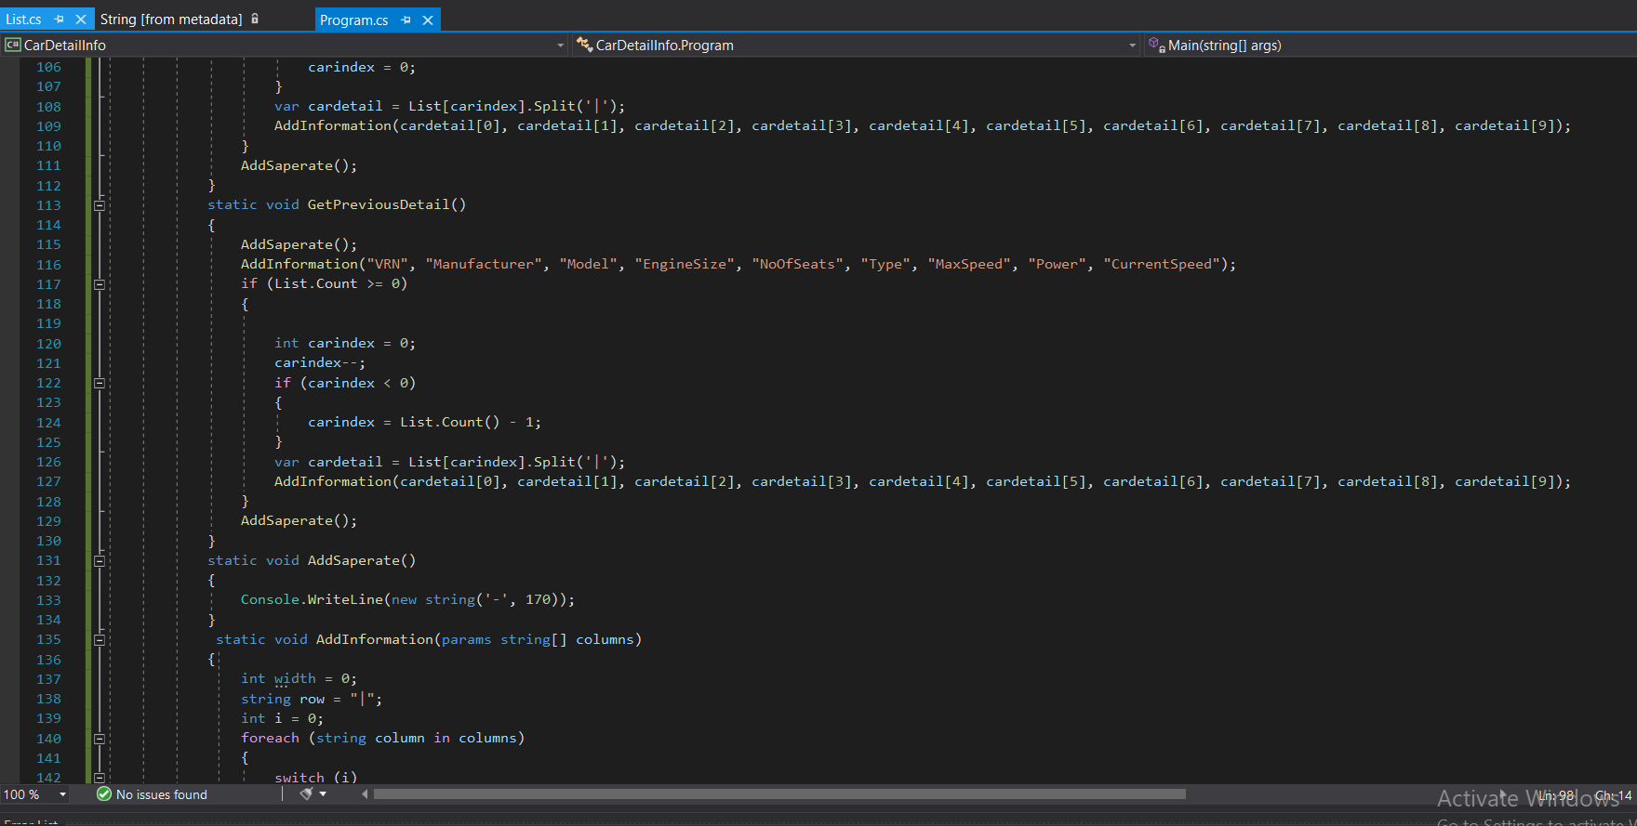

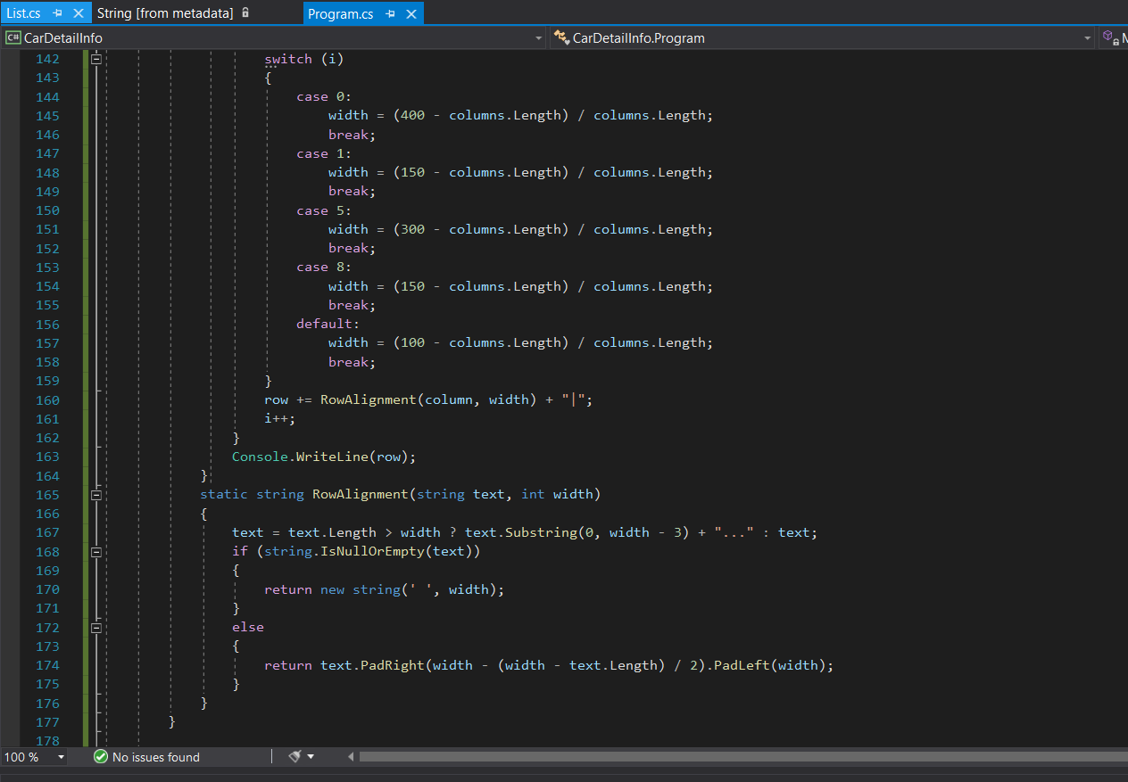

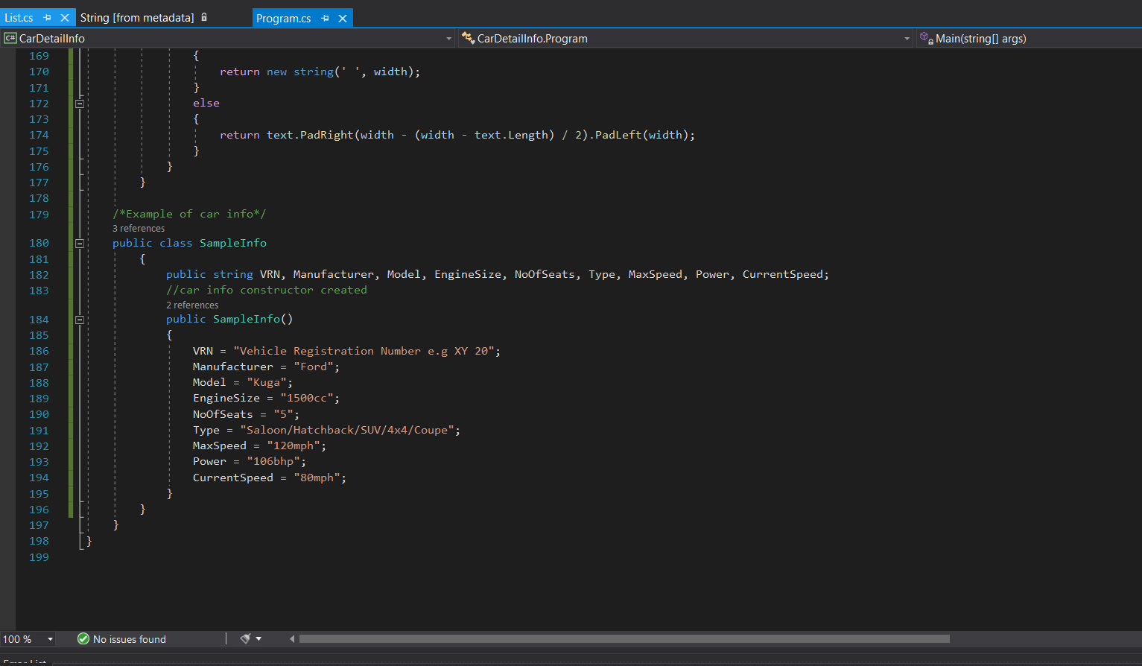

Output:

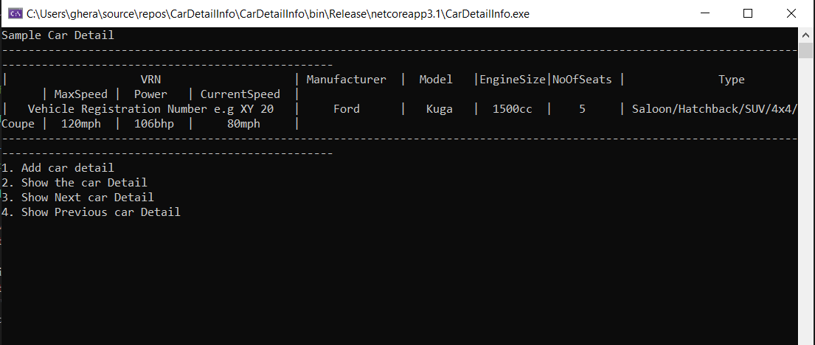

References

Print, S. C., 2019. [Online]
Available at: https://www.dotnettricks.com/learn/oops/understanding-inheritance-and-different-types-of-inheritance
Techterms, 2007. [Online]
Available at: https://techterms.com/definition/array
TestBytes, 2017. [Online]
Available at: https://www.testbytes.net/blog/types-software-testing-models/
w3school, 2020. [Online]
Available at: https://www.w3schools.com/php/php_oop_inheritance.asp
w3schools, 2020. [Online]
Available at: https://www.w3schools.com/cpp/cpp_oop.asp

