
Prifysgol Cymru Y Orlndud Dewi San| University of Wales Trinity Saint David
APPENDIX GA36d

LEVEL 7 ASSESSMENT SPECIFICATION
Student name: | SIMRANJEET KAUR | Student ID number: | 2106253
Programme: | Computer Networks and Security
Module: | Security Analysis Techniques and Procedures
Module code: | ACCA7030 | Contribution to  Overall Module  Assessment (%): | 100%
Lecturer: | Dr Carlene Campbell | Internal Verifier: | Nitheesh Kaliyamurthy
Assignment Title: | Penetration testing on a Live Website and research into cyber security incident and defensive technique case study. | Word count (or equivalent): | 5,000
Submission deadline: | Jan 17th2022 | Return date of provisional marks  & written feedback:
Submission method: | All written assessments, where practical and possible, must be submitted via Turnitin unless otherwise instructed by the Lecturer. (Please DO NOT put this assessment specification into Turnitin or it will match many similarities with other students' submissions.)  Alternative submission method (if applicable):  Late submission of the assessment will result in a late penalty mark. Penalties for late submission: Up to one week late, maximum mark of 50%. Over one week late, 0%. Only the Extenuating Circumstances Panel may approve a change to submission dates.
Academic honesty / referencing: | Academic honesty is required. In the main body of your submission you must give credit to authors on whose research and ideas your work is based. Append to your submission a reference list that indicates the books, articles, etc. that you have used, cited or quoted in order to complete this assessment.
Module Learning Outcomes (from module syllabus)
Provide a systematic understanding of a wide range of current research and technological advances in cyber security incidents and defensive techniques.
Perform information security assessments, investigate, analyse, and support cyber security activities of an organisation with effective usage of security tools and methodologies.

COMPUTER NETWORKS AND SECURITY

Table of Contents
Introduction 3
PART A 3
Part B 10
Conclusion 10
Reference List 11

Introduction
Network security involves calculated taken by organizations to identify and stop disallowed control from outside muggers. Kali Linux is a software for Linux distribution structure for digital theoretical and insight testing. It is Handel and back by abusive Security.

PART A
This part has been developed by kali-Linux. There are using uniscan library. Kali Linux is one of the most famous Operating systems. This system has been helped by Security experts in over the world. Kali Linux is based on Debian (Jeremiah, 2019). Linux position focuses on security and testing on penetration. Kali Linux has many hundred tools and libraries that are matched many various data of security tasks.
From this kali, Linux software first installs the library that this Uniscan. Uniscan is an example of a distant File with, a Local File and Command implementation threat scanner. In this coding portion, there has been must be an install uniscan library. Uniscan has some applications. There has been using uniscan.pl.After complete install, the coding part has been written down. From this screenshot uniscan library "u" means exam of URL. There are paste a data that is companies URL.

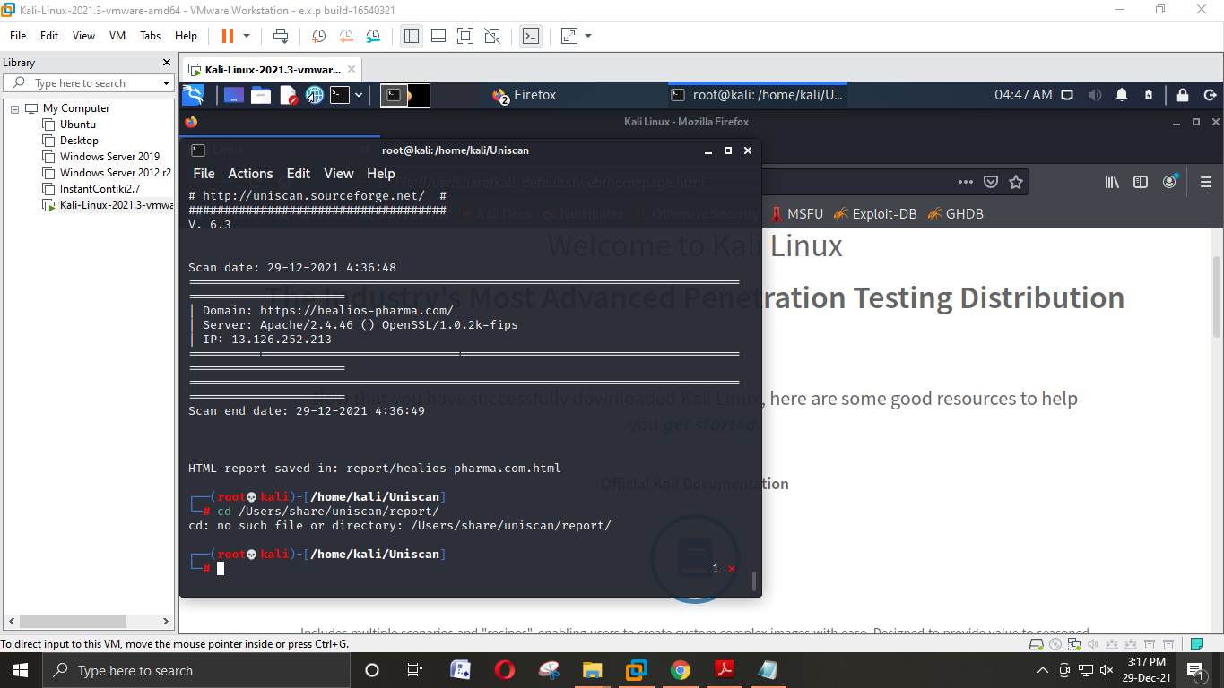
Figure 1: Basic scan of this website
(Source: Self-created)
This figure mainly shows the basic scan of the website.
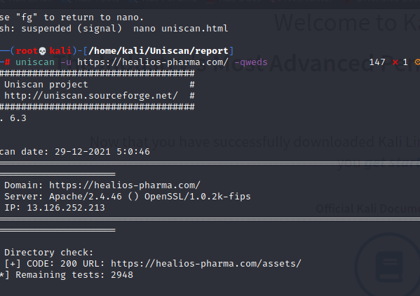
Figure 2:Coding of full information on this website.
(Source: Self-created)

After writing this code, then a piece of full detailed information has been opened.
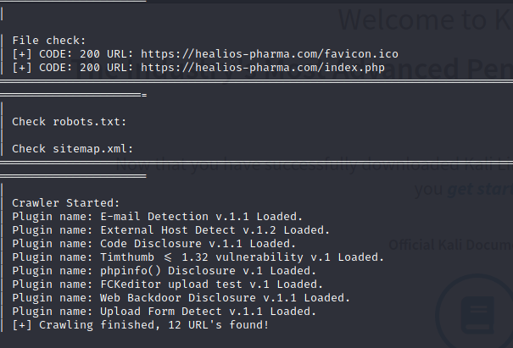
Figure 3:Check file of this website
(Source: Self-created)

From this figure can see how many files have been used on this website.
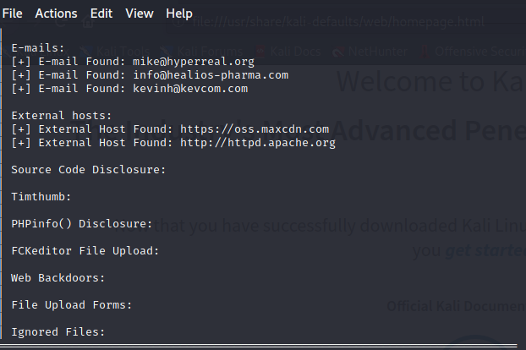
Figure 4: Check e-mail and external host
(Source: Self-created)

This figure mainly means how many emails and the external host has been used here. Php and web backdoor have not to been shown here.
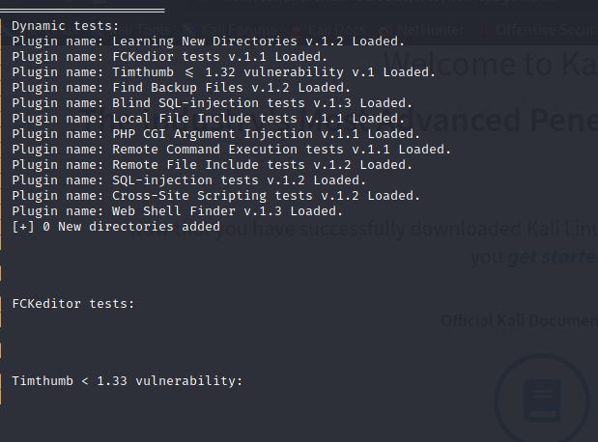
Figure 5: Dynamic test
(Source: Self-created)

This figure has been showing the Php CGI version and SQL injection test.
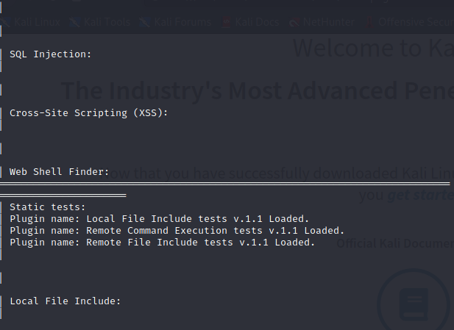

Figure 6:Static test
(Source: Self-created)

This figure has is showing some static names on this website.
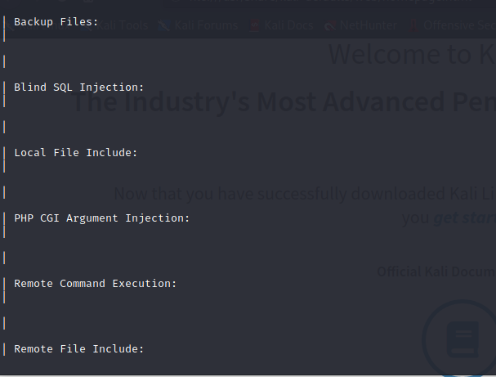
Figure 6:Check SQL and PHP
(Source: Self-created)

Part B
- This project has been successfully done. From this project, the coding part has been created help of Kali Linux. It is a basic ethical hacking concept. Basically, Ethical hacking has been used for the security of websites, and misuse or hack for the website. A good ethical hacker has found errors in this website and again recorrect this error of this website also more secure this site. But a black hack hacker has been misusing this error and hack in this website for harm. with the help of the Uniscan tool can easily see where is an error or mistake on our website (Cisaret al. 2019). Uniscan is a web vulnerabilities scanner and power full tool. During this project, have gained a lot of bits of knowledge on ethical hacking. The help of this uniscan this project has been easy. In this project apply on this uniscan code can easily scan this website. The help of this uniscan and their option can comfortably have been found details information of this website. After finishing this step, a lot of information has been gained. Now can easily be investigated deleted file, error, directory for this website, robot. text for full details of this website like how much page has here, the frequency for this website with dynamics and static check. Apply on this project here can investigate and remove harm or error this website.
- After finishing the coding part have been getting lots of information from this website. Already know how many folders, images, E-mail have been used on this website. In this process can be known host of the website and which programming language has been used in this website (Deviarindaet al. 2020). From part 1, there have been already pasted all document and coding parts in this website. The help of this full information in this website can easily modify this website as well as more secure it.

Conclusion
In this project, it can be concluded uniscan has very important tool and powerful tools. This project can improve the knowledge that benefits future projects. Ethical hacking has most important for a secure website. The help of this ethical hacking can easily protect our website.

Reference List
Cisar, P. and Pinter, R., 2019. Some ethical hacking possibilities in Kali Linux environment. Journal of Applied Technical and Educational Sciences, 9(4), pp.129-149.
Deviarinda, J.P., Budiyono, A. and Almaarif, A., 2020. ANALYSIS OF POTENTIAL SECURITY ISSUES IN REGIONAL GOVERNMENT X WEBSITE USING SCANNING METHOD IN KALI LINUX. FoITIC, pp.169-174.
Jeremiah, J., 2019. Awareness Case Study for Understanding and Preventing Social Engineering Threats using Kali Linux Penetration Testing Toolkit. ech Insig, p.43.

marking criteria and Student FEEDBACK

This section details the assessment criteria. The extent to which these are demonstrated by you determines your mark. The marks available for each criterion are shown. Lecturers will use the space provided to comment on the achievement of the task(s), including those areas in which you have performed well and areas that would benefit from development/improvement.

Common Assessment Criteria Applied (Assignment 1) | Marks available | Marks  awarded
1. Engagement with Literature Skills
Extent of research and/or own reading, selection of credible sources, application of appropriate referencing conventions.
You have done basic research. You need to do more in-depth research. You have used the wrong referencing style. You need to use IEEE number convention. More referencing content need to be done. (Grade mark: 33.33%) | 15 | 5
2. Knowledge and Understanding Skills
Extent of knowledge and understanding of concepts and underlying principles associated with the discipline.
Did not demonstrated relevant knowledge and understanding. Seems you did not understand the module and content delivered. (Grade mark: 33.33%) | 15 | 5
3. Cognitive and Intellectual Skills
Analysis, evaluation and synthesis; logic, argument and judgement; analytical reflection; organisation of ideas and evidence
Your introduction needs to be improved. Your introduction should give a background to the work along with some general research information of the subject areas, followed by what the rest of the report will include. You have provided screen shot of basic pen test but no discussion analysis and findings. You have not done any cost solutions and timetable for the execution of solutions. You have not done task 2, the forensics aspect. Your report demonstrated that you did not engage with the module. Your conclusion needs to be improved, it should summarised your key areas of the report. (Grade mark: 37.50%) | 40 | 15
4. Practical Application Skills
Deployment of methods, materials, tools and techniques; application of concepts; formulation of innovative and creative solutions to solve problems.
Basic screenshots showing access to the website. Fig 4 is not from the website. (Grade mark: 20.00%) | 25 | 5
5. Transferable Skills for Life and Professional Practice
Attributes in professional practice: individual and collaborative working; deployment of appropriate media; presentation and organisation.
A presentable work (Grade mark: 50.00%) | 5 | 2.5

Assignment Mark (Assessment marks are subject to ratification at the Exam Board. These comments and marks are to give feedback on module work and are for guidance only until they are confirmed. ) | Late Submission Penalties (tick if appropriate) |  | 33%
 | Up to four weeks late |  | 33%
 | First Attempt? |  | 33%

