BMIH6007
International Meetings Management
for the
Hotel Industry
LEVEL 6
Autumn Term 2024
Module Lead: Kathryn Flynn
Student Name:Alexandra Craescu
Student ID:2111926

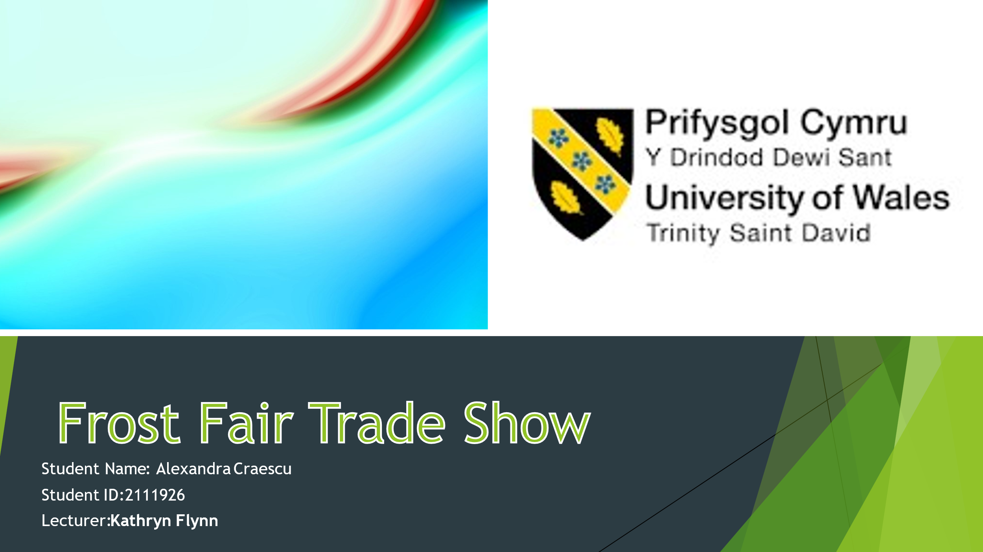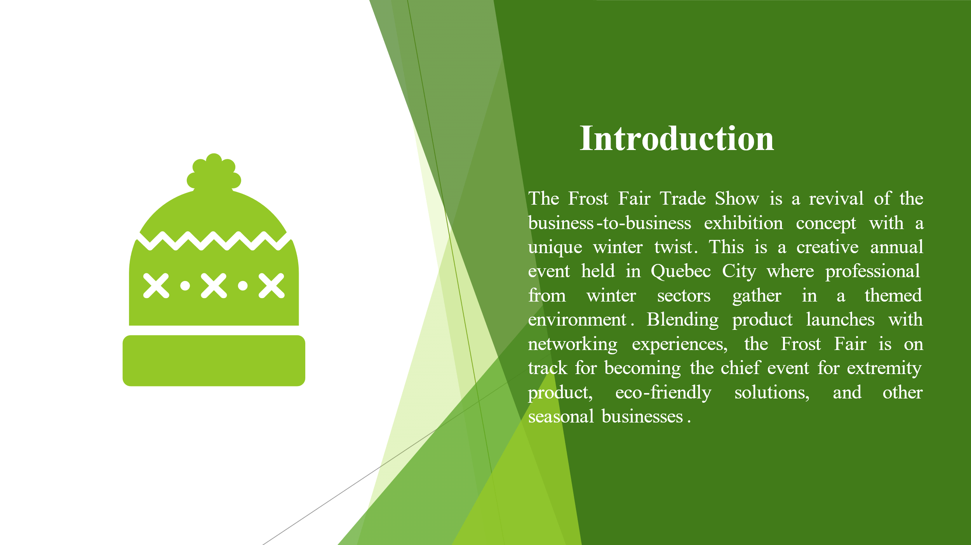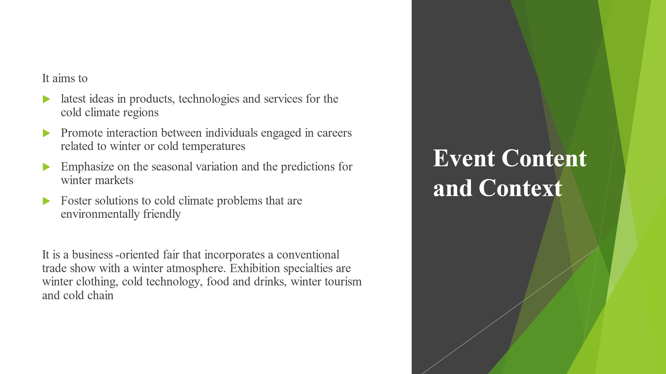

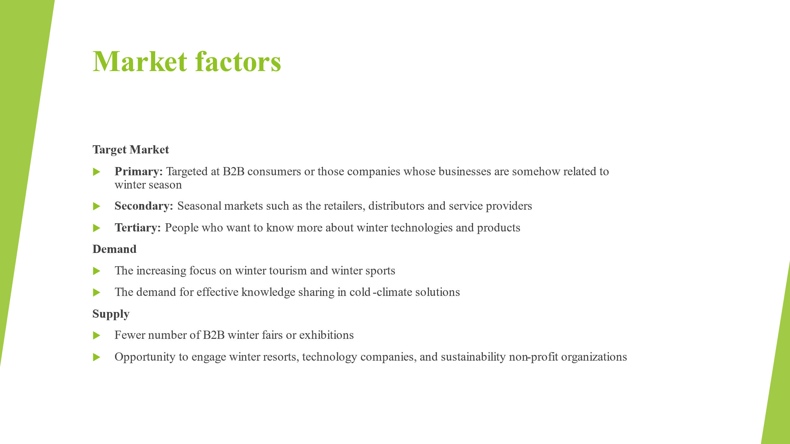
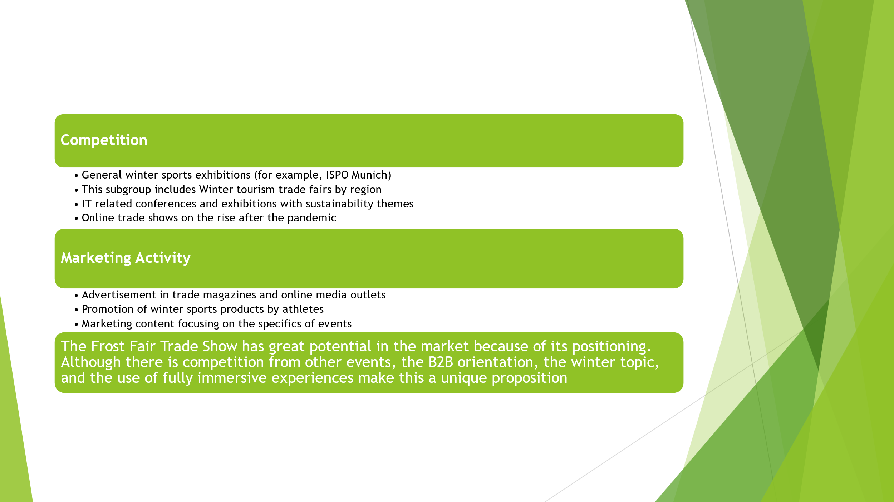

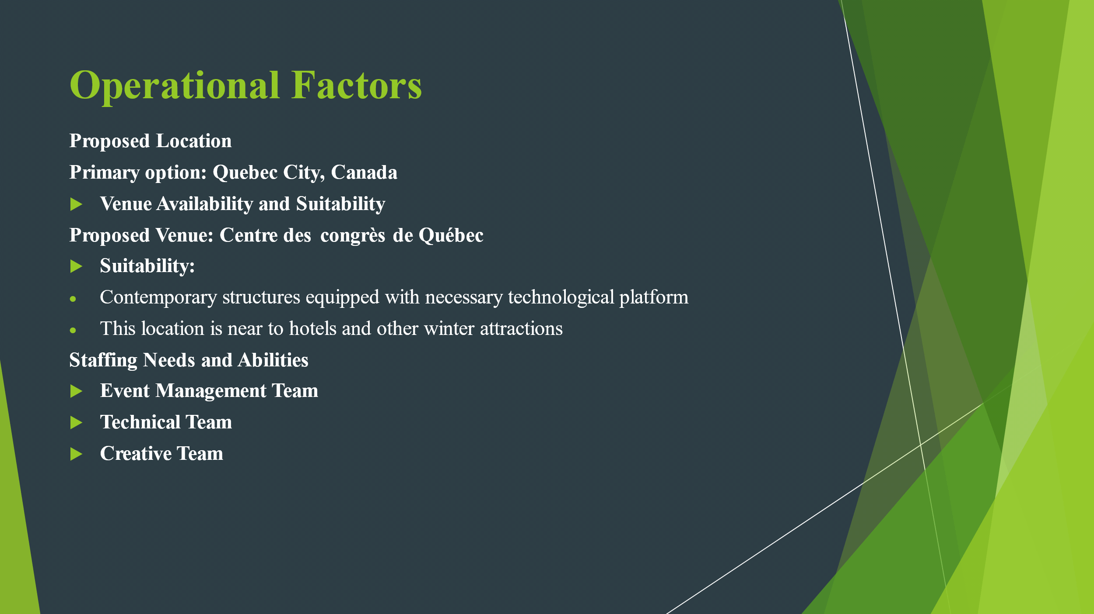
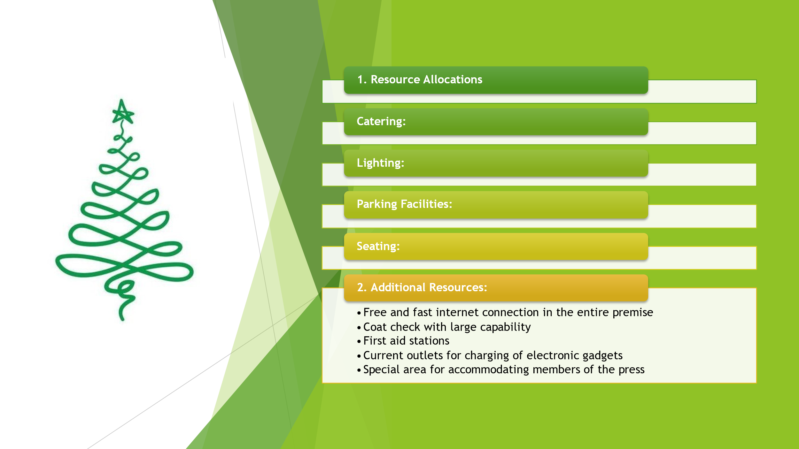

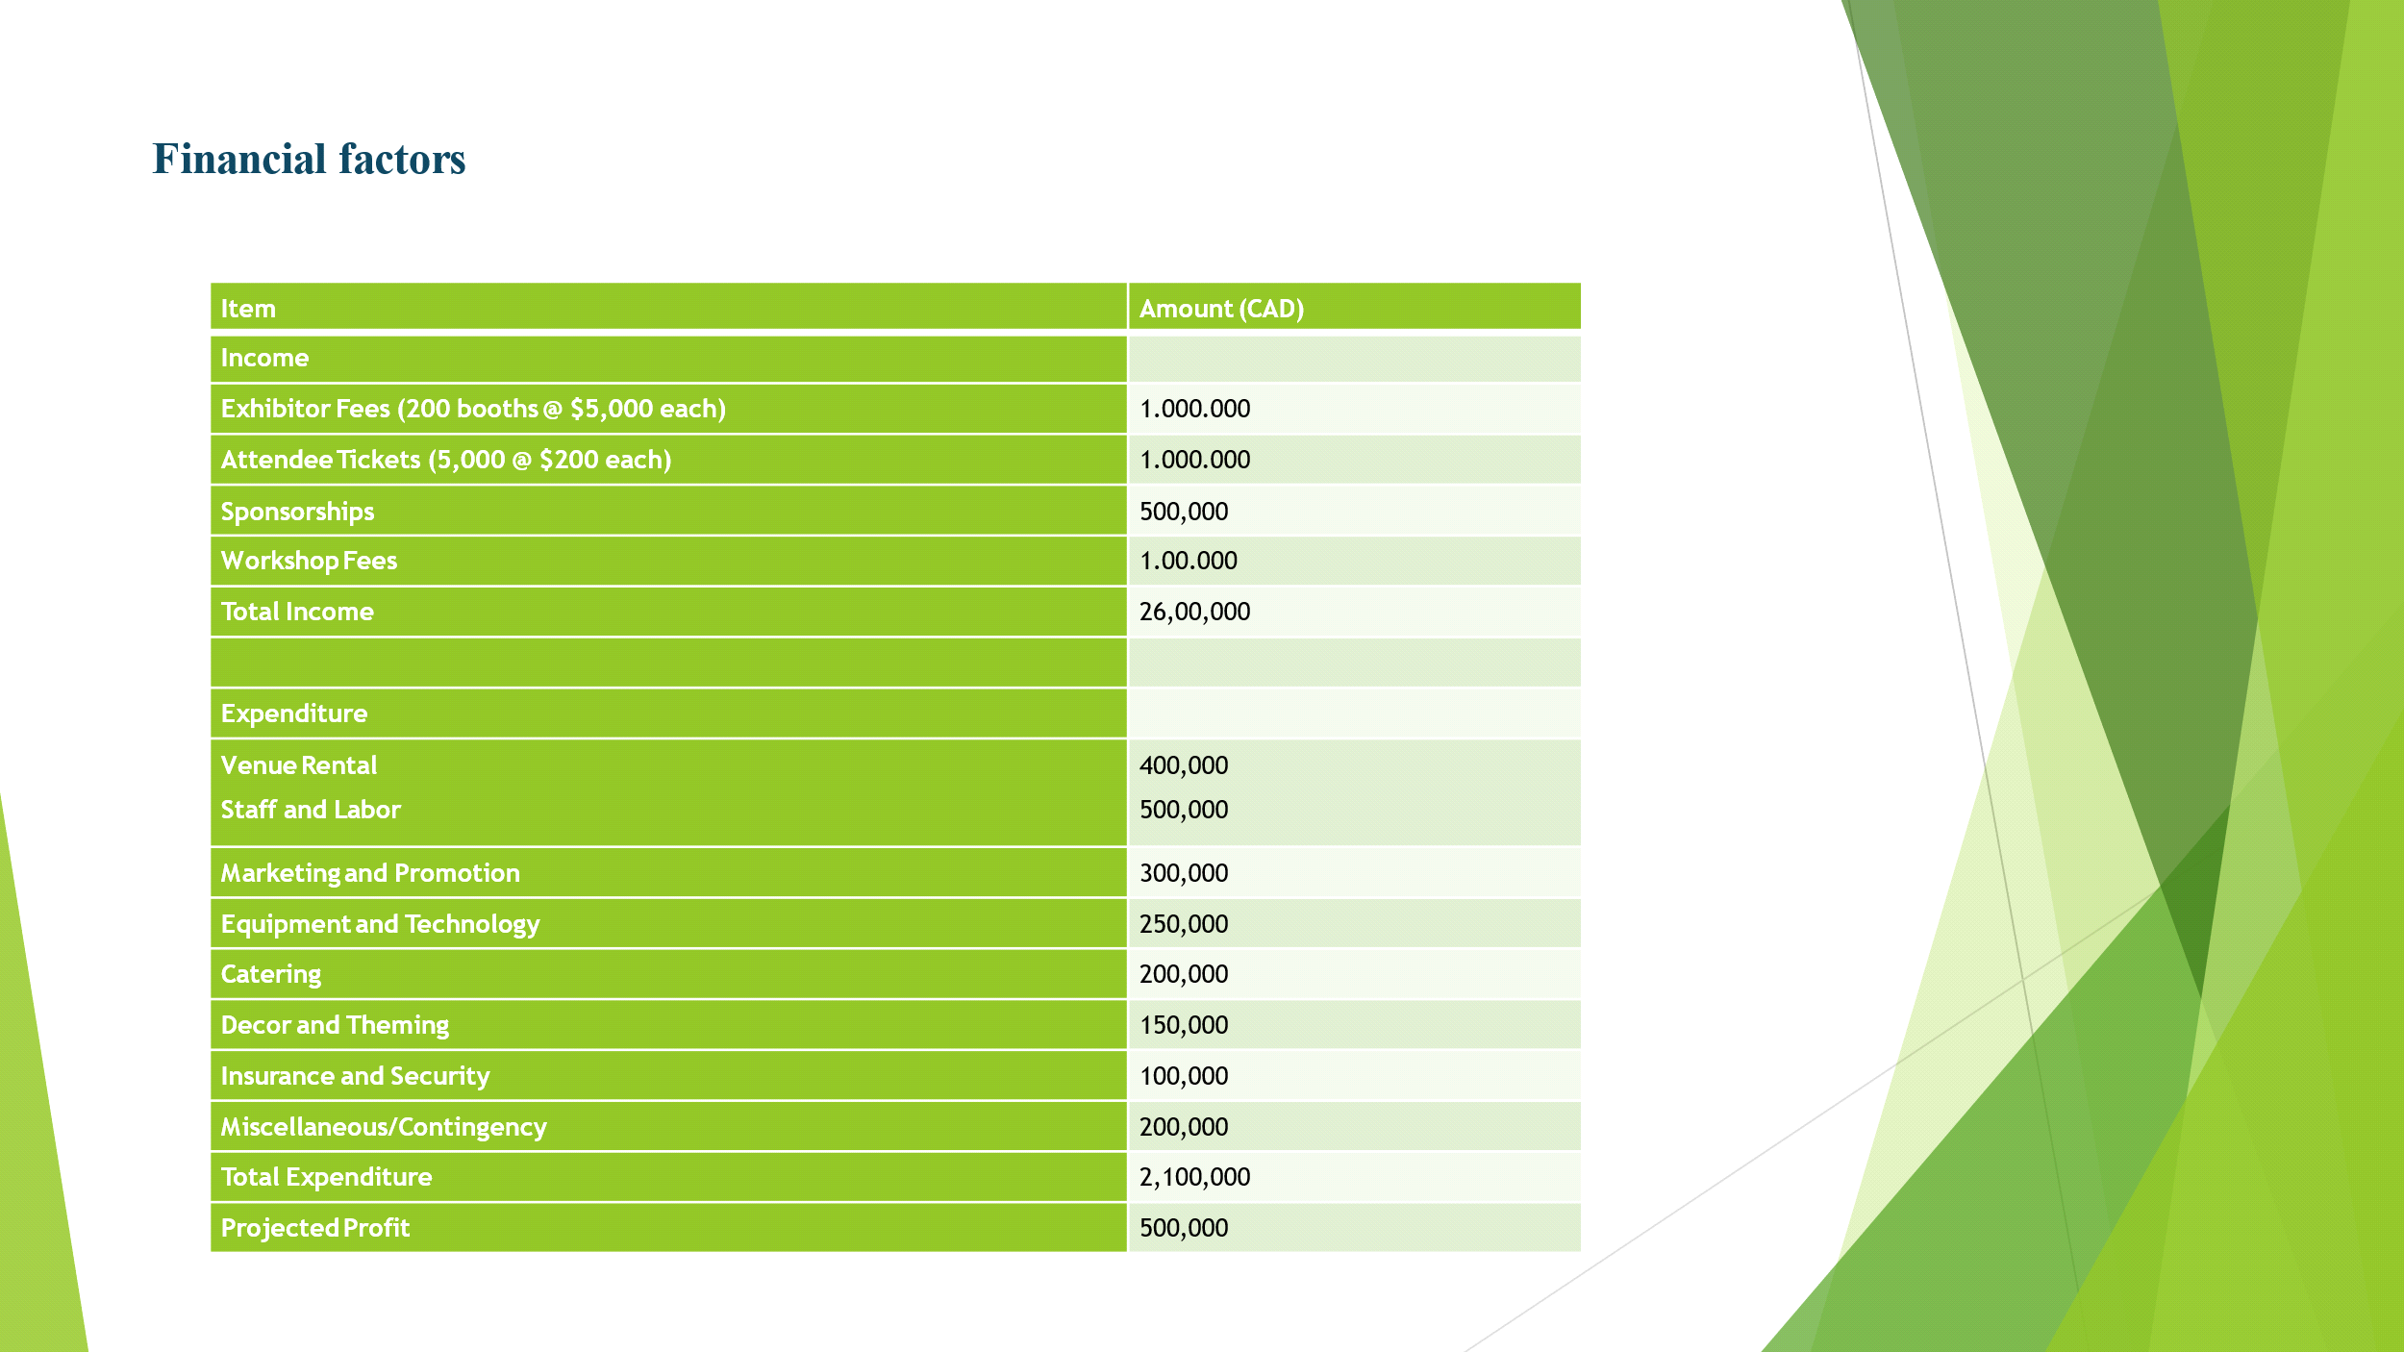

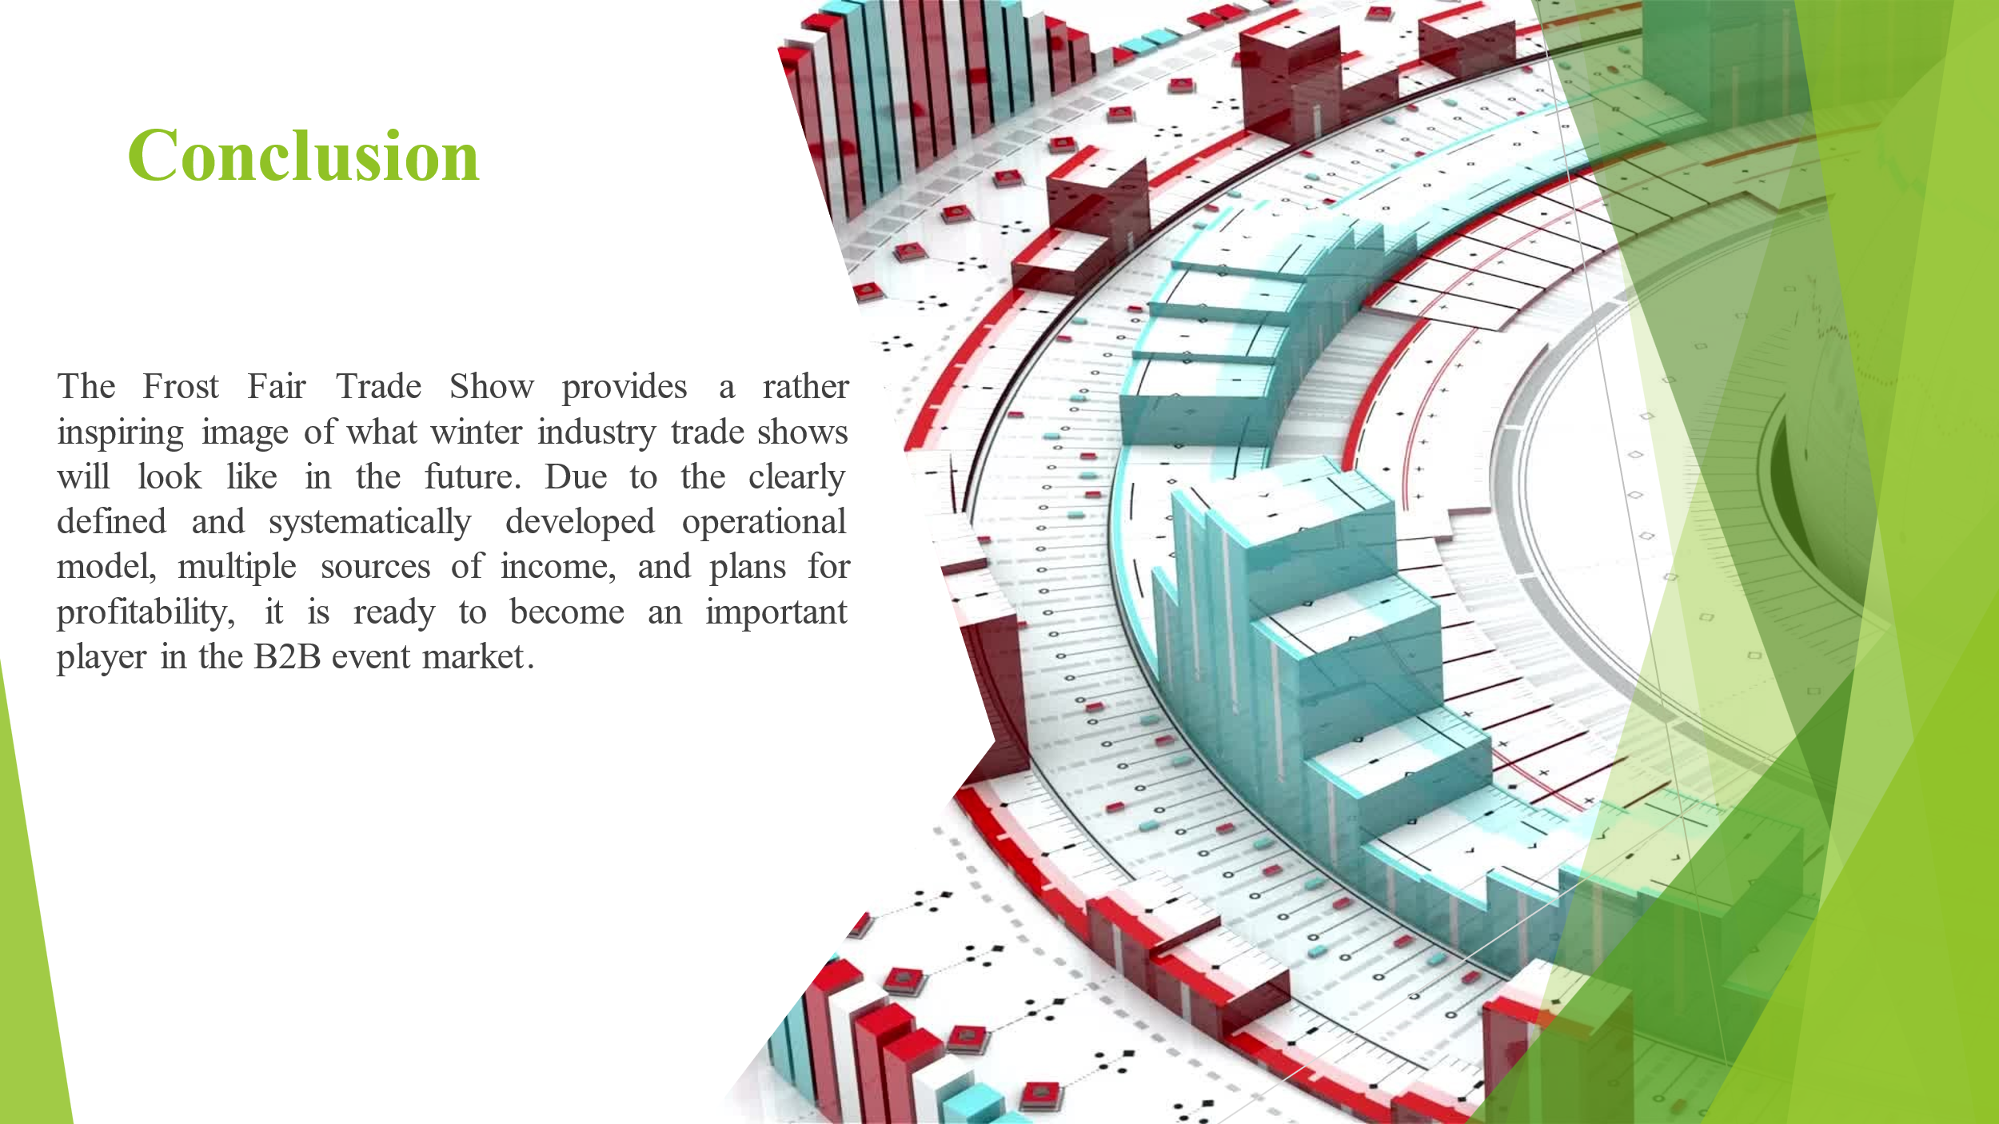



- Anderson, L. (2023). The Rise of Experiential B2B Events. Journal of Business Marketing, 45(3), 210-225.
- Beaulieu, M. (2022). Quebec City: A Hub for Winter Tourism. Canadian Travel Quarterly, 18(2), 45-60.
- Chen, W. (2024). Sustainable Solutions for Cold Climates. Environmental Technology Review, 12(1), 78-95.
- Davidson, R. (2023). The Impact of Virtual Trade Shows on B2B Marketing. Digital Business Review, 7(4), 112-128.
- Eriksson, J. (2022). Winter Sports Industry: Market Trends and Forecasts. Nordic Business Report, 29(3), 67-82.
- Frost, A. (2023). Financial Planning for Large-Scale Events. Event Management Finance, 14(2), 34-50.
- Garcia, S. (2024). Innovations in Cold Weather Technology. Tech Horizons, 9(1), 15-30.
- Harris, T. (2023). Staffing Strategies for Major Trade Shows. Human Resource Management in Events, 6(3), 89-105.
- Johnson, K. (2022). The Economics of Seasonal Business. Journal of Business Cycles, 33(4), 201-217.
- Kim, J. (2024). Sustainable Practices in Event Management. Green Events Quarterly, 11(2), 56-71.
- Lee, M. (2023). Marketing Strategies for Niche B2B Events. International Journal of Event Marketing, 8(3), 123-139.
- Martinez, C. (2022). The Future of Trade Shows: Blending Physical and Digital Experiences. Event Tech Journal, 5(1), 22-38.
- Nakamura, H. (2024). Innovative Catering Concepts for Large-Scale Events. Hospitality and Events Review, 16(4), 178-194.
- Olsson, P. (2023). Risk Management in Winter-Themed Events. Event Safety and Security, 7(2), 45-61.
- Patel, R. (2022). Designing Immersive Experiences for B2B Events. Experience Design Quarterly, 19(3), 90-106.
- Quinn, L. (2024). The Impact of Climate Change on Winter Tourism. Journal of Sustainable Tourism, 32(1), 5-21.
- Roberts, S. (2023). Venue Selection for Large-Scale Trade Shows. Event Venues and Facilities, 10(4), 134-150.
- Smith, A. (2022). Financial Modelling for Event Profitability. Event Finance Review, 15(2), 67-83.
- Thompson, E. (2024). The Role of Government Support in Business Events. Public Policy and Events, 8(1), 28-44.
- Zhang, Y. (2023). Technology Integration in Modern Trade Shows. Event Technology Review, 6(3), 101-117.

