
Program: Master of Business Administration

Title:
SmartGrowth AI: An AI-Powered Marketing Agency for Service-Based SMEs in the UK

Name: Anika Ayub
Student ID: 2504343
Module Name: Business Development Proposal
Module Code: LCMB7037

Lecturer’s Name: Amare Desta
Professor of Information & Knowledge Management
Senior Lecturer, Director of Studies, Doctoral Supervisor, Internal Examiner and Chair
University of Wales Trinity Saint David (London Campus)

Word Count: 2717

Term 3

Table of Contents

AI Use Acknowledgement 3
1. Introduction 3
1.1 Business Canvas Model 4
2. Literature Review 5
2.1 Small and Medium-sized Enterprises (SMEs) 5
2.2 Digital Marketing and SME Growth 6
2.3 Artificial Intelligence in Marketing 6
2.4 Business Development and Value Creation 7
2.5 Competitive Advantage 7
2.6 Research Gap 8
3. Methodology 8
3.1 Research Philosophy 8
3.2 Research Approach 9
3.3 Research Design 9
3.4 Data Collection 9
Primary Research 9
Secondary Research 10
3.5 Sampling Strategy 10
Market Demand Questionnaire 11
Interview Questions 11
3.6 Data Analysis 12
3.7 Ethical Considerations 12
3.8 Reliability and Validity 13
4. Initial Market Opportunity Analysis 13
5. Limitations 14
6. Timeframe 14
6.1 Gantt Chart 15
7. Conclusion 15
References 16

BDP Outline

AI Use Acknowledgement
Artificial Intelligence (AI) tools were used to support the development of this Business Development Proposal (BDP). AI assisted with brainstorming ideas, generating images, refining sentence structure, improving grammar, and organising the overall report structure. All business concepts, analysis, critical evaluation, and final decisions were independently reviewed, verified, and edited by the author. Academic sources were selected based on their relevance and credibility, and all references have been cited using the Harvard referencing style. The author accepts full responsibility for the originality, accuracy, interpretation, and conclusions presented in this proposal. AI has been used solely as a productivity and language support tool in accordance with university academic integrity guidelines.

1. Introduction
Small and Medium-sized Enterprises (SMEs) form the backbone of the UK economy, representing over 99% of private sector businesses and making a substantial contribution to employment and economic growth (Department for Business and Trade, 2024). Nevertheless, many service-based SMEs struggle to develop effective marketing strategies due to limited financial resources, inadequate in-house expertise and intense competition within digital markets (Kotler et al., 2022). Consequently, many organisations outsource marketing functions to overseas providers, benefiting from lower costs but often sacrificing communication quality, local market knowledge and strategic alignment. Simultaneously, Artificial Intelligence (AI) has transformed marketing by enhancing content creation, customer analytics, advertising optimisation and market research. AI technologies improve productivity, automate repetitive tasks and reduce operational costs (Davenport, Guha, Grewal and Bressgott, 2020). However, human creativity, emotional intelligence and strategic judgement remain essential for successful branding and customer engagement (Huang and Rust, 2021). This proposal introduces SmartGrowth AI, a UK-based agency integrating AI with human expertise to deliver affordable marketing, market research, product development ideation, implementation planning, SEO, paid advertising and strategic consultancy. Initially employing eight to ten professionals and expanding to twenty within its first year, the London-based agency aims to evaluate commercial feasibility, customer needs, competition, operational requirements, strategic opportunities, graduate employment, SME competitiveness and innovation within the UK's digital economy.

Business Canvas Model
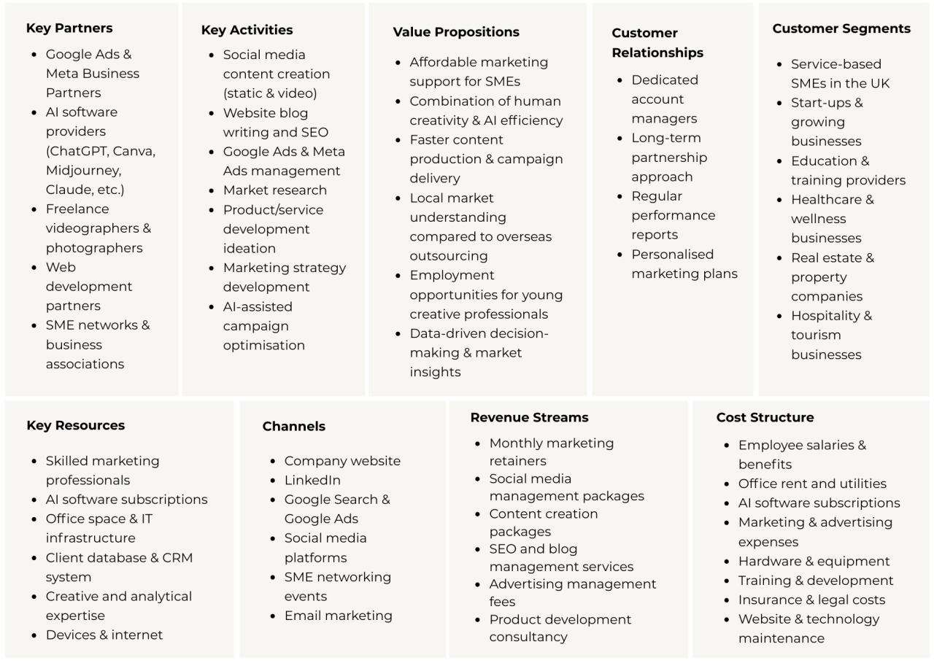
Figure 1: Business Model Canvas of SmartGrowth AI (Self Developed)

Let’s assume that a typical client of SmartGrowth AI would be a UK service-based SME, such as an education consultancy, NZ Associates Education sought to strengthen its student placement, it consulted with SmartGrowth AI to develop a more effective digital marketing strategy. Working alongside Google and Meta ads, use of AI, and creative freelancers, SmartGrowth AI designed integrated campaigns using SEO, paid advertising, content creation, social media management, and business development strategies. Its use of AI, and skilled marketing professionals will enable data-driven decisions that will improve campaign performance for NZ Associates Education. By combining artificial intelligence with human creativity, SmartGrowth AI will deliver personalised and affordable marketing solutions, creating a stronger competitive position for NZ Associates (Huang and Rust, 2021). Regular performance reports, and dedicated account management will strengthen trust and encourage a long-term client relationship. Through Google and Meta ads, LinkedIn, email marketing and its website, SmartGrowth AI will connect NZ Associates Education with potential students. As a UK education consultancy, NZ Associates Education will represent SmartGrowth AI's target SME customer segment. SmartGrowth AI will generate revenue through social media campaign management services, and content development services, while managing costs through staff salaries, AI software subscriptions, advertising expenditure, technology infrastructure and continuous employee training. Together, these interconnected elements create sustainable value for the organisation, reflecting Osterwalder and Pigneur's (2010) Business Model Canvas framework.

2. Literature Review

2.1 Small and Medium-sized Enterprises (SMEs)
Small and Medium-sized Enterprises (SMEs) are widely recognised as organisations employing fewer than 250 employees and generating turnover below established financial thresholds (European Commission, 2020). In the United Kingdom, SMEs account for approximately 99.8% of all registered businesses and contribute over half of private sector employment (Department for Business and Trade, 2024). Their flexibility, innovation capacity, and entrepreneurial nature make SMEs essential drivers of regional and national economic development (Burns, 2020).
Despite their importance, SMEs often experience resource constraints that limit investment in specialised marketing functions (Storey, 2016). Unlike larger corporations, smaller businesses rarely possess dedicated marketing departments, making outsourced marketing services an increasingly attractive option.

2.2 Digital Marketing and SME Growth
Digital marketing has become one of the primary determinants of business competitiveness. Chaffey and Ellis-Chadwick (2022) define digital marketing as achieving marketing objectives through digital technologies, online platforms, and customer data.
Research suggests that SMEs adopting digital marketing experience improved customer engagement, increased sales performance, and stronger brand visibility (Tiago and Veríssimo, 2014). Social media marketing, search engine optimisation (SEO), pay-per-click advertising (PPC), email marketing, and content marketing are among the most influential digital strategies used by growing businesses (Kingsnorth, 2022).
However, many SMEs struggle to implement these activities because of financial limitations, insufficient expertise, and rapidly changing digital technologies (Taiminen and Karjaluoto, 2015). Consequently, marketing agencies have become valuable strategic partners rather than simple service providers.

2.3 Artificial Intelligence in Marketing
Artificial Intelligence has significantly transformed marketing practice by improving operational efficiency, customer targeting, and decision-making processes. Davenport et al. (2020) argue that AI enables organisations to analyse large datasets, automate routine tasks, and personalise customer experiences at unprecedented speed.
Applications of AI within marketing include:
- Automated content generation
- Customer segmentation
- Predictive analytics
- Marketing automation
- Campaign optimisation
- Consumer behaviour analysis
Nevertheless, Huang and Rust (2021) argue that while AI excels at analytical and repetitive activities, creative thinking, emotional understanding, ethical judgement, and relationship building remain predominantly human capabilities.
Therefore, organisations increasingly adopt hybrid models where AI enhances productivity while human professionals provide strategic oversight and creativity. This balanced approach aligns closely with the proposed SmartGrowth AI business model.

2.4 Business Development and Value Creation
Business development extends beyond customer acquisition and sales. According to Osterwalder and Pigneur (2010), sustainable business success requires creating value through integrated customer relationships, innovative business models, strategic partnerships, and operational efficiency.
SmartGrowth AI intends to differentiate itself by integrating marketing consultancy with business development services. Rather than producing content alone, the agency will support SMEs through competitor analysis, market research, product development ideation, and implementation planning.
This integrated service model enables clients to improve not only marketing performance but also wider organisational growth.

2.5 Competitive Advantage
Porter (1985) argues that competitive advantage is achieved through either cost leadership or differentiation. For SmartGrowth AI, differentiation represents the most appropriate strategic position.
The company's competitive advantage is based on four interconnected capabilities:
- AI-enhanced productivity
- Human creativity and strategic expertise
- UK market knowledge
- Affordable SME-focused pricing
Unlike larger agencies such as Jellyfish, Hallam, and Croud, SmartGrowth AI specifically targets service-based SMEs that require personalised support but cannot justify enterprise-level marketing costs.
Furthermore, employing young graduates trained in AI-assisted marketing enables the business to maintain innovation while creating employment opportunities within the UK creative economy.

2.6 Research Gap
Existing literature extensively discusses AI adoption, digital marketing, and SME competitiveness individually. However, relatively limited research explores business models that deliberately integrate AI efficiency with human creativity specifically for UK service-based SMEs.
Furthermore, many established marketing agencies primarily focus on campaign delivery rather than combining marketing services with business development consultancy. Consequently, there is an opportunity to investigate whether SMEs value an integrated service offering capable of improving both marketing performance and long-term business growth.
The proposed Business Development Proposal addresses this gap by evaluating the commercial feasibility of SmartGrowth AI as a hybrid marketing agency designed specifically for the UK SME market.

3. Methodology

3.1 Research Philosophy
This study adopts a pragmatic research philosophy, which is appropriate for business development research because it focuses on practical solutions to real-world business problems rather than relying exclusively on either positivist or interpretivist assumptions (Saunders, Lewis and Thornhill, 2023). Pragmatism allows the researcher to use multiple sources of evidence to investigate the commercial feasibility of SmartGrowth AI. The philosophy is particularly suitable because the project seeks to understand market opportunities, customer expectations, and operational requirements while developing a practical business model for implementation.

3.2 Research Approach
The study follows an inductive research approach. Rather than testing an existing theory, the research aims to generate practical insights from current market conditions, customer needs, and industry trends. The inductive approach is appropriate because SmartGrowth AI represents a new business concept that combines artificial intelligence with human creativity for service-based SMEs. Findings from the literature review, market analysis, and customer research will be used to refine the proposed business model and identify opportunities for competitive advantage (Bryman, 2021).

3.3 Research Design
A mixed-methods research design will be adopted to provide a comprehensive understanding of the proposed business opportunity. Quantitative data will provide measurable information regarding SME demand, marketing expenditure, and digital marketing adoption, while qualitative data will provide insights into customer expectations, perceived challenges, and preferences for AI-supported marketing services.
Combining both methods improves the reliability of the findings by allowing different sources of evidence to complement each other (Creswell and Creswell, 2023).

3.4 Data Collection

Primary Research
Primary research will be conducted through an online questionnaire distributed to owners and managers of UK service-based SMEs. The questionnaire will investigate:
- Current marketing practices
- Marketing challenges
- Use of external marketing agencies
- Attitudes towards Artificial Intelligence
- Willingness to purchase AI-powered marketing services
- Budget expectations
- Preferred marketing services
In addition, a small number of semi-structured interviews may be conducted with SME owners to gain deeper insights into their marketing needs and decision-making processes.

Secondary Research
Secondary data will be collected from a wide range of credible academic and industry sources, including:
- Peer-reviewed journal articles
- Academic textbooks
- UK Government publications
- Department for Business and Trade reports
- Office for National Statistics (ONS)
- Statista
- IBISWorld industry reports
- Company websites (Jellyfish, Hallam and Croud)
These sources will be used to analyse market trends, AI adoption, SME characteristics, competitor strategies, and the UK digital marketing industry.

3.5 Sampling Strategy
The research will use purposive sampling, selecting participants who meet the characteristics of the target market. Respondents will include owners, directors, and marketing managers of service-based SMEs operating within the United Kingdom.
The businesses will represent sectors including:
- Real estate
- Education
- Healthcare
- Hospitality
- Recruitment
- Consultancy
- Fitness
- Travel services
Approximately 20–30 questionnaire responses will provide an initial understanding of market demand, while 3–5 interviews will provide richer qualitative insights.
Market Demand Questionnaire:
https://forms.gle/21HroNMuk1FEBwPe6
Interview Questions:
- What are the biggest marketing challenges your business currently faces, and how do these affect your business growth?
Purpose: To identify the main marketing problems experienced by UK service-based SMEs.
- What factors are most important to you when choosing a marketing agency, and why?
Purpose: To understand customer expectations, purchasing decisions, and the attributes they value most. E.g., price, quality, trust, knowledge, communication.
- What are your views on using an AI-powered marketing agency that combines artificial intelligence with human creativity? What would encourage or discourage you from using such a service?
Purpose: To explore SMEs' perceptions of AI, willingness to adopt AI-assisted marketing services, and any concerns or expectations.

3.6 Data Analysis
Quantitative data obtained from questionnaires will be analysed using descriptive statistical techniques, including:
- Frequency distributions
- Percentages
- Bar charts
- Pie charts
These analyses will identify common trends regarding marketing expenditure, AI adoption, and customer preferences.
Qualitative interview responses will be analysed using thematic analysis (Braun and Clarke, 2006). Responses will be grouped into themes such as affordability, trust, communication, AI adoption, service expectations, and competitive advantages. The findings will be integrated with the literature review to identify opportunities and potential risks for SmartGrowth AI.

3.7 Ethical Considerations
Ethical principles will be followed throughout the research process. Participation will be entirely voluntary, and respondents will receive clear information regarding the purpose of the study before providing informed consent. Participants will have the right to withdraw at any stage without penalty.
Personal information will remain confidential and anonymous in accordance with the UK General Data Protection Regulation (UK GDPR) and university ethical guidelines. Data will be stored securely and used solely for academic purposes. No misleading information will be provided, and the research findings will be reported honestly and objectively.

3.8 Reliability and Validity
To improve reliability, questionnaire questions will be clearly worded and based on the research objectives. The use of multiple data sources—including academic literature, industry reports, questionnaires, and interviews—will strengthen the credibility of the findings through data triangulation (Saunders et al., 2023).
Validity will be enhanced by ensuring that the research instruments accurately measure SME marketing needs, attitudes towards AI, and demand for outsourced marketing services. Using recognised academic sources and established research methods will further improve the overall quality of the study.
- Initial Market Opportunity Analysis
The UK represents a favourable market for SmartGrowth AI because SMEs dominate the business landscape and increasingly depend on digital channels to attract customers. According to the Department for Business and Trade (2024), SMEs account for more than 99% of UK private sector businesses, creating substantial demand for affordable marketing support. Service-based SMEs in sectors such as education, hospitality, fitness, consultancy, and real estate rely heavily on online visibility, customer engagement, and lead generation, yet many lack dedicated marketing teams.
The growth of AI adoption in business operations further strengthens the opportunity. Recent industry reports show that UK businesses are increasingly investing in AI-driven tools to improve productivity, reduce costs, and enhance customer targeting (Davenport et al., 2020). However, many smaller firms lack the expertise to integrate AI effectively into their marketing activities. SmartGrowth AI addresses this gap by offering AI-supported marketing services managed by a UK-based creative team.
The competitive environment includes established agencies such as Jellyfish, Hallam, and Croud. These firms possess strong reputations and extensive resources, but they primarily target medium and large organisations. Their pricing structures and service models may be less accessible for smaller SMEs seeking personalised support. SmartGrowth AI intends to position itself as a specialist partner for service-based SMEs by combining AI efficiency, human creativity, moderate pricing, and business development consultancy.
Operating initially from a shared office in London allows the business to minimise fixed costs while accessing one of the UK's largest SME ecosystems. The hybrid delivery model also enables nationwide service coverage without requiring multiple physical offices. These factors indicate a realistic opportunity for market entry and early customer acquisition.

5. Limitations
This study has several limitations. First, the primary research sample will be relatively small and focused mainly on service-based SMEs, which may restrict the generalisability of the findings across all UK industries. Second, the project evaluates a proposed business rather than an established company, meaning financial projections and customer demand estimates remain assumptions based on available evidence. Third, the rapid development of AI technologies may alter market conditions, customer expectations, and competitive dynamics during the implementation period. Finally, time and resource constraints limit the depth of competitor analysis and large-scale market testing. Despite these limitations, the research provides a realistic preliminary assessment of the commercial feasibility of SmartGrowth AI.

6. Timeframe
The Business Development Proposal will be completed over an eight-week period between 18 July 2026 and 10 September 2026. Week 1 will focus on preliminary research. Week 2 will be dedicated to writing the introduction, while Week 3 will involve identifying relevant theories. Week 4 will focus on the literature review, followed by secondary market research in Week 5. Questionnaire design and interviews will be conducted during Week 6, with competitor analysis undertaken in Week 7. Week 8 will focus on data analysis, developing the Business Model Canvas, and drafting the report. The final stage will involve editing, proofreading, formatting, and preparing the proposal for submission. This schedule provides sufficient time for research, critical evaluation, and the successful completion of the proposal before the submission deadline.
6.1 Gantt Chart

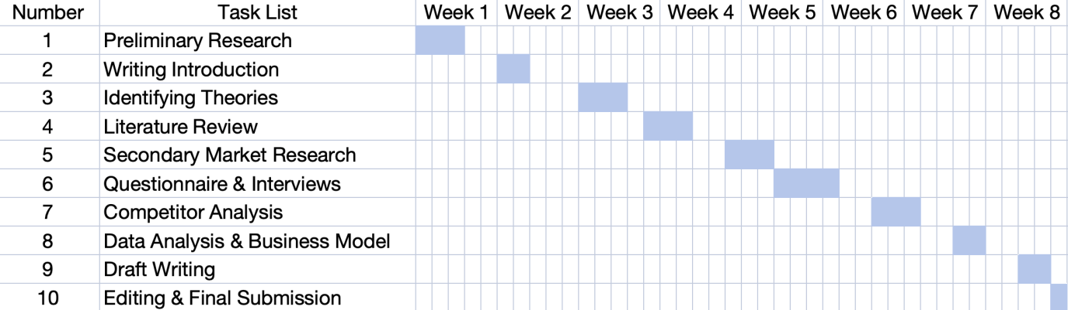

Figure 02: Gantt Chart Showing the Time-frame Of The Project (Self Developed)

7. Conclusion
This Business Development Proposal outlines the feasibility of establishing SmartGrowth AI as an AI-powered marketing agency serving UK service-based SMEs. The study identifies a clear market opportunity created by growing demand for affordable digital marketing support, increasing adoption of AI technologies, and dissatisfaction with purely outsourced solutions. The literature suggests that combining AI efficiency with human creativity can improve productivity while preserving the strategic and emotional elements of marketing. The proposed methodology provides a practical framework for assessing customer demand, competitor positioning, and operational requirements. Although the research is subject to limitations relating to sample size and market uncertainty, the findings indicate that SmartGrowth AI has the potential to deliver value to SMEs, create employment opportunities, and establish a differentiated position within the UK marketing services sector.

References
Braun, V. and Clarke, V. (2006) ‘Using Thematic Analysis in Psychology’, Qualitative Research in Psychology, 3(2), pp. 77–101.
Bryman, A. (2021) Social Research Methods. 6th edn. Oxford: Oxford University Press.
Burns, P. (2020) Entrepreneurship and Small Business. 5th edn. London: Red Globe Press.
Chaffey, D. and Ellis-Chadwick, F. (2022) Digital Marketing. 8th edn. Harlow: Pearson.
Creswell, J.W. and Creswell, J.D. (2023) Research Design: Qualitative, Quantitative and Mixed Methods Approaches. 6th edn. Thousand Oaks: Sage.
Davenport, T.H., Guha, A., Grewal, D. and Bressgott, T. (2020) ‘How Artificial Intelligence Will Change the Future of Marketing’, Journal of the Academy of Marketing Science, 48(1), pp. 24–42.
Department for Business and Trade (2024) Business Population Estimates for the UK 2024. London: DBT.
European Commission (2020) User Guide to the SME Definition. Brussels: European Commission.
Huang, M.-H. and Rust, R.T. (2021) ‘A Strategic Framework for Artificial Intelligence in Marketing’, Journal of the Academy of Marketing Science, 49(1), pp. 30–50.
Kingsnorth, S. (2022) Digital Marketing Strategy. 3rd edn. London: Kogan Page.
Kotler, P., Keller, K.L. and Chernev, A. (2022) Marketing Management. 16th Global edn. Harlow: Pearson.
Osterwalder, A. and Pigneur, Y. (2010) Business Model Generation. Hoboken: Wiley.
Porter, M.E. (1985) Competitive Advantage: Creating and Sustaining Superior Performance. New York: Free Press.
Saunders, M., Lewis, P. and Thornhill, A. (2023) Research Methods for Business Students. 9th edn. Harlow: Pearson.
Storey, D.J. (2016) Understanding the Small Business Sector. London: Routledge.
Taiminen, H.M. and Karjaluoto, H. (2015) ‘The Usage of Digital Marketing Channels in SMEs’, Journal of Small Business and Enterprise Development, 22(4), pp. 633–651.
Tiago, M.T.P.M.B. and Veríssimo, J.M.C. (2014) ‘Digital Marketing and Social Media: Why Bother?’, Business Horizons, 57(6), pp. 703–708.

