POOR LEADERSHIP AND EXTRA WORKING HOURS LEADING TO POOR EMPLOYEE ENGAGEMENT IN ASDA
Student: Mihai Tilea (2124071)
Lecturer: Laila Maazouz
University Of Whales Trinity Saint Davis
Module: BMSW4004_LON
Date: 02.02.2022
Table of Contents
Introduction 3
The workplace problem 3
Analysing Information 4
Root Cause Analysis (RCA) 4
Applying Situational Analysis Models 4
SWOT 4
PESTLE Analysis 5
Range Of Alternative Solutions 6
Evaluation Of Alternative Solutions 7
Implementing The Solution 7
Communication plan with stakeholders 9
Monitoring And Review Techniques 10
Conclusion 11
Reference List 12

Introduction
Problem-solving refers to the act of identifying a problem where the causes are deciphered so that relevant solutions can be decided and implemented gradually. Problem-solving within business ventures is very crucial for resolving conflicts, making proper decisions and employee engagement can be confirmed effectively. Risks can be addressed through problem-solving which implies that maximum development can be attributed. Better professional life can be deciphered which highlights better outcomes within the business organisation can be attributed.
Company Overview
Asda is regarded as Britain's largest retailer which was founded in the 1960s in Yorkshire. The employees here are dedicated to serving their loyal customers where the online services are also provided so that maximum sales are generated eventually (Corporate. Asda, 2022). Asda has over 18 million loyal customers and 98% of houses within the UK use their products daily. The employees are treated with respect and integrity which implies that their sales are sufficient (Corporate. Asda, 2022).

The workplace problem
Business organisations try to achieve maximum employee satisfaction but their management fails and maximum productivity cannot be ensured. Asda also has several management issues that disrupt the job satisfaction level among the employees. The excess workload is reported to be one of the major issues existing within Asda where staff feels frustrated and their involvement in the work remains low (Glassdoor, 2022). The shift timings are also very strict which implies that the workers do not get enough time for relaxation which implies overall conditions have declined eventually. According to the opinion of Ajayi et al. (2019), higher working hours without breaks generally lead to problems among the workers and a level of dissatisfaction can be observed among them. Many employees within Asda have highlighted that they have faced poor leadership from the senior managers which have increased their stress and work efficiency also has been negatively impacted (Glassdoor, 2022). It has been determined that the leaders do not recognize the hard work of the employees which implies their overall conditions have declined further. In addition to that, their work-life balance also has declined which implies that the chances of human attrition rate are significantly high.

Analysing Information

Root Cause Analysis (RCA)
There are some major dissatisfactory employment factors such as excessive work pressure and poor leadership that violate the well-being of the employees. The causes and effects are presented below:
Cause 1: Excessive Work Pressure
Effect 1: As has been determined, Asda implies very strict and long working hours which implies that employees do not receive any scope for taking breaks and relaxation. When staff is deprived of recreation during working hours, they feel monotonous and their productivity in work also decreases eventually (Gilleen et al. 2021). Therefore, work-life balance within Asda is not maintained which implies that overall conditions become rather poor and higher productivity failed to be achieved. The human attrition rate within Asda has increased by 10% between 2020 to 2021 (Corporate. Asda, 2022). This highlights that employees have opted for other companies that provide better work-life balance and flexible working hours.
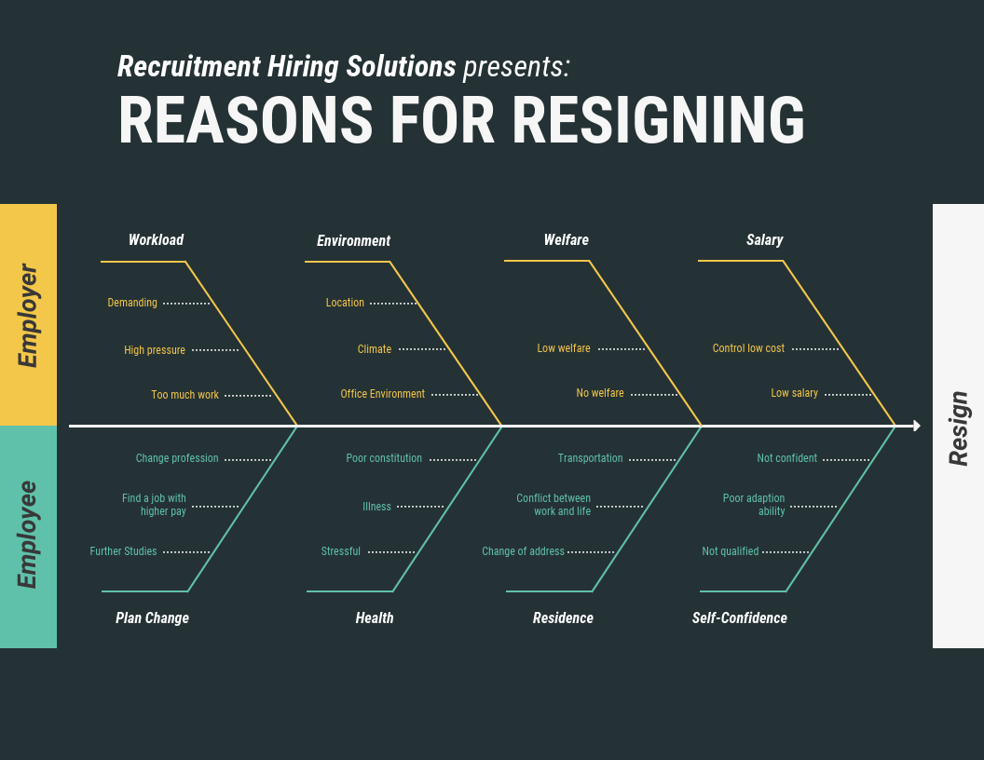
Figure 1: Fish Bone Diagram
(Source: Researchgate.com)

Cause 2: Ineffective Leadership
Effect 2: According to the employee feedback 60% of the employees have highlighted that they have faced poor leadership which implies that the working culture is also negative (Glassdoor, 2022). The leaders have always been uncooperative which implies that they do not allow the workers to share their ideas and opinions and overall conditions become poor to obtain. According to the statement of Knight et al. (2019), work engagement generally declined which implies that ineffective leadership can lead to improper operations and maximum development can be attributed. In addition to that, ineffective leadership also highlights within Asda which implies that they do not recognize the hard work of the workers. Thus, the employees of Asda also have faced partiality from the leaders which highlights maximum development can be gathered (Glassdoor, 2022). Employees also experienced tension from the leaders and their work efficiency has also declined eventually and payments are also not enough.

Applying Situational Analysis Models

SWOT
Strengths
Asda has a higher brand recognition across the globe due to its higher network of distribution
(Shastri, 2021). Moreover, they sell a diverse range of products and different customers' demands can be met significantly (Corporate. Asda, 2022). Moreover, so many employees also work here which implies that effective outcomes are provided to them.
Weaknesses
However, Asda faces different types of challenges where higher employee turnover is observed which has increased by 10% within a year (Shastri, 2021). Therefore, the company also faces a lack of sales because dissatisfied employees do not serve the customers properly and effective sales failed to gather (Corporate. Asda, 2022).
Opportunities
There is a scope of employee satisfaction that needs to be increased (Corporate. Asda, 2022). Moreover, the company can increase its online presence so that employee benefits can be improved and maximum development also becomes possible. The workers also feel more influenced in doing good work and better sales can be deciphered eventually.
Threats
Due to poor employee productivity the customer satisfaction level is also low within Asda (Corporate. Asda, 2022). The management also faces higher competition because the employee turnover is high which implies that overall development has also declined gradually further. The productivity level also decreases which implies that overall development within the operations becomes rather difficult.

PESTLE Analysis
Political: The UK Government is supportive and provides funds and incentives which implies that Asda can acquire help from the legal bodies in providing provisions for training and development of the employees for increasing their retention rate and maximum development can be confirmed eventually (BBC, 2022). However, the application of Brexit can also result in Asda strengthening the training of their existing employees because of recruitment of the workers from European countries at lower wages.
Economical: In 2021, the retail industry within the UK has generated sales of €421 billion which deploys over 5% growth within the GDP rate (Retail Economics.co.uk, 2022). In addition to that, the inflation rate in 2022 increased by 11.1%. From this discussion, if the employees serve the customers properly effective sales are possible within Asda.
Social: The UK unemployment rate has increased by 3.6% within 6 months which implies overall development can be attributed (Statista, 2022). Consumer spending habits have changed after the pandemic which implies that customers are prone to invest in necessary items rather than luxury goods. Thus, to decrease the unemployment rate Asda needs to improve their employee satisfaction so that the human attrition rate can be eventually decreased.
Technological: UK is a technologically advanced country where all the advanced applications within the business are possible and maximum development can be attributed. Asda has been using Artificial Intelligence generated automated robots to clean the floors within the stores (Stevens, 2020). Therefore, the employees are free from doing repetitive tasks to accelerate their engagement in the business.
Legal: The application of employment laws implies that the "Employment Rights Act 1996" highlights that all the staff has the scope to report it against the employers which demonstrate that employees are to receive all the benefits and respect under this law (Legislation.gov.uk, 2018).
Environmental: Sustainable practices are undertaken by Asda that protects the environment as well as society. 35% of carbon emissions have been reduced within the business operations and zero landfill wastes are acquired from 2020 (Asda, 2022). 85% recycling is observed within the business operations of Asda which implies that overall development can be generated. In addition to that, employees have to improve their work and better outcomes are confirmed.

Range Of Alternative Solutions
The three most effective solutions that can be implemented by Asda for accelerating job satisfaction among employees have been discussed:
- Flexible working hours: The employees within Asda have highlighted that the working hours are long and strict. Therefore, flexible working hours can be integrated within Asda which implies that employees will take a break to make their minds fresh and then their work efficiency will also be increased eventually (Chung and Van der Lippe, 2020). Thus, their work-life balance can be maintained and overall development can be attributed.
- Good Communication by the leaders: The leaders have to initiate a proper conversation with the employees so that their ideas are shared and opinions are regarded while making decisions to make them feel respected and involved within the workplace (Verčič, 2021). The leaders also have to become good listeners so that they become aware of the employees' wants and higher demands can be ensured.
- Provide incentives for working long hours: The management has to offer monetary incentives, travel tickets, or food coupons for the employees who are working for longer hours for attracting the employees' attention and maximum development can be attributed eventually (Knight et al. 2019). A salary hike can also be an option so that workers feel motivated to do their work properly.

Evaluation Of Alternative Solutions
 | Weight | Flexible hours | Good Communication | Incentives
Budget | 3 | 15 | 12 | 9
Employee engagement | 5 | 20 | 25 | 20
Experience building | 4 | 12 | 20 | 8
Morale Boosting | 5 | 5 | 10 | 25
Table 1: Alternative Solutions
(Source: Self-Developed)

Implementing The Solution
Stages | 1st week (12th to 18th December, 2022) | 2nd and 3rd week (19th to 25th December, 2022) | 3rd week (26th December to 1st January, 2023) | 4th week (2nd January to 8th January, 2023)
Decision making | Staff working for extra or long hours will be given incentives, bonuses, and travel allowances. These gifts will motivate the employees to work more productively and their engagement within the work will also remain high
Evaluating performances |  | The leaders will evaluate the individual performances and recognize the hard work done by the employees and maximum development can be attributed. Feedback will also be provided for future improvements.
Budget Planning |  |  | The managers will also set a budget for integrating provisions for training and development so that the skill gaps among the staff can be addressed and better involvement within work can be confirmed.
Implementing |  |  |  | The leaders will meet the employees face-to-face and interact with them about the changes they want to make within the workplace so that continuous engagement in work remains significantly high.
Table 2: Implementation Plan
(Source: Self-Developed)

Communication plan with stakeholders
The engagement of stakeholders is very important for business development and maximum outcomes can be attributed.
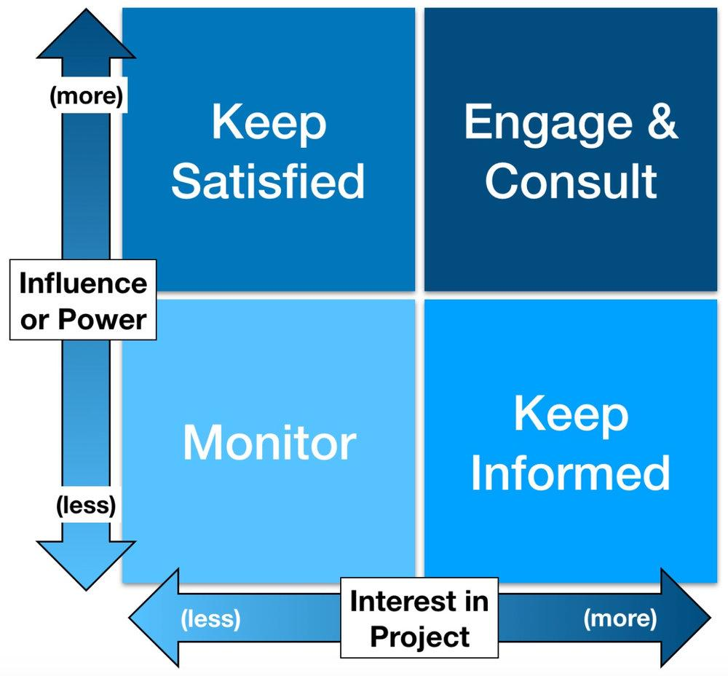
Figure 2: Power Interest Grid
(Source: created by the learner)

Similarly, stakeholder engagement also highlights the overall business functions. The stakeholder communication plan is as follows:
Stakeholder | Type | Power and interest | Issues | Communication
Group Leader | Primary | Reviewing the performance of the employees individually. | Lack of transparency | Feedback through mails
Employees | Primary | A healthy work-life balance is required for higher work productivity | The opinions of the employees are not regarded
Manager | Primary | To look after the overall operations within the business and inspire the staff to do good work | Direct communication with employees is not done | Mails and feedback can be used
Table 3: Communication plan with stakeholders
(Source: Self-Developed)

Monitoring And Review Techniques
The management within Asda needs to use the ADKAR model to improve the level of employee satisfaction and engagement in work. They are as follows:
Awareness: The leaders have become aware of integrating good communication and making the employees involved while decision-making (Gilleen et al. 2021). Better communication can solve complex situations within Asda.
Desire: Bonuses, incentives, and travel allowances can be attributed and salary hikes can be improved eventually.
Knowledge: Training can be provided to the employees so that their skill gaps can be addressed and maximum development can be acquired (Verčič, 2021)
Ability: The employees can work even more productively when they are aware of their problems and higher efficiency can be ensured.
Reinforcement: The success of the organisation can be ensured by the productivity among the workers can be generated and maximum development is ensured.

Conclusion
Based on the above discussion, it is understood that employees within Asda are not happy about the long hours and strict schedule they have to maintain on all the working days. Moreover, the leaders also do not appreciate the employees' achievements have declined their work motivation and the human attrition rate has increased by 10% within 6 months. Thus, it is understood that proper bonuses, travel allowances, and good communication should be generated by the leaders for influencing the customers' attention.

Reference List
Ajayi, S.O., Jones, W. and Unuigbe, M., 2019. Occupational stress management for UK construction professionals: Understanding the causes and strategies for improvement. Journal of engineering, design and technology.
Asda, 2022. Better Planet. Available from https://www.asda.com/creating-change-for-better/better-planet. Accessed on 6/12/2022.
BBC, 2022. United Kingdom country profile. Available from https://www.bbc.com/news/world-europe-18023389. Accessed on 6/12/2022.
Chung, H. and Van der Lippe, T., 2020. Flexible working, work–life balance, and gender equality: Introduction. Social Indicators Research, 151(2), pp.365-381.
Corporate. Asda, 2022. Our Story. Available from https://corporate.asda.com/our-story#:~:text=Founded%20in%20the%201960s%20in,and%20depots%20across%20the%20UK. Accessed on 6/12/2022.
Gilleen, J., Santaolalla, A., Valdearenas, L., Salice, C. and Fusté, M., 2021. Impact of the COVID-19 pandemic on the mental health and well-being of UK healthcare workers. BJPsych open, 7(3).
Glassdoor, 2022. ASDA Reviews. Available from https://www.glassdoor.co.in/Reviews/ASDA-Reviews-E10108.htm. Accessed on 6/12/2022.
Knight, C., Patterson, M. and Dawson, J., 2019. Work engagement interventions can be effective: a systematic review. European Journal of Work and Organizational Psychology, 28(3), pp.348-372.
Legislation.gov.uk, 2018. Employment Rights Act 1996. Available from https://www.legislation.gov.uk/ukpga/1996/18/contents. Accessed on 6/12/2022.
Retaileconomics.co.uk, 2022. UK Retail Stats and Facts. Available from https://www.retaileconomics.co.uk/library-retail-stats-and-facts. Accessed on 6/12/2022.
Shastri, A., 2021. Thorough SWOT Analysis of Asda – A Lifestyle and Retailer Supermarket Bases In The UK. Available from https://iide.co/case-studies/swot-analysis-of-asda/. Accessed on 6/12/2022.
Statista, 2022. Unemployment rate in the United Kingdom (UK) from 1999 to 2021. Available from https://www.statista.com/statistics/263709/unemployment-rate-in-the-united-kingdom/. Accessed on 6/12/2022.
Stevens, B., 2020. Asda becomes first UK supermarket to roll out automated cleaning robots. Available from https://www.chargedretail.co.uk/2020/07/16/asda-becomes-first-uk-supermarket-to-roll-out-automated-cleaning-robots/. Accessed on 6/12/2022.
Verčič, A.T., 2021. The impact of employee engagement, organisational support and employer branding on internal communication satisfaction. Public Relations Review, 47(1), p.102009.

