

The Global Business Environment
Analyse the impact of the pandemic on Tesla

Module Code: LCCB4005
Assignment Title: Environmental Analysis of an industry-Assessment2
Module Lecturer’s Name: Rexon Nting
Student Name: Diana Paula Stratulat

Student ID: 2024156

Table of contents

Introduction 1
Impact of the pandemic on the electric vehicle industry 2
Survival strategies adopted by Tesla during the turbulent pandemic times 4
Industry Success Factors 5
Conclusion 6
References 7

Introduction
The pandemic had an international impact on the world from a wide variety of standpoints. It changed the way people work, socialize and spend time for a very long time. Although the pandemic is easing in many parts of the world now, some of the changes created by the pandemic are expected to be permanent for the world. The world will have to get used to the new normal. This situation had an immense impact on mobility solutions around the world. Tesla, as part of the companies offering such vehicles, was affected as well, although not in similar terms. This assignment seeks to explore and understand the impact the pandemic had on Tesla, the positives, and the negatives and how the company plans to go on in the future.

Impact of the pandemic on the electric vehicle industry
Positive impact
The massive reach and ubiquity of the pandemic reignited the debate about sustainability and reaffirmed the position of the environmentalists. Human intervention at every level is having a bad effect on the environment. Furthermore, the sheer scale of human exploitation is dangerously altering the balance of ecology on Earth. This is not only jeopardizing other species but also human civilization as well (Barrett, 2021). The outbreak of coronavirus proved that. One of the reasons the electric car industry showed remarkable resilience in the face of difficult macroeconomic situations is because there has been a momentous shift in the consumer psyche regarding the products and services they are using. Therefore, most consumers are likely to buy electric cars when they have the funds or have the prospect of buying a car (Salome and Joy, 2021). Electric cars have significantly captured the imagination of the people in such a manner that it is now quite impossible for the general automakers to survive in the business for the long term without bringing something similar. The pandemic slowed down the process of fossil fuel import and export, which further contributed to the price hike of oil and gas. This acted as the economic push for the people who are thinking of buying a car for themselves. The following chart shows the change in electric car sales during the height of the pandemic against the general oil or gas-based car sales in the same period.
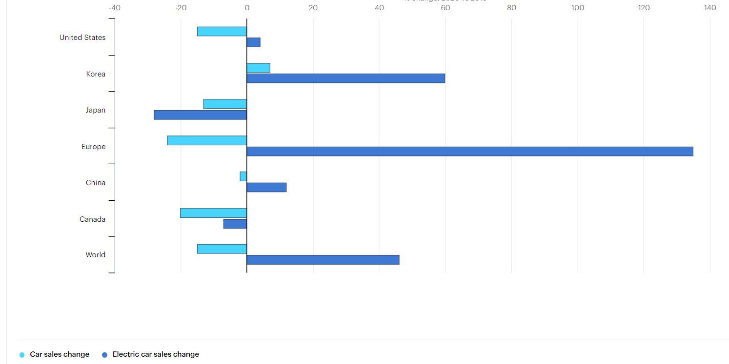
Figure 1. Change in overall automobile sales compared with the change in electric vehicle sales (Charlee, 2020)
This figure proves beyond doubt that the consumer mind has already undergone a momentous change and is unlikely to turn back to oil or gas-based car again. Also, there is a possibility that these figures that portray the significant shift towards electric cars may have been corrupted by other factors (Sylvester, 2021). For example, people who are buying electric cars are generally wealthy compared to most of the general consumers. When the pandemic stroke, the number of people who were affected by the sudden downturn of the economy was high. The wealthy people who could buy electric cars and already decided on buying an electric car simply went ahead and bought them because they were not affected that much to reduce their consumption steeply (Egbert, 2021). On the other hand, general oil and gas-driven cars and bought by people from various income levels and walks of life. The pandemic severely limited their ability to take out an auto loan sustainably and make a significant purchase. That’s why the oil and gas-based automobile sales were down during coronavirus. This point is argued by critics of electric cars. However, only time can tell which story represents the better truth.
However, the pandemic created more concern for the health of the planet and civilization in general. This concern, while not very helpful in the short term, might contribute towards the long-term growth of the business by creating demand for electric vehicles and permanently changing the consumer psyche (Nixon, 2020). The significant and momentous shift towards electric vehicles may not be confirmed yet, but the pandemic and the high environmental concern will drive the world towards that. In that point of view, the pandemic can be seen as a blessing for the electric car industry to some extent.
Negative impact
The electric car industry suffered its share of the negative impact of the coronavirus pandemic as well. Electric cars are dependent on the future growth of demand. The industry leaders are leveraging the businesses and companies by speculating that the market will have a sizable amount of demand by a specified period (Rosanna, 2020). Demand for automobiles is dependent on several factors like savings, income growth, support, future cash flows etcetera. Pandemic left a strong impact on savings. Overall, savings in countries like the United States, the United Kingdom, France, Denmark, Spain, Germany declined significantly during the coronavirus pandemic (Jayceon, 2021). This sharp downturn in savings is likely to impact future sales of electric cars, although they did not manifest themselves during the pandemic itself till now. While the number of workers is steady for the economy as a whole, the income gap is rising, and further lockdowns coupled with a health crisis is likely to reduce the income of most of the corporate groups. This may create a job crisis for the workers, both white collars and blue collars. This is going to reduce the demand for electric cars in both the short and long term unless electric car makers come up with newer strategies for the middle income and low-income market (Timotha, 2019). At this moment, these two segments of the market are mostly being ignored by the major automakers, including Tesla. While the social revolution is helping strengthen the brand demand for electric cars, the pandemic problem coupled with income reduction at all levels of the economy is hurting the long-term savings accumulation, which eventually would have created an increased demand for electric vehicles. Therefore, it can be deduced that while the pandemic did raise a concern about the environment, it also reduced the economic means through which people could buy electric vehicles. For Tesla, the brand value increase was immense, but being unable to sell cars failed to bring in cash flows which would have eventually helped the business to remain successful.

Survival strategies adopted by Tesla during the turbulent pandemic times
Tesla, during the initial waves of lockdown, prepared for a full-blown financial crisis created by an absolute lack of cash flows and the high-cost structure created by innovation activities and pushing products into a newly developing market. To combat such problems, Tesla went for more capital injection in the form of new long-term debts and issuing preference shares to the public (Colby and Flanagan, 2019). But as the months of the pandemic progressed, Tesla soon realized that it isn’t going to be as bad as they thought. The number of workers remained mostly stable at factories working for Tesla or processing Tesla orders. Tesla was also able to push through multiple reforms for working processes that allowed workers to work from home or enable any form of remote working. The survival strategies of Tesla took the form of three pillars. They are, creating and adopting workplace reforms to ensure health standards, pushing through production and marketing deadlines, taking advantage of a surprisingly robust stock market to gain more financial capital (Danielle and Phoenix, 2020). These three strategies were targeted mainly towards four departments, human resources, sales, production and finance.
On the HR front, Tesla quickly adopted virtual meetings and work teams as the principal methods of working. Even performance management tools and performance tracking systems quickly evolved to accommodate for such systems in the core working systems of Tesla. High performance working methods was also applied to such new work processes. While it did not work as well as offline working methods, the offline working methods was developed after numerous testing and development, but it did work remarkably well compared to other automobile industry players.
The marketing process was revamped by Elon Musk himself taking the helm. Tesla usually doesn’t do much advertisement (Truman and Jared, 2021). A lot of the marketing is done by Elon Musk’s advancements and announcement events. With Elon Musk taking the stage, the marketing for Tesla products got a new lifeline. The production process, on the other hand, was re-evaluated and production estimates were downgraded to reduce working capital requirements. In other words, the planning and execution of Tesla strategies during the pandemic firmly remained down to earth and practical.
Tesla took advantage of the robust stock exchanges to recapitalize itself. Furthermore, the increased level of capital was used to expedite technological progress and the production process at Tesla.
The technological progress afforded by the higher level of equity capital created a lower risk environment for the company, at least financially. Combined with better HR management, stronger marketing and down to earth production planning, recapitalization allowed Tesla to remain in the market stronger than ever (Bailey and Whitney, 2019). However, the macroeconomic conditions that have reduced the level of savings economy-wide will badly affect Tesla’s sales in the future. However, from CEO Elon Musk’s point of view, he argued that such setbacks only pushed the success of Tesla a little further. He believes that the success of Tesla is a matter of timing rather than business factors. He has a strong faith in the business prospects of Tesla and believes that Tesla will become the industry leader if it continues to work in the way it is working now.

Industry Success Factors
Several factors decide the overall success of the players in the industry. However, as none of the industry players has succeeded yet from a traditional business perspective, it cannot be conclusively spoken about the terms and conditions that will lead to early success for each of the players (Kerri and Seymour, 2019). However, based on industry cycle and market theories, some factors can be readily identified which can provide a boost for the development of the business model of each of the companies. The following are some of them.
Market development: At this moment the entire electric vehicle market is completely underdeveloped. The buyers aren’t aware of the different aspects of the offering and they are reluctant to make a sizable investment into something they do not know whether they can use well (Evelyn and Brenna, 2019). It is up to the managers of the industry players to make sure to speed up demand creation. This is dependent on the product education level of the workers, viability of the product overall and the economics related to consumption and holding of the product in question. The faster a specific brand will be able to develop the market conditioned to the specific offering of the brand, the better the possibility that the brand will come to dominate the industry until it reaches maturity.
Profitability and financial expansion: The electric vehicle market, due to being new, will require a lot of investments and development to become mature enough to create profit. Therefore, only the industry players who become able to mobilize sizable capital will be able to dominate the industry (Barrett, 2021). Profitability or expectation of profitability will play a large part in ensuring that the company in question secures sizable investments from the investors.
Technological know-how: The development of technological know-how will play a strong role in market development. One of the reasons electric vehicles are suffering from a lack of sales is because the infrastructure isn’t ready yet. Furthermore, the technology associated with electric vehicles does not make them a very good choice when compared to fossil fuel-driven cars (Rosanna, 2020).

Conclusion
The electric vehicle industry is booming. The pandemic has had its effects on the industry in general, but overall, the industry is trying to exploit every single advantage they have while mitigating the problems of the industry. Tesla is no different. Use of good strategies, combined with the power of leadership, this industry is expected to disrupt the market for mobility solutions soon enough. This assignment discusses in-depth about the effect the pandemic had or has on the industry and how it is trying to grow with what it has.

References
Bailey, L. and Whitney, R. (2019). Evolution of value spectrum in the electric automotive industry. Journal of Competitive Studies and Business Value Creation, 2018(4), pp.42-57.
Barrett, K. (2021). Developing the electric car. Journal of Finance and Investments, 2021(6), pp.12-14.
Charlee, T. (2020). The Tesla method of dominating capital markets. Journal of Finance and Investments, 2017(17), pp.19-45.
Colby, M. and Flanagan, A. (2019). A quantitative look at the demand for electric vehicles. Journal of Managerial Sciences, 2017(5), pp.65-67.
Danielle, L. and Phoenix, C. (2020). The rise of Tesla and the implications for the greater automotive industry. Journal of Statistics for Humane Studies, 2018(3), pp.12-15.
Egbert, F. (2021). Why Human Resource Management Matters. Journal of Human Resource Development, 2021(5), pp.5-16.
Evelyn, P. and Brenna, B. (2019). Leveraging Talents to Create Growth. Journal of Finance and Competitive Studies, 2019(3), pp.2-3.
Jayceon, T. (2021). The competitive advantage of electric vehicles during the pandemic. Journal of Cultural Studies, 2019(2), pp.12-14.
Kerri, B. and Seymour, L. (2019). How the Value Spectrum Makes or Breaks an Organization. Journal of Management and Business Strategy, 2019(8), pp.41-42.
Nixon, N. (2020). Elon Musk’s leadership and potential. Journal of Human Resources, 2017(9), pp.8-11.
Rosanna, H. (2020). How Leadership Changes an Organization. Journal of Leadership and Cultural Studies, 2020(3), pp.65-78.
Salome, G. and Joy, A. (2021). Market development versus buyer education in the context of electric vehicles. Journal of Finance, 2021(8), pp.56-57.
Sylvester, K. (2021). Measuring the Return on Investment from Human Resources. Journal of Finance and Investments, 2021(9), pp.21-22.
Timotha, H. (2019). Good versus Bad Leadership and Their Implications for the Larger Firm. Journal of Management Studies, 2020(6), pp.13-15.
Truman, G. and Jared, R. (2021). The Strategy of boldness. Journal of Culture Development, 2017(1), pp.15-77.

