Micros and peripherals

Lucy Henson
Student No: 2418593

L4 – Micros and peripherals
ACDA4022
Embedded Electronic systems Engineering Degree Apprenticeship

Contents
introduction 2
Section 1 3
Circuit design 3
Section 2 6
Section 3 11
On and off led switch 11
Left and right program 14
Piezo sounder 16

introduction
This report is split into 3 sections the first details the recreation of a project using a 7-segment display and PIC16F84 to count to 15 in hexadecimal. The recreation involves a detailed analysis of the circuit design used in the project. Section 2 describes how the circuit was able to display hexadecimal characters 0-F including the binary calculations used. Section 3 involves creating 6 different programs using the PIC16F84 and then showing a flow chart of how the programs work

Section 1

Circuit design
The components used in recreating the count project can be seen below in the table. Along with the original circuit schematic for count.
Component | Quantity
PIC16F84 | 1
Common anode 7 segment display | 1
Crystal oscillator | 1
Capacitor | 2
Push buttons | 2
Resistor 4K7 | 1
Resistor 10K | 2
Resistor 220 | 7

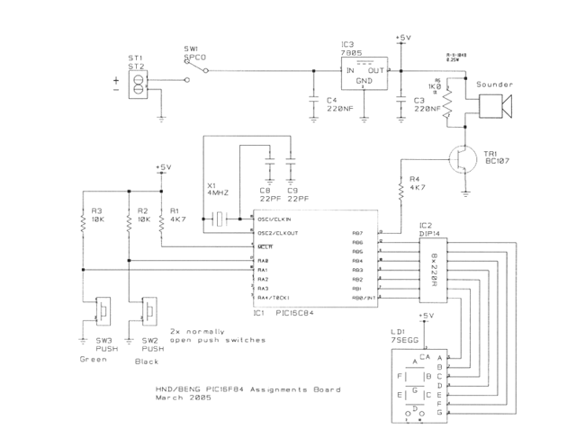
Figure 1 schematic for Count
7 220ohm current limiting resistors are connected to the common anode 7 segment display to prevent any damage to the LED. This could also be achieved with a resistor network which the original schematic has compared to the one in Proteus. The 10K resistors connected to the push buttons are setting them high this is to prevent the inputs from being floating where they could randomly be either high or low which would cause the program to behave irregular. The external crystal oscillator is used to generate a higher clock signal which would provide more stable timing as the pic16f84 doesn’t have an in-built internal oscillator. A current limiting resistor is not needed for the oscillator as it won’t be going anywhere near its overdriven limit. The 2 capacitors either side of the oscillator are being used to provide stability as manufacturers specify a required load capacitance for the crystal to operate at its intended frequency. The transistor is used with the peizo buzzer to boost the current as the PICs GPIO pins can’t source enough current for loud sounds and piezo need voltage changes (sinking/sourcing) to vibrate. Below is a picture to illustrate the difference between sourcing and sinking.
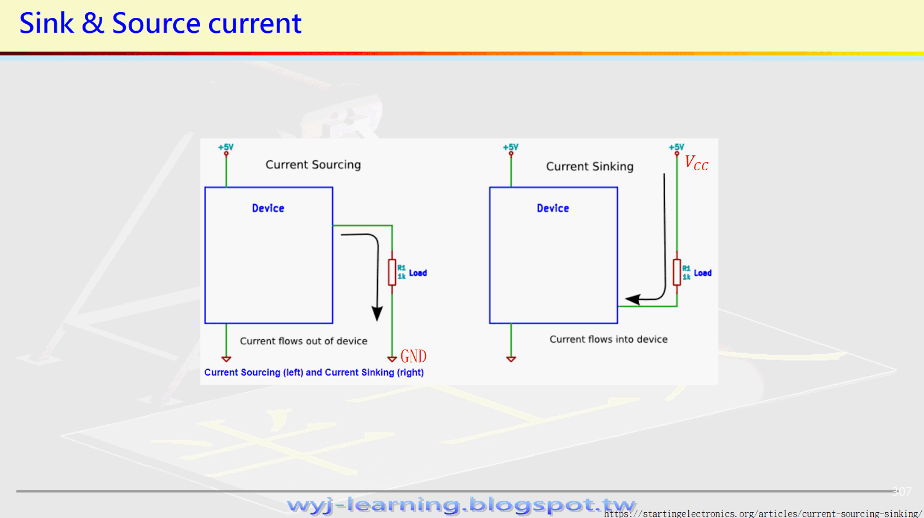
Figure 2 Sourcing and sinking differences
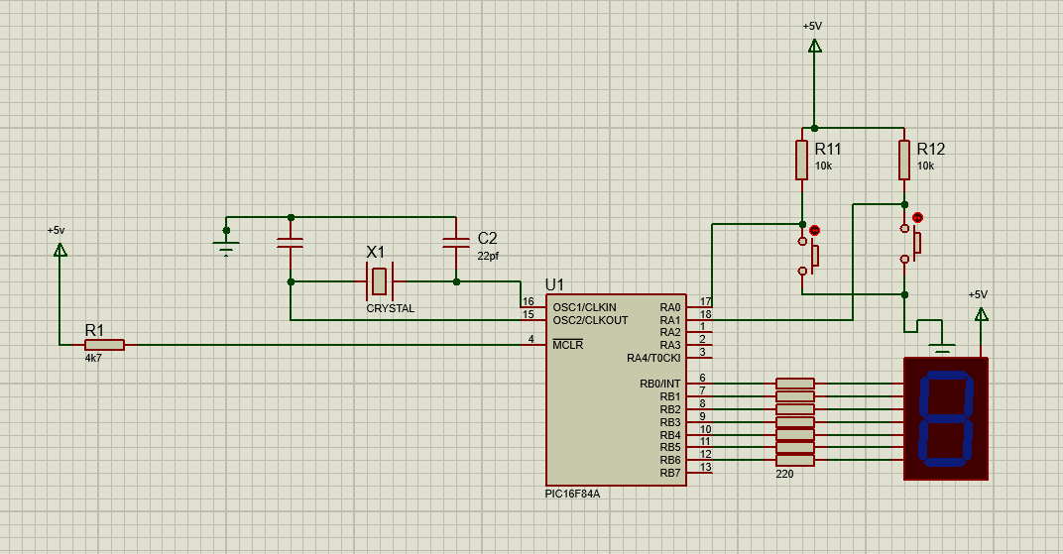
Figure 3 Schematic for count in proteus
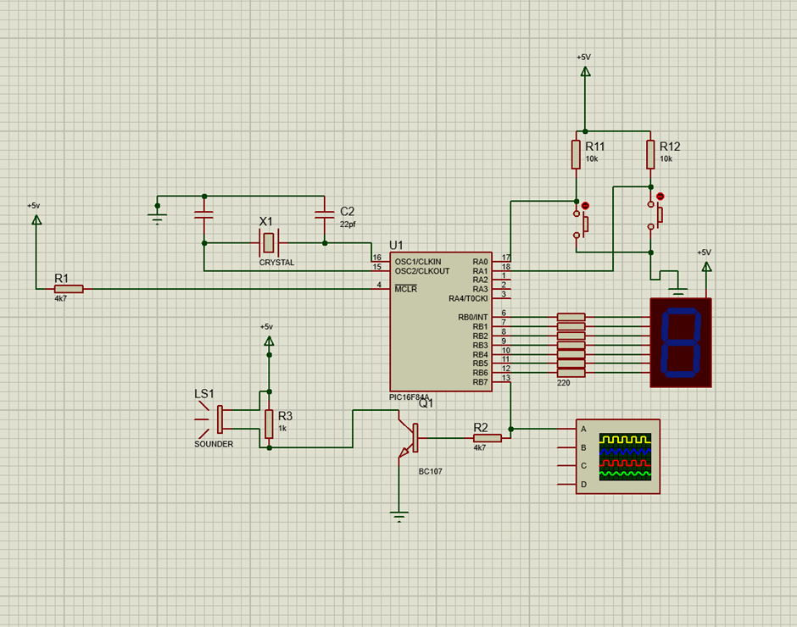
This is the count circuit recreated in proteus.
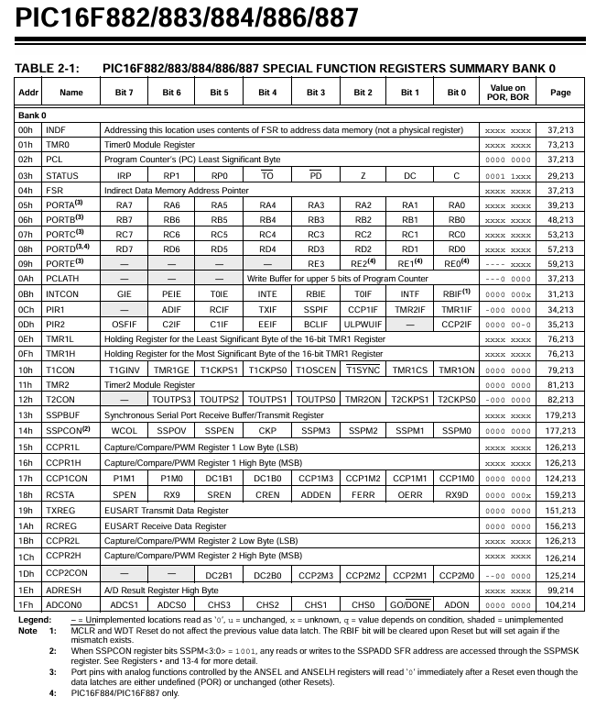
Figure 4 datasheet for pic16f84

Section 2

The circuit was able to display hexadecimal characters on the 7-segment display using bitwise calculations. It included a common anode 7 segment display where all its positive terminals (anodes) are connected to a single common pin which is connected to a positive voltage source. To light up a segment you apply a low (logic 0) signal to its corresponding negative terminal (cathode) via a current limiting resistor this is different from a cathode display where all the cathodes are joined, and a high signal turns the segments on. This was worked out by understanding that the logic of the display is active low therefor a segment of the display would only light up when its pin is connected to ground. The common pin would be connected to positive power (VCC). To create a character on the display I drew a table with the vertical side going down in hex from 0 to F. The horizontal side had all the names for the segments. I then filled the table with 1s or 0s to create the characters.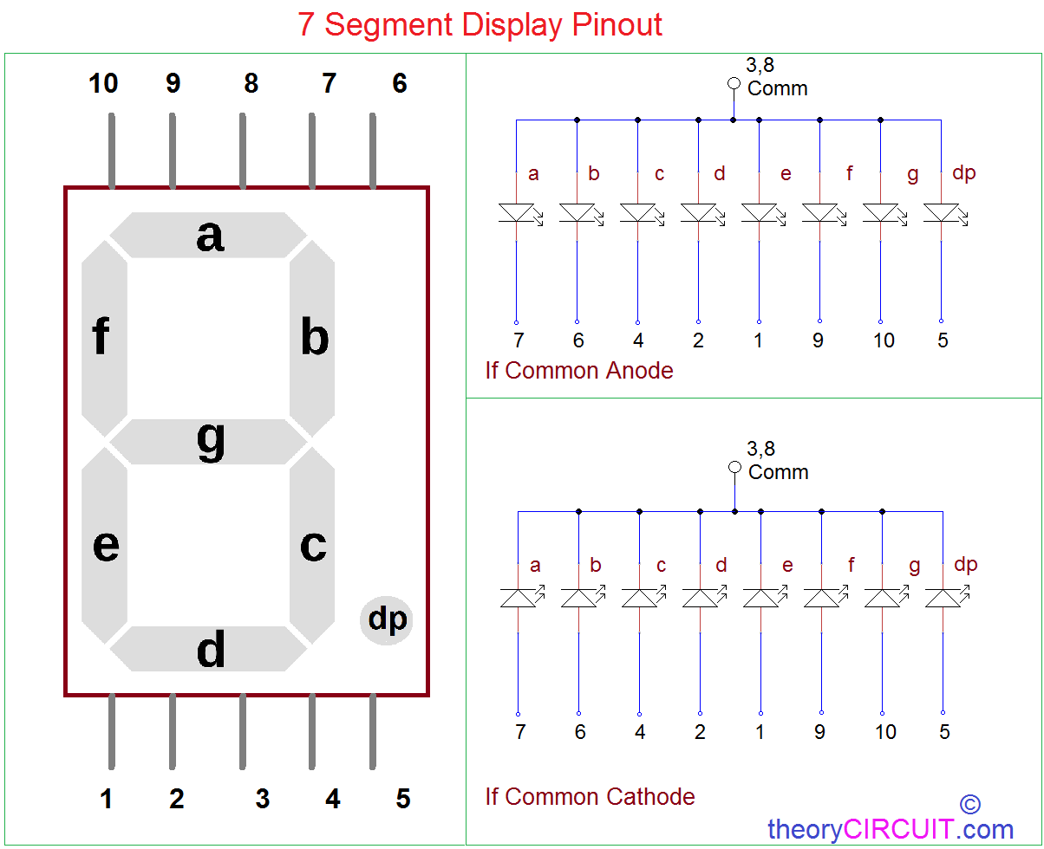
Figure 5 7 segment section names for common anode
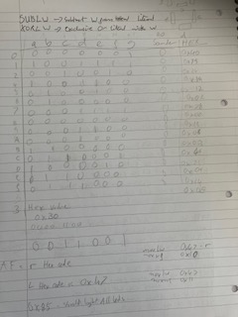
Figure 6 My truth table for the 7-segment display
…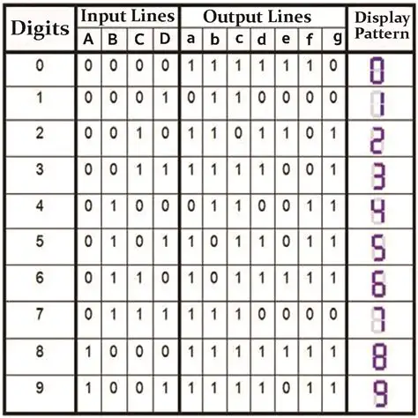
Figure 7 7 segment truth table
to display the characters on the display I created a table address with the literal binary values for all the characters at the start of the program. The program then calls a subroutine which is named display the subroutine then gets the count value and adds the offset to the start of the table address. It will then read the lookup table and then put the contents of the table into portB which is where the display is connected in the circuit. This means that the display will show the hexadecimal character.
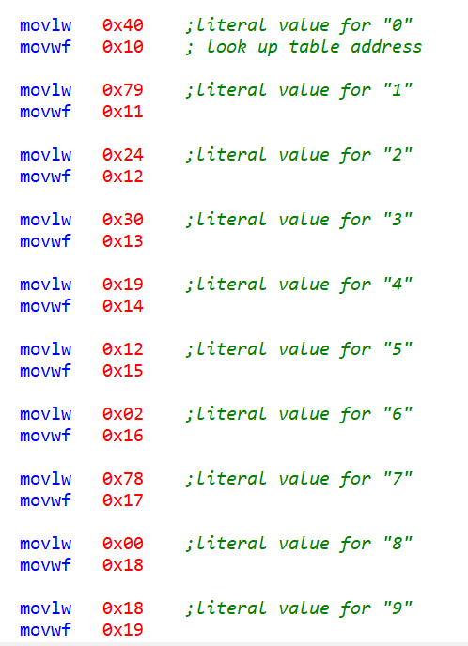
Figure 8 address table containing hex code characters
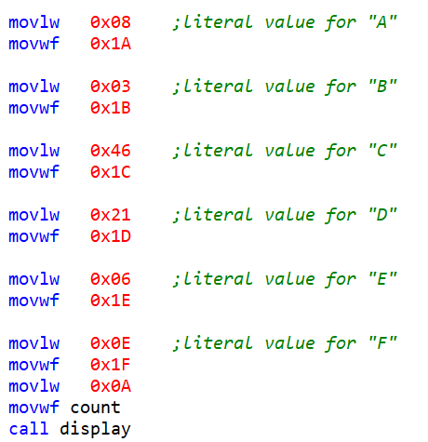
Figure 9 address table containing hex code characters
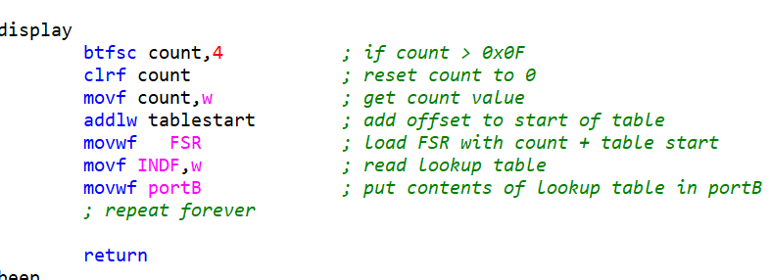
Figure 10 Count display program
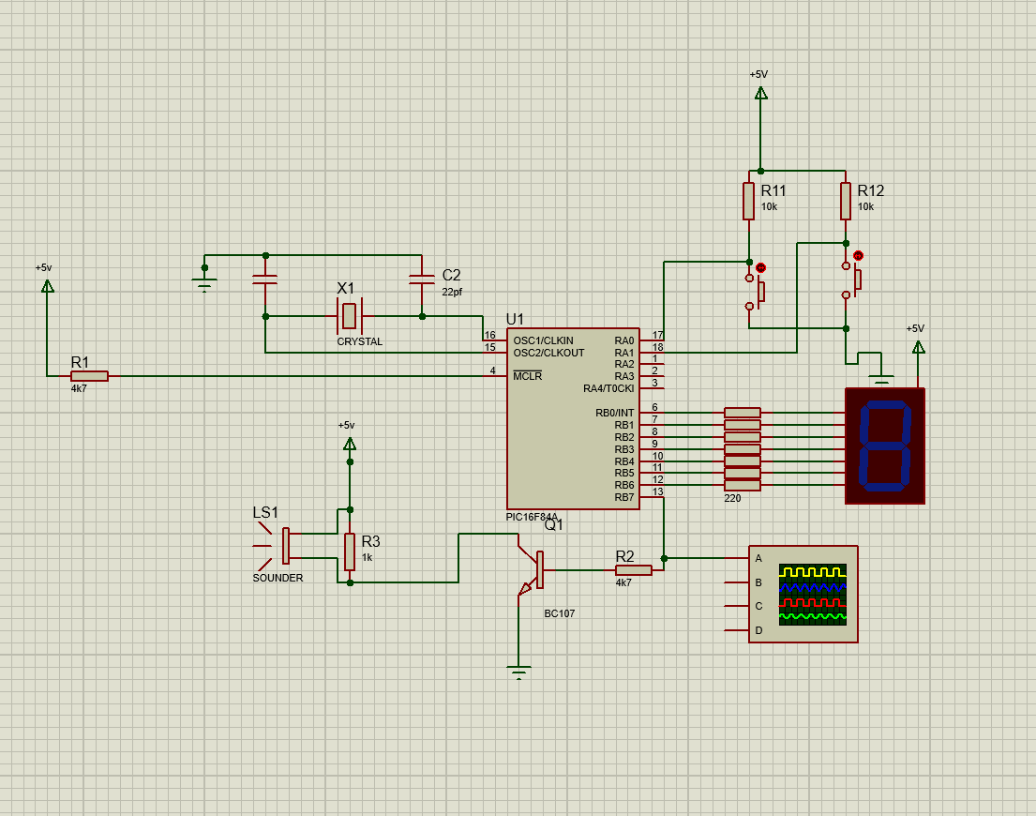
Figure 11 Count program

Section 3

On and off led switch
The task was to write a program with two buttons controlling the same 7 segment display. One of the buttons will turn all the LED segments of the display on and will be latched so that the display stays on the other will turn all the segments off. Flow chart can be seen below. Along with the screenshot of the program.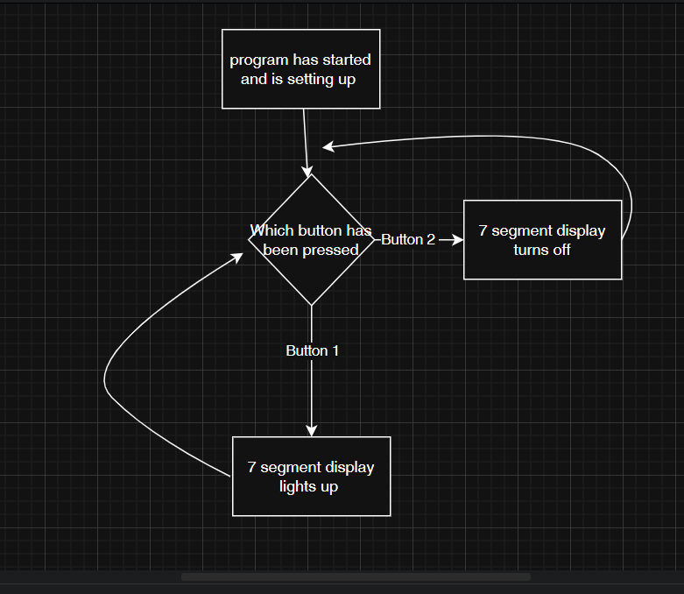
Figure 12 On and off buttons
The program works by mapping all the ports to free registers which can be seen below in the memory map. The start routine sets portB as the output along with clearing its outputs. The main loop is continually monitoring PortA to see if either button has been pressed. If the on button has been pressed the 7-segment display will turn on and stay on while the off button will turn the led off.
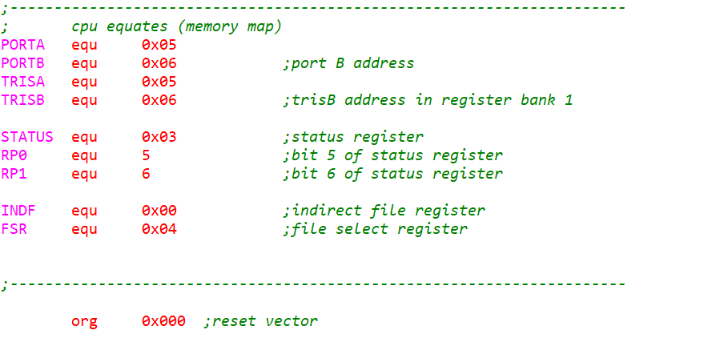
Figure 13 memory map for on off buttons
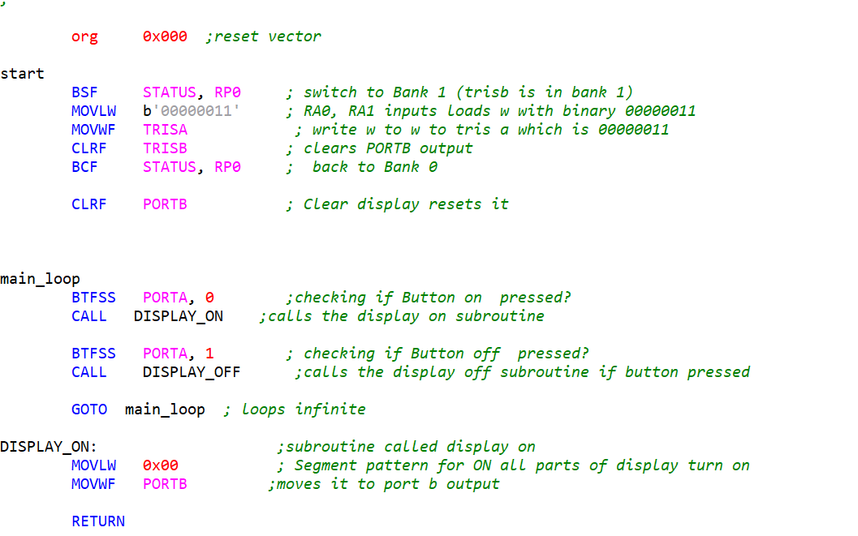
Figure 14 Main loop of on and off buttons

Left and right program
The task was to create a program where when Button 1 is pressed the 7-segment display displays a L character and when the button 2 is pressed the character r is displayed. The flow chart can be seen below.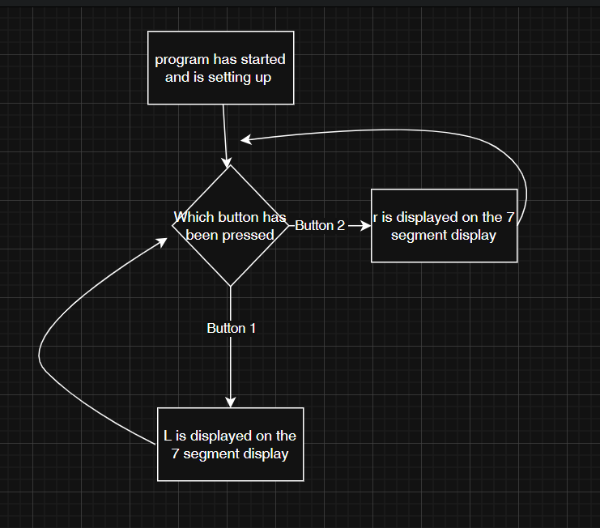
Figure 15 Left and Right buttons
The program is very similar to the on and off button program the only difference being that the subroutines have changed the hex code inside of them. I used the truth table for the 7-segment display to work out the hex code for L and r when I was doing it I couldn’t seem to get the R instead only r. I then substituted the hex code into the subroutines.
Figure 16 memory map for the left and right program
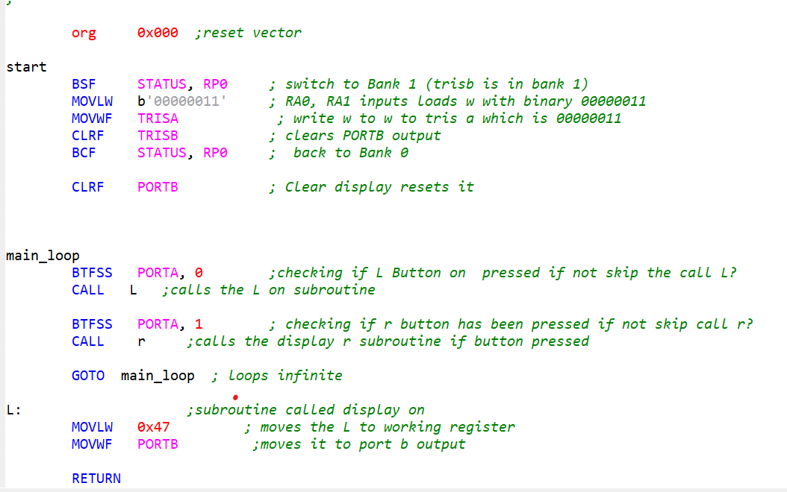
Figure 17 main loop for the left and right program

Figure 18 Count 0.2s increment

Piezo sounder
The task was to create a program where when one button is pressed the speakers connected to it create a tone and then when the other button is pressed it creates a different tone. This program is similar to the other 2 with the main loop constantly checking to see if either of the buttons had been pressed.The main difference with this program is the inclsuion of the pauses.To create a square wave as it’s the simplist way to output a sound to the speaker.They work by toggling the portB 7 on for the duration of the either of the pauses then toggling it off for the pause duration.The different durations in the pauses causes the different tones. 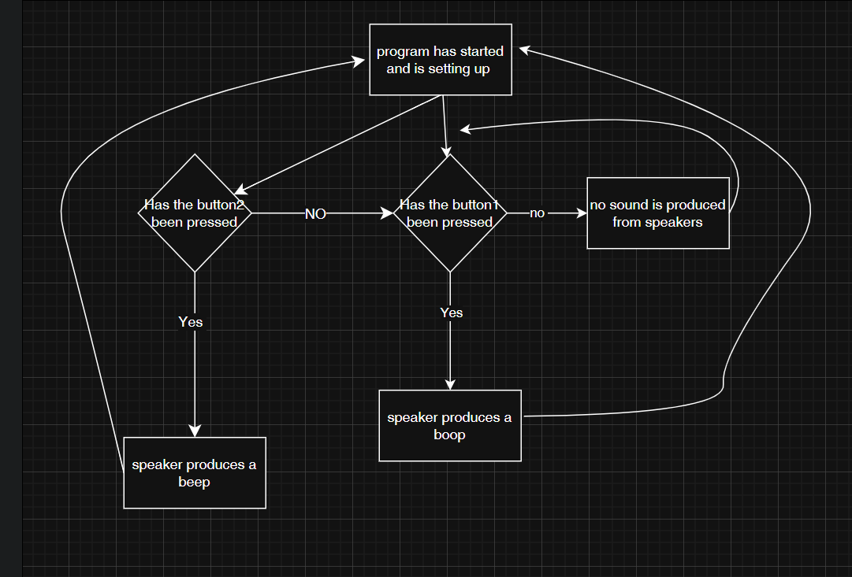
Figure 19 Flowchart for the piezo buzzer
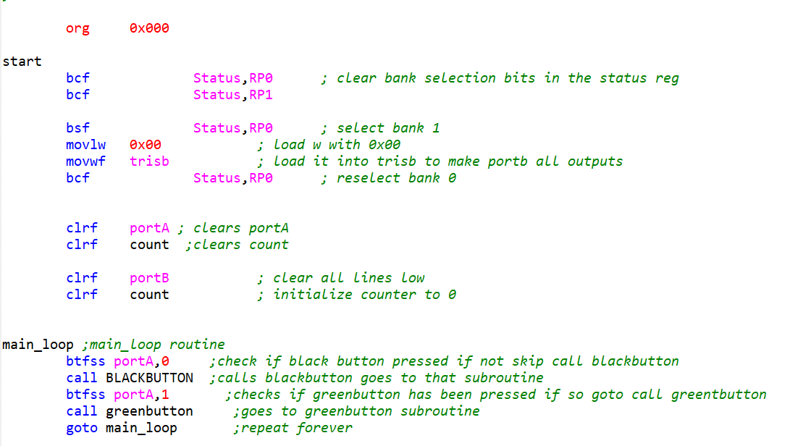
Figure 20 piezo buzzer main loop
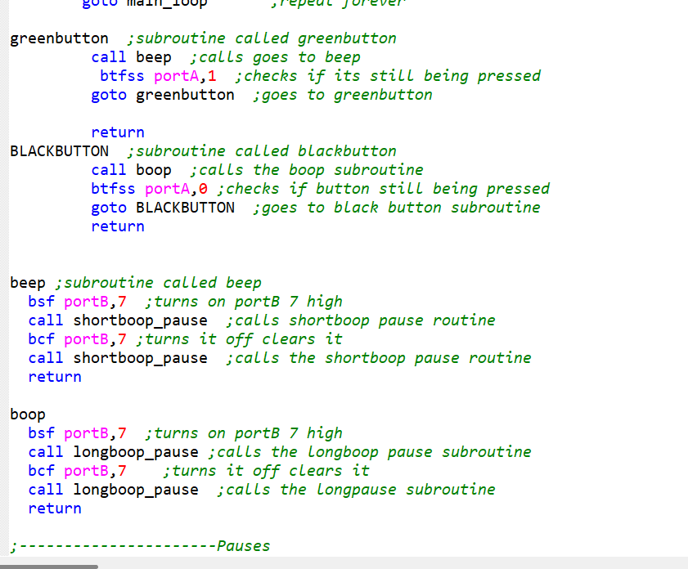
Figure 21 Piezo buzzer different tones
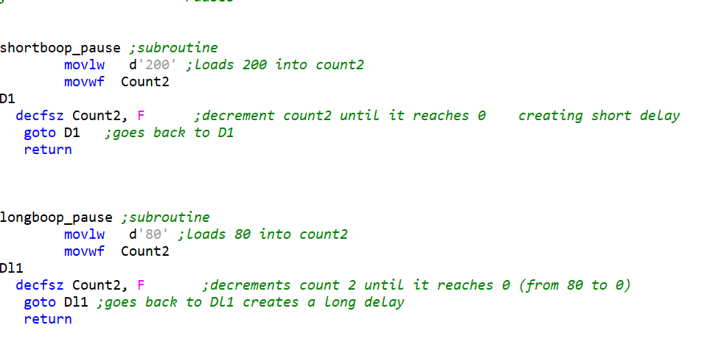
Figure 22 piezo buzzer different pauses

