University of Wales Trinity Saint David.
School of Computing.
Nicholas Jones, P149676.
18/05/2019
Communications & Protocols (ACDA5000).
Lecturer, Prof Ian Wells.

Comparative performance of
advanced modulation schemes



Abstract
Digital information can be communicated using various methods, some methods involve the use of different types of modulation techniques, Amplitude shift keying, Phase shift keying and Quadrature phase shift keying are the techniques being simulated using MATLAB Simulink, these modulation schemes are designed from the ground up, hence the use of Simulink’s pre-built modulation blocks are prohibited, additive white gaussian noise is the communication channel between the modulator and demodulator in each simulation, this will then add various amounts of noise to the transmitted information, test of each of the modulation schemes with various amounts of noise were conducted with the results being recorded in Excel and relevant graphs produced, these results were then analysed and compared against each other.
Furthermore, the chosen error correction scheme was Hamming code, unfortunately this was not successfully implemented within the current modulation designs, so Simulink pre-built modulation blocks were used instead, the same tests were conducted, and the results were plotted in a graph within Excel.
All test result was put into one graph and then analysed, as expected the models that had hamming error correction and detection applied to them performed better at higher noise levels than those that did not have error detection implemented.

Contents
Abstract i
1 Introduction 1
1.1 Aim 1
1.2 Objectives 1
2 Signal to noise ratio 1
3 ASK modulation 2
3.1 ASK design Simulink 2
3.2 ASK design testing 3
3.3 AWGN noise results ASK 8
4 PSK modulation 9
4.1 PSK design Simulink 10
4.2 PSK design testing 11
4.3 AWGN noise results PSK 15
5 QPSK modulation 16
5.1 QPSK design Simulink 17
5.2 QPSK design testing 18
5.3 AWGN noise results QPSK 27
6 Summary of results without error correction 28
7 Hamming code implementation 29
7.1 PSK Hamming code models 29
7.2 QPSK Hamming code models 31
7.3 Analysis of data packets in these models 32
8 Analysis of all results 35
9 Conclusion & discussion 36
10 References 37

Introduction
Amplitude shift keying (ASK), phase shift keying (PSK) and quadrature phase shift keying (QPSK) are amongst the many types of modulation techniques used to transmit digital data [1, pp. 427–428]. Models of each modulation scheme need to be created in MATLAB Simulink, these then need to be critically analysed and compared with the presence of Additive White Gaussian Noise (AWGN). Hamming error correction scheme will then need to be employed throughout each model and further tests and analysis is to be conducted.

Aim
To simulate and critically review different modulation schemes by comparison with and without an error correction scheme.

Objectives
- Survey literature on digital modulation schemes and error correction methods.
- Create MATLAB Simulink models for each of the modulation schemes.
- Conduct analysis of each modulation scheme for performance with increasing levels of noise.
- Compare results between each of the modulation techniques.
- Conduct the same tests on each modulation scheme with a chosen error control method.
- Analyse results from error control tests and compare results from previous tests.
- Conclusion.

Signal to noise ratio
To simulate noise onto the transmitted data then the ‘Add White Gaussian Noise’ block in Simulink will be used as the communication channel, this block has settings to alter the level of noise to be added, the units that can be used are, Eb/No, Es/No or SNR these are different measurement types of signal to noise ratio (SNR).
Eb/No is energy per bit against the noise density and is used when comparing bit error rate of a modulation [2], Es/No is energy per symbol against noise density [3], literature suggests that there is a relationship between these signal to noise ratio measurements. For testing purposes Eb/No will be used in each of the below modulation schemes, if there is time then tests with Es/No and SNR may also be conducted.

ASK modulation
Amplitude shift keying (ASK) is a simple form of modulation where bursts of a sinusoidal carrier is used to represent binary information of either a one or a zero [4] the below Figure 1 shows a pictorial representation of this modulation.
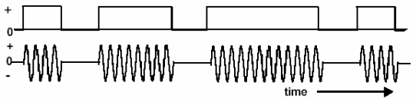
Figure 1 ASK illustration [4].
In Figure 1 a binary signal to the top represents the digital data that needs to be transmitted, the sinusoidal signal at the bottom is the carrier that transmits this data, this modulation scheme is a simple form of On Of Keying (OOK), when a binary 1 needs to be transmitted the carrier wave transmits a signal and when a binary 0 needs transmitting the carrier wave stops.

ASK design Simulink
Figure 2 shows the Simulink model used for ASK modulation.
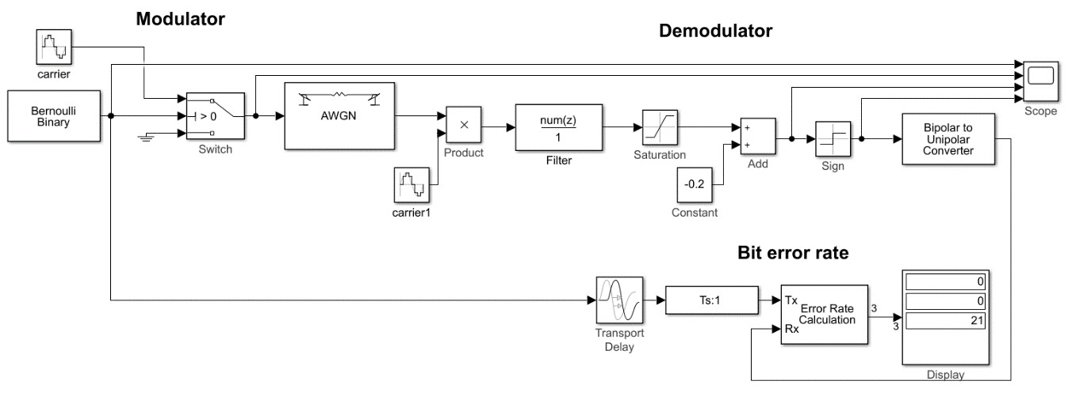
Figure 2 ASK design in Simulink.
Looking at Figure 2 the model can be split into 3 main parts, the modulator is to the left of the ‘AWGN’ block, then the demodulator is to the right, and below is the bit error rate calculations, the frequency of the 2 carrier blocks is set to 100 Hz, and a sample time of 1/1000 is used throughout the design, the Bernoulli binary generator outputs a random stream of 1’s and 0’s which is fed into the switch, the switch then transitions between either the carrier input or a ground input, this is dependent on whether a 1 or a 0 has been received from the Bernoulli generator, a 1 would cause the switch to allow the carrier through to the communication channel which can be simulated to have noise by use of the AWGN block.
After the AWGN block is the demodulator, this is slightly more complex when compared to the modulator as various stages need some form of signal conditioning before extracting the original transmitted data, the transmitted data is fed into the product block which is multiplied with the carrier1 block, this data is then fed into a low pas filter which has a cut off set too 5 Hz, the saturation block then limits the levels to 0.4 and 0.1 before having 0.2 subtracted from it, this then ensures the levels go above and below zero, the sign block then takes these +- levels and fixes them to either -1 or +1, this bipolar data is then converted to unipolar and outputs a stream of 1’s and 0’s.
The Bit error rate section takes the original Bernoulli binary data adds some delay by use of Transport delay block and Ts:1 block which is then fed into port ‘Tx’ of the error rate calculation, this error rate calculation block takes the demodulated data into its ‘Rx’ port and then compares the data to check for errors, the result is then output to the display, the display shows 3 sets of data, the bottom is how many bits were originally transmitted, the middle is how many errors were detected and the top is the ratio of ‘errors detected’ divided by the number of ‘bits transmitted’ this can then be multiplied by 100 to give a percentage.

ASK design testing
For testing a scope has been placed on the model, this is used to confirm each stage of the design is functioning correctly, the AWGN block has been disabled so as to ensure no interference is included and simulation time is set to 20. Figure 3 shows the scope attached at various stages.
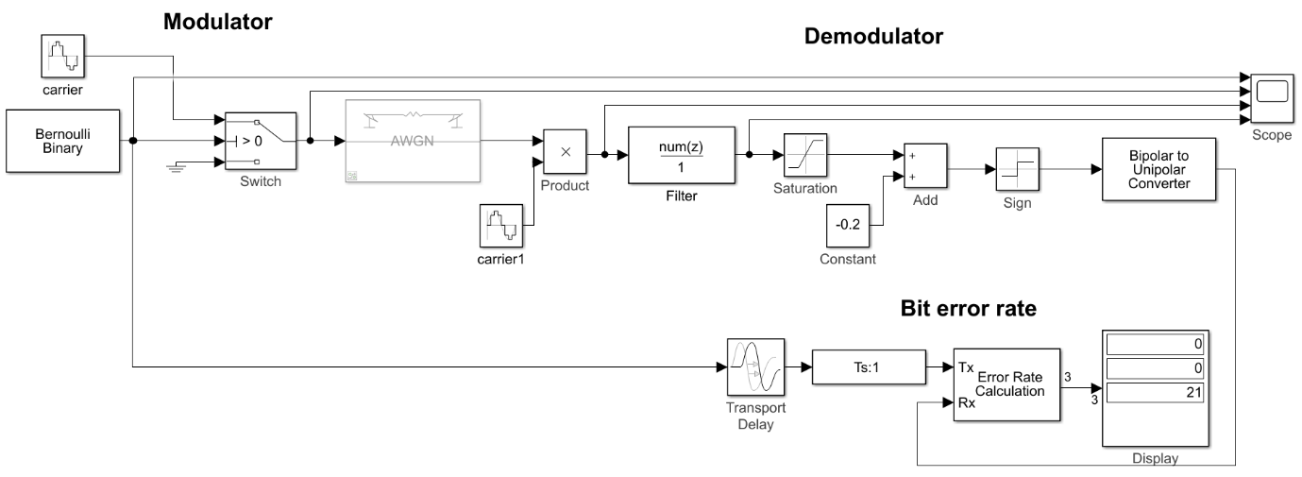
Figure 3 ASK testing 1.
The scope in Figure 3 has 4 channel inputs, channel 1 is looking at the serial data from the Bernoulli binary generator, channel 2 is monitoring the output of the switch, channel 3 is showing the data multiplied by the reference carrier and channel 4 shows the data once it has passed through the low pass filter. Figure 4 below shows the scope output.
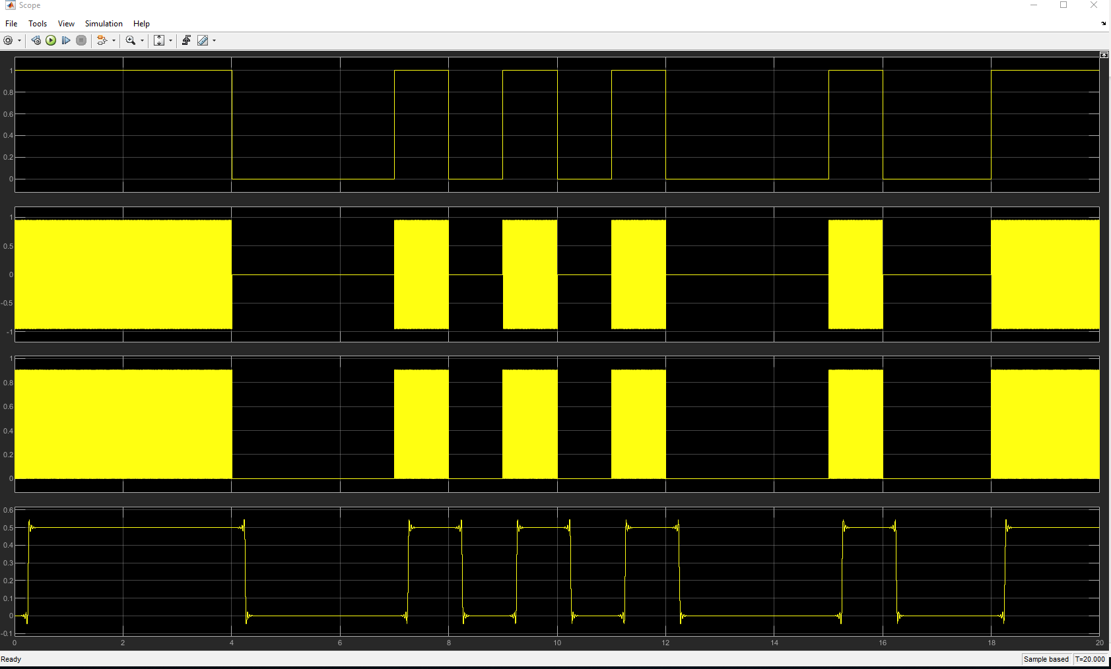
Figure 4 ASK scope test 1.
The scope output in Figure 4 shows the original binary data at the top (channel 1), this is a clear random sequence of either 1 or 0, channel 2 shows the carrier wave being passed through the switch whenever a binary 1 is received at its input, this carrier wave is sinusoidal so swings from +1 to -1, channel 3 is the result of multiplying the received carrier with the reference carrier of the same 100 Hz frequency, here the level for binary 1 is 0.9 and binary 0 is zero, channel 4 shows the low pass filter in operation by filtering out the high frequency noise, there is a slight delay of 0.24 seconds (240 ms) during this. Figure 5 below shows the scope zoomed in.
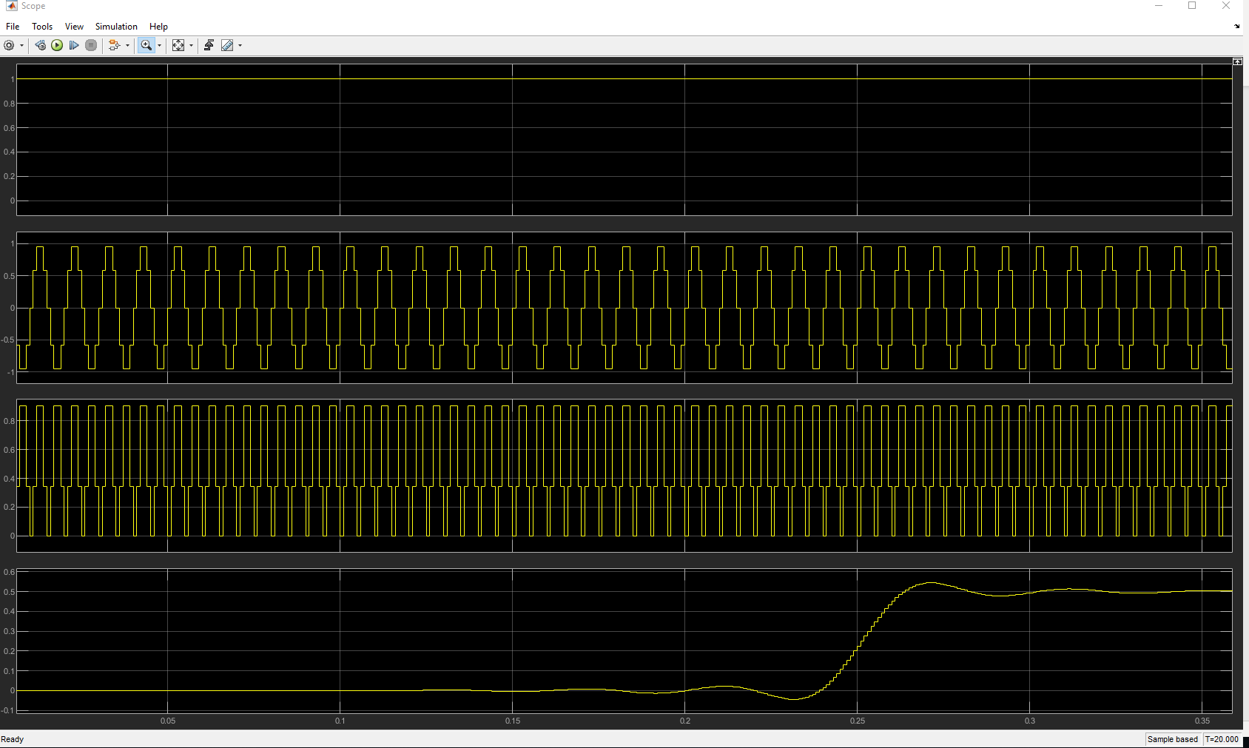
Figure 5 ASK delay test 1.
To calculate the delay the scope seen in Figure 5 has been zoomed in, channel 4 shows the delay of 0.24 seconds (240 ms) before it starts to transition from low to high.
Figure 6 shows the scope has now been moved, channel 1 is on the output of the filter, channel 2 is after the saturation block, channel 3 on the output of the addition block and channel 4 is after the sign block.
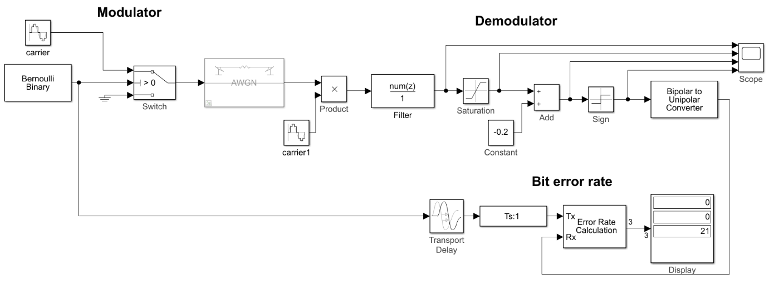
Figure 6 ASK testing 2.
Running the simulation shown in Figure 6 produces the following scope output seen in Figure 7 below.
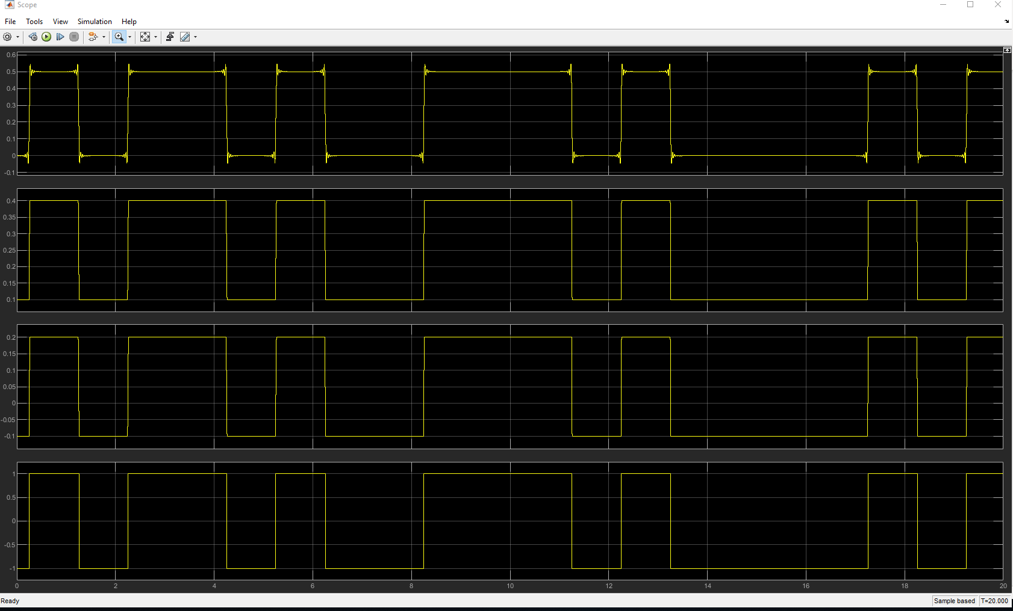
Figure 7 ASK scope test 2.
Seen in Figure 7 channel 1 shows the output of the filter, this is the same as previous test when channel 4 was used, channel 2 shows the signal being conditioned to upper level of 0.4 and lower level of 0.1, channel 3 shows the result of subtracting 0.2, this then brings the signal to + and – levels, channel 4 shows the sign block fixing these levels to -1 for binary 0 and +1 for binary 1.
Figure 8 shows the next test phase, channel 1 of the scope is on the output of the sign block, channel 2 shows the output of the bipolar to unipolar block, channel 3 is back on the original data stream and channel 4 is not connected.
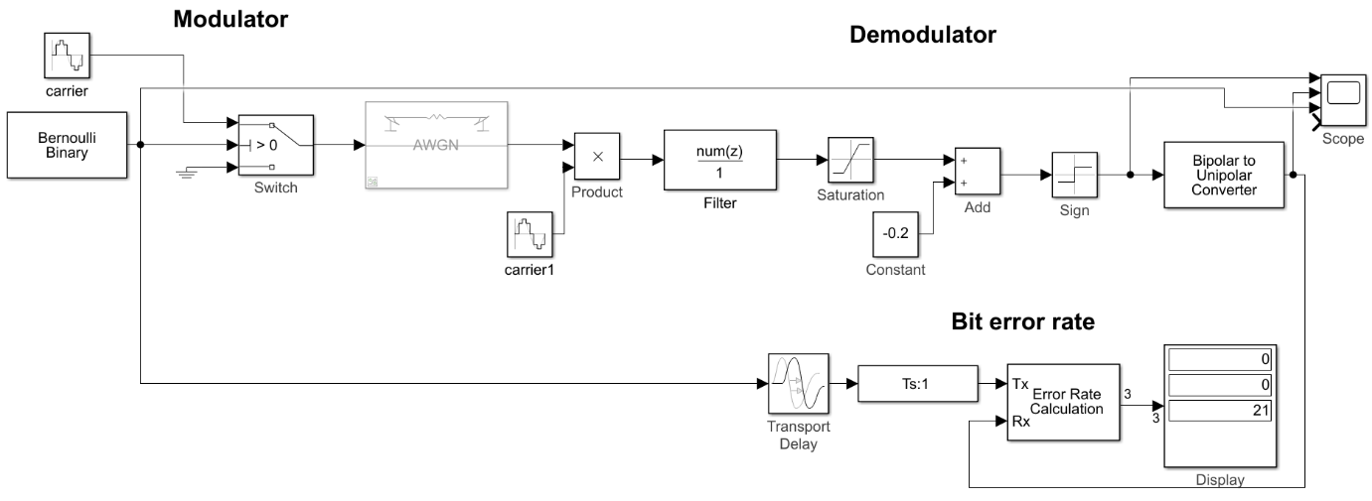
Figure 8 ASK testing 3.
Running the simulation shown in Figure 8 produces the following output on the scope in Figure 9.
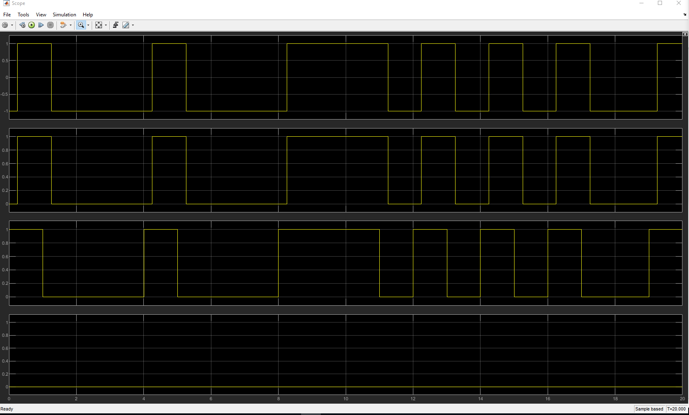
Figure 9 ASK scope test 3.
Figure 9 now shows channel 1 on the output of the sign block, channel 2 shows the bipolar to unipolar block, this converts the +1 and -1 levels to binary 0 and 1, from here the data is fed into the error calculation block to compare original data with received data, as no noise has been added then no errors would be detected. Channel 3 is on the original data stream, it can be seen there is a delay between original data transmission and received data, this delay calculation is seen in Figure 10 below.
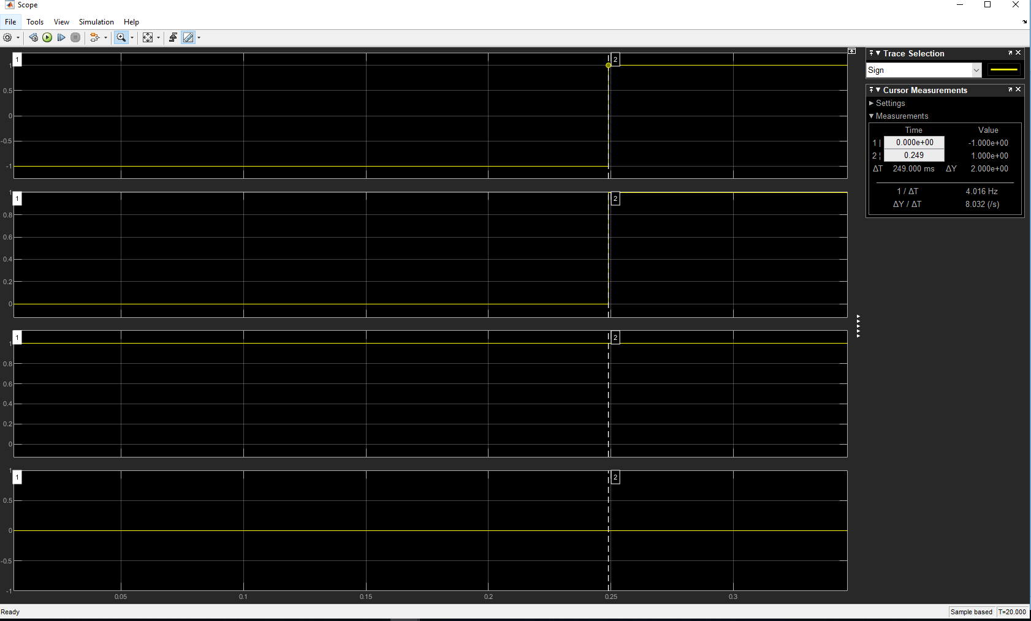
Figure 10 ASK delay test 2.
Figure 10 shows the scope zoomed in on the first transition bit, a cursor is placed at the 0 time mark and the second cursor placed on the first transition from low to high, looking at the properties box the delay of the system is 0.249 seconds (249 ms).

AWGN noise results ASK
The AWGN block has been set to use the Eb/No for its noise setting, bits per symbol is set to 1, Simulink simulation time has been set to 500. Test were then conducted starting with Eb/No set to +60 this value was then decremented initially in steps of 5 until errors started to occur then steps of 1 was used until it was apparent that the error rate was not differing to much anymore then steps of 5 was used for last several samples finishing up with the Eb/No set to -40, the results were put into an excel spreadsheet and a graph seen in Figure 11 was plotted.
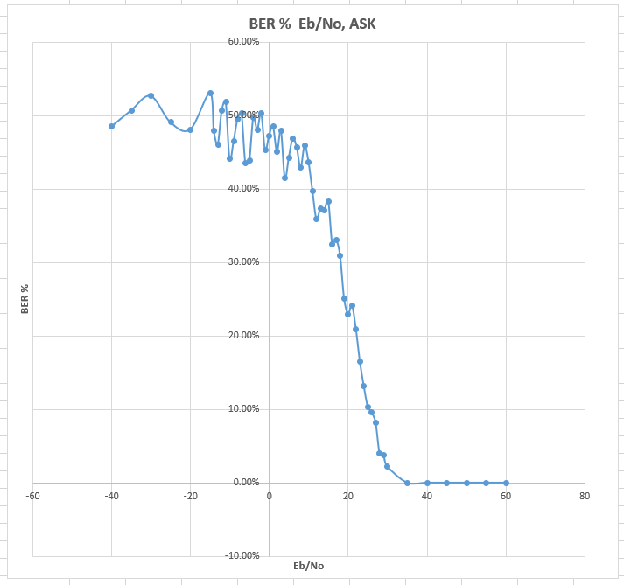
Figure 11 ASK, graph.
The graph in Figure 11 shows the Eb/No value on the X axis and the bit error rate as a percentage on the Y axis, when the Eb/No was 35 or more then no errors were detected, when the Eb/No reached 30 errors were started to be detected, the bit error rate has a sharp increase between 30 and 4 Eb/No.

PSK modulation
Phase Shift Keying (PSK) modulation differs from ASK where by amplitude is constant but the phase of the carrier is shifted [5], this modulation scheme also known as Binary phase shift keying (BPSK) is only capable of transmitting one bit at a time, either a 1 or a 0 [6], Figure 12 shows the relationship between binary data and the modulating carrier.
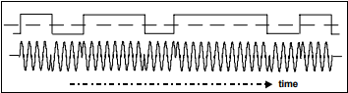
Figure 12 PSK illustration [7].
Looking at Figure 12 the binary data is of bi polar where by it crosses through zero when transitioning from a 1 to 0 and 0 to 1, each time there is a cross of zero the phase of the carrier is shifted, having this symmetrical waveform and using the zero cross for phase shift can make it easier for recovery of the data [7]. A constellation diagram showing two symbols is seen in Figure 13.
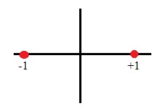
Figure 13 BPSK constellation diagram [8].
The constellation diagram in Figure 13 shows two symbols spaced at 180° from each other, one symbol would represent a 0 and the other a 1, the transmitted information is depended on the phase of the carrier wave.

PSK design Simulink
Figure 14 below shows the Simulink design of the PSK model used.
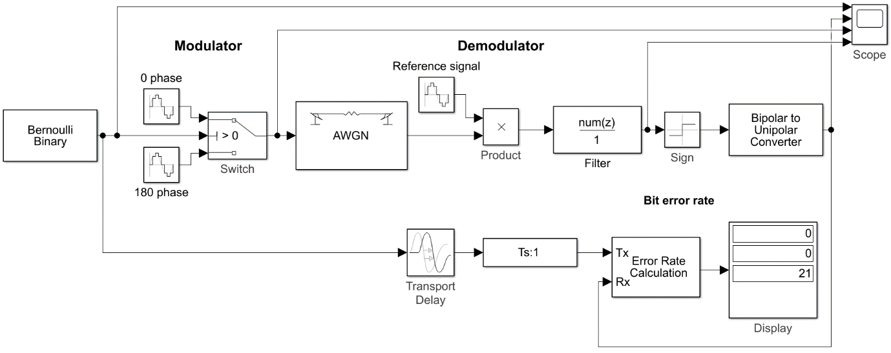
Figure 14 PSK design in Simulink.
Looking at Figure 14 there is some similarities with the ASK model, the Bit error rate section is exactly the same, the modulator section uses the same Bernoulli binary generator for the data stream which is then fed into a switch, but this time the switch allows two carriers through, these carriers are set to have a frequency of 100 Hz but their phase differs by 180°, when a 1 is applied to the switch the carrier has a phase of 0° and when a 0 is applied a phase of 180° is allowed through, the AWGN block is the simulated communication channel, the demodulation section multiplies the received signal by the reference signal which is set to 100 Hz and has a phase of 0°, here the signal passes through a low pass filter with its cut off frequency of 5 Hz, the sign block is used to fix the signal at either -1 or +1 before being converted to unipolar, the data is then fed into the error detection block.

PSK design testing
Similar to the ASK model, testing of the design for correct operation has been conducted, Figure 15 shows the setup of the scope for first test phase.
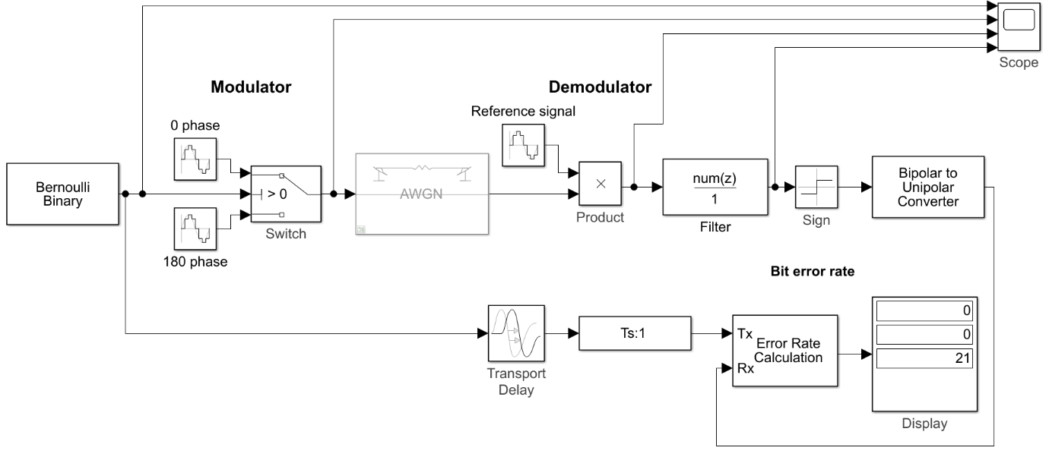
Figure 15 PSK test 1.
The test of this modulation will follow the same pattern as the ASK test whereby the scope seen in Figure 15 will be moved throughout the design to confirm correct operation.
Figure 16 shows the output of the first test.
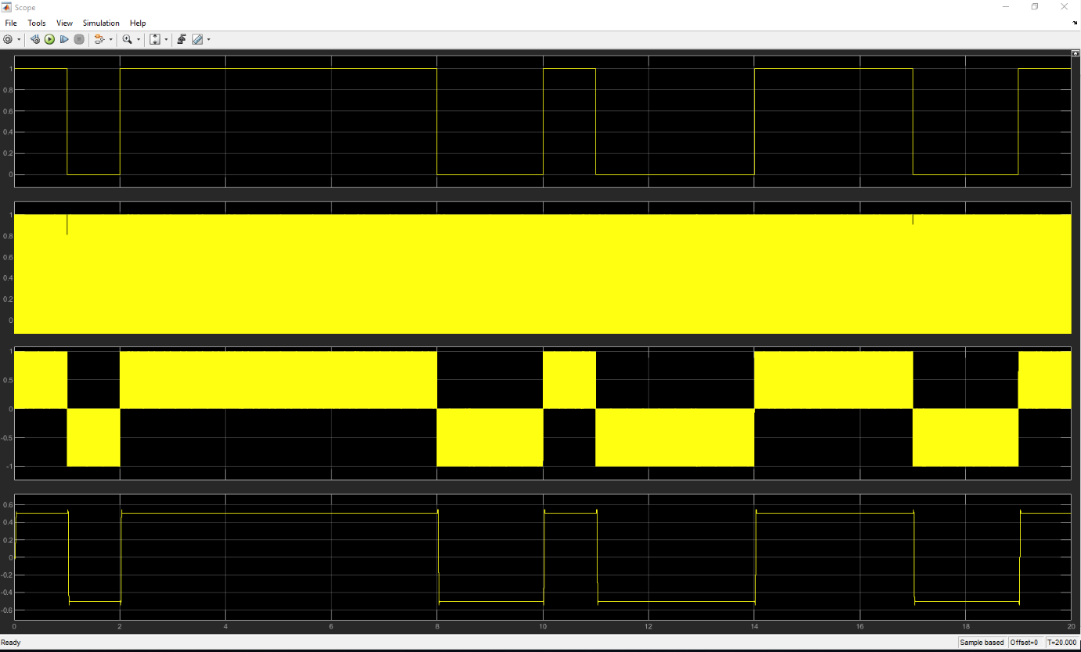
Figure 16 PSK scope test 1.
Four channels of the scope shown in Figure 16 are connected at various parts of the design, channel 1 shows the original data that needs to be transmitted, channel 2 on the output of the switch shows the data being modulated, channel 3 is the result of multiplying the transmitted data with the demodulation reference carrier, channel 4 shows the low pass filter working, Figure 17 shows a zoomed in view of this data.
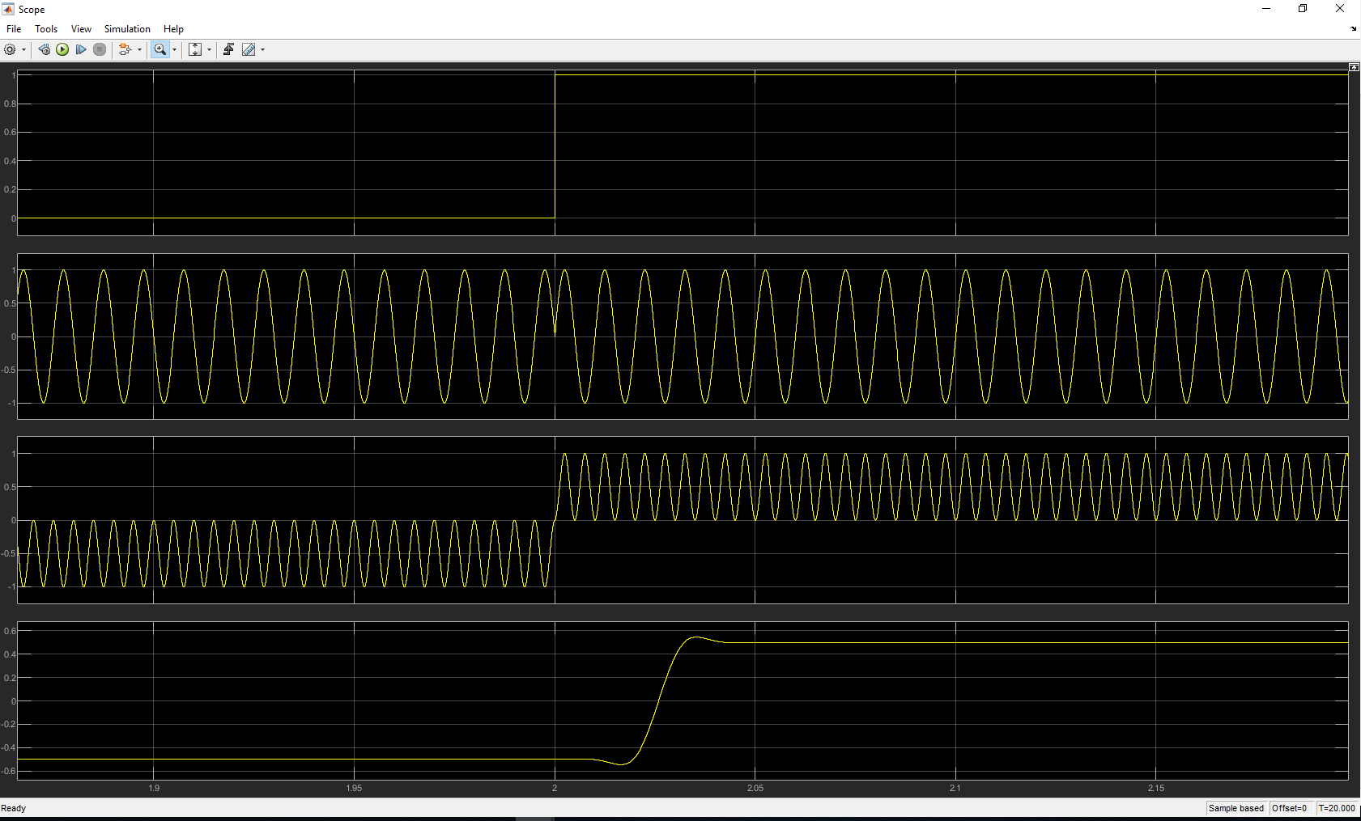
Figure 17 PSK scope phase.
Figure 17 has the scoped zoomed in on one of the transitions, channel 2 shows the phase shift occurring when the data transitions from binary 0 to binary 1.
Figure 18 shows the scope has been moved along the design.
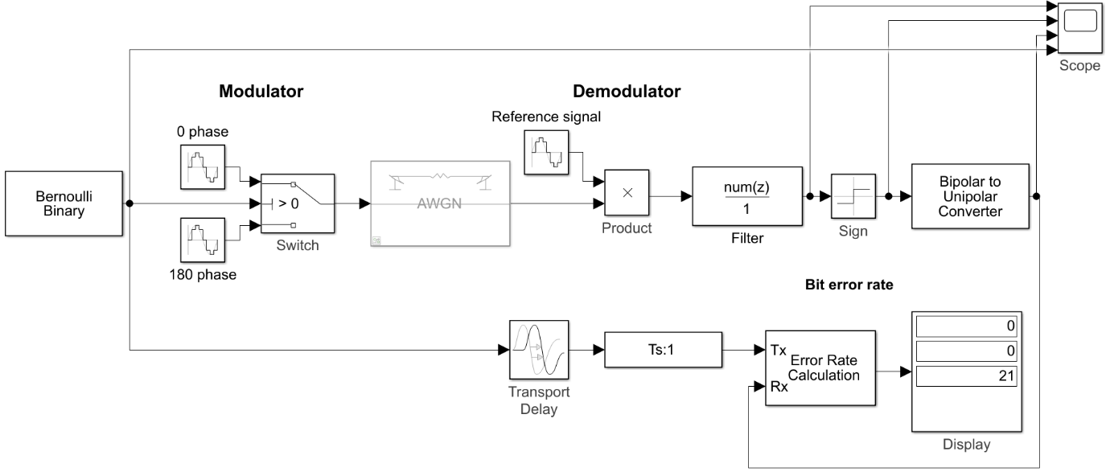
Figure 18 PSK test 2.
In Figure 18 the scope has been moved across to show the rest of the design in operation, channel 1 now shows the output of the filter, channel 2 and 3 shows the signal being converted from bipolar to unipolar and channel 4 shows the original data. Figure 19 shows the output on the scope.
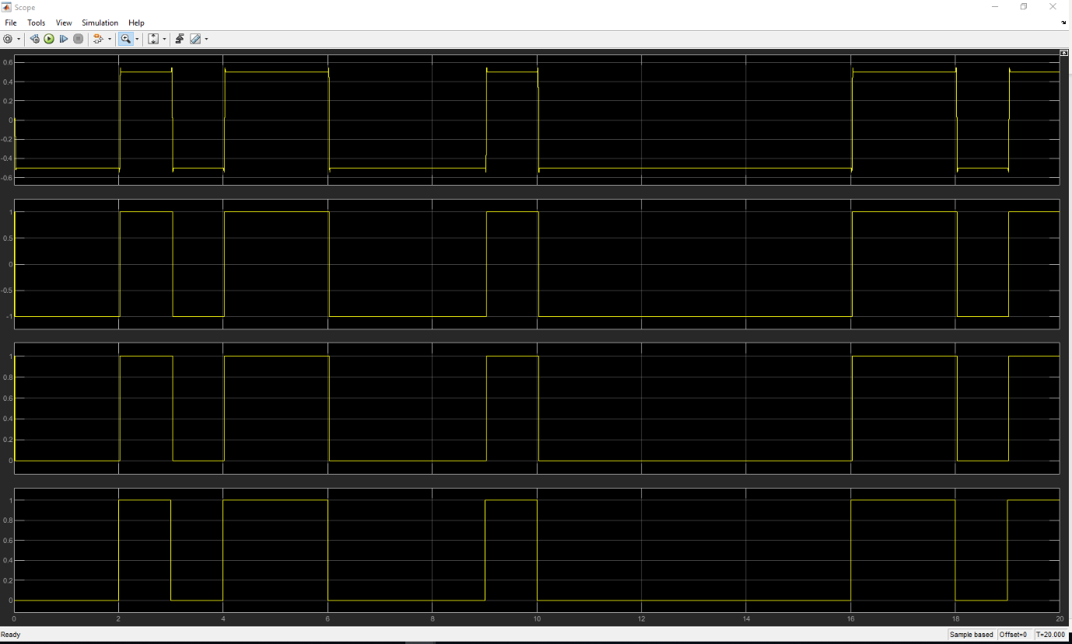
Figure 19 PSK scope test 2.
The scope in Figure 19 shows similar results to the ASK model with the sign block and bipolar to unipolar block operating correctly, one thing to note here is there does not appear to be any delay, Figure 20 shows the scope zoomed in on one of the transition periods.
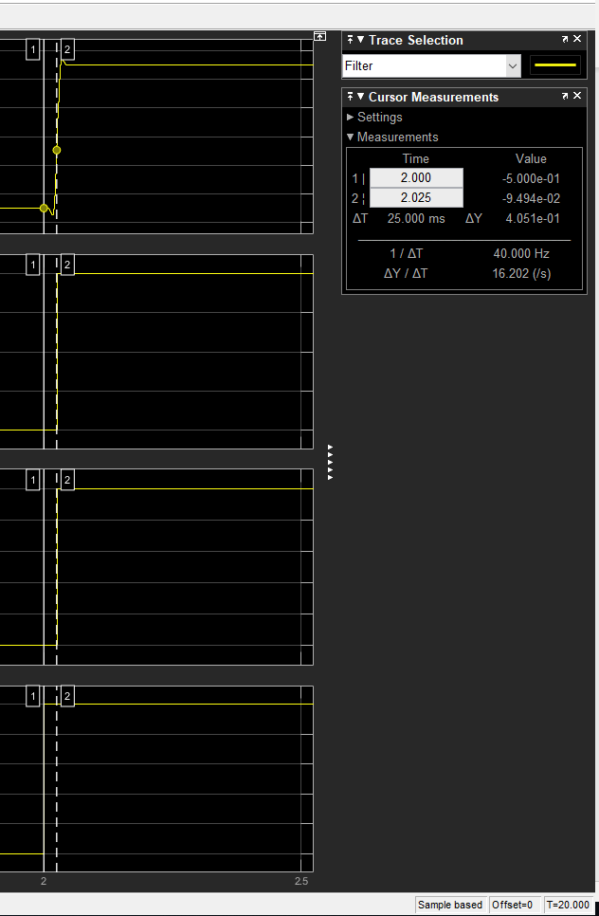
Figure 20 PSK scope delay.
Figure 20 shows the scoped zoomed in onto one of the transition periods, cursor one is on the original data and cursor two is on the recovered data, looking at the properties box there is a delay of 0.025 seconds (25 ms) with this system, at the moment it’s unclear as to why the ASK model is nearly 10 times slower than this model.

AWGN noise results PSK
Again, here the AWGN block has been set to use the Eb/No for its noise setting, bits per symbol is set to 1, Simulink time has been set to 500. Test were then conducted starting with Eb/No set to +60 this value was then decremented initially in steps of 5 until errors started to occur then steps of 1 was used until it was apparent that the error rate was not differing to much anymore so steps of 5 was used for last several samples finishing up with the Eb/No set to -40, the results were put into an excel spreadsheet and a graph seen in Figure 21
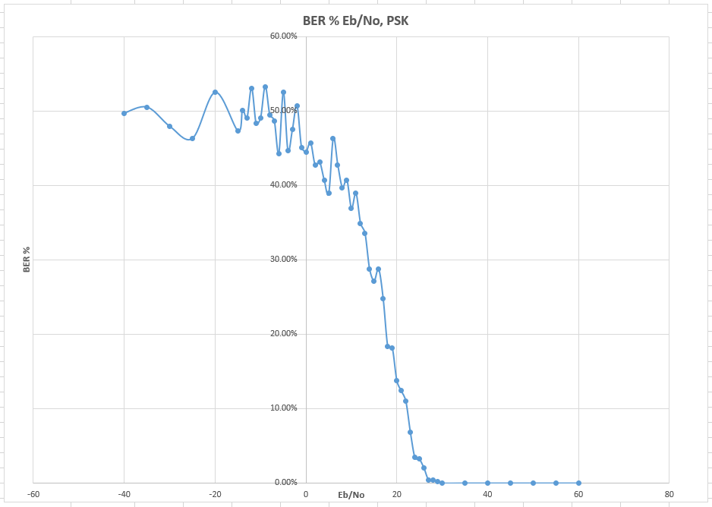
Figure 21 PSK, graph.
The graph in Figure 21 is very similar to the ASK results except errors were detected at 29 Eb/No, this also has a sharp increase of bit error rate from 29 down to 3 Eb/No, the data starts to roll off at about 45% with a maximum average of 50% BER.

QPSK modulation
QPSK modulation scheme is a higher order modulation technique when compared to PSK [5], four constellation points are used, these points, known as symbols, signify two bits of data each [8]. Below Figure 22 illustrates the relationship between the binary data and their corresponding phase.
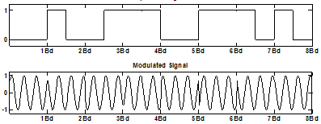
Figure 22 QPSK illustration [9].
Looking at the modulated signal in Figure 22 there is multiple different phase shifts this is dependent on what 2 bit symbol is being transmitted. Figure 23 shows the constellation diagram for this.
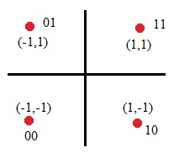
Figure 23 QPSK constellation diagram [8].
In Figure 23 there is four symbols evenly distributed with each one representing a different phase, in this instance the phases are 45°, 135°, 225° and 315°, each symbol carries two bits of data, the arrangement of these follows the Gray code encoding in such that each neighbouring symbol on has only one bit change [10].

QPSK design Simulink
Figure 24 shows the design used to model QPSK modulation, this consists of a more complex modulator and demodulator section.
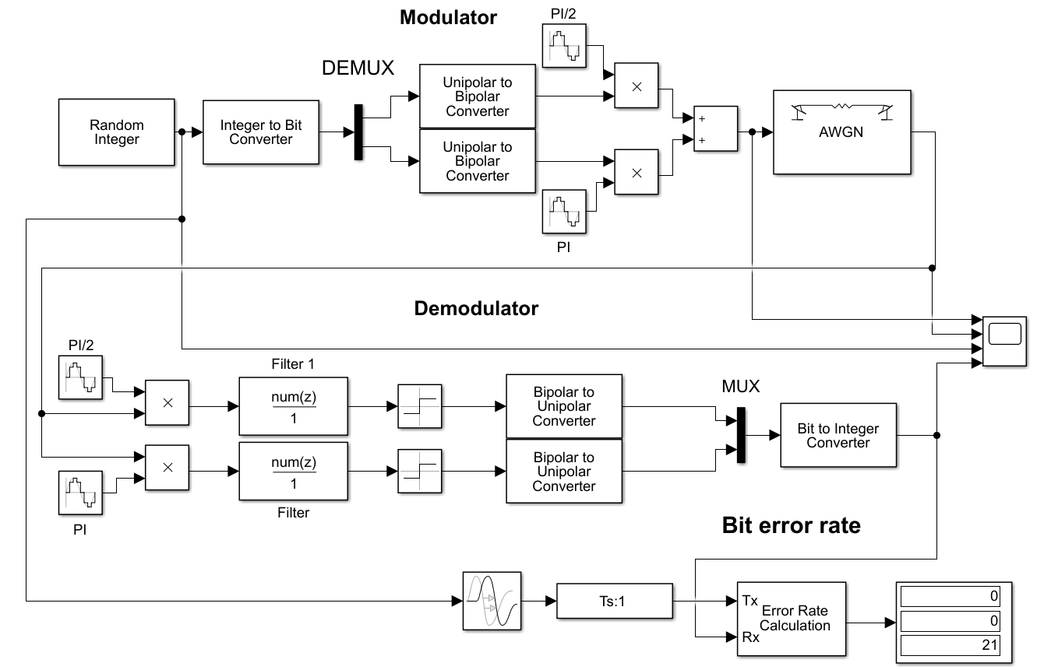
Figure 24 QPSK design in Simulink.
Seen in Figure 24 the bit error rate section is the same as ASK and PSK, it’s the modulator and demodulator that is different, as QPSK can transmit either 00, 01, 11 or 10 it needs integer (INT) numbers ranging from 0 to 3 as it data, the random integer block is set to output this range of INT data, this data is then converted into bits, the output from the INT to Bit converter is in the form of 2 bits per received INT number, the ‘Demux’ block then splits this data into 2, the data going in to the unipolar to bipolar conversion blocks is output as a + or – signal stream, this is then multiplied with the carrier blocks of different phases, before the data is passed to the communication channel it is added together. The demodulation takes the transmitted data which is fed into the two multiplying blocks, these blocks have two carries fed into them, the data is then fed in parallel through some low pass filters set to 5 Hz, through the sign blocks, converted from bipolar to unipolar then fed into the ‘Mux’ block, this Mux block then takes the parallel data and converts it into serial data before it gets converted back to an integer number.

QPSK design testing
Testing of this design will follow the same pattern as the previous two models, Figure 25 shows the first test phase set up.

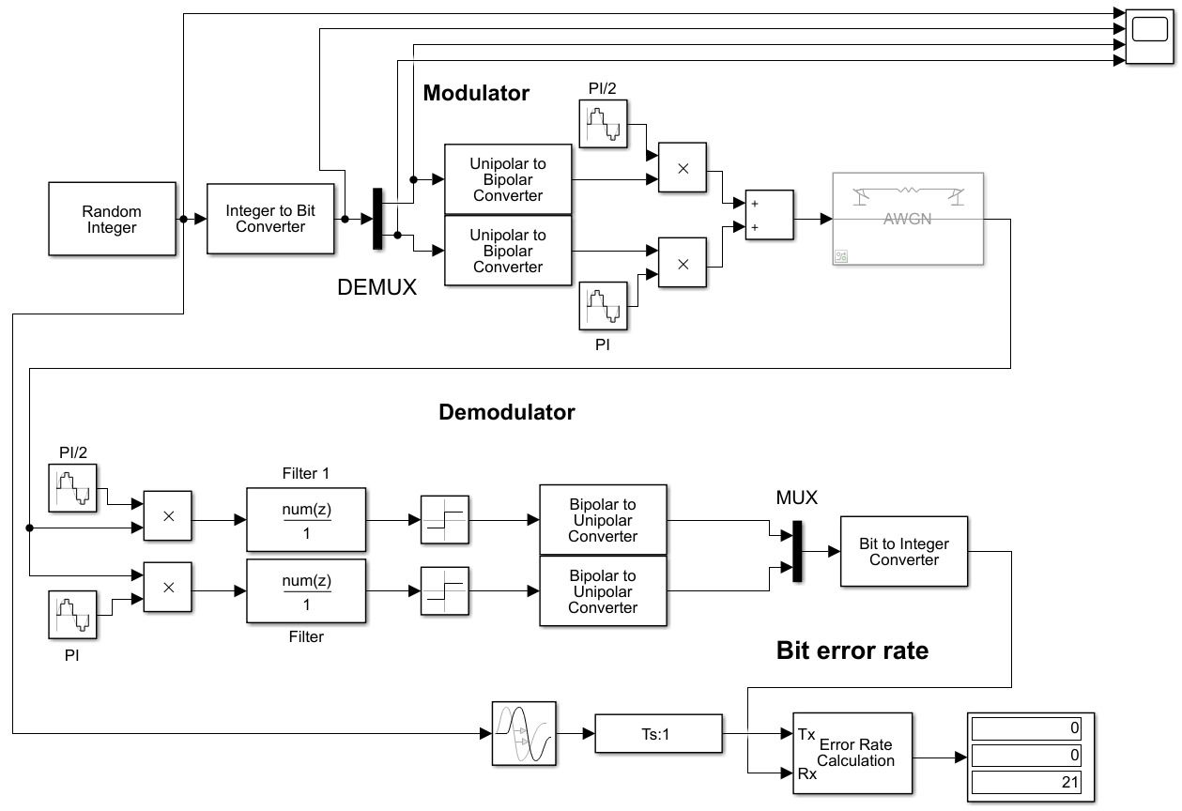
Figure 25 QPSK test 1.
In Figure 25 the scope has been placed at the beginning of the design, simulation time is set to 20 and the AWGN block has been disabled. Figure 26 shows the outputs of each stage on the scope.
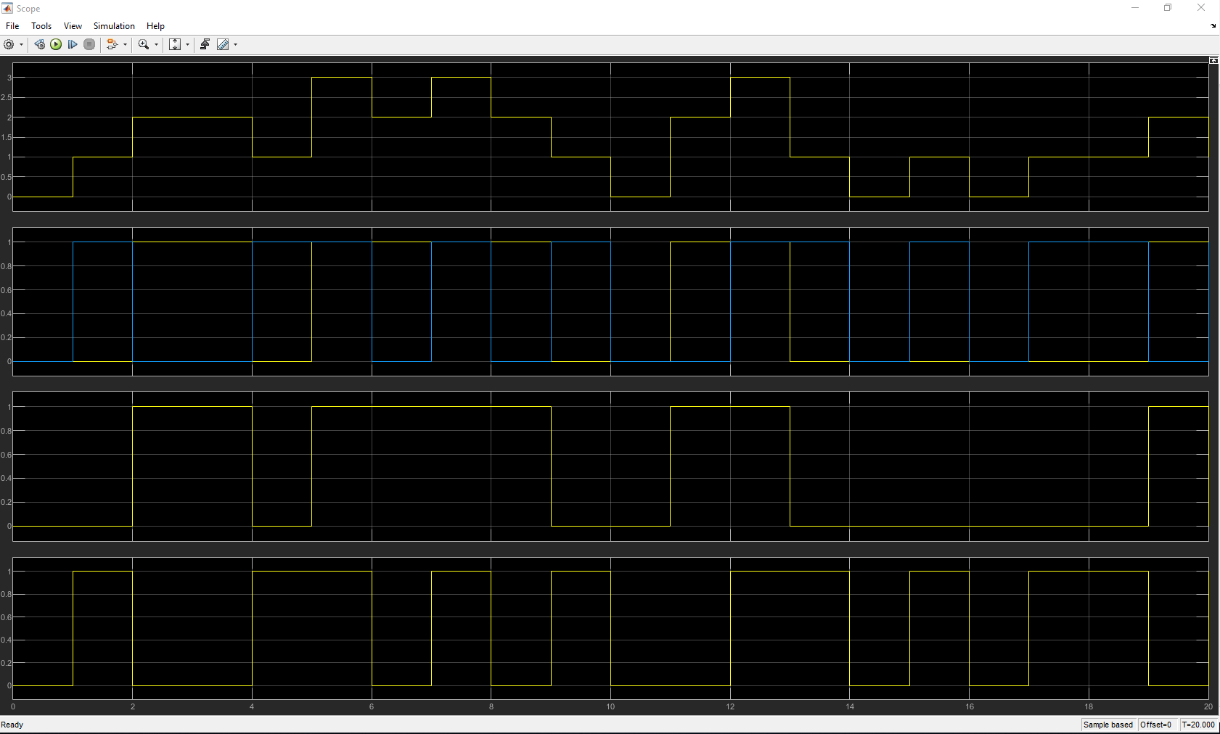
Figure 26 QPSK scope test 1.
In Figure 26 channel 1 shows the random INT numbers being generated with levels going from 0 to 3, channel 2 shows this data being converted into bits so 1’s and 0’s, this data is parallel hence there being multiple traces, channel 3 and 4 shows the data has been converted into serial data stream this data is unipolar hence levels of 0 and 1 are seen.
Figure 27 shows the scope has been moved with channels 1 and 2 on the output of the unipolar to bipolar converters and channels 3 and 4 shows the data being multiplied with the different carrier phases.
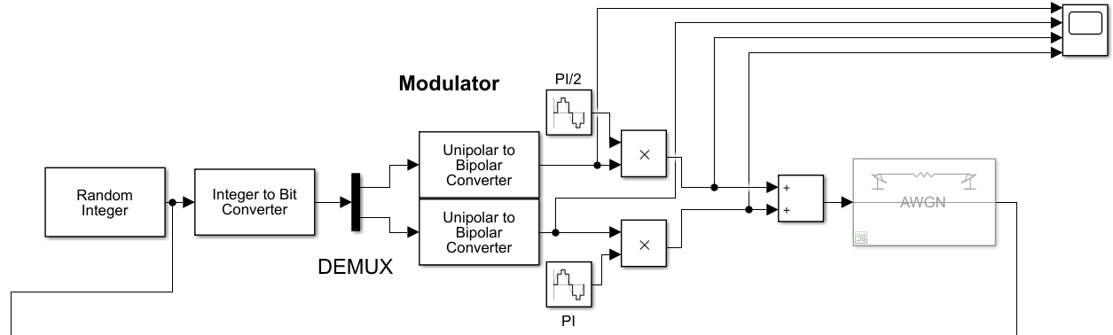
Figure 27 QPSK test 2.
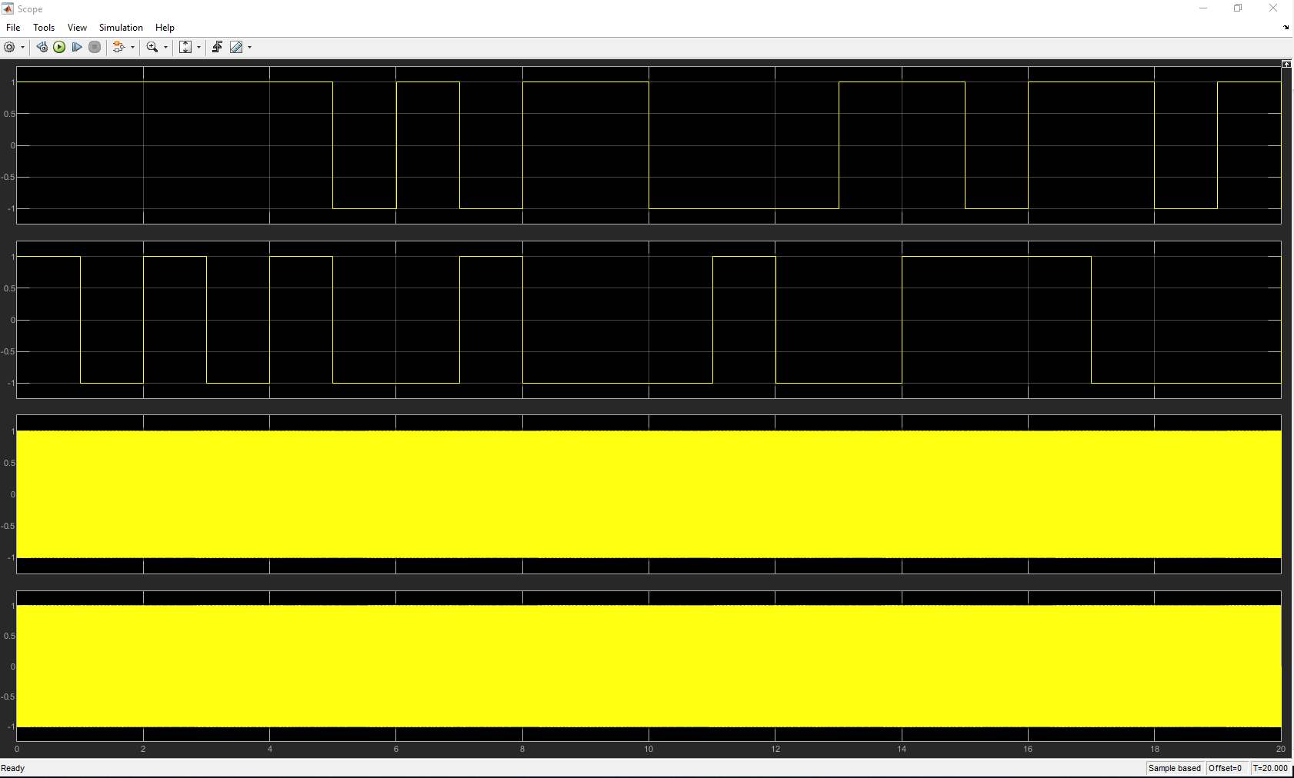
Figure 28 QPSK scope test 2.
Channel 1 and 2 in Figure 28 shows the data being converted into bipolar form, with 3 and 4 showing the data being modulated with their respective carriers. Below Figure 29 shows the scope zoomed in.
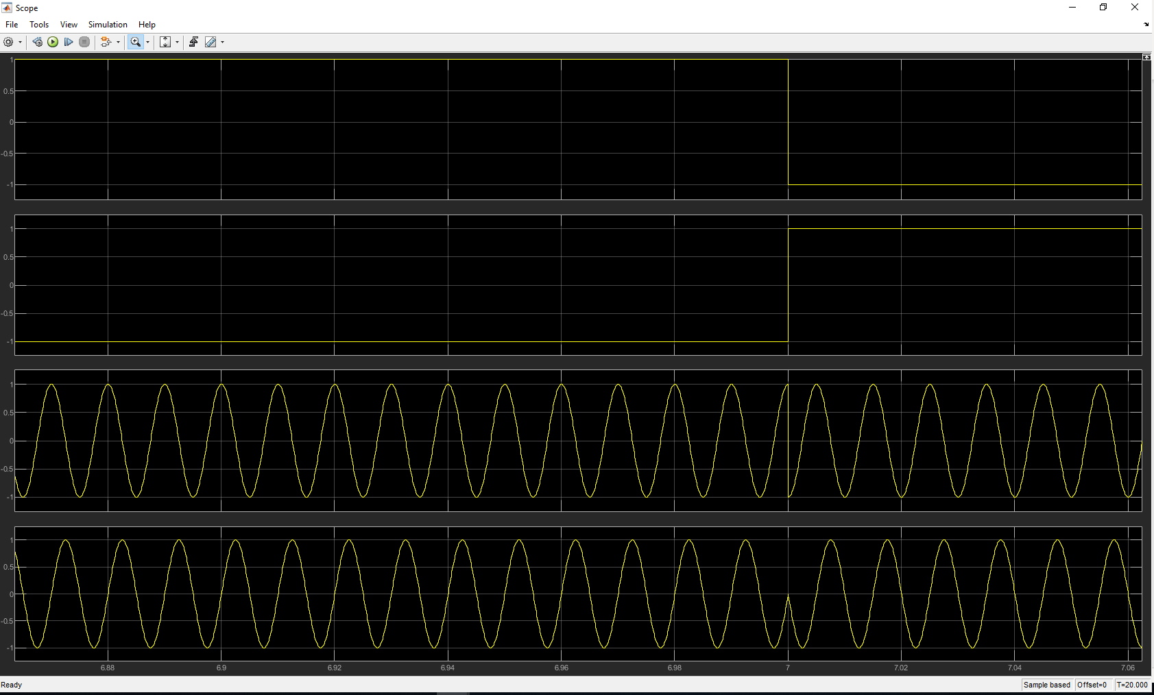
Figure 29 QPSK scope phase 1.
Looking at Figure 29 channel 3 and 4 shows there is a phase shift when the data transitions from one level to another.
This next test seen in Figure 30 shows the scope before and after the addition block.
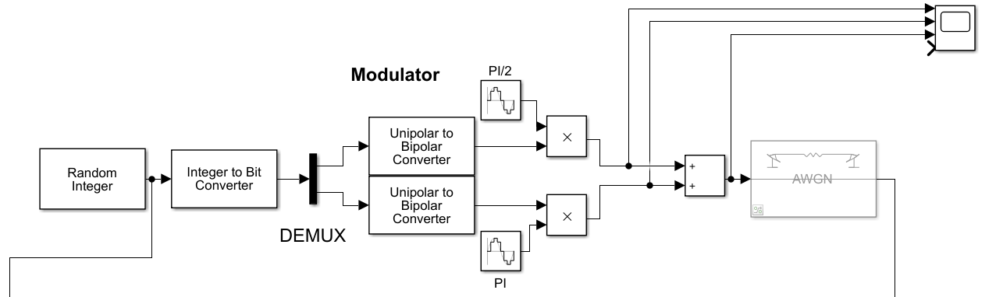
Figure 30 QPSK test 3.
The test setup seen in Figure 30 will complete the test phase for the modulation side of the model, Figure 31 shows the scopes output when running this test.
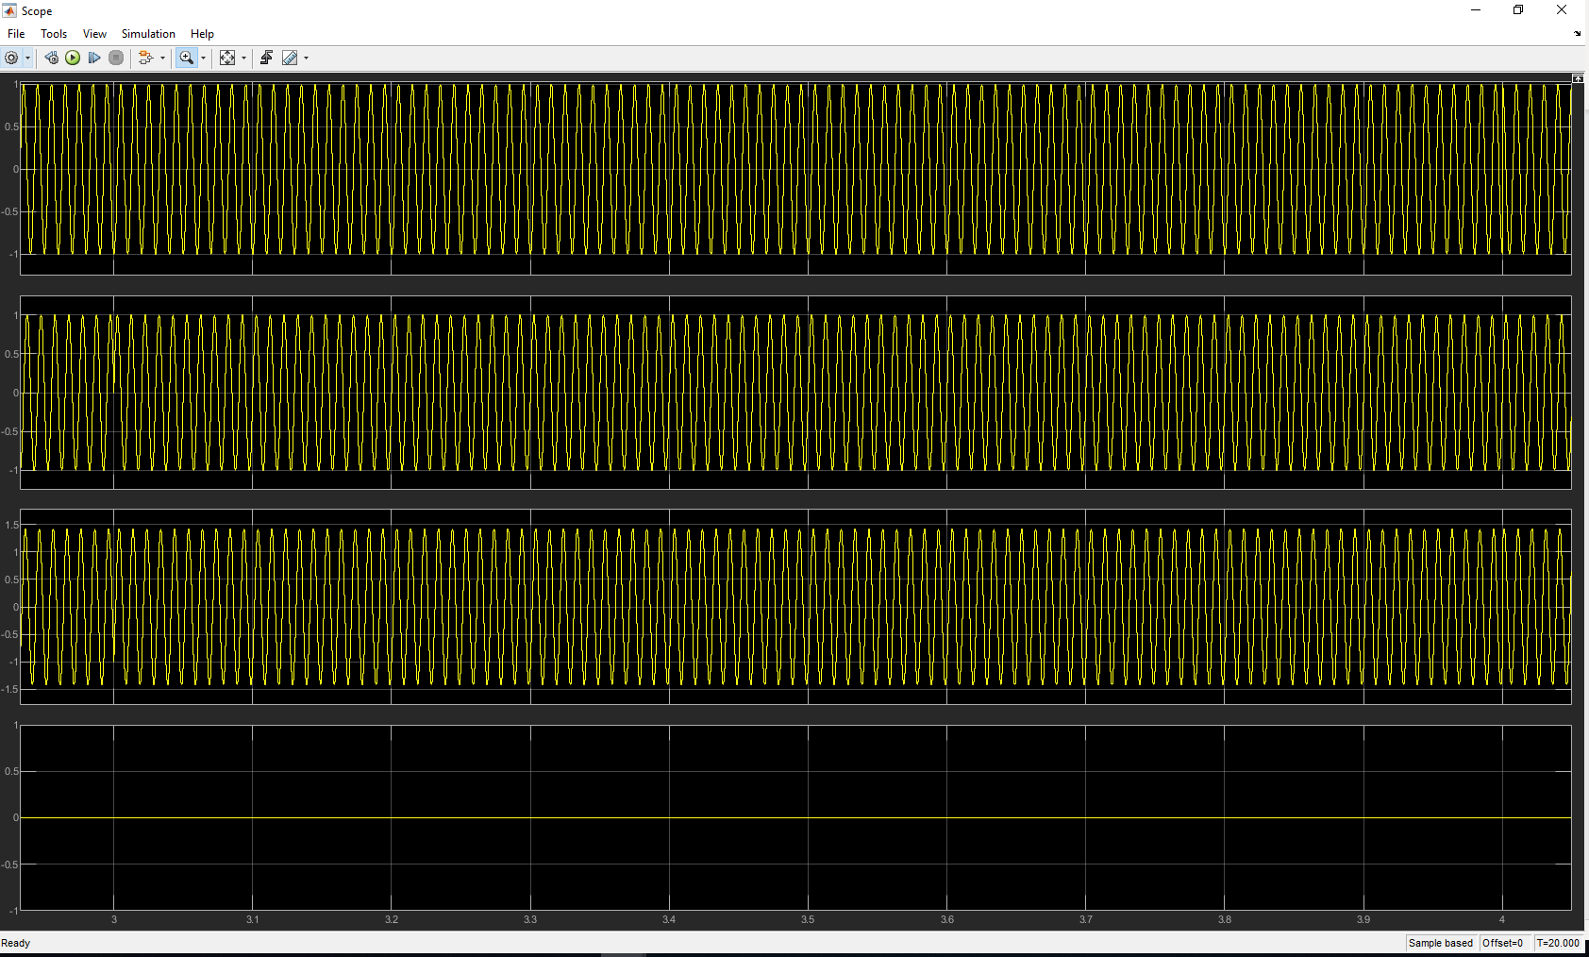
Figure 31 QPSK scope phase 2.
Figure 31 shows the scope has been zoomed in, channel 3 is the actual modulation to be transmitted through the communication channel, this shows that when a phase shift occurs in either channel 1 or 2, there is a phase shift of the actual transmitted signal.
Figure 32 Shows the scope has been moved to the demodulator section, channel 1 is on the transmitted modulation, channel 2 and 3 shows the data being multiplied by the two carriers of different phases.
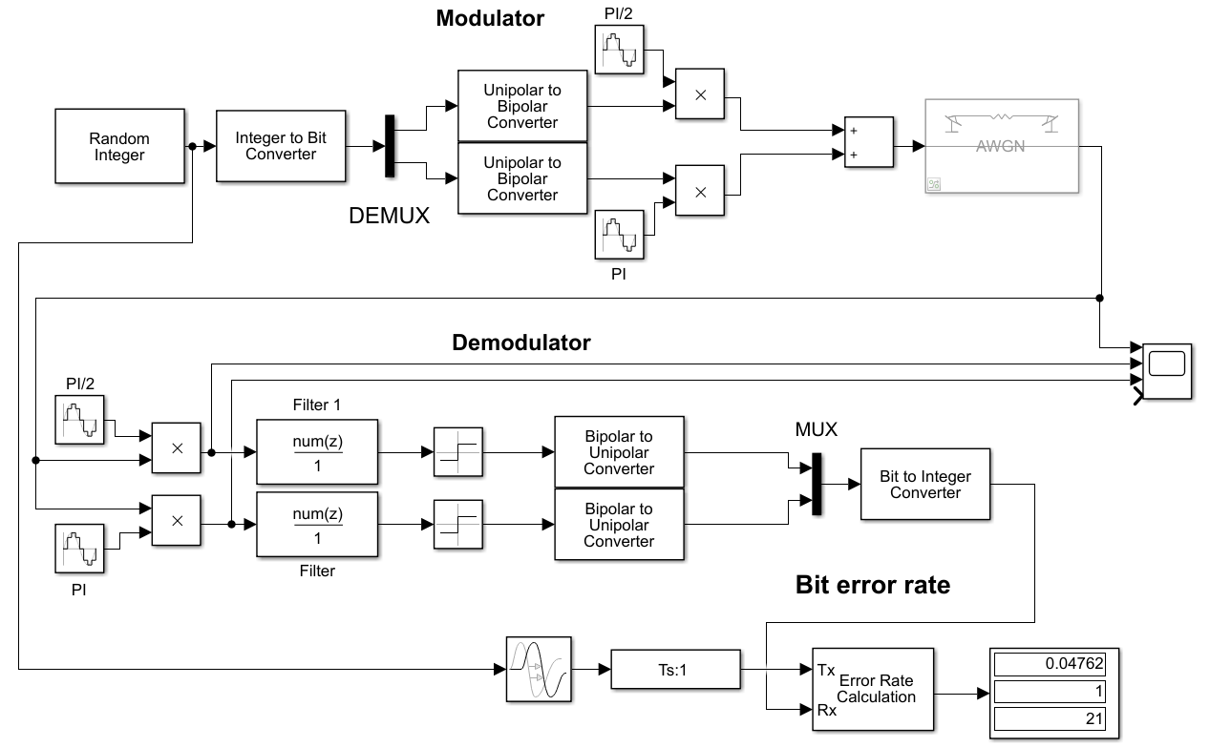
Figure 32 QPSK test 4.
This test seen in Figure 32, when run produces an output on the scope seen in Figure 33 below.
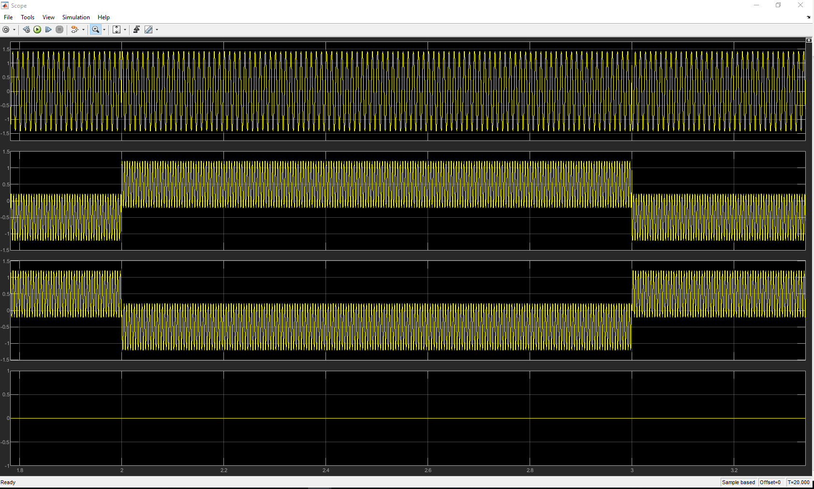
Figure 33 QPSK demodulation scope 1.
Figure 33 shows the scoped zoomed in, channel 1 shows the transmitted data and some phase shifting can be seen, channel 2 and 3 then shows the data has been split into parallel ready to be filtered and conditioned. The next Figure 34 shows the scope has been moved to either side of the two filters.
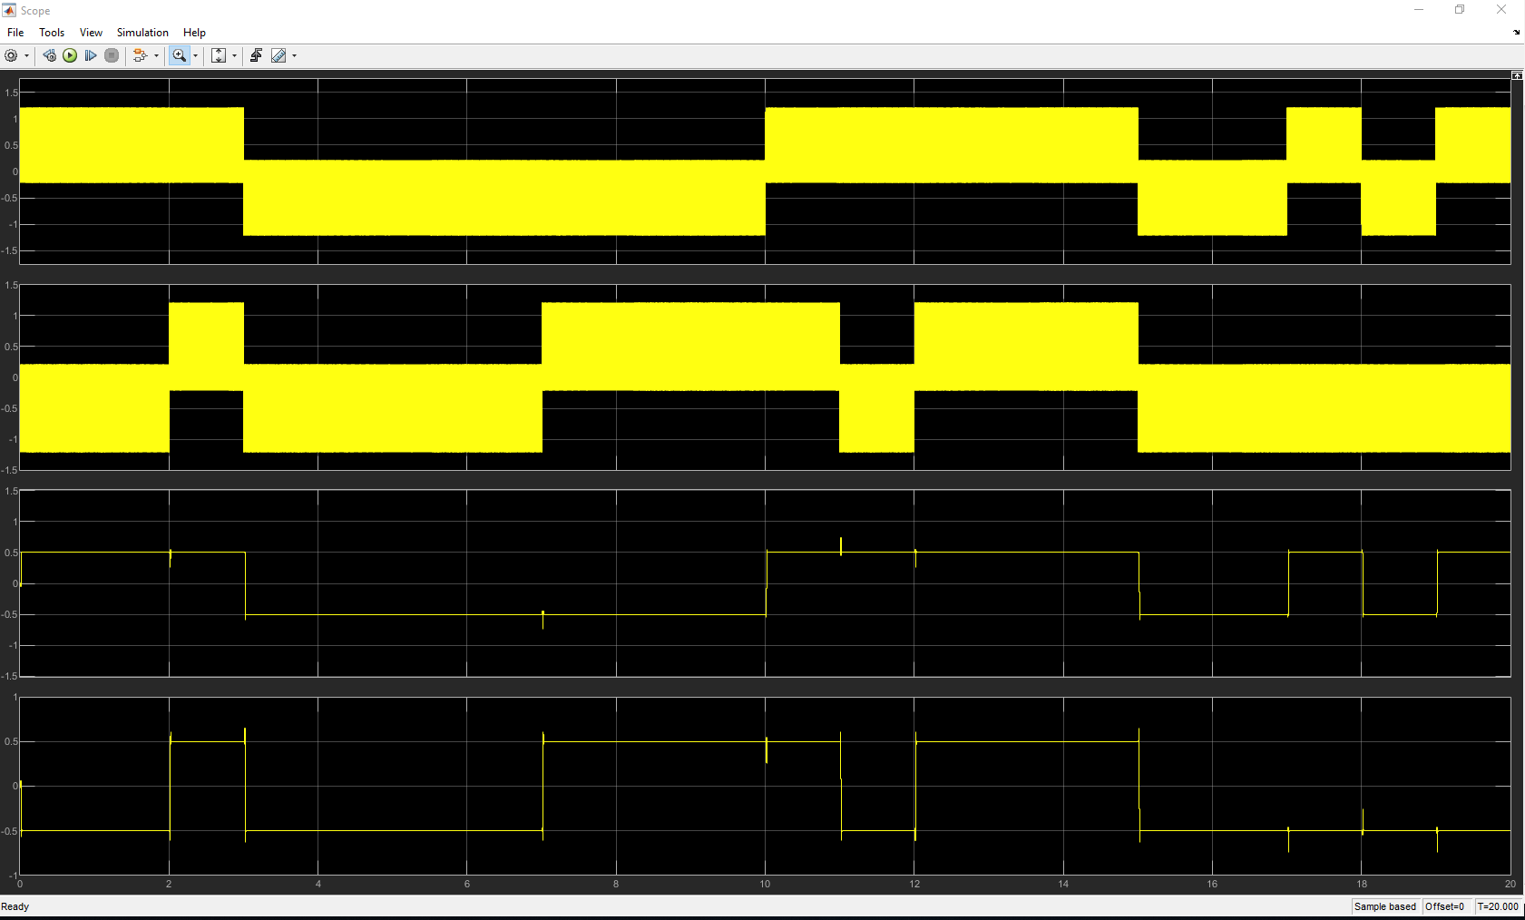
Figure 34 QPSK demodulation scope 2.
In Figure 34 channel 1 and 2 are on the input of each low pass filter and channel 3 and 4 shows the output where the high frequencies have been filtered out.
Here in Figure 35 the scope shows the signal being conditioned by the sign blocks and converted to unipolar form.
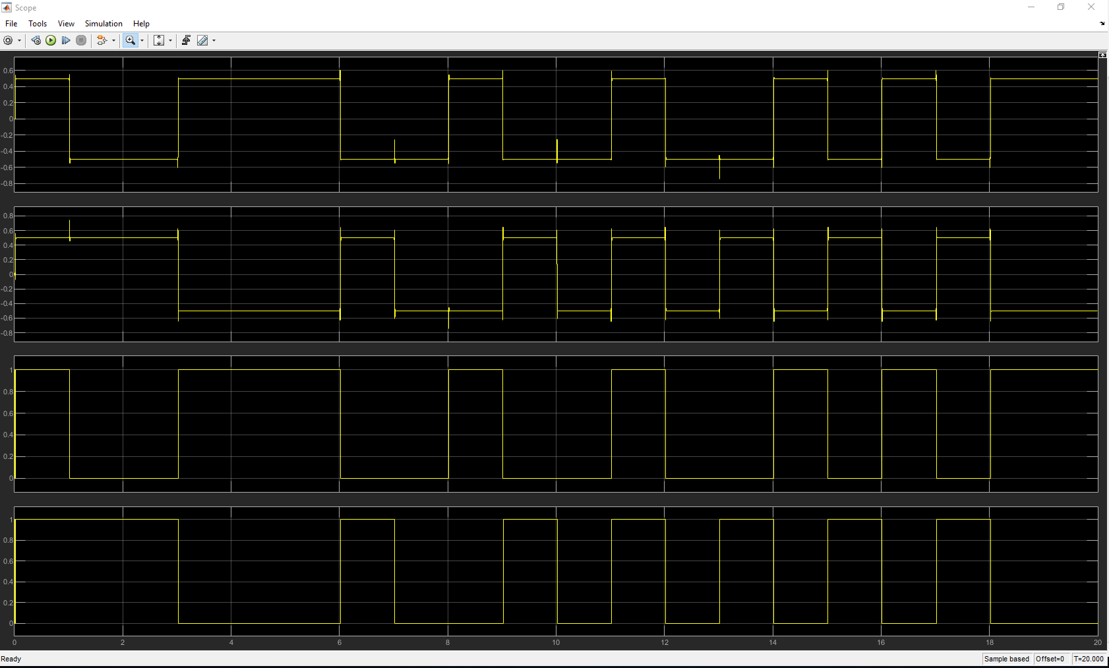
Figure 35 QPSK demodulation scope 3.
Channel 1 and 2 in Figure 35 shows the input to the sign blocks, the levels are form approximately -0.5 to +0.5, not shown here in this test these levels are then fixed to either -1 or +1, channel 3 and 4 shows the data has been converted to unipolar form.
Figure 36 shows the setup used for this next test, here data is being analysed between the original data and the demodulated received data.
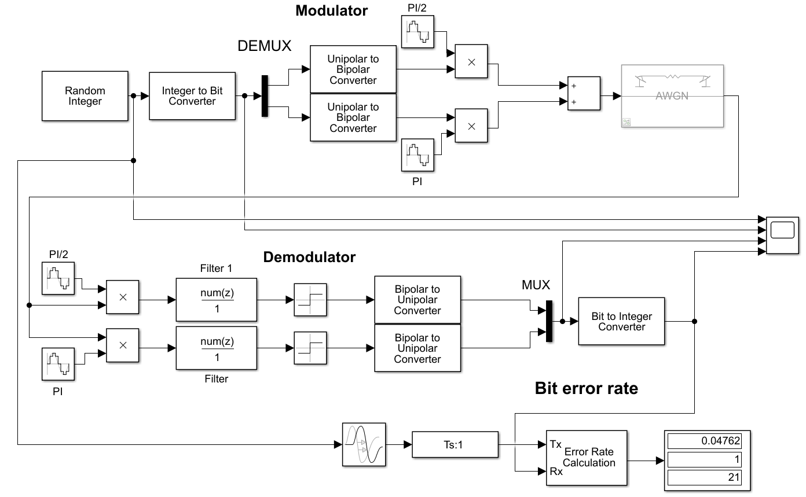
Figure 36 QPSK test 5.
The scope in Figure 36 has been placed at the original data and received data, Figure 37 shows the output when running this test.
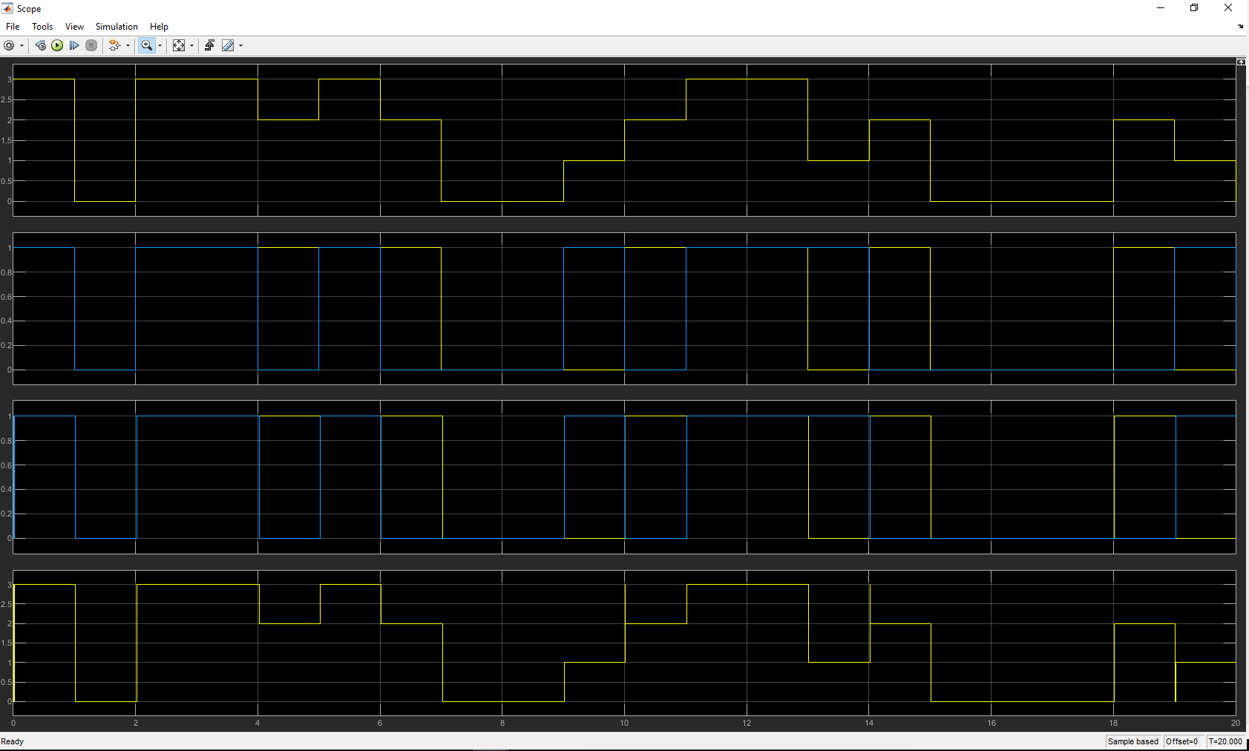
Figure 37 QPSK scope test 4.
In Figure 37 channel 1 and channel 4 shows the INT number being transmitted and received, channel 2 and 3 showing the data as parallel from before the Demux block and after the Mux block, here it is clear that the data sent is the same as what was received.
Figure 38 shows the scoped zoomed in to calculate delay in system.
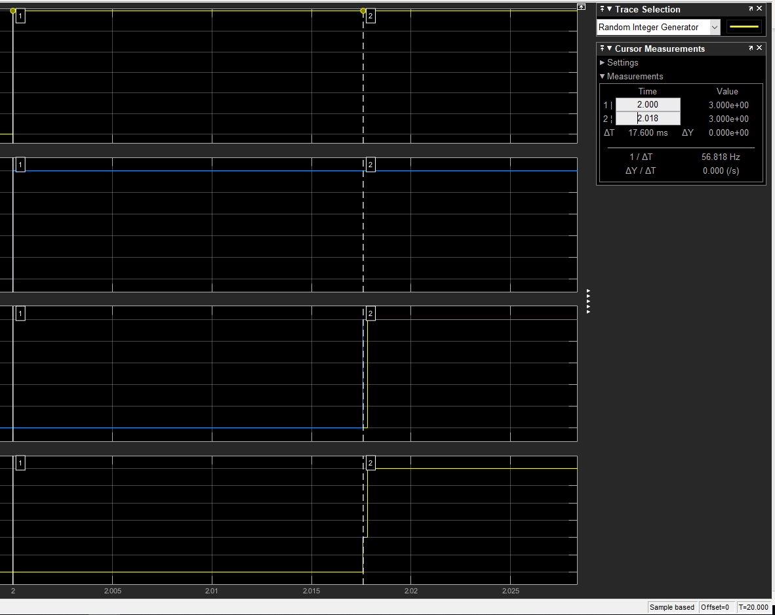
Figure 38 QPSK scope delay.
Figure 38 shows the same test to calculate delay like the previous modulations, the scope has been zoomed in on a transition period set by channel 1, cursor 1 is then placed on this, cursor 2 is placed at the transition mark on channel 4, looking at the properties box it shows a difference of 0.018 seconds, this has been rounded up, the actual delay of this system is 0.0176 seconds (17.6 ms) as proven by the absolute value also seen in the properties box.

AWGN noise results QPSK
The AWGN block has a setting called ‘Number of bits per symbol, as QPSK has 2 bits per symbol then this was set to 2, sticking with Eb/No, the same tests was conducted, the results from this was plotted in excel and the following graph in Figure 39 was created.
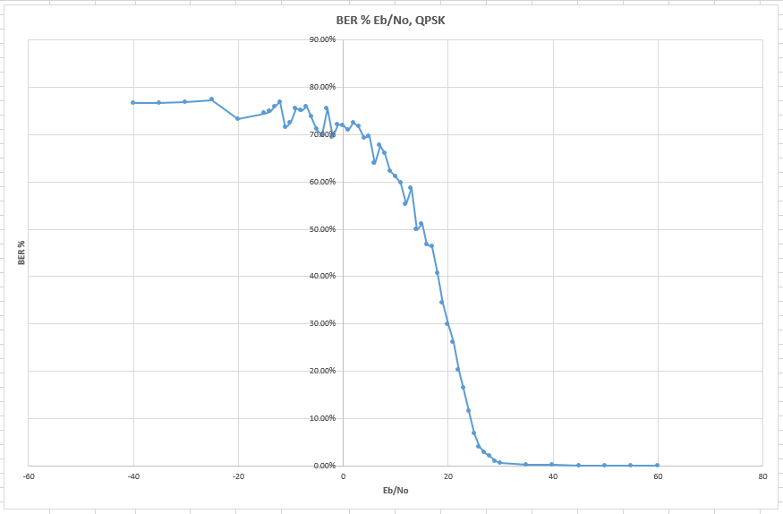
Figure 39 QPSK, graph.
The graph in Figure 39 has a similar pattern to the previous graphs already seen, errors here were detected at 40 Eb/No which showed 1 bit error, once Eb/No reached 29 that is where the bit error rate started to deteriorate, the difference here when compared to ASK and PSK is the curve does not start to roll off until BER reaches about 70%.

Summary of results without error correction
Putting all the results into one produces a graph shown in Figure 40 below.
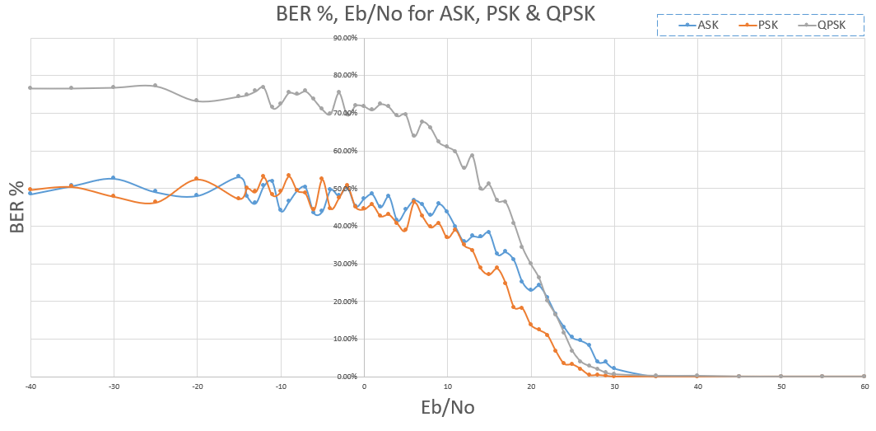
Figure 40 ASK, PSK, QPSK, graph.
The graph in Figure 40 shows all three results from each of the modulation schemes, the graph layout is still the same as previous ones, the blue data shows ASK, orange data shows PSK and grey data shows QPSK. Going by these results ASK was first to start showing errors then QPSK followed by PSK, the QPSK bit error rate has deteriorated more rapidly when compared to the other 2 modulation schemes and it does reach bit error rate levels of 70%.

Hamming code implementation
Hamming code is a system that can detect errors within digital transmission, as-well as detection it can also rectify these errors [11], the way this works is by adding extra parity bits to the original data before transmission, these parity bits are then used to determine if an error has occurred and where in the data packet this error took place [12] at its simplest a 7,4 correction scheme can be used, the 7 represents the whole encoded data packet, the 4 is the actual data information before being encoded.
Whilst trying to implement the Hamming encoder and decoder blocks into the previous modulation models it become apparent that it was not as easy as thought, after spending several hours on the ASK model, hamming encoding was accomplished and data was transmitted across the communication channel, but recovery of the original data was not successful.
MATLAB Simulink does provide pre-built modulation blocks covering most types of digital modulation, what it does not provide is ASK modulation, being conscious of time and wanting to gain some experience with the hamming code blocks then models have been created using the pre-built modulation blocks and the same tests as previous have been conducted.

PSK Hamming code models
Figure 41 below shows the model used to implement Hamming code to the data being transmitted. In this model there is 4 Demux blocks with scopes attached, these have been used to visualise the data frames that are in parallel form.
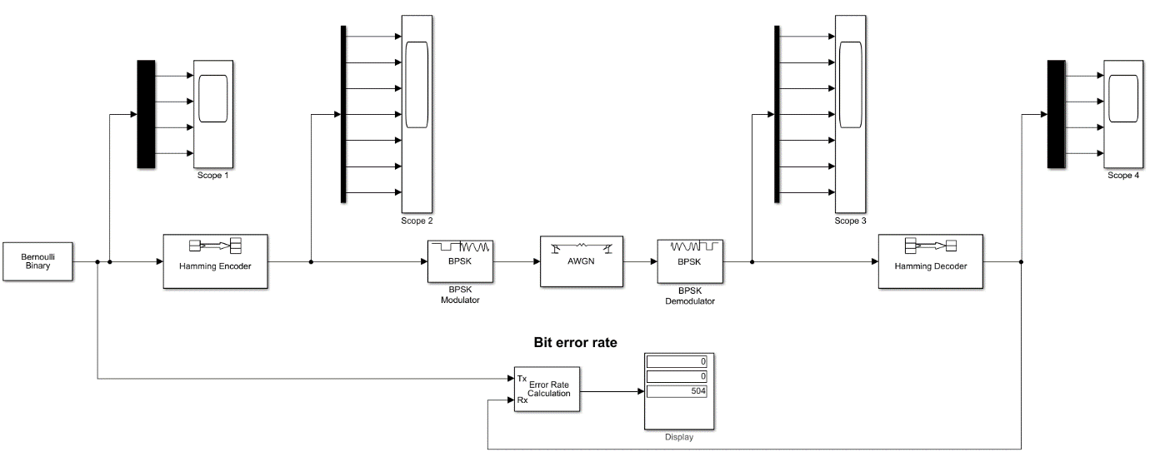
Figure 41 BPSK Hamming code model.
The model shown in Figure 41 can be split into 3 main parts, to the left of the AWGN block is Hamming encoding and modulation section, after the AWGN block is the demodulation and decoding of the data and to the bottom is the error checking section, set up of the simulation time is the same as previous which is 500, the AWGN settings is also the same as previous with the ‘number of bits per symbol’ equal to one.
For the hamming encoder block to function it needs frames of data, in this instance the settings are ‘codeword length’ is 7 and ‘message length’ is 4, what that entails is the information data needs to be 4 bits long and then 3 parity bits are added to make up the codeword length, to be able to provide the hamming encoder block with the right length of information the setting of ‘samples per frame’ in the ‘Bernoulli binary generator is set to 4.
The results were put into Excel and a graph shown in Figure 42 of bit error rate % against Eb/No was plotted.
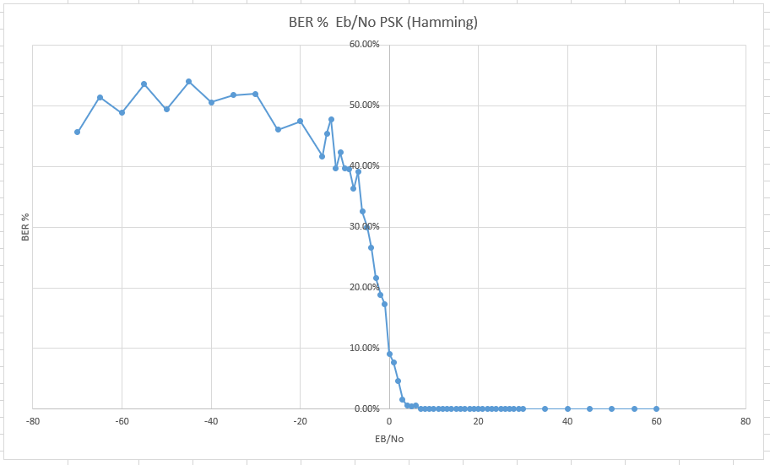
Figure 42 PSK graph with hamming correction.
The graph in Figure 42 shows the results gained from this test, here errors started to appear when the Eb/No reached as low as 6, similar to previous results the error rate then climbed fairly quickly.

QPSK Hamming code models
The model seen in Figure 43 below is what was used to simulate Hamming encoding and decoding with QPSK.
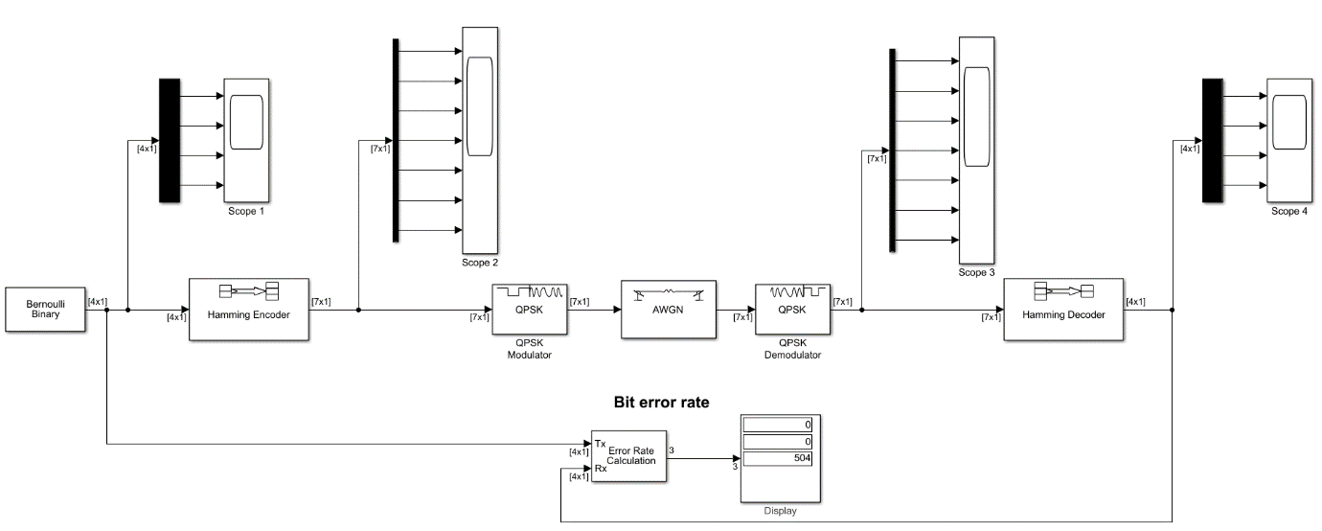
Figure 43 QPSK Hamming code model.
The settings used throughout this model is the same as the previous PSK model, except the modulation and demodulation blocks are for QPSK, the same test were conducted and plotted in Excel, Figure 44 shows this.
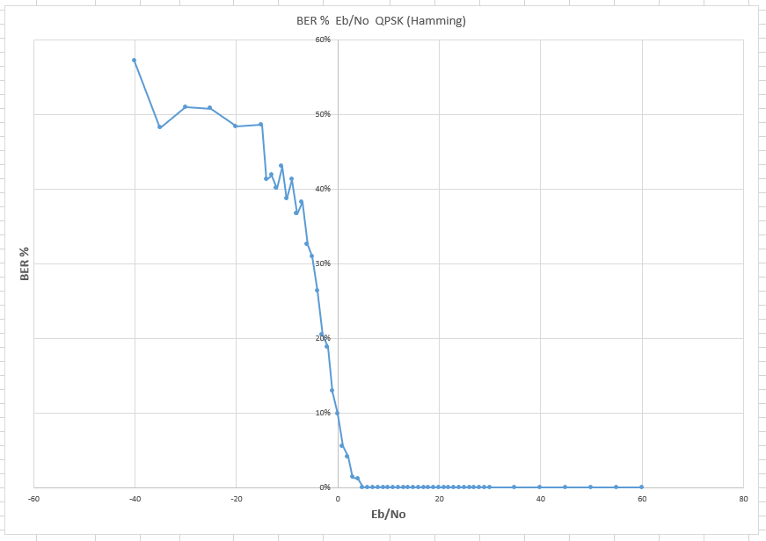
Figure 44 QPSK graph hamming.
The QPSK results seen in Figure 44 is very similar to the PSK results previous, with the errors detected stating at 5 Eb/No and again the bot error rate increased fairly rapidly from there.

Analysis of data packets in these models
As both models are the same except for their modulation blocks some testing has been done to visualise the data via the 4 scopes on the models. Figure 45 and Figure 46 shows the two 4 channel scopes, scope 1 and 4.
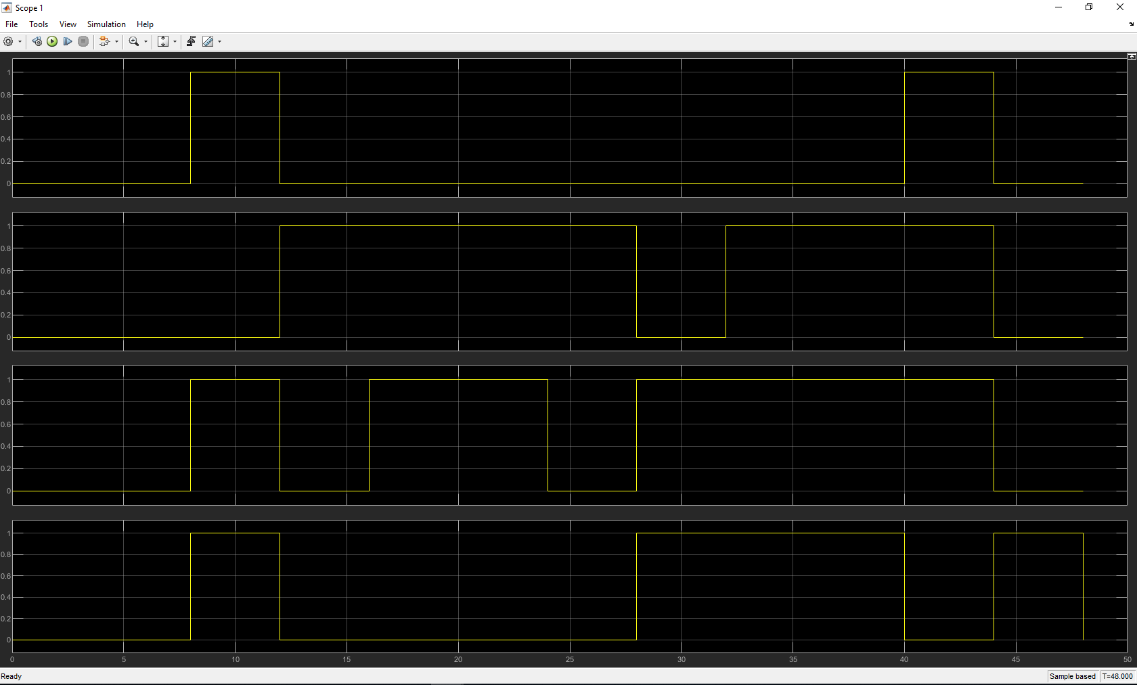
Figure 45 Hamming scope 1.
Figure 45 shows the first scope (scope 1) connected to the original data, the four channels represent the data frame that is in parallel. Figure 46 below shows the received data on scope 4.
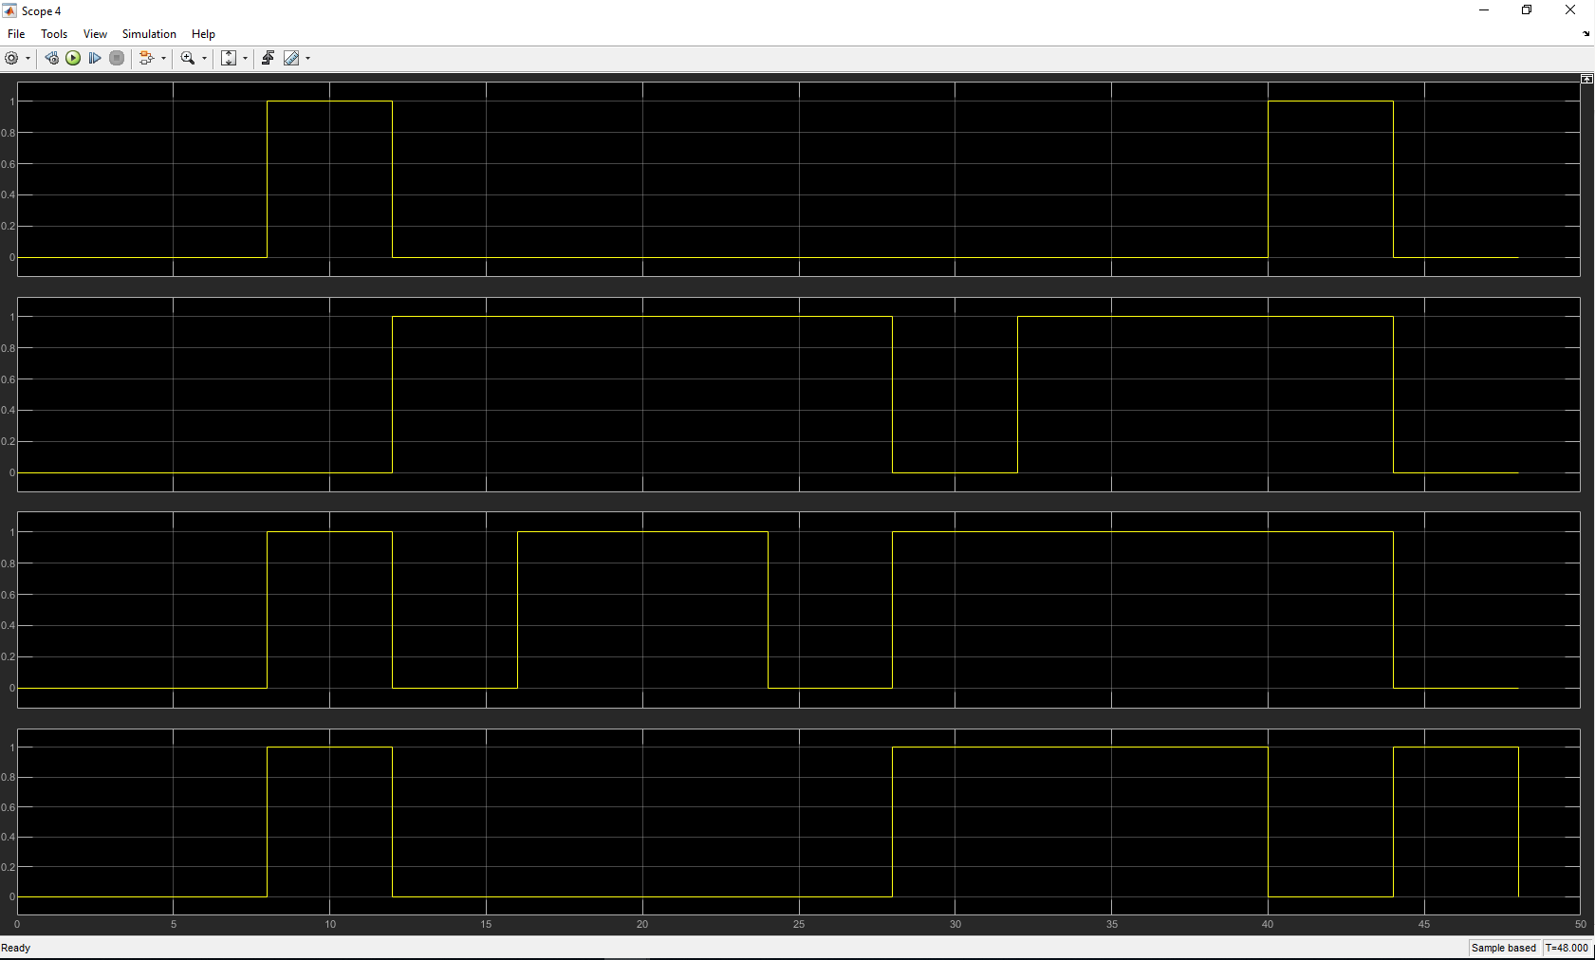
Figure 46 Hamming scope 4.
Figure 46 and Figure 45 shows the same data being transmitted and received.
Figure 47 and Figure 48 shows scope 2 and scope 3 where the data has parity bits added to the original 4 bit data frames.
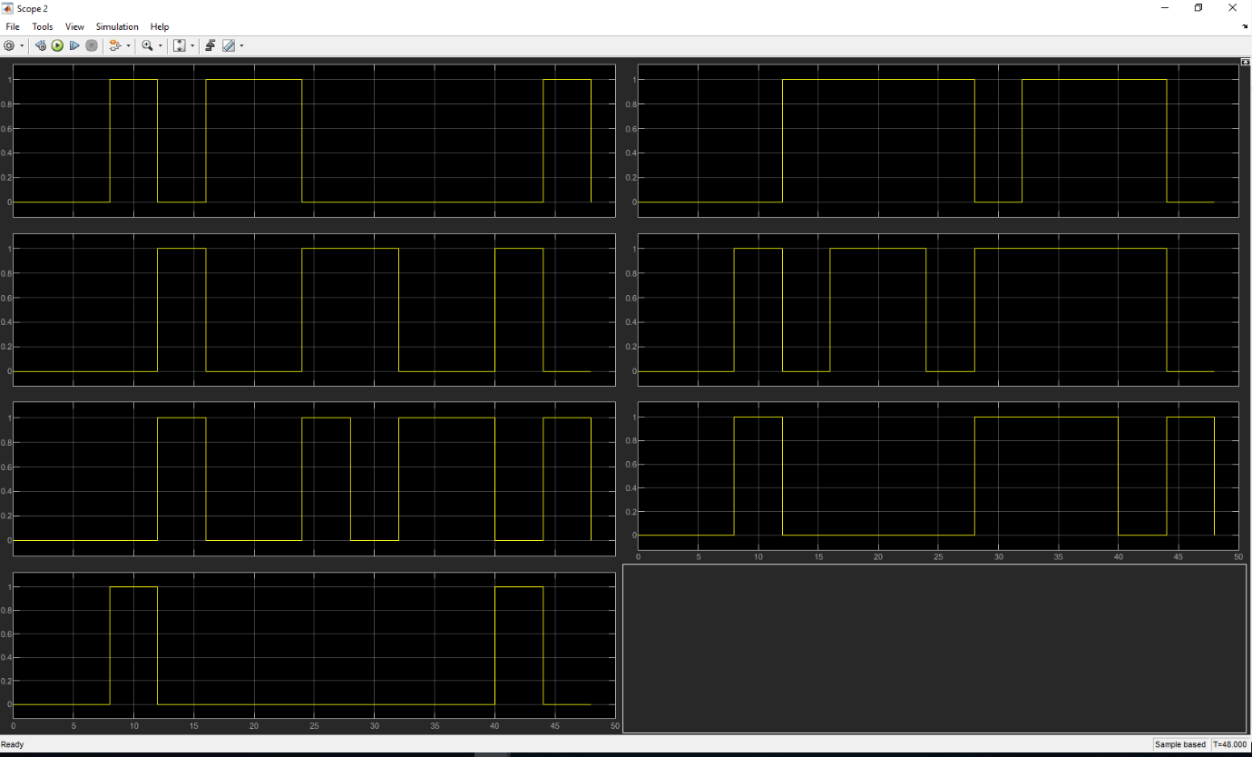
Figure 47 Hamming scope 2.
Figure 47 shows scope 2 output where the data has been encoded with 3 parity bits before being passed to the modulator block.
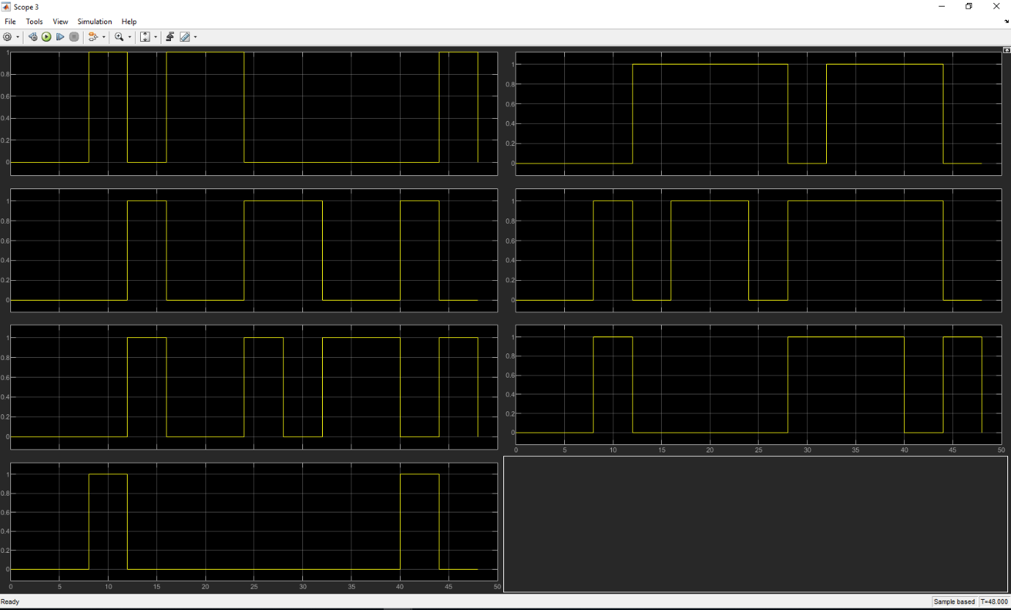
Figure 48 Hamming scope 3.
Figure 48 shows scope 3 output where the same data is seen after the demodulator block.
When comparing the data in scope 1 and scope 2, the original data in scope 1, channels 1 – 4 correlate to the encoded data in scope 2 where channel 1 in scope 1 is channel 4 in scope 2, channel 2 in scope 1 is channel 5 in scope 2, channel 3 in scope 1 is channel 6 in scope 2 and channel 4 in scope 1 is channel 7 in scope 2. The same is also true with scope 3 and 4.

Analysis of all results
All results from the five tests were plotted on to one graph, this is seen in Figure 49 below, ASK is the light Blue line, PSK is the Orange line, QPSK is the Grey line, PSK with hamming code is the Yellow line and QPSK with hamming code is the dark Blue line.
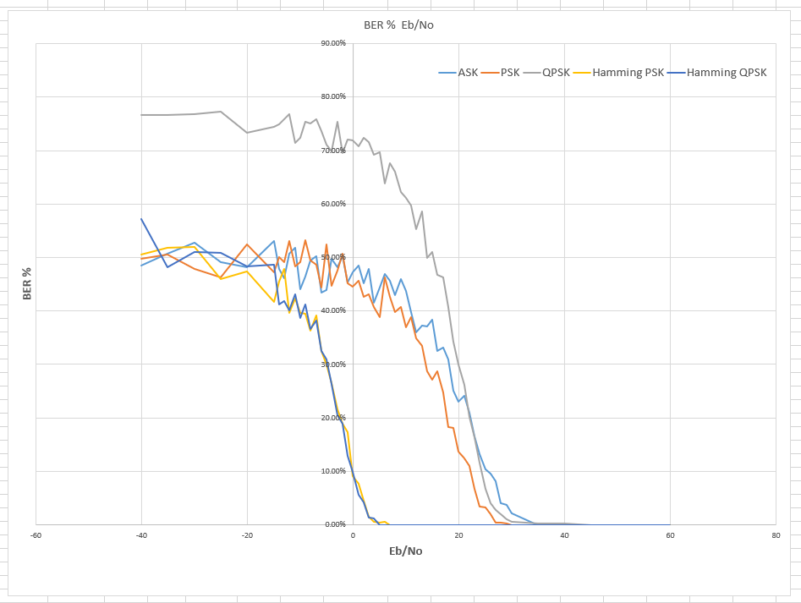
Figure 49 Graph results from all tests.
Looking at the graph in Figure 49 it is clear that the modulation schemes with hamming (7,4) coding applied have a far better data recovery rate when Eb/No is low, each of the three non-error correction modulation schemes start to receive errors when Eb/No is about 30. Once errors have been detected they all rapidly increase their Bit error rate until about 45% before slowly levelling off, the exception is the QPSK model was capable of reaching 70% BER, it is unsure as to why this happened, further testing with various settings may reveal a possible set up error, what was noticed during testing is the time Simulink took when simulating this model was extremely high when compared to the rest of the models. Unfortunately ASK was not simulated with Hamming code error correction added, at a guess and going by results gained so far then it would be expected to follow a similar pattern to the PSK and QPSK with hamming code error correction.

Conclusion & discussion
In general, this has been a challenging task, more so with trying to implement error correction into the original modulation schemes, given more time then this may have been accomplished but unfortunately other work commitments have forced this to conclude at this stage. With regards to the 249 ms delay found with the ASK model, this may be down to the sample rate only being 1/1000 whereas the other models were set to 1/10000, this was only noticed when finalising this report.
Further work would include going through the settings of each model and trying to confirm that they are optimised for that particular design, this will also involve various setting modes of signal to noise ratio in the AWGN block, with that, more experience will be gained and hopefully implementation of the hamming code will be successful without the use of the pre-made modulation blocks, results can then be replotted to see if the QPSK model shows something different to the 70% BER that it reached

References
[1] R. W. Stewart, K. W. Barlee, D. S. W. Atkinson, and L. H. Crockett, Eds., Software defined radio using MATLAB & Simulink and the RTL-SDR, 1. ed. Glasgow: Department of Electronic and Electrical Engineering, University of Strathclyde, Strathclyde Academic Media, 2015.
[2] ‘Eb/N0 Explained’. [Online]. Available: http://www.sss-mag.com/ebn0.html. [Accessed: 16-May-2019].
[3] ‘Add white Gaussian noise to input signal - Simulink - MathWorks United Kingdom’. [Online]. Available: https://uk.mathworks.com/help/comm/ref/awgnchannel.html. [Accessed: 12-May-2019].
[4] ‘ASK- Amplitude Shift Keying’. [Online]. Available: https://www.ele.uri.edu/Courses/ele436/labs/ASKnFSK.pdf. [Accessed: 12-May-2019].
[5] G. Smithson, ‘Introduction to digital modulation schemes’, in IEE Colloquium on Design of Digital Cellular Handsets, London, UK, 1998, vol. 1998, pp. 2–2.
[6] S. P. Singh, S. Sengar, R. Bajpai, and S. Iyer, ‘Next-Generation Variable-Line-Rate Optical WDM Networks: Issues and Challenges’, J Opt Commun, vol. 34, no. 4, Jan. 2013.
[7] ‘D1-08.pdf’. [Online]. Available: http://www.eng.auburn.edu/~troppel/courses/TIMS-manuals-r5/TIMS%20Experiment%20Manuals/Student_Text/Vol-D1/D1-08.pdf. [Accessed: 12-May-2019].
[8] ‘BPSK vs QPSK | Difference between BPSK and QPSK modulation’. [Online]. Available: http://www.rfwireless-world.com/Terminology/BPSK-vs-QPSK.html. [Accessed: 12-May-2019].
[9] [Online]. Available: https://kics.edu.pk/wdsp/flextrainer/images/QPSK_tx.html. [Accessed: 12-May-2019].
[10] R. Katti and S. Prince, ‘Ultrafast optical binary to gray code and gray to binary code conversion based on phase modulation in Mach–Zehnder interferometer’, Opt. Eng., vol. 56, no. 2, p. 025101, Feb. 2017.
[11] ‘What is Hamming code? - Definition from WhatIs.com’, WhatIs.com. [Online]. Available: https://whatis.techtarget.com/definition/Hamming-code. [Accessed: 16-May-2019].
[12] D. J. C. MacKay, ‘Information Theory, Inference, and Learning Algorithms’, p. 640.

