Learning in the Digital Era
ACCA4025
Assignment One

Dylan Thomas

Student number - 2014801

Table of Contents.
Table of Contents
Link to E-Portfolio | Page 2
Task 1 | Page 3
Task 2 | Page 3
Task 3 | Page 4
Task 4 | Page 4

e-Portfolio.
- The link to my e-portfolio homepage. - https://2014801.wixsite.com/myportfolio

- A screenshot of my e-portfolio homepage
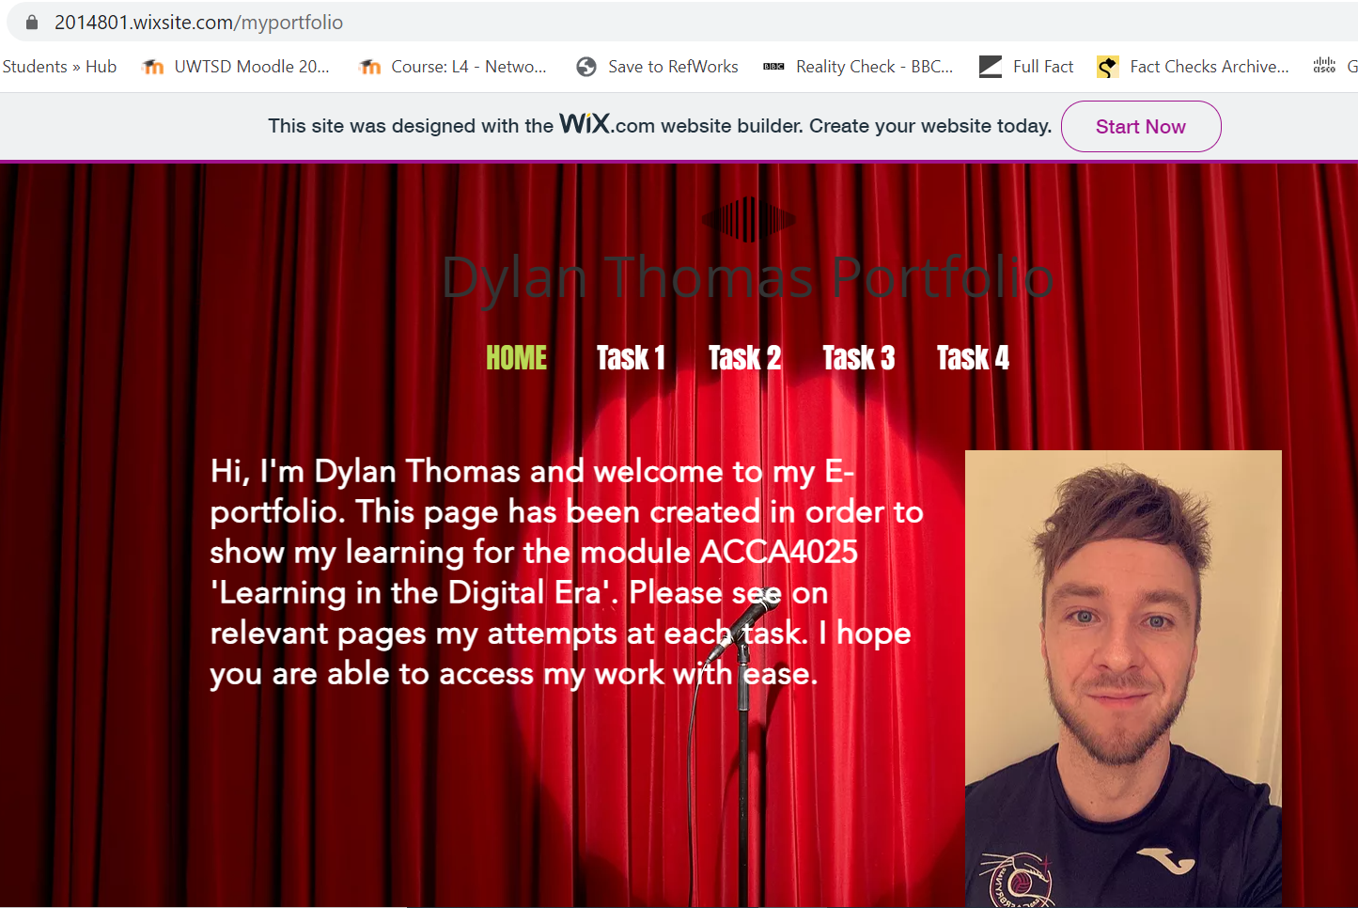

Task 1 – Written summary.
Please see E-portfolio + Cloud Links - https://2014801.wixsite.com/myportfolio/task-1
https://uowtsd-my.sharepoint.com/:w:/g/personal/2014801_student_uwtsd_ac_uk/EUMSitHXag9AmKXPwVFhV_IB7boe1qgVANQaE24hlPjuUQ?e=VNyAxw

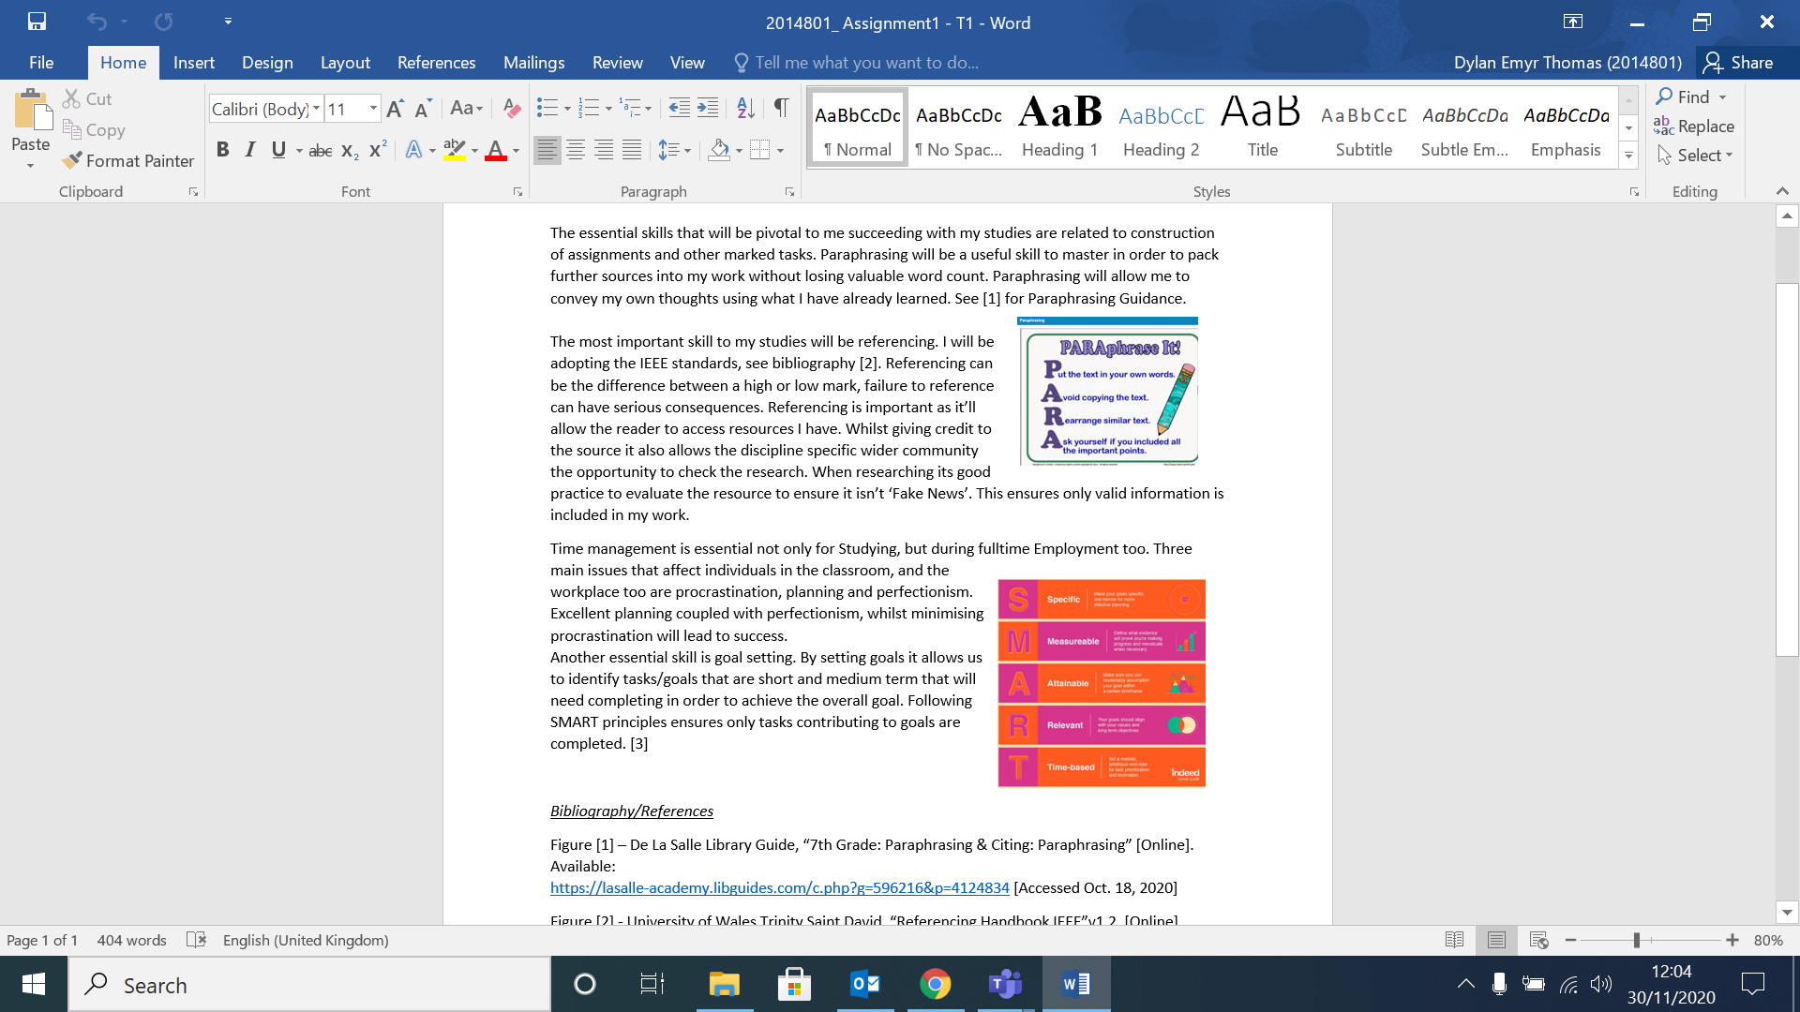

Task 2 – Mind Map.
Please see E-portfolio + Cloud Links - https://2014801.wixsite.com/myportfolio/task-2-1
https://uowtsd-my.sharepoint.com/:b:/g/personal/2014801_student_uwtsd_ac_uk/ETn14Kcr0WdKo65OEf-EsCkBSroeUDjA6hNmifjvw9DbeA?e=ksfzUx

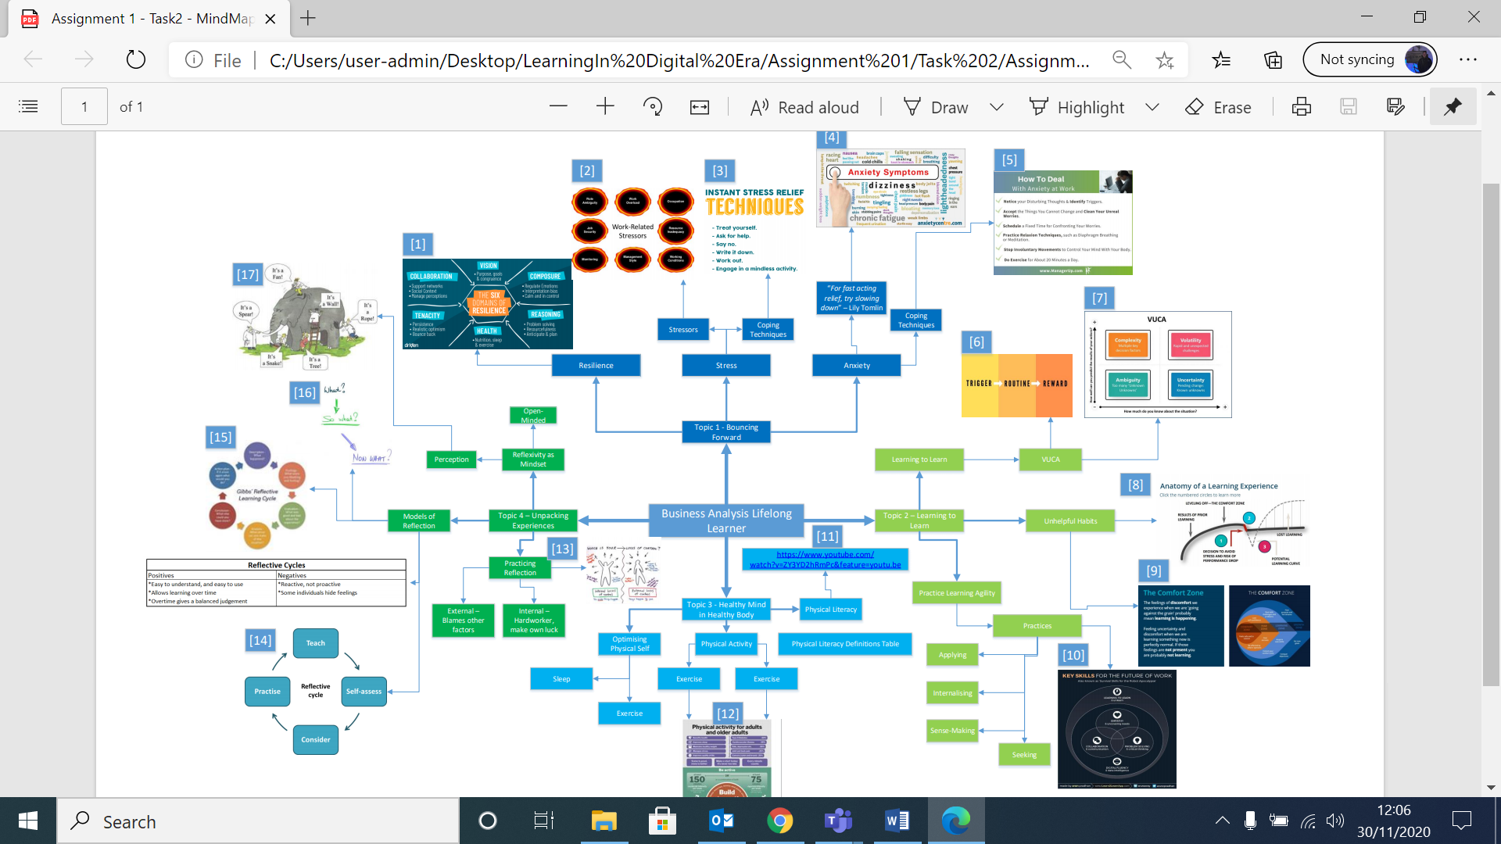
Task 3 – Video presentation.
Please see E-portfolio + Cloud Links - https://2014801.wixsite.com/myportfolio/task-3-1
Video made via Microsoft PowerPoint.
https://uowtsd-my.sharepoint.com/:p:/g/personal/2014801_student_uwtsd_ac_uk/Edze8kt7_ONHpRAdg5_j5cEB7Mh0DbcdDerxa_DiHbm8Yg?e=SR94sm

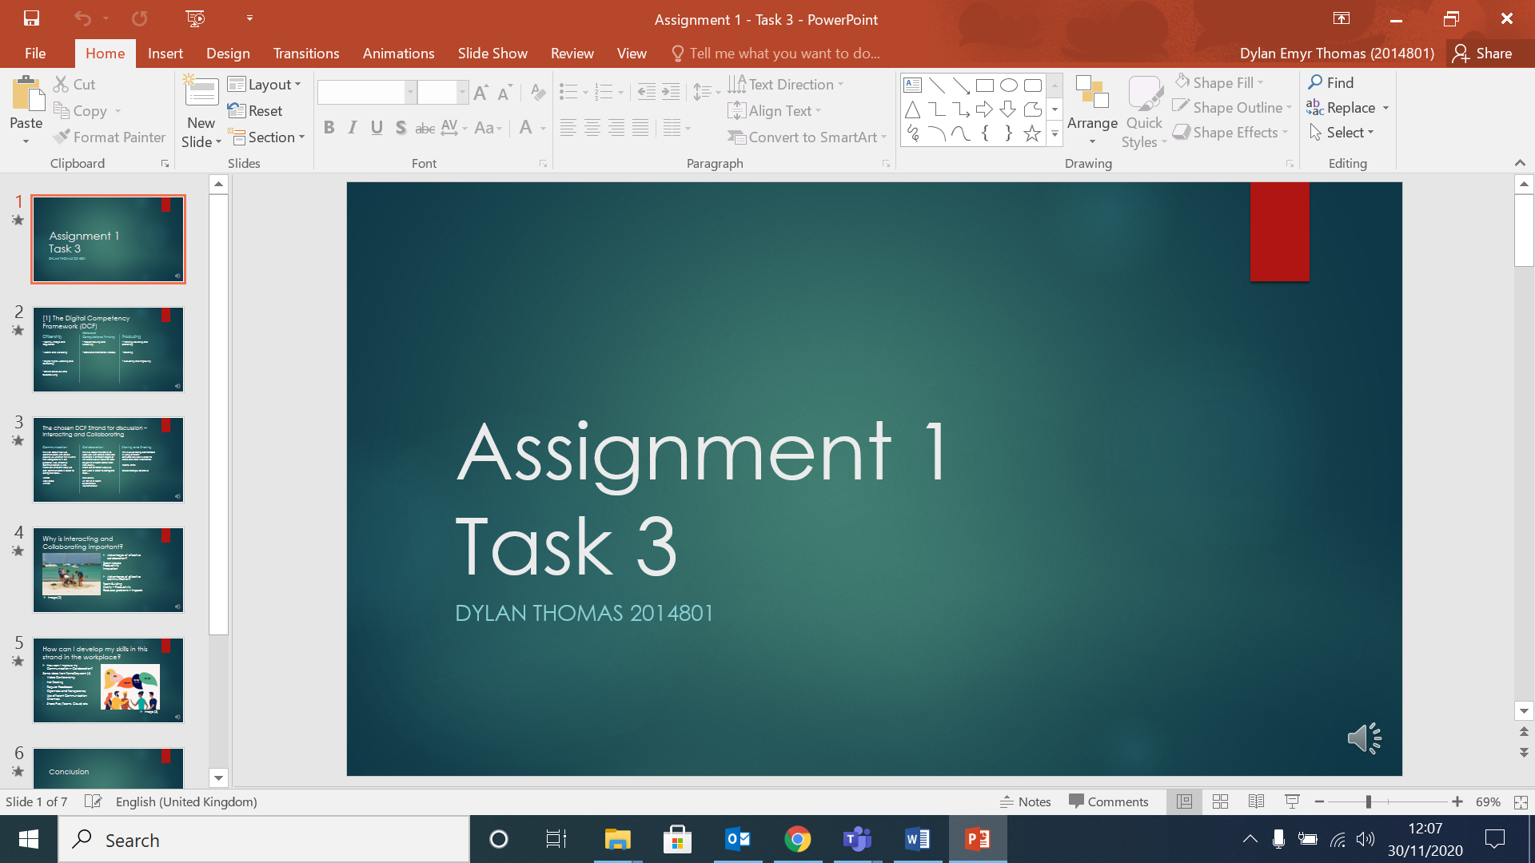
Task 4 – Academic poster.
Please see E-portfolio + Cloud Links - https://2014801.wixsite.com/myportfolio/task-4
Poster made via Microsoft Publisher.
https://uowtsd-my.sharepoint.com/:u:/g/personal/2014801_student_uwtsd_ac_uk/Ebs_TaRX9kVCvhNm2YNYeLUB986OW-EpBYA0h1ydf4-3UQ?e=7JPFI3



