

LEVEL 4

SEMESTER 1 & 2

MODULE CODE: SHSS4062
PROFESSIONAL DEVELOPMENT AND PRACTICE
aSSESSMENT TYPE: aSSIGNMENT
Assessment/Component: 1

COMPONENT WEIGHTING: 50 %

WORD COUNT: 1500 WORDS

MODULE TUTOR: GERAINT FORSTER

Task

Choose ONE of the essay titles allocated to your degree group below, and using relevant and reliable research to support your points, write a 1500 word essay on that topic. Pay particular attention to the structure and referencing of the essay, as these correspond to a large proportion of the available marks. Please refer to your lecture notes on referencing and essay writing in order to ensure you are following the correct format – you must reference as described in the core text ‘Cite them Right’.

SUBMISSION DETAILS: Submit via turnitin by 3:00pm on 2nd November 2018

Essay titles (please choose only ONE of these, from the relevant options for your degree):

BA Physical Education:
- Discuss the components that of a good essay.
BA Outdoor Adventure Education:
- Discuss the components of a good essay, and identify common mistakes to avoid.
- Discuss the key features of an "adventurous" activity.
- Discuss whether there really is a need for children to play freely outdoors.

BSc Health, Nutrition and Lifestyle:
- Discuss the components of a good essay, and identify common mistakes to avoid.
- Discuss the role of Registered Nutritionists, Registered Dieticians, Nutritional Therapists and other professions who offer dietary advice in the United Kingdom. Consider the inequality in qualifications and codes of conduct in relation to the above.
- Discuss the causes of the so called ‘obesity crisis’ facing the UK.

School of Sport, Health & Outdoor Education

Assessment Feedback Sheet

Student No./Name: Rebecca Bevan 1808305
Module: Professional Development and Practice
Module Code: SHSS4062

Personal Evaluation – to support your academic progress please complete the section below BEFORE submitting your work.
What do you consider to be the best aspects of this work? |  |  | Researching Statistics and information.
Which aspects do you consider could have been improved in this piece of work? |  |  | Referencing, require better understanding of different references from different sources.
What have you found most satisfying whilst undertaking this submission? |  |  | Completion of my first assignment.
ASSESSMENT CRITERIA | Learning  Outcomes |  | GRADE
ASSESSMENT CRITERIA |  |  | Poor  0-25% | Unsatisfactory  26-39% | Satisfactory  40 – 49% |  | Good  50 – 59% | Very Good  60 – 69% | Excellent  70 – 85% |  | Exceptional  86– 100% | %
Essay content and quality of resources used | 1 |  |  |  |  |  |  |  |  |  |  | 30%
Referencing within the essay | 1 |  |  |  |  |  |  |  |  |  |  | 20%
Correctly constructed reference list | 1 |  |  |  |  |  |  |  |  |  |  | 20%
Structure of essay and clarity of writing | 1 |  |  |  |  |  |  |  |  |  |  | 30%
It is expected that students will present work that is proof read, correctly referenced and adheres to the Assessment Checklist. Therefore a range of 0 – 10 marks will be deducted for non-completion of any of the points on the checklist below.
TUTOR COMMENTS:

Submission date: 2/11/18  via Turnitin |  | Return date:  (at least within 4 weeks) |  |  |  | Tutor: |  |  |  | Mark:

Assignment Checklist

- Please complete the Personal Evaluation section of the Assessment Feedback sheet, add your name and details, and paste the whole of this assignment document into the front of your assignment

- Submission is a single word file, clearly labelled with your name and module code
- Font style - Times New Roman, size -12 for text and 14 for headings
- Ink colour – black only
- Line spacing – 1.5 line spacing and 2cm- 2.5cm page margins
- Quotations more than three lines to be indented 1 line spacing
- One line space between paragraphs, paragraphs must be left aligned
- Pagination (your assignment should have page numbers)
- All tables and figures are internally referenced and have a title
- Word count checked and written at end of text (before references and any appendix)
- Assignment is within 10% of the word limit (excluding references and any appendices)
- All references in the text are included in the reference list
- Correct referencing following the Harvard style, as described in the UWTSD Referencing Guide.
- Correct spelling using UK English
- Correct use of punctuation
- Grammar and syntax correct- double check anything that has a green line under it
- I have read my assignment out loud to myself and it makes sense and is easy to read
- Somebody else has read my work and it makes sense to him or her!
- I have checked and I have not plagiarised
Failure to follow these guidelines will cost you marks!
The United Kingdom is currently facing a rising epidemic in obesity. But the question is why? I am going to discuss the possible causes of the Obesity crisis here in the UK and discuss a few of the many the health problems which obesity can bring on, supported by researched evidence from credible professionals, organisations and publications.

Obesity is now considered to be one of the major health threats in the developed world, leaving people diagnosed with heart problems such as coronary heart disease. The scope of the problem in the result of prevalence of a combination of health hazards. Seidell (1998). There are a number of factors that are contributing to the increased rate in obesity in the UK.

Childhood obesity is continuously on the rise, with treatment proving to be more ineffective then effective. The main concern being that obese children tent to become obese adults with increased risk of several health issues such as diabetes and heart disease. Data shows that almost a third of children aged two to 15 are overweight or obese; The Guardian (2018).

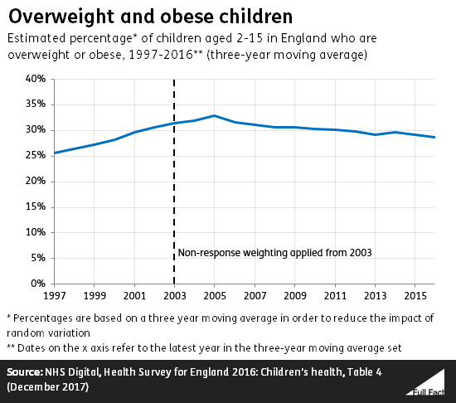
The UK’s independent fact checking charity (2017)

According to BBC (2016) only 26% of us meet the World Health Organisation’s recommended 5-a-day, up from 23% in 2015. Processed ‘Ready’ Meals are widely available to us in large selection of meals suited to many peoples busy life styles, or lack of knowledge and culinary skills, as they are ‘easy’. Fast food outlets are on the rise throughout the UK. If you were to walk down the high street, several fast food chains become available, and many more keeps being added to our high streets and shopping outlets. Public Health England (2014) collected data to show the number of fast food outlets throughout England, from 2011 with 45,837 to 2014 with a total of 47,928 fast food premises. That’s an increase of 2091 fast food premises in just 3 years, in England alone. The BBC Good Food Nation Survey found that most people ate fast food on average two days per week. But in the 16 to 20-year-old category, one in six ate fast food at least twice a day, with one in eight among 21 to 34-year-olds eating as frequently. BBC (2016). Mass produced food corporations have easy access to sophisticated advertising tools and opportunities to influence the population. Mass produced foods are made ready to go, often a lot cheaper and more convenient than the healthier alternative. According to Statistics on Obesity, Physical Activity and Diet – England, (2017) In 2005, 56% of women and 68% of men were overweight or obese. Obesity prevalence increased since 1993 from 15% to 27% in 2005.
People tend to have an unhealthy relationship with food. Many eat due to boredom, some eat when they are stressed. Some families may not think about the impact they are having on their children, and their future relationship with food. Some parents seem to be oblivious to the fact that their child is learning from them, if the parent has an unhealthy relationship with food which has been normalised, that way of thinking is going to normalised through generations, ultimately resulting in poor health and possible onset of genetic diseases. According to Cancerresearchuk.org obesity campaign (2018) obesity is the second biggest preventable cause of cancer in the UK- more than 1 in 20 cancer cases are caused by excess weight.

Parents who are stressed can become exhausted from living ‘pay cheque to pay cheque’ lifestyles and may not have the luxury of buying all fresh foods and cooking from scratch, having to make do with the cheaper, less nutritional options which are more likely to be high in calories which would be more filling, but also full of additives. Cooking from scratch can prove to be more expensive, from buying ingredients and equipment to utility costs of running a cooker; making the microwave a much more attractive option. Lack of education in relation to the importance of nutrition, having knowledge of the daily intake recommendations for different food groups, being unaware of the correct food portion sizes results in food often being served in oversized portions, not just at home but when eating out, Burger King for example promote ‘king size’ meals encouraging consumers to ‘upgrade’. And a reduction in the amount of physical activities people are taking part in. Eating too much, and not exercising enough will cause the body to store the extra intake of energy as adipose tissue around the body. This, being repeated each meal time will cause weight gain and other possible health issues such as obesity, diabetes, and heart disease. This is an imbalance between energy intake and energy expenditure. People are eating and drinking more food than the energy they are using.

However, Social inequality suggests that children born into poorer families are more likely to become obese than those born into wealthy families. People living in poorer areas not only die sooner but spend more of their lives with disability - an average total difference of 17 year. Marmot (2010). According to Marmot (2011) The lower one's social and economic status, the poorer one's health is likely to be. Data from the National Child Measurement Programme 2012/2013 show us that the most deprived 4-5-year olds and 10-11-year olds are twice as likely to be obese than the least deprived:
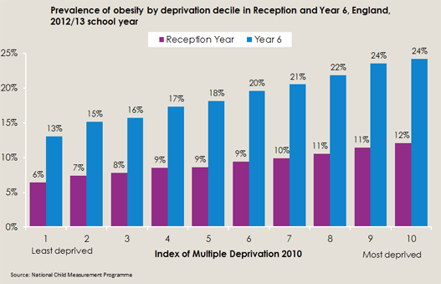
National Child Measurement Programme (2012/2013)

Society is continuously changing. Information fed to the public can often be confusing, or contradicting of previous advisories, leaving people with mixed messages and unsure of which advice to follow. Society today is overrun by technology. We are consumed by video games, TV’s, mobile telephones and various other interactive screens, leaving individuals in a sedentary state for periods of time much longer than recommended. In 2017 Cancer Research UK launched their Obesity Campaign, claiming that Obesity is the second leading cause of cancer after tobacco. According to cancerresearchuk.org Obesity campaign (2018);
Junk food adverts appear up to 9 times every hour at children’s peak viewing times. Our research has found that children who remember seeing one junk food advert on TV a day could eat an extra 18,00 calories in a year – or almost 350 calories a week.
In 2011, Physical activity guidelines by the four Chief Medical Officers recommends for ages 5 years and below, 3 hours each day one a child is able to walk. Ages 5-18 years, 1 to several hours of moderate to vigorous physical activity daily; and 19-65+ years recommended 2.5 hours of moderate to vigorous physical activity each week, with muscle strength activities included twice weekly. According to Public Health England, there has been a 40% drop in the number of children getting enough physical activity (PHE, 2017). Whereas 20 years ago technology was still basic, and children would often be seen spending time outdoors doing physical activities such as riding a bike or playing ball or tag for example. Currently, just 23% of boys and 20% of girls meet the national recommended level of activity. Furthermore, 1 in 5 children start primary school overweight or obese, rising to more than a third by the time they leave. The survey also identified the main barriers to physical activity and reveals that the worry of ‘not being very good’ was one of the most common, affecting 22% of children. This increases with age as it affects just 17% of 5-year olds, compared to 29% of 11-year olds. (PHE, 2017).

In conclusion, there is no singular cause of the obesity crisis in the United Kingdom. Some of the factors which lead to obesity could be environmental, lack of knowledge, social status, finances, immobility or illnesses. The biggest health risk of overweight and obesity is coronary heart disease, costing the NHS and government millions each year. The government proves to be trying to fight this epidemic, however, with little to no improvement on each contributing factor towards obesity there will be very little improvement on the current statistics for the UK. Organisations such as Cancer Research UK are also working to improve the obesity levels of the UK with launching their Obesity Campaign 2018, claiming that Obesity is the second biggest cause of cancer after smoking; with heart disease being the second biggest killer in the UK today. Although heart disease is ranked the second biggest killer in the United Kingdom, it remains the number one killer worldwide with almost 9 million related death.

Word count – 1400

BBC (2016). Available:
https://www.bbc.co.uk/news/health-37511554

BBC Good Food Nation Survey (2018). Available:
https://www.bbcgoodfood.com/howto/guide/childhood-obesity

Cancer Research UK (2018). Available:
https://www.cancerresearchuk.org/about-cancer/causes-of-cancer/obesity-weight-and-cancer/what-causes-obesity

Local Government Association- Public Health England. Available:
https://lginform.local.gov.uk/reports/lgastandard?mod-metric=3357&mod-area=E92000001&mod-group=AllRegions_England&mod-type=namedComparisonGroup

Lovell. N (2015) Childhood Obesity and the Marmot phenomenon. Available: https://www.health.org.uk/blog/childhood-obesity-and-marmot-phenomenon

Marmot, M. (2011) - Marmot Review report – 'Fair Society, Healthy Lives. Available:

https://www.local.gov.uk/marmot-review-report-fair-society-healthy-lives

Public Health England (2017). available:
https://www.gov.uk/government/news/new-physical-activity-guidelines

Seidell, J.C. (1998) Dietary fat and obesity: an epidemiologic perspective. American Journal of Clinical Nutrition 67: 546S-550S

Statistics on Obesity, Physical Activity and Diet – England (2017). Available:
https://data.gov.uk/dataset/a7fb45df-7566-488b-80d8-a5dd5e52ff32/statistics-on-obesity-physical-activity-and-diet-england

The Guardian (2018). Available:
https://www.theguardian.com/theobserver/2018/jun/24/obesity-crisis-demands-more-action-and-investment

UK Independent fact checking charity. Available:
https://fullfact.org/health/childhood-obesity/

