How to access the online library for Referencing

Search UWTSD in your search engine, the website link should appear, click on the below:
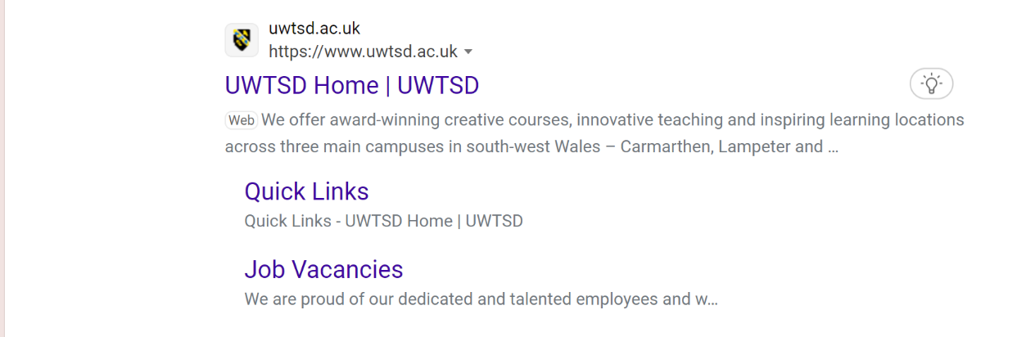

This is the page you should see, click on quick links at the top left hand corner to see all of the quick access tiles:



You should now see the below page, you can access all of the useful resources via this page however to access the library please click on library and learning resources:



You should then be taken to this page:

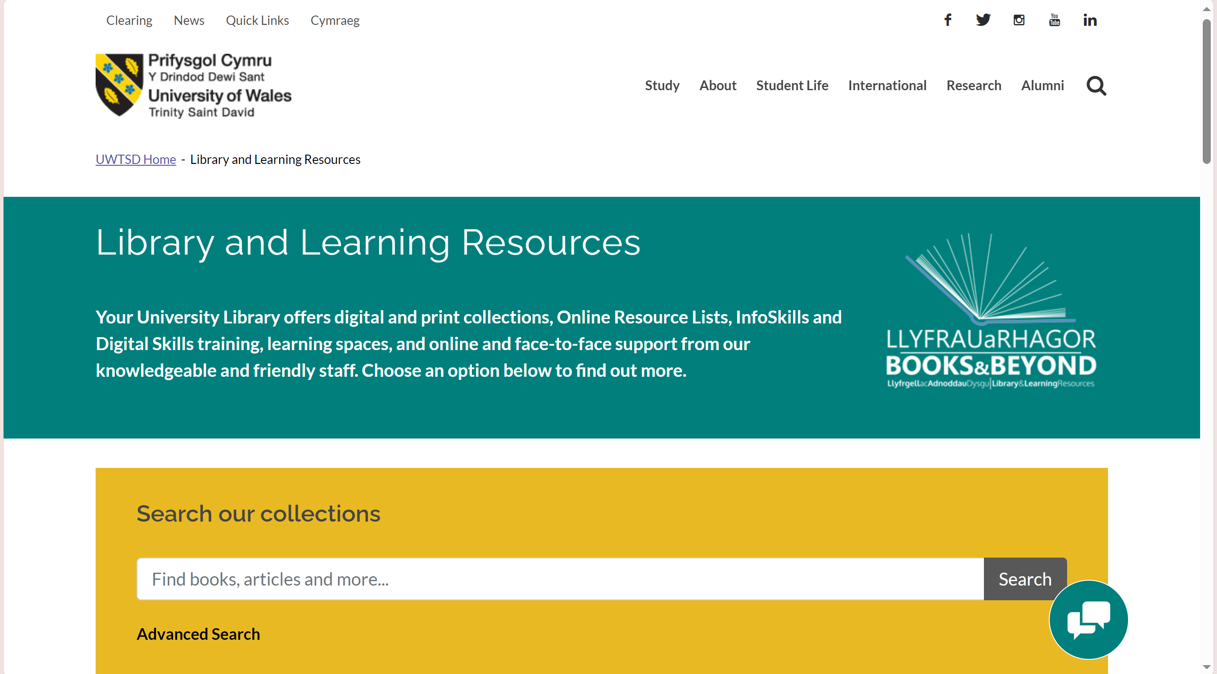
Specifically for referencing you can type directly into the search box ‘cite them right’ and click the search button.

Once this has been done you should be taken to a new page that looks like the below. Please ensure you click sign in to see al of the results and be able to access the database at the next step. Just click on sign in, it should automatically pull through your log in details however the first time you use it it may ask you to input these (UWTSD log ins) thereafter they will be saved.

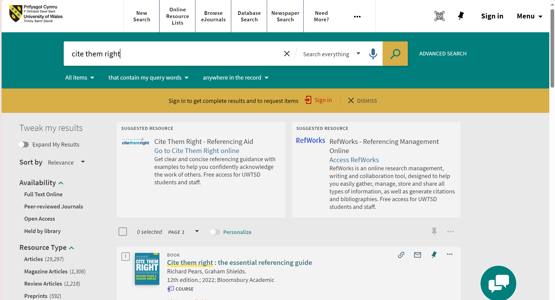
The handbook may be listed as unavailable however this should already be available on your Ducere modules if you prefer a handbook.
To continue to the database, once signed in click on the ‘cite them right database’,

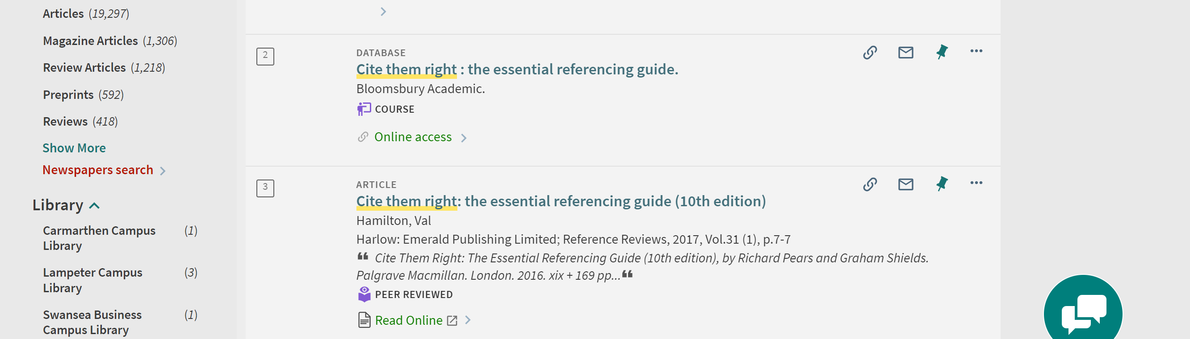
Then cite them right online:

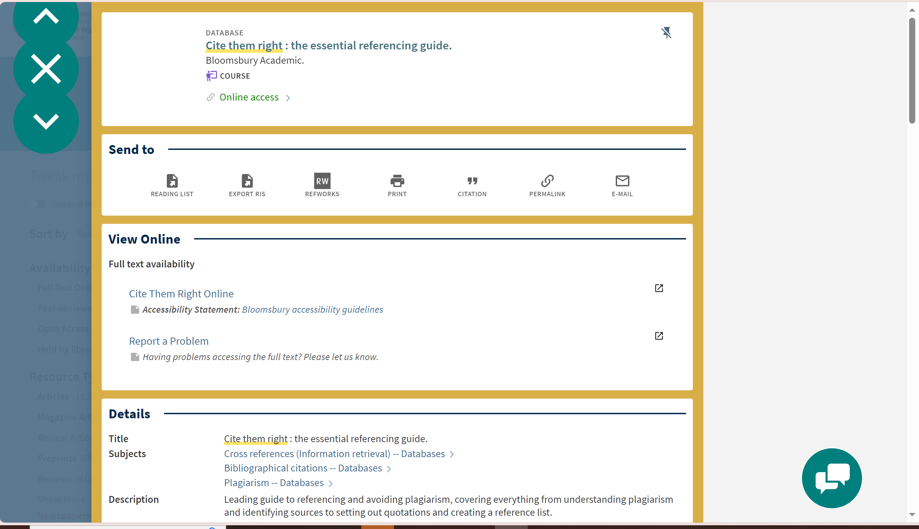

Choose your referencing style, on this course it will always be Harvard:

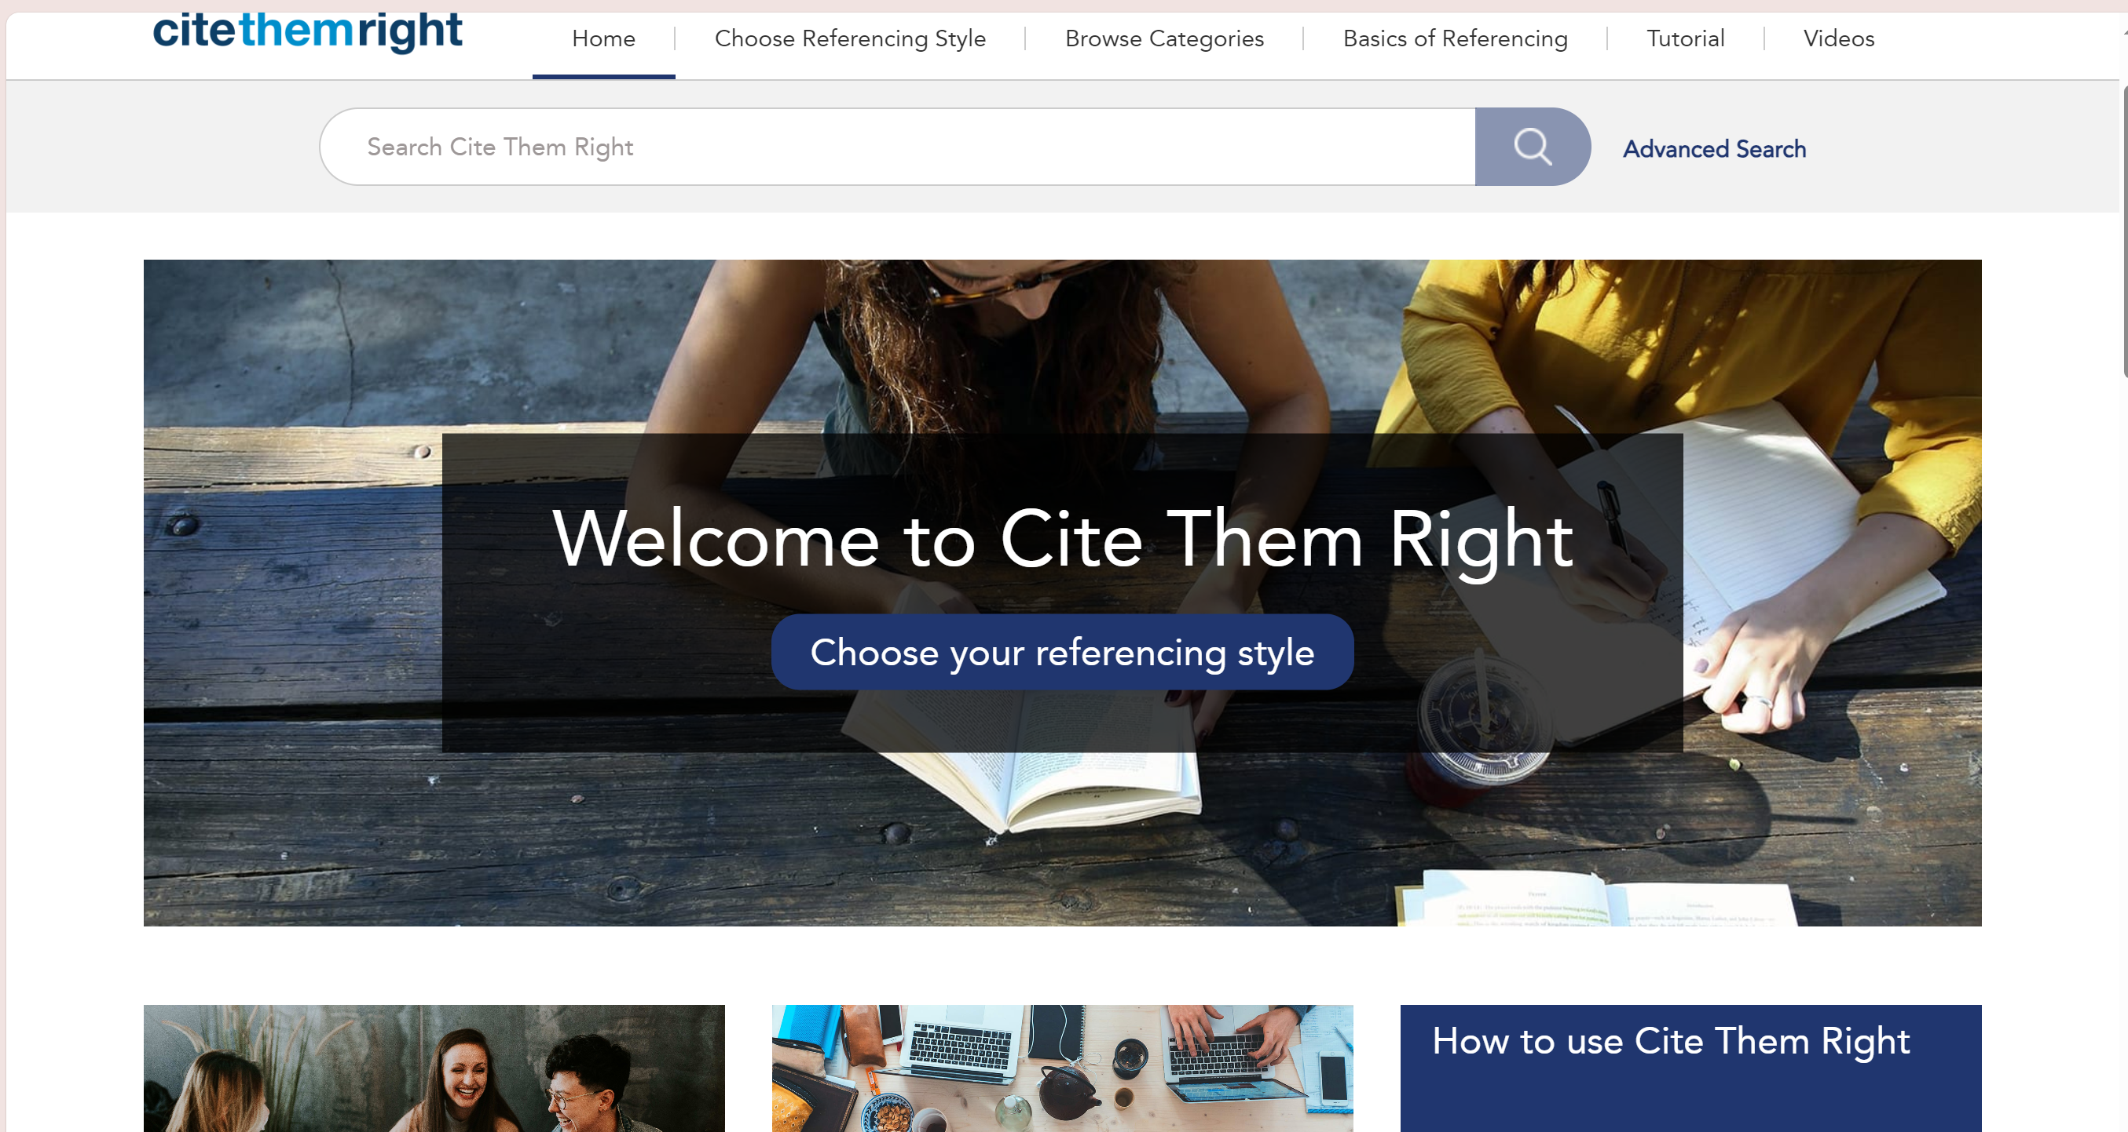



From here you can click on Books, journals etc whatever content you are referencing and it will show you examples of how to reference that source.

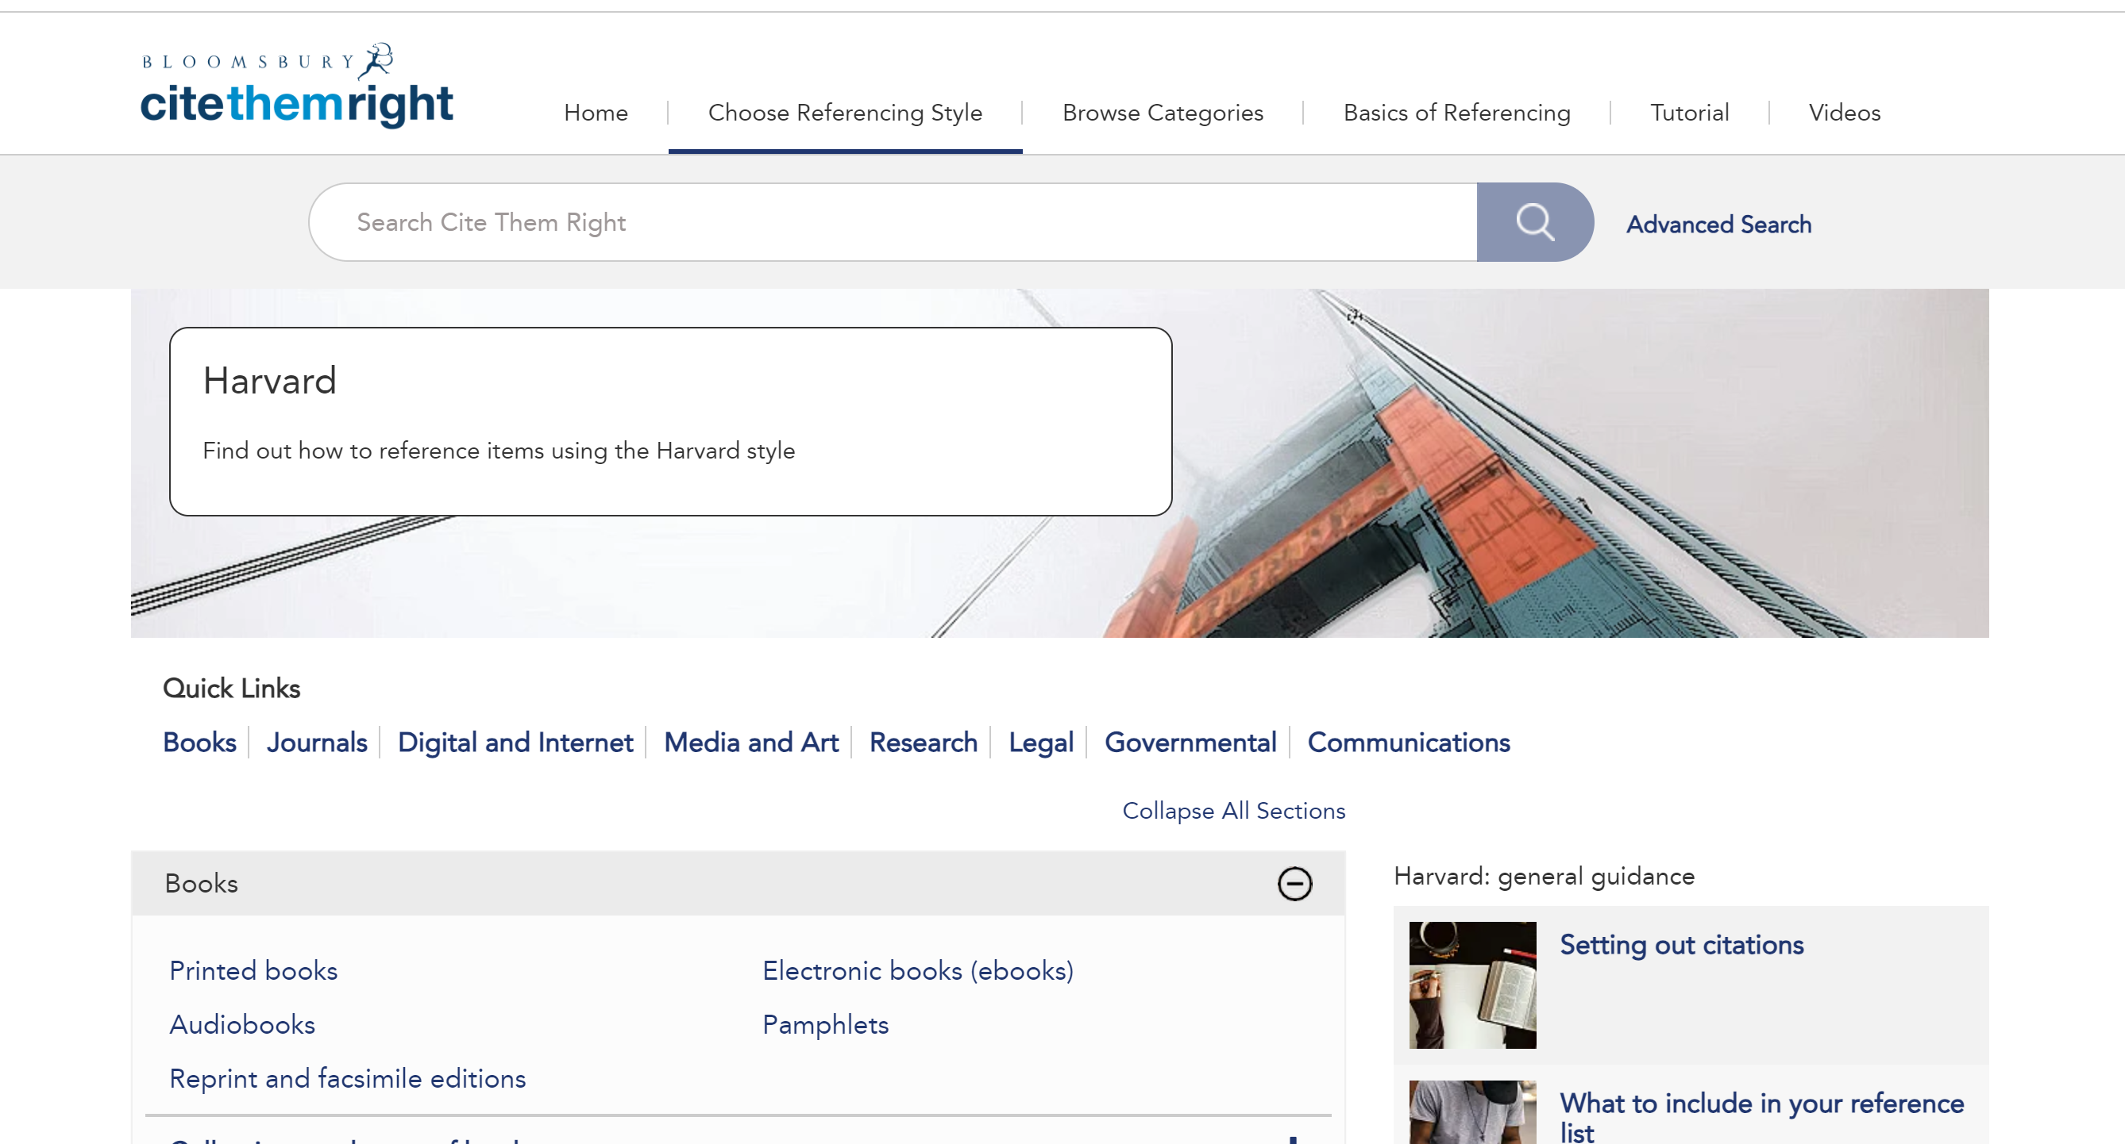

An example of referencing a book is below (based on one author):

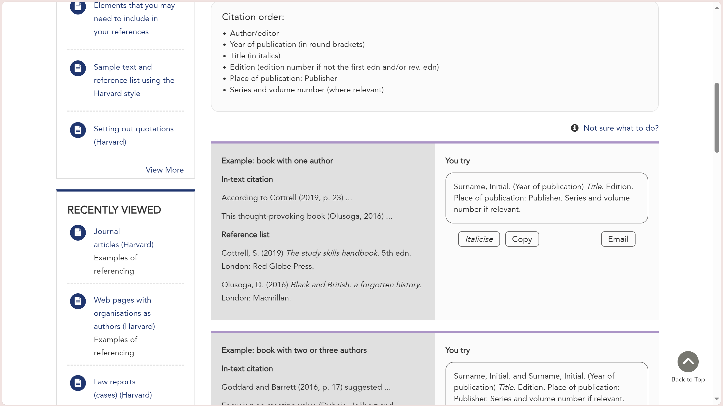

It may seem like a lot initially however when you have gone through the process once your library account should be a lot quicker next time. You can also pin the cite them right database to your favourites on library to make it an instant access when you log in.

If you feel a referencing session would be beneficial then please contact the library to book in for a specific session.

Thank you

