Render a 3D object into a virtual reality environment using different shading and lighting techniques on the Sony PS4 Development Kit.

Name: George Thomas

Course: BSc Computer Games Development

Preferred Supervisor: Andrew Baker

Word Count: 3614 words

Table of Contents
Introduction to project proposal 4
Background Literature 4
Aims and Objectives 10
Conclusion 10
Introduction to research and development methods 11
Research Methodology 11
Development Methodology 11
Risks 12
Ethics 13
Analysis and Deliverables 13
Conclusion 13
Physical Resources 14
Human Resources 14
Timeline 14
Conclusion 15
References 16

Table of Figures
Figure 1 Diffuse reflection [9] 5
Figure 2 Comparing the angle of a light source and a point on a surface [8] 6
Figure 3 Specular reflection [9] 7
Figure 4 combination of ambient, diffuse and specular illuminations [9] 8
Figure 5 example of Flat shading 8
Figure 6 Gouraud shading of a sphere [9] 9
Figure 7 Phong shading of a sphere [9] 10
Figure 8 Gantt chart 14
Figure 9 Gannt chart 14

Introduction to project proposal
This Project will look at rendering a 3d model into a virtual reality scene. This will be done using various shading and lighting methods. The overall goal is that a user will be able to enter this virtual reality environment and will be able to walk around and view the object in a completely 3d space. This will be achieved using the PS4 development kit.
Virtual reality is quickly becoming more and more popular with many well-known companies throwing their hats into the virtual reality ring. Sony is no exception to this with their introduction of the PSVR. The PSVR is a very powerful virtual reality device but due to Sony’s exclusivity with their dev kit, it is difficult to develop software for the device. However, UWTSD Swansea has recently gained access to some PS4 development kits which will allow for some experimenting with basic scenes on the PSVR.
Introduction to background literature
In the background literature, we will briefly discuss the current literature and research on the topic of this project. As well as look at the main aim of the project and any objectives.

Background Literature

Virtual reality is a 3D computer generated environment that a user is able to interact with and explore. The aim of virtual reality is to stimulate the user’s senses in order to create the illusion of reality [1]. “A key feature of virtual reality is real-time interactivity”[2]. This means that VR can read the users input and respond “instantaneously”. VR needs to simulate reality, meaning it needs to "fool" the user into believing that they are in this environment. For example, humans have around 180 degrees of vision, so the environment would have to provide the user with peripheral vision because even though we aren't constantly using our peripheral vision, we would notice if it was gone [1]. The general design for modern VR is the same across all leading VR companies. This consists of a VR headset which will output to the user. They also have some form of camera or sensor to track the user’s movement and warns them of any real-life obstacles. Finally, they generally have two controllers that are designed to replicate the user’s hands.
The PSVR is the cheapest of the major VR devices at the moment, however, it doesn't compromise quality for the price. The device is reasonably easy to set up and is comfortable to wear. The graphics are high quality and there is little to no motion sickness in the games. [3] The problem with the PSVR is that anyone wanting to develop on the system will need to use Sony’s PS4 development kit. It is an expensive piece of kit, costing upwards of $2500 [4], and due to the non-disclosure agreement involved with owning one of these kits, not much can be found online about developing on these systems. However online forums have said that the dev kits use the ‘PhyreEngine’ [5] [6].
When rendering an object in a 3d space there are two main steps; visibility and shading[7]. Shading is affected by many things, such as the angle and distance of the camera, the amount of light in the scene, the direction of the light, and the colour of the object. There are various types of lighting available for a 3d scene, such as emissive, ambient, diffuse, spot lights, point lights, and directional lights. Each of these will lead to the object being shaded differently.
There are three main components that are used when shading in computer graphics, these are the ambient lighting, diffuse reflection, and specular reflection. Ambient lighting is a non-directional light source, it simulates light that has been reflected a large number of times from a large number of surfaces, this gives it the appearance of coming equally in all directions [8]. The intensity of ambient lighting is constant and is unaffected by any change in the scene/world.
Diffuse reflection occurs when light from a specific direction is reflected off a dull surface with equal intensity in all directions [8]. Figure 1 below shows an example of diffuse reflection.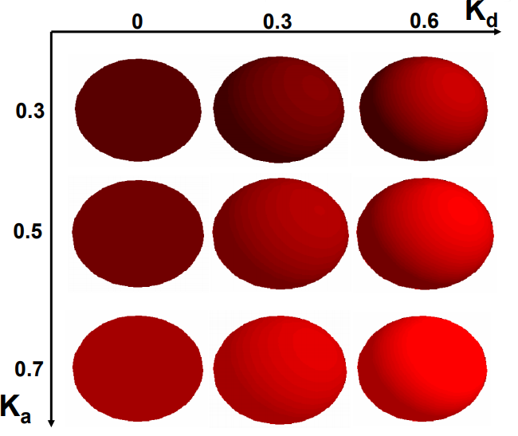
Figure 1 Diffuse reflection [9]

When applying diffuse reflection on an object, we consider the point as a differential area [10]. If a beam of light is perpendicular to the area, 100% of the light source is striking the area. When a beam of light is at an angle to the area, the cross-section of the beam is larger than the area. This means that the light covers a larger region than the shading area and so
the area gets less light photons. As the angle of the light source increases, the area gets less and fewer photons of light. If the beam of light is parallel to the area, it will receive no light at all.[10] See figure 1, where dL is the cross-section of the light source and dA is the differential area.

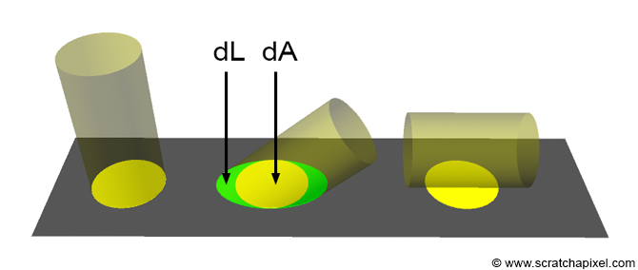
Figure 2 Comparing the angle of a light source and a point on a surface [8]

This relationship between the amount of light a surface gets, and the angle between the light source and the normal is well known in the world of computer graphics and is known as ‘Lambert's Cosine law' [10]. This can be mathematically represented using the equation $\cos{θ}=N.L$, where N is the normal this equation determines the brightness of the object. We can use Lambert’s cosine law to find the intensity of the reflection by using the equation $I=Ip*Kd*\cos{θ}$ [8]. Where N is the normal and L is the direction of the light source, these are always normalized [11]. is the intensity, Ip is the intensity of the light source, Kd is the diffuse reflection coefficient and $\cos{θ}$ being Lamberts Cosine law.
As mentioned previous, ambient lighting comes from all directions so it would make sense that it would affect the intensity. Another factor that would affect the intensity is the distance of the object from the light source. Adding these two components into the equation gives us a new equation. $I=(Ia*Ka)+((Ip*Kd)/(d))*\cos{θ}$. Where d is distance and Ia and Ka are the ambient intensity and ambient reflection coefficient respectively.

Where diffuse reflection is the reflection off of a dull surface, specular reflection is the reflection off a shiny surface. Specular reflection obeys the laws of reflection so light is reflected at a definite angle in a specific direction [12]. The equation for specular reflection is as follows $I=Ip*\cos^{n}α*W(θ)$. Where n is specular reflection exponent and W is the specular component of non-specular materials[8][13]. In figure 3 below you can see an example of specular reflection. When compared to diffuse reflection in figure 1, it shows a clear difference in the types of reflection.
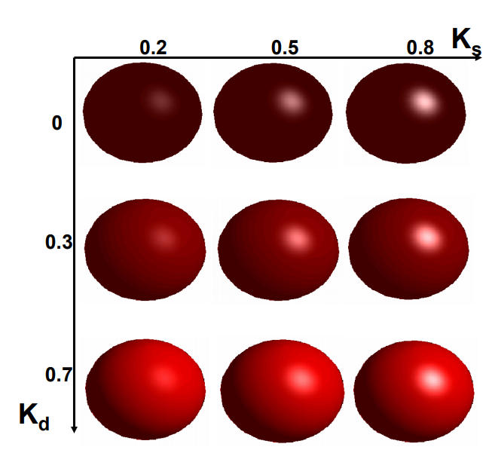
Figure 3 Specular reflection [9]
We can combine the equations of diffuse lighting, ambient lighting, and specular lighting to get a general lighting equation. $I=(Ia*Ka)+((Ip*Kd)/(d))*\cos{θ}$ + $Ip*\cos^{n}α*W(θ)$. Figure 4 below shows the result of combining ambient, diffuse and specular illuminations, from the image it is quite clear that the most realistic object is the object that has all three combined.
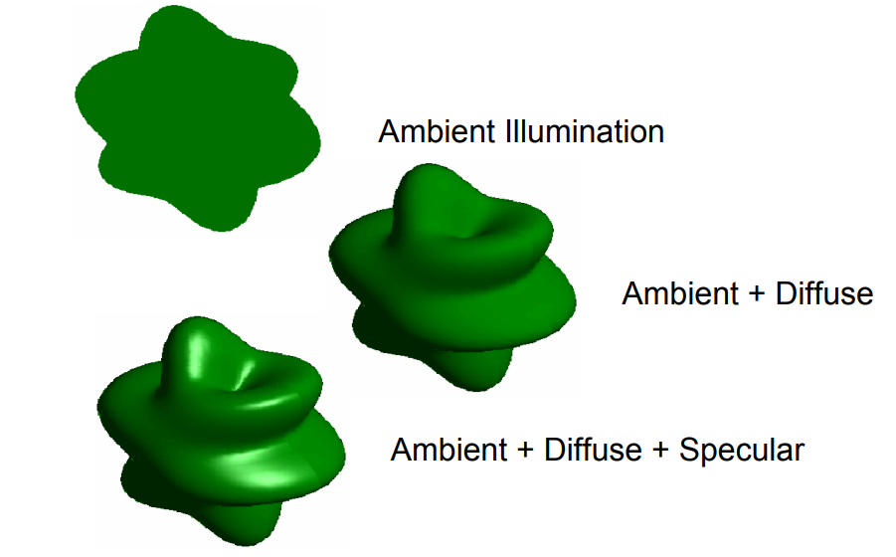
Figure 4 combination of ambient, diffuse and specular illuminations [9]

When it comes to applying shading, there are 3 commonly used techniques. Flat shading, Gouraud shading, and Phong shading. Flat shading is by far the easiest shading method and is also the least computationally expensive. When flat shading an object, each polygon is shaded entirely in a single colour. This colour is determined by the normal of the polygon, the lighting equations, and the material properties. Figure 2.1 shows an example of flat shading. As you can see, the image is very blocky and the difference in colours is very visible. It is a fast method of shading but doesn’t produce a very realistic image.
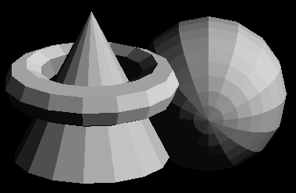
Figure 5 example of Flat shading

Gouraud shading, named after Henri Gouraud [14] is also known as intensity interpolation shading[15]. Gouraud shading will take the normal at each vertex, it will then determine a colour value for that vertex using the lighting equations. The colour value for each pixel along the edge of a polygon is determined with linear interpolation at each vertex. There is then linear interpolation across each scan line which will fill the polygon with colour [8]. Figure 6 shows a graphical representation of Gouraud shading, much unlike flat shading, the colours transition a lot more smoothly. Giving the object a more realistic appearance.
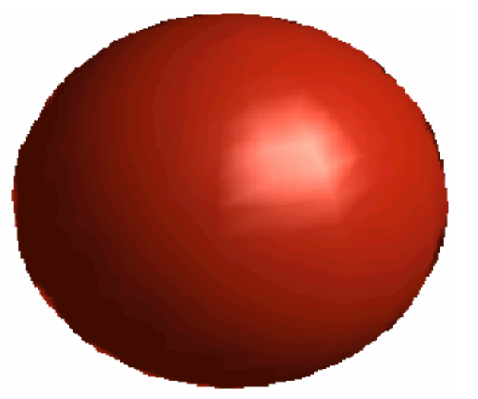
Figure 6 Gouraud shading of a sphere [9]

Phong shading is the most accurate method of shading, however, it is also the most computationally expensive to use. It works in a similar way to Gouraud shading. But instead of using normal at each vertex and interpolating colours between them, Phong shading instead interpolates the normal. Linear interpolation of normal at each vertex will provide a normal value for every pixel along the edge of the polygon. As well as linear interpolation along scan lines to get normal values for each pixel in the polygon[8]. Using the normal at each pixel we can get the colour value for the pixel. Figure 7 below shows an example of Phong shading on the same sphere as figure 6 above. As you can see from figure 7, the lighting is more accurate and shows that Phong shading is slightly smoother than Gouraud shading.

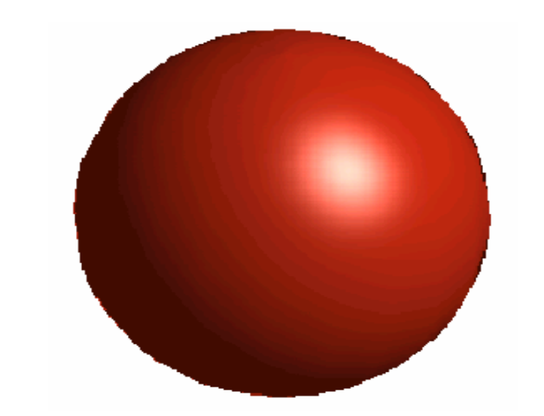
Figure 7 Phong shading of a sphere [9]

Aims and Objectives
The overall aim of this project is to create a VR environment using the PS4 development kit that will be able to load in and render a 3d model to this scene and apply different lighting and shading techniques to the object. For this goal to be achieved there are four objectives that need to be completed:
- Conduct a literature review on shading and lighting techniques and the PS4 development kit.
- Create an object loader that will load and render an object into a VR environment
- Apply different combinations of different shading and lighting techniques to the object.
- Evaluate the software and note any improvements that could be made

Conclusion
In this section of the report, we have discussed the basic idea of the project. We have also had a brief look into the current information available, as well as lay out the aims and objectives for the project.

Introduction to research and development methods
In this section, we will look at the research methodology and the development methodology. We will also consider the possible risks involved with the project and any ethical issues that may be involved with this project. Finally, we will look at analysis and deliverables

Research Methodology
Before the project can even start, there will need to be a research methodology in place. Initially, a philosophy will need to be selected. For this project, the best fit for the philosophy will be Positivism. A positivist philosophy states that only data from sensory experience and mathematical treatment of data is a source of knowledge. Positivism is all about facts, figures, and data. The other possible philosophy is phenomenology, in this philosophy, there is a concentration on the structures of experience or consciousness [16]. Positivism is pretty much a perfect fit for this project, as although the result is something that a user will experience, the development and implementation of this project will require no help from how individuals think about the project.
The next decision is the approach. There are two options to chose from when it comes to approaches and each one complements a different philosophy. The inductive approach involves creating theories and gathering data based on human experiences and opinions, this approach compliments phenomenology. The other approach, deductive, is very much the opposite of this. It is more analytical and involves creating a hypothesis and gathering data to test it. This approach seems best suited for the chosen project.
Now that the philosophy and the approach have been selected, it is time to select the three main strategies. Out of the five main strategies to choose from, there are two strategies that are obvious choices for this assignment. The first chosen strategy is the software development strategy. It is a strategy that is generally used for the chosen philosophy and approach. The strategy involves designing, developing and testing software. Considering the chosen project, this strategy was a no-brainer. Another apt choice for a strategy is the experiment strategy. Experimenting involves formal experiments to prove or disprove a research hypothesis. This project will be experimenting to prove that it is possible to render and shade a 3d object using Sony's development kit, so again this seemed like an obvious strategy to choose.
The final strategy is a little more of a difficult choice as none of the other strategies seemed like an obvious choice for this project. That being said, surveys could be easily ruled out as collecting information from a group of people isn’t required for this project. Similarly, with case studies, the project will not be comparing two objects or organisations so again this can be ruled out.
That leaves document analysis. This strategy involves collecting data from a group of documents using a designed set of research questions, this can be used in this project for researching the different lighting and shading techniques required for the project.

Development Methodology
The development methodology that has been chosen for this project is feature-driven development. It is a methodology that is used for software development process that involves iterations. It is an agile development process that revolves around quick development cycles and provides systems that are constantly developing. [17] There are five processes of FDD:
- Develop an overall Model – the goal being to create a high-level object model that is generally more shape than content. But it should address the fundamental issue of the project and over time this will be built upon to slowly shape the final product
- Build a features list – grouping them into related subject areas[18].
- Plan by feature - This step involves assigning owners to the features on the features lists.
- Design by feature – produce a design package for each feature set. This should ass more content to the object model.
- Build by feature – plan an activity for each feature and develop code.
There are several best practices for FDD including object modelling, which is the creation of high-level class diagrams. developing by feature and regular builds. This methodology is very well suited to the chosen project and that is why it has been selected as the development methodology. FDD was formed by recognising the strengths and weaknesses of humans and has shown to be a highly efficient method for complex projects.

Risks
There are quite a few risks for this project and these will need to be managed before and during the development of the project.
- Sony’s NDA – Sony’s non-disclosure agreement on the development kit means that the resources available for the project are very limited. If there was an issue with the dev kit or the software behind it, the only place to look for answers is the dev kit forums which are private and only users with authorised access to the development kits can visit them.
- Lack of access to resources - Because the dev kit is a very private system, the university only has access to a few of them, and availability of these devices cannot be guaranteed. Also, the VR systems used for testing will be in highly sought after and access to these can also not be guaranteed
- Timing – due to the nature of the project and the availability of the systems, completing the project in the allotted time. Getting tasks completed on time will be crucial to the success of the project.
- Unrealistic goals- due to the timing risks previously stated, a strict plan will need to be in place and followed. However, a new risk surfaces due to this, the risk being that some goals may be unrealistic for the allotted time
- Other deadlines – Although this project is a major part of the final year at university, there will still be other assignments that will need to be completed alongside this project. This could prove to be a big problem if time isn't managed well. Falling behind on any assignment can prove to have huge consequences as it will cause a disruption to the schedule.
The first two risks are a little bit tricky to overcome, the only solution is to book times to use the system in advance as to not cause any unexpected delays, of course, there will still be times where the systems are not available but, at that time, other vital work towards the project can be done or of coursework towards the other assignments can be done when unable to access the required resources. Timing is a risk that can be easily managed, provided effort is made to keep to a schedule. Using a Gantt chart a timeframe and plan can be made and provided it is followed there should be no timing issues. As for unrealistic goals, if all tasks are split up into smaller and more manageable tasks then there should be no issue with timing. Other deadlines are a risk that could either become the most damaging risk of them all, or it could be no issue at all. It comes back to time management if all assignments are managed correctly and there is no falling behind then there should be no risk.

Ethics
There will be no ethical issues while undertaking this project

Analysis and Deliverables
Once the system has been completed there will be several ways to evaluate the results. First and foremost, will be software testing, does the system do what it should? Are there any issues that need to be addressed? Another method that will be used is user testing. Fundamentally the system will be a VR experience so having user testing to evaluate the system seems like a good method of evaluation. There can be multiple user tests using different people to ensure that the results of the tests are similar and valid. The final method of analysis to be completed will be to compare the initial requirements of the system to the final product and compare the differences. Does the system achieve its goal?

Conclusion
In this section, we have looked at the different research methodology types and have outlined the ones that have been chosen for this project. We have also looked at the chosen development methodology. We have considered the risks of the project and looked mentioned the ethics of the project. Finally, the analysis and the deliverables of the project have been discussed.

Physical Resources
As stated prior, access to the Sony’s development kit is crucial for the completion of this project. Access to the private forums is another vital resource requires. Some of the more obvious resources needed are access to a PC, however, due to the nature of the system, a higher specification PC will be needed. Access to information about the different techniques that will be used is needed also, such as books and journal papers on the topic, these can be borrowed from the university or found in the online library provided.

Human Resources
Regarding human resources, there won’t be much needed. The only people required for this project will be the project proposer, George Thomas. The project supervisor and a few test subjects for the final product, these will be easy enough to find.

Timeline
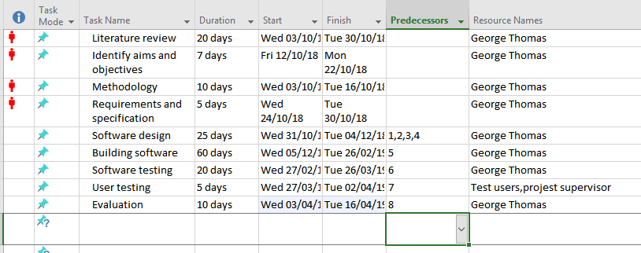
Figure 8 Gantt chart
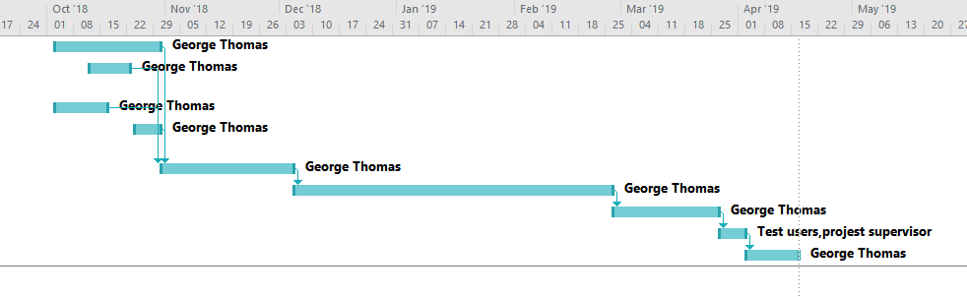
Figure 9 Gannt chart
Figures 8 and 9 above show the proposed timescale estimated for the project. They have been displayed as a Gantt chart to better represent the timescale. It is estimated that it will take roughly 42 days to complete the research stage of the project and a further 120 days for the development and the implementation of the project. As you can see from the Gantt chart, the main resource required for these tasks is the project proposer with only the user testing requiring anyone else. The plan for the time scale above seems plausible and without any unforeseen risks or problems, the project should be completed in good time.

Conclusion
In this project proposal, we have briefly looked at the current literature and research behind the fundamental ideas of the project. We have also discussed the aims and objectives of the project, as well as the different methodologies that will be used. The risks and ethicality of the project have been considered and the methods of analysis have been decided. We have investigated the physical resources and the human resources that will be required for the implementation and testing of the project. Finally, we have looked at a rough timeline of the project.

References
[1] “What is Virtual Reality? - Virtual Reality Society,” Virtual Reality Society. [Online]. Available: https://www.vrs.org.uk/virtual-reality/what-is-virtual-reality.html. [Accessed: 02-May-2018].
[2] G. Burdea and P. Coiffet, Virtual reality technology. J. Wiley-Interscience, 2003.
[3] “PSVR Review | Trusted Reviews.” [Online]. Available: http://www.trustedreviews.com/reviews/playstation-vr. [Accessed: 03-May-2018].
[4] “So how much does it cost to develop for PlayStation 4? - Polygon.” [Online]. Available: https://www.polygon.com/2013/7/24/4553842/so-how-much-does-it-cost-to-develop-for-playstation-4. [Accessed: 03-May-2018].
[5] Matthew S. Stenquist, “What programming languages are used in video consoles like the PS4 or Xbox One to develop games? - Quora.” [Online]. Available: https://www.quora.com/What-programming-languages-are-used-in-video-consoles-like-the-PS4-or-Xbox-One-to-develop-games. [Accessed: 03-May-2018].
[6] “PhyreEngineTM | SIE R&amp;D West.” [Online]. Available: http://rdwest.playstation.com/research-technology/phyreengine/. [Accessed: 03-May-2018].
[7] “Introduction to Shading (What is Shading: Light-Matter interaction).” [Online]. Available: https://www.scratchapixel.com/lessons/3d-basic-rendering/introduction-to-shading. [Accessed: 03-May-2018].
[8] “Intro to Computer Graphics: Lighting and Shading.” [Online]. Available: https://www.cs.uic.edu/~jbell/CourseNotes/ComputerGraphics/LightingAndShading.html. [Accessed: 03-May-2018].
[9] “Illumination Models and Shading.”
[10] “Introduction to Shading (Diffuse and Lambertian Shading).” [Online]. Available: https://www.scratchapixel.com/lessons/3d-basic-rendering/introduction-to-shading/diffuse-lambertian-shading. [Accessed: 03-May-2018].
[11] “Diffuse Reflection.” [Online]. Available: https://www.siggraph.org/education/materials/HyperGraph/illumin/diffuse_reflection.htm. [Accessed: 03-May-2018].
[12] “Specular Reflection - Definition,” AZoOptics. [Online]. Available: https://www.azooptics.com/Article.aspx?ArticleID=822. [Accessed: 03-May-2018].
[13] S. Y. Chen, G. J. Luo, X. Li, S. M. Ji, and B. W. Zhang, “The Specular Exponent as a Criterion for Appearance Quality Assessment of Pearllike Objects by Artificial Vision,” IEEE Trans. Ind. Electron., vol. 59, no. 8, 2012.
[14] H. Gouraud, “Computer display of curved surfaces.” 1971.
[15] “Weblet Importer.” [Online]. Available: https://www.stack.nl/~dimitri/3dsview/gouraud.html. [Accessed: 03-May-2018].
[16] Stanford University. and Center for the Study of Language and Information (U.S.), Stanford encyclopedia of philosophy. Stanford University, 1997.
[17] “Feature Driven Development: A Guide | Arrk Group.” [Online]. Available: https://www.arrkgroup.com/thought-leadership/feature-driven-development-a-guide/. [Accessed: 03-May-2018].
[18] “Feature Driven Development (FDD) and Agile Modeling.” [Online]. Available: http://agilemodeling.com/essays/fdd.htm. [Accessed: 03-May-2018].

