Prosbectws yr Ysgol School Prospectus
Leanne Marie

ECES6008
Radical Education
Ysgol Oakfield

WELCOME TO YSGOL GYNRADD OAKFIELD

Dear Parents/Carers,
Ysgol Oakfield would like to extend a warm welcome to all parents, carers, and children. This prospectus is full of information and hopes to give parents and carers an insight to what Ysgol Oakfield has to offer. Each school is unique and Ysgol Oakfield is no exception!

Ysgol Oakfield is a small, independent school with large outdoor areas and caters for children aged four to eleven years old. Class sizes go to a maximum of twenty pupils per class. It is a predominantly English-medium school which means that most teaching is done through the medium of English and Welsh is used as a second language. The use of Welsh is encouraged, we are proud of our Welsh culture and heritage. We support the Welsh Government’s ‘Cymraeg 2050’ vision which aims to see one million Welsh speakers by 2050 (Welsh Government, 2019).

All parents and carers want the best, high-quality, education for their children but they also want them to feel happy, safe and secure. We believe we can offer all these things. Our school prides itself on its happy, nurturing and inclusive environment which meets the needs of all children whilst also ensuring excellent learning outcomes and standards. Our school helps children reach their full potential, in both their learning journey and in terms of their well-being.

Children’s rights are of the highest importance at Ysgol Oakfield. Wales was the first country to make the United Nations Convention on the Rights of the Child (UNCRC) part of its domestic law (Children’s Commissioner for Wales, 2021) and the school enshrines the Seven Core Aims as set out by the Welsh Government and as part its core aims. Ysgol Oakfield strives to ensure that:

- Children have a flying start and the best possible basis for their future growth and development.
- Children have access to a comprehensive range of education, training and learning opportunities.
- Children enjoy the best possible physical and mental health.
- Children have access to play, leisure, sporting and cultural activities.
- Children are listened to and treated with respect.
- Children have a safe home and community.
- Children are not disadvantaged by poverty (Play Wales, 2021).

Parents and carers are invited to have an active role in their child’s learning and the school also extends a warm welcome to the wider community. Working in partnership is important as working together in mutual respect and support provides better outcomes for both children and the wider community. This prospectus has been produced to give parents and carers information on the school’s:

Structures – what a day here at Ysgol Oakfield looks like.
Curriculum – what children learn in our school.
Pedagogy – what teaching in our school looks like and how children learn.
Assessment – how children’s learning is assessed.
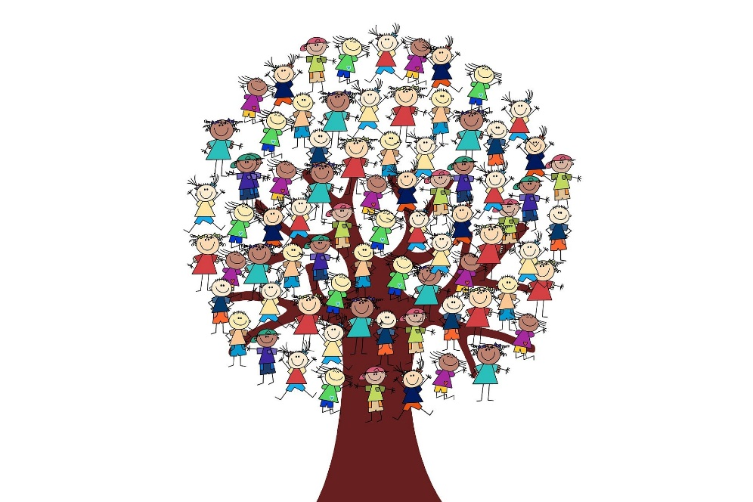

Key Terms

This section of the prospectus will define various terms to give a clear context and background knowledge to the use of language within this literature. Key terms and definitions to consider are schooling and education. The Education Act 1996 defines a school as ‘an educational institution which is outside the further education sector and the higher education sector and is an institution for providing (a) primary education, (b) secondary education, or (c) both primary and secondary education’ (The Education Act 1996, c. 56). While many associate the term ‘education’ with a school, Gobby and Millei (2017) say that education can often be confused with schooling. Schooling is a formal way of educating children in institutions such as preschools and schools. It involves teachers implementing a formal curriculum or a syllabus compromised of distinct subjects. They explain that a child can be educated without formal arrangements, such as a school, by other means such as learning from experience (Gobby and Millei, 2017).

Ysgol Oakfield defines ‘schooling’ as providing educational experiences and opportunities for children to develop and learn. The school acts as an environment which supports and nurtures children to support them in their learning journey.

Two important aspects to also consider are the principles of mainstream schooling and the role of the state in providing schooling. Mainstream schools often have similar principles in ensuring schooling is effective. Three key areas are positive climates for learning, high quality teaching and learning and community engagement in learning. To explore these areas further, some key principles will be discussed. Firstly, mainstream schools need to have a clear focus and high expectations for learners (New Visions for Public Schools, 2021). A clear focus and expectations play a large role in a school’s culture and to motivate staff, pupils and the community. An essential principle in high quality teaching and learning is meaningful assessment of pupil learning (New Visions for Public Schools, 2021). This occurs when teachers use assessment as tool to identify a pupil’s needs and provide them with the correct support to widen their learning. Partnerships with parents, carers and organisations are also a key principle. Positive partnerships with parents and carers are effective in enhancing a child’s learning as well as their well-being. Along with the partnership of organisations, schools are able to provide more opportunities and resources as well as providing better outcomes from a safeguarding and health perspective (New Visions for Public Schools, 2021). In regard to the role of the state in providing education, local authorities (previously called local education authorities) have many roles and responsibilities in school provision in Wales. Local authorities play an essential role in the financing of schools and must also secure that sufficient schools for providing primary and secondary education are available for its area (Law Wales, 2021). They must also contribute towards the spiritual moral mental and physical development of the community by ensuring that efficient education is available to meet the needs of people in the local area (Law Wales, 2021).

Ysgol Oakfield, however, is an independent school. Independent schools are not financed by local authorities, they are independent in finances and governance. Schools are governed by a board of directors that have been elected by independent means and a system of governance which ensures the independent operation (Welsh Independent Schools Council, 2021). Independent schools have freedom from standard curriculum constraints and can choose what they teach, their educational philosophy and how they teach.

Aims and Values

Ysgol Oakfield has five clear values:
- Respect – Everyone must show respect for one another including children, teachers, staff and parents. Everyone is treated as equally important as one another.
- Quality – The school aims to provide the highest quality relationships, real-life experiences, opportunities and environments. The environment is viewed as the third teacher.
- Uniqueness – We strive to continue to maintain and develop our uniqueness as a school within our philosophies and practices.
- Academic excellence – We aim to support and encourage learners’ natural curiosity and desire to learn and achieve.
- Well-being – Positive well-being and happiness is equally as important as attainment at Ysgol Oakfield. We ensure that children are in a safe, nurturing environment where they feel loved and valued.

Ysgol Oakfield aims for us all, as learners, to:
- Promote inclusion and equality of opportunity for all
- Recognise and celebrate individuals’ abilities and gifts
- Provide an ethos with a highly stimulating and motivating environment where children take responsibly for their own learning
- Respect childhood as a time to explore
- Be confident enough to ask questions and take risks
- Participate in an enriching curriculum which evolves to meet the needs of all learners
- Take pride in the school and outdoor environments
- Determine individual needs and build on existing gifts and talents
- Encourage curiosity
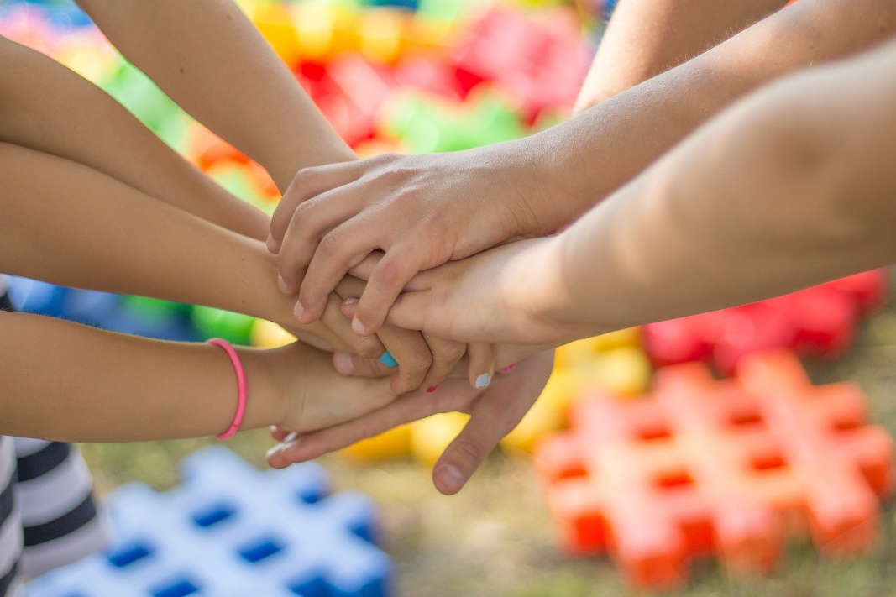

The overall philosophy and ethos of the school is inspired by Loris Malaguzzi, A.S Neill and John Holt. The school’s view on respect and freedom is promoted by all three radical educationalists. Malaguzzi saw the child as a subject of rights (Learning and Teaching Scotland, 2006), who has the right to be respected and not undermined, with Neill viewing a five-year-old child’s vote just as important as a school governors in school meetings (Summerhill, 2021). We view childhood as being a time to explore. Holt said that children are born leaders and are naturally curious (Costley, 2011) and Malaguzzi spoke of this within children’s rights as they have to the right to ‘realise and expand’ on their own potential driven by their own curiosity to make sense of the world (Learning and Teaching Scotland, 2006). All three had views which described children wanting to acquire knowledge of the world through curiosity, exploration and experiences. Aiming to derive learning from children’s interests and values is an important aim to Ysgol Oakfield. According to Neill, learning should come from interest and not compulsion. This was implemented this within Summerhill by giving children freedom to develop themselves using their own creativity (Humes, 2015). Learning and Ysgol Oakfield is based off of children’s own inquisitiveness rather than a rigid curriculum with no room for scope. Holt supported learner-driven learning (Key Line, 2009) as did Malaguzzi (Hewett, 2001). Ysgol Oakfield supports Malaguzzi, Neill and Holt’s idea that teachers should have a more passive role and therefore, teachers at our school are seen more as co-learners rather than figures with authority who are there to impart knowledge. The environment is highly valued and the outdoor environment is seen to be just as important as the indoor classroom. Children are encouraged to take pride in both spaces.

We take inspiration from these radical theorists but in respect of our own culture, values and opinions and age-appropriateness. We feel that the mixture of these ideologies along with our own make Ysgol Oakfield unique. To quote Howard Gardener:

It is a mistake to take any approach and assume like a flower you can take it from one soil and put it in another one. That never works. We have to figure out what aspects of that are most important to us and what kind of soil we need to make those aspects grow (Gardner, 2006, quoted in, Learning and Teaching Scotland, 2006, p. 23).

Underpinning Ideology

Ysgol Oakfield’s overall philosophy and ideology has been inspired by careful analysation of important, recognised, radical theorists in education. It is the philosophy and ideology that serves a reference point when creating and deciding on the school’s aims, values, school structures, curriculum, pedagogy and assessment. The school mostly is inspired by Loris Malaguzzi who created Reggio Emilia schools and A.S Neill, the founder of Summerhill School. John Holt’s views on education are also valued. However, many other theorists have influenced Ysgol Oakfield’s ideologies which will be referred to throughout this prospectus. To provide an understanding of how Ysgol Oakfield has cultivated it’s aims, values and overall ethos, this section of the prospectus will provide a brief overview of Malaguzzi, Neill and Holt’s ideas in which the school has taken inspiration from.

Loris Malaguzzi – Reggio Emilia Schools

Malaguzzi was began his teaching career in the 1940’s and dedicated his life to the education of children. He created the Reggio Emilia approach with the influences of theorists such as Piaget, Vygotsky and Montessori (Kinney and Wharton, 2008). A key element of his approach was the image of the child. The child is a subject of rights and educators should view children as individuals who have unlimited potential. They have the right to ‘realise and expand’ their potential by and are driven by curiosity (Learning and Teaching Scotland, 2006). Children’s learning should also be based on interests. Children are active constructors of their own knowledge and have the desire to learn (Hewett, 2001). Malaguzzi also saw the environment as ‘the third teacher’ and that teachers and parents are co-learners and that learning should be documented (Hewett, 2001).

A.S Neill – Summerhill School

A.S Neill is the founder of Summerhill School and was a British progressive educationist (Summerhill, 2021). He founded Summerhill School in 1942 and is the original ‘free’ school (Neill, 1960). The school was founded on Neill’s educational ideologies. Neill has faith in the goodness of the child (Aubrey and Riley, 2017) and when given freedom, will develop in creative and positive ways (Humes, 2015). However, freedom should not be confused with license, respect is a two way process (Aubrey and Riley, 2017). Neill made lessons at Summerhill optional as learning should be the stimulus of interest and not compulsion (Humes, 2015). He thought the aim of education is to find happiness and that education was about both intellectual and emotional development (Aubrey and Riley, 2017). It was in his belief that formal education and books were less important than character and self-determination (Humes, 2015) and said books were the ‘least important apparatus in education’ (Summerhill, 2021).

John Holt’s views on education

John Holt was an American teacher who tried to reform the education system. An important element to Holt’s ideologies is that children are born learners and that they are naturally curious and want to make sense of the world. He felt that adults tend to underestimate children’s ability and capacity to think, feel and interpret events (Costley, 2011). Holt wanted teachers to have a more passive role and to guide and support, rather than interfere and allow children to have more time think, learn and be creative. He believed that children learn best through real-life experiences and that their education should be driven by themselves (Key Line, 2009). In his book, ‘How Children Fail’ (Holt, 1990), Holt spoke of how children lack a desire to learn and feel unmotivated due to a prescribed curriculum and that knowledge of the world cannot be taught through abstract (Holt, 1990).

School Structures

Timetable

The morning session begins at 9.00am.

A snack is usually given around 10.30am, is it dependant on when the children want a break. Children are not made to take a break at a certain time as it disrupts their learning, they decide when they would like to do this.

Lunchtime is at 12:00pm until 1:00pm.

The afternoon session begins at 1:00pm and the day finishes at 3:00pm.

Ysgol Oakfield is open 48 weeks of the year. Without school holidays, children and teachers have the great benefit of time. Time to investigate, time to stop, to think, to enquire and to create. It gives children and teachers the opportunity to dive deeply into an integrated curriculum and means that there is no need for homework which relieves pressure at home and allows families to spend more time together. As the school is open for 48 weeks of the year, parents and carers are allowed to take children out on holidays at any time. Traditional schools often fine parents for taking children out during term time which results in expensive summer holidays but Ysgol Oakfield gives parents and carers the benefits of not having to pay increased prices during holidays.

The environment as a teacher

Ysgol Oakfield agrees with Malaguzzi’s view that the environment is the ‘third teacher’ and bases spaces around his vision. It is referred to as the third teacher due to the potential it has to inspire children (IGrow, 2020). Classrooms are bright welcoming spaces filled with natural light and are set up for open-ended play, activities and exploration. All furniture is designed to be multi-functional. For example, screens may be used for children to create shadow pictures whilst also used as a divider of two spaces (Learning and Teaching Scotland, 2006). This promotes creativity and resourceful-ness within children. Classrooms are not made up of desks and whiteboards which are set in a structured way like traditional schools, the classroom in Ysgol Oakfield is an open-ended space providing limitless opportunities which encourage independence. The organisation of space and materials is set out to ensure maximum ease of use for individual children and for group work which promote independence (Learning and Teaching Scotland, 2006). For example, art materials are placed in see-through containers so that children can find resources themselves. Classrooms are not painted in bright colours with displays done by teachers, instead, children’s art work hangs on the light walls next to wall-size windows which integrates to integrate the outdoor environment. It is in this way that children are able to contribute colour themselves through their artwork and belongings rather than set displays (Learning and Teaching Scotland, 2006). By doing so, all classrooms and unique and personalised, individuality is encouraged and children feel that their contributions are valued. The environment is fluid and changes frequently to accommodate children’s interests and projects.

The outdoor environment is very valuable to learning at Ysgol Oakfield. The indoor and outdoor environment integrate and link together as school as place of learning and exploration cannot be is not a single place, i.e., the indoor classroom. The outdoors is used as a learning space, the same as an indoor classroom is. Important learning takes place outside and there is not a clear line which separates indoor and outdoor learning (Summerhill, 2020). The outdoors enables children to have memorable and stimulating experiences whilst instilling excitement and motivation to learn whilst also improving children’s well-being (Harris, 2018).

Curriculum

Ysgol Oakfield has eight areas of learning. These are:
- Mathematical Development
- Literacy Development
- Digital Competence Development
- Physical Development
- Science Development
- Human and Social Development
- Creative and Aesthetic Development
- Spiritual, Social, Cultural and Moral awareness

As Ysgol Oakfield is an independent school, we do not have to follow the national curriculum. Our unique curriculum is one that originates from the child and is negotiated between the children, teachers and parents. The best way to describe our curriculum is using a quote by Carla Rinaldi – ‘This is not a free journey but neither is it a journey of rigid timetables and schedules; rather, it is akin to a journey guided by a compass’ (Rinaldi, quoted in, Learning and Teaching Scotland, 2006, p, 15). Rinaldi said this in the context of ‘Progettazione’ which is what Reggio Emilia schools follow. As a unique school, our curriculum is a blend of Progettazione, Neill and Holt’s views and the Welsh Governments guidance and framework. We aim for independent, ambitious and inquisitive learners who develop valuable skills to use in adult life. Ysgol Oakfield has various areas of learning and development. Literacy, numeracy and digital competence are important areas of learning. They can be taught as distinct, separate lessons and within a cross-curricular way. Cross curricular learning is important in children’s learning. Dewey believed that there was ‘no benefit in creating a false opposition between subjects’ (Rowley and Cooper, 2009, p.1). Relevant to Dewey’s belief, the Welsh Government have said:

The cross-curricular responsibilities of literacy, numeracy and digital competence support almost all learning and are essential for learners to be able to participate successfully and confidently in the modern world. Literacy, numeracy and digital competence need to be considered as part of school-level curriculum design across all areas of learning and experience (Welsh Government, 2019, p. 11).

Whilst literacy, numeracy and digital competence are essential, creative and aesthetic development is treated as equally as important at Ysgol Oakfield. Children are encouraged to take part in a number of expressive arts within creative and aesthetic development including sculpture, dramatic play, dancing, painting, ceramics, shadow play, puppetry and music. The importance placed on the expressive arts has been researched by Howard Gardner who is an American psychologist who has worked closely with Reggio Emilia schools where the expressive arts play a large role in education. They believe expressive arts important as they allow children to express themselves in different ways, focusing too much on literacy and numeracy skills can de-value children’s gifts and abilities and it can give children the ability to view the world in different ways (Learning and Teaching Scotland, 2006). A.S Neill was also a large advocate of creative and aesthetic development as he saw expressive arts as having a therapeutic function (Hobson, 2016). Which can be seen today as the arts are often used for therapeutic purposes. He also believed it gave less-academically children the chance to excel at other things (Hobson, 2016). At Ysgol Oakfield, we celebrate all forms of success, through academia, gifts and abilities.

Topics are dependent on children’s interests at Ysgol Oakfield. Every two weeks (or when the children feel they want to learn something new), the teacher will sit down with the children and ask what they would like to learn. Or, topics will arise from children showing natural interest. We take participation very seriously as Ysgol Oakfield. Teachers use Hart’s ‘Ladder of Participation’ to ensure that we are reaching the highest levels – child initiated and directed and child-initiated shared decisions with adults (Dunhill, Elliott and Shaw, 2010). Many schools say that children are active participants in choosing themes and topics but it is tokenism. UNICEF (1992) say that ‘tokenism is used to describe those instances in which children are apparently given a voice, but in fact have little or no choice’ (UNICEF, 1992, p. 9).

Pedagogy

At Ysgol Oakfield, we use various pedagogical approaches to inspire children to be curious, discover, explore and make meaningful connections between different areas of learning and development to become ambitious, independent, successful learners. Below are two approaches that the school uses.

Learning through real-life experiences and discovery

Learning through real life experiences is essential for children’s development and Ysgol Oakfield aims to deliver this type of learning as much as possible. This type of learning is often known as ‘active’ learning and is implemented through the form of hands-on, concrete experiences which allow children to explore and discover. Many theorists recognised the importance of this pedagogical approach such as Frobel, Vygotsky, Piaget, Kolb and Dewey (Kolb and Kolb, 2013). Dewey, in particular, said that children’s education should be based around real-life experiences and that experimentation and independent thinking are aspects that should be encouraged (Pound, 2006). Furthermore, Dewey recommended that children have plenty of opportunities to engage in which increase their knowledge and understanding of the world (Pound, 2006). As a school in Wales, Ysgol Oakfield values the Welsh Governments guidance and frameworks, who particularly also advocate experiential learning. The Foundation Phase’s (2015) ideology is essentially based around active learning. The Welsh Government (2015) state that ‘children learn through first-hand experiences’ and ‘first-hand experiences allow children to develop an understanding of themselves and the world they live in’ (Welsh Government, 2015, p. 3). They also go on to state ‘Indoor and outdoor environments that are fun, exciting, stimulating and safe promote children’s development and natural curiosity to explore and learn through first-hand experiences’ (Welsh Government, 2015, p. 3). Holt criticised traditional schools for not giving children enough time to experiment (Costley, 2011) and said that formal schooling destroys the natural love and desire to learn (Holt, 1990) as he thought that too much emphasis was given to seeking the ‘right’ answers (Costley, 2011). As Ysgol Oakfield uses projects as a pedagogical approach, which will be explained next, and is open 48 weeks of the year, children are given limitless time. There are no time constraints on rushing areas of learning or to finish projects and with. This allows children to revisit different topics throughout the year which enables plenty of discovery and exploration time. At our school, we recognise the importance of the learning process rather than the end project therefore children are not pressured to quickly find the ‘right’ answers.

Project work

Project work is a pedagogical approach used by Ysgol Oakfield and is how a lot of learning and teaching is carried out. Dewey is often linked to project work approaches within education. Dewey stressed that children learn through doing, through real-life experiences and that they should develop their own interests (Pound, 2006). Projects may last for days or several weeks, some may be short-term and some may be long-term. Due to this flexibility, children can revisit projects throughout the year. Children are seen as researchers and through projects children have opportunities to discover, question, discuss, come up with hypotheses and verify thoughts (Hewett, 2001). Teachers will seek underlying or overarching ideas that they have observed within children’s play and inquiry as a basis for projects. Within project work, teachers follow the children’s lead and direction of the project and aim to guide, facilitate and support children as opposed to interfering. Teachers do not make pre-determined plans for projects but plan for possibilities. They will reflect, explore, research plan possible ways to extend projects by the means of educational visits and materials and then take these back to the classroom for investigation (Edwards, Gandidi and Foreman, 1998). The children often compare and analyse photographs, drawing, information and previous conversations to determine the direction of their projects (Gigi, 2008). Children’s individual interests can be developed into group experiences and projects and children are invited to join projects if they are interested in co-researching similar learning interests. Dewey and Vygotksy both emphasised the important of group work and collaborative learning, (Pound, 2006). Vygotksy found within his research that when children were set tasks on their own, ‘they rarely did as well when they were working in collaboration with a peer’ (Welsh Government, 2010, p. 6). The engagement enables children to refine thinking, Conclusions within his research, along with contributions from other theorists, is that nearly eighty percent of what children learn is learnt from each other and collaborative work ensures better outcomes for all (Welsh Government, 2010).

Here is an example of a project at Ysgol Oakfield. The children recently showed interest in plants and from this stemmed multiple learning opportunities and experiences such as:
- Researching different kinds of plants
- Growing plants
- Comparing indoor and outdoor plants
- Comparing plants growing in different climates
- Outdoor educational visits
- Researching what plants need to grow
- Examination of photosynthesis of indoor and outdoor plants
- Making leaf prints with leaves gathered from outside
- Germinating beans and lentils in pots
- Making plants out of playdough (Arseven, 2014).

Assessment

At Ysgol Oakfield, we do not use tests or examinations as forms of assessment. We recognise the important of the learning process, not the outcome assessed through the form of a test. We use alternative methods formed from research, previous practice and key theorist ideas which suit our pedagogical approaches. The methods in which we use will be explained below.

Kolb’s Experiential Learning Cycle

Kolb defines learning as ‘the process whereby knowledge is created through the transformation of experience’ (Kolb, 1984, p. 41, quoted in, Kolb and Kolb, 2013, p.7). He created an experiential learning cycle which can be used for assessment. The four pillars in his theory are ‘concrete experience’, ‘reflective observation’, ‘abstract conceptualisation’ and ‘active experimentation’ (Kolb and Kolb, 2013). To explain this method through the implementation of an activity, growing vegetables will be used as an example. Planting the vegetable seeds would be the concrete activity and children speaking to one another about how the planting went and predicting how they think the vegetable may grow would be the reflective observation. Comparing and analysing how each of the children’s vegetable had turned out would be the abstract conceptualisation and trying to grow different types of things such as flowers and plants would be the active experimentation. Teachers use a template designed by Ysgol Oakfield to assess children’s learning based on what they have seen using Kolb’s method.

Learning experience | What happened
Concrete experience – the activity
Reflective observation – sharing thoughts, processing
Abstract conceptualisation – reflecting on the experience
Active experimentation – testing, applying what was learnt
An example of an observational template used by teachers to assess learning.

Scaffolding using Vygotsky’s Zone of Proximal Development (ZPD)

After teachers observe children’s learning, they aim to build on the child’s prior knowledge by identifying gaps in knowledge and supporting them to progress in their learning. This is often known as ‘Scaffolding’ which derives from Vygotsky’s Zone of Proximal Development (ZPD). The Zone of Proximal Development is the gap between what children can achieve without support and what they can achieve with support (Welsh Government, 2008). The ZPD is not a permenant state, it is a stage towards children being able to do something independently (Welsh Government, 2010). Vygotsky said that ‘what a child can achieve with assistance today, a child will be able to achieve independently tomorrow’ (Welsh Government, 2008, p. 30). The key to using ZPD to assess learners is to identify what their ZPD is (Welsh Government, 2010). Temporary support is provided to children and then when the child is able to achieve the skill independently, the temporary support is taken away (Chaucer School, 2021). Vygotsky emphasised teachers matching learning activities to the child’s level of development and encouraging progression in children’s thinking (Welsh Government, 2008).

Conclusion

To conclude this prospectus, we believe Ysgol Oakfield offers a truly unique schooling experience and approach which has been formulated with children at the centre to provide them with the best possible outcomes. The school has taken inspiration from theorists and radical figures in education who are widely recognised in education today such as Malaguzzi, Holt, Dewey and Vygotsky. By drawing on these different ideologies and approaches, Ysgol Oakfield has created an educational experience which differs from traditional schooling’s criticisms. Traditional schooling has been criticised for destroying children’s natural love for learning and not allowing for enough independent thought, discovery and creativity (Holt, 1990). Ysgol Oakfield has aimed to ensure that children who attend the school develop into inquisitive, confident learners as we recognise the importance of allowing children to be researchers and respect that childhood is a time to explore through first-hand experiences as advocated by theorists such as Dewey and Kolb. All children are individuals and different, therefore the school does not believe that a standard national curriculum meets the needs of all learners. By allowing children to be leaders in their learning, embracing uniqueness and valuing the expressive arts, children are able to feel truly valued and respected. Happiness and well-being is just as important as academic success at Ysgol Oakfield and we aim to ensure children are able to thrive in a positive environment. Research has found that settings who use child centred approach and use the outdoors as a learning environment promote children’s holistic development and well-being (Harris, 2018) as well as social skills and behaviour (Pickering, 2018). In later life, children who have grown in these educational settings had higher self-confidence and higher production levels (Arseven, 2014).


Reference list

Arseven, A. (2014) ‘The Reggio Emilia approach and curriculum development process’, International Journal of Academic Research, 6(1), pp. 166-171.

Aubrey, K. and Riley, A. (2017) Understanding and Using Educational Theories. London: SAGE.

Chaucer School (2021) Effective Scaffolding. Available at: http://www.chaucer.sheffield.sch.uk/images/schoolimprovement/tla/scaffolding.pdf (Accessed: 24 March 2021).

Children’s Commissioner for Wales (2021) Children’s rights. Available at: https://www.childcomwales.org.uk/uncrc-childrens-rights/#:~:text=In%202011%20Wales%20became%20the,this%20ground%2Dbreaking%20measure%20here. (Accessed: 6 March 2021).

Costley, K. (2011) Holt’s Theories in the 1970’s Ironically Become Predictions for the Next Century. Arkansas: Arkansas Tech University.

Dunhill, A. and Elliott, B. and Shaw, B. (2010) Effective Communication and Engagement with Children and Young People, Their Families and Carers. Exeter: Learning Matters.

Edwards, C. and Ganini, L. and Foreman, G. (1998) The Hundred Languages of Children: The Reggio Emilia Approach Advanced Reflections. New York: Ablex Publishing Company.
Gigi, S-Y. (2008) ‘Documentation: Ideas and Applications from the Reggio Emilia Approach’, Teaching Artist Journal, 6(2), pp. 126-134.

Gobby, B. and Millei, Z. (2017) Schooling, It’s History and Power. Perth: Curtin University.

Harris, F. (2018) ‘Outdoor learning spaces: The case of forest school.’, Area, 50(2), pp. 222-232.

Harris, F. (2018) ‘Outdoor learning spaces: The case of the forest school.’, Area, 50(2), pp. 222-232.

Hewett, V. (2001) ‘Examining the Reggio Emilia Approach to Early Education’, Early Childhood Education Journal, 29(2), pp. 95-100.

Hobson, P. (2016) ‘A.S Neill’, in Palmer, J. (ed.) The Routledge Encyclopaedia of Inspirational Thinkers. London: Routledge.

Holt, J. (1990) How Children Fail. Harmondsworth: Penguin.

Humes, W. (2015) ‘A.S Neill and Scotland: attitudes, omissions and influences’, Scottish Educational Review, 47(1), pp. 66-85.

iGrow (2020) Nursery School 2020 Prospectus. Available at: http://igrownurseryschool.co.za/wp-content/uploads/2019/09/iGrow-prospective-parent-document-2020.pdf (19 (Accessed: 19 March 2021).
Key Line (2009) Teaching and Learning Theoretical Perspectives. Available at: https://resources.hwb.wales.gov.uk/VTC/2008-09/key_skills/disc1/KEYLIN/KEYLIN10.pdf (Accessed: 23 March 2021).

Kinney, L. and Wharton, P. (2008) An Encounter with Reggio Emilia. Oxon: Routledge.

Kolb, D. and Kolb, A. (2013) The Kolb Learning Style Inventory 4.0: Guide to Theory, Psychometrics, Research & Applications. Available at: https://www.researchgate.net/profile/David_Kolb/publication/303446688_The_Kolb_Learning_Style_Inventory_40_Guide_to_Theory_Psychometrics_Research_Applications/links/57437c4c08ae9f741b3a1a58/The-Kolb-Learning-Style-Inventory-40-Guide-to-Theory-Psychometrics-Research-Applications.pdf (Accessed: 24 March 2021).

Law Wales (2021) Local Authority Role. Available at: https://law.gov.wales/publicservices/education/school-and-other-education-for-children/Schools-maintained-by-local-authorities/local-auth-role/?lang=en#/publicservices/education/school-and-other-education-for-children/Schools-maintained-by-local-authorities/local-auth-role/?tab=overview&lang=en (Accessed: 18 March 2021).

Learning and Teaching Scotland (2006) The Reggio Emilia Approach to Early Years Education. Available at: http://igrownurseryschool.co.za/wp-content/uploads/2019/09/iGrow-prospective-parent-document-2020.pdf (Accessed: 19 March 2021).

Neill, A.S. (1960) Summerhill: A Radical Approach to Child Rearing. New York: Hart Publishing Company.
New Visions for Public Schools (2021) 10 Principles of Effective Schools. Available at: https://www.newvisions.org/page/-/Prelaunch%20files/PDFs/10%20Principals%20of%20Effective%20Schools.pdf (Accessed: 6 March 2021).

Pickering, S. (2018) ‘The value of outdoor learning’ in Cremin, T. and Burnett, C. (eds.) Learning to teach in the primary school. 4th ed. London: Routledge.

Pound, L. (2006) How Children Learn. London: Practical Pre-School Books.

Rowley, C. and Cooper, H. (2009) ‘Cross-curricular learning and the development of learning’, in, Rowley, C. and Cooper, H. (eds) Cross-curricular Approaches to Teaching and Learning. London: SAGE.

Summerhill (2020) About Summerhill. Available at: http://www.summerhillschool.co.uk/about.php (Accessed: 19 March 2021).

Summerhill (2021) A.S NEILL. Available at: http://www.summerhillschool.co.uk/asneill.php (Accessed: 23 March 2021).

Summerhill (2021) Summerhill Policy Statements. Available at: http://www.summerhillschool.co.uk/summerhill-policy-statement.php (Accessed: 23 March 2021).

The Education Act 1996, c. 56. Available at: https://www.legislation.gov.uk/ukpga/1996/56/section/4 (Accessed: 4 March 2021).

UNICEF (1992) Children’s Participation. Available at: https://www.unicef-irc.org/publications/pdf/childrens_participation.pdf (Accessed: 23 March 2021).

Welsh Government (2008) Learning and Teach Pedagogy. Available at: https://hwb.gov.wales/api/storage/8f0b360f-f1f6-4bec-b11a-df88168007f9/learning-and-teaching-pedagogy.pdf (Accessed: 24 March 2021).

Welsh Government (2010) How to develop thinking and assessment for learning in the classroom. Available at: https://hwb.gov.wales/api/storage/663d00fd-9c3b-4003-9a1f-0012bad39fad/how-to-develop-thinking-and-assessment-for-learning-in-the-classroom.pdf (Accessed: 24 March 2021).

Welsh Government (2015) Foundation Phase Framework. Available at: https://hwb.gov.wales/storage/d5d8e39c-b534-40cb-a3f5-7e2e126d8077/foundationphase-framework.pdf (Accessed: 24 March 2021).

Welsh Government (2019) Cymraeg 2050: a million Welsh speakers. Available at: https://gov.wales/sites/default/files/publications/2020-04/cymraeg-2050-a-million-welsh-speakers-action-plan-2019-to-2020.pdf (Accessed: 6 March 2021).

Welsh Government (2019) Draft Curriculum for Wales 2022: A guide to Curriculum for Wales. Available at: https://s3-eu-west-1.amazonaws.com/hwb-live-storage/cd/b4/f8/7c/b7d34ffb968d9a09de4d460c/a-guide-to-curriculum-for-wales-2022.pdf (Accessed: 23 March 2021).

Welsh Independent Schools Council (2021) Introduction to Independent Schools Council. Available at: https://www.welshisc.co.uk/ (Accessed: 18 March 2021).

