

Module Name: Data Security, Governance and Compliance
Module Code: ACCA7028
Programme: MSc Cybersecurity and Digital Forensics
Assignment Title: Apply the principles and practices of Data security, Governance and Compliance based on a given scenario
Level: 7 Assessment
Student Name: Nirav Thummar
Student ID Number:2537379
Lecturer: Dr Ayman El Hajjar

Table of Contents
1.0 Abstract 3
2.0 Introduction 3
2.1 Background and Contextual Analysis 3
2.2 Statement of Architectural Assumption 4
3.0 Critical Evaluation of Information Security Frameworks and Models 5
3.1 ISO/IEC 27000 Series (ISMS) 5
3.2 NIST Cybersecurity Framework (CSF) 5
3.3 COBIT 2019 6
3.4 ITIL 4 6
3.5 Center for Internet Security (CIS) Controls 6
3.6 Comparative Analysis and Strategic Synthesis 7
4.0 Designing an Approach to Information Security and Governance 7
4.1 Enterprise Governance and Strategic Planning 7
4.2 Legal Compliance, Ethics, and Data Privacy 9
4.3 Quantitative and Qualitative Risk Management 9
4.4. Security Policy and Procedures Development 10
4.5 Protection Mechanisms: Implementing Zero Trust Architecture (ZTA) 11
4.6 Third-Party Vendor and SLA Management 12
4.7 Contingency, Incident Response, and Business Continuity 13
5.0 The Necessity for Continuous Updates in Security Standards 14
5.1 Emerging Technologies (AI, IoT, and Edge Computing) 14
5.2 Asymmetric and Evolving Threat Landscapes 15
5.3 Navigating Dynamic Global Compliance and Data Sovereignty Demands 15
6.0 Conclusion 16
7.0 References List 17

1.0 Abstract
This document sets out the vital analysed, the suggested Level 7 security, governance and compliance plan for AeroLink Logistics (ALL), a globally-driven global supply chain concern. The program set will tackle the current breaches of client PII plus transport documents ensuing due to enhanced attack surface within the ALL organisation. The rapid nature of digital growth within ALL-marked by its 88% dependence on outsourcing both IaaS and SaaS-based solutions, the proliferation of IoT sensors and unmanaged remote endpoints spanning multiple time zones-has led to a massive increase in their attack surface. This report will critically assess industry-recognized best practices, such as ISO/IEC 27001, NIST Cybersecurity Framework, COBIT 2019, ITIL 4, and CIS Controls, and propose a hybrid approach combining defence-in-depth architecture that instantiates a formally governed structure via RACI matrices, Zero Trust Architecture (ZTA) protection for all endpoints, and stringent third-party risk management processes. The strategy will include a critical assessment of the ongoing need to update security regulations and internal policies so as to combat any imbalances arising from technological advances, as well as evolving regulatory and industry best practices on the global stage.

2.0 Introduction

2.1 Background and Contextual Analysis
AeroLink Logistics (ALL) is a multinational supply-chain company operating internationally with real-time tracking, warehousing and distribution capabilities enabled by interlocking digital ecosystems [15]. ALL implemented aggressive digital transformation to remain competitive. Multi-tenant cloud infrastructure fleet sensors and AI powered analytics are the basis of this scaling [10].
This rapid adoption occurred at the expense of enterprise security governance [5]. Remote operations allowing employees, suppliers, and 3PL partners to access applications on unmanaged devices eliminated ALL's network perimeter [4]. This gap is compounded by the decision taken at the executive level to outsource approximately 88% of ALL's underlying IT infrastructure to the cloud [12]. This reliance on IaaS and SaaS public cloud providers has left ALL with shared accountability, limited visibility and control over corporate and client data [17].
These insecurities were evident by the multitude of crippling data breaches [14] to ALL, leaking not only business shipping information, to be exploited in either Industrial espionage, or physical theft of cargo [8]. But also, client PII, leading to a considerable reduction in funds from regulatory fines, and reputational damage and a mistrust from our customers. Diagnostic tests have found lack of inter-departmental communication, ambiguit of duties amongst vendor contracts, varied encryption protocols and the outright non-existence of compliance audits against international best practices and/or standards. Such as ISO/IEC 27001 (1). To address all these risks and meet regulatory requirements and for its IT infrastructure, an enterprise-wide information security and governance strategy must be developed.

2.2 Statement of Architectural Assumption
The following assumptions have been stipulated to design realistic and feasible security architecture given ALL’s operating context and its regulatory and business constraints, the following has been stipulated as the set of assumptions.
• Regulatory Landscape:
Due to multinational operations and cross-border processing of customer PII by ALL, the organization is required to comply with several mandated data protection legal requirements including the EU and UK GDPR [8], CCPA, and growing data localization laws in various nations across the APAC region.
• Infrastructure Landscape:
The vast majority (88%) of its IT is an external, multi-tenant public cloud deployment [12]. 12% of the IT infrastructure remains on-premises as legacy systems that require a seamless and secure hybrid encrypted connection to the cloud platform.
• Executive Sponsorship and Resources:
Cybersecurity has been identified by the Board of Directors as the leading risk from an ERM standpoint after recent breaches. The Board has therefore allocated CAPEX and OPEX resources towards remediation in technical domains and corporate governance framework.
• Existing security maturity:
ALL’s enterprise-level security maturity stands at level 1(Initial) as defined by CMMI’s Capability Maturity Model Integration framework [5], with the core properties such as unstructured processes, disparate controls, siloed ownership of responsibilities, and ad hoc handling of incidents.

3.0 Critical Evaluation of Information Security Frameworks and Models
No single information security framework in isolation will meet the organizational, technical, or operational needs of a contemporary enterprise heavily reliant upon cloud technologies. Enterprises will therefore need to synthesize multiple frameworks to provide a robust security posture. A critical evaluation of prevalent security frameworks is provided below to build a foundational architecture for ALL.

3.1 ISO/IEC 27000 Series (ISMS)
The ISO/IEC 27000 series, centered upon the certifiable ISO/IEC 27001 standard, defines "how a framework shall be established, implemented, maintained, and continually improved for information security management." [1].
- Pros: Provides an international standard against which the security framework of an organization may be independently assessed. Formal certification provides a business-level security trust factor, crucial after multiple failures such as supply-chain breaches that have caused adverse client impacts [11]. Uses a risk-based approach in conjunction with the PDCA model and the ISO/IEC 27005 risk assessment guideline, which builds a systematic risk assessment strategy that is missing in ALL [1].
- Cons: A significant burden of documentation will be created, and the framework becomes administratively difficult to manage [11]. If implemented without tailoring to the operational realities, the documentation process will impede ALL's dynamic supply-chain scheduling and its analytical capabilities through AI [10]. While ISO/IEC 27001 defines control objectives for system security, it cannot provide detailed configuration specifics to implement robust defenses for edge devices or cloud tenants [12].

3.2 NIST Cybersecurity Framework (CSF)
The NIST CSF presents its own organization of security actions around five defined functions: Identify, Protect, Detect, Respond, and Recover [3].
- Pros: Provides taxonomy that can correlate and align its technological security operation actions with business-level corporate governance directives [3]. The 'Respond' and 'Recover' functions within its operational guidelines directly correspond to the gaps highlighted in section 2.1 [3]. Due to its outcome-focused nature, it enables a smooth integration among disparate business units [3].
- Cons: It is not a certifiable scheme but rather provides voluntary guidance for security actions. While it directly enhances operational resilience, the absence of a certification scheme means that direct third-party compliance testing, required by some global security authorities, cannot be verified through its own structure [8].

3.3 COBIT 2019
The COBIT 2019 framework defines Enterprise Governance of IT (EGIT) and presents a clear and well-defined scope differentiating between Governance (evaluate, direct and monitor by Board of Directors) and Management (plan, build, run and monitor by top management) [5].
- Pros: The lack of well-defined governance or a clearly defined accountable entity within ALL’s operational structure remains the most serious vulnerability. The COBIT 2019 governance framework addresses this by describing various levels of governance components along with their design factors and specifying RACI charts [5]. Ensures security goals align with business goals and are not simply isolated functions of IT departments [5].
- Cons: COBIT 2019 operates at an IT governance level, giving little in the way of specific details concerning the technical elements like encryption protocols, network micro-segmentation, or endpoint defenses [4].

3.4 ITIL 4
ITIL 4 is a service management framework which follows a service value system to deliver value to the customer [6].
- Pros: As 88% of ALL's infrastructure is outsourced [15], ITIL practices, including Service Supplier and Level Management, help control vendor cloud environments and enforce SLAs [6].
- Cons: It focuses on service delivery and operations, as is implied by its name. While including a specific practice of incident management, it lacks threat modelling, cryptographic procedures, and proactive offensive cybersecurity practices necessary for defenses against threats [3].

3.5 Center for Internet Security (CIS) Controls
The CIS controls provide prescriptive, prioritized lists of actions designed to mitigate the most widespread cyberattacks [7].
- Pros: These are clearly prescriptive technological definitions of security controls [7]. Basic security controls like CIS control 1 (Inventory and Control of Enterprise Assets) and CIS control 3 (Data Protection) would help to remove the unknown around ALL’s fleet of uncontrolled remote endpoints and unencrypted data stores and address urgent technical needs [7].
- Cons: They are focused on technology rather than the higher-level organizational and legal/compliance aspects [1].

3.6 Comparative Analysis and Strategic Synthesis
The dependency on one architectural and operative framework also creates inherent limitations. ALL needs to design a hybrid security architecture where the strengths of each model will complement each other: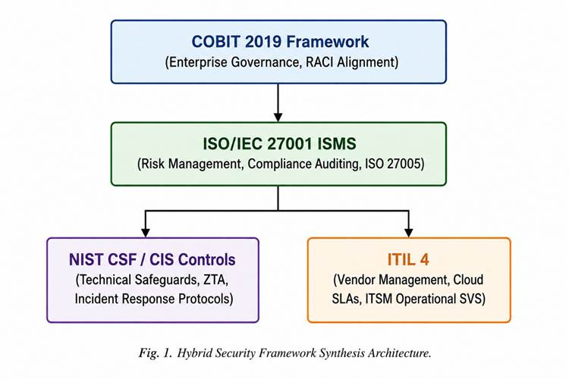

4.0 Designing an Approach to Information Security and Governance
From this hybrid approach, we present structured approach or blueprint for operational security at AeroLink Logistics.

4.1 Enterprise Governance and Strategic Planning
In an effort to reduce departmental siloing and non-compliance we recommend the implementation of a dedicated governance unit for information security within ALL [5].
- Information Security Steering Committee (ISSC).
A dedicated ISSC will be established and headed by the Chief Information Security Officer (CISO). The membership of the committee will consist of: Chief Operating Officer (COO), Data Protection Officer (DPO), Head of Supply Chain Operations, and General Counsel. Regular, monthly ISSC meetings will assist with corporate-strategy changes, define risk tolerance levels and sign enterprise-wide policy decisions [5].
- Formalization of roles (COBIT RACI matrix)
It will implement an operational framework based on a COBIT-level RACI matrix [5]:

Governance Activity | CISO | DPO | Cloud Vendors | Remote Employees | ISSC
Information Security Strategy | A | C | I | I | R
GDPR Data Privacy Compliance | C | A / R | C | I | I
IaaS/SaaS Technical Controls | A | I | R | I | I
Endpoint & Device Security Policy | A | C | I | R | I
Security Incident Escalation | A | C | R | R | I

TABLE I: COBIT-ALIGNED RACI MATRIX FOR SECURITY GOVERNANCE
(Key: R = Responsible for execution; A = Accountable for outcome; C = Consulted; I = Informed)

- Strategic Business Alignment:
The implemented security controls will be embedded in fundamental logistics processes [5]. The protection of the real-time shipment tracking data and that the systems will be up and accessible ensures that data integrity is maintained, enabling continuous operations and SLA compliance.

4.2 Legal Compliance, Ethics, and Data Privacy
Failure to adequately protect customer PII will expose ALL to legal penalties and fines under Article 83 of the GDPR, as well as business bans and ongoing operational restrictions [8].
- Data Protection Impact Assessments (DPIAs):
All large-scale PII processing will be subject to mandatory, regular DPIA assessments in accordance with GDPR article 35[8] assessment: purpose of processing, lawful grounds, data domiciliation and transfer within, out and across boundaries of [the state, city or country etc.] etc, including encryption [8].
- Designation of a Data Protection Officer (DPO):
A free data protection officer will be put in place and will be in charge of the Data Protection activity [8], the main communication channel with regulatory bodies (i.e. The Information Commissioner’s Office (ICO) [8]), the data protection audits at regular intervals [8], the management of access requests by customers/third parties for data held (subject matter expert).
- Ethical AI Governance:
The analytics engine that performs route optimisation and prediction [10] has the strictest privacy limitations placed on it. Raw client PII will not be ingested by the machine learning model, and data streams to the analytics engine will undergo anonymization & differential privacy so that any unintended exposures, whether explicit in nature or resulting from unintended algorithmic biases are mitigated, as detailed in [10] for an understanding of why differential privacy is essential.

4.3 Quantitative and Qualitative Risk Management
ALL risk management activities will shift from incident-focused, backward-looking response to a more forward-looking Risk Management Framework grounded on ISO/IEC27005 [1].

- Asset Cataloguing:
Any physical and digital asset (cloud-based databases, containerized IoT sensors, containerized gateways, remote endpoints, etc.) will be registered into a common Configuration Management Database [6], [7].
- Risk Evaluation Methodology:
We propose a Risk Identification approach that measures Likelihood against Business Impact in the following matrix [1]:

Risk Score = Likelihood (1 - 5) * Impact (1 - 5)

For example, an unsecured remote device (Likelihood=4, Impact=5) yields a Risk Score of 20, deemed unacceptable and requiring immediate remediation [1]:

- Third-Party Risk Management (TPRM):
Due to the fact that 88% of its IT function is outsourced [12] and, ALL will implement a TPRM, in collaboration with IT [12] and a set of required controls for Vendors including: annual review of their type 2 certifications, required ISO/IEC 27001 Certification and regular third-party vulnerability scans and reporting as part of contractually binding requirements [1].

4.4. Security Policy and Procedures Development
Formalization of these requirements The policy hierarchy to implement these needs will be established by the Proposed policy [11].
- Information Security Policy (ISP):
The overarching policy that comes down from the Board of Directors; specifies our desired security stance, compliance needs and the repercussions for violations[5].
- Bring Your Own Device (BYOD) & Remote Work Policy:
Personal, unmanaged computing systems are out of bounds and cannot connect to internal network resources. All employees must use enterprise-managed devices with MDM and EDR. Personal devices are permitted only via encrypted, isolated virtual environments managed by UEM [4].
- Data Classification Policy:
Four levels-Public, Internal, Confidential (e.g., operational shipment schedules), Restricted (e.g., customer PII and credentials) [1]. Programmatically enforce access control and encryption levels according to classification levels. [7].

4.5 Protection Mechanisms: Implementing Zero Trust Architecture (ZTA)
With the disappearance of a discrete network perimeter, it is imperative that ALL adopt a Zero Trust Architecture (ZTA) and adhere to the core tenets of NIST SP 800-207: "never trust, always verify" [4].

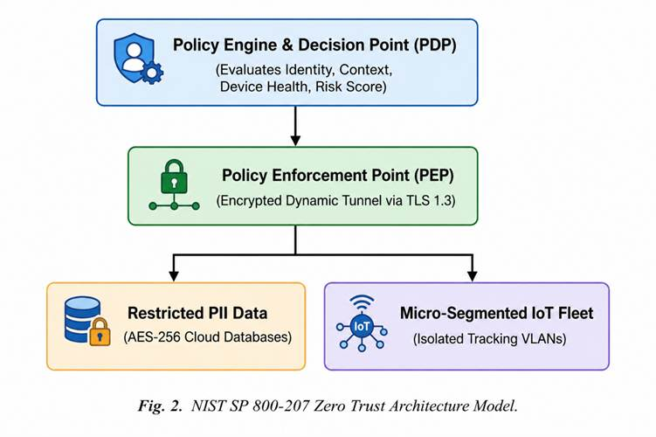

- Identification and Access Management (IAM):
There will be verification of identity for any entry. This will leverage Single Sign-On (SSO) with centrally enforced, mandatory Multi-Factor Authentication (MFA) that relies on the FIDO2 standard. All requests for access will be made based on contextual telemetry including location, time, device health, access method, and network trust status [4].
- Role-Based Access Control (RBAC) and Least Privilege:
Any access request will be granted with least privilege access based on RBAC role and granted using just-in-time access (JIT). External suppliers shall be constrained to access only those logistic modules relevant to their role under contractual relationship and shall not be allowed to move laterally into the customer PII environments [4].

- Cryptographic Safeguards:
Cryptographic controls: encryption shall be implemented across all environments using strong cryptography [7]. Data at rest stored in public cloud IaaS will be secured using AES-256 encryption using Hardware Security Modules (HSMs) managed by ALL for cryptographic key protection [12]. All data in transit, including any data streaming from IoT tracking sensors across public networks, shall be encrypted to standards no lower than TLS 1.3 or IPsec tunnels [10].
- IoT Network micro-segmentation:
Any IoT tracking devices utilized with the shipping containers [10] will be constrained to separate and micro-segmented virtual networks (VLANs/SDP). Direct network communication from IoT tracking devices to internal corporate databases will be prohibited by default to ensure containment if any single point is compromised [4].

4.6 Third-Party Vendor and SLA Management
Management of ALL’s outsourcing of its IT infrastructure necessitates formal vendor governance [12].
- Operationalising Cloud Shared Responsibilities:
Contractual agreements should state the security division between ALL and its cloud solution provider [12].

Customer Responsibility (ALL): Data Classification, IAM, Client | | Encryption, Endpoint Security, Network Traffic, User Training
Vendor Responsibility (IaaS/SaaS): Physical Infrastructure, Host | | OS, Hypervisor, Physical Data Center Security, Core Hardware
TABLE II: CLOUD SHARED RESPONSIBILITY MODEL ASSIGNMENT
- Contractual security SLAs:
Service contracts need to incorporate legally defensible measures and enforceable metrics for security performance [6]. Vendors are required to provide at least 24-hours notification of security compromise or suspicion of compromise affecting any of ALL’s data and any SLA failures related to security incidents, with penalties including financial service credits for failing to comply with these terms [6].
- Right to audit clause:
Security clauses in contracts must contain a right of inspection by ALL or its designated auditors or any third-party auditors and have legal standing to perform audits on the vendor’s configuration and security environment as well as penetration test reports and verification that security controls have been implemented [1].

4.7 Contingency, Incident Response, and Business Continuity
In preparation for possible security incidents, ALL will develop and maintain an Incident Response Plan (IRP) and a Business Continuity Plan (BCP) aligned with the NIST CSF Respond and Recover functions [3].
- Computer Security Incident Response Team (CSIRT):
ALL will form a CSIRT comprising technical staff that will technically staff, the CISO, legal counsel, forensics specialists, and public relations representatives from across the organisation [3].
- Incident Response lifecycle:
The CSIRT will use a four-phase incident methodology to respond to security incidents [3]:

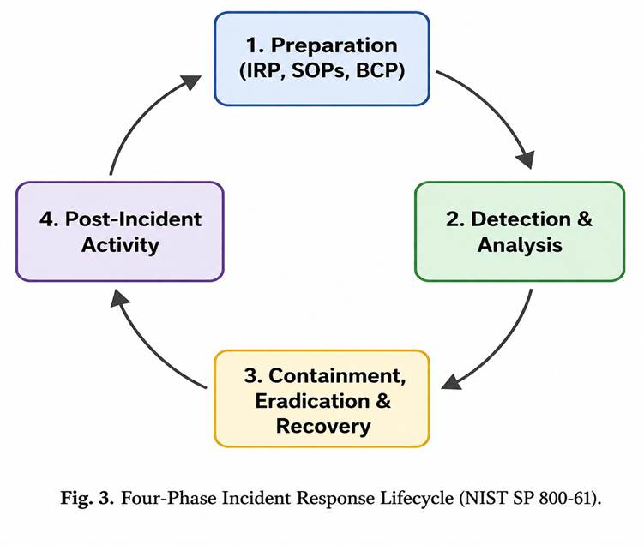
- Disaster Recovery (DR):
Critical system disaster recovery (DR) requirements (RPO & RTO) shall be defined. Real-time Tracking Databases will have an RTO of less than 2 hours and an RPO of less than 15 minutes. Immutable, air-gapped backups will be maintained at a geographically dispersed location [7].

5.0 The Necessity for Continuous Updates in Security Standards
Developing a static set of security controls can only provide point-in-time protection. Effective information security governance is a process that involves an iterative assessment and adjustment approach [1]. There are three primary reasons why security standards for ALL need to be perpetually updated: new emerging technologies, continuously changing threat vectors and evolving compliance requirements.

5.1 Emerging Technologies (AI, IoT, and Edge Computing)
ALL will leverage advanced technologies integrated with operational activities such as cloud solutions, IoT telemetry and predictive Artificial Intelligence capabilities [10]. Newer technologies are being introduced at a more rapid rate than traditional information security models [10].
- IoT Expansion and Edge Vulnerabilities:
The growing footprint of IoT solutions increases ALL's attack surface [10]. The small size and, consequently, limited processing power of IoT tracking devices hinder the utilization of common endpoint security clients [4]. Many IoT solutions inherently contain manufacturer defaults that are unknown to the device administrators or remain undetected over their lifecycle [9]. As ALL expands its tracking capability, its policies should mandate the use of secure boot capabilities, cryptographically signed firmware updates and the adherence to newer standards like the UK Product Security and Telecommunications Infrastructure (PSTI) Act [9].

- Adversarial Artificial Intelligence Risks:
Leveraging AI for dispatch and routing capabilities introduces a novel attack vector including input poisoning and model evasion [10]. Malicious users might inject manipulated data which could poison an AI router model’s understanding of the data and cause logistics issues or conceal of illegal cargo. As well, the rapid advances in generative AI tools increase the possibility of malicious social-engineering attacks targeting supply chain personnel. Standards will need to be updated to ensure rigorous integrity assurance of ALL training data, training it with anti-adversarial properties and modelling ALL of the attack vulnerabilities tied to adversarial AI [10].

5.2 Asymmetric and Evolving Threat Landscapes
Attackers continuously develop and utilize tactics, techniques, and procedures (TTPs) to bypass static security controls [14].
- Supply Chain Attacks:
Threat actors will increasingly utilize the weak link in the overall attack chain and compromise a well-protected supply chain partner in order to access the organizations' networks and data stores [14]. Given that 88% of ALL’s data resides on cloud-based platforms [15] a security compromise on a single SaaS supplier could impact several organizations in the supply chain and ALL's internal and cloud data [14]. TPRM efforts should advance beyond the scope of an annual security risk review to real-time risk identification with a Continuous Threat Exposure Management (CTEM) program [14].

- Multi-Staged Ransomware and Data Extortion:
With time and advances in technical capabilities, attackers have moved beyond single-step Data-Encryption-as-a-service ransomware to Multi-stage ransomware attack schemes involving a primary exfiltration of sensitive client data combined with service interruption and client harassment [14].Security standards need to shift from basic prevention of data encryption to data exfiltration and unauthorized data disclosure prevention through Data Loss Prevention (DLP) controls, behavioural network controls, and zero-trust access controls [4].

5.3 Navigating Dynamic Global Compliance and Data Sovereignty Demands
The world is undergoing constant revision of legal requirements regulating the use and management of personal information [8].
- Regulatory Fragmentation:
Present-day data privacy legislation and statutes--GDPR (EU/UK), CCPA (US), LGPD (Brazil), DPDP place substantial obligations regarding data minimization, the administration of consent and breach declaration timelines [8]. When ALL advances into an additional international business marketplace, it should re-evaluate its enforcement framework to accommodate a collection of differing legal duties across various locales [8].

- Data Sovereignty and Localization Requirements:
Governments increasingly impose legal dictates to necessitate the storage of citizens’ personally identifiable information within their particular regions [10]. Compliance with ALL’s cloud-based monitoring systems [12] requires it to constantly scan cloud data store placements and to engage regionally relevant cloud service providers [15].
- Continuous Compliance Auditing:
Annual compliance audits do not demonstrate legal requirements are being met [8]. An organization's legal defensibility requires constant monitoring of compliance, automatic configuration checks and regular DPIA reviews, all of which need to be regularly updated as the systems and operating environments are adapted [1].

6.0 Conclusion
AeroLink Logistics stands at a crucial inflection point in its journey with regard to its technology infrastructure. Whilst cloud, IoT-enabled tracking, and analytics capabilities through AI are steps towards improving operational efficiency; there is a failed established governance model that has led to numerous data breaches that increase risk for the enterprise [12]. It involves the hybrid IT models, with COBIT 2019 utilized for executive governance [5], ISO/IEC 27001 for operational infrastructure, NIST CSF and CIS Controls for the technical layers of zero trust architecture [3], and NIST SP 800-61 for incident response [17]. It will implement information access controls to the multi-tenant cloud data, fix accountability for breach and protect organizationally sensitive data [4]. It is the first step of an information assurance journey. ALL, as a globally managed entity must continue to evolve and embrace information assurance, governance and regulatory compliance as a continuous process for its corporate lifecycle, rather than a single activity to deploy and abandon, in the face of evolving security challenges, complex technologies on the edge and increasing global data privacy regulations [10].

7.0 References List

[1] N. I. Technology, The NIST Cybersecurity Framework (CSF) 2.0, National Institute of Standards and Technology, 2024.
[2] S. W. Rose, Zero Trust Architecture, 2020.
[3] ISACA, COBIT 2019 Framework: Governance and Management Objectives, 2018.
[4] E. P. Union, Regulation (EU) 2016/679 of the European Parliament and of the Council of 27 April 2016 on the protection of natural persons with regard to the processing of personal data and on the free movement of such data, and repealing Directive 95/46/EC (General Da, 2016.
[5] U. Parliament, Product Security and Telecommunications Infrastructure Act 2022, 2022.
[6] E. Tabassi, Artificial Intelligence Risk Management Framework (AI RMF 1.0), 2023.
[7] A. Calder, ISO27001/ISO27002: A Pocket Guide, 2013.
[8] C. S. Alliance, Security Guidance for Critical Areas of Focus in Cloud Computing v5, 2024.
[9] C. a. Investigation, #StopRansomware: CL0P Ransomware Gang Exploits CVE-2023-34362 MOVEit Vulnerability, 2023.
[10] Z. a. Dimitrios, â€œAddressing cloud computing security issues in supply chain networks,â€ Future Generation Computer Systems, pp. 583â€“592, 2012.
[11] P. Cichonski, Computer Security Incident Handling Guide, 2012.
[12] N. I. Technology, Cybersecurity Supply Chain Risk Management Practices for Systems and Organizations, 2022.
[13] I. O. Standardization, Information security, cybersecurity and privacy protection â€” Guidance on managing information security risks, International Organization for Standardization, 2022.
[14] N. I. Technology, Cybersecurity Supply Chain Risk Management Practices for Systems and Organizations: National Institute of Standards and Technology, 2022.
[15] A. Limited, ITIL Foundation: ITIL 4 Edition, 2019.
[16] C. f. Security, CIS Critical Security Controls Version 8, 2021.

