


Digital Marketing
LCMB7010

Name: Crystal Hall
Student ID: 2237516
Module: Digital Management
Code: LCMB7010
Lecturer: Dr Jaya Gopalkrishnan
Word count: 5000

O



2023

Table of Contents
Part 1 3
1. Introduction 3
1.1. Rationale 3
1.2. Company background 3
2. ASOS Organisational Analysis and its Current Digital Strategy 4
2.1. Political Forces 4
3. Micro-environment: PESTEL 5
3.1. Political Forces 5
3.2. Economic Forces 5
3.3. Social Forces 6
3.4. Technological Forces 6
3.5. Environmental Forces 6
3.6. Legal Forces 6
4. Customer Insights in the UK: 7
4.1. Customer Lifecycle Management 7
4.2. R.A.C.E Framework 8
5. Customer Experience 9
5.1. Outline customer journey 9
6. Customer Journey 10
6.1. A Comparative Analysis of Three Persona Shoppers 10
7. Competitor Analysis: SWOT 12
Part 2 15
8. Digital Marketing strategy 15
9. Overarching Strategy TOWS 18
10. Digital communications: Tactics and tools 20
11. STP Analysis of ASOS (Segmenting Targeting and Positioning) 21
12. Key Metrics and KPI’s 22
13. Strategy Costs 23
14. Recommendations 23
15. Conclusion 24
16. References 25
17. References Appendix (if any) 30

Part 1

Introduction

Rationale
The purpose of this study is to develop a thorough digital marketing strategy specifically for the UK market, concentrating on ASOS within the clothing sector. This approach will be data-driven and customer-focused by carefully reviewing the company's brand strategy, narrative, purpose, vision, and values in addition to a microenvironment and PESTLE analysis of the UK market. A clear customer journey will be built through thorough competitive research and the development of three buyer personas. Content will be systematically developed, evaluated, and optimised while channels are found. The paper will also go into detail on e-CRM, traffic development, social networking, email marketing, permission marketing, marketing automation, and content marketing. A user-experience marketing plan will also be developed. The plan will cover governance, reputation management, and the effects of AI on customer interactions while including SMART targets, strategies, tools, key indicators, KPIs, and cost estimates. This all-encompassing strategy will make it possible to develop an intelligent and successful digital marketing plan based on actual market research.

Company background
ASOS (As Seen on Screen) has become a pioneering global force in retailing since its founding in 2000. ASOS, headquartered in London, UK, integrates innovative strategies, dynamic fashion retail, and the leadership of CEO José Antonio Ramos Calamonte to establish a distinct segment in the evolving landscape of online commerce. ASOS was founded on the allure of celebrity fashion and initially offered a variety of products and clothing from film and television. Transitioning from diverse celebrity-inspired goods to a clothing focus and adopting the "ASOS" acronym in 2002 (Butler, 2018), ASOS quickly became a global fashion juggernaut, transcending borders with a presence in 238 countries. ASOS's voyage exemplifies innovation, as it has pioneered consumer engagement via platforms such as Instagram and innovative features. Under the leadership of José Antonio Ramos Calamonte, the company's diversification into cosmetics and menswear bolstered its position as an industry pioneer. ASOS's story resonates as a beacon of visionary leadership, strategic adaptation, and consumer engagement in the global retailing industry, with approximately 3,300 employees fuelling its robust financial performance (From Forbes, 2020)

ASOS Organisational Analysis and its Current Digital Strategy
This investigation examines ASOS' organisational structure and the company's evolving digital strategy. This report discusses the primary objective, core values, and most recent strategic acquisitions of ASOS. The focus is on their digital capabilities, which include expanding their brand online, strengthening their connection with consumers, and forming innovative partnerships. This summary explores the history of ASOS and highlights the company's unique position in the world of digital fashion.

Political Forces
The objective of ASOS is to become the leading global destination for 20-somethings in fashion by providing a welcoming and expressive platform that cuts across all demographics. In addition to being a haven for fashion lovers, the company actively supports diversity, freedom of speech, and a strategic development philosophy that reflects its love of inclusivity and self-expression (ASOS, 2022). Embracing uniqueness, innovation, diversity, and authenticity, ASOS actively targets the fashion tastes of 20-somethings (Digital Marketing Institute, 2019). Their recent acquisition of Arcadia brands for £265 million, which included Topshop, Topman, Miss Selfridge, and HIIT, exemplifies a potent strategy to grow internationally and increase earnings through strategic alliances, like Nordstrom in the US (Financial Times, 2023).
Although the UK, US, and Germany continue to be important markets for ASOS, the firm is aware that global expansion is essential to its goal. With such a wide audience, ASOS is able to cater to a diverse and global clientele while forging clever retail partnerships to increase brand recognition and reach. (ASOS, 2022).
In an environment where mobile contact is the norm, ASOS's dedication to being mobile-first is noteworthy. This strategic approach is entirely in line with millennial preferences, given that 69% of traffic to their website comes from mobile devices. The ASOS Magazine and the amusing "Style Feed," along with other high-quality content, are successfully integrated with product sales in their content marketing strategy to improve user engagement. To increase audience engagement, they deliberately incorporated ASOS Insider influencers, enabling direct shopping from the featured outfits on the brand's numerous social media platforms (Digital Marketing Institute, 2019).
The future of ASOS depends on its collaboration with Microsoft and the incorporation of AI through a renewed five-year cloud arrangement. This partnership uses AI and Microsoft Azure to increase global scalability and personalised purchasing. Plans are for expanding the product line and optimising stock through the "ASOS Partner Fulfilment" programme. CTO Cliff Cohen acknowledges the importance of security. Scott Guthrie of Microsoft emphasises how this gives ASOS more influence in the fast-paced world of online fashion shopping, securing its place at the fore of digital transformation (ASOS, 2022b).

Micro-environment: PESTEL
(Source created by learner, 2023)

Political Forces
ASOS works amid political stability and regulatory dynamics in the UK, US, EU, and beyond. ASOS's native nation, the UK, has stable politics and strong consumer and worker regulations. Trade agreements and Brexit have an impact on international operations. Tariffs and taxes impact import prices and profitability. E-commerce and data privacy are essential to trust (Reuters, 2017).

Economic Forces
British businesses compete worldwide with a wide selection, competitive pricing, and speedy shipping. British retailers predict £28 billion in overseas online sales by 2020, up from £4 billion in 2012. Leading retailer ASOS expected a 25–30% sales increase for the fiscal year. ASOS's full-year retail sales rose 34%, and it performed well in the UK and abroad. The 1% gain in ASOS shares values the company at £4.8 billion (Reuters, 2014, 2017).

Social Forces
Online retailers like ASOS are popular with UK consumers because of their ease and social media influence. ASOS handles UK cultural concerns to adapt to demographics and ethics-based fashion trends, particularly in cities. "Fashion with Integrity" promotes ASOS's ideals and social media influencer collaborations. To compete, ASOS must focus on mobile marketing, social media, and technology (AT&T et al., n.d.; Dwivedi et al., 2021; ASOS, 2023).

Technological Forces
ASOS's dynamic business model relies on social media and technology to speed delivery and develop sustainably. ASOS's dedication to leading e-commerce fashion trends is shown by its weekly addition of 5,000 new designs (Reuters, 2017).

Environmental Forces
The digital economy is developing because of new markets and technology, affecting worldwide commerce. Social networking, cloud computing, and mobility are changing fashion retail and customer behaviour. Businesses must participate in the digital economy and new marketplaces at this disruptive time when economic advancement and technology merge for long-term success (AT&T et al., n.d.).

Legal Forces
ASOS and the UK fashion retail industry are affected by labour and intellectual property laws. The Anti-Slavery International-assisted Modern Slavery Statement shows ASOS's commitment to open risk management that complies with UN criteria for fragile supply chains (ASOS, 2023a). ASOS's economic impact report shows its effect on society and the UK economy. It created 31,000 jobs and £825 million in taxes. ASOS intends to boost GDP to £3.8 billion, create 25,000 jobs, and make £7 billion. ASOS supports suppliers, SMEs, and upskilling (ASOS, 2023a).

Customer Insights in the UK:
Introduction to Customer Life Cycle and R.A.C.E010).

Customer Lifecycle Management

(Source created by learner, 2023)
Acquisition: Digital marketing is used by top online clothing retailer ASOS to draw in and retain customers. For efficient plans, they analyse acquisition sources and channels. Reflecting the worldwide movement towards digital technology, ASOS promotes connections via social media and their website in the UK (Dwivedi et al., 2021).

Onboarding: Understanding how customer experiences and digital content management affect onboarding is essential. Digital content exchanges with customers influence brand perception and future intentions. Positive experiences influence post-purchase behaviour and encourage intention sharing. For ASOS and consumers to have long-lasting connections, effective digital content management is crucial throughout onboarding (Dwivedi et al., 2021).

Engagement: ASOS needs social media to engage consumers. Customising messages improves consumer satisfaction and adapts to changing tastes. Positive digital interactions promote sharing (Dwivedi et al., 2021).

Retention: Digital marketing has allowed ASOS.com, an online clothing and cosmetics company, to develop rapidly. The fourth-largest online fashion retailer by revenue, with over 85,000 products and high net online sales, ASOS targets 20-something men and women. Mission, values, and branding reflect this young emphasis (Digital Marketing Institute, 2019).
Loyalty: An interacting digital content experience influences future purchasing intentions, and dependability influences eWOM's reputation. Perspective alignment improves social media research. Research subjects include strategic AR marketing, AR's revenue role, ethical AI culture, and ethical AI use in digital marketing. Data privacy and transparency are essential to ethical AI design. AI's importance in marketing and industries drives innovation (Dwivedi et al., 2021).

R.A.C.E Framework

(Source created by learner, 2023)

Reach: ASOS must focus on 18-34-year-olds on Instagram. Engaging content, influencer partnerships, and Google and Facebook advertisements for precision targeting are needed. Fast loading times and keyword SEO will attract fashion-conscious shoppers. It is important to use YouGov and BrandIndex findings. They should use their "Brand of the Year" status to build trust and awareness (Brophy, 2018).

Act: As its popularity as a shopping destination has grown, ASOS has consistently improved its purchase consideration score, which has gone from 6% in July 2013 to 11% in July 2018 (Helplama, 2023). Despite having a sizable user base, ASOS still had a small 2% year-over-year revenue growth in 2022, suggesting that new techniques for improving revenue growth may be necessary (Brophy, 2018).

Convert: Millions of people visit ASOS' extensive online presence each year, with 70.8 million doing so in February 2023 and 3019.8 million in 2022 (Helplama, 2023). The business employs a proactive strategy and makes significant expenditures on social media sites like TikTok and Instagram, using these platforms to communicate with clients and increase conversions (Brophy, 2018).

Engage: ASOS's impressive success in the fiercely competitive fashion industry results from its dual strategy of competitive pricing and trend leadership, promoting customer loyalty and continuous growth (Helplama, 2023). Additionally, ASOS prioritises client involvement via programmes that increase operational efficiency and the shopping experience, highlighting the company's perpetual dedication to customer pleasure (Brophy, 2018).

Customer Experience

Outline customer journey

(Source created by learner, 2023) Customer journey map

Customer Journey
Examining behaviours, causes of action, concerns, and barriers is a part of customer journey assessment. It is essential to understand client behaviours and how they affect development. Understanding is mostly dependent on recognising motives and the underlying emotions or incentives. To improve the experience, it is crucial to identify and deal with doubts, jargon, and barriers. Finally, it's crucial for optimisation to identify any structural, procedural, financial, or implementation challenges. Multiple touchpoints on this trip map might make it confusing, so it's important to understand them to improve this path. Using one of the personas, we can map out their journey. Sarah's first encounter with ASOS occurs during "Awareness," when she is introduced to the retailer using advertisements or internet searches. Sarah's then goes on to the "Research" step to learn more about ASOS's offers and products. Once at the "purchase" stage, the decision goes on to make product purchases. Once a product has been purchased, the "out-of-box experience (OOBE)" becomes crucial, ensuring a smooth setup and initial usage. (Richardson, 2010).

A Comparative Analysis of Three Persona Shoppers
Buyer personas use demographic data to identify the aims, wants, and limits of brand purchasers. ENBD targets millennials who are drawn to advertisements but has to find a balance between drawing clients and providing high-quality service. Millennials prioritise safety and security, with men often demonstrating caution and scepticism (Akre et al., 2019). When comparing ASOS customers Amanda, David, and Sarah, their similar enthusiasm for fashion and dedication to ASOS's convenience become clear. Amanda, a single marketing coordinator from Scotland, contrasts with David, a graphic designer in Manchester in a long-term partnership, while Sarah, located in London, balances life as a single mother and part-time receptionist. Their various cultures have inspired their distinct buying preferences. Their buying triggers set them apart. Amanda finds inspiration in social media and sustainability; David looks for unique streetwear on ASOS; and Sarah prioritises the platform's ease to keep her style within price limits. Regardless of wealth, they all place a great emphasis on cost and routinely seek out specials and discounts to add to their fashion preferences (Akre et al., 2019).
(Source created by learner, 2023)

(Source created by learner, 2023)
(Source created by learner, 2023)

Competitor Analysis: SWOT
(Source created by learner, 2023)
(Semrush, 2023)
Strength: ASOS, a top 10 global clothing company with a growing online fashion following, stands out in the e-commerce fashion sector. The wide selection of clothing and cosmetics it provides strengthens its reputation and transforms it into a one-stop shop. ASOS creates modern items by fusing in-house brands like ASOS DESIGN with designer partnerships. With a loyal following because of its inclusion and body acceptance, ASOS stands out from the competition. Customers in more than 200 countries may access the newest trends thanks to ASOS's effective worldwide supply network and adaptable websites. These qualities make ASOS a potent force in the online fashion industry, encouraging trust, adherence, and expansion (Admin, 2023; Klaus, 2014).

Weakness: ASOS is vulnerable to UK economic instability because of its UK market dependency. Lack of stores inhibits in-person customer interactions compared to competitors. Competition from Boohoo, Zalando, H&M, and Amazon pushes pricing and innovation. Third-party suppliers cause ASOS supply chain disruptions, quality issues, and ethical issues. Brands struggle to maintain product quality and customer satisfaction. Logistics and structure are difficult with rapid growth; success involves staying ahead of fashion trends. Brexit may impact ASOS's supply chain and costs. Fast-fashion companies have to combine sustainability, profitability, and customer demand (Admin, 2023; Zigu, 2011).

Opportunities: Globalisation drives client demand and mobile device use, which is expanding ASOS (Admin, 2023; Zigu, 2011). ASOS must define the digital customer experience and tailor approaches to specific groups and places to dominate online shopping. A cross-functional, value-driven strategy, coordination, and digital channel optimisation are needed. User insights drive development, and staff training enhances the customer experience and sustains ASOS's online shopping leadership. ASOS's international expansion, focus on emerging markets, improved shopping experience, physical store exploration, sustainability, influencer collaborations, product diversification, supply chain optimisation, strategic acquisitions, and customer loyalty efforts position it to dominate online fashion (Admin, 2023; Zigu, 2011).

Threat: Boohoo, Amazon, Zalando, and H&M compete with ASOS in digital and physical retail, with branding initiatives spanning foot traffic and online platforms. Currency and economic fluctuations threaten ASOS's financial stability and adaptability immediately. Personal consumer data breaches may have serious reputational and legal consequences, making cybersecurity and data protection top priorities. Consumer choices and fashion trends affect sales and inventory management. ASOS is vulnerable to supply chain disruptions and economic downturns due to its reliance on third-party suppliers. Tariffs, regulatory reforms, and post-Brexit currency volatility will increase costs and disrupt operations. Intellectual property infringements threaten legal status and company image, emphasising the necessity of cybersecurity, reputation management, and technical solutions (Admin, 2023; Zigu, 2011).

Part 2

Digital Marketing strategy
A generic digital marketing strategy development process
(Source created by learner, 2023)

Specific: By using advanced campaign planning strategies and looking into outside tech solutions, ASOS may improve its digital marketing knowledge (Chaffey and Ellis-Chadwick, 2019). To remain competitive in the rapidly changing digital market, several actions are essential. Also, ASOS is in a good position to take advantage of business prospects. To leverage its digital expertise to expand into new markets and reach a broader global customer base, ASOS also has the ability to improve the online shopping experience and acquire a competitive advantage thanks to cutting-edge disruptive technologies like artificial intelligence and virtual reality (Li, 2010). These possibilities highlight ASOS's potential for development and innovation in the field of online fashion retail.

ASOS is reviewing its budget allocation, geographical focus, and consumer acquisition techniques. Despite a 1% growth in sales to £3,936.5 million in 2022, ASOS had financial difficulties, including a 180 basis point fall in gross margin, a significant -105% decline in operating profit, and a -89% decline in adjusted profit before tax. In addition, ASOS is preparing for a non-cash stock write-off in FY23 that is anticipated to be between £100 million and £130 million. A new business strategy and shift focused on increasing gross margins and producing cash in the second half of FY23 are ASOS's attempts to secure market share in expectation of a contracting UK retail market (ASOS PLC, 2022).

Measurable:
ASOS's fiscal year 2022 financials show mixed results. Group sales increased by 2% to £3,936.5 million, but gross margin fell by 180 basis points to 43.6%. Adjusted EBIT dropped 79% to £44.1 million, and adjusted profit before tax plummeted 89% to £22.0 million. Operating profit went from £190.1 million to (£9.8) million, and reported profit before tax decreased significantly from £177.1 million to (£31.9) million. Diluted profits per share fell from 128.5p to 30.9p, and ASOS reported a net debt of (£152.9) million.Operationally, ASOS saw a 7% revenue increase in its UK headquarters, driven by product selection and a unique aesthetic. The Topshop brand performed well, with a 105% sales increase in the UK, US, and EU. Under new leadership, ASOS identified challenges in foreign operations, customer acquisition, supply chain efficiency, data use, and leadership strength. To tackle these issues, ASOS unveiled a strategic plan that includes model updates, cost reduction, improved financial flexibility, and cultural enhancements. Through capital allocation review and banking renegotiations, ASOS secured over £650 million in cash and facilities. The company expects a non-cash stock write-off of £100 million to £130 million in FY23 and announces that non-executive directors Luke Jensen and Eugenia Ulasewicz won't seek re-election at the next AGM (ASOS PLC, 2022).
(ASOS PLC, 2022).

Achievable: ASOS' ASOS's 2022 financial year-end report directs strategy and finances. ASOS raised group sales 1% or 2% in constant currency despite sector complexity. These stats demonstrate ASOS's perseverance. It says that CEO José Antonio Ramos Calamonte intends to enhance operations, minimise expenses, strengthen the financial sheet, and lead. Pragmatism, transparency, commercial model renewal, cost-cutting, a flexible financial sheet, and leadership development are their 12-month approaches. A rigorous capital allocation review displays foresight. These actions are viable ways to solve issues and accomplish objectives in a changing retail ecology (ASOS PLC, 2022).

Relevant: ASOS's client retention and economic strategy is: Thriving in the UK Market: ASOS's selected range of products, distinctive visual identity, and growing active customer base and Premier customers generated 7% revenue growth in its UK core business. Topshop Triumph: ASOS's UK position and US and EU sales and margins improved after the Topshop purchase, which generated 105% revenue increase. CEO's Vision and Diagnostic: The new CEO assessed worldwide operations, client acquisition, the commercial model, supply chain efficiency, and data and digital advancement potential. Four key actions: ASOS's proactive approach to sustainable growth in a dynamic economy included renewing the commercial model, optimising inventory management, streamlining the cost structure, ensuring a resilient balance sheet, and improving leadership and corporate culture for the next year (ASOS PLC, 2022).

Timed: ASOS's 2022 year-end report reveals a strategy roadmap demonstrating their dedication to deadlines despite market constraints. Their UK core operation revenue rose 7%, demonstrating their resilience to changing market circumstances. ASOS's choice of CEO, José Antonio Ramos Calamonte, shows its willingness to face challenges and possibilities. They've set a 12-month plan for commercial model renewal, cost reduction, balance sheet fortification, and leadership and cultural improvements. These actions are quantifiable goals that drive change within timeframes. Their extensive capital allocation analysis shows their commitment to operational model optimisation, targeted marketing initiatives, resource efficiency, and strategic goals, which show their adaptability and emphasis on operational efficiency as they manage difficulties and capture opportunities in a changing industry (ASOS PLC, 2022).

Overarching Strategy TOWS
Top of Form
Bottom of Form
 | External Opportunities (O) | External Threats (T)
Internal Strengths (S) | SO  "Maxi-Maxi Strategy"  Strategies that use strengths to maximize opportunities. | ST  "Maxi-Mini Strategy"  Strategies that use strengths to minimize threats.
Internal Weaknesses (W) | WO  "Mini-Maxi Strategy"  Strategies that minimize weaknesses by taking advantage of opportunities. | WT  "Mini-Mini Strategy"  Strategies that minimize weaknesses and avoid threats.

(Source created by learner, 2023)
Threats (External Factors): ASOS needs to innovate to maintain market share in a competitive digital ecosystem (Chaffey and Ellis-Chadwick, 2019). As newcomers compete for market share, online fashion retail remains a danger. To meet changing client tastes, ASOS's digital approach must change quickly (Li, 2010). ASOS also has to manage supply chain interruptions and worldwide events that might delay product delivery. These external difficulties highlight ASOS's strategic need for agility, compliance, and supply chain management.

Opportunities (External Factors): ASOS may improve its digital marketing by using refined campaign planning and external technology (Chaffey and Ellis-Chadwick, 2019). These actions are essential to compete in the ever-changing digital world. ASOS, a major online apparel store, may also capitalise on strategic possibilities. First, it may use its digital capabilities to enter new markets and reach more customers worldwide. Second, disruptive technologies like artificial intelligence and virtual reality may help ASOS improve online shopping and acquire a competitive advantage. ASOS's marketing methods can benefit from customer prefer to the ease accesses of online shopping and ease (Li, 2010).

Weaknesses (Internal Factors): ASOS's digital strategy has internal weaknesses that impact control and effectiveness, especially when deciding whether to outsource or insource some components of its digital marketing (Chaffey and Ellis-Chadwick, 2019). Another difficulty that is essential for a satisfying consumer experience is ensuring constant, high-quality content. Despite ASOS's dominance in online fashion shopping, there are still internal issues that need to be addressed. When businesses rely too much on internet sales, they are vulnerable to technological changes and changing customer tastes. As opposed to certain rivals, ASOS has a smaller physical footprint, which limits its market reach and visibility. ASOS's image might be harmed by the excessive consumer data collection that creates data privacy issues and possible legal hurdles. It is essential that ASOS address these issues if it wants to stay competitive and achieve long-term success.

Strengths (Internal Factors): ASOS improves its digital strategy by using internal capabilities. Online marketing and sales operations are synchronised when the teams for digital marketing and e-commerce are integrated. Collaboration and creativity are promoted through cross-functional teams and steering committees. Internal resources support the creation and execution of a digital marketing plan. Integrated reporting on the success of digital marketing provides valuable information (Chaffey and Ellis-Chadwick, 2019). ASO has sound web presence with an established online platform which is clean and easy to navigate, ASOS successfully connects with a large client base (ASOS plc., 2022). Personalised marketing and better user experiences are made possible by comprehensive data analytics, which is in line with the principles of behavioural economics and increases client loyalty. To adapt to disruptive technologies and digital Darwinism, ASOS encourages an innovation culture. Product development that is innovative and driven by skilled workers ensures competitiveness (Li, 2010).

Overarching Strategy for ASOS: The three pillars of innovation, customer centricity, and operational effectiveness should be the company's core values. To do this, the business needs to invest in innovative technologies like mobile commerce, virtual reality, and artificial intelligence, which can be used to improve the online shopping experience, customise suggestions, and speed up the purchasing process. For the purpose of improving the user experience and influencing product offers, marketing tactics, and consumer trends, digital ethnography must be given priority to obtain deeper insights into customer behaviour, preferences, and trends. The effectiveness of internal operations, cost savings, and increased efficiency may all be achieved with careful examination of insourcing and outsourcing choices. The key to positively influencing consumer choices is using behavioural economics concepts. To maximise campaign performance and consumer engagement, it is essential to investigate cutting-edge technological solutions for digital marketing, such as analytics tools, CRM platforms, and marketing automation systems. By putting in place reliable content management systems and quality control procedures, it is possible to maintain a good user experience by ensuring consistent and high-quality material across platforms. These strategies enable ASOS to navigate the dynamic digital landscape, stay competitive, and cater to its tech-savvy, fashion-conscious audience while upholding ethical and corporate responsibility standards (Chaffey and Ellis-Chadwick, 2019; Li, 2010).

Digital communications: Tactics and tools
In the digital marketing environment, ASOS ahead of its competitors in Search Engine Marketing (SEM), blending SEO and paid advertising to increase website exposure which is reflected in their statistics. Ensuring that bounce rates are kept low 40.36% (SimilarWeb, 2023b). The standardisation of meta data, optimisation of landing pages, and production of attractive product content provide ASOS a competitive edge in SEM. ASOS also uses content marketing to keep their audience engaged. This approach includes blogs, articles, videos, podcasts, and infographics.

ASOS also uses Online Advertising, including aesthetically appealing Display Ads on websites and social media platforms and specific search engine and social media advertising formats. This accuracy in online advertising assures target audience engagement. The brand prioritises consent and relevance in email marketing to offer personalised communications that affect purchase intent. ASOS prioritises mobile optimisation in their SEO and SEM activities due to the rise of mobile devices. Finally, the brand uses Social Media Marketing to increase brand awareness, audience engagement, and purchase intent on Facebook, Instagram, Twitter, and LinkedIn (Bismo, Putra, and Melysa, 2019; Chaffey and Ellis-Chadwick, 2019)(Appendix 01).

STP Analysis of ASOS (Segmenting Targeting and Positioning)

(Source created by learner, 2023)
Segmenting: ASOS, the renowned online fashion retailer, stands out for its expertise in marketing segmentation. Their approach involves a comprehensive segmentation strategy based on demographics, lifestyle, and psychographics, this helps ASOS to focus and become more precise wiith customization to meet specific customer needs. By catering to young age demographics, style preferences, and shopping behaviours, ASOS makes sure that they capture a wide-ranging appeal. They adeptly curate collections of trendy, budget-friendly fashion items for the youth market while also offering a spectrum of premium brands for those in pursuit of high-end fashion. ASOS's unwavering commitment to segmentation serves as the key to reaching a diverse audience of fashion-conscious individuals, transcending boundaries of age, gender, or income level. (Ries and Trout, 1972)
Targeting: ASOS has refined its targeting method. ASOS main aim is to focus certain clientele while keeping its brand identity strong. Their demographic-driven tend to targets a broad range of age/genders groups, and economic levels . ASOS marketing is tailored to numerous client demographics as well, guaranteeing that everyone may enjoy their clothes. This targeted targeting enables ASOS to keep its fashion-forward brand image while appealing to a wide spectrum of product fans. Hanlon (2023).
Positioning: ASOS is known for its inventiveness, trendiness, and accessibility. ASOS is a fashion e-commerce giant that sells a variety of fashionable clothes and accessories. Their ads emphasise fashion's emotional appeal and their items' confidence, originality, and inclusion. ASOS targets specific client groups via geographic, demographic, psychographic, and psychological segmentation. They engage customers via "ASOS Insider" and have a significant internet presence internationally. Quality, trendsetting, and convenience keep ASOS at the top of the online fashion industry. (Hanlon, 2023).

Key Metrics and KPI’s
In today's digital age, effective marketing is essential to connect with consumers many of who are text-savvy. ASOS has recognized the significance of digital channels like intergram and tictok, with a particular focus on Facebook and YouTube (Appendix 03). This aligns perfectly with ASOS's successful targeting of the 20-something demographic (Appendix 02). Encouraging customers engagement and creating psychological connections that support brand loyalty are essential for success in this digital environment (Bismo, Putra, & Melysa, 2019).

In this dynamic arena, metrics like the conversion rate take center stage, representing the percentage of visitors who complete desired actions (Data Smarties, 2022). Interestingly, only a mere 2% of online shoppers convert into customers, and retargeting efforts manage to bring back 8% of them, resulting in a 0.7% click-through rate for retargeted ads and 0.07% conversion rate (Yeo et al., 2020). However, ASOS has bucked this trend, with revenue increasing by 2% year over year to reach £3.93 billion in 2022, indicating their success in converting more visitors into loyal customers (Helplama, 2023).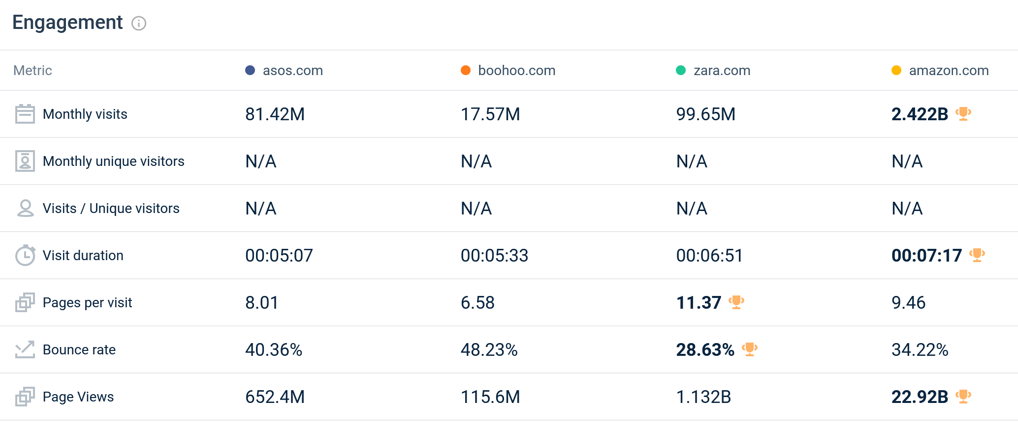
(SimilarWeb, 2023)

Strategy Costs
In the last financial year, ASOS's marketing investment increased significantly, up about 22% to over £224 million, showing that ASOS understands the demographics of its customers. While specific rate of conversion data is not available, a positive year-over-year trend shows a high level of interaction, and the statistics show that the consumers interactions are successful. A 7% increase in total visits in 2022 indicates that ASOS succeeded in consumer interaction in the UK, which may have been affected by targeted marketing spending. Additionally, a notable 5% rise in average order frequency demonstrated elevated consumer involvement and satisfaction. An impressive 87.9% of all visits were made using a mobile device, which is in line with the mobile shopping trend. With a 5% increase in its active customer base, ASOS successfully recruited and kept 8.9 million clients. The average basket value (ABV) and average units per basket (ABS) decreased, which may be related to clearing efforts and promotional spending that, although drawing in more consumers, had an adverse effect on average transaction values (ASOS, 2022b) (Appendix 05).

Recommendations
To maximise ASOS's digital marketing effectiveness, we recommend a strategic approach that leverages its organisational strengths and opportunities. First, ASOS should completely accept the fusion of its e-commerce and digital marketing teams and capitalise on its organisational structure. This includes creating a thorough strategy—a Maxi-Maxi Strategy—to encourage cross-team cooperation and creativity while spending money on training and information exchange to improve skills and promote a culture of collaborative problem-solving. Second, thorough analysis is essential when deciding whether to insource or outsource digital marketing to reduce weaknesses and maximise potential. It is advised to carry out a comprehensive cost-benefit analysis in line with ASOS's unique goals and, if required, contact outside experts. A Maxi-Mini strategy must be continuously reviewed to react to the constantly shifting dynamics of the digital marketing industry. By following these suggestions, ASOS may successfully navigate the digital marketing environment, building on existing advantages and embracing new opportunities. (Chaffey and Ellis-Chadwick, 2019)

Conclusion
Finally, ASOS strategically uses digital technology to their advantage, dominating the the world of fashion. Their strategies include partnerships with influencers, like Georgia May (A, 2022) that cater to millennial interests, online growth, and their social media engagement. ASOS is prominent in the digital economy thanks to its commitment to cultural trends, diversity, and its market competitiveness.

ASOS engage, and keep consumers with a large product range and individualised offers, making the target group feel special and improve their interaction with a brand ASOS uses analytics and the R.A.C.E method. Their ability to scale and personalize will increase thanks to ASOS's collaboration with Microsoft and AI integration. The "ASOS Partner Fulfilment" project will increase stock management and expand options. Because of its emphasis on security, ASOS has taken the lead in the online clothing shopping revolution.

ASOS's present path shows its dedication to innovation, diversity, and customer service through social media and smart online tactics. Responding to digital data regarding the constant shift of customer tastes and market conditions confirms to ASOS prominence in online within fashion market. With a strong foundation in digital marketing and the strategies it uses, ASOS is poised for a promising future as they strive to become the UK's top fashion market store.

References
A, D. (2022). All About The ASOS Influencer Program - How To Collab With Asos. [online] www.netinfluencer.com. Available at: https://www.netinfluencer.com/asos-influencer-program/#:~:text=Georgia%20May [Accessed 1 Sep. 2023].
Admin (2023). ASOS SWOT Analysis - The Strategy Story. [online] The Strategy Story. Available at: https://thestrategystory.com/blog/asos-swot-analysis/ [Accessed 2 Sep. 2023].
Akre, V., Rajan, A., Ahamed, J., Amri, A.A. and Daisi, S.A. (2019). Smart Digital Marketing of Financial Services to Millennial Generation using emerging technological tools and buyer persona. [online] IEEE Xplore. doi:https://doi.org/10.1109/ITT48889.2019.9075106.
ASOS (2021). Our purpose and values. [online] ASOS plc. Available at: https://www.asosplc.com/this-is-asos/our-purpose-and-values/ [Accessed 9 Aug. 2023].
ASOS (2022a). Acceleration Of ASOS Brands Strategy. [online] ASOS plc. Available at: https://www.asosplc.com/news/acceleration-asos-brands-strategy/ [Accessed 9 Aug. 2023].
ASOS (2022b). ASOS continues to drive forward future growth with the Microsoft Cloud. [online] ASOS plc. Available at: https://www.asosplc.com/news/asos-continues-drive-forward-future-growth-microsoft-cloud/#:~:text=ASOS%20will%20evolve%20its%20existing [Accessed 1 Sep. 2023].
ASOS (2022c). CHANGE DRIVING NOW ASOS Plc Annual Report and Accounts 2022. [online] annualreports.com. Available at: https://www.annualreports.com/HostedData/AnnualReports/PDF/LSE_ASOS_2022.pdf [Accessed 4 Sep. 2023].
ASOS (2023a). ASOS calls for implementation of mandatory human rights due diligence legislation. [online] ASOS plc. Available at: https://www.asosplc.com/news/asos-calls-implementation-mandatory-human-rights-due-diligence-legislation/.
ASOS (2023b). Equity story. [online] ASOS plc. Available at: https://www.asosplc.com/fashion-with-integrity/equity-story/ [Accessed 31 Aug. 2023].
ASOS (2023c). Partnerships. [online] ASOS plc. Available at: https://www.asosplc.com/fashion-with-integrity/people/partnerships/ [Accessed 2 Sep. 2023].
ASOS (2022). CHANGE DRIVING NOW ASOS Plc Annual Report and Accounts 2022. [online] Available at: https://www.annualreports.com/HostedData/AnnualReports/PDF/LSE_ASOS_2022.pdf [Accessed 2023].
ASOS PLC (2022). Final results for the year to 31 August 2022. [online] ASOS plc. Available at: https://www.asosplc.com/news/final-results-year-31-august-2022/ [Accessed 2 Sep. 2023].
ASOS plc (2023). Our purpose and values. [online] ASOS plc. Available at: https://www.asosplc.com/this-is-asos/our-purpose-and-values/#:~:text=Our%20vision%20is%20to%20be [Accessed 2 Sep. 2023].
Bismo, A., Putra, S. and Melysa (2019). Application of Digital Marketing (social media and email marketing) and its Impact on Customer Engagement in Purchase Intention: a case study at PT. Soltius Indonesia. 2019 International Conference on Information Management and Technology (ICIMTech). doi:https://doi.org/10.1109/icimtech.2019.8843763.
Brophy, A. (2018). ASOS – Marketing Week Masters ‘Brand of the Year’ | YouGov. [online] Yougov.co.uk. Available at: https://yougov.co.uk/topics/consumer/articles-reports/2018/10/10/asos-marketing-week-masters-brand-year [Accessed 31 Aug. 2023].
Butler, S. (2018a). Asos: the seesaw history of a global online fashion giant. [online] the Guardian. Available at: https://www.theguardian.com/business/2018/dec/17/asos-the-seesaw-history-of-a-global-online-fashion-giant [Accessed 15 Aug. 2023].
Butler, S. (2018b). Asos: the seesaw history of a global online fashion giant. [online] the Guardian. Available at: https://www.theguardian.com/business/2018/dec/17/asos-the-seesaw-history-of-a-global-online-fashion-giant [Accessed 16 Aug. 2023].
Chaffey, D. (2022). RACE marketing model definition - What is? | Digital marketing Glossary. [online] Dr Dave Chaffey: Digital Insights. Available at: https://www.davechaffey.com/digital-marketing-glossary/race-marketing-planning-model/ [Accessed 1 Sep. 2023].
Chaffey, D. and Ellis-Chadwick, F. (2019). Digital Marketing. 7th ed. Pearson UK.
Charlton, G. (2013). Online department store SEO: ASOS gets the onsite basics right. [online] Econsultancy. Available at: https://econsultancy.com/online-department-store-seo-asos-gets-the-onsite-basics-right/ [Accessed 4 Sep. 2023].
CIPD (2023). PESTLE analysis. [online] www.cipd.org. Available at: https://www.cipd.org/uk/knowledge/factsheets/pestle-analysis-factsheet/ [Accessed 16 Aug. 2023].
Data Smarties (2022). 6 Conversion Rate Mistakes | Data Smarties. [online] www.youtube.com. Available at: https://www.youtube.com/watch?v=aFTjC47Ymm0&t=63s [Accessed 3 Sep. 2023].
Digital Marketing Institute (2019). ASOS: Setting the Trend with Innovative Digital Strategies | DMI. [online] Digital Marketing Institute. Available at: https://digitalmarketinginstitute.com/blog/asos-setting-the-trend-with-innovative-digital-strategies [Accessed 15 Aug. 2023].
Dwivedi, Y.K., Ismagilova, E., Hughes, D.L., Carlson, J., Filieri, R., Jacobson, J., Jain, V., Karjaluoto, H., Kefi, H., Krishen, A.S., Kumar, V., Rahman, M.M., Raman, R., Rauschnabel, P.A., Rowley, J., Salo, J., Tran, G.A. and Wang, Y. (2021). Setting the future of digital and social media marketing research: Perspectives and research propositions. International Journal of Information Management, 59(1), pp.1–37. doi:https://doi.org/10.1016/j.ijinfomgt.2020.102168.
Evan (2021). RACE Model: Improve your Digital Marketing Strategy. [online] Shout.com. Available at: https://shout.com/digital-marketing/race-model-for-digital-marketing/ [Accessed 1 Sep. 2023].
Financial Times (2023). Subscribe to read | Financial Times. [online] www.ft.com. Available at: https://www.ft.com/content/015699a2-bbb0-4fc5-a4f8-47028de35ba9 [Accessed 9 Aug. 2023].
Forbes (2020). ASOS. Forbes. [online] Available at: https://www.forbes.com/companies/asos/ [Accessed 15 Aug. 2023].
Hanlon, A. (2022). The segmentation, targeting, positioning (STP) marketing model. [online] Smart Insights. Available at: https://www.smartinsights.com/digital-marketing-strategy/customer-segmentation-targeting/segmentation-targeting-and-positioning/ [Accessed 4 Sep. 2023].
Hanlon, A. (2023). How to Use the 7Ps Marketing Mix? - Smart Insights. [online] Smart Insights. Available at: https://www.smartinsights.com/marketing-planning/marketing-models/how-to-use-the-7ps-marketing-mix/ [Accessed 4 Sep. 2023].
Helplama (2023). ASOS Revenue And Usage Statistics 2023. [online] Helplama.com. Available at: https://helplama.com/asos-revenue-usage-statistics/ [Accessed 31 Aug. 2023].
Hills, J. (2018). Asos profit warning: A sign of political turmoil beginning to bite? [online] ITV News. Available at: https://www.itv.com/news/2018-12-17/asos-profit-warning-a-sign-of-political-turmoil-beginning-to-bite [Accessed 16 Aug. 2023].
Hitt, M.A. (2017). STRATEGIC MANAGEMENT : concepts and cases, competitiveness and globalization. Cengage Learning.
Klaus, P. (2014). Towards practical relevance — Delivering superior firm performance through digital customer experience strategies. Journal of Direct, Data and Digital Marketing Practice, 15(4), pp.306–316. doi:https://doi.org/10.1057/dddmp.2014.20.
Langley, P. and Rieple, A. (2021). Incumbents’ capabilities to win in a digitised world: The case of the fashion industry. Technological Forecasting and Social Change, [online] 167(120718), p.120718. doi:https://doi.org/10.1016/j.techfore.2021.120718.
Li, C. (2010). Groundswell. Winning in a World Transformed by Social Technologies. Strategic Direction, 26(8). doi:https://doi.org/10.1108/sd.2010.05626hae.002.
Marketline Advantage (2021). COMPANY PROFILEASOS Plc. [online] MarketLine Advantage. Available at: https://www.studocu.com/row/document/university-of-hafr-al-batin/mechanical-structure/asos-plc-swot-its-for-marketing-swat-for-asos-com-just/27121478 [Accessed 2 Sep. 2023].
Merry, L. (2022). 7 of the best SEO blogs to follow into 2023. The Telegraph. [online] 10 Nov. Available at: https://www.telegraph.co.uk/business/search-marketing/best-seo-guides-2023/ [Accessed 4 Sep. 2023].
Miklosik, A., Kuchta, M., Evans, N. and Zak, S. (2019). Towards the Adoption of Machine Learning-Based Analytical Tools in Digital Marketing. IEEE Access, 7, pp.85705–85718. doi:https://doi.org/10.1109/access.2019.2924425.
MindTools (2023). MindTools | Home. [online] www.mindtools.com. Available at: https://www.mindtools.com/auqstul/the-tows-matrix [Accessed 2 Sep. 2023].
Mubai, C. (2017). How ASOS use Digital Marketing? [online] Medium. Available at: https://medium.com/@chenmubai619/how-asos-use-digital-marketing-790d3806a7d6 [Accessed 15 Aug. 2023].
Olmstead, L. (2019). ASOS’s SEO Mistakes Sunk Profits By 87%: What Happened? [online] learn.g2.com. Available at: https://learn.g2.com/asos-seo [Accessed 4 Sep. 2023].
Partington, R. and Kollewe, J. (2018). Asos shock shows UK’s economic problems extend beyond high street. [online] the Guardian. Available at: https://www.theguardian.com/business/2018/dec/18/asos-shock-shows-uks-economic-problems-extend-beyond-high-street [Accessed 16 Aug. 2023].
Paulo (2014). Will Digital Make Or Break ASOS? [online] Digital Marketing Institute. Available at: https://digitalmarketinginstitute.com/blog/analysing-asos-digital-strategy [Accessed 15 Aug. 2023].
Peleg Mizrachi, M. and Tal, A. (2022). Regulation for Promoting Sustainable, Fair and Circular Fashion. Sustainability, [online] 14(1), p.502. doi:https://doi.org/10.3390/su14010502.
Ravikumar, S. (2022). Britain to investigate ASOS, Boohoo and Asda’s environmental claims. Reuters. [online] 29 Jul. Available at: https://www.reuters.com/business/retail-consumer/uk-probes-fashion-groups-asos-boohoo-asda-over-green-claims-2022-07-29/ [Accessed 31 Aug. 2023].
REUTERS (2014). E-commerce edge helps British retailers expand abroad. Reuters. [online] 13 May. Available at: https://www.reuters.com/article/retail-britain/e-commerce-edge-helps-british-retailers-expand-abroad-idUSL5N0MU3WT20140513 [Accessed 17 Aug. 2023].
REUTERS (2017). UPDATE 2-ASOS raises sales guidance as fast-fashion formula maintains momentum. Reuters. [online] 17 Oct. Available at: https://www.reuters.com/article/asos-results/update-2-asos-raises-sales-guidance-as-fast-fashion-formula-maintains-momentum-idUSL8N1MS0X7 [Accessed 17 Aug. 2023].
Reuters (2014). UK retailer ASOS suspends orders after suspected warehouse arson. Reuters. [online] 21 Jun. Available at: https://www.reuters.com/article/uk-britain-asos-idUKKBN0EW0E720140621 [Accessed 2 Sep. 2023].
Richardson, A. (2010). Using Customer Journey Maps to Improve Customer Experience. [online] Harvard Business Review. Available at: https://hbr.org/2010/11/using-customer-journey-maps-to [Accessed 4 Sep. 2023].
Semrush (2023). asos.com Alternatives & Competitors - Websites Like asos.com. [online] Semrush. Available at: https://www.semrush.com/website/asos.com/competitors/ [Accessed 1 Sep. 2023].
Shaw, A.A. (2020). PESTLE Analysis of the Fashion Industry. [online] Marketing Tutor. Available at: https://www.marketingtutor.net/pestle-analysis-of-the-fashion-industry/ [Accessed 16 Aug. 2023].
SimilarWeb (2023a). Similarweb.com - Digital World Market Intelligence Platform. [online] SimilarWeb.com. Available at: https://pro.similarweb.com/?#/digitalsuite/websiteanalysis/overview/website-performance/*/999/3m?webSource=Total&key=asos.com,boohoo.com,zara.com,amazon.com [Accessed 4 Sep. 2023].
SimilarWeb (2023b). Website Performance. [online] Similarweb.com. Available at: https://pro.similarweb.com/#/digitalsuite/websiteanalysis/overview/website-performance/ [Accessed 1 Sep. 2023].
Statista (2023). ASOS marketing spend 2021. [online] Statista. Available at: https://www.statista.com/statistics/1231038/asos-marketing-spending/#:~:text=British%20online%20fashion%20retailer%20ASOS [Accessed 4 Sep. 2023].
Yeo, J., Hwang, S.-W., Kim, S., Koh, E. and Lipka, N. (2020). Conversion Prediction from Clickstream: Modeling Market Prediction and Customer Predictability. IEEE Transactions on Knowledge and Data Engineering, 32(2), pp.246–259. doi:https://doi.org/10.1109/tkde.2018.2884467.
Zigu (2011). ASOS SWOT Analysis | Top ASOS Competitors & USP | Brand Analysis | MBA Skool-Study.Learn.Share. [online] MBA Skool-Study.Learn.Share. Available at: https://www.mbaskool.com/brandguide/lifestyle-and-retail/12876-asos.html [Accessed 2 Sep. 2023].

References Appendix (if any)
Appendix 01:
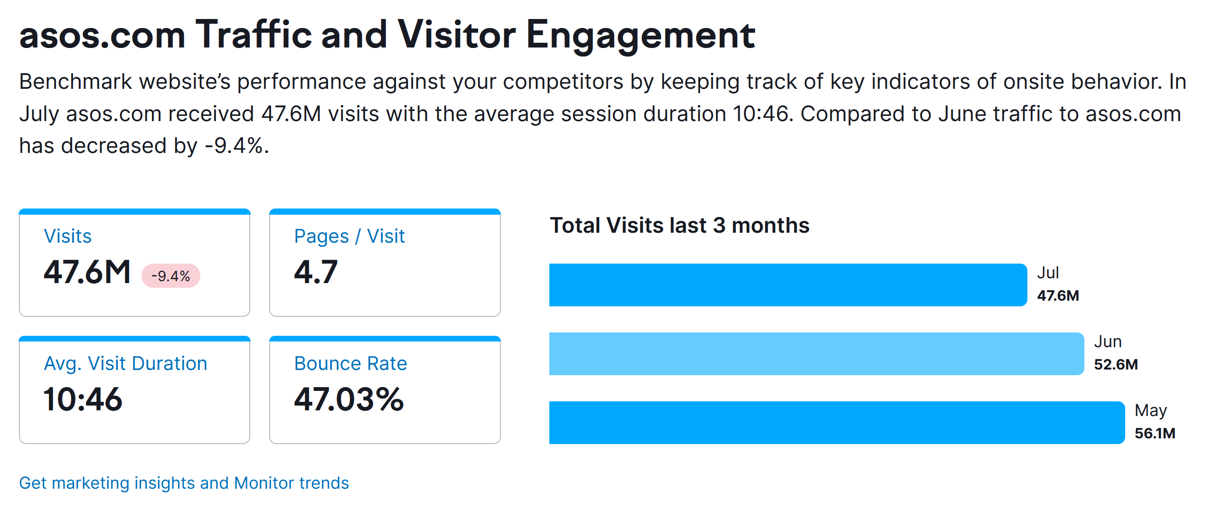

Appendix 02: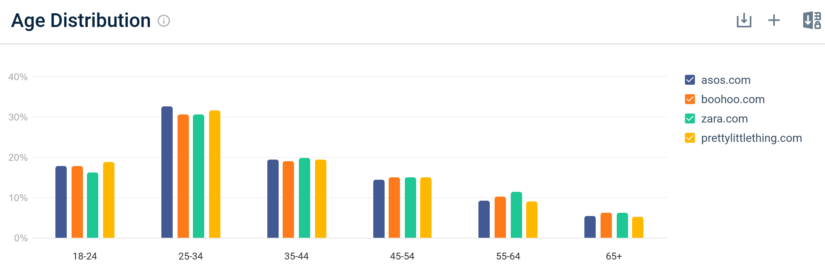
(SimilarWeb, 2023)
Appendix 03:
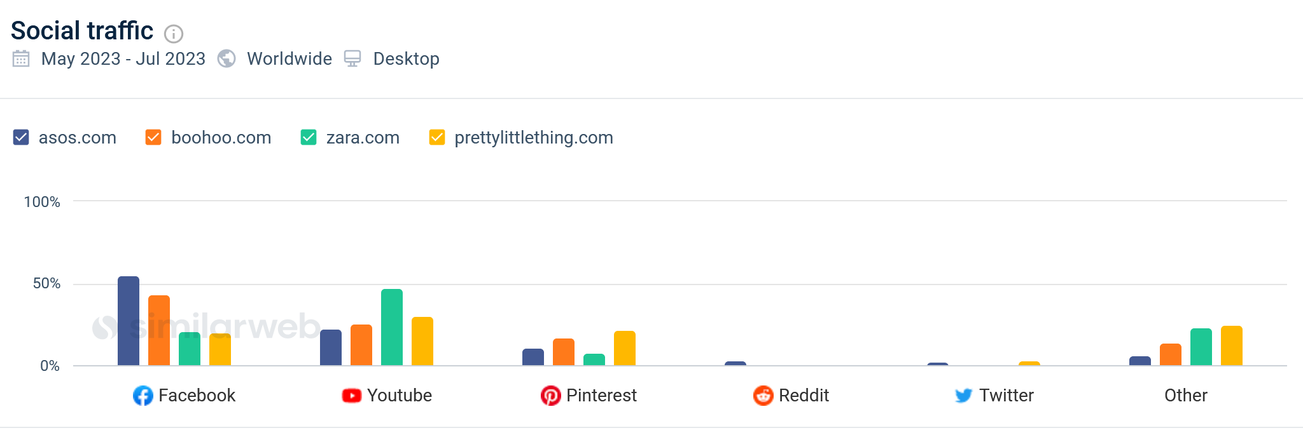
(SimilarWeb, 2023)

Appendix 04: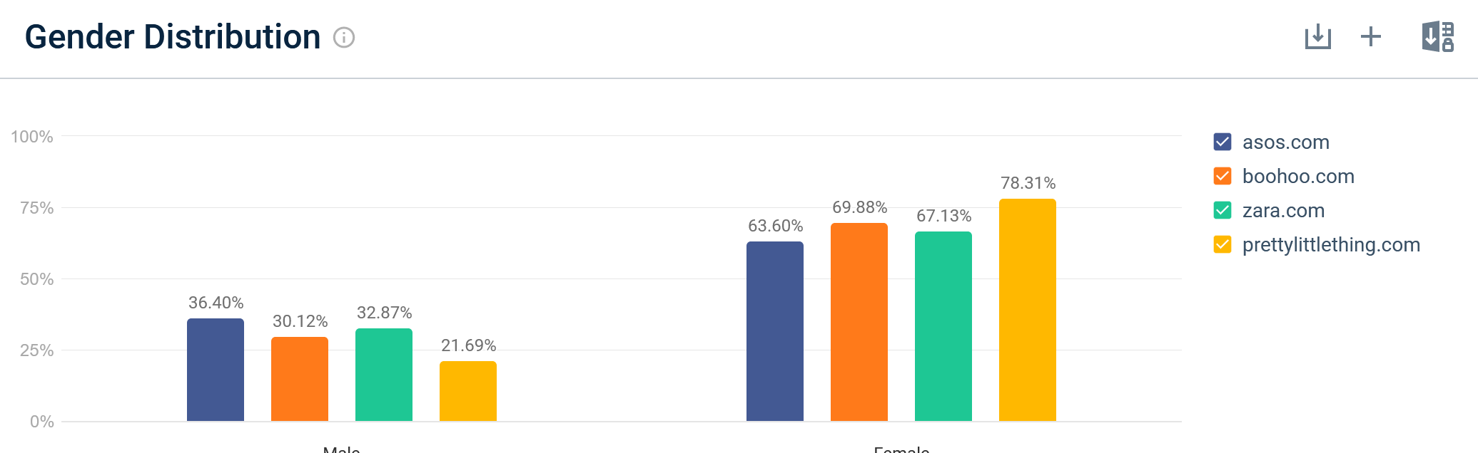 (SimilarWeb, 2023)

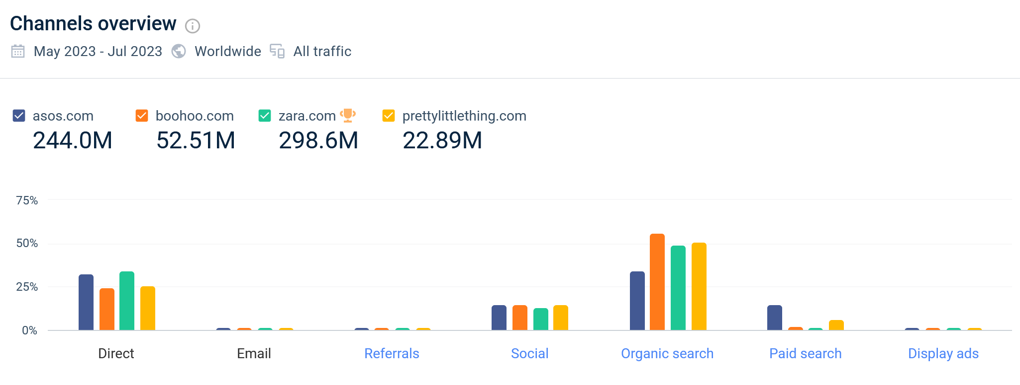
Appendix 05: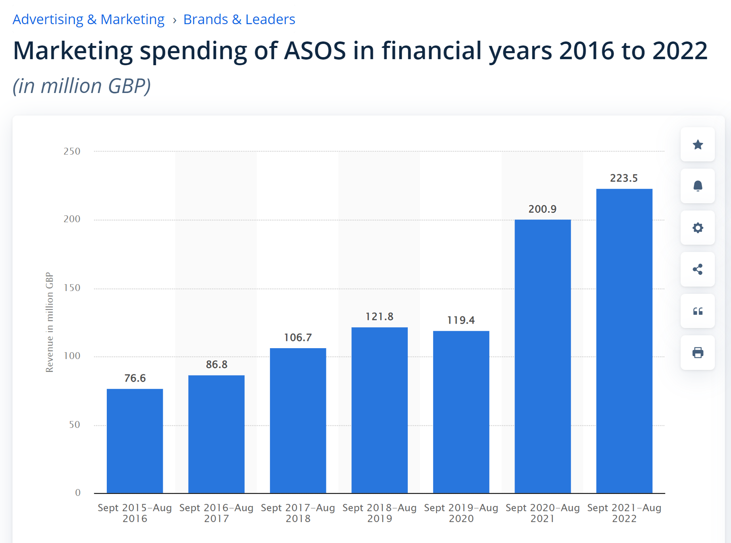
(Statista, 2023)

