

Applied Computing

Wales Institute of Science and Art (WISA)

Advanced Cybersecurity (ACCB6000)


Lab 5: Post F(Ph)ishing









1

What we do?
- Set up your Lab
- Use tools to gain access
  - Metagoofil
  - Metasploit
  - HackKey
- Record your reflections
Disclaimer
Do not try these in unsupervised environments/ real time environments. Attempting to use certain tools is real time environments or without proper written consents from the owners of the network is punishable offense. All our labs are only for educational purposes and to be practiced under supervised environments.

Takeaway

Document maintenance now adds value and credit for the owners for your life time!!! See how.... Yes, there is a shared folder created which could be assessable for all the Cybersecurity students. You could post your maintenance/ manual/ troubleshooting steps with your name and it will remain there for years. Each poster will be awarded with for their work
Description
Metagoofil: Used to gather data/ available documents which are public. It uses search engines to search, download and then generate a report. Lets look what we can get!!!
Recommendations
You could use any of the following as per your convenience. Highlighted is used here.
- VirtualBox
- VMware Workstation Pro
- VMware Fusion Pro (for Mac),
- VMware ESXi
- Microsoft Hyper-V
What you need?
- Virtual Machines running Kali Linux (Attacker), Windows 7/ XP
- Internet access

The configurations/ ip addressing below listed is based on this topology. Make necessary changes as you work on.
Win 7 | Win XP | Kali
10.0.2.6 | 10.0.2.4 | 10.0.2.15
10.0.2.1 | 10.0.2.1 | 10.0.2.1



Task 1: Use Metagoofil
In Kali Linux:
kali@kali:~$ metagoofil
bash: metagoofil: command not found

kali@kali:~$ apt -get install metagoofil
E: Command line option 'g' [from -get] is not understood in combination with the other options.

kali@kali:~$ sudo metagoofil [sudo] password for kali:
sudo: metagoofil: command not found

kali@kali:~$ sudo apt-get install metagoofil
Reading package lists... Done
Building dependency tree
Reading state information... Done
E: Unable to locate package metagoofil

kali@kali:~$ sudo apt-get update
Get:1 http://kali.download/kali kali-rolling InRelease [30.5 kB]
Get:2 http://kali.download/kali kali-rolling/main amd64 Packages [16.7 MB]
Get:3 http://kali.download/kali kali-rolling/contrib amd64 Packages [101 kB]
Get:4 http://kali.download/kali kali-rolling/non-free amd64 Packages [200 kB]
Fetched 17.1 MB in 4s (4,590 kB/s)
Reading package lists... Done

kali@kali:~$ sudo apt-get install checkinstall
Reading package lists... Done
Building dependency tree Reading state information... Done Suggested packages:
gettext
The following NEW packages will be installed:
checkinstall
0 upgraded, 1 newly installed, 0 to remove and 860 not upgraded.
Need to get 114 kB of archives.
After this operation, 455 kB of additional disk space will be used. Get:1 http://kali.download/kali kali-rolling/main amd64 checkinstall amd64
1.6.2+git20170426.d24a630-2 [114 kB]
Fetched 114 kB in 0s (264 kB/s)
Selecting previously unselected package checkinstall.
(Reading database ... 276117 files and directories currently installed.)
Preparing to unpack .../checkinstall_1.6.2+git20170426.d24a630-2_amd64.deb ...
Unpacking checkinstall (1.6.2+git20170426.d24a630-2) ...
Setting up checkinstall (1.6.2+git20170426.d24a630-2) ...
Processing triggers for man-db (2.9.3-2) ...
Processing triggers for kali-menu (2020.3.2) ...

kali@kali:~$ sudo apt-get install metagoofil
Reading package lists... Done
Building dependency tree
Reading state information... Done
The following additional packages will be installed:
python3-googlesearch
The following NEW packages will be installed: metagoofil python3-googlesearch
0 upgraded, 2 newly installed, 0 to remove and 860 not upgraded.
Need to get 61.6 kB of archives.
After this operation, 223 kB of additional disk space will be used.
Do you want to continue? [Y/n] Y
Get:1 http://kali.download/kali kali-rolling/main amd64 python3-googlesearch all 2.0.2-
0kali1 [45.3 kB]
Get:2 http://kali.download/kali kali-rolling/main amd64 metagoofil all 2.2.+git201903070kali1 [16.3 kB]
Fetched 61.6 kB in 1s (114 kB/s)
Selecting previously unselected package python3-googlesearch. (Reading database ... 276150 files and directories currently installed.) Preparing to unpack .../python3-googlesearch_2.0.2-0kali1_all.deb ...
Unpacking python3-googlesearch (2.0.2-0kali1) ...
Selecting previously unselected package metagoofil.
Preparing to unpack .../metagoofil_2.2.+git20190307-0kali1_all.deb ...
Unpacking metagoofil (2.2.+git20190307-0kali1) ...
Setting up python3-googlesearch (2.0.2-0kali1) ...
Setting up metagoofil (2.2.+git20190307-0kali1) ...
Processing triggers for kali-menu (2020.3.2) ...

kali@kali:~$ sudo metagoofil usage: metagoofil.py [-h] -d DOMAIN [-e DELAY] [-f] [-i URL_TIMEOUT] [-l
SEARCH_MAX]
[-n DOWNLOAD_FILE_LIMIT] [-o SAVE_DIRECTORY] [-r
NUMBER_OF_THREADS] -t
FILE_TYPES [-u [USER_AGENT]] [-w] metagoofil.py: error: the following arguments are required: -d, -t

kali@kali:~$ sudo metagoofil -d apple.com -t doc,pdf -l 200 -n 5 -o applefiles -f [+] Adding -w for you
[*] Downloaded files will be saved here: applefiles
[+] Creating folder: applefiles
[*] Searching for 200 .doc files and waiting 30.0 seconds between searches
[+] Downloading file - [41472 bytes]
http://store.apple.com/Catalog/US/Images/ProofofAcademicIdentificationForm.doc
[+] Downloading file - [76288 bytes]
http://store.apple.com/Catalog/China/Images/rejection_letter.doc
[+] Downloading file - [86528 bytes]
https://opensource.apple.com/source/Security/Security-29770/doc/AppleTP_Spec.doc
[+] Downloading file - [95744 bytes]
https://opensource.apple.com/source/Security/Security31122/doc/Apple_OID_Assignments.doc
[+] Downloading file - [492544 bytes] https://opensource.apple.com/source/bootp/bootp254/Documentation/BSDP.doc
[*] Searching for 200 .pdf files and waiting 30.0 seconds between searches
[+] Downloading file - [523915 bytes]
https://www.apple.com/jp/support/cip/pdfs/optidrive_pmg4mdd.j.pdf
[+] Downloading file - [147348 bytes]
https://www.apple.com/privacy/parentaldisclosureconsent.pdf
[+] Downloading file - [650435 bytes]
https://www.apple.com/jp/support/cip/pdfs/powersupply_pmg4mdd.j.pdf
[+] Downloading file - [394620 bytes]
https://www.apple.com/jp/support/cip/pdfs/battery_pmg4mdd.j.pdf
[+] Downloading file - [337 bytes]
http://www.apple.com/certificateauthority/Application_Integration_CPS/ [+] Total download: 2509231 bytes / 2450.42 KB / 2.39 MB [+] Done!

Now, you could go to the folder and check the files downloaded…
kali@kali:~$ sudo metagoofil -d apple.com -t doc,pdf -l 200 -n 5 -o applefiles -f
-
d DOMAIN
–t FILE_TYPES
-
l SEARCH_MAX]
-
n DOWNLOAD_FILE_LIMIT
-
o SAVE_DIRECTORY
-
f Output File

Record your reflections about the tool you used.
This tool is extremely powerful as it gives you the ability to search a website for any file types that you specify and downloads them directly to the users machine, This can be used to steal highly sensitive information or anything

Task 2: Use Metasploit
In Kali Linux:

The Backend Database support… PostgreSQL
When attempting to do a pen-test, always remember based on the scenario it may take long time to complete. In that case, we can use the backend database support for POSTGRESQL. Using this support, you could store your results now and then.
Commands used here!!! – A summary
root@kali:~# systemctl start postgresql root@kali:~# msfdb init
root@kali:~# msfdb

root@kali:~# sudo msfconsole

msf > services
The services command allows us to display the services running on the hosts

Hints
To modify the database configuration file, we can edit the database.yml file located in
/usr/share/metasploit-framework/config/database.yml:
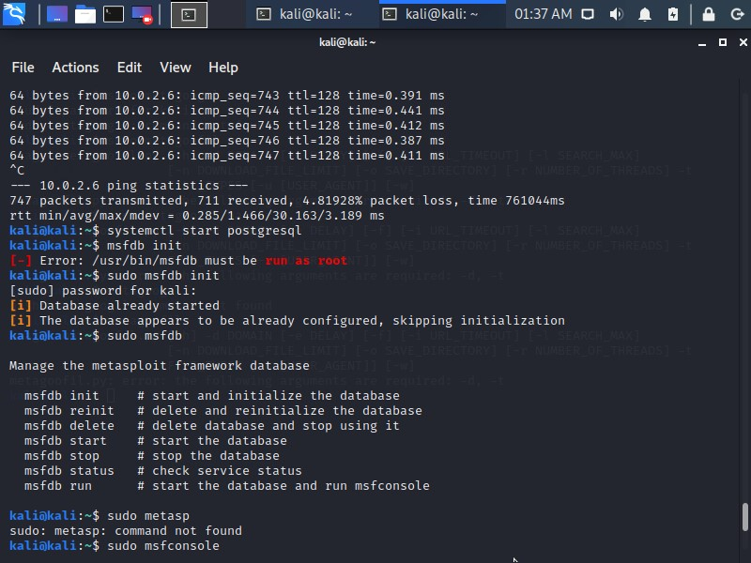

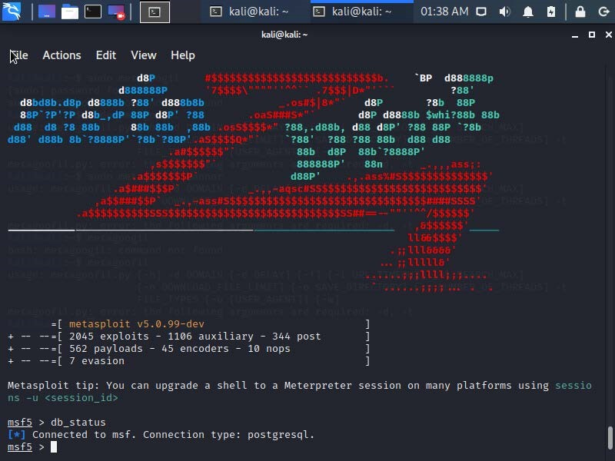
msf > services -h

In Kali Linux:

Auxiliary Modules… in Metasploit
We shall use Auxiliary modules like Enumerator (The way to collect information passively) to get the DNS details like zone transfers, reverse lookups, SRV record brute forcing etc.

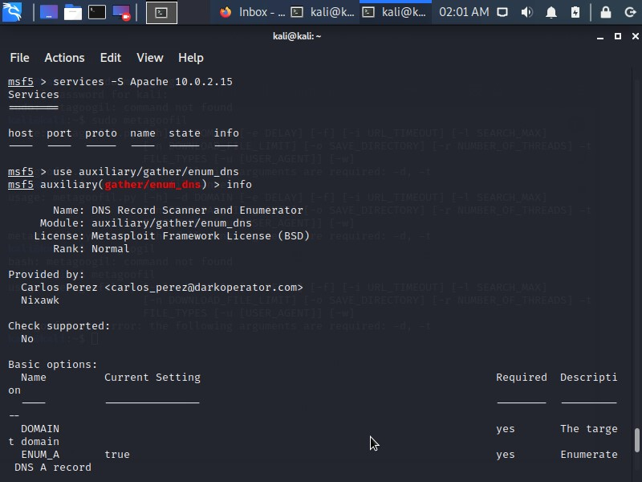
Commands used here!!! – A summary
msf5 > services -S Apache 10.0.2.15
Services
========

host port proto name state info
---- ---- ----- ---- ----- ----

msf5 > use auxiliary/gather/enum_dns
msf5 auxiliary(gather/enum_dns) > info

Name: DNS Record Scanner and Enumerator
Module: auxiliary/gather/enum_dns
License: Metasploit Framework License (BSD)
Rank: Normal

Provided by:
Carlos Perez <carlos_perez@darkoperator.com>
Nixawk

Check supported:
No

Basic options:
Name Current Setting Required Description
---- --------------- -------- -----------
DOMAIN yes The target domain
ENUM_A true yes Enumerate DNS A record
ENUM_AXFR true yes Initiate a zone transfer against each NS record
ENUM_BRT false yes Brute force subdomains and hostnames via the supplied wordlist
ENUM_CNAME true yes Enumerate DNS CNAME record
ENUM_MX true yes Enumerate DNS MX record
ENUM_NS true yes Enumerate DNS NS record
ENUM_RVL false yes Reverse lookup a range of IP addresses
ENUM_SOA true yes Enumerate DNS SOA record
ENUM_SRV true yes Enumerate the most common SRV records
ENUM_TLD false yes Perform a TLD expansion by replacing the TLD with the IANA TLD list
ENUM_TXT true yes Enumerate DNS TXT record
IPRANGE no The target address range or CIDR identifier
NS no Specify the nameservers to use for queries, space separated
Proxies no A proxy chain of format type:host:port[,type:host:port][...]
RPORT 53 yes The target port (TCP)
SEARCHLIST no DNS domain search list, comma separated
STOP_WLDCRD false yes Stops bruteforce enumeration if wildcard resolution is detected
THREADS 1 no Threads for ENUM_BRT
WORDLIST /usr/share/metasploit-framework/data/wordlists/namelist.txt no Wordlist of subdomains

Description:
This module can be used to gather information about a domain from a
given DNS server by performing various DNS queries such as zone
transfers, reverse lookups, SRV record brute forcing, and other
techniques.

References:
https://cvedetails.com/cve/CVE-1999-0532/
OSVDB (492)

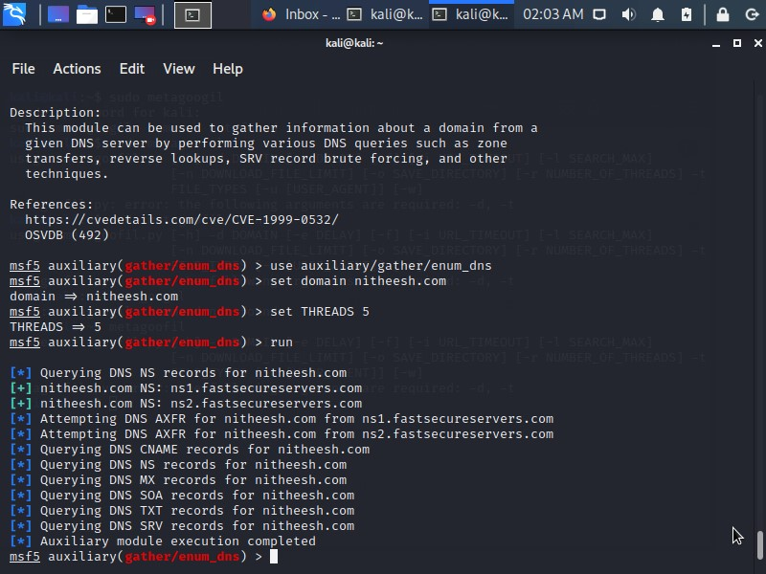
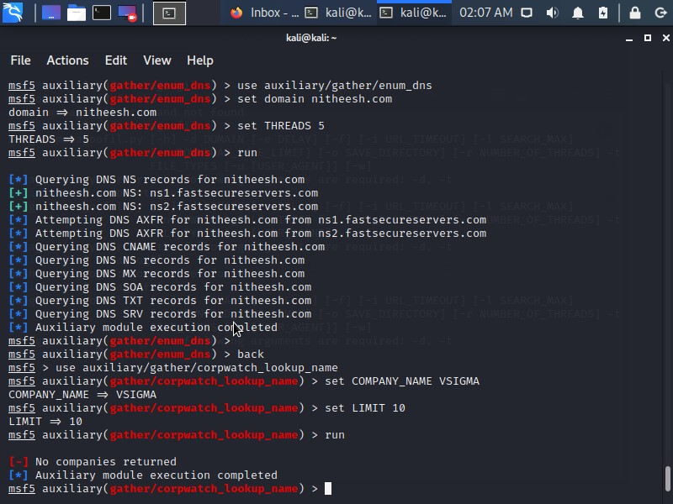
We shall use Auxiliary modules like Enumerator (The way to collect information actively) by setting ENUM_BRT (Brute forcing mode) to true.
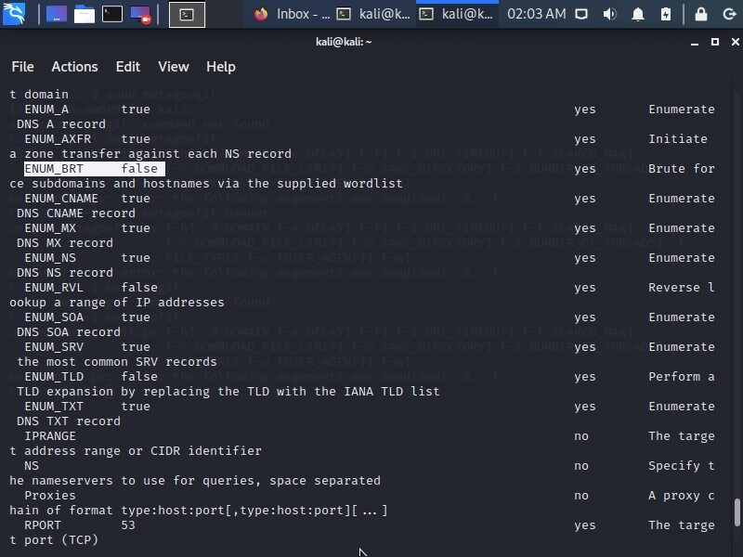

We shall use Auxiliary modules like Enumerator to search for company names too...
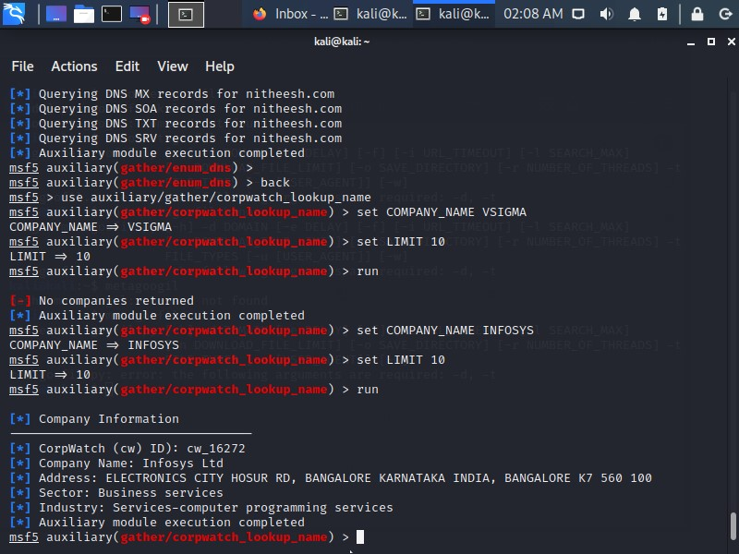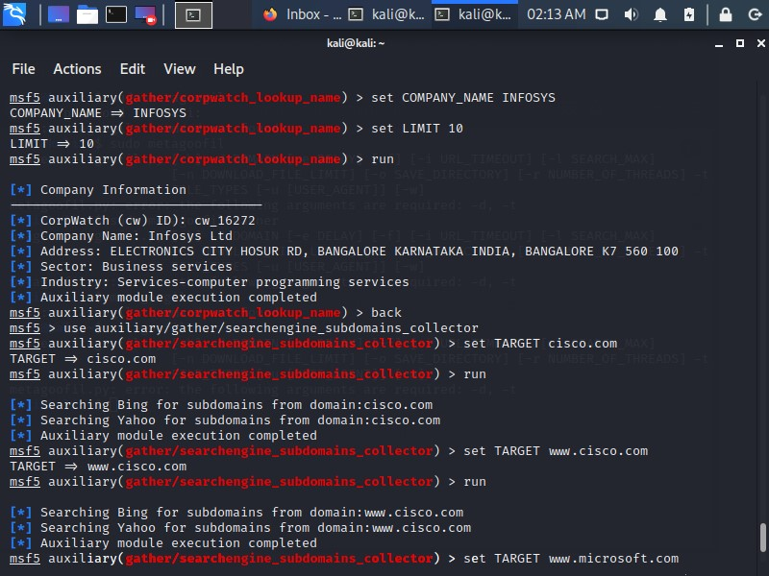

We shall use Auxiliary modules like Enumerator to search for sub domains too...
We shall use Auxiliary modules like Enumerator to search for ftp too…
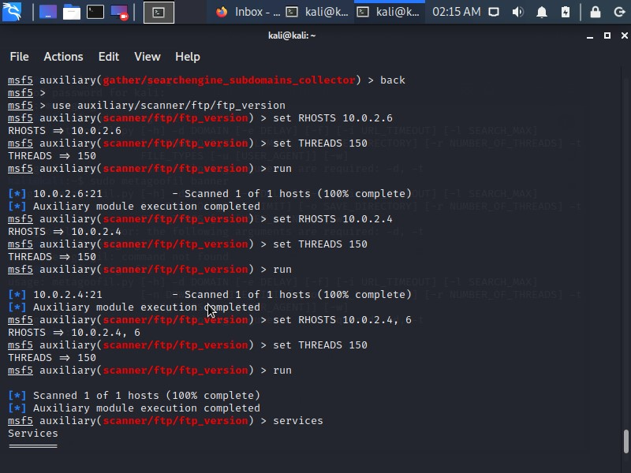

We shall use Auxiliary modules like Enumerator to search for the users too… We shall use SMTP for that.
To understand, Generally, SMTP uses to work with names of the users and its emails. So, we can use SMTP services to get those details.
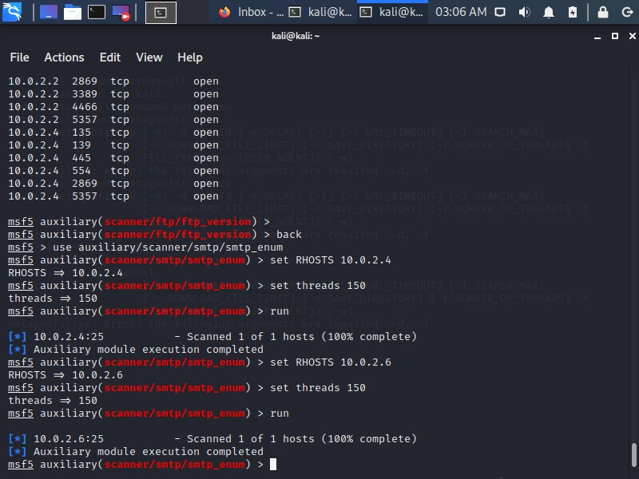

In Kali Linux:

MS17-010 EternalBlue SMB Remote … in Metasploit
We shall use this vulnerable service for scanning phase… The above stated module is called ETERNALBLUE exploit, is said to be used as part of the WannaCry ransomware attack. It is used commence an payload and affect Windows machines without security update MS17-010 for Microsoft Windows SMB Server SMBv1 Server …..
We will do this next Lab…

