Appendices ECAD7004

Appendix 1 – Lesson Plan

Time | Activities/Methodology/Key Concepts  (Teacher’s Role – including key teaching points and key questions) | Pupil Tasks  (Pupils’ role -including differentiation strategies, engagement in formative assessment and homework) | Resources  (Including Health and Safety requirement)
Opening phase (with links to prior learning) | Powerpoint about the History of Space Travel – discuss journeys in to space - questioning  Show how to research the different astronauts and find out key information to include on their space passport  Show example of space passport – go through what goes on each section  Questioning using hands up approach (lesson 1 and 2) | Discuss the different astronauts and their space journeys : what do we already know, what do we need to find out.  Create a space passport for one of their choice  Think about the key information to include on their space passport : name, date of birth, their space mission | Powerpoint  Video on Tim Peake  Space passport
Teaching & Core Learning | Assist children with filling in space passports- define key terms and what information needs to be placed where  H.A and M.A; general information and mission information included on passport  L.A; general information included on passport | Research information about their chosen astronaut on chromebooks  Fill in space passport with relevant information | Space passports  Chromebooks
Plenary | Recap what we have learnt, discuss space journeys – look at examples of space passports create share ideas  Video : Tim Peakes launch in to space https://www.youtube.com/watch?v=bSfYdr8Oj9w  Siaradwch gyda partner – share ideas  Question & answerusing lollipop sticks  (lesson 1)  Question answer using mini whiteboards  (lesson 2) | Share examples of work  Think pair share how they would feel if they were Tim Peake going up to space for the first time | Video link  Lollipop sticks  Mini whiteboards

Appendix 2- Information Sheet

CONSENT FORM

PROJECT TITLE: ‘Does the use of a no hands up policy increase levels of student engagement and participation?’

Name of Researcher: Miss K Lee and Miss Z Thomas

Please initial box

1. I confirm that I have read and understand the information sheet dated 7th January for the above study.

2. I understand that my child’s participation is voluntary and that I am free to withdraw my child from the study at any time, without giving any reason.

3. I understand that my child can choose to withdraw at any time, without giving a reason.

4. I understand that the information given by my child will be used in a university assignment.

5. I understand that my child’s name will not appear at any time.

6. I agree for my child to take part in the above study.

_____________________ _____________________________ __________
Child’s name Parent signature Date

When completed, please return to Cyfarthfa Park Primary by the 10th January 2020.

Thank you.

INFORMATION sheet

PROJECT TITLE: ‘Does the use of a no hands up policy increase levels of student engagement and participation?’

Dear Parent / Guardian,

Our names are Zoe Thomas and Kylie Lee. We are studying for a PGCE qualification at Yr Athrofa, University of Wales Trinity Saint David. We are currently student teachers within Cyfarthfa Park Primary School and we are teaching in your child’s class.

We would like to invite your child to participate in our research project. The title of the project is ‘Does the use of a no hands up policy increase levels of student engagement and participation?’ and we aim to use the data we have collected to assist with our research project and inform our future practice. Through your child’s participation, we hope to ascertain a better understanding how levels of participation change when using a no hands up approach.

The observation will take place during a normal lesson. Following the lesson an informal interview will take where your child may be asked a number of questions based on the research. They have the right to withdraw from the process at any time.

All names will be kept strictly confidential and will only be known by myself and my research partner. Your child’s participation in this study is completely voluntary so you or your child can withdraw from the study at any stage. Your child will also be asked to give their assent before the beginning of the study.

After careful and precise analysis of the data obtained from the lesson observation and group interview, we would be happy to provide you with a copy of the findings at your request. The results of the research will be discussed in a university assignment that will contribute to our PGCE course. The results of this study will be stored on password protected USB device and all raw data will be destroyed once the assessment has been marked.

We thank you in advance for your time. If any questions do arise, feel free to contact us at your convenience.

Yours sincerely,

Zoe Thomas and Kylie Lee

Appendix 3- Observation schedule (seating plans lesson 1)
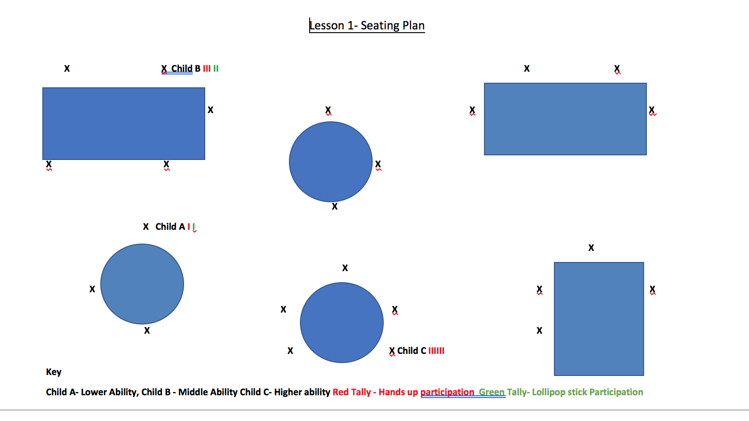

Appendix 3- Observation Schedule (seating plans – lesson 1)

Appendix 4- Observation Schedule (seating plans – lesson 2)

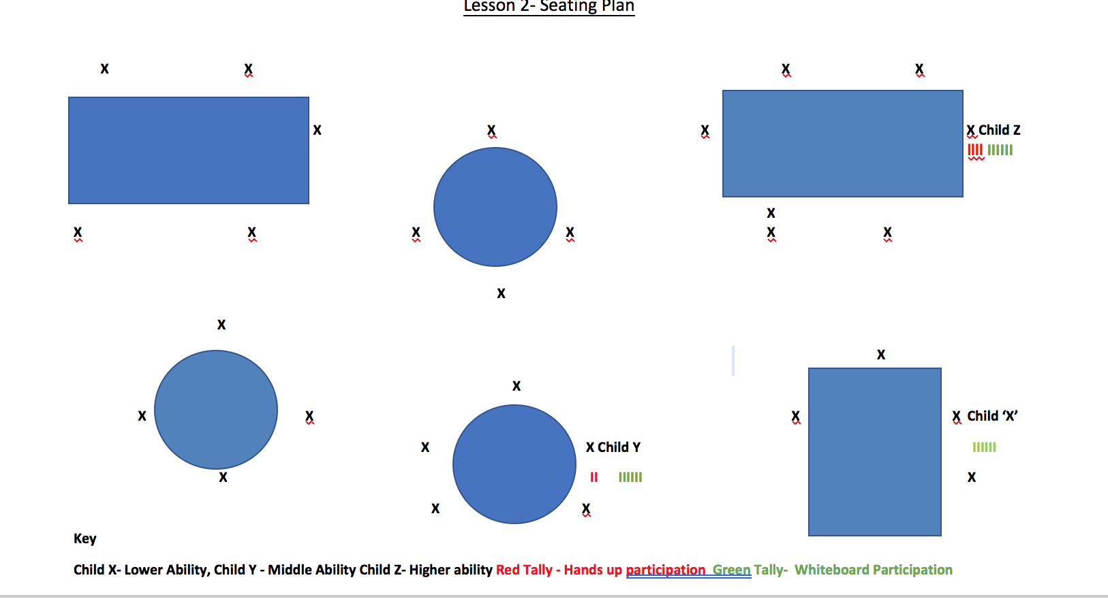

Appendix 5- Observation Schedule (Leuvan scale- lesson 1)

Appendix 6- Observation Schedule (Leuvan scale- lesson 2)

Appendix 7- Interview results (Lesson 1)

Lesson 1

Child A

Student interview questions

- How do you feel when the teacher asks you a question?
Really nervous.

- How do you answer questions in class?
Usually the teacher choose people with their hands up.

- How do you feel about putting your hand up for a question?
I don’t like putting my hand up, it make me feel scared.

- How did the teacher choose children to answer questions?
We put our hands up to answer questions at the start then the lollipop sticks choose people.

- Which method of answering questions do you prefer?
I don’t really like it when we get picked to answer without putting our hand up but it makes me pay more attention because I don’t want to look silly in front of everyone.

- How often do you feel you get a chance to answer a question during lesson time?
Not much but I don’t put my hand up, but it is fairer when the lollipop sticks are used because other people get a turn.

- If your name is chosen to answer a question, how does it make you feel?
I feel anxious because I might not know the answer.

- If you didn’t know the answer to a question what would you do?
Ask someone on my table if they know the answer.

Child B

Student interview questions

- How do you feel when the teacher asks you a question?
Sometimes I feel okay when I know the answer.

- How do you answer questions in class?
Most of the time we put our hands up to answer questions.

- How do you feel about putting your hand up for a question?
I sometimes feel scared in case I get the answer wrong but I have a go anyway.

- How did the teacher choose children to answer questions?
At the start of the lesson we put our hands up to answer questions, at the end of the lesson the teacher chose people’s names to answer on the lollipop sticks.

- Which method of answering questions do you prefer?
I prefer it when I can put my hand up when I’m sure I know the answer, I have to listen more when the teacher is just picking us.

- How often do you feel you get a chance to answer a question during lesson time?
Don’t get much chance because the teacher chooses people who put their hands up a lot.

- If your name is chosen to answer a question, how does it make you feel?
Nervous in case I say the wrong answer or I might not know what it is.

- If you didn’t know the answer to a question what would you do?
Ask a friend.

Child C

Student interview questions

- How do you feel when the teacher asks you a question?
I feel confident and ready to answer the question.

- How do you answer questions in class?
Most of the time we put our hands up to answer questions, sometimes we get chosen with the lollipop sticks.

- How do you feel about putting your hand up for a question?
I feel confident because I know the answer usually.

- How did the teacher choose children to answer questions?
At the start of the lesson we could put our hands up to answer questions, at the end of the lesson the teacher chose names with lollipop sticks.

- Which method of answering questions do you prefer?
I prefer putting my hand up to answer because I get more chance.

- How often do you feel you get a chance to answer a question during lesson time?
I usually put my hand up a lot so get lots of chances to answer a question, I didn’t get much chance today because my name wasn’t chosen with the lollipop sticks so I was disappointed because I knew the answer.

- If your name is chosen to answer a question, how does it make you feel?
I like answering questions so I like it when my name is chosen.

- If you didn’t know the answer to a question what would you do?
Ask a friend on the table or research on the chromebooks after.

Appendix 8- Interview results (Lesson 2)

Lesson 2

Child X

Student interview questions

- How do you feel when the teacher asks you a question?
Really nervous in case I don’t know what the answer is.

- How do you answer questions in class?
Usually we put our hands up to answer questions.

- How do you feel about putting your hand up for a question?
I don’t like putting my hand up to answer a question unless I’m really sure I know the answer.

- How did the teacher choose children to answer questions?
We put our hands up to answer questions at the start then used the whiteboards at the end of the lesson, everyone had to give an answer even if it was wrong.

- Which method of answering questions do you prefer?
I like when we can use the whiteboards because the teacher is looking at everyone answers, it makes me feel better.

- How often do you feel you get a chance to answer a question during lesson time?
Not a lot because I don’t like putting my hand up in some lessons.

- If your name is chosen to answer a question, how does it make you feel?
I get nervous if the teacher chooses me because I might not have been listening or don’t know what the answer is.

- If you didn’t know the answer to a question what would you do?
Ask someone on my table to help me.

Child Y

Student interview questions

- How do you feel when the teacher asks you a question?
A bit nervous because I don’t know if the answer is going to be right.

- How do you answer questions in class?
Most of the time we put our hands up to answer questions.

- How do you feel about putting your hand up for a question?
Feel proud when I put my hand up to answer, usually feel confident I know the answer if I have chosen to put my hand up.

- How did the teacher choose children to answer questions?
At the start of the lesson we put our hands up to answer questions, at the end of the lesson we wrote our answers on the whiteboards.

- Which method of answering questions do you prefer?
I prefer it when we all answer the question together like when using the mini whiteboards

- How often do you feel you get a chance to answer a question during lesson time?
It depends on what lesson it is, if I feel confident like in maths I put my hand up more often so get more chances to answer.

- If your name is chosen to answer a question, how does it make you feel?
Nervous, especially if the teacher chooses me without me putting my hand up.

- If you didn’t know the answer to a question what would you do?
Ask a friend for help.

Child Z

Student interview questions

- How do you feel when the teacher asks you a question?
Mostly confidence, sometimes a bit nervous.

- How do you answer questions in class?
Most of the time we put our hands up to answer questions.

- How do you feel about putting your hand up for a question?
Feel okay about putting my hand up, I usually feel confident because most of the time I know the answer.

- How did the teacher choose children to answer questions?
At the start of the lesson we could put our hands up to answer questions, at the end of the lesson we wrote our answers on the whiteboards and showed the teacher.

- Which method of answering questions do you prefer?
I like both ways.

- How often do you feel you get a chance to answer a question during lesson time?
I usually put my hand up a lot so get lots of chances to answer a question.

- If your name is chosen to answer a question, how does it make you feel?
Mixture of emotions, but I like answering questions most of the time.

- If you didn’t know the answer to a question what would you do?
Take a guess.

Appendix 9- Reflection pro forma (lesson 1)

Lesson 1 03/02/2020

Reflection pro-forma: Gibb’s reflective cycle (1988)

Description

- When and where did this happen?
Year 3/4 class of mixed ability children, 27 pupils in the class. History lesson.
- Why were you there?
Partner 1– teaching the research lesson.
Partner 2- observing patterns of students’ participation and engagement.
- Who else was there?
Research partner
- What happened?
Children were asked question and told to put their hands up to answer. Partner 2 observed the behaviour and engagement levels when putting their hands up to answer questions. Looking at how children behaved and reacted to using a hands-up approach and using lollipop sticks to select at random during the second half.
- What did you do?
Delivered the planned research lesson to the first class of children (partner 1).
- What did other people do?
Partner 2 observed the levels of participation and engagement of the focus group, 1 child chosen from lower, middle and higher ability groupings. Interviewed focus group after the lesson (see interview questions) gather data on children’s feelings regarding the lesson and a hands-up vs no approach.
- What was the result of this situation?
Observed that children putting hands up often showed higher levels of participation and engagement. Children not participating were more easily distracted, they appeared to not be engaged and less focused because they were choosing not to put their hands up to answer questions and the likelihood of being chosen was low. Observing this approach will inform my future practice. More children were engagement when using a no hands up policy.

Feelings
- What did you feel before this situation took place?
We expected children who were putting their hands up to answer to be more focused than those who were not- results show what we predicted would happen.
- What did you feel while this situation took place?
Predictions were accurate- some children were more engaged than others. The seating plan was useful to record data and allow results to be analysed.
- What do you think other people felt during this situation?
Research partner- we shared the same observations and feelings regarding the lesson and data recorded.
- What did you feel after the situation?
Research question and observation techniques provided useful results. Interviews showed feelings that were predicted and helped form analysis and reflection
- What do you think about the situation now?
From interview data children feel how we predicted and when a different approach is implemented will reinforce these feelings and levels of participation should increase.

Evaluation

- What was positive about this situation?
Children put hands up to answer, data was collected, interviews were successful and provided an insight in to how children felt regarding the situation and approach to questioning taken during the lesson.
- What was negative?
Same children putting hands up – but this was predicted using a hands-up approach. Not all children given opportunity to answer during the lesson.
- What went well?
Data was collected from seating plan- (how many times children answered recorded using a tally).
Interviews were successful and provided us with raw data to work with.
- What didn't go so well?
Partner 2 found it difficult to observe child as they were a different class (no background knowledge of the children) it was more of a snapshot, not a full picture, data might therefore be an unfair representation.
- What did you and other people do to contribute to the situation (either positively or negatively)?
Research partner able to observe and collect data.

Analysis and Conclusion

- What else can you make of the situation?
Research question an area that will develop and inform future practice. Interviews are useful way of collecting data and allow a deeper insight into thoughts and feelings on a situation.
- What else could be done?
Further research, observed over a longer period of time to ensure a fair test and results are more reliable – more than just a snapshot.
- What could be done differently next time?
Observe for a longer period of time to give a better understanding and collect more data to understand changes that are made over time.

Appendix 10- Reflection pro forma (lesson 2)

Lesson 2 – 4/2/2020

Reflection pro-forma: Gibb’s reflective cycle (1988)

Description

- When and where did this happen?
Year 3/4 class of mixed ability children, 28 pupils in the class. 17 SEN pupils in the class.
History focused lesson.
- Why were you there?
Partner 1– teaching the second research lesson.
Partner 2- observing patterns of students’ participation and engagement and how they have changed using a different approach.
- Who else was there?
Research partner.
- What happened?
Children were asked questions normally using a hands-up approach to start with, then told there was a no hands-up policy and mini whiteboards were used to get feedback from the whole class during the second half. Partner 2 observed the behaviour and engagement levels when putting their hands up to answer questions. Looking at how children behaved and reacted differently using a no hands-up approach compared to the first research lesson when using a whole class approach.
- What did you do?
Delivered the second planned research lesson to the second class of children (partner 2).
- What did other people do?
Partner 1 observed the levels of participation and engagement of the focus group, 1 child chosen from lower, middle and higher ability groupings. Interviewed focus group after the lesson (see interview questions) gather data on children’s feelings regarding the lesson and no hands up approach.
- What was the result of this situation?
Observed higher levels of participation and engagement. Children showed greater levels of participation and engagement when using the mini whiteboards, all students were on task as they all had to provide an answer. They were more engaged as they were giving a wait time before having to show their answers. Observing this approach will inform my future practice.
Feelings
- What did you feel before this situation took place?
We expected children who were answering to be more focused and engaged- results show what we predicted would happen.
- What did you feel while this situation took place?
Predictions were accurate all children were more engaged as they could have been chosen to answer a question. The seating plan was useful to record data and allow results to be analysed.
- What do you think other people felt during this situation?
Research partner- we shared the same observations and feelings regarding the lesson and data recorded.
- What did you feel after the situation?
Research question and observation techniques provided useful results. Interviews showed feelings that were predicted and helped form analysis and reflection.
- What do you think about the situation now?
From observation and data collected the research question was proven correct as a no hands up policy increased levels of student participation and engagement.

Evaluation

- What was positive about this situation?
We were able to gain pupil voice about the approach they preferred to develop future practice. Data collected during this lesson show a change in levels of participation and engagement which was the intended outcome of the research.
- What was negative?
Some children were nervous from this change of routine becoming withdrawn because they were being chosen at random to answer the questions.
- What went well?
- Data collected during this lesson show a change in levels of participation and engagement which was the intended outcome of the research. Children were able to provide answer using a different method of questioning.
- What didn't go so well?
Some children were affected by the change of routine.
Analysis and Conclusion
- What else can you make of the situation?
Research question an area that will develop and inform future practice, it was apparent that children were more engaged when using a different approach such as lollipop sticks. Data collected from interviews demonstrated children’s feelings that they had to listen more intently when being selected at random to answer questions.
- What else could be done? What could be done differently next time?
Can give them more opportunities to ask for help such as phone a friend if they need help to reduce feelings of anxiety and nervousness. To make sure children are aware that we learn from wrong answers, children are encouraged to have a go.

