
Skills for the Workplace
Module Assignment Submission
Student Name: | Alyson Downes
Student Number: | 2024912
Module No: | BMSK4006
Module Title: | Part 1 Business Plan

Statement of Confirmation of Authenticity
By the act of making this submission, the student declares that this is the work of the student named above. The work has not, in whole or in part, been knowingly presented elsewhere for assessment, or where assessment has been built on a previous assessment, this has been identified. Where materials have been used from other sources it has been properly acknowledged. If this statement is untrue, the student acknowledges that an assessment offence has been committed.
Attention is drawn to the plagiarism and unfair practice policies of both the University and of ILM.

Table of Contents
Title Page 3
Executive Summary 4
Introduction 4
Market and Competitors 5
Sales and Marketing Strategy 7
Product or Service Offerings 7
Pricing Strategy 8
Operations 8
Financial Plan 9
References 13
Appendices 14

Title Page



Business plan for Simply Brownies
By Alyson Downes

14th July 2021

2 Derwent Street
Llanelli
Carmarthenshire
SA15 3EP

07970 889511
Simplybrownies@gmail.com
Simplybrownies.co.uk

Executive Summary

Simply Brownies Mission
Simply Brownies offers luxury brownies with a superior taste, in a wide range of flavours. Customers can order online through the website. Orders are available for UK wide delivery or can be collected free of charge from Llanelli for local customers.
The Company and Management
Simply Brownies is owned and run solely by Alyson Downes and will be operated as a sole proprietorship.
Products
Brownies are available in boxes of 4, 6, 9 and 12. There is also a slab option which would be suitable as a cake alternative for celebrations. All options are available in a wide range of flavours and are entirely customisable. Customers will select their flavour options from my pick and mix menu.
The Market
The target market for the business is 18–59-year-olds. The majority will likely be females. They will be social media users and internet savvy.
Competitive Advantage
Unlike competitors, Simply Brownies will offer a pick and mix menu and the customer will build their own box using that menu. The owner is also confident that the brownies will be the best the customer has tasted and would expect regular repeat orders.
Financial Projections
The start-up costs for Simply Brownies are extremely low, and the business is seeking a business loan of £1000. This, along with the owner’s personal investment of £500 will cover all start-up costs. Running costs are also low as the business will be operated from the owner’s home. Cash flow projections predict a profit of over £9000 in the first year of trading.

Introduction

According to Your Company Formations (2020) the UK bakery market is worth in the region of £3.6 billion annually, which equates to 11 million sales per day. Before the pandemic hit, the market was growing at a rate of 2.1% per annum (Whitney 2019), although the artisan corner of the market was seeing a growth closer to 5%.
The pandemic has seen a growing demand for smaller, snack sized treats (British Baker 2021) and this trend is expected to continue throughout the next year. Instead of larger celebration cakes, consumers are instead looking for smaller bakes such as brownies, that will still have a visual impact and look appealing.
Simply Brownies fits in to the bespoke, artisan corner of the market. As the name suggests, the business will sell brownies. Orders will be taken exclusively online through the website. Although it is expected that the majority of sales will be local, as that is the area that will be targeted in the majority of the marketing, the business will also offer UK wide delivery. Royal Mail will be used for delivery and the customer will cover the postage cost. Local customers will be able to use the free ‘click and collect’ option.
Although there are many other bakers in the local area, there is only one business that specialises solely in brownies, and they are gluten free only. They do not have a website, and do not offer UK wide delivery as an option. There are other UK business that offer brownies by post, but it is not believed that there is a single company dominating the market at this time.
Simply Brownies will be unique as it offers a completely customisable service. Unlike other companies who offer boxes of set flavours, Simply Brownies’ will be entirely chosen by the customer using the pick and mix menu. The owner is also confident that the brownies will be superior in taste and quality.
Simply Brownies will be a sole proprietorship. As the start-up costs are low, there is very little risk involved in operating as a sole trader. The business will be an additional income and the owner will continue to work in paid employment as well as running the business for at least the first year of trading. The owner will run the business alone with no staff. The owner has experience of working in accounts and currently works in payroll, so will not be hiring an accountant. The business is small, and the book-keeping will not be overly complicated, so it is not thought to be necessary.

Market and Competitors

Although brownies can be enjoyed by anyone, the target market will be adults between 18 and 59. Advertising will be exclusively through social media channels, and orders will be exclusively accepted through the website, so it makes sense that the target market will be people on the younger side, who are more likely to be social media users and computer literate. 18–59-year-olds currently make up 56% of the UK population (Gov.UK, 2020)
Brownies will be available for delivery UK wide, although it is expected that more than 50% of customers will be local which will enable them take advantage of the free ‘click and collect’ option. The owner has previously run a successful celebration cake business and built up a loyal local customer base whilst doing so. The owner believes that many of these customers would order from Simply Brownies and from her experience of running the cake business, it is expected that the majority of orders would come from females.
The owner believes that customers will order brownies far more frequently than they would celebration cakes. Although it is expected that at least 70% of orders will be purchased for celebrations or to be given as gifts, as brownies are cheaper and can be purchased in a variety of box sizes, it is expected that Simply Brownies will receive many orders from people simply wanting to treat themselves or their loved ones. Repeat orders are extremely likely.
As for competition, although there are a number of bakers in the local area, there is only one that focuses fully on brownies. The owner does not believe that particular business would be considered competition as they do not have a website or take orders directly, they simply supply local cafes. This is not a market that Simply Brownies is looking to break in to. The closest business model to Simply Brownies is a company called Big Bear Blondies who are based in Beddau, South Wales (Big Bear Blondies, 2020).
Their business model is similar to Simply Brownies, in that they open orders on their website for that particular week only, orders are paid for upfront and cannot be ordered further in advance. Whereas they open their orders on a Sunday and keep them open until they sell-out for the week, Simply Brownies orders will be open Wednesday to Sunday (unless they reach the maximum order threshold before Sunday, in which case they will close earlier), and will be prepared for postage or collection the following week. Big Bear Blondies products are also of a similar size to Simply Brownies, although the owner believes that Simply Brownies’ are of a superior quality when it comes to taste.
The main difference between businesses is that when ordering with Simply Brownies, the customer chooses only the flavours they want. Big Bear Blondies release six flavours a week and their boxes contain one of each flavour. This can mean customers that may otherwise want a box every week, could be deterred from ordering some weeks if the flavours are not to their taste. With Simply Brownies this is not an issue. As well as offering a range of different sized boxes, customers will also select their own flavours using the pick and mix menu. Big Bear Blondies charge £13 for a box of 6, whilst Simply Brownies will charge £15, so the pricing strategies are not hugely dissimilar.
Big Bear Blondies also advertise exclusively on social media and are extremely popular, so there are no concerns that the market is not large enough for both businesses. The maximum number of orders they can accept in a week is 200, and they regularly post on social media to inform their customers that they have sold out and orders have closed. Selling 200 boxes every week at £13 per box would give them an annual turnover of £135,200.
The PEST analysis (Kenton, W. 2020) highlighted the risk of grocery price increases. Both Brexit and inflation due to the economic recovery post pandemic can drive up grocery prices which will mean the product will cost more to produce. However, Simply Brownies profit margins are wide enough that the effect will not be detrimental, and there will still be opportunity to make a healthy profit.
A SWOT analysis has also been completed:
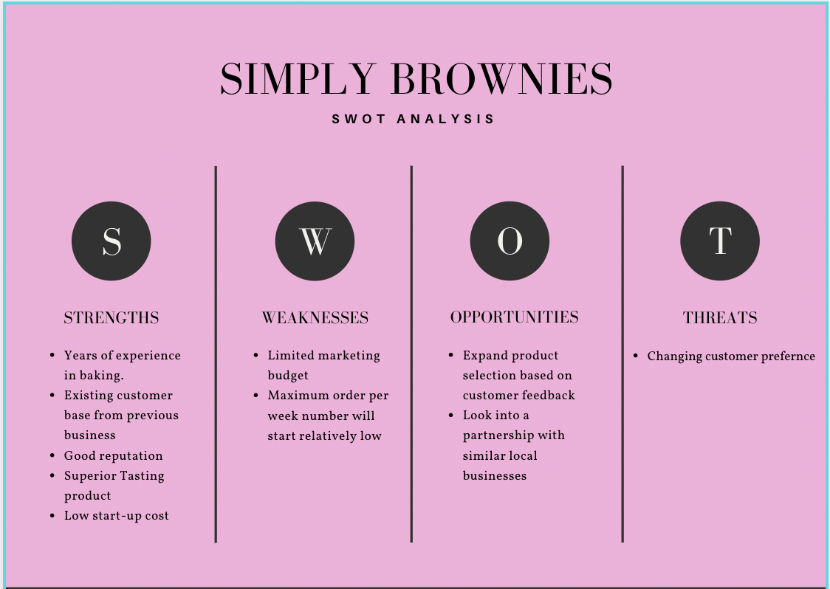
The main risk to the business will be illness, as the owner will be running the business alone with no staff. The business model means that orders are not accepted for more than a week in advance, so were the owner to become ill, orders would close for the week and not be turned back on until the owner was recovered. As the maximum order capacity per week is 40, that would be the maximum number of orders that would need to be cancelled and refunded if this were to happen. The owner does not believe this would be disastrous. There would be no income for the period of illness, but as the business’ running costs without having to purchase ingredients and packaging are very low, there would be very little in the way of loss. Any losses that occurred would be quicky recuperated when trading re-started. There is also the risk of customer court action. The owner has purchased product and public liability insurance with cover up to £5 million so would be covered if this should occur. There is also the risk of fire or flood. Damages would be covered by building and contents insurance, and although the business would be unable to trade until all damage was repaired which would mean no income, as stated earlier, running costs are low enough that this would not mean that the business would be unable to cover them should the worst happen.
In the current climate it is also worth mentioning, that should we enter another lockdown, the business would still be able to trade, and the owner would not expect a big difference in the number of sales received.

Sales and Marketing Strategy

Simply Brownies will be marketed exclusively through social media and orders accepted solely through the website. The owner would expect sales to start relatively slowly until the business’ social media accounts grow a larger following. No orders will be accepted through the business’ social media channels; they are solely to advertise Simply Brownies products and widen the customer base.
The business will increase social media posts, run competitions and add limited edition seasonal flavours around Christmas and Easter so the owner would expect to see an increase in sales at those times. There should also be an increase in orders for Mother's Day, Father's Day and Valentine's Day. There may also be a slight increase in July for Teacher's gifts, but not as significant as other occasions. The business could expect a slight dip in January (new year’s resolution diets, plus reining in spending after Christmas) as well as in August during holiday season.
Simply Brownies intend to run a monthly competition on both Facebook and Instagram. The prize will be a box of 6 brownies. Entrants will need to like the page, like the post, tag a friend in the comments and share the post to their ‘stories’. The owner believes this strategy will grow their follower base and number of people viewing the page, month on month.

Product or Service Offerings

Simply Brownies will offer a wide range of different flavoured brownies. They will be available in boxes of 4, 6, 9 or 12. There is also a ‘slab’ option. This is a 9-inch square brownie. It will be decorated according to the flavour selection, and can contain a customisable message, such as ‘Happy Birthday’. This option can be used as an alternative to a celebration cake and could be used for a number of different occasions.
Simply Brownies will also offer seasonal flavours and products, such as mini-egg and crème egg at easter, or gingerbread and Christmas tree shaped brownies at Christmas. Slabs can also be seasonal, and packaging styles and colours will be customised for sales ordered as gifts for occasions, such as Mother’s Day and Valentine’s Day.
Simply Brownies believe the unique selling point for the business is the taste of the product, as well as the fully customisable options available to the customer who will order only the flavours they want, using the pick and mix menu.
A price and flavour list available to view in the appendix.

Pricing Strategy

The owner came up with the pricing strategy by researching similar business models, calculating their costs, and deciding which end of the market the business was to be a part of. The owner did not want to charge the lowest price possible, as Simply Brownies offer products very good quality products, and the pricing reflects that.

Operations

Simply Brownies will be operated out of the owner’s home kitchen. The owner has completed the level 2 hygiene certificate (High Speed Training, 2021) and registered the business with Carmarthenshire County Council. An environmental health officer has inspected the kitchen as well as the food hygiene qualification, cleaning schedules and storage space. They have also viewed ingredient lists which have been printed that show any allergens in the products. These are given to customers with each order, along with storage instructions. The business has followed all advice from the Food Standards Agency website and Safer Food Better Business information packs and been awarded a 5* hygiene rating. (Food Standards Agency, 2020). Simply Brownies also has public and product liability insurance in place.
The current kitchen space is small, although if the business were to grow to a point that enabled the owner to give up work and focus solely on it, there is room for expansion. However, that is not necessary at the moment.
The business intends to purchase brownie tins, mixing bowls, utensils and pans, and that is all that will be required in the way of equipment. The owner will be using the oven that is currently in the kitchen as that will be adequate. After the first year of trading, the business may purchase an additional oven which would enable more orders to be fulfilled, however that is not required at this point.
Simply Brownies will be able to bake four orders at the same time, and this will take around 45 minutes to complete in total. The maximum number of orders that can be accepted initially will be 40 per week. This is manageable for the owner alongside paid employment. If Simply Brownies’ sales increase according to the forecast, after six months the owner intends to reduce the hours at her full-time job, which will mean orders can increase to 60 per week.
Orders will be accepted solely through the website. Customers will be able to place orders from Wednesday to Sunday each week, which will be delivered or ready to collect on Thursday, Friday or Saturday of the following week. Customers will be able to select the day they would prefer. Orders will not be able to be made any further in advance. This will mean that on a Sunday evening when orders have closed, the owner will be able to see exactly what has been ordered for the following week, and the quantity of ingredients required. Ingredients will be sourced from supermarkets, and other supplies such as packaging will be purchased online in bulk.
The payment infrastructure used on the website so that customers can make card payments will be Stripe (Stripe, 2021)
All orders will be paid for before ingredients have been purchased, so there is no risk of late payment.

Financial Plan

Simply Brownies does not have huge start-up or running costs as it will be operated from the business owner’s home. The biggest investment will be the website design and build.
Simply Brownies intend to apply for a business loan of £1000 which be repaid over a £24 month period. The owner will also be investing £500 from savings. The largest start-up cost will be the design and creation of the website. All orders will be taken through the website, so it is imperative that it works exactly that way that the owner requires, and no costs will be cut in this area. The owner has been quoted £1000 for this service.
The remainder of the start-up funds will be used for equipment and supplies such as packaging.
Products costings, prices and profit margins are shown in the table below:

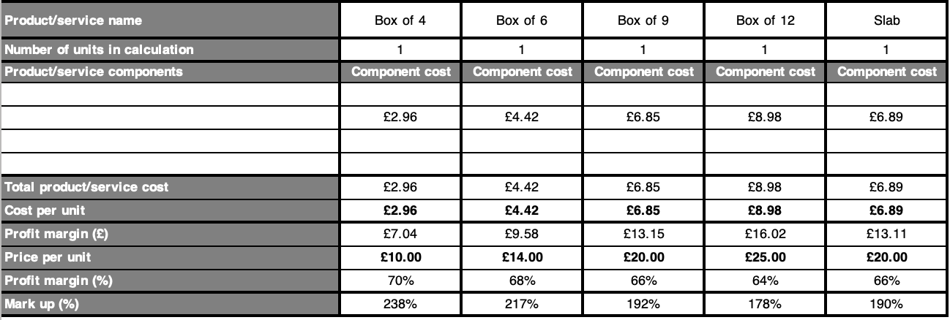

Sales forecast for the first year (number of sales):

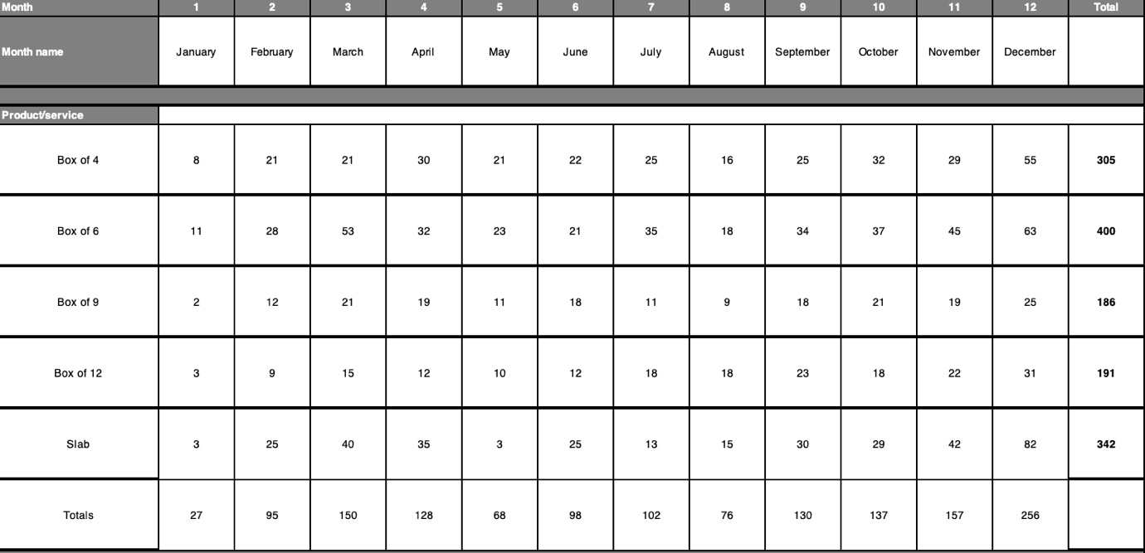

Income from sales according to forecast:

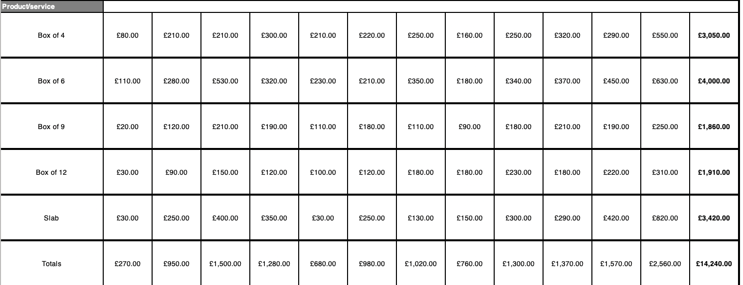

Sales Costs:

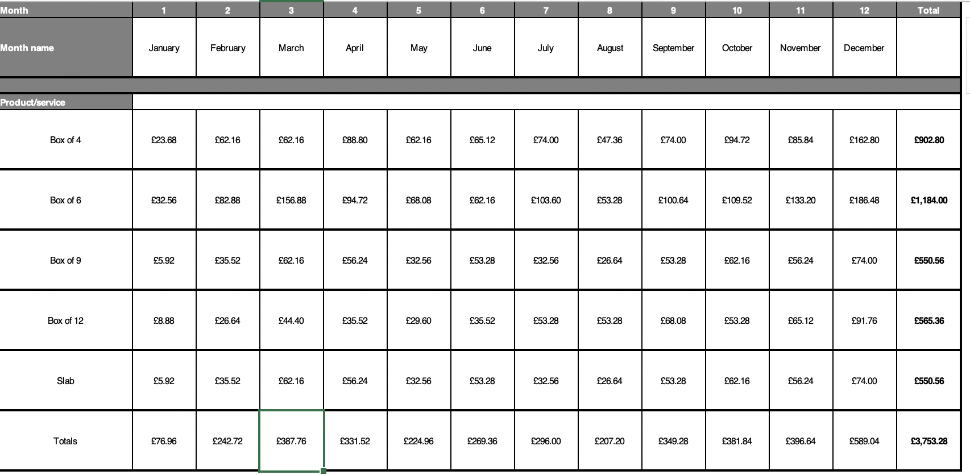

From January to June, the owner will continue to work full time, so living costs can be covered with salary alone. From July 1st, the owner intends to reduce her hours at work which will enable additional orders to be taken. All profit made during the first 6 months, as well as the excess from the owner’s wages will be saved to use as a contingency plan/in case of emergency.
The cashflow for first year of business predicts a profit of £9235.88:

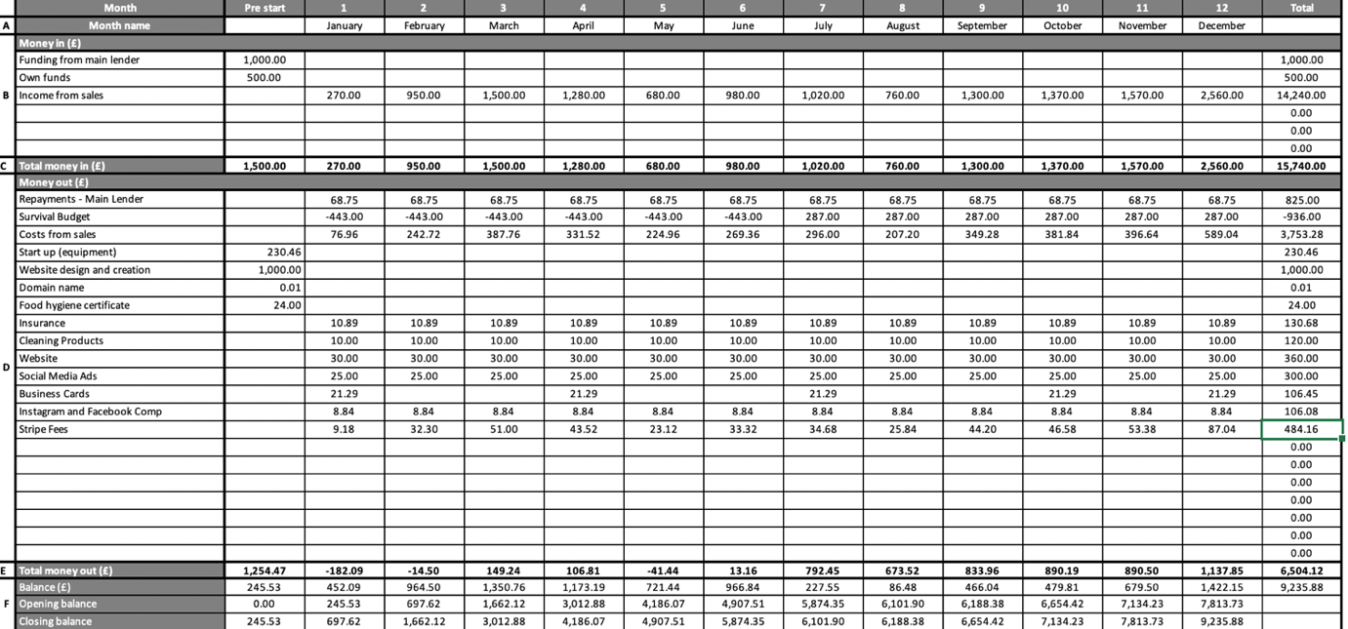

Cashflow forecast with sales 20% lower than forecast:
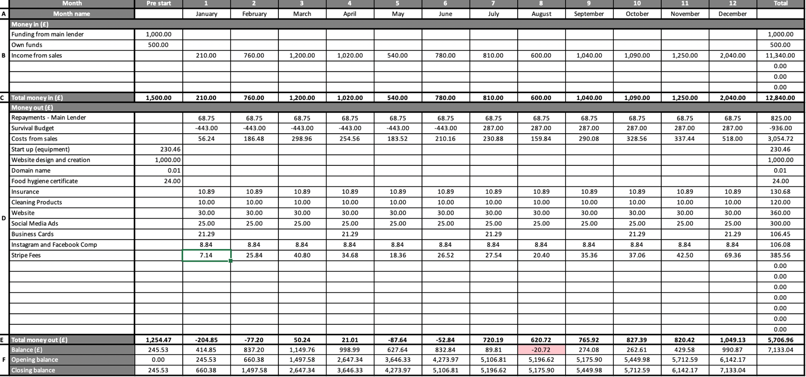

Simply Brownies business model means that all orders are paid for in advance, therefore there is no risk of late payment.
In the extremely unlikely event that no orders are received, then obviously the owner would not go ahead and reduce her hours at her full-time job after six months of trading as planned. The owner would not need to purchase ingredients, packaging, business cards or any other running supplies, and all other outgoings such as loan repayments, insurance and website running costs are low enough that costs could comfortably be covered using her salary. The owner believes that the amount of the loan required is low enough that even with zero sales, the risk to any potential lender is extremely low.

References

Big Bear Blondies (2020) Welcome to Big Bear Blondies [Online] Available at: https://www.bigbearblondies.com/ (Accessed 30th June 2021)
British Baker (2021) Top Bakery Trends for 2021: Part 2 [Online] Available at: https://bakeryinfo.co.uk/finished-goods-reports/top-bakery-trends-for-2021-revealed-part-2/652037.article (Accessed 4th July 2021)
Food Standards Agency (2020) Safer Food Better Business [Online] Available at: https://www.food.gov.uk/business-guidance/safer-food-better-business-sfbb (Accessed 30th June 2021)
Food Standards Agency (2020) Starting a Food Business from Home [Online} Available at: https://www.food.gov.uk/business-guidance/starting-a-food-business-from-home (Accessed 30th June 2021)
Kenton, W. (2020) PEST Analysis [Online] Available at: https://www.investopedia.com/terms/p/pest-analysis.asp#:~:text=PEST%20Analysis%20(political%2C%20economic%2C,are%20central%20to%20this%20model (Accessed 8th July 2021)
Gov.Uk (2020) Age Groups [Online] Available at: https://www.ethnicity-facts-figures.service.gov.uk/uk-population-by-ethnicity/demographics/age-groups/latest (Accessed 6th July 2021)
High Speed Training (2021) Looking for a Food Hygiene Certificate [Online] Available at: https://www.highspeedtraining.co.uk/food-hygiene/ (Accessed 2nd July 2021)
Ibis World (2021) Bakery Product retailing in the UK [Online] Available at: https://www.ibisworld.com/united-kingdom/market-research-reports/bakery-product-retailing-industry/ (Accessed 4th July 2021)
Stripe (2021) Payments Infrastructure for the Internet [Online] Available at: https://stripe.com/gb?utm_campaign=paid_brand-UK_en_Search_Brand_Stripe-2032860449&utm_medium=cpc&utm_source=google&ad_content=355351450259&utm_term=kwd-94834400&utm_matchtype=e&utm_adposition=&utm_device=c&gclid=Cj0KCQjwraqHBhDsARIsAKuGZeEuDEClgC3P9Tq0-b8PfKE8htWJ_2zoOLQ3cua_-dsb6gVkEf8549caAiYgEALw_wcB (Accessed 4th July 2021)
Ward, S. (2020) Business Plan Example: The Business Overview [Online] https://www.thebalancesmb.com/business-plan-example-of-the-industry-overview-2948009 (Accessed 4th July 2021)
Whitney, P. (2019) Overview of the Market [Online] Available at: https://www.hallidays.co.uk/views-and-insight/sector-report/bakery-product-production-industry (Accessed 4th July 2021)
Your Company Formations (2020) How to Start up your own Artisan Bakery Business [Online} Available at: https://www.yourcompanyformations.co.uk/blog/how-to-start-up-your-own-artisan-bakery-business/ (Accessed 4th July 2021)

Appendices

Price and flavour list:
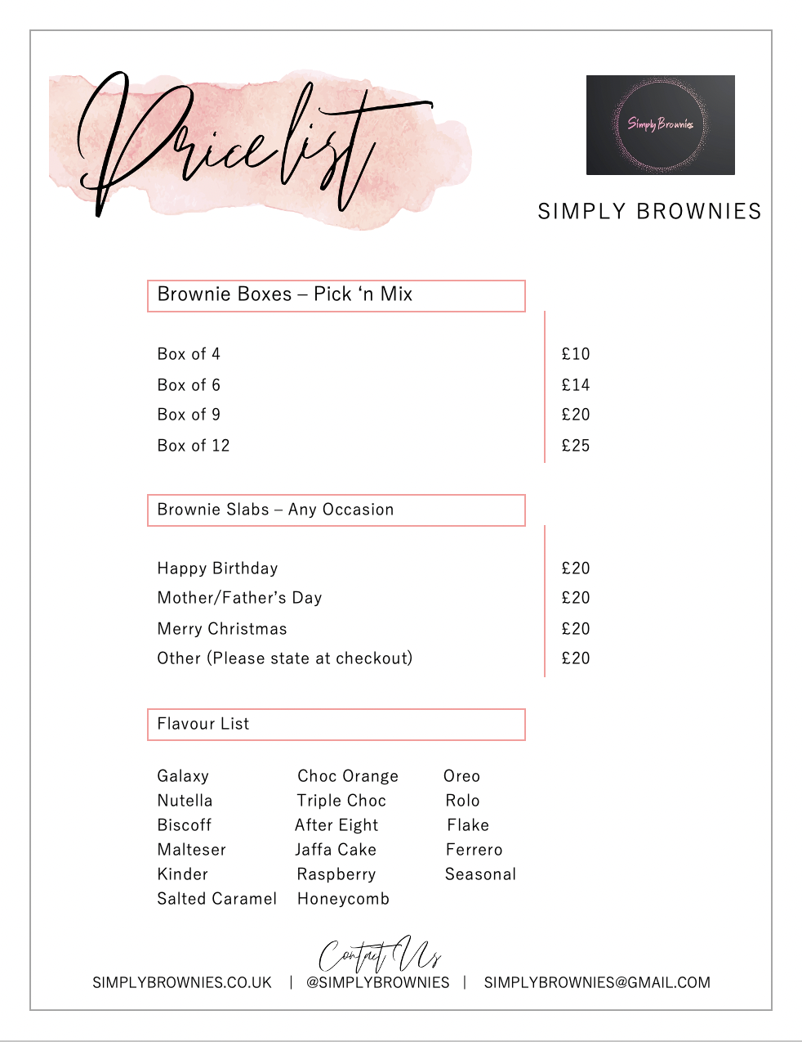

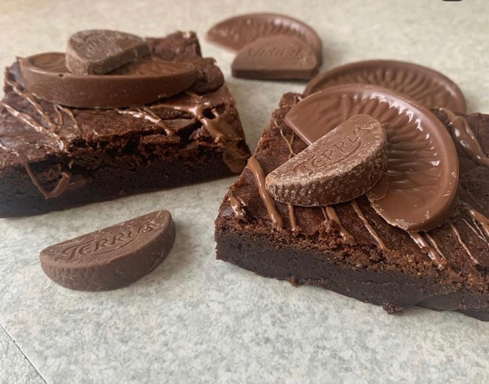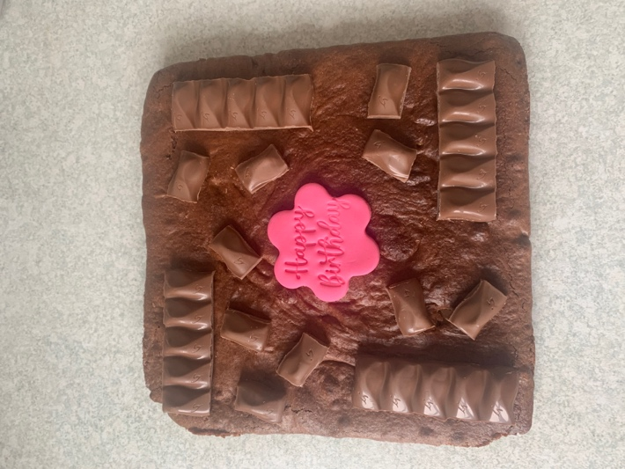
Sample choc orange brownie Sample Happy Birthday slab
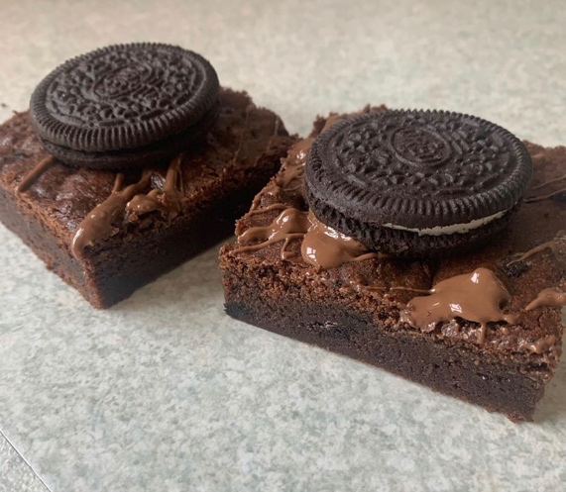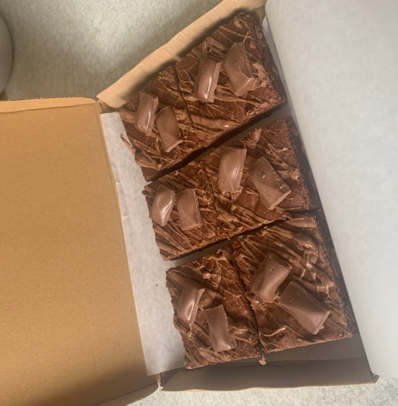
Sample Oreo brownie Sample box of 6
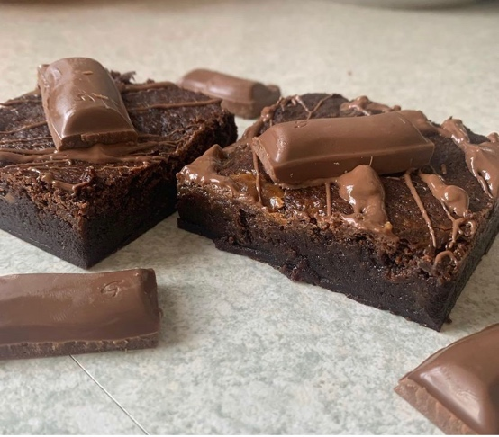
Sample Ferrero brownie Sample Galaxy brownie
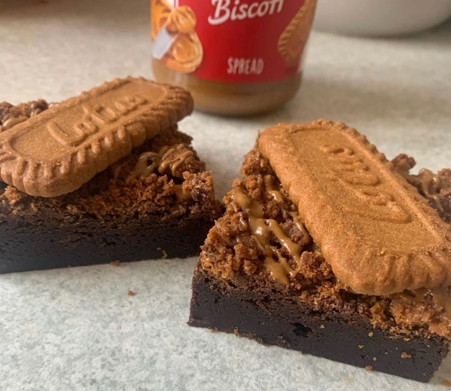
Sample Biscoff brownie

Costs and Prices

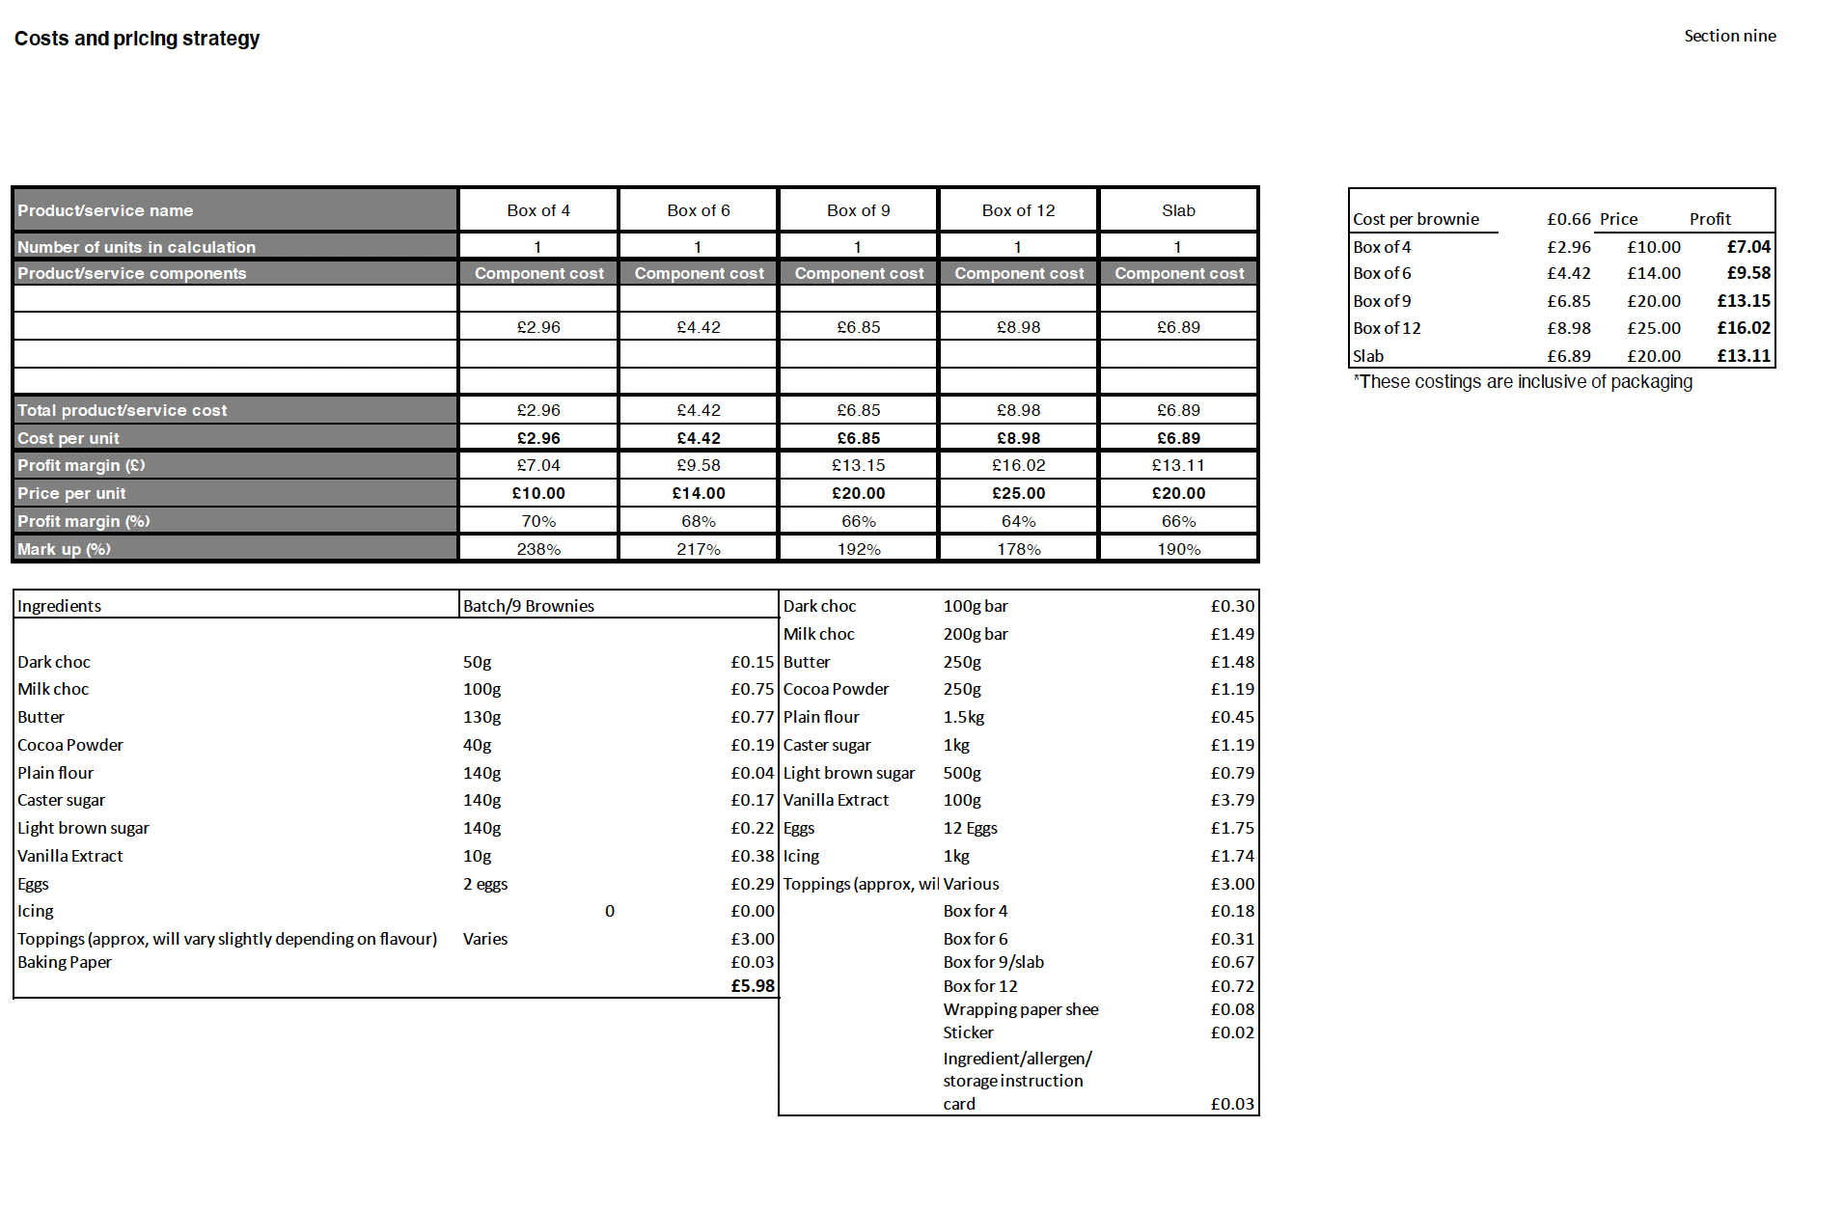

Sales Forecast – Number of Sales

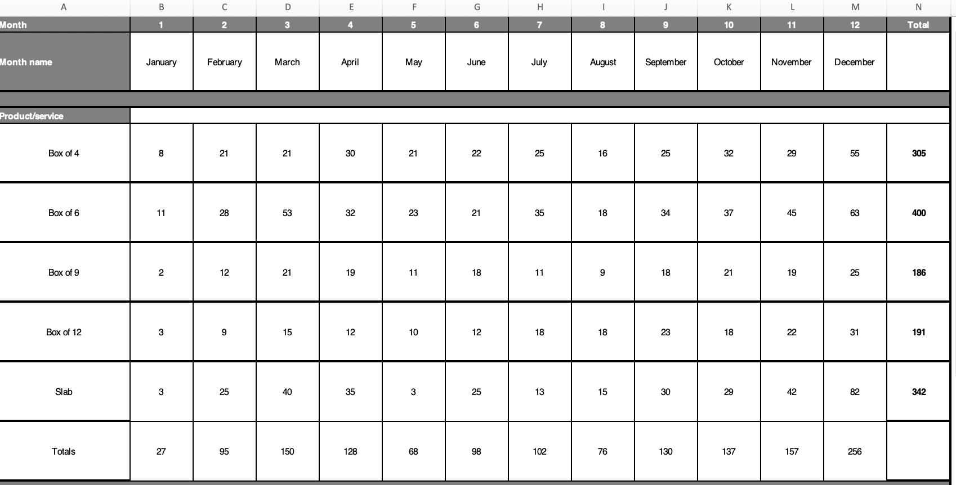

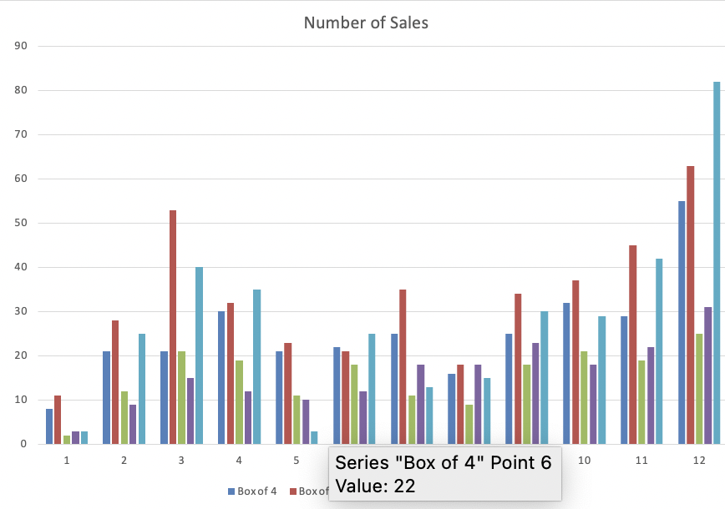

Sales Forecast – Sales Income

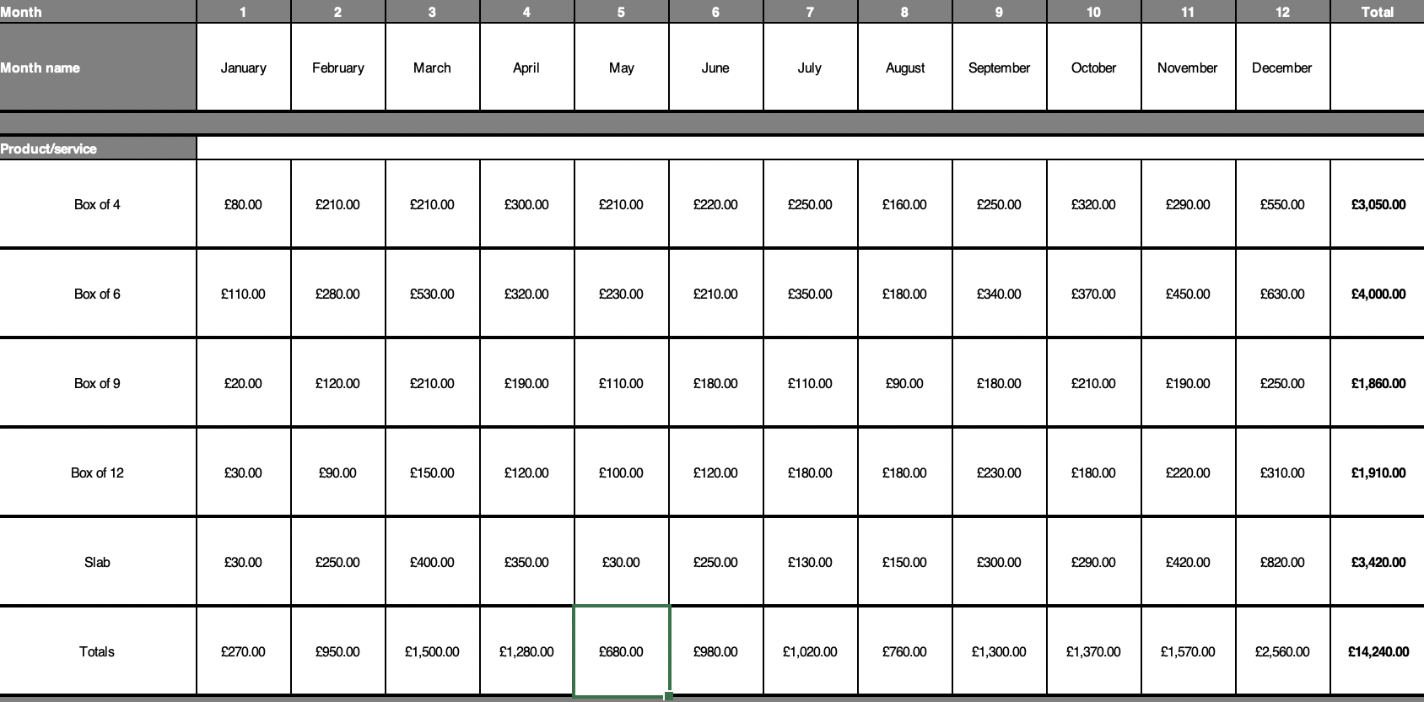

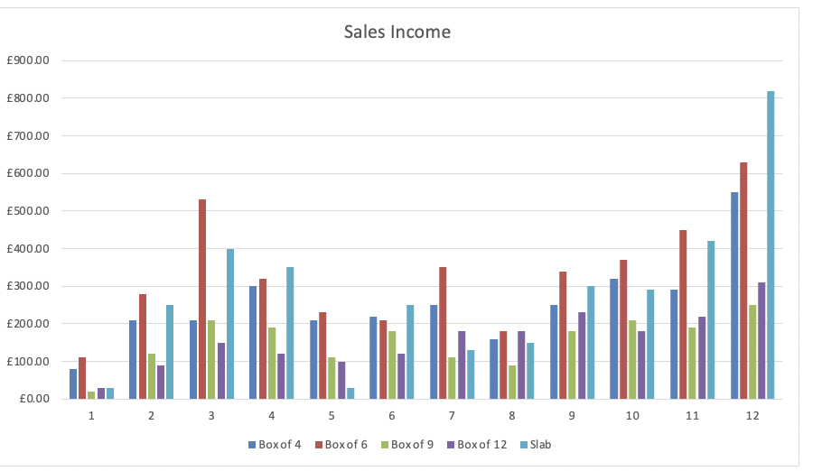

Sales Forecast – Sales Costs

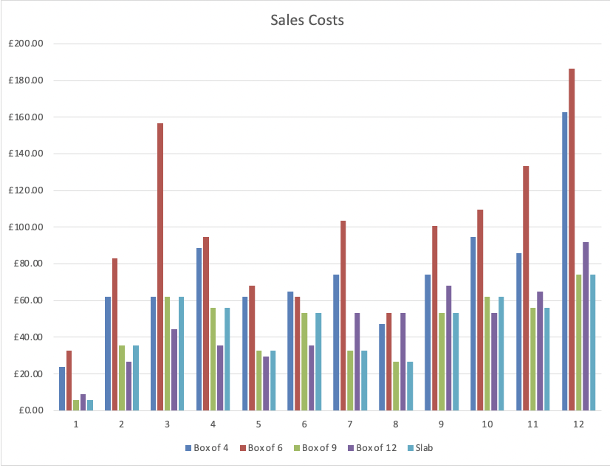

Survival Budget:
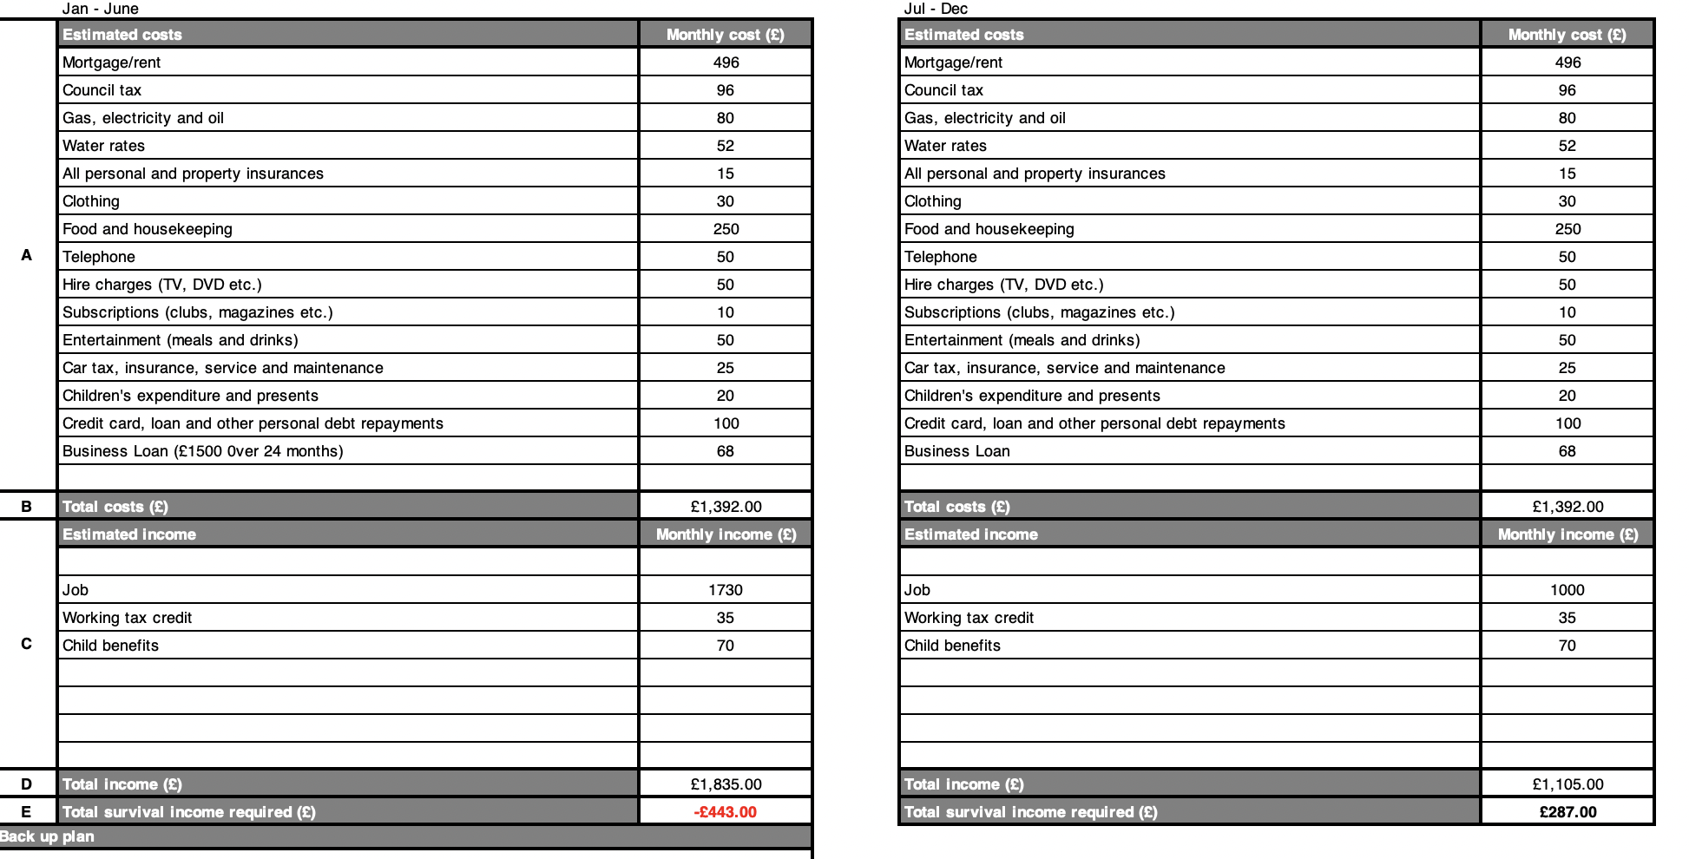

Cashflow Forecast for First Year:
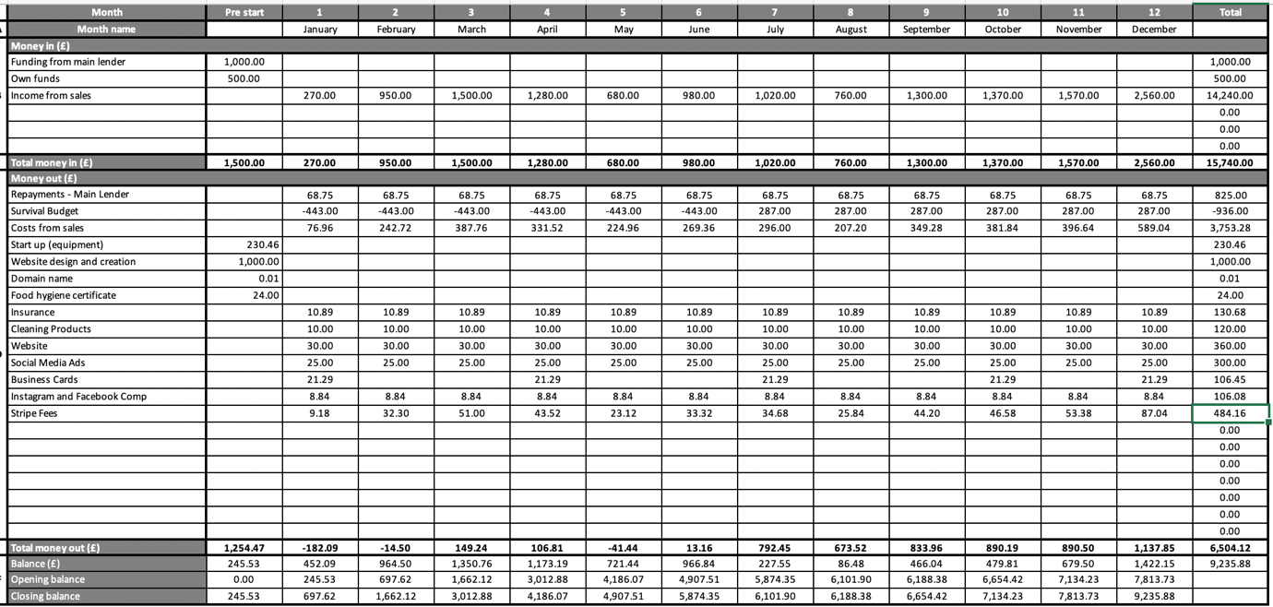

Costs Table:
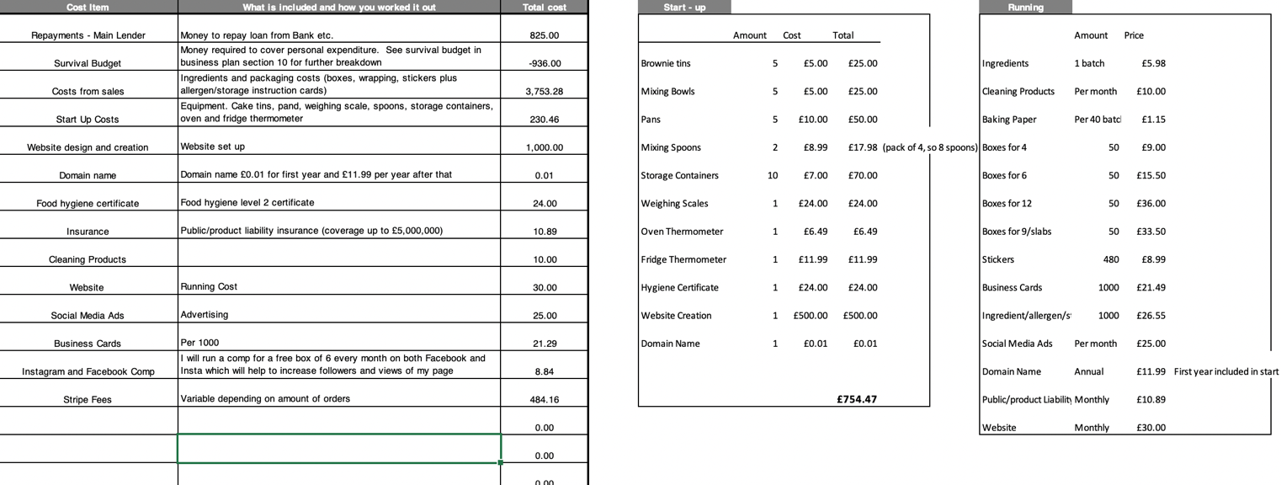

Sales and Costs Forecasts with 20% Fewer Sales
Sales:
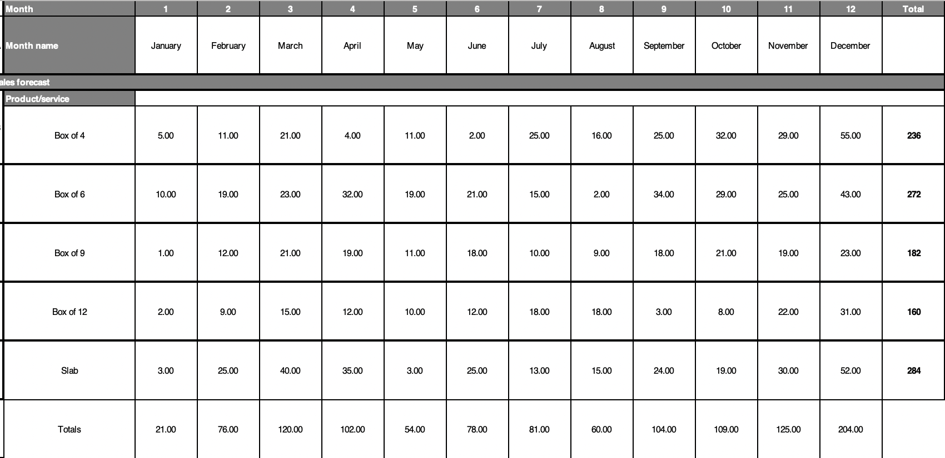

Income:
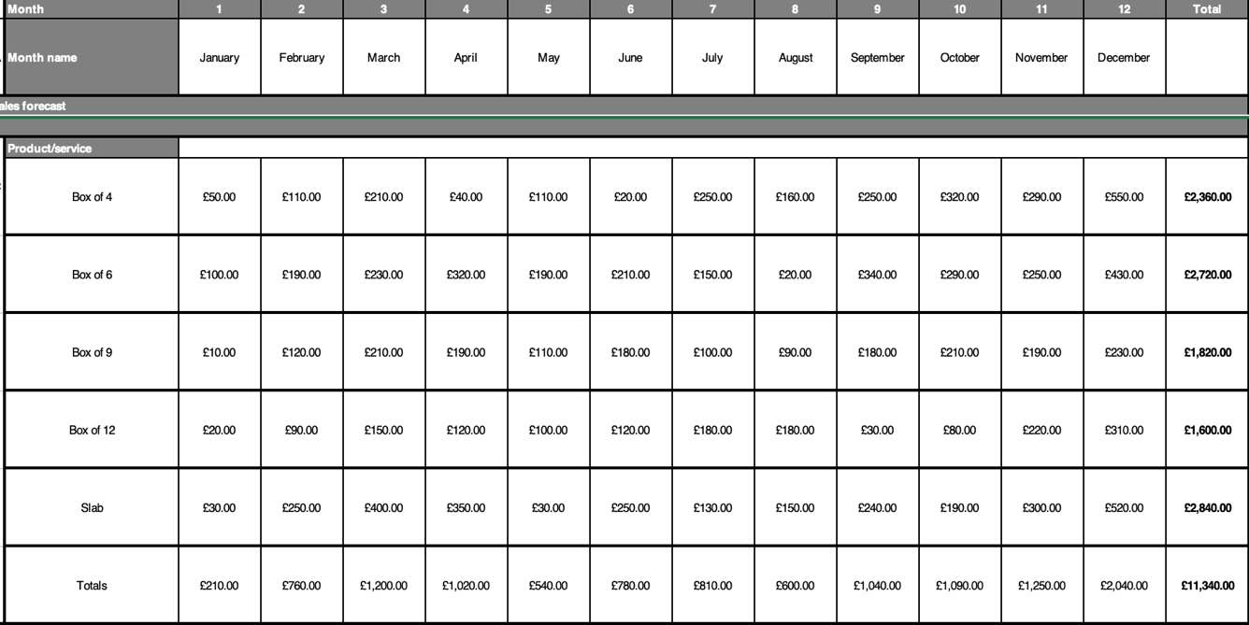
Income:
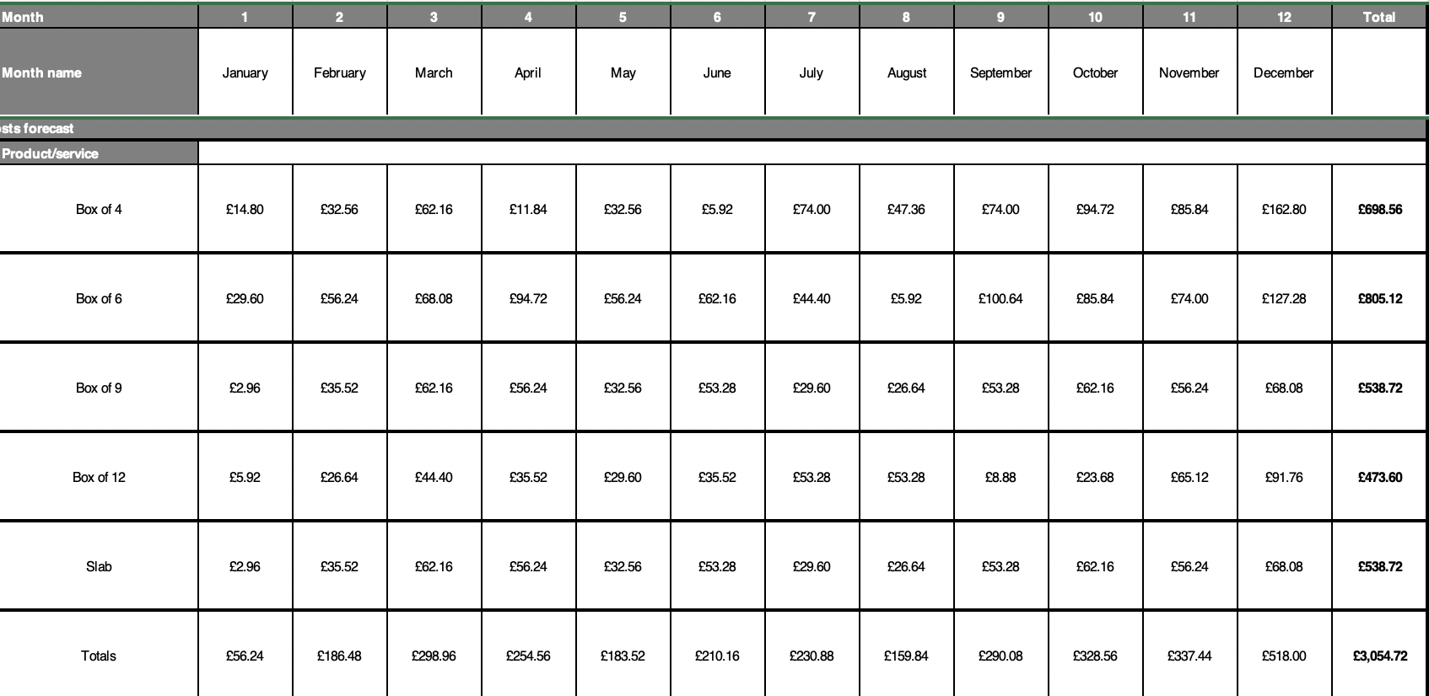

Cashflow Forecast with 20% Fewer Sales:


