
Strategies for Resilience and Prosperity
Lidl

November 1, 2022
Anne-marie Thomas
2011226

Contents
Executive summary
1.0 Introduction to Lidl Page 3
1.1 Lidl Background Page 4
1.2 Report Objective Page 5
1.3 Competitive Strategy Page 6

2.0 Main Findings
2.1Overview of Lidl’s strategy Page 7
2.2 Analysis of Lid’s Business strategy Page 8
2.3 Porters Generic Framework Page 10
2.4 Advantages and Disadvantages of Porter’s Five Forces Page 11
2.5 Bowman’s strategic clock Page 12
2.6 Evaluation of Porter’s Generic strategy and Bowman’s clock Page 14
2.7 Swot and PESTEL of Lidl Page 15
2.8 Management tools Advantages and Disadvantages Page 17

3.0 Conclusion Page 18

4.0 References Page 19
2011226
Executive Summary
The objective of this report is to give an overview of Lidl and their strategies for resilience and prosperity, whilst looking at the companies background and objectives and competitive strategy. Analysing the company’s internal and external factors by using a SWOT and PESTEL, and strategic model ‘s and theorist’s that created these model’s.

2011226
1.0 Introduction to Lidl
Lidl was founded in Germany in 1973 with three members of staff and only 500 products for sale. (About Lidl GB - Lidl Great Britain, n.d.),
Lidl mission statement is ‘To enhance the lives of our customers, by providing quality products at market leading value’. Whilst also promising customer satisfaction at the heart of everything they do. (LIDL Mission Statement 2022 | LIDL Mission & Vision Analysis, 2021)

2011226
1.1 Lidl Background
Lidl first came to life as a fruit wholesale in 1932 with Josef Schwarz become a partner in Südfrüchte Großhandlung Lidl & Co and developed into a general food wholesaler in 1973, (10 Facts About Lidl | Less Known Facts, 2017)
After being successful in Germany although this took nearly 16 years they expanded to France in 1989, before coming to the United Kingdom in November 1994.
it is now one of the leading grocery retail names in the United kingdom, with over 935 stores and 13 regional distribution centres, with over 28,000 members of staff. (Welcome to Lidl - Lidl International, n.d.)
Lidl strive to provide their customers with the highest quality products possible by keeping their prices as low as they can, whilst also sourcing locally where possible with over two thirds of their products being sourced from UK suppliers. (Our History, n.d.). Delivering outstanding customer satisfaction, whilst working with their business partners to achieve their sustainable relationship and continue their positive contributions to local communities.
Lidl strive to achieve their ongoing success by investing in recruitment, training, and development of their people.

2011226
1.2 Report Objectives
The purpose of this report is to critically analyse Lidl and recognise Lidl’s strategic standing for resilience and Prosperity. Evaluate their business strategy and how they organise their strategic direction, whilst looking at strategic theorists that Lidl can or may have used during their business journey whilst looking at the components of their internal and external factors.
look at various theorist and their views on strategic strategy and how a business should implement various strategic ideas to improve their strategic positions within the competitive world.
Identify Lidl business strategies and their current position in their business environment.

2011226
1.3 Competitive Strategy
Fundamentally, a business strategy is a companies plan of what they are going to do in the future their long-term plan to achieve their strategic goals. When a business strategy is not well defined or interpreted it is highly likely a business will start to struggle and could even end up becoming victims of their own success.
Johnson states that ‘Strategy is the direction and scope of an organisation over the long term’ (Johnson et al 2011).
Gerry Johnson and Kevin Scholes authors of the book ‘Exploring corporate Strategy’ also state ‘strategy should determine how resources should be configured to meet the needs of markets and stakeholders’(johnson2008)
Strategy consultant Martin Heubel states ‘A strategy explains how a company plans to compete in a market and how it intends to grow at a profit’. (Heubel, 2022)
Organisations can identify internal and external factors that influence and effect their businesses. This can be done various ways however one is a SWOT and Pestel analysis that business use worldwide to conduct analyses to assess the condition, and environment for strategic planning.(Contributor, 2022)
Swot doesn’t only assists companies in assessing their current situation but also in implementing countermeasures to remove obstacles and stop things from preventing them from realising their full potential. Whereas PEST will look at external factors and essentially used for market research. (Contributor, 2022)
Bowman’s clock is a marketing tool that aids business stablish their market position regarding their competitors. (“Bowman Strategy Clock,” 2022)
This report will also look at Henry Mintzerberg and his five configurations approach to strategic management. (Mintzbergs Five Configurations of Strategic Management, n.d.)
Harvard Business School professor Michael E Porter identified three varieties of generic strategy that can be chosen by businesses when trying to identify their competitive advantages.
Cost Leadership
Differentiation
Focus
Companies may, however, be unable to successfully implement one of these general tactics. Porter characterises this as being ‘stuck in the middle’ (Heubel, 2022)

2011226
2.0 Main Findings
2.1 Overview of Lidl’s Strategy

An international discount chain with approximately 10,000 locations worldwide, an America brand that supply a daily, weekly & monthly low cost strategy designed to provide a no frills easy shopping experience for all, by having stores layout straight forward.
Lidl is strategizing to transform the way we shop, currently selling fresh fruit and vegetables, fresh fish ,meat produce, chilled foods, beers, wines and spirits along with house hold staples of cleaning products and health and beauty items. Lidl also has an instore bakery’s which makes it a one stop shop.
Lidl sustainable strategy is to ‘make good food accessible to everyone’, their vision is to provide foods and products and ensure they are sold and consumed in a manner that benefits producers, the planet and people. (Lidl UK - Sustainability - Lidl Great Britain, n.d.)
Lidl have three themes The Producer, People and The Planet, each category Lidl have profiled priority issues, set clear ambitions and measurable targets.
October 2022 Lidl’s sales in the UK grew dramatically to 20.9 percent, this is the highest growth that has been seen in the UK since 2014. (Statista, 2022). This has stemmed from using their strategic framework to make Lidl successful.
The annual revenue of Lidl in 2020 was 97.8 Billion Euros, Lidl plan to achieve a net sale of 130 Billion Euros by the end of 2026. This would make an increase of revenue of 33 Billion Euros.(shaw,2022)

2011226
2.2 Analysis of Lidl Business Strategies.
‘A detailed plan for achieving success in one part or all parts of a business’(Cambridge Dictionary, 2022)
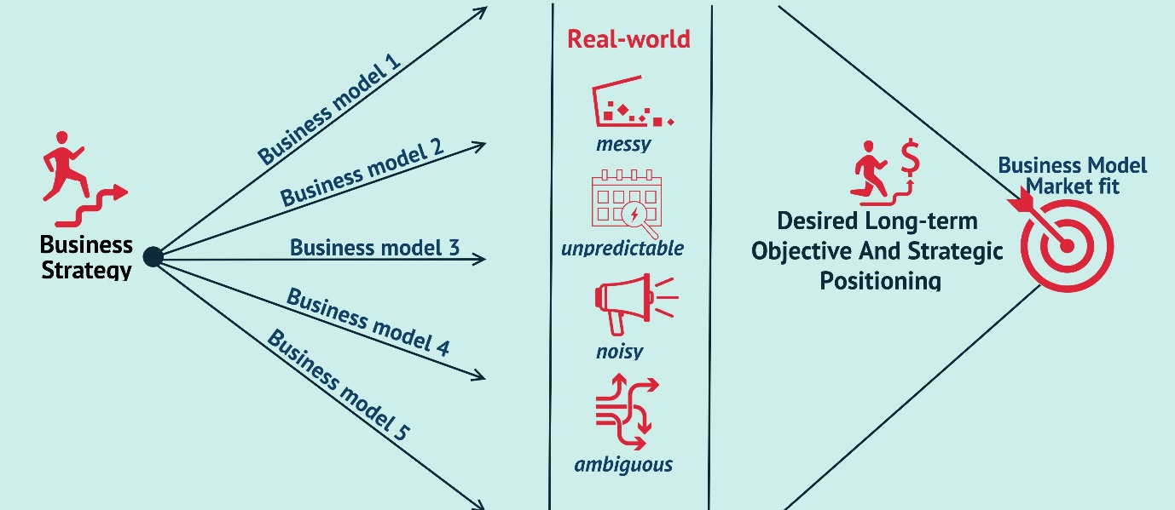
(What Is a Business Strategy - Bing Images, n.d.)

Stakeholder analysis
To be a competent company in analysing Lidl business strategies you must first identify the stakeholders whom have the most impact on Lidl and those who would be most impacted by any decisions that Lidl make. A stakeholder includes any person with an interest in the company which included investors, employees and their customers both current and future.
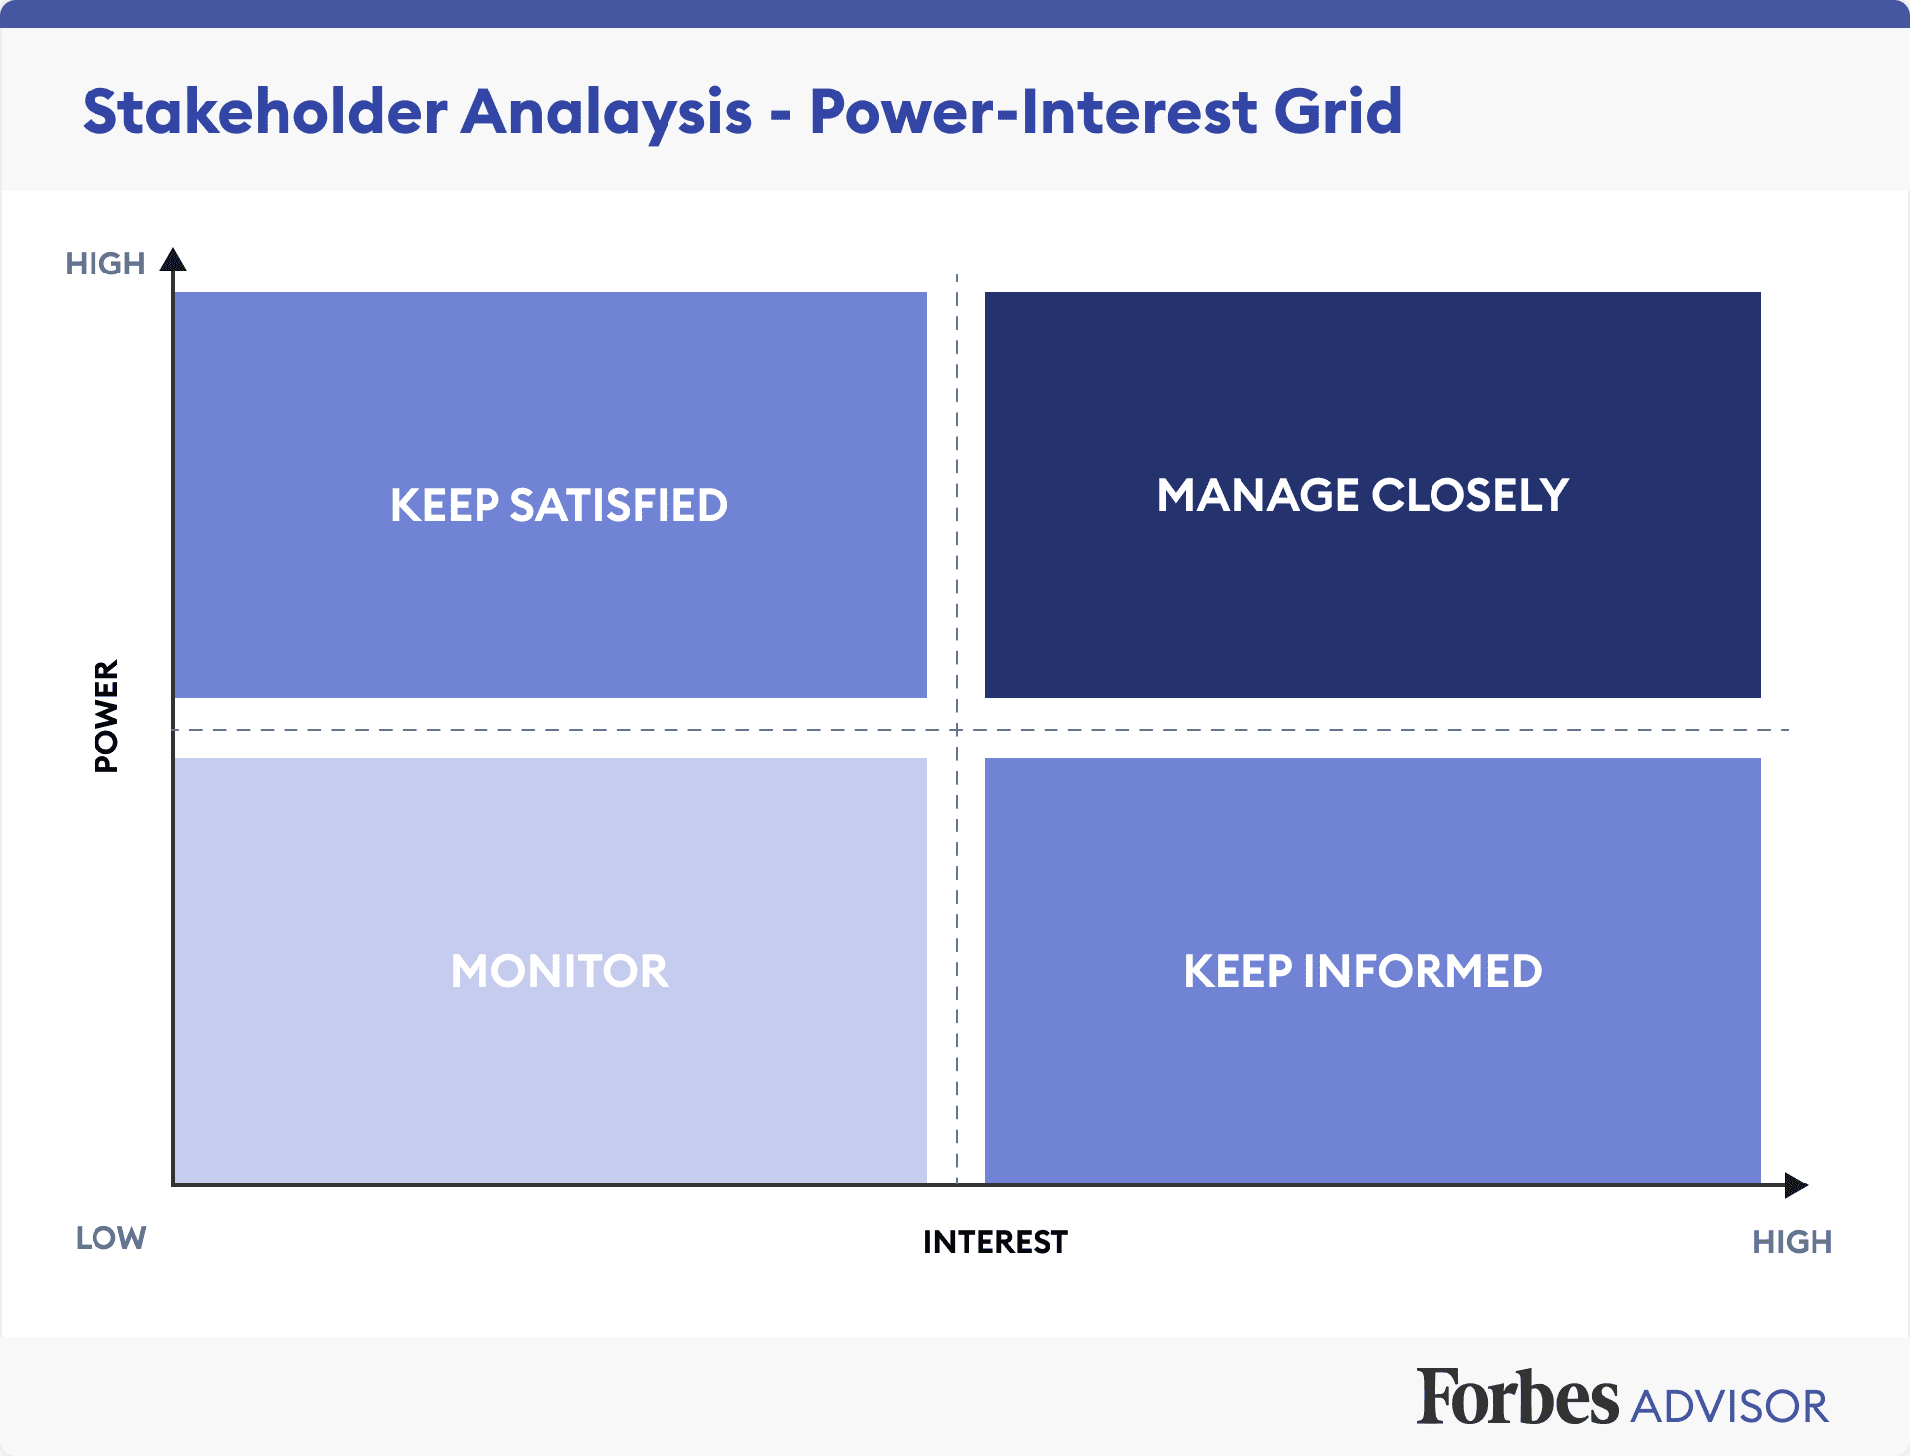
2011226 (Hoory, 2022)
By creating a stakeholder analysis you create a list of persons that the company need to communicate with about progress and any projects the company may have. The importance of understating each stakeholders needs and what they expect, to avoid any collision with each other or with any of the main requirements. (Hoory, 2022)

2011226
2.3 Porters Generic Framework strategy - Porters Five Forces.

Porters’ generic strategic framework can be applied to Lidl, there is a report by M Rahman called ‘Porters five forces analysis on the UK supermarket industry’. The report aims to examine competitiveness of the UK supermarket industry which in the report from 2020 states is £181 billion and is expected to grow rapidly in the coming years. (Rahman, 2020)
Porters Five Forces strategic model identifies and analgises the five competitive forces that shape every aspect of the business industry, this helps understand the business weakness and strengths in its industry. Porters Five Forces is often used to identify a business structure clarify corporate strategy.
- Competition in the industry
- Potential of new entrants into the industry
- Power of suppliers
- Power of customers
- Threat of substitute products
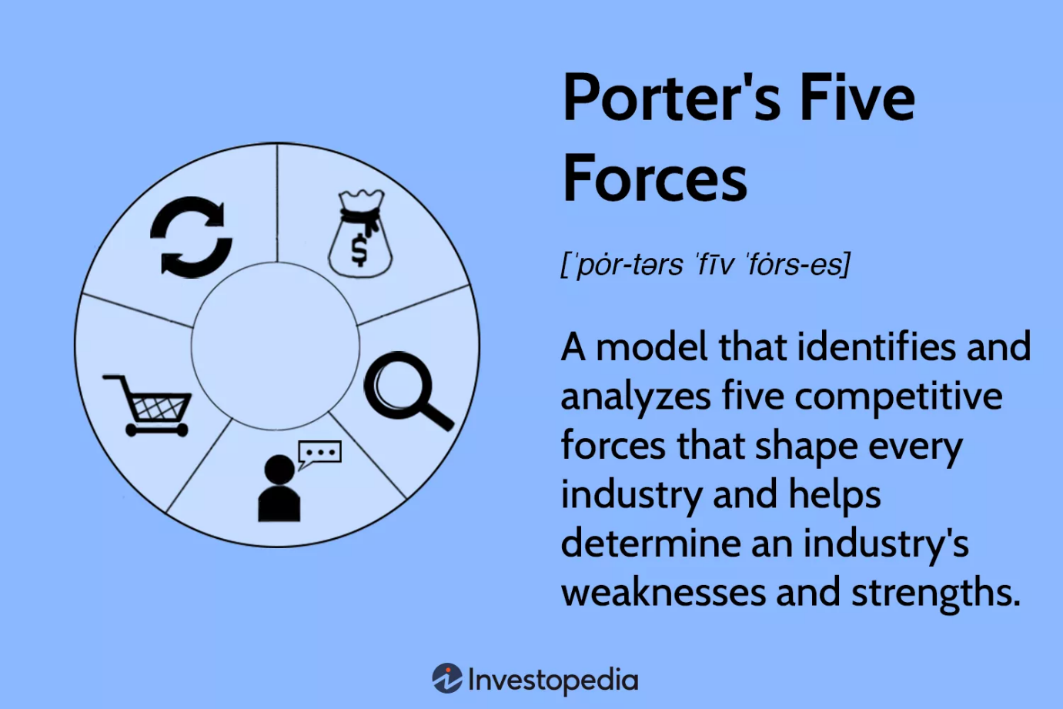
(Porter’s 5 Forces Explained and How to Use the Model, 2022b)

2011226
2.4 Advantages and disadvantages of Porters Five Forces

Some say that Porters strategies are outdated as they were created over 40 years ago, and backward looking with findings only relevant in the short term due to globalization. (Porter’s 5 Forces Explained and How to Use the Model, 2022b). Whilst another issue is that the framework is structured so that each business is placed on in one industry group where many businesses cross over many different groups, another issue identified by using Porter’s model is all five forces need to be looked at equally and some industries aren’t as impacted by all five.
Strategic planners and managers can understand how different factors under each of the five aspects affect the profitability of the industry, lower profitability will come from a strong force and greater profitability will come from a weaker force, by using this knowledge and judgement of the industry this type of analysis can be effective and lucrative for the business.

2011226
2.5Bowman’s Strategic Clock
Bowman’s Clock strategy was developed by two famed economists Cliff Bowman and David Faulkner, the clock focuses on the position of companies in the market in contrast to their competitors. (Bhasin, 2019).
Bowman’s clock is an accompaniment to Porters generic strategies, by applying Bowman’s Clock to Lidl will enable them to analyse their position in the market compared to their competitors. Competitive advantage and the cost advantage this will work to a company’s strengths,
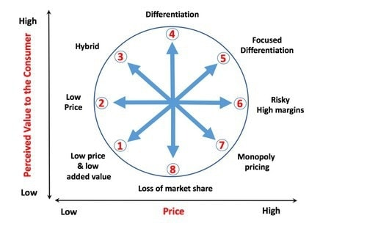
(Bhasin, 2019)

In the image above you can see Bowman’s has 8 possible strategies that a business can use, the eight strategies dived over four quads the eight strategies are displayed in clock form to compliment the name of the model Bowan’s Clock.
The strategic managers can plot their position that offers the most competitive advantages in the market in comparison to its competitors.
Lidl’s point on the Bowman’s clock is at position Two – Low price, business that produce or sell large quantities of products, and low prices. The L on the diagram below marks Lidl’s place on the Bowan’s Clock.

2011226
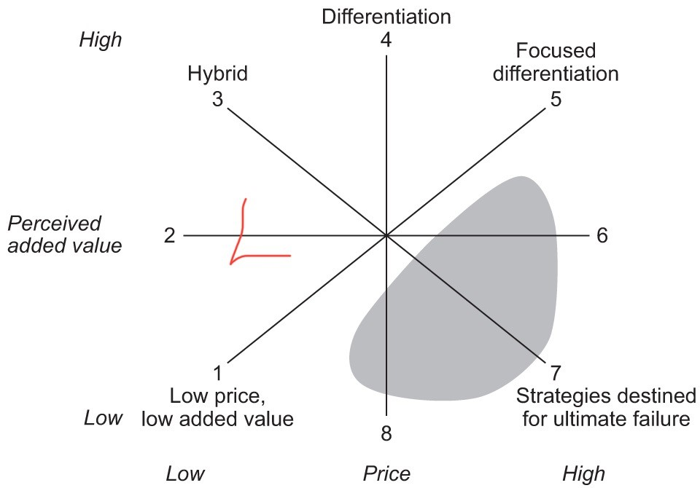

2011226
2.6 Evaluation of Porters Generic Strategy and Bowman’s Strategic Clock
Where Porters model is helpful to Lidl in some extent, some find the approach a little generic and require more detailed information. Bowman’s Clock is a more detailed frame work and was created to expand on Porter’s approaches. Both these approaches will help Lidl gain an insight to their company and the outside market, whilst help make improvements within. The majority of companies strive to be in 1-4 on the Bowman’s Clock, potion 6 through to 8 are not viable in the competitive market.

2011226
2.7 Evaluation of SWOT and PESTEL of Lidl
Focusing on internal and external strengths and weaknesses of Lidl, whilst also looking at the external opportunities and threats the company has to endure.

For a company to develop and expand at a diagnostic stage it is important to use a well know and broadly used strategic framework to analyse and monitor internal and external factors that have an impact on any organisation, whilst using a framework that is easily adjustable to the target of development, whilst considering the companies’ stakeholders e.g., normal citizens, politicians, owners.
A Pestel analysis is a detailed view of the environment a business is situated in, some companies call it a’ Birds Eye View’ (Contributor, 2022) this is where a company or individual tries to discover specific trends which include aspects of Legal and Environmental factors within the market place.
A SWOT analysis helps to recognise strengths, weaknesses, opportunities, and threats to your business, it is often used for strategic planning to stay ahead of the competitive market. Below is both a S.W.O.T and P.E.S.T.E.L of Lidl made up from my opinion from research and articles I have read.

S- Award winning brand
Own Label in store
Discounted goods
Loyalty card
Lidl has over 10,000 stores across Europe (MBA Skool Team, 2020)
The company operates in more than 25 countries across Europe (MBA Skool Team,2020)
W- Few employees in store to help customers
Rushed at tills
Supply chain issue due to Brexit
O-Market expansion
Online and digital expansion
T- competitors
Brexit
Price wars

P.E.S.T.E.L
Political – Brexit issues
Membership of the EU commerce
Economic- Low price
Discount chain
Social- Sustainability
Employee satisfaction
Technological- web shop
Internet and social medial advertising
Legal- legal action overpay dispute
Environmental- Support British farming
Environmentally friendly carrier bags
Energy efficient

SWOT and PESTEL of Lidl above has help identify a variation of external and internal factors, which will help the strategic management of the company. On research this report has identified that Lidl is one of the global leading retail chains.
Porter’s five forces and SWOT analysis are both tools that companies use to assist them with their strategic management decisions. Companies use Porter’s five forces to look at the competitive environment where they use a SWOT to look more in depth at the internal aspects and potential of the company.

2011226
2.8 Management tools advantages and Disadvantages
Advantages of using strategic model tools could be that the business has a strategic framework to work from, understands internal and external factors whilst monitoring the measurement of progress.
Disadvantages of using certain strategic models could be companies must avoid complacency, the company needs to always be aware of customers’ needs and the competitions whilst being vigilant and ready for global and local issues arising. Strategic plans often cease to function due to outside factors beyond the business control, such as the economic environment, competitors, and technological change.

2011226
3.0Conclusion
Many companies have in place and use strategic tools not one tool has been proven better than any other strategic tool, the right tool depends on the business in question and what suits them. Lidl’s strategic management seems to be working for them now whilst still adhering to their vison of
‘make good food accessible to everyone', whilst making sure their food and products are produced, sold and consumed in the best possible way to benefit the producers, people and the planet. (Lidl UK - Sustainability - Lidl Great Britain, n.d.-b)

2011226
References

10 facts about Lidl | less known facts. (2017, March 29). Less Known Facts | Less Known Facts That You Should Know. Retrieved October 24, 2022, from https://lessknownfacts.com/10-facts-about-lidl/

10 Reasons Why Strategic Plans Fail. (2011, November 30). Forbes. https://www.forbes.com/sites/aileron/2011/11/30/10-reasons-why-strategic-plans-fail/?sh=31cd37886a8b

About Lidl GB - Lidl Great Britain. (n.d.). Lidl.co.uk. Retrieved October 24, 2022, from https://corporate.lidl.co.uk/

Bhasin, H. (2019, April 17). What is Bowman’s Strategy Clock? Marketing91. https://www.marketing91.com/what-is-bowmans-strategy-clock/

Bowman Strategy Clock. (2022, May 12). Toolshero. Retrieved October 24, 2022, from https://www.toolshero.com/strategy/bowman-strategy-clock/

Cambridge Dictionary. (2022). business strategy definition: a detailed plan for achieving success in one part or all parts of a business: Learn more. https://dictionary.cambridge.org/dictionary/english/business-strategy

Contributor, P. (2022, July 21). PESTLE and SWOT Analysis: When to use SWOT. PESTLE Analysis. https://pestleanalysis.com/pestle-and-swot-analysis/

Contributor, P. (2022, October 4). SWOT vs. PEST, and How to Decide Which One to Use. PESTLE Analysis. Retrieved October 24, 2022, from https://pestleanalysis.com/swot-vs-pest-analysis/

Cuofano? W. I. G. (2022, August 27). What is Bowman’s Strategy Clock And Why It Matters In Business. FourWeekMBA. https://fourweekmba.com/bowmans-strategy-clock/

Heubel, M. (2022, August 21). What is Strategy? Definition, Components & Examples Explained. Consulterce. Retrieved October 24, 2022, from https://consulterce.com/business-strategy/

Hoory, L. (2022, August 8). What Is A Stakeholder Analysis? Everything You Need To Know. Forbes Advisor. https://www.forbes.com/advisor/business/what-is-stakeholder-analysis/

https: \/\/bsmarketingstrategy.com\/author\/admin\/#author. (2021, November 18). LIDL Marketing Strategy –. Business Marketing Strategy. https://bsmarketingstrategy.com/lidl-marketing-strategy/

Johnson, G and Scholes, K (2004) Exploring Corporate Strategy, London: Prentice Hall
Johnson, G, Scholes, K and Whittington, R (2011) Exploring Corporate Strategy: Text and Cases, London: Prentice Hall

Johnson. (2008). Student access kit for online materials that accompany: Gerry Johnson, Kevan Scholes, Richard Whittington, Exploring corporate strategy, eighth edition. Pearson Prentice Hall.

LIDL Mission Statement 2022 | LIDL Mission & Vision Analysis. (2021, February 22). Mission Statement. https://mission-statement.com/lidl-mission/

Lidl UK - Sustainability - Lidl Great Britain. (n.d.). Lidl.co.uk. Retrieved November 1, 2022, from https://corporate.lidl.co.uk/sustainability

Lidl UK - Sustainability - Lidl Great Britain. (n.d.-b). Lidl.co.uk. Retrieve
d November 1, 2022, from https://corporate.lidl.co.uk/sustainability

Mahru, M. (2020, September 4). Lidl Stiftung & Co. KG SWOT & PESTLE Analysis. SWOT & PESTLE.com. https://www.swotandpestle.com/lidl/

MBA Skool Team. (2020, April 26). LIDL SWOT Analysis, Competitors & USP. MBA Skool. https://www.mbaskool.com/brandguide/lifestyle-and-retail/2038-lidl.html

Mintzbergs Five Configurations of Strategic Management. (n.d.). Retrieved October 24, 2022, from https://www.managementstudyguide.com/mintzbergs-five-configurations-of-strategic-management.htm

Our history. (n.d.). Lidl GB and International. Retrieved October 24, 2022, from https://careers.lidl.co.uk/life-at-lidl/our-history

Porter’s 5 Forces Explained and How to Use the Model. (2022b, August 1). Investopedia. https://www.investopedia.com/terms/p/porter.asp

Rahman, M. (2020, January 1). Porter’s five forces analysis of the UK supermarket industry. Howandwhat. https://howandwhat.net/porters-five-forces-analysis-uk-supermarket-industry/

Statista. (2022, October 19). Lidl sales growth year-on-year in Great Britain 2014-2022. https://www.statista.com/statistics/386773/lidl-sales-percentage-change-great-britain-uk/

Welcome to Lidl - Lidl International. (n.d.). Lidl.in. Retrieved October 24, 2022, from https://info.lidl/en

what is a business strategy - Bing images. (n.d.). Retrieved November 1, 2022, from https://www.bing.com/images/search?q=what+is+a+business+strategy

