NOSS Assignment 2

Task 1
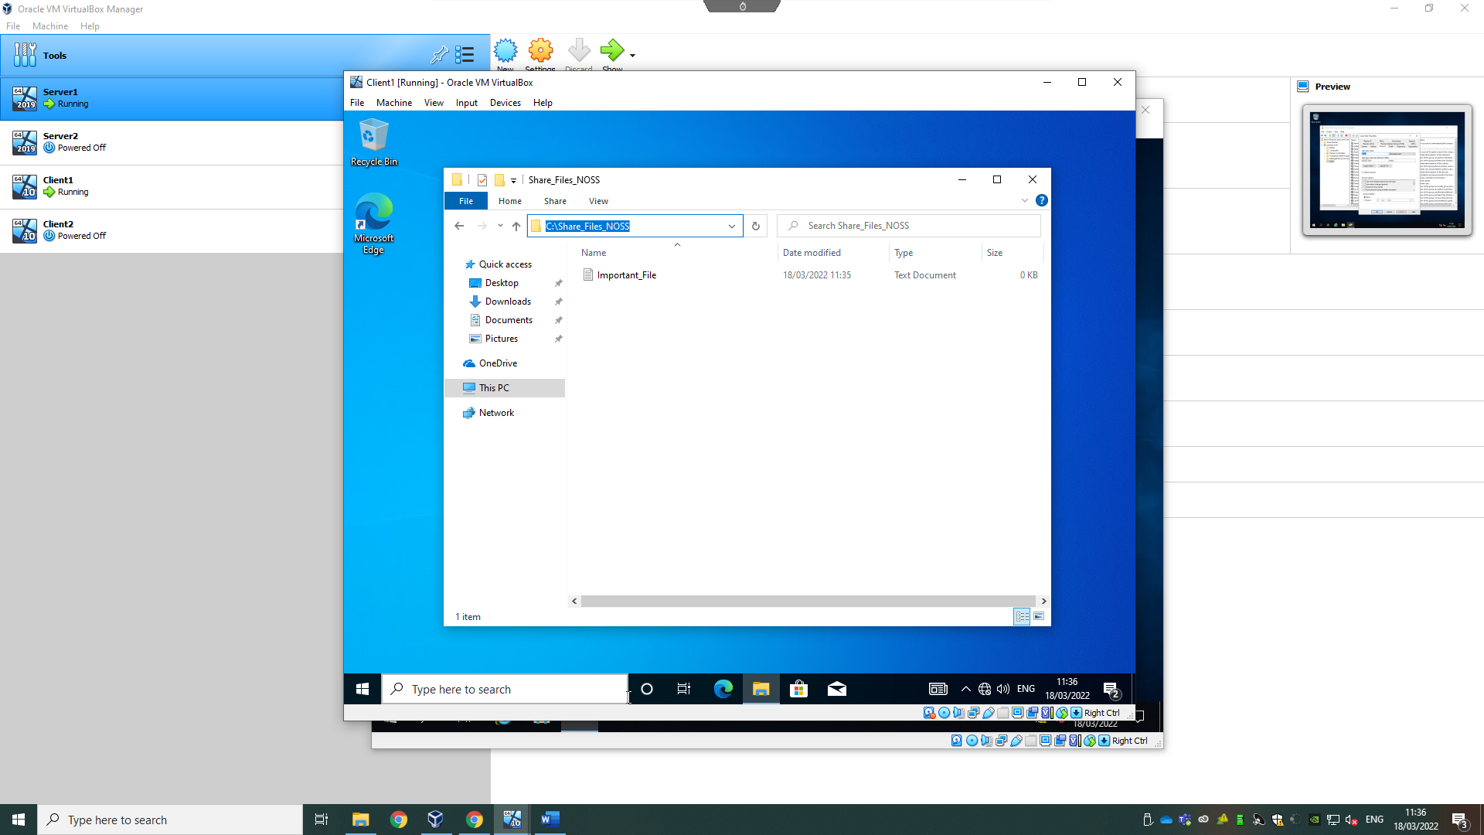
Creating a folder with a file in C
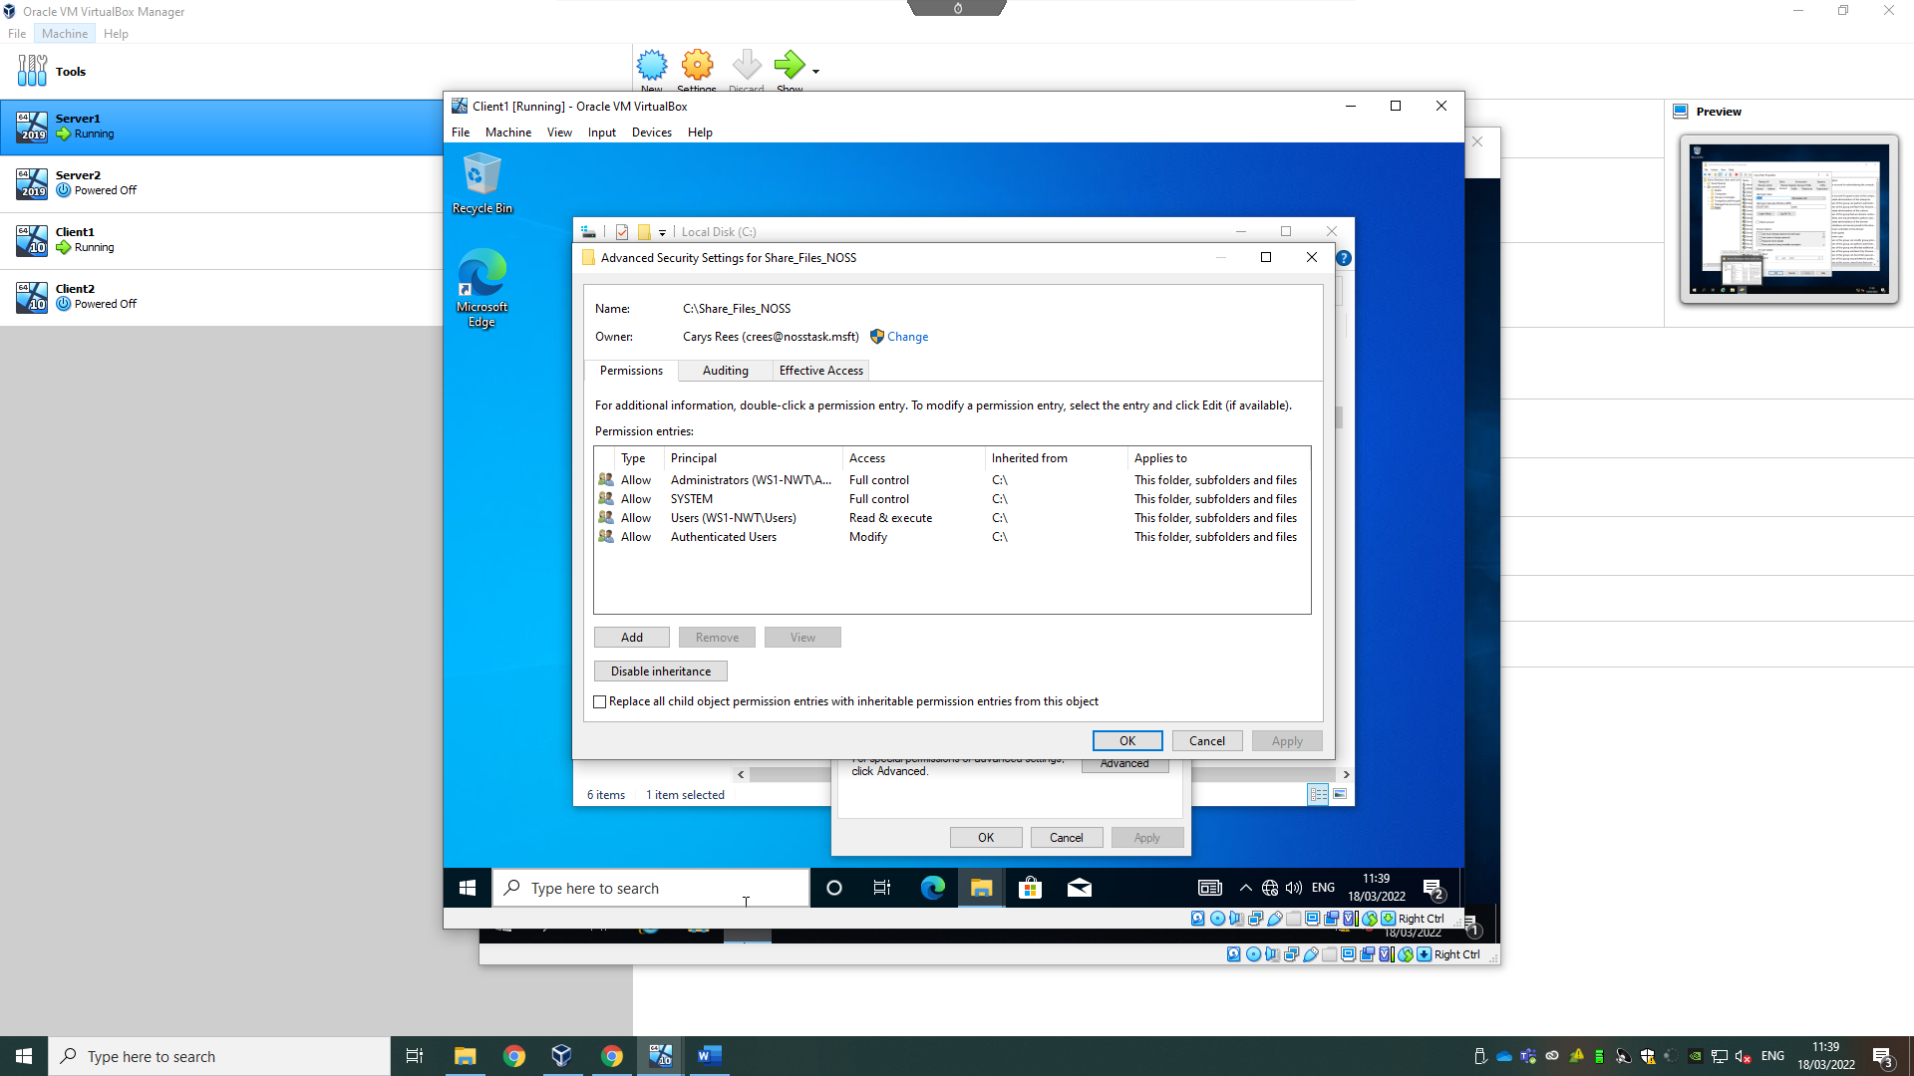
Adding users and creating some that are admin users and some that can only read/write to show the different controls users have.
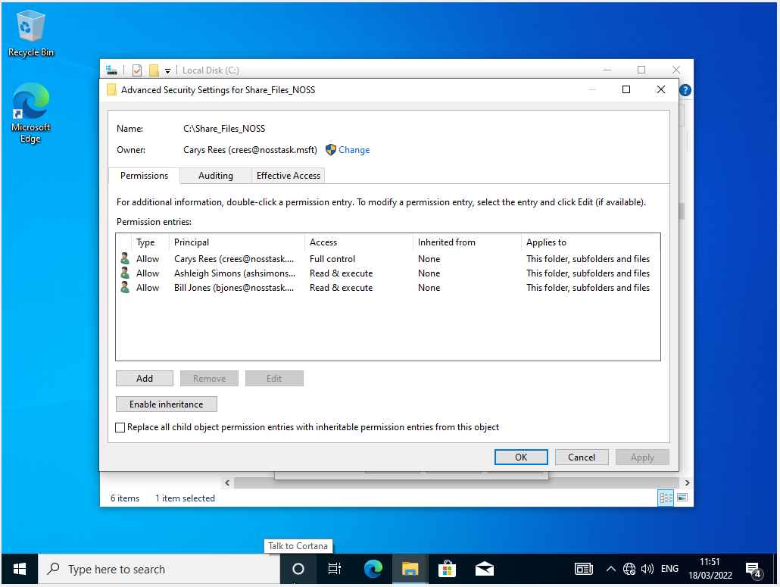
This is the same situation as the screenshot above.
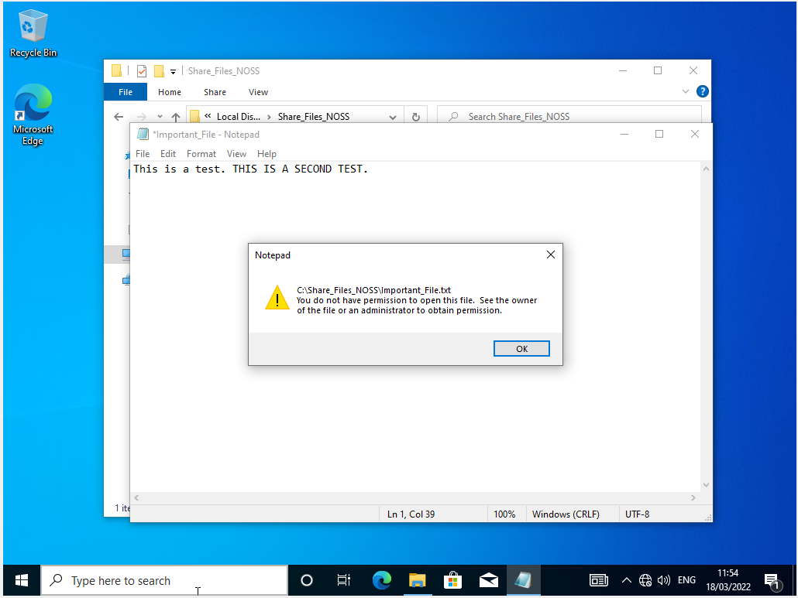
This is to show that the read/write user cannot edit a file, thus showing the rules have worked.
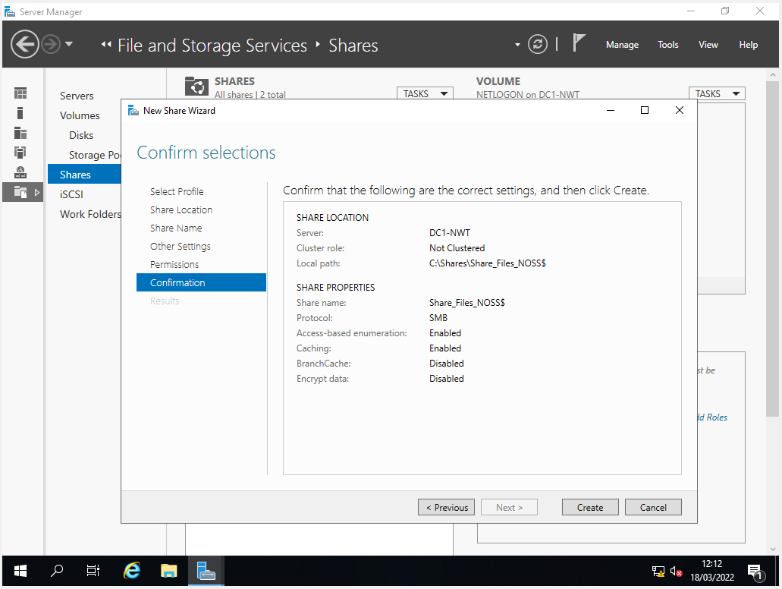
SMB type share.
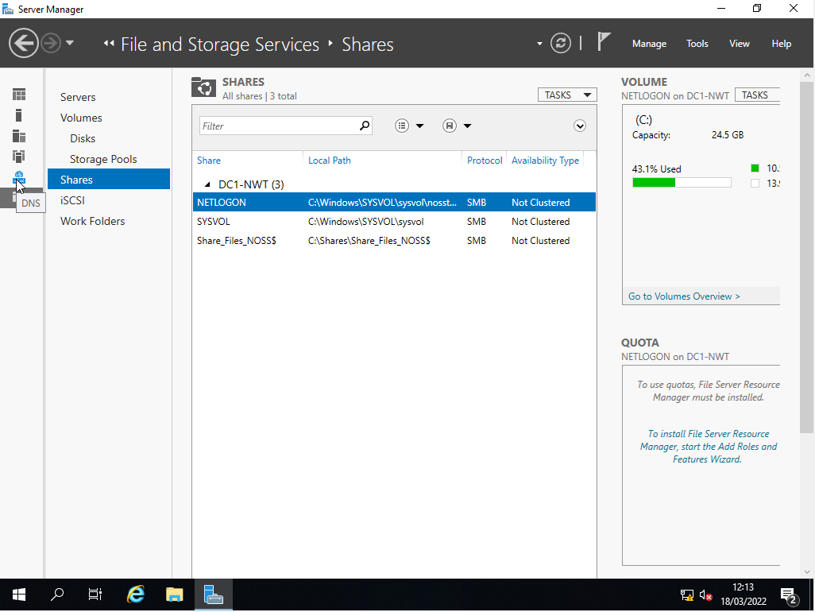
This is an alternative way of sharing files, which is browsing the computers on the network and seeing if there are any shares associated with that Server/Computer.

Task 2
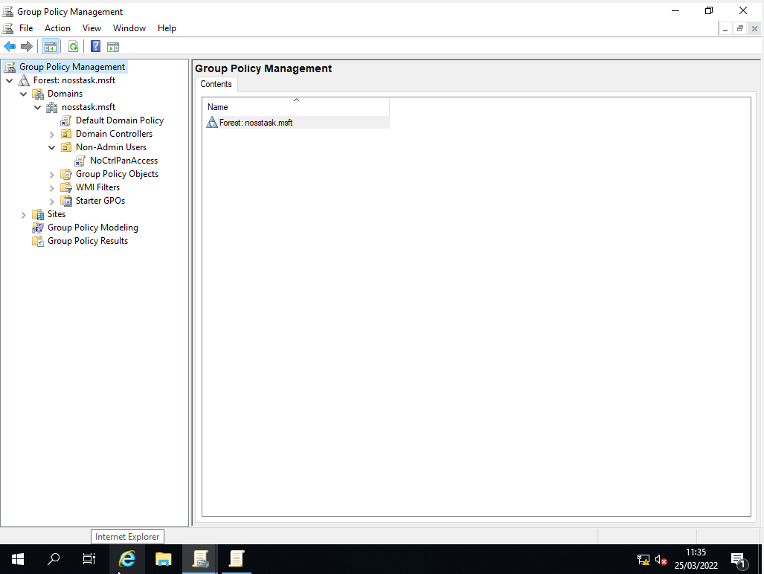
Restricting access to the control panel to safeguard users from making administrative changes to the settings of the systems on the network.
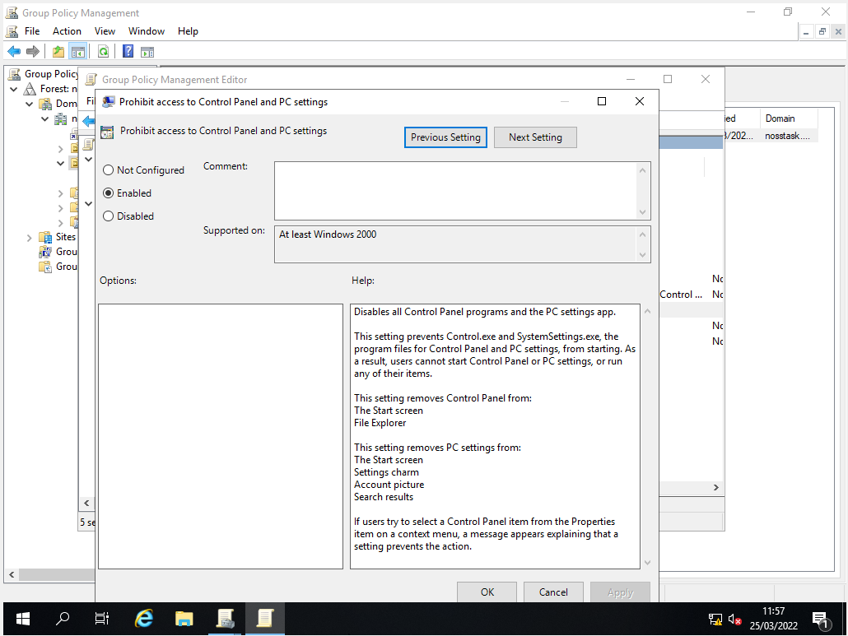
Policy created
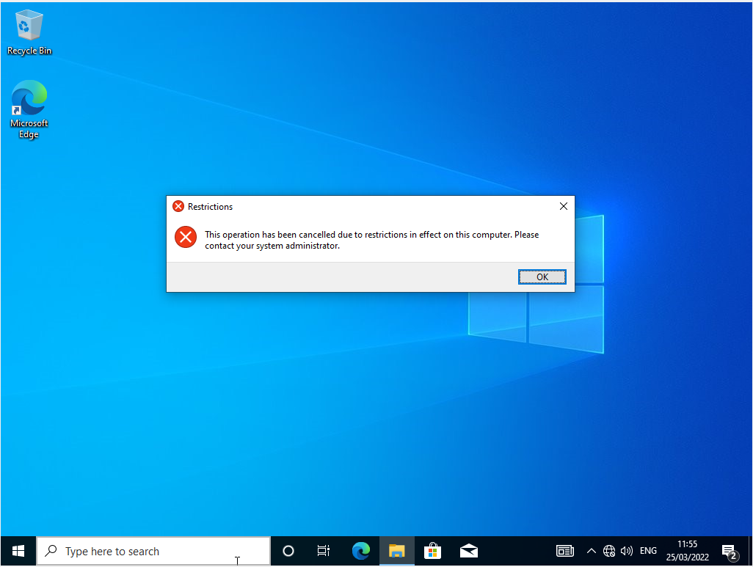
Stops user from opening control panel to change any features. And not able to open settings.
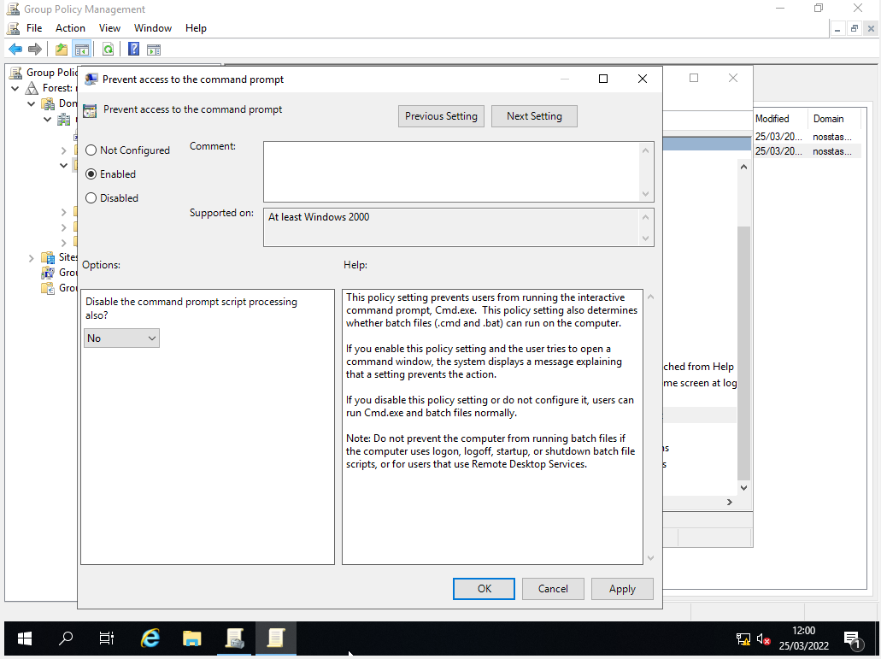
Preventing access to the command prompt so that users cannot change settings on the system.
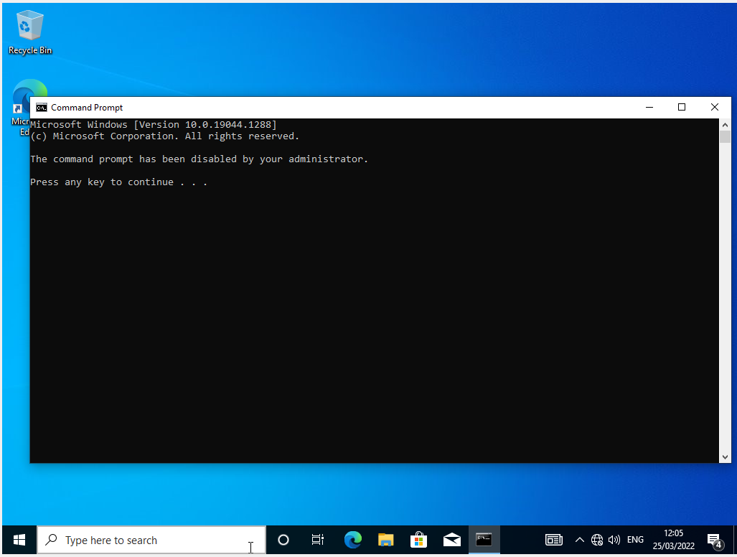
Error message on client1 – created a policy that disables the user to access command prompt.
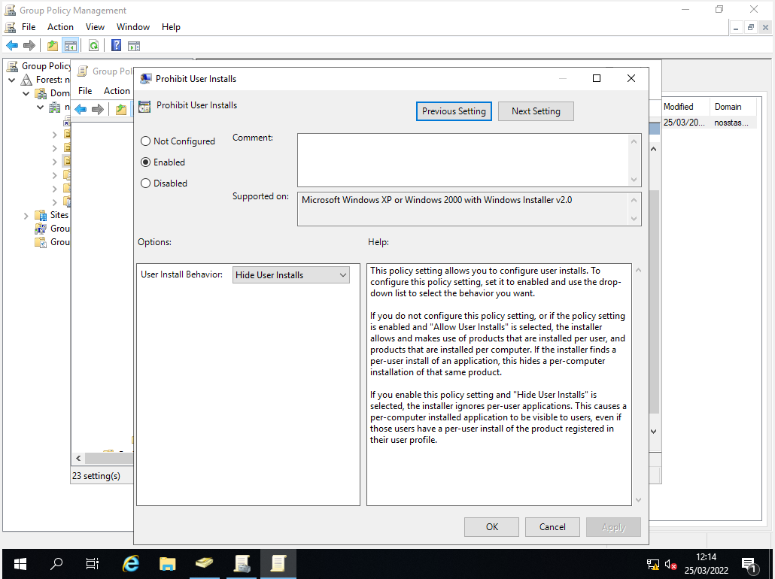
Enabling policy 4
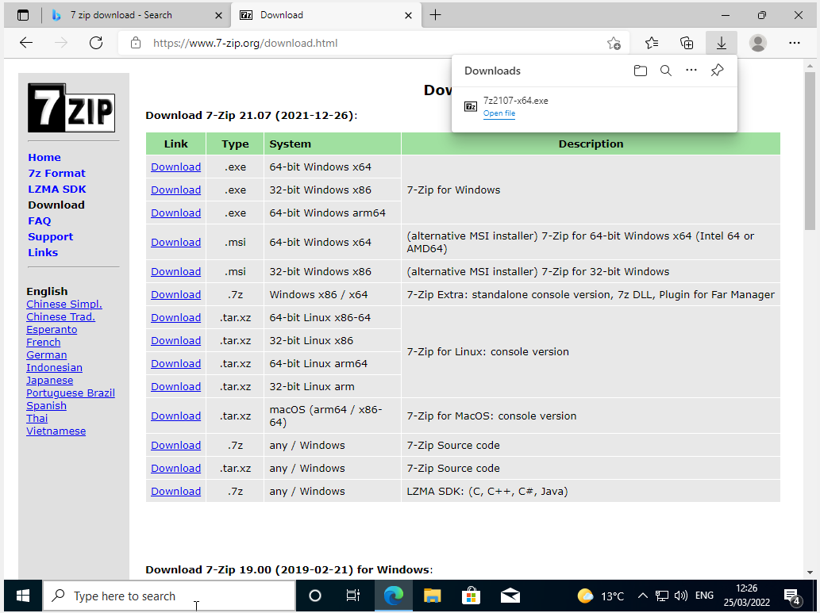
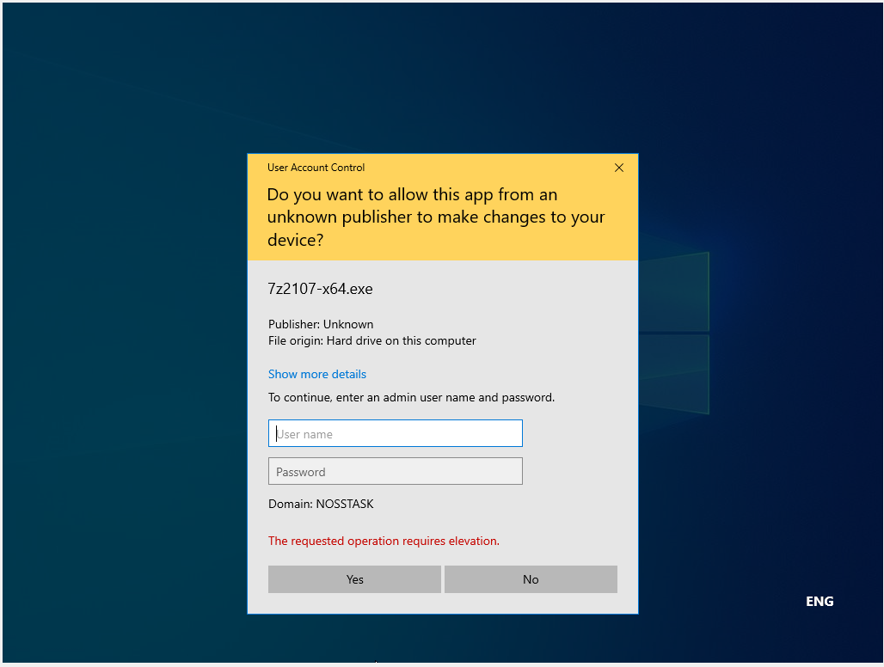
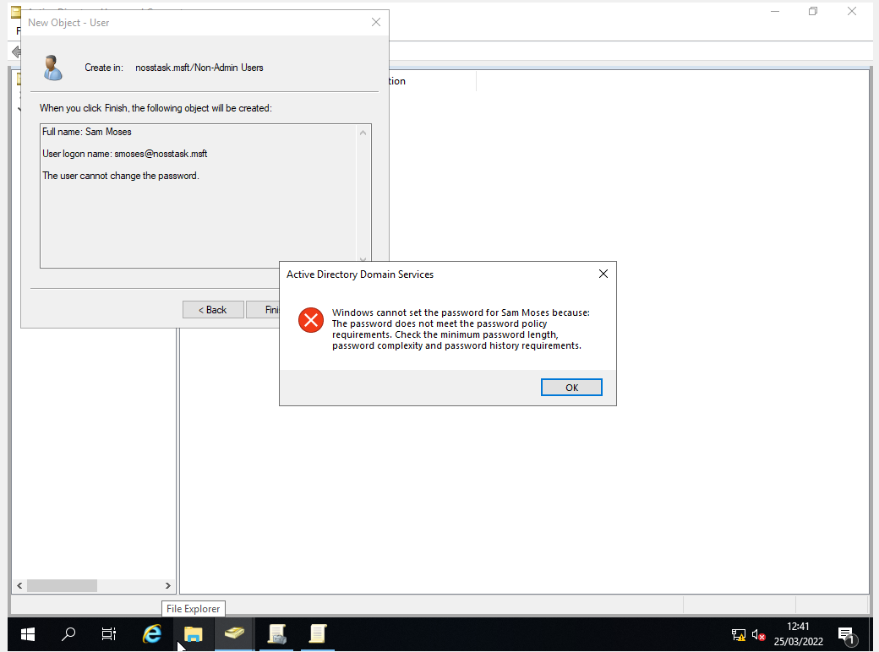
Entering password 123456 to see if it will accept it. Does not accept such a simple password.
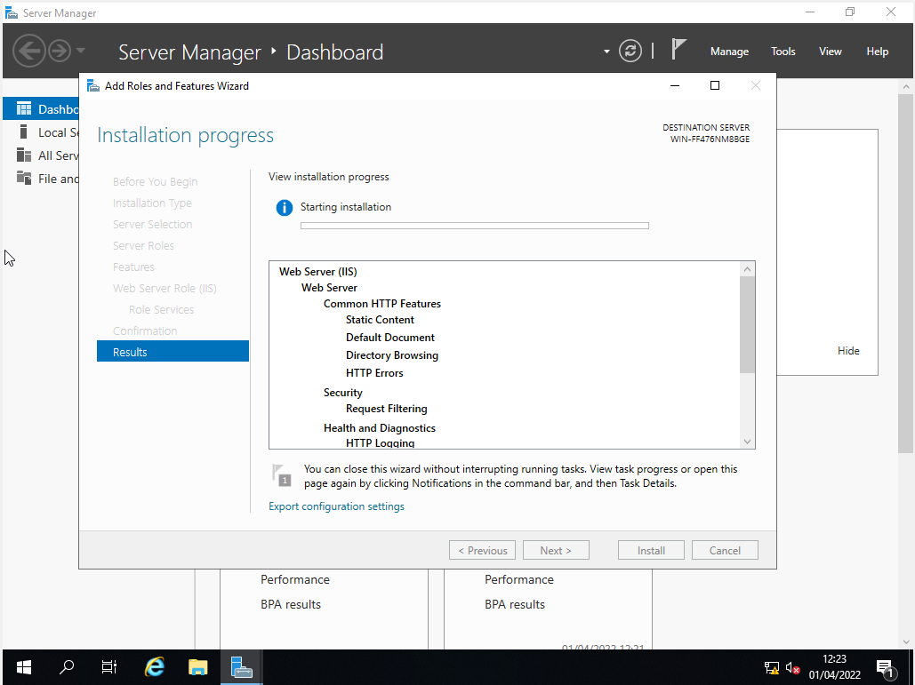
This is for server 2
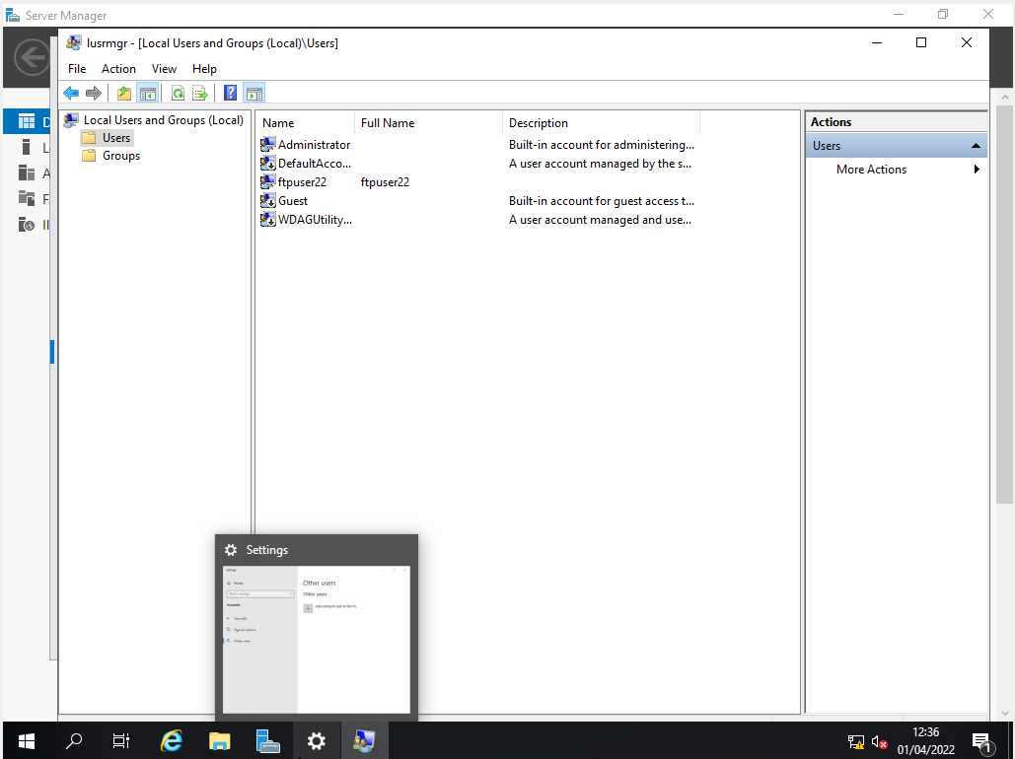
Created a new user
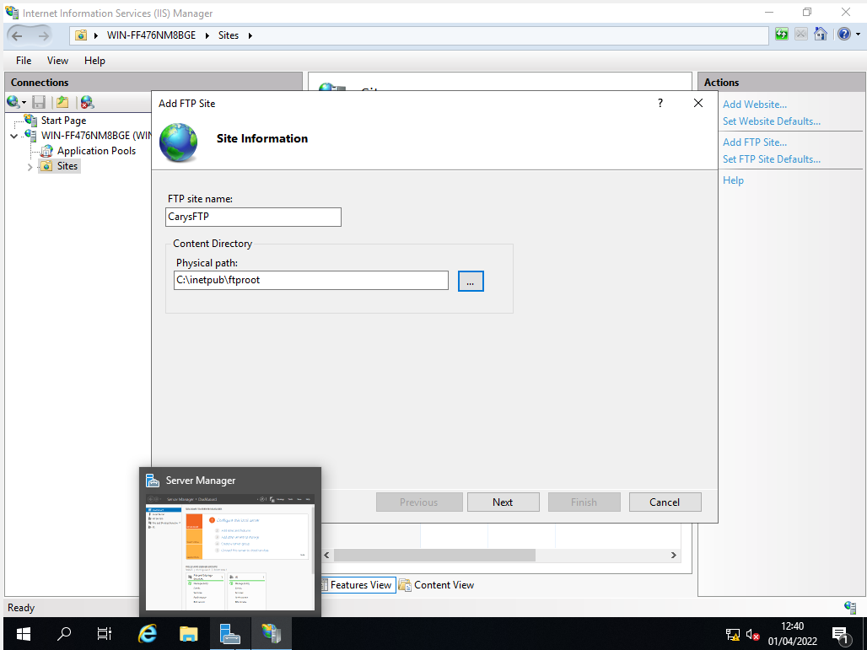
Adding an FTP site
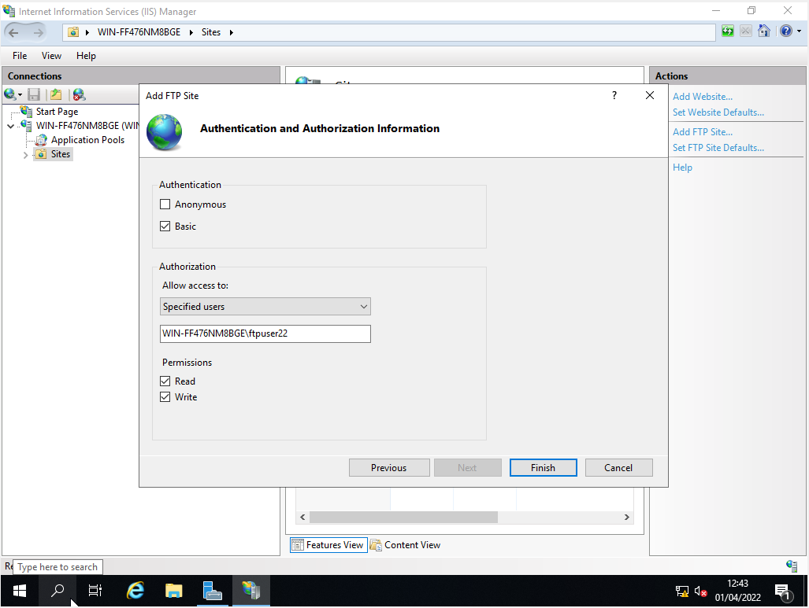
Adding computer name and username to create FTP site
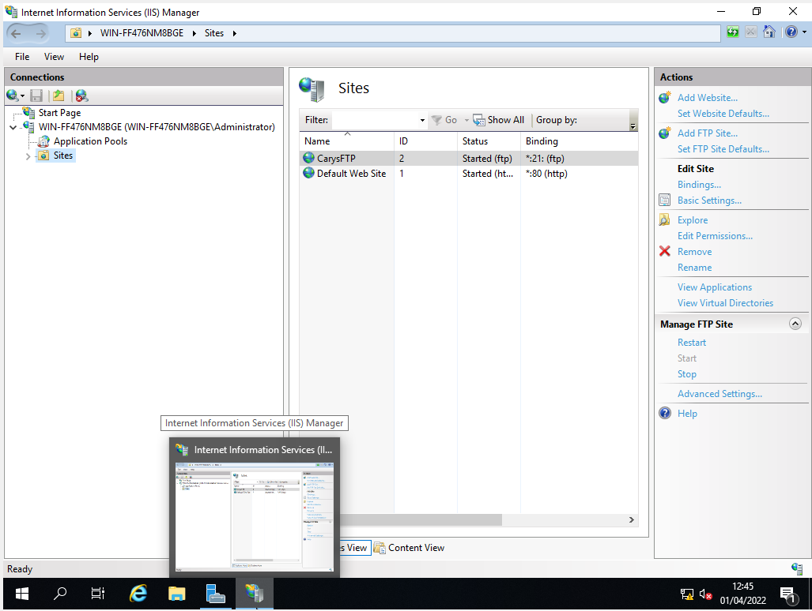
FTP site created
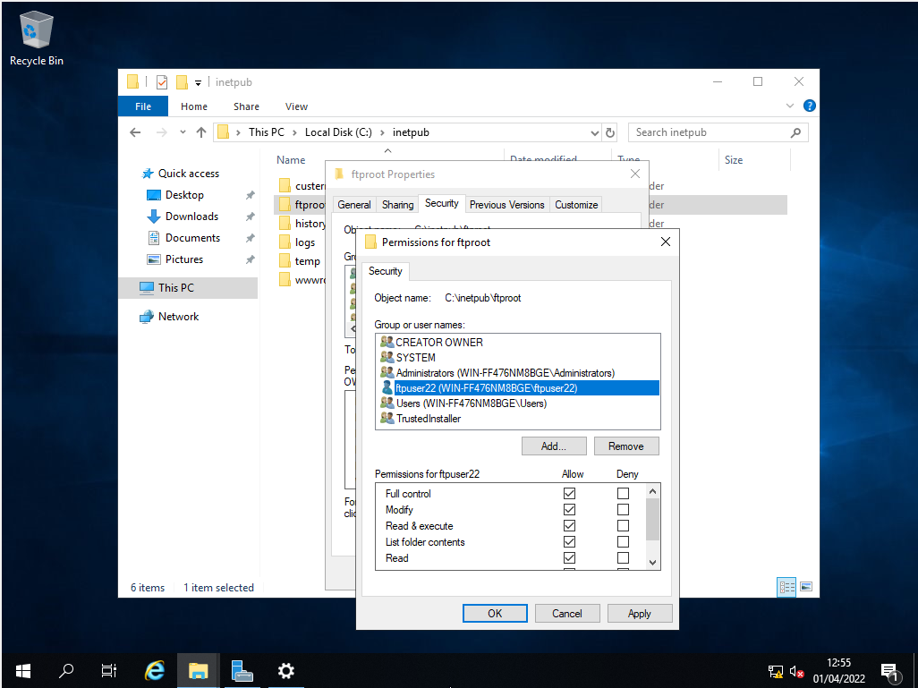
New user has full control
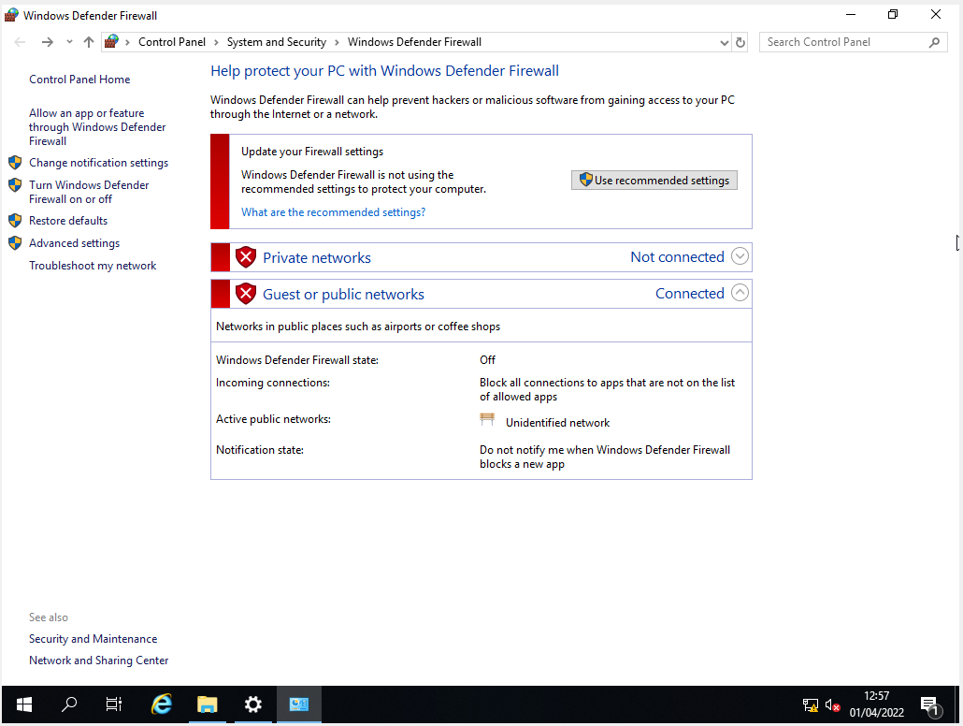
Firewall is turned off on server 2
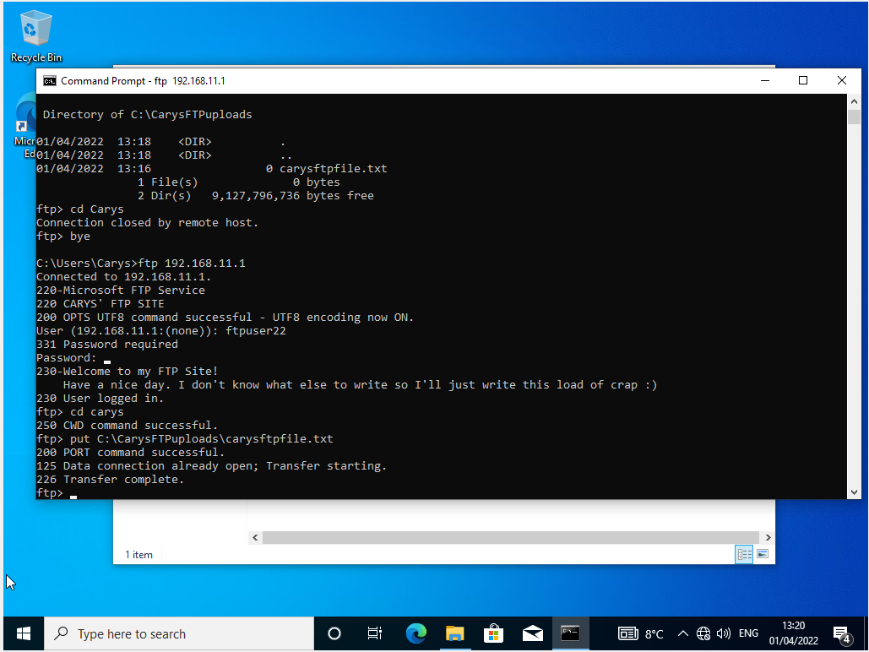
Only authorised users can access the ftp
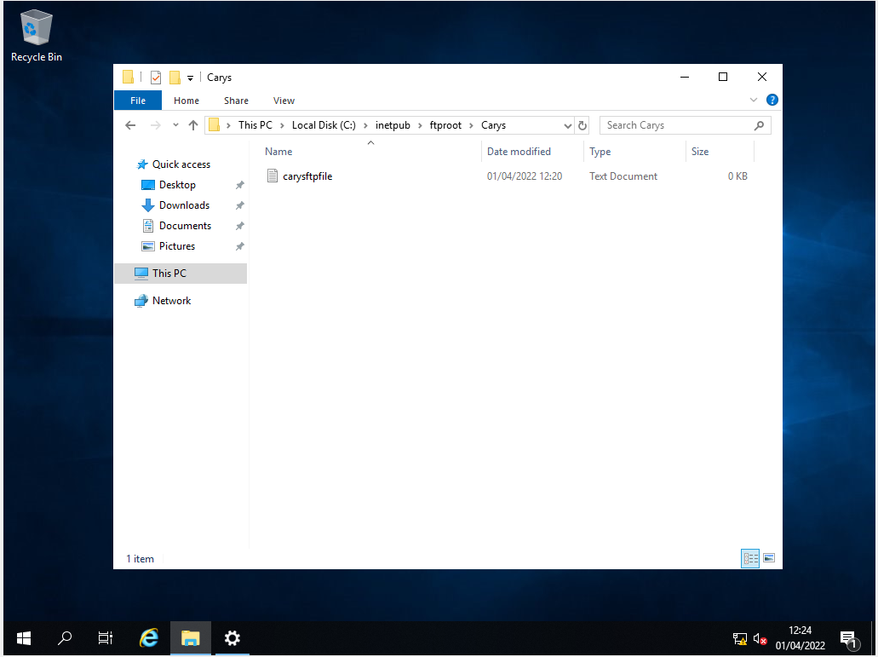
File has gone from client 2 to server 2

Task 3
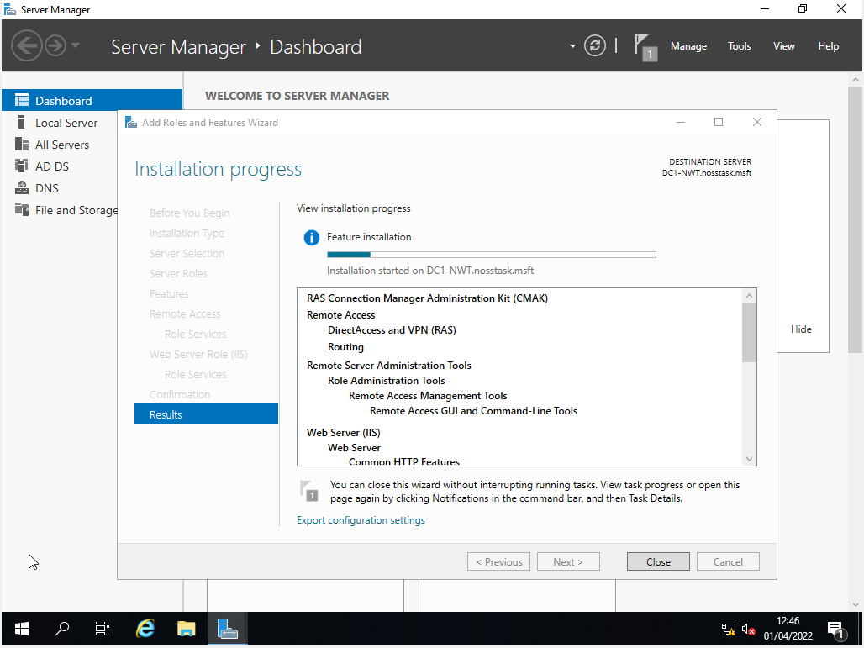
Installing Remote access and router to server 1
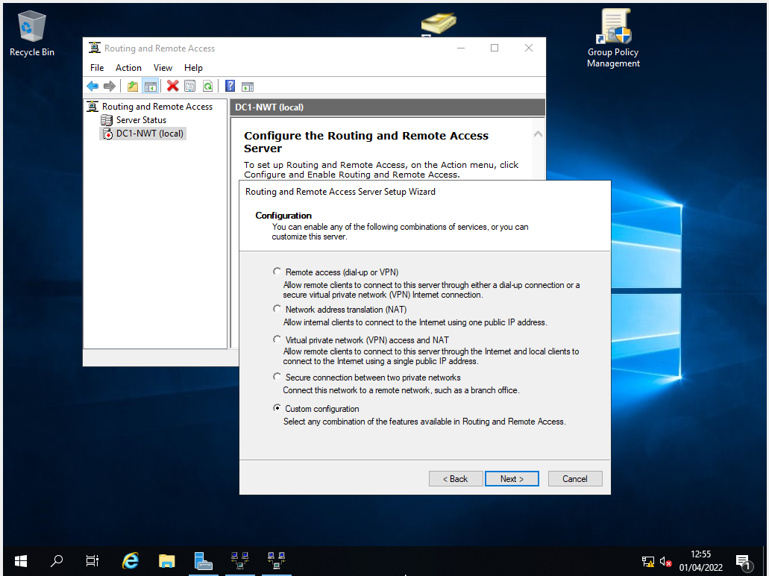
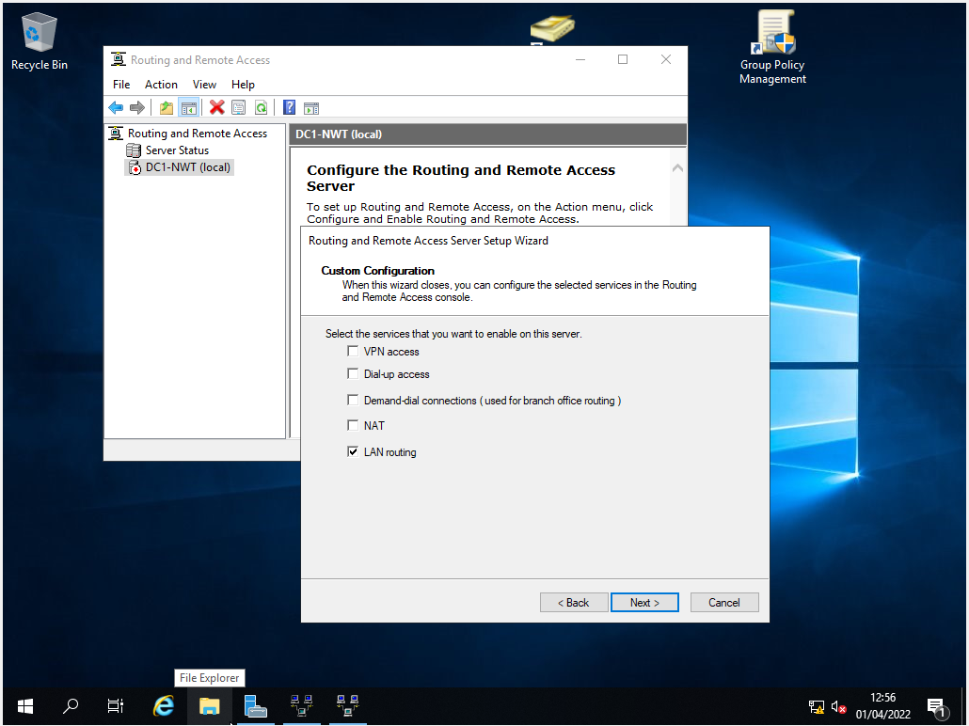
Repeated the same steps on server 2 to configure remote access and routing
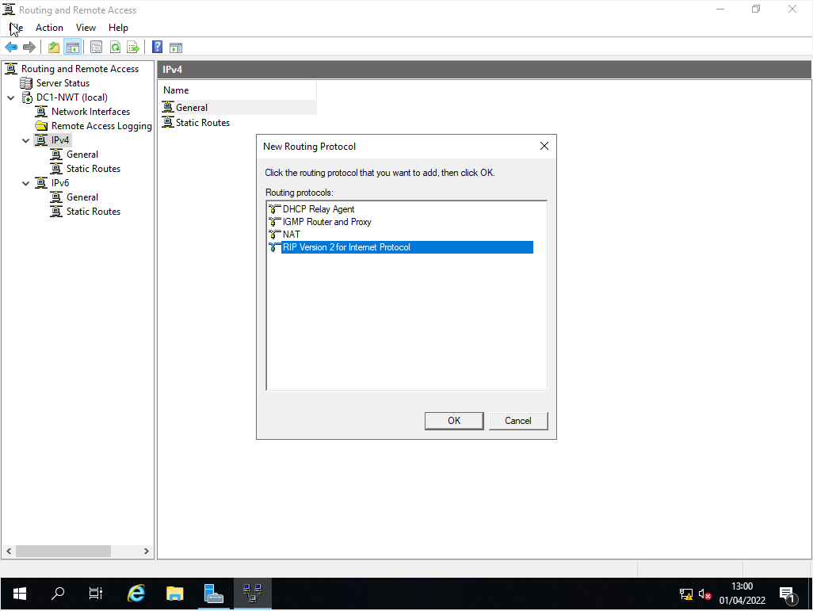
Added rip version 2
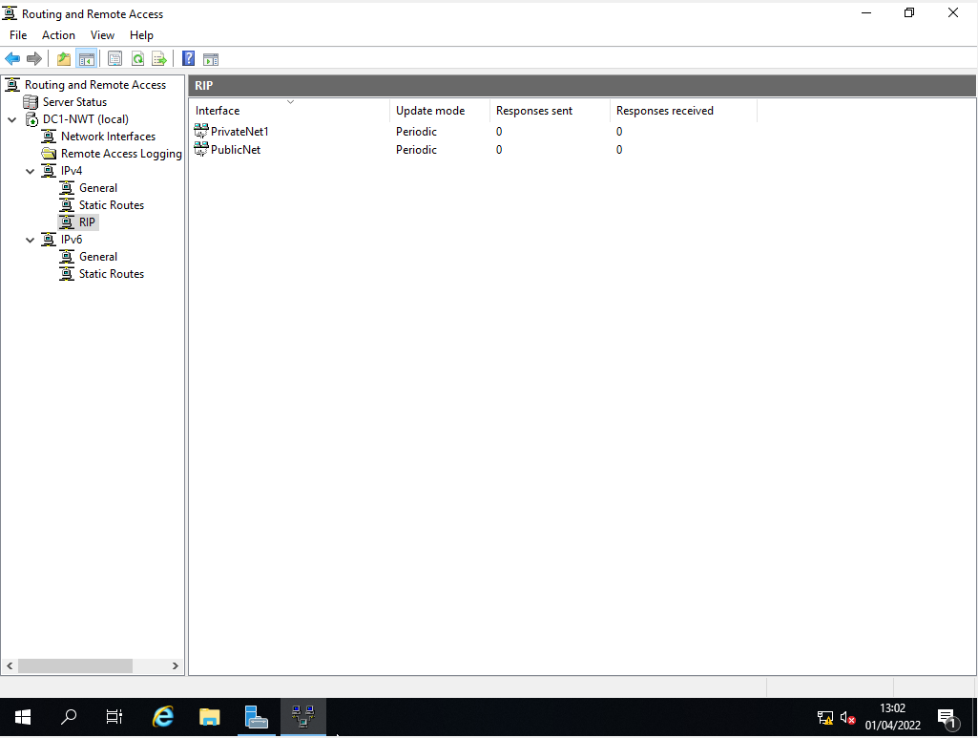
RIP added to the router. Router is useless without a routing protocol such as RIP V2. So we’ve added private and public nets so they communicate. Repeated the same process on server 2.

4 – IP Packet Filtering
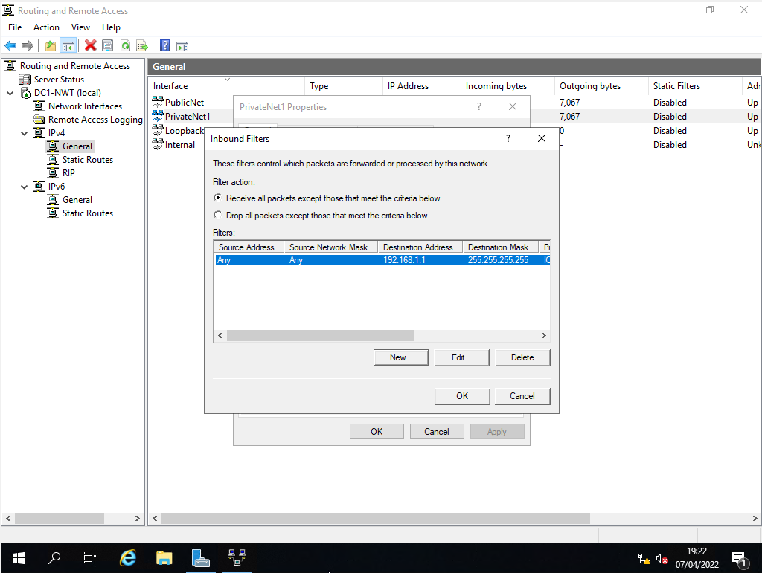
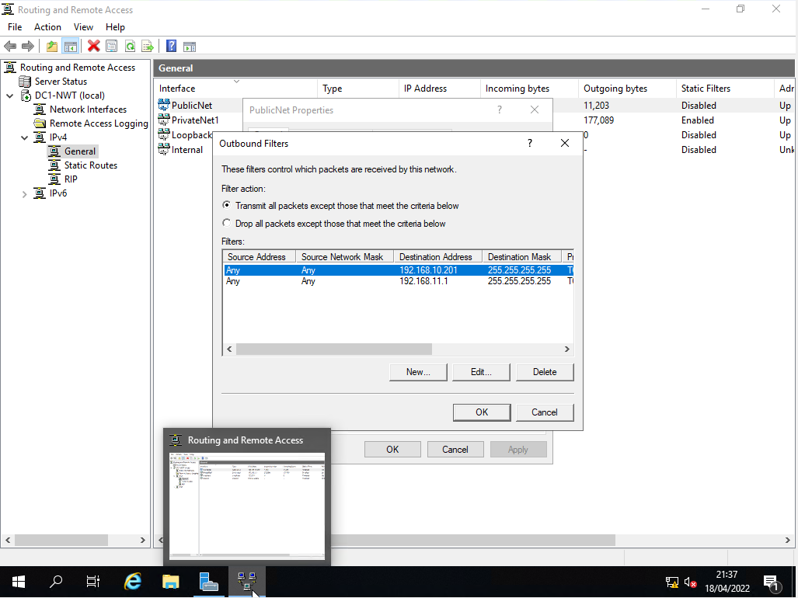
Filter 1 stopping ‘anyone’ in PrivateNet1 from Pinging the Router Firewall Service.
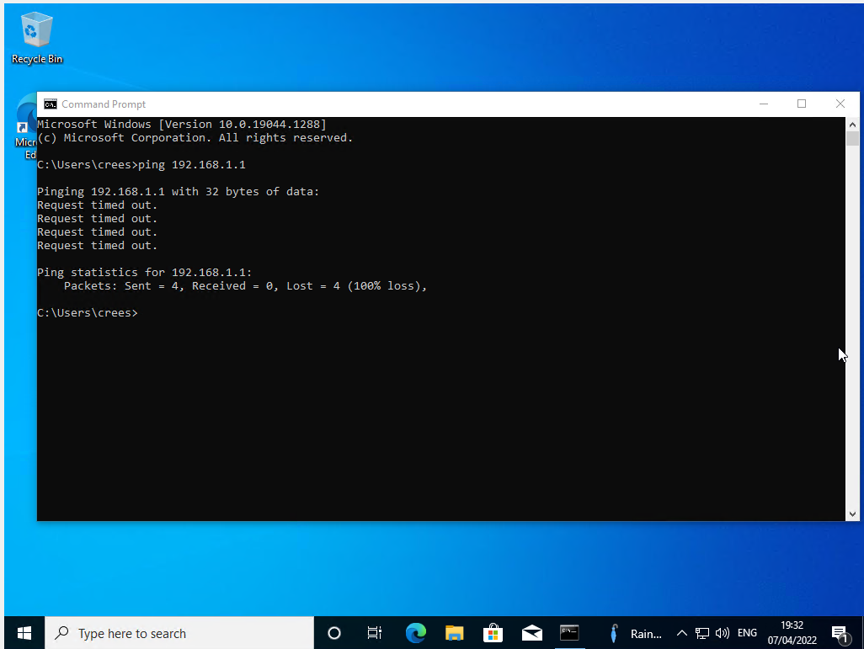
Client1 cannot ping server 1 as the router is denying ping access.

Filter 2 –
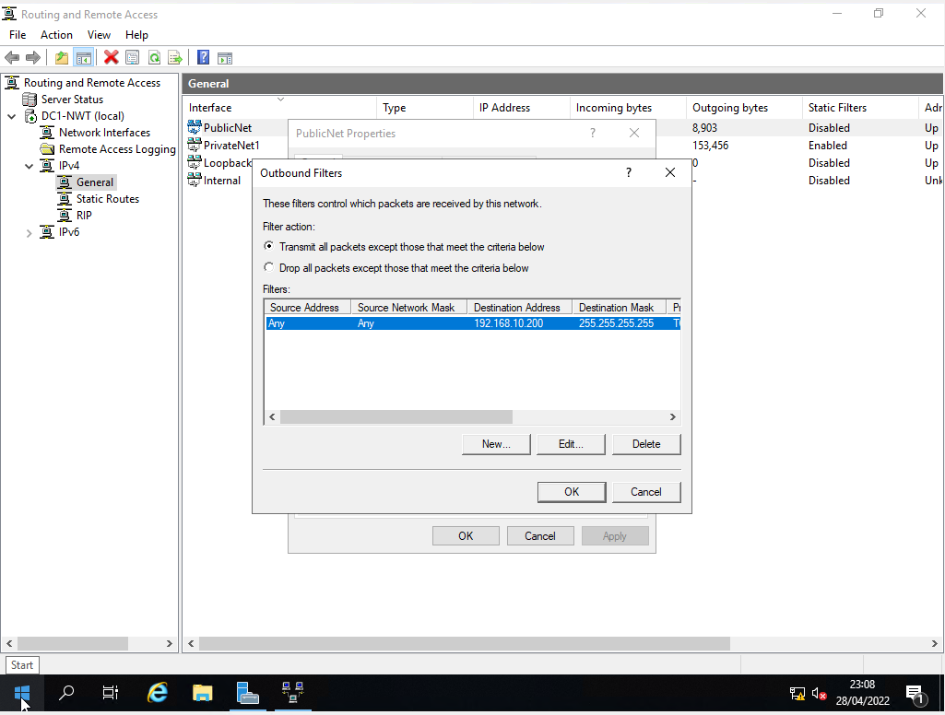
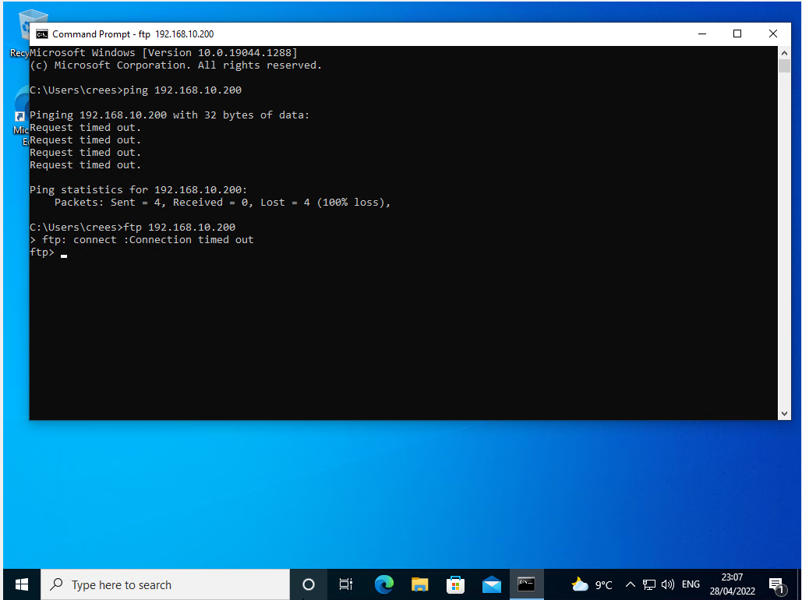
Client1 cannot ping server 1 as the router is denying ping access.

Filter 3 –
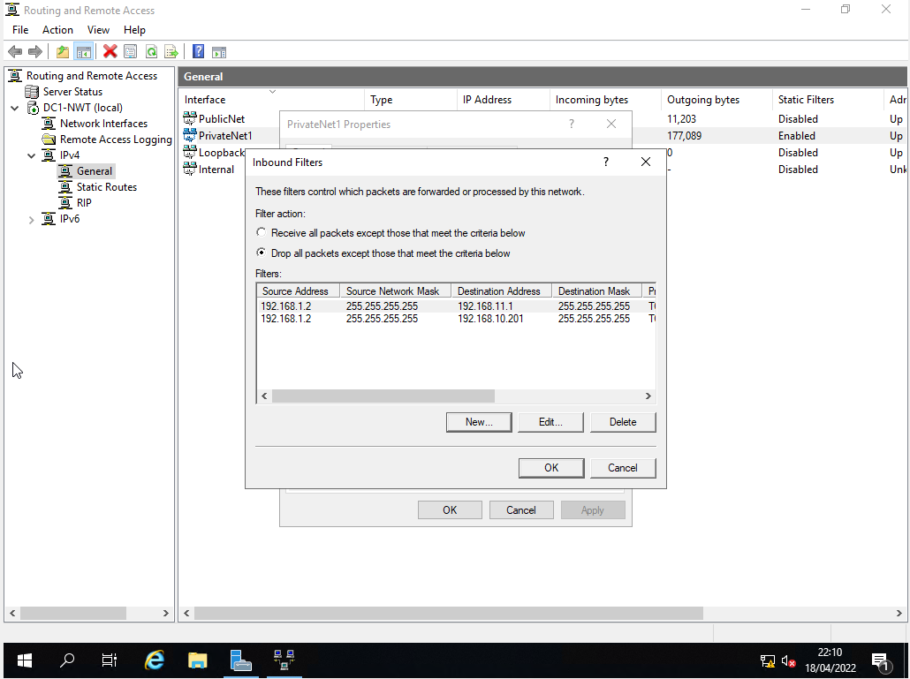
It drops everything so only the rules specified are allowed to access the ftp server

Task 3: Observational Task
Passwords currently must be complex in modern network environments. This is fundamental to ensure that people cannot guess passwords gain unauthorised access to the network. There are multiple password policies to adhere to such as complexity and length and the password age. Some organisations force users to change their password more or less 90 days to ensure the security of the business.
Some examples of passwords especially susceptible to brute attacks are:
- Easy to guess passwords such as “password£
- Numbers/letters such as “1234” or “abcd”
- A string of characters that appear sequentially on the keyboard such as “@#$%^&”
- Their name/families’ names
- Phone number, reg, birth date, address, etc.
- Multiples of the same character such as “rrrrrr”
- Default/suggested passwords, even if they seem strong
- Usernames or host names used as passwords
- Any of the above with a number added at the end such as “1”
The best practices for password policy includes:
- Configuring a minimum password length
- Enforcing a password history policy with at least 10 previous passwords remembered
- Setting a minimum password age of 3 days
- Enabling the setting that requires passwords to meet complexity requirements
- Track all password changes with Netwix Auditor for Active Directory
A failover cluster is a collection of separate computers that work together to improve clustered role availability and scalability (formerly called clustered applications and services). Physical wires and software link the clustered servers (called nodes). If one or more cluster nodes fail, the service is taken up by other nodes (a process known as failover). The clustered roles are also proactively checked to ensure that they are functioning effectively. They are restarted or relocated to another node if they are not working. [3].
Cluster Shared Volume (CSV) capability is also available in failover clusters, which offers a consistent, distributed namespace for clustered roles to access shared storage across all nodes. Users benefit from the Failover Clustering feature since service interruptions are kept to a minimal. Failover clustering have many practical applications which includes things like, for applications such as Microsoft SQL Server and Hyper-V virtual machines, which are required for highly accessible or constantly available file sharing. Alongside this, clustered roles operate on physical servers or virtual machines placed on Hyper-V servers that are highly available. [3]. The main importance is that it allows the end users to keep utilising applications and services without experiencing any timeouts if a server fails.
When creating a virtual machine, it is important to set a sufficient amount of memory for them to have enough storage to facilitate a High Availability (HA) or Continuous Availability (CA). Because of this, it is important to set the servers up with 4096MB of memory. Also, it is important to change the size value of the virtual hard disk as 25GB, which will allow plenty of space for the user to use the machine with no issues. Next, it is important to have at least 128MB in the display category for the video memory, as having more video memory is useful as it can store more graphics data and therefore provide better texture quality and rendering [1].
Choosing the correct operating system to install is important as it shapes the look and usage of the operating system. Therefore, choosing the Windows Server 2019 Datacenter Desktop Experience is a good option as it is the operating system that most users are familiar with. The benefit of this operating system is that it comes with a built-in anti-virus and protection system. [2]. The nice thing about windows is that is comes pre-installed with the office package, along with the ‘Photos’ app, which allows the users to utilise these apps without having to install them onto the system themselves. The interface of an operating system is fundamental for the user as the start menu’s straightforward layout, along with the taskbar at the bottom of the screen, allows the user to effortlessly pin and go to the files and apps, while the Cortana interface is a welcome addition.
As outlined above on task 2.1, critical failover and redundancy practices were created in order to allow the system to free up spare storage when certain files have not been used for a long period of time. This is essential on a computer system as it constantly attempts to free up spare space and therefore keep the system constantly performing at its best.
The network policy is fundamental in any business or organisation, it includes policies such as a password being changed every 90 days, no simple passwords, specific users being admin, others only being read/write etc. The network employees will be admin users, which will allow them access to alter any fundamental settings, for example to add or delete users from the network. Whereas the read/write users will not be able to access these setting, or use the command prompt, or any function that will affect the usability of the system. [4].
It is important to have access networks, which are built to connect users, such as bringing users together within an office building, data centre networks link servers that store data and applications and make them accessible to users, along with Wide-area networks (WANs) link users to applications across great distances, such as connecting the employees to the organisation’s apps. [5].
There are thousands of communication protocols used in a network, as they simply cannot work without them. There are implemented in hardware and software, essentially a network cannot exist without them. They are formal descriptions of digital message formats and rules, that are required to exchange messages in or between computing systems. Allowing two networks to communicate allows the user to send information and is happening in everyday life.
Domain names are converted to IP addresses by the Domain Name System (DNS), which are then used by browsers to load web pages. Every internet-connected device has its own IP address, which is used by other devices to find it. DNS servers allow individuals to type normal words into their browsers, such as Fortinet.com, without having to remember the IP address for each website. [6].
A DNS server is a computer that keeps a database of public IP addresses and the names of the websites that an IP address leads to. DNS serves as the internet’s phone book. The DNS finds the correct IP address whenever people type domain names like Yahoo.com into the address bar of their web browsers. The device is directed to the correct location to access the site’s data by the IP address of the site. DNS is used by the Active Directory Domain Services to locate domain controllers. Computes use DNS to locate Active Directory Domain controllers for performing any of the main Active Directory functions, such as authentication, updating or searching. [7].
IT server management is a method of overseeing and maintaining server so that they run at maximum performance. This includes hardware, software, security, and backup administration. Its major goal is to reduce server slowdowns and downtime, build safe environments, and guarantee that servers continue to satisfy an organisation needs as it expands. Server management was used to ensure that the maintenance of anything, is done. Whether that is the computers file systems, security, firewalls, etc.
Enforcement of security policies is essential for organisations as it ensures the security of their confidential information. Installing a zero trust networks is a good way to monitor the network. A zero-trust network admits only those who have been granted network access. That implies that if an end user bypasses IT and IT security to speed up the launch of an application, that user will be refused access to corporate IT data and resources when attempting a network connection. A zero-trust network is an effective technique to enforce security while also making it simple to identify and trace anomalous access attempts and/or network use patterns. [8].
Domain level policies are essential as these are settings that an administrator wishes to apply to the whole organisation. By right clicking the domain name on the left-hand side of the terminal window and establishing a group policy object at this level, group policy objects may be generated at the top of the organisational tree.
In conclusion, it is clear to identify the different password policies and the important of enforcing them on a continuous basis, what failover clustering for high availability systems/services is and the importance of this on a computer system. Along with drafting a network policy that establishes clear rules for employees to abide by.

References
[1] Mesaki, “How Much Video Memory Do You Need? | GPUSpecs.com,” GPUSpecs.com, Aug. 09, 2020. https://gpuspecs.com/faq/how-much-video-memory-do-you-need#:~:text=Having%20more%20video%20memory%20is,better%20texture%20quality%20and%20rendering. (accessed Apr. 26, 2022).
[2] “4 things to consider when choosing an operating system for your school - Stone Group,” Stone Group, Oct. 23, 2017. https://www.stonegroup.co.uk/insights/choosing-an-operating-system-for-your-school/ (accessed Apr. 26, 2022).
‌[3] JasonGerend, “Failover Clustering,” Microsoft.com, Feb. 11, 2022. https://docs.microsoft.com/en-us/windows-server/failover-clustering/failover-clustering-overview (accessed Apr. 26, 2022).
[4] Evaseydl, “Network Considerations and User Accounts,” Microsoft.com, Aug. 07, 2020. https://docs.microsoft.com/en-us/windows-server/remote/multipoint-services/network-considerations-and-user-accounts (accessed Apr. 26, 2022).
‌[5] “Intent-based networking explained,” Cisco, Feb. 2022. https://www.cisco.com/c/en/us/solutions/enterprise-networks/what-is-network-architecture.html#~q-a (accessed Apr. 26, 2022).
[6] “What Is DNS? Definition & How DNS Works | Fortinet,” Fortinet, 2022. https://www.fortinet.com/resources/cyberglossary/what-is-dns (accessed Apr. 26, 2022).

[7] JasonGerend, “Domain Name System (DNS),” Microsoft.com, Jan. 10, 2022. https://docs.microsoft.com/en-us/windows-server/networking/dns/dns-top#:~:text=Active%20Directory%20Domain%20Services%20(AD,locate%20Active%20Directory%20domain%20controllers. (Accessed Apr. 26, 2022).

[8] “5 ways to enforce company security,” TechRepublic, Jan. 25, 2019. https://www.techrepublic.com/article/5-ways-to-enforce-company-security/ (accessed Apr. 26, 2022).
‌
‌
‌

