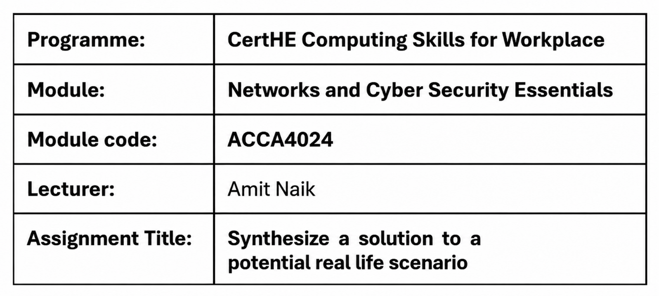


Student Name: Swastika Sarker
Student Number: 2441945
Group: 01
Date: 13/08/2026

Contents
1. Introduction 4
2. Organisational Context and Security Objectives 4
2.1 Organisational Overview 5
2.2 Critical Information Assets 5
2.3 Security Objectives 6
2.4 Governance Objectives 6
3. Identification and Assessment of Cybersecurity Threats 7
3.1 Internal Threat 7
3.2 External Threats 8
3.3 Risk Assessment 8
3.4 Risk Matrix 9
4. Cybersecurity and Data Governance Policies 10
4.1 Information Security Policy 10
4.2 Access Control and Authentication Policy 10
4.3 Data Protection and Incident Response Policy 10
4.4 Governance and Continuous Improvement 11
5. Threat Mitigation and Security Controls 12
5.1 Network and Access Security 12
5.2 Data and Endpoint Protection 12
5.3 Continuous Monitoring and Security Awareness 12
6. Monitoring, Incident Response and Business Continuity 13
6.1 Continuous Security Monitoring 13
6.2 Incident Response 13
6.3 Business Continuity and Disaster Recovery 14
7. Staff Awareness and Continuous Improvement 14
7.1 Security Awareness and Training 15
7.2 Continuous Improvement 15
8. Conclusion 16
Reference: 17
Appendix: PowerPoint Presentation 18

1. Introduction
Industry 4.0 changes manufacturing by infusing IT and OT, cloud computing and IoT into manufacturing processes to improve productivity and automation. These technologies enable SteelForm Manufacturing Ltd (SFM), a medium-sized manufacturing company focused on the automotive and aerospace sectors, to operate with ease. But increased connectivity increases the risk of cyber-attacks, like ransomware, phishing, malware and unauthorised access. A successful attack could hit production, compromise sensitive information and create a disruption within business continuity. This report assesses the cybersecurity exposures encountered by SteelForm Manufacturing Ltd and suggests management approaches, security controls and incident response plans using the NIST Cybersecurity Framework (CSF) 2.0, ISO/IEC 27001:2022 and UK GDPR to enhance organisational resilience.
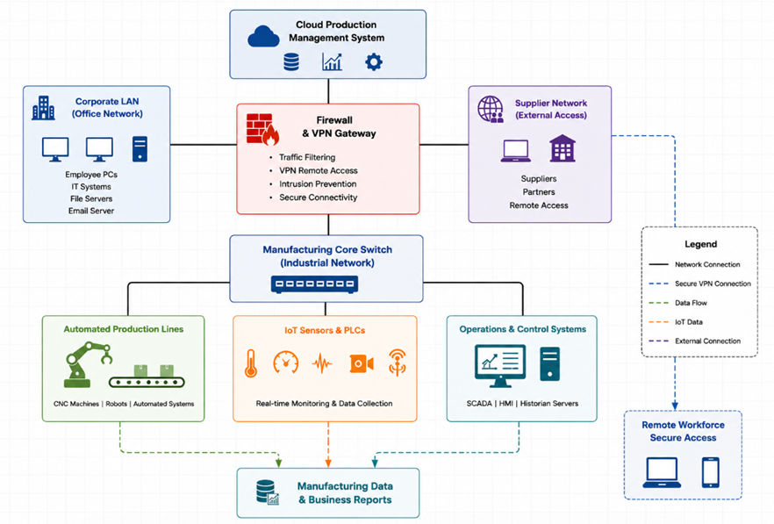
Figure 1. High-Level Cybersecurity Architecture of SteelForm Manufacturing Ltd
Source: Author's illustration developed for SteelForm Manufacturing Ltd based on the NIST Cybersecurity Framework (CSF) 2.0 [1], ISO/IEC 27001:2022 [2], and IEC 62443 [11].

2. Organisational Context and Security Objectives

2.1 Organisational Overview
SteelForm Manufacturing Ltd (SFM) is a medium-sized manufacturer supplying precision components to the automotive and aerospace industries. The organisation has adopted Industry 4.0 technologies, including Industrial Control Systems (ICS), Programmable Logic Controllers (PLCs), Internet of Things (IoT) sensors and a cloud-based production management system, to improve production efficiency and product quality. These interconnected technologies enable real-time monitoring, predictive maintenance and improved operational performance. However, integrating Information Technology (IT) and Operational Technology (OT) also increases the organisation's exposure to cyber threats, including ransomware, unauthorised access and attacks targeting industrial control systems. Consequently, cybersecurity governance is essential to protect critical business operations, minimise operational disruption and maintain compliance with recognised security standards [1], [2], [11].

2.2 Critical Information Assets
SteelForm depends on several critical information assets, including engineering drawings, customer contracts, cloud production systems, Industrial Control Systems (ICS), employee records and supplier databases. Protecting these assets is essential to preserve confidentiality, integrity and availability. Any compromise could lead to production delays, financial losses, regulatory penalties and reputational damage [2], [3].
Table 1. Critical Information Assets
Information Asset | Business Importance | Primary Security Requirement
Engineering drawings and CAD files | Intellectual property supporting product development | Confidentiality and Integrity
Customer contracts and production specifications | Commercial agreements and manufacturing requirements | Confidentiality
Cloud production management platform | Production planning and operational control | Availability and Integrity
Industrial Control Systems (ICS) and PLCs | Automated manufacturing operations | Availability
IoT sensors | Real-time equipment monitoring | Integrity
Employee and HR records | Personal and payroll information | Confidentiality
Supplier database | Procurement and supply chain management | Confidentiality and Availability
Financial systems | Purchasing, invoicing and budgeting | Integrity

2.3 Security Objectives
SteelForm's cybersecurity strategy is based on the Confidentiality, Integrity and Availability (CIA) Triad. Confidentiality protects sensitive engineering designs, customer contracts and employee information from unauthorised disclosure. Integrity ensures that production data and manufacturing processes remain accurate and protected against unauthorised modification, reducing the risk of defective products. Availability ensures that cloud services, Industrial Control Systems (ICS) and production equipment remain operational to avoid manufacturing delays and financial losses. Applying the CIA Triad enables SteelForm to support business continuity, regulatory compliance and customer confidence while reducing operational risk [1], [2], [10].

2.4 Governance Objectives
SteelForm should implement an Information Security Management System (ISMS) aligned with ISO/IEC 27001:2022 and adopt the NIST Cybersecurity Framework (CSF) 2.0. Senior management, department managers and employees should share responsibility for managing cyber risks, enforcing security policies and supporting continuous improvement to strengthen organisational resilience [1], [2], [4].
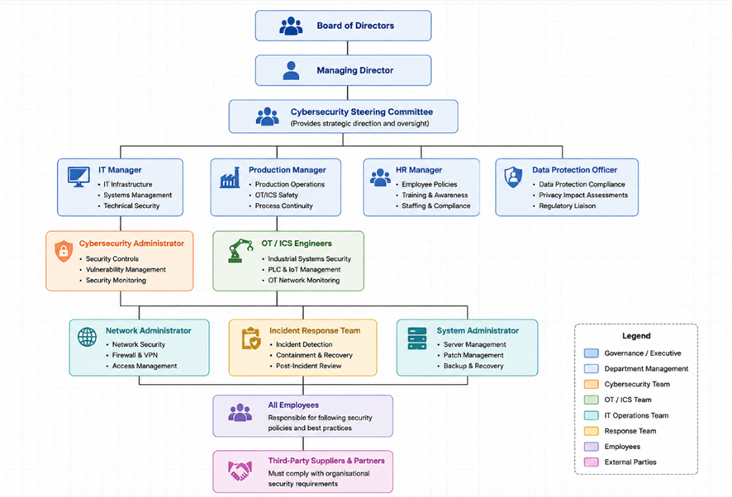
Figure 2. Organisational Security Governance Structure of SteelForm Manufacturing Ltd
Source: Author's illustration developed for SteelForm Manufacturing Ltd based on ISO/IEC 27001:2022 [2] and the NIST Cybersecurity Framework (CSF) 2.0 [1].

3. Identification and Assessment of Cybersecurity Threats

3.1 Internal Threat
SteelForm Manufacturing Ltd faces several internal cybersecurity threats that could affect its manufacturing operations and sensitive information. Insider threats may arise from employees, contractors or third-party personnel who misuse authorised access to steal confidential engineering data or disrupt production systems. Human error also remains a significant risk, as employees may unintentionally disclose sensitive information, use weak passwords or respond to phishing emails. Because the organisation operates interconnected IT and Operational Technology (OT) environments, a single mistake can affect multiple business processes. Implementing role-based access control (RBAC), multi-factor authentication (MFA) and regular security awareness training can significantly reduce these risks [2], [5], [6].

3.2 External Threats
The manufacturing environment around SteelForm still faces significant external risks as cyber threats. Ransomware is one of the most serious threats because attackers can encrypt production systems, interrupt manufacturing operations and demand payment for data recovery, leading to substantial financial and operational losses [9], [12]. There are still phishing attacks that attempt to obtain the employee credentials or distribute malware using fraudulent emails [7]. Moreover, malware, Advanced Persistent Threats (APTs) and attacks targeting Industrial Control Systems (ICS) can compromise production equipment, disrupt automated manufacturing processes and expose confidential engineering information [11]. Additionally, supply chain attacks pose a growing threat, since compromised software vendors or service providers can introduce malicious code into trusted systems [7], [8]. As SteelForm increasingly relies on cloud computing and IoT technologies, its attack surface continues to expand. Attackers may exploit software vulnerabilities, insecure remote access or misconfigured cloud services to gain unauthorised access to production systems. For a manufacturing organisation, successful exploitation could interrupt automated production lines, delay deliveries to automotive and aerospace customers and increase financial losses. Therefore, maintaining secure configurations, timely software updates and continuous monitoring is essential to reduce both operational and business risks [1], [7], [11].

3.3 Risk Assessment
SteelForm should conduct regular risk assessments to identify vulnerabilities, evaluate the likelihood of cyber threats and determine their potential impact on business operations. High-risk threats such as ransomware, phishing and ICS attacks should receive priority because they could cause production downtime, financial losses and reputational damage. Lower-risk issues should continue to be monitored through periodic security reviews. Applying a structured risk assessment process enables the organisation to prioritise resources effectively and supports compliance with the NIST Cybersecurity Framework (CSF) 2.0 and ISO/IEC 27001:2022 [1], [2].
SteelForm should review cybersecurity risks regularly because the threat landscape continues to evolve. Conducting periodic risk assessments enables management to prioritise security investments according to business impact rather than implementing controls indiscriminately. This risk-based approach improves resource allocation, supports regulatory compliance and strengthens organisational resilience against emerging cyber threats [1], [2].
Table 2. Cybersecurity Risk Assessment
Threat | Likelihood | Business Impact | Risk Level
Ransomware | High | Very High | Critical
Phishing | High | High | High
Malware | High | High | High
Insider Threat | Medium | High | High
Weak Passwords | High | Medium | High
Human Error | High | Medium | High
Supply Chain Attack | Medium | High | High
ICS Exploitation | Medium | Very High | Critical

Interpretation:
Table 2 highlights that ransomware and Industrial Control System (ICS) attacks represent the highest risks because they have the potential to interrupt manufacturing operations and cause significant financial and reputational damage. Consequently, these threats should receive the highest priority when allocating cybersecurity resources.

3.4 Risk Matrix

Threat | Likelihood |  | Impact | Risk Level
Ransomware | High | High |  | 🔴 Critical
Phishing | High | Medium |  | 🟠 High
Insider Threat | Medium | High |  | 🟠 High
IoT Device Compromise | Medium | High |  | 🟠 High
DDoS Attack | Low | High |  | 🟡 Medium
USB Malware | Medium | Medium |  | 🟡 Medium

Figure 4. Risk Matrix for SteelForm Manufacturing Ltd

4. Cybersecurity and Data Governance Policies

4.1 Information Security Policy
An Information Security Policy provides the foundation for SteelForm's cybersecurity programme by defining how information assets should be protected throughout the organisation. The policy should establish security objectives, management responsibilities and employee obligations while ensuring compliance with legal and regulatory requirements. It should apply to all employees, contractors and third-party suppliers who access organisational systems. Regular policy reviews ensure that security controls remain effective against emerging cyber threats and changing business requirements [2], [3].

4.2 Access Control and Authentication Policy
SteelForm should implement an Access Control Policy based on the principle of least privilege, ensuring employees can only access information and systems required for their job roles. Role-Based Access Control (RBAC) should be combined with Multi-Factor Authentication (MFA) to reduce the risk of unauthorised access and credential theft. Strong password requirements, regular account reviews and prompt removal of inactive accounts further strengthen organisational security. These measures protect both IT and Operational Technology (OT) environments from internal misuse and external cyberattacks [2], [6].

4.3 Data Protection and Incident Response Policy
A Data Protection Policy should define how confidential business information, customer records and employee data are collected, stored, processed and securely disposed of in accordance with UK GDPR. Sensitive data should be encrypted during storage and transmission, while regular backups should support business continuity following a cyber incident [3]. In addition, SteelForm should maintain an Incident Response Policy that clearly defines procedures for identifying, reporting, containing, recovering from and reviewing cybersecurity incidents. Following a structured incident response process enables the organisation to minimise operational disruption and continuously improve its security posture [5].

4.4 Governance and Continuous Improvement
Effective cybersecurity governance requires active support from senior management together with clearly defined responsibilities across the organisation. SteelForm should implement an Information Security Management System (ISMS) aligned with ISO/IEC 27001:2022 and adopt the NIST Cybersecurity Framework (CSF) 2.0 to manage cyber risks systematically [1], [2]. Regular security audits, policy reviews and employee training should be conducted to identify improvement opportunities and ensure ongoing compliance with industry standards and regulatory requirements Continuous improvement ensures that security controls remain effective as technologies and cyber threats evolve. By combining the governance requirements of ISO/IEC 27001 with the operational guidance provided by the NIST Cybersecurity Framework, SteelForm can establish a proactive cybersecurity programme that supports both regulatory compliance and long-term business resilience [1], [2], [4].
Table 2. Summary of Recommended Cybersecurity Policies
Policy | Primary Objective | Main Standard
Information Security Policy | Overall governance | ISO/IEC 27001 [2]
Access Control Policy | Prevent unauthorised access | CIS Controls [6]
Password Policy | Secure authentication | CIS Controls [6]
Data Governance Policy | Protect organisational data | UK GDPR [3]
Network Security Policy | Protect IT and OT networks | IEC 62443 [11]
Incident Response Policy | Manage cybersecurity incidents | NIST SP 800-61 [5]
Backup and Disaster Recovery Policy | Ensure business continuity | NIST SP 800-61 [5]
Acceptable Use Policy | Promote secure user behaviour | ISO/IEC 27001 [2]

5. Threat Mitigation and Security Controls

5.1 Network and Access Security
SteelForm should implement layered security controls to protect its IT and Operational Technology (OT) environments. Network segmentation should separate corporate networks from Industrial Control Systems (ICS) to minimise the spread of cyberattacks. Firewalls, Intrusion Detection Systems (IDS) and Intrusion Prevention Systems (IPS) should monitor and filter network traffic to identify malicious activity. Access to critical systems should follow the principle of least privilege through Role-Based Access Control (RBAC) and Multi-Factor Authentication (MFA), reducing the risk of unauthorised access and credential compromise [1], [2], [6].

5.2 Data and Endpoint Protection
Sensitive business information, including engineering drawings, customer records and production data, should be protected using encryption during storage and transmission. Endpoint protection software should be deployed across servers, workstations and mobile devices to detect malware and ransomware before they affect business operations. Regular software updates, vulnerability assessments and timely security patching should be performed to reduce exploitable weaknesses within both IT and OT systems. Secure backup procedures should also be implemented to ensure critical data can be restored quickly following a cyber incident, supporting business continuity and reducing operational downtime [2], [5], [12].

5.3 Continuous Monitoring and Security Awareness
Continuous monitoring enables SteelForm to identify security incidents before they cause significant disruption. Security Information and Event Management (SIEM) solutions should collect and analyse logs from servers, network devices and industrial systems to detect suspicious behaviour in real time. Automated alerts enable security teams to respond quickly to potential threats and minimise business impact [5]. However, technical controls alone cannot eliminate cyber risks. Employees should receive regular cybersecurity awareness training covering phishing, password security, safe handling of sensitive information and incident reporting procedures. Combining technical controls with informed employee behaviour creates a stronger security culture and significantly improves the organisation's resilience against evolving cyber threats [4], [9].

Table 3. Recommended Security Controls
Security Control | Purpose
Network Segmentation | Isolates IT and OT environments
RBAC and MFA | Prevents unauthorised access
Encryption | Protects sensitive information
IDS/IPS | Detects and blocks malicious traffic
SIEM | Monitors and analyses security events
Security Awareness Training | Reduces human error and phishing risks

Evaluation:
The recommended controls adopt a defence-in-depth approach by combining preventive, detective and corrective measures. Implementing multiple layers of security reduces the likelihood that a single vulnerability will compromise critical manufacturing systems or sensitive business information.

6. Monitoring, Incident Response and Business Continuity

6.1 Continuous Security Monitoring
Continuous monitoring enables SteelForm Manufacturing Ltd to detect cybersecurity threats before they significantly affect business operations. A Security Information and Event Management (SIEM) system should collect and analyse logs from servers, network devices, cloud platforms and Industrial Control Systems (ICS) to identify suspicious activities in real time. Intrusion Detection Systems (IDS) and Intrusion Prevention Systems (IPS) should complement SIEM by identifying and blocking malicious network traffic. Continuous monitoring improves threat visibility, supports faster decision-making and reduces the likelihood of prolonged cyber incidents [1], [5], [6].

6.2 Incident Response
SteelForm should maintain a formal Incident Response Plan aligned with the NIST Incident Response Framework. The plan should define procedures for identifying, reporting, containing, eradicating and recovering from cybersecurity incidents while clearly assigning responsibilities to relevant personnel. Following a structured response process helps minimise production downtime, protect critical information assets and ensure evidence is preserved for investigation. After each incident, lessons learned should be reviewed to improve existing security controls and reduce the likelihood of similar attacks occurring in the future [1], [5].

6.3 Business Continuity and Disaster Recovery
Business continuity planning is essential to ensure that SteelForm can continue critical manufacturing operations during or after a cyberattack. Regular backups of production data, engineering designs and business systems should be stored securely and tested periodically to confirm successful recovery. Disaster recovery procedures should define recovery priorities, system restoration processes and communication plans to minimise operational disruption. Combining effective business continuity planning with proactive monitoring and incident response strengthens organisational resilience and enables SteelForm to recover more quickly from cybersecurity incidents [2], [12].

Table 4. Monitoring and Response Measures
Measure | Purpose
SIEM | Monitors and analyses security events
IDS/IPS | Detects and blocks malicious activity
Incident Response Plan | Provides structured response procedures
Secure Backups | Enables rapid data recovery
Disaster Recovery Plan | Restores critical business operations

Evaluation:
Continuous monitoring and an effective incident response capability reduce the time required to detect, contain and recover from cybersecurity incidents. This minimises production downtime and supports business continuity within SteelForm's manufacturing environment.

7. Staff Awareness and Continuous Improvement

7.1 Security Awareness and Training
Employees play a vital role in protecting SteelForm Manufacturing Ltd from cyber threats. Regular cybersecurity awareness training should educate staff on recognising phishing emails, creating strong passwords, using Multi-Factor Authentication (MFA), handling sensitive information securely and reporting suspicious activities promptly. Since human error remains a leading cause of cybersecurity incidents, continuous training helps reduce the likelihood of accidental data breaches and social engineering attacks. Training programmes should be updated regularly to address emerging cyber threats and ensure employees understand their responsibilities for protecting organisational assets [6], [9].

7.2 Continuous Improvement
Cybersecurity should be viewed as an ongoing process rather than a one-time implementation. SteelForm should regularly review security policies, conduct internal audits, perform vulnerability assessments and test incident response procedures to identify areas for improvement. Lessons learned from security incidents should be incorporated into future risk management activities, ensuring that controls remain effective against evolving threats. Aligning continuous improvement with the NIST Cybersecurity Framework (CSF) 2.0 and ISO/IEC 27001:2022 enables the organisation to strengthen its security posture, maintain regulatory compliance and improve long-term organisational resilience [1], [2], [4].

Table 5. Staff Awareness Activities
Activity | Purpose
Phishing Awareness Training | Reduces social engineering attacks
Password and MFA Training | Strengthens account security
Incident Reporting | Encourages early threat detection
Regular Security Audits | Supports continuous improvement

Evaluation:
Although technical controls provide essential protection, employee awareness remains equally important because many cyber incidents originate from phishing attacks and human error. Developing a strong security culture complements technical safeguards and improves the organisation's overall resilience.

8. Conclusion
SteelForm Manufacturing Ltd operates within an increasingly connected manufacturing environment were integrating Information Technology (IT) and Operational Technology (OT) creates both business opportunities and cybersecurity challenges. This report has identified the principal cyber threats affecting the organisation and recommended appropriate governance arrangements, security policies and technical controls to reduce organisational risk. Implementing an Information Security Management System (ISMS), supported by the NIST Cybersecurity Framework (CSF) 2.0 and ISO/IEC 27001:2022, will strengthen risk management, improve regulatory compliance and enhance operational resilience [1], [2]. Furthermore, continuous monitoring, effective incident response planning and regular employee awareness training will enable SteelForm to detect, respond to and recover from cyber incidents more efficiently. By integrating effective governance, technical security controls and continuous staff awareness, SteelForm can strengthen its cybersecurity posture, protect critical manufacturing operations and improve long-term resilience against emerging cyber threats. Ultimately, cybersecurity should be viewed as a strategic business function that supports operational excellence, customer confidence and sustainable organisational growth rather than simply an IT responsibility [1], [2], [4], [9].

Reference:

[1] | National Institute of Standards and Technology (NIST), Cybersecurity Framework (CSF) 2.0. Gaithersburg, MD, USA: NIST, 2024.

[2] | International Organization for Standardization, ISO/IEC 27001:2022 Information Security, Cybersecurity and Privacy Protection—Information Security Management Systems—Requirements. Geneva, Switzerland: ISO, 2022.

[3] | Information Commissioner's Office, Guide to the UK General Data Protection Regulation (UK GDPR). Wilmslow, UK: ICO, 2024.

[4] | National Cyber Security Centre, Cyber Assessment Framework (CAF). London, UK: NCSC, 2024.

[5] | P. Cichonski, T. Millar, T. Grance and K. Scarfone, Computer Security Incident Handling Guide, NIST SP 800-61 Rev. 2. Gaithersburg, MD, USA: NIST.

[6] | Center for Internet Security, CIS Critical Security Controls v8. East Greenbush, NY, USA: CIS, 2021.

[7] | European Union Agency for Cybersecurity, ENISA Threat Landscape 2024. Heraklion, Greece: ENISA, 2024.

[8] | Cybersecurity and Infrastructure Security Agency, Cybersecurity Performance Goals. Washington, DC, USA: CISA, 2024.

[9] | Verizon, 2025 Data Breach Investigations Report (DBIR). New York, NY, USA: Verizon Business, 2025.

[10] | C. P. Pfleeger and S. L. Pfleeger, Security in Computing, 6th ed. Boston, MA, USA: Pearson, 2022.

[11] | International Electrotechnical Commission, IEC 62443: Industrial Communication Networks – Network and System Security. Geneva, Switzerland: IEC.

[12] | IBM, Cost of a Data Breach Report 2025. Armonk, NY, USA: IBM Security, 2025.

Appendix: PowerPoint Presentation

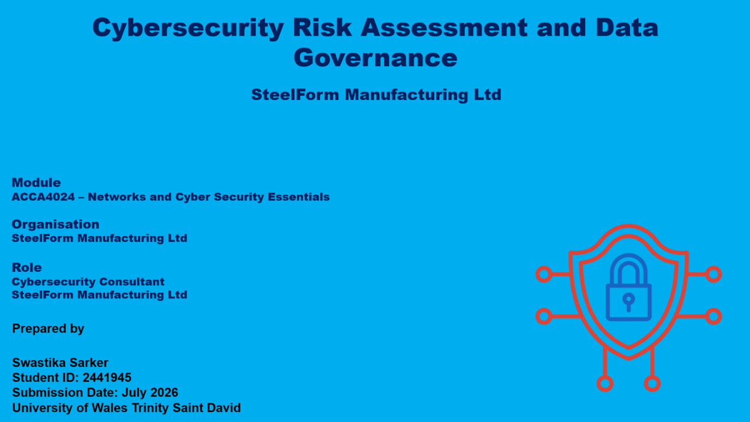
Slide -1
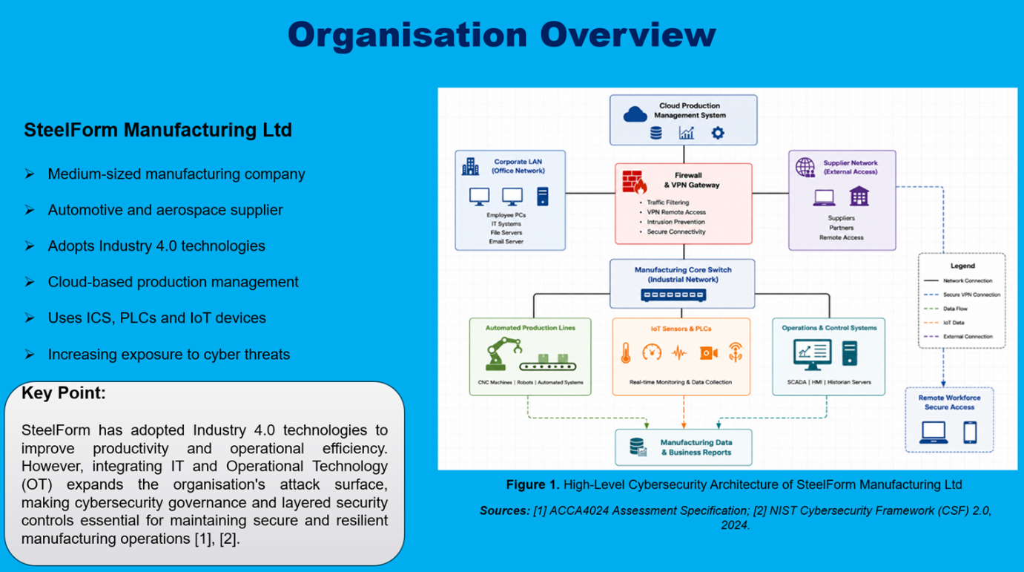
Slide -2

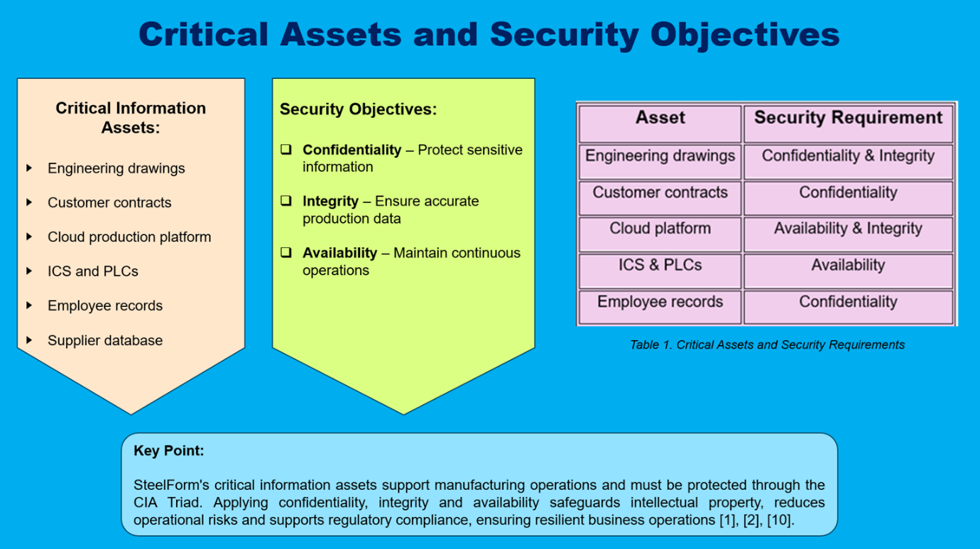
Slide -3

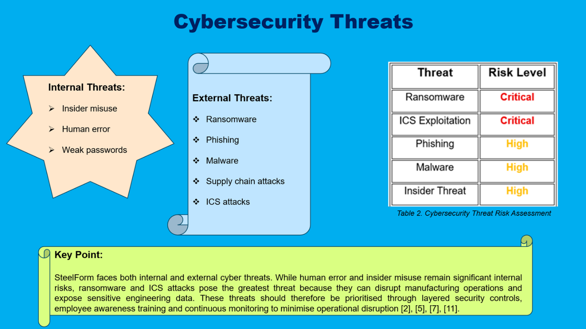
Slide -4

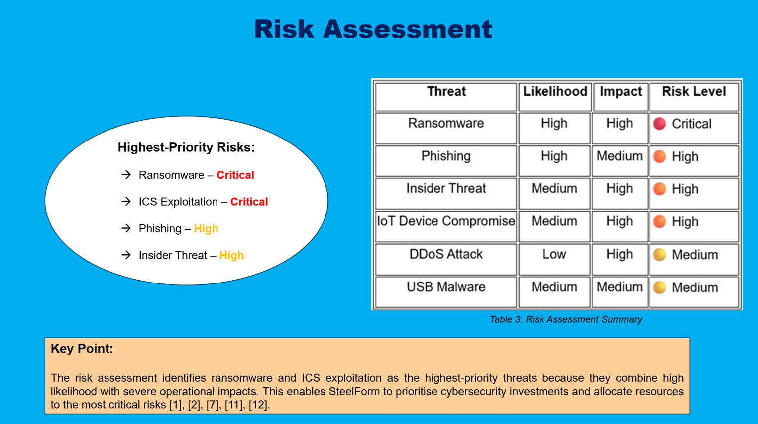
Slide -5

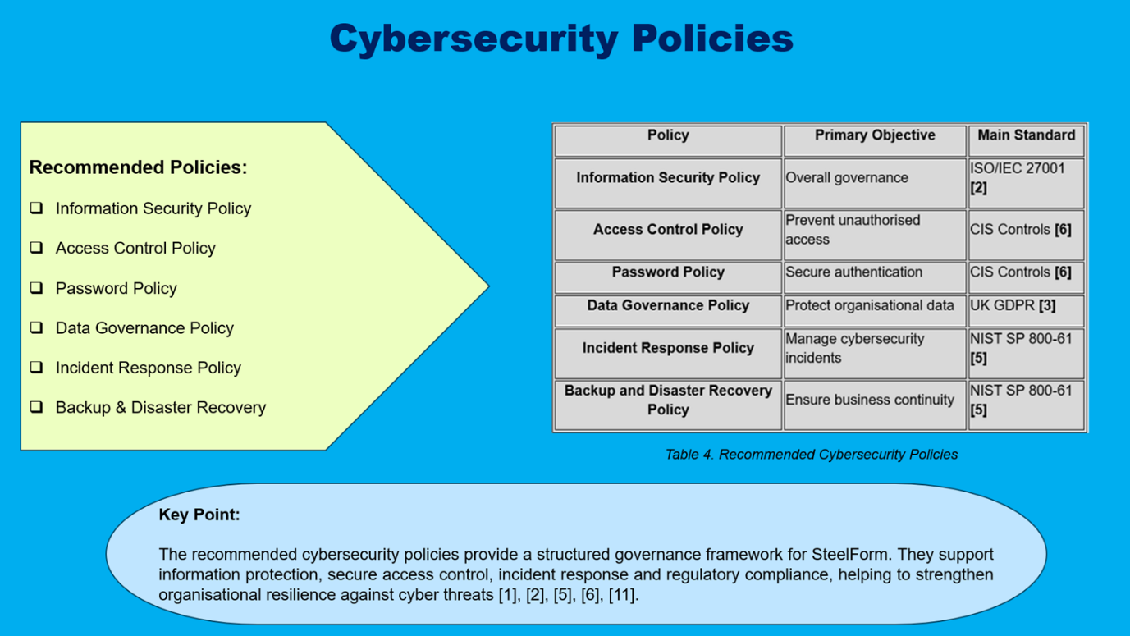
Slide -6

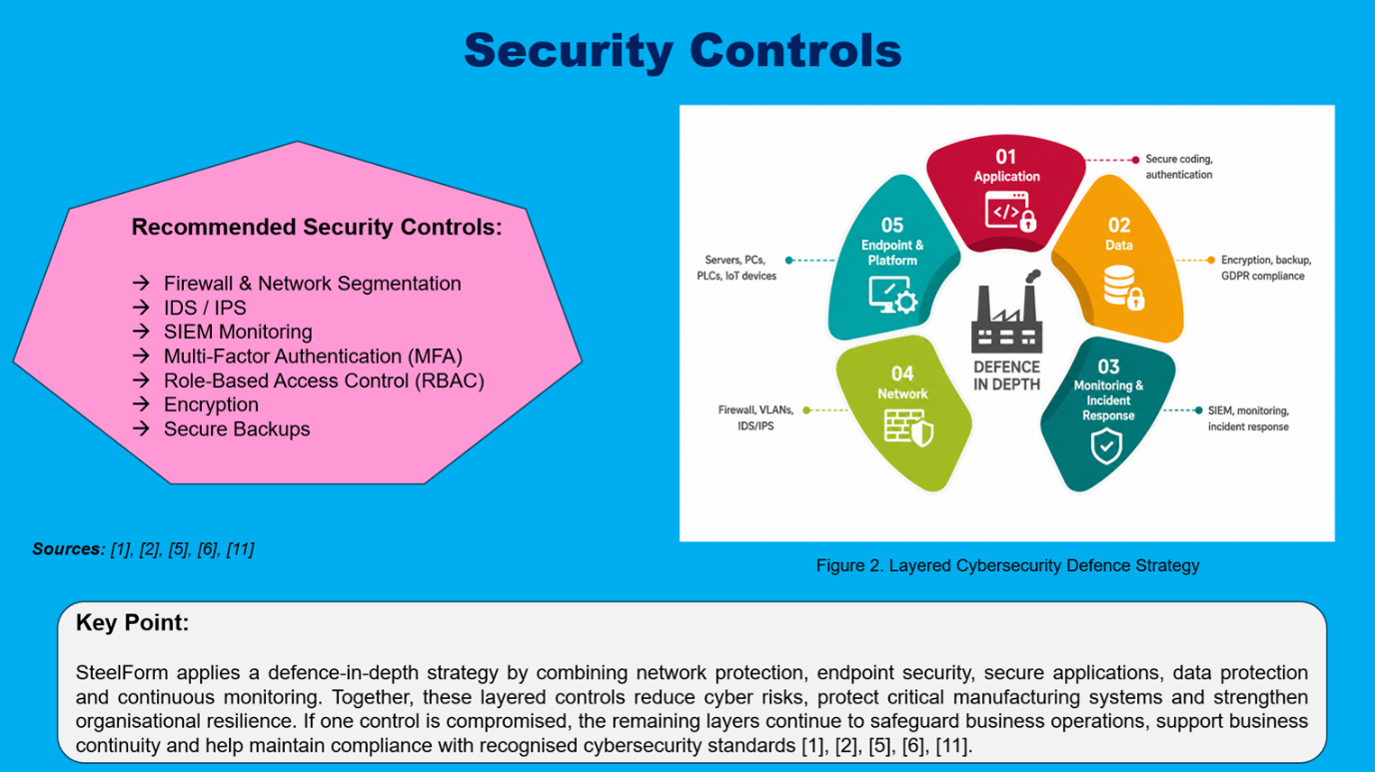
Slide -7

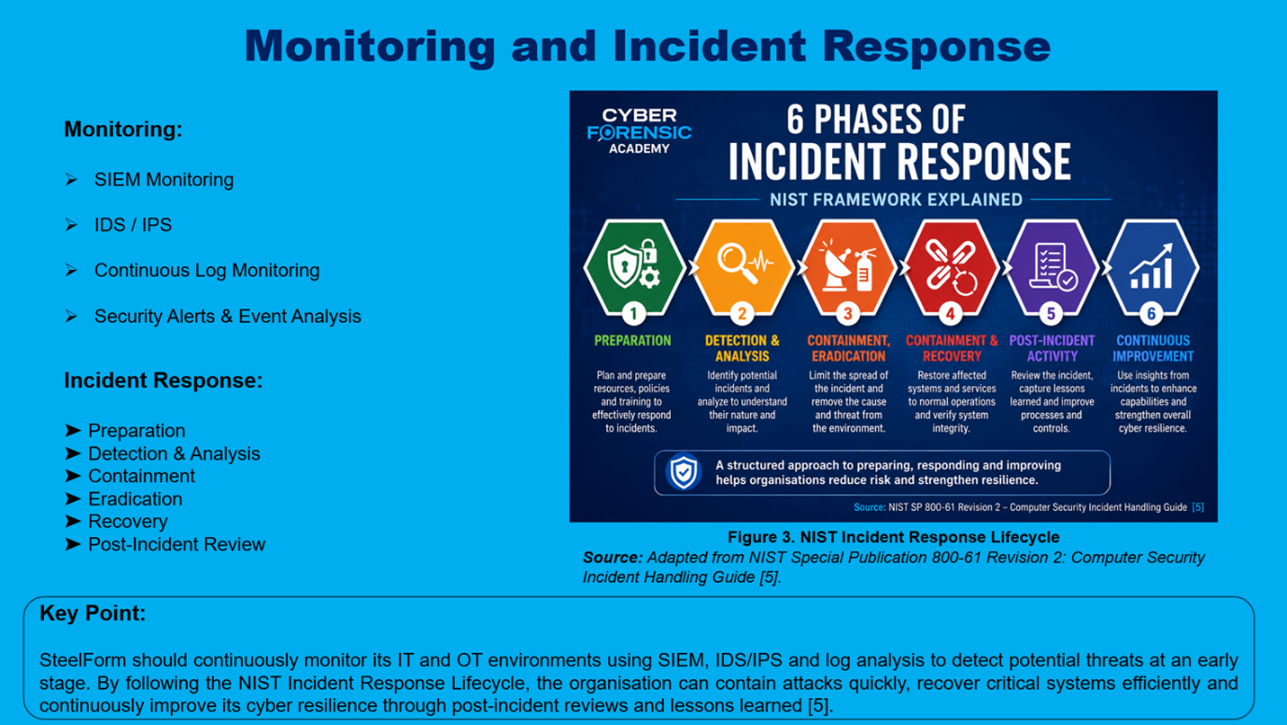
Slide -8

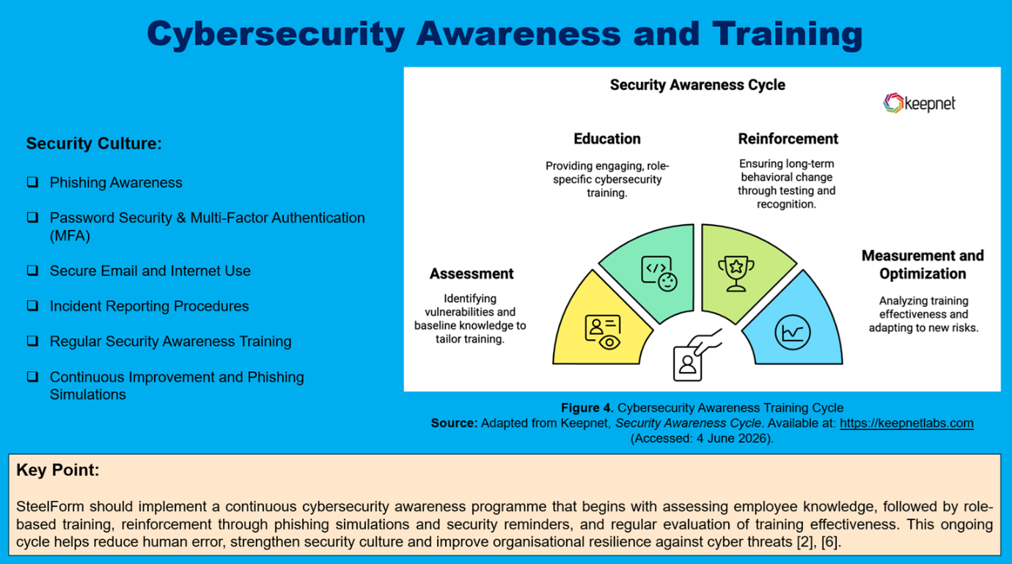
Slide -9

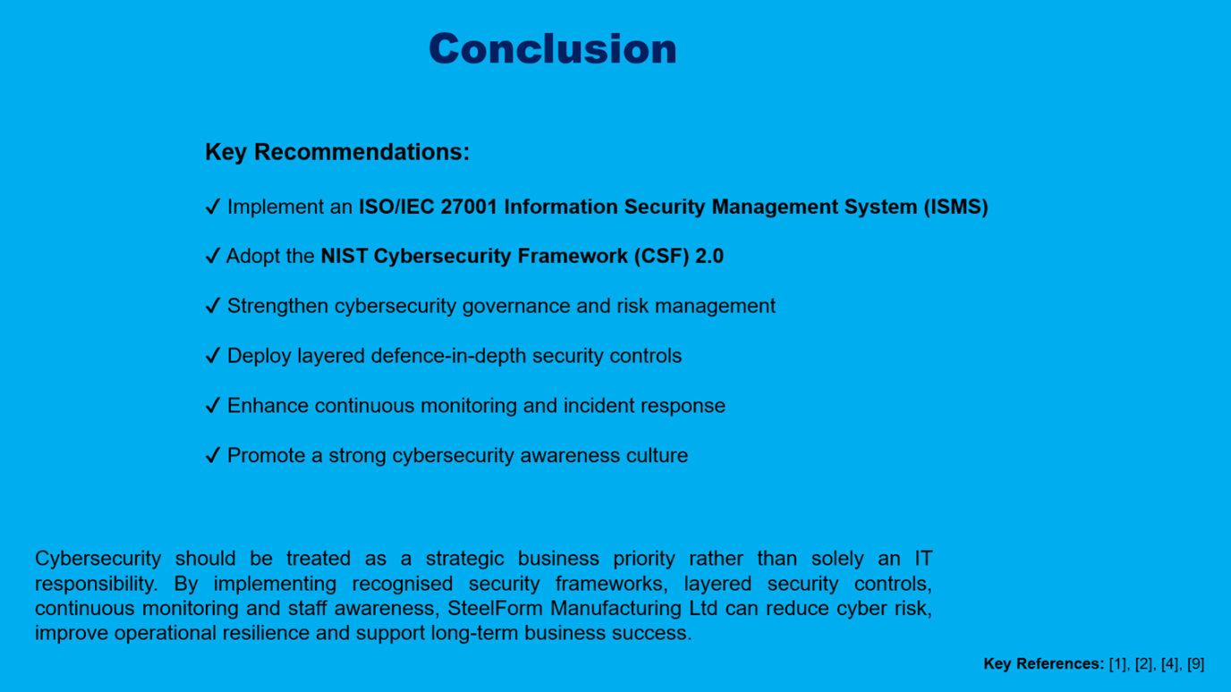
Slide -10

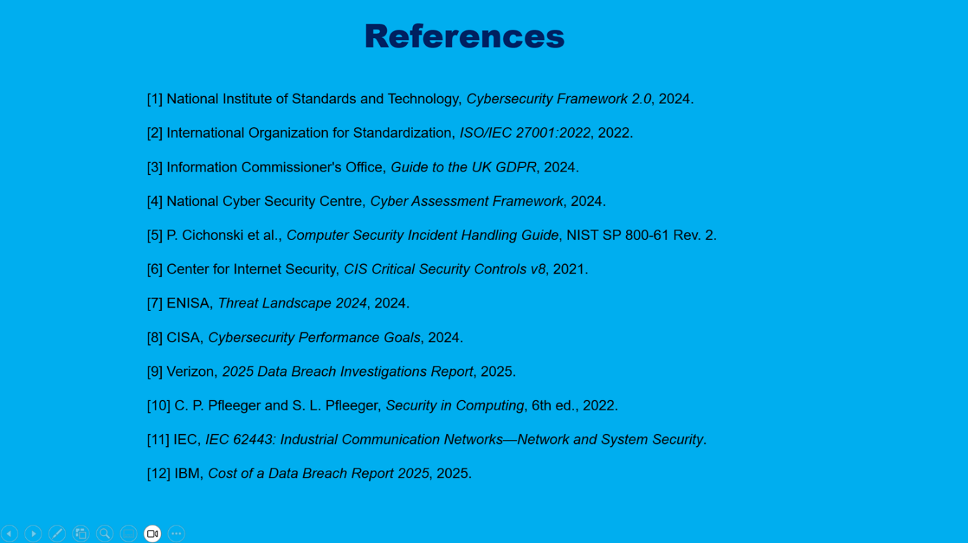
Slide -11


Slide -12

