

Problem Solving and Decision Making

Report

Student: Corneliu Ionut Baba

Student Number: 1906079

Module code: BMSW4004_LON

Lecturer: Winifred Soribe

Due date: 30.08.2020

Table of content:

- Introduction………………………………………………………………………………………. -pag 2
- Identification of a complex Problem…………………………………………………… -pag 2
  - Perceived problem……………………………………………………………………………… -pag 2
2.2 Prove how big the problem is……………………………………………………………… -pag 3
2.3 Identify the potential causes of the problem and prove what’s causes the problem-pag 3
2.4 Generate and implement solution……………………………………………….. -pag 6
2.5 Prove you have fixed the problem for good…………………………………. -pag 7
- Conclusions…………………………………………………………………………. -pag 8
- References………………………………………………………………………….. -pag8

- Introduction

In this presentation I will present as a manager in the management team at Amazon.uk an issue at work that we faced immediately after the government in UK decided to impose restrictions on the population and companies due to the covid-19 pandemic. In order to objectify the existence of this problem and then to find the solution to solve this problem I will stage the approach of this situation and find the solution according to Problem solving techniques - How to solve problems in the work place in 6 easy steps that I learned in within the course in term three.

- Identification of a complex problem at workplace

2.1 Perceived problem

- What is the perceived problem ?

Working at Amazon here in London as a Manager I can say that in the period before covid-19 our company had a constant progress in terms of sales, orders made online by customers. That is why the adjustments or solutions we had to make in organizing our work were also made step by step, from time to time so as to be efficient and to offer an ever better quality of the services offered to our clients.

- Why we have a problem

Immediately after the lockdown, due to the fact that most people did not leave their homes for a long time and due to the fact that many of the shops in the city were temporarily closed, the online orders we received increased exponentially.
Before covid-19, in order to make deliveries more efficient, we send the same drivers every day in the same areas to deliver the orders received. The areas were divided in such a way that, from our previous experience, we found that the orders received from customers are around 130-200 per day.

- When and what problem we face

After the restrictions were imposed due to covid-19 and in the context in which people were very scared to leave their homes anyway, the estimated number of orders in the same area that I gave the previous example increased a lot. In some areas they have doubled in others they have tripled.
Due to this fact we noticed that we are facing a serious problem at workplace.

- Who and how has the problem

The drivers did not have the necessary time to cover the entire predetermined area, the delivery time increased a lot being forced to work overtime, and the remuneration was the same as before.

For this reason they became more stressed and some of them even wanted to resign from working at Amazon.

- The impact of this problem and the purpose of solving it

The impact of this situation has a repercussions on both the company's employees and customers. Employees work more for the same remuneration being more stressed and tired because the their tasks are too many and customers no longer receive the packages within the predetermined time interval or on the predetermined delivery day.

The purpose of evaluating this situation is to satisfy both our employees and our customers.

The workers being adequately remunerated for the work performed and at the same time offering them a normal work schedule, and customers to be satisfied with the promptness with which their orders are delivered.

2.2 Prove how big the problem is

To be sure if the newly created situation at workplace is really a problem that needs to be solved, or if it is just something temporary without becoming something permanent we waited 2 weeks before taking solutions. During this time we asked the opinion of the drivers who deliver the orders, of the staff in the warehouse who packs the products and of the managers who deal with customer complaints. Their views have led to the conclusion that we are indeed facing a serious problem that needs to be resolved.

Complaints from customers have become much more than before the lockdown, our drivers who deliver the packages complain that they are tired and stressed because they work harder, and their interaction with customers has become stressful due to fears created by the possibility of contacting this virus. -19, and their salary remained the same as in the past.

2.3 Identify the potential causes of the problem and prove what’s causes the problem

In the process that we started to find solutions to solve the problem we face at workplace, we first looked for the causes of the problem.
In order to understand the situation of our company in its complexity we did a comprehensive analysis of the causes that generate this problem both internally, those strictly related to the organization and logistics of our company, as well as from the macro- environment perspective in which we did a very serious PESTLE and SWOT analysis.

- Internal organizational and logistical causes

In the 2 weeks of evaluation of new situations in which our company is, we realized that due to the restrictions imposed by the government in the context of the covid-19 virus, due to the regulations of physical distance and fear of illness of the population, the preparation and delivery process. of orders received slowed down, and the number of orders increased greatly.

The causes of this situation being these three

- Due to the social distance and hygiene regulations that we had to implement, including in the warehouse where we have the products.

- The time of the order preparation and delivery process has slowed down, both in the warehouse and in the actual interaction time between our agent and the client.

- Due to the fact that many stores were temporarily closed, as well as the restrictions imposed by the government on the population not to leave the house, and especially due to people's fears of leaving the house, the number of orders we receive on Amazon or doubled and in some areas or tripled.

- PESTEL ANALYSIS

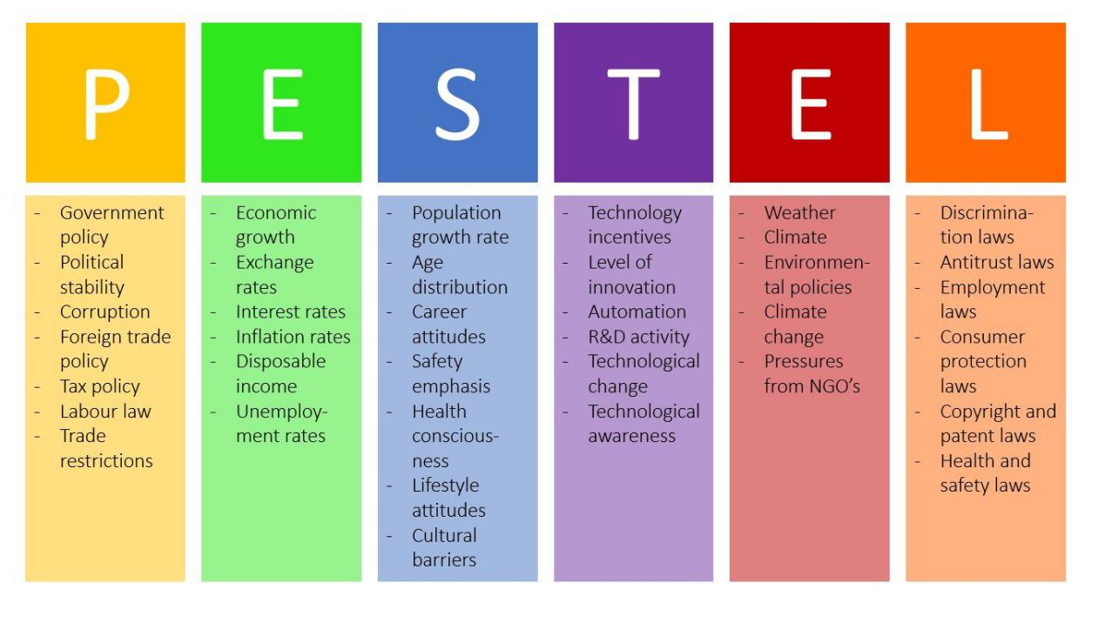

P - Political factors.

From a political point of view, the decisions taken by the government through the restrictions imposed on the population and companies due to the covid-19 pandemic caused immediate and major effects on the development of our company's activities, and were a determining factor in generating the work issue we debate here.

Social distancing, restrictions on people's freedom of movement, are the main causes on which political decisions have influenced the activity of our company.

From another point of view, the government offered grants and other facilities during this period, which economically help our company.

E - Economical.

From an economic point of view I can say that the covid-19 pandemic helped our company to double or tripled sales, but at the same time in the evaluations we make to find the right solution to solve the problem that our company has, we must evaluate very carefully the economic impact that the possibility of hiring more staff has.

We must evaluate correctly because the work in our company requires a certain prior training so that the employed staff can offer a high standard of the offered services.

And to know for sure if the salaries we will offer to our new employees will be able to be covered by the current increase in sales, and if this will remain in the long run.

S - Social.

One social factor that causes the problem we face is the attitude of workers to work. Because the rules have changed due to hygiene measures and social distancing, and due to work that requires more involvement and devotion, the attitude of workers has worsened, they are more stressed and tired and dissatisfied that wages have not yet increased in these conditions.
This is an important aspect that we must consider in order to find the best solution.

T - Technological

E - Environmental

L - Legal.

In this case, the law on safety and health has changed and the requirements are very clear, there is a need for a face mask, sanitary alcohol is needed for employees to wash their hands, it is necessary to avoid any physical contact between employees, etc.

- SWOT ANALYSIS

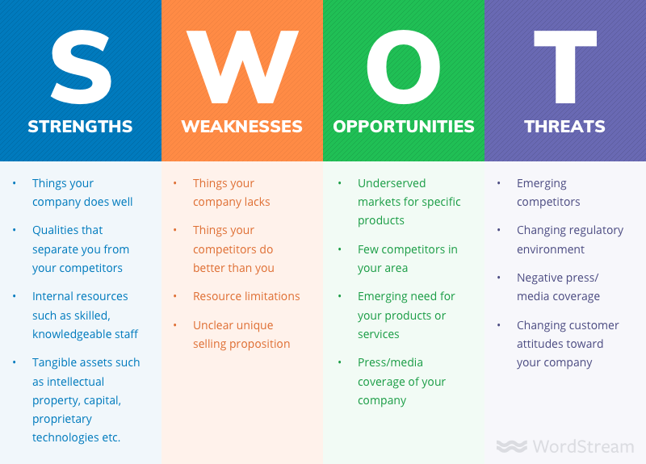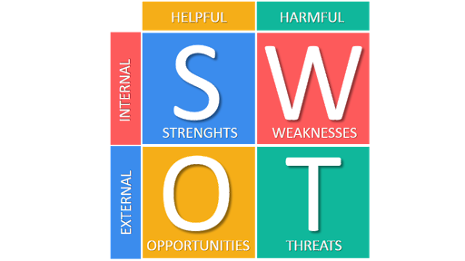

- Strengths

- We are market leaders in the field of online deliveries.
- During the restrictions our sales increased a lot.
- We have a very solid distribution system, which must be slightly adapted to the current situation.

- Opportunities

- It is a favorable corridor to become suppliers of products in many more fields.
- It is definitely a chance that our employees can all work full time if the employees of other companies are sent home.
- It is a chance to have many more customers who, if we are prompt with deliveries, will continue to buy from us.

- Weaknesses

- Due to the hygiene regulations imposed by the government in this context of covid-19, deliveries are slower, each delivery requires more time.
- In the warehouse, the physical distance between the people must be kept, which slows down the work efficiency.

- Threats

- Due to the accumulated stress and fatigue, it is possible for some employees to resign.
- The Corona covid-19 virus is a threat to all of us being always in the front line and coming into contact with many people.

By analyzing Pestle and Swot, we realized that the problem we face is real and serious, and we proved that what generates it is real.

2.4 Generate and implement solutions.

- Propose a range of alternative solutions to the problem

After discussing at the meeting with the managers about this problem, at the end of the discussions were proposed four solutions that we considered to solve the problem.

We will weigh the advantages and disadvantages of each proposal and finally we will choose the proposal we will implement.

- To hire one more person in each delivery car. So on each car we have the driver and another employee, and the two distribute the packages to different addresses. This will reduce delivery time efficiently.

This solution seems to be the most efficient temporarily, and would even help streamline work and cover all orders in a timely manner. But due to government regulations regarding the covid-19 pandemic, keeping physical distance between employees makes it virtually impossible to implement this solution.

- To buy more delivery vans to hire new drivers and to reduce the delivery areas for each agent so that each has a maximum of 200 deliveries per day.

This solution is also very attractive and which we hope will become a reality in the future. But because now the doubling of sales has been generated by an exceptional social situation, we are not sure that the investment we will make in the new vans will be profitable considering that this situation can end at any time.

- Let's keep the same staff as before and make them work extra time. And to pay them well overtime, and to offer them bonuses for effort.

Certainly this solution would be the most desired among many employees. Everyone wants to make more money, and now they seem to have a great opportunity in this regard. But it would not be a legal solution, because many employees will work long hours, and what is even clearer, over time employees will feel tired and stressed and less and less time to be with family and relax, and this in the context of a pandemic when the human immune system is very important, is not a serious solution to consider.

- Let's hire more drivers to whom we will offer part time job, and on each van there will be 2 drivers who will work with different time schedule on the same day.

In the end, we considered this solution to be the best in the current context. We keep the same staff and hire part-time drivers who will be called to work on days and for areas where orders cannot be covered by the main drivers in the normal 8-hour work schedule.

2.5 Prove you have fixed the problem for good.

- New Plan

So we made a new plan in which on the previous day the staff responsible for accounting for orders to check on the default areas for each driver how many orders there are for the next day, so as to let us know if for that area the next day we need to call the second driver to come to work part time.

In order to make sure that the plan works, we assigned a new function to the staff that accounts for the orders received, namely to check if the ones from the previous day were all delivered according to the plan, in order to make the necessary adjustments where necessary.

- Conclusion

In conclusion, we noticed the problem, we analyzed it after finding that it was a serious problem, we identified its causes, we checked to make sure that those are the real causes, and then we came up with several proposals that we finally debated them by agreeing on the best solution, which we later put into practice according to a new plan that we communicated to the employees and in this way we solved this problem using Problem solving techniques - How to solve problems in the work place in 6 easy steps

- References

Park, R., 2015. Employee participation and outcomes: organizational strategy does matter. Employee Relations, 37(5), pp.604-622.
https://www.cipd.co.uk/knowledge/strategy/organisational-development/pestle-analysis-factsheet

Özbilgin, M., Bartels-Ellis, F. and Gibbs, P., 2019. Global Diversity Management. Cham: Springer International Publishing.

Buchanan, D. and Huczynski, A., 2020. Organizational Behaviour. New York: Pearson Education Limited.

Editorial, R., 2020. MKS.L - Marks And Spencer Group Plc Profile | Reuters. [online] Reuters.com. Available at: <https://www.reuters.com/companies/MKS.L> [Accessed 20 August 2020].
https://www.liveplan.com/blog/what-is-a-swot-analysis-and-how-to-do-it-right-with-examples/

https://www.business-to-you.com/scanning-the-environment-pestel-analysis/
https://www.businessballs.com/strategy-innovation/swot-analysis/

