Gender and Health Inequalities: A Focus on Women in the UK

NAME: GITA DASA
STUDENT NUMBER: 2506059
MODULE CODE: LCHS7000
MODULE TITTL: SOCIAL EPIDEMIOLOGY AND
PUBLIC HEALTH DEVELOPMENT
LEACTURER NAME: DR HAMDI HUSSAIN
ASSIGNMENT TITTLE: ANALYTICAL REPORT

Task 1
Gender and Health Inequalities: A Focus on Women in the UK
Introduction
Gender disparities in health cover numerous areas, such as access to healthcare and the quality of services offered to both men and women. In the UK, it is known that women outlive men, and women born in the UK live to an average age of 82.9, which is compared to the average age at which men born in the country live (79 years) (ONS, 2021). The life expectancy is relatively high, but, on the other hand, the morbidity of the female gender is even higher than that of pathologies such as depression and anxiety disorders and reproductive health complications (Genevieve, 2025; Matud et al., 2024). Such health disparities are causally attributable to factors that involve both biologic determinants and socially and economically affected ones (Genevieve, 2025; Matud et al., 2024). The report examines the health issues affecting women in the UK and the National strategies in place to address these inequalities.
Background and Preconditions in The Refrainment.
Biological orientations, gender standards, and institutional discrimination are some of the factors that contribute to gender inequalities in health in the UK. These are the challenges that women are often left to contend with, as detailed in the following sections.
Three Disease/Illness rates:
- Increased Mental Illnesses
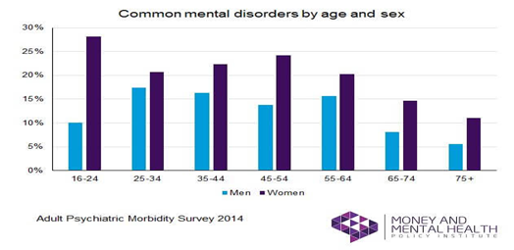
The prevalence rates of depression and anxiety in women are nearly twice as high as the prevalence rates in men (NHS Digital, 2023). Such a discrepancy can be attributed to the need to consider gender and social pressure, as revealed by the BMJ Global Health research (Chang et al., 2025). There is also an additional segment of the population that 1/ 5 women say that they were psychologically affected by workplace and family stress (Jeffrey, 2025). The risk of mental illnesses is further aggravated by the fact that women will be exposed to unpaid caregiving at work and at home (Chen & Wang,2021). Addressing through gender-sensitive psychological support, which will not exacerbate domestic violence (Chen & Wang, 2021).
- Reproductive Health Inequality.
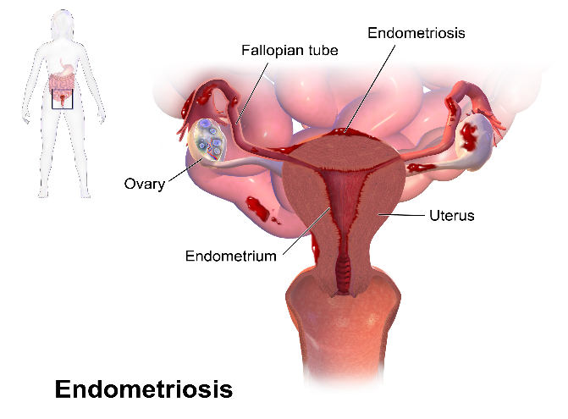
The problems that are particular to the female reproductive system, such as endometriosis, which 1 in 10 women in the UK have, are not researched (Khaledian et al., 2025). Late diagnosis and choice of treatment have been contributed to by the lack of knowledge and insufficient research (Perez & Coutinho, 2021). This condition, e.g., menopause or polycystic ovary syndrome (PCOS), is not well recognised due to the absence of research and gender biases in diagnosis (Health Inequalities - Office for National Statistics, 2021). A national effort to encourage medical workers to conduct research and training can reduce these delays (Raghupathi et al., 2025).
- Cardiovascular Disease (CVD)
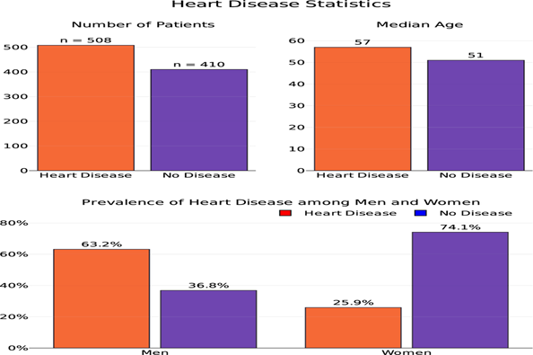
CVD is primarily the leading cause of women's death in the UK because it takes 27% of all women's deaths per annum in the UK (British Heart Foundation, 2023). It has been shown that due to the emergence of atypical symptoms, women extend emergency treatment by 20 % more than typical (Khaledian et al., 2025). This is because the symptoms of heart disease are not as well perceived in women as they are in men, thus delaying treatment (Jeffrey, 2025; Crespí-Lloréns et al., 2021). Solutions to reduce such delays include improving the NHS's ability to recognise cardiac symptoms in women and raising awareness to reduce them.
Three Social Issues:

- Social Isolation and Loneliness
Social isolation is particularly high in older women in the UK. Women aged 65 years and above are more prone to social isolation, and 39% of older women live alone, compared to 22% of men (Colvin, 2023). Social isolation is also linked to the high chances of premature mortality (Bridger et al., 2023). Furthermore, the vulnerability of such women is because they became widows while taking care of the sick. To address this issue, they should implement more community programs (such as Age UK Connections) and social prescribing within GP clinics to promote even greater social engagement (Qu, 2025; Wellard, 2022).

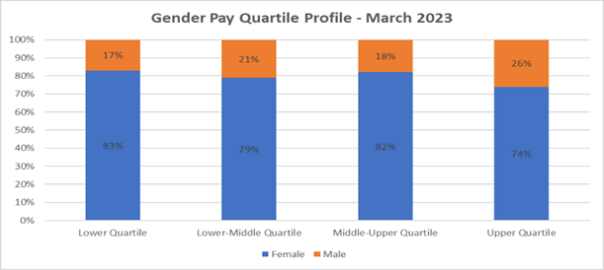
- Poverty and Economic Inequality
Women living under the poverty line are, comparatively, 22 % in the UK in comparison with 18% of men (ONS,2023). The gender pay gap in the NHS England is calculated to be 11.8% (NHS England, 2023). Women are unable to achieve economic independence due to the imbalance in the distribution of low-paid/part-time jobs, as well as the unequal caregiving burden (Gavurova et al., 2020). Solutions to address this issue include closing the gender pay gap through better childcare offers and offering financial literacy training to reduce the economic determinants of ill health.

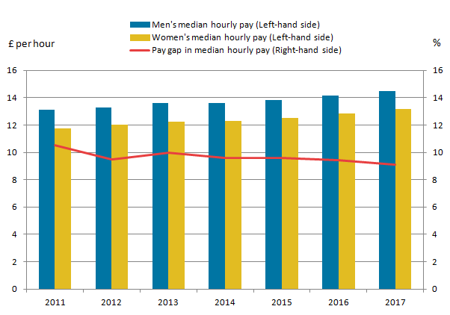
- Workplace Discrimination and Healthcare Access

Women report experiencing discriminatory healthcare and facing longer waiting periods for specialist care (Jeffrey, 2025). All these issues are exacerbated by inadequate support within the workplace, particularly regarding menstrual leaves and maternity cover. Fear of stigma or lack of entitlement prevents many women from seeking medical intervention (Chen & Wang, 2021). Enforcing gender-equality policies in the workplace and improving flexible working rights can ensure that employment does not hinder women’s health.
National Response to Reduce Health Inequalities

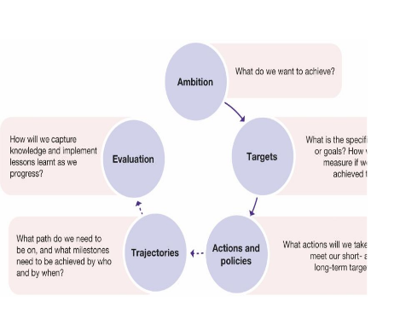

The 100,000+ women who reported delayed or unnoticed diagnoses triggered the introduction of the UK government's Women's Health Strategy. The plan focuses on menopause, reproductive care, and equitable access to healthcare (Department of Health and Social Care, 2023). Women's Health Hubs have improved the situation by providing contraceptive and gynaecological services (The 2024).
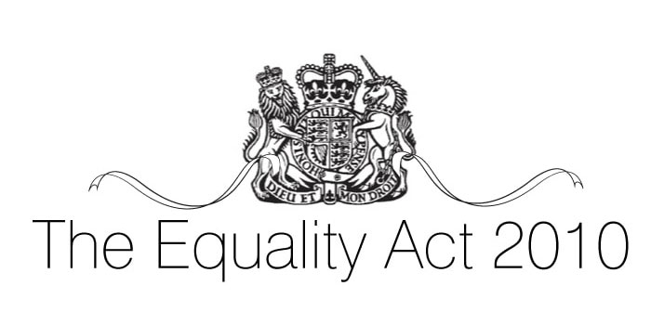
The Equality Act 2010 and the NHS Long Term Plan
These frameworks involve state agencies in combating gender inequality in health services. It is proposed that the NHS Long Term Plan will reduce maternal mortality and improve mental health care provision for women. However, disparities still exist according to region (Office for Statistics Regulation, 2025).
Organisations That Support the Chosen Group
Women’s Health Concern (WHC)
WHC is a significant UK charity involved in education provision, counselling, and advocacy on health issues affecting women. It is a source of knowledge about conditions such as menopause, endometriosis, and heart disease, publishing evidence-based resources and conducting national surveys (Gavurova et al., 2020). Stonewall helps to provide equitable healthcare to gender-different and LGBTQ+ individuals (Chen & Wang, 2021). Their Trans Health Matters initiative educates NHS providers on inclusive care, leading to the emergence of new training events within NHS Trusts (McDermott et al., 2021).
Conclusion
In conclusion, gender health inequalities in the UK are predetermined by biological, economic, and sociocultural factors that are disadvantageous to women and gender diverse people. Women fall victim to mental illnesses, reproductive health problems and social deprivation such as poverty and social discrimination in their workplaces. Despite attempts to build awareness, such as the Women's Health Strategy and organisations like Women's Health Care and Stonewall, there is more to come. More action on this matter (through investment in women's health research, gender-sensitive healthcare training, and social determinant policies such as poverty reduction) is, however, necessary to achieve gender equity in health outcomes.
Task 2
Epidemiological Analysis of Type 2 Diabetes in the London Borough of Hackney
Introduction
Definition of the Health Problem
Type 2 diabetes (T2D) is a chronic, non-communicable, metabolic disorder in which the body does not produce insulin in sufficient amounts or cannot utilize it efficiently, leading to high blood sugar levels, which may harm essential organs such as the heart, kidneys, and eyes (Wang and Nurmagambetov, 2024). The risk factors for T2D include malnutrition, a sedentary lifestyle, and obesity, among others, as well as hereditary and socioeconomic factors. It has also been a significant cause of morbidity and mortality in the global population, and catastrophic effects on both patients and medical institutions (Kirkby et al., 2023).
Reported Social, Cultural, and Health Consequences:
T2D significantly affects the poor communities, especially South Asians and Blacks in Hackney, which are genetically and lifestyle-related. Its complications, like heart diseases and kidney failure, make the disease result in premature death, a low quality of life, and costly treatment as well (Moorthie et al., 2022; Regenold & Vindrola-Padros, 2021).
Levels of Incidence/Prevalence
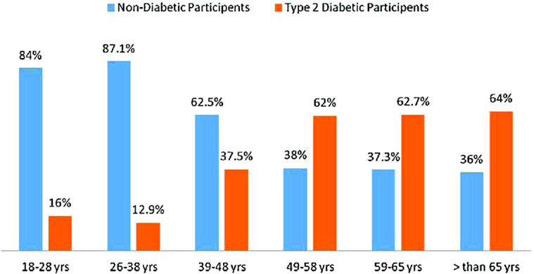
The number of adults diagnosed with diabetes in the world is 463 million as of 2019 and estimated to rise to 700 million in 2045 (International Diabetes Federation, 2019). It is estimated that in the UK, 4.7million people are infected with diabetes. The Incidence of diabetes in Hackney is also extremely high, and the percentage of adults with T2D is 9.6 % as opposed to the country average of 6.9 % (Raghupathi et al., 2025). Hackney has a high issue of managing the disease, especially the heterogeneous population of the region, mostly socioeconomically disadvantaged.
Public Health Measures Designed to Address the Health Problem
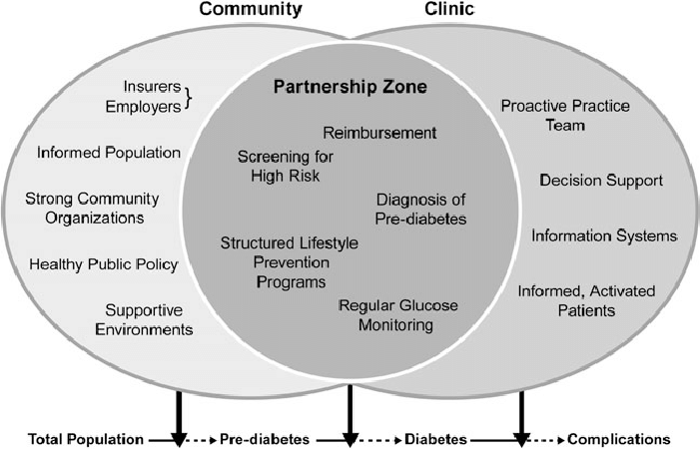

The T2DM control activities targeting the people of Hackney are various community health activities that are implemented on the 3 Ps (Prevention, Protection, and Promotion).
1. Prevention:
The purpose of the Diabetes Prevention Programme (DPP) is to target highly at-risk individuals who are likely to develop T2D, especially the obese, with the help of lifestyle-based behavioral interventions, including weight management, dietary education, and physical activity-based interventions. Prevention Programme Diabetes NHS (2023) states that a 25% reduction in the development of T2D in the groups (Chen & Wang, 2021).
2.Protection:
The NHS screening programme is relevant in the early detection of T2DM. The patients of Hackney GPs aged 40 years and older are also periodically screened against the risk factors of T2DM. Early detection assists in determining whether the interventions can be performed in time, either through the prescription of drugs and a lifestyle to prevent heart disease and kidney disease complications. As the Public Health England (2023) findings claim, the results of the screening cause a reduction in the number of hospitalisations and an increase in the monthly results.
- Promotion

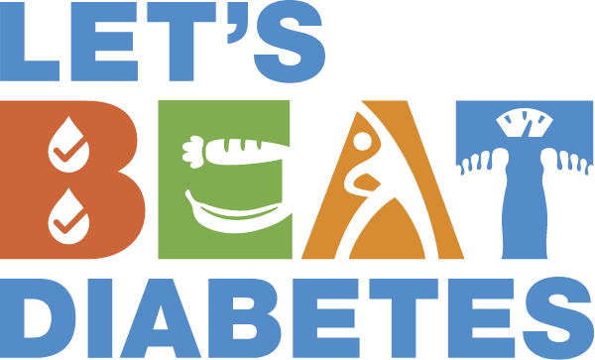

The Self-Assessment of the T2D risk factor, such as the Diabetes UK campaign called Know Your Risk, is promoted by the campaigns held in the UK and the NHS concerning the topic of public health. They are the campaigns that promote the topicality of the healthy weight, a healthy diet, and physical activity (Stefko et al., 2020). The local campaigns that take place in the Hackney area are aimed at the most vulnerable layers of the population, i.e., ethnic minorities, and the resources are presented in different languages (Regenold & Vindrola-Padros, 2021).
Key Determinants/Risk Factors of Type 2 Diabetes
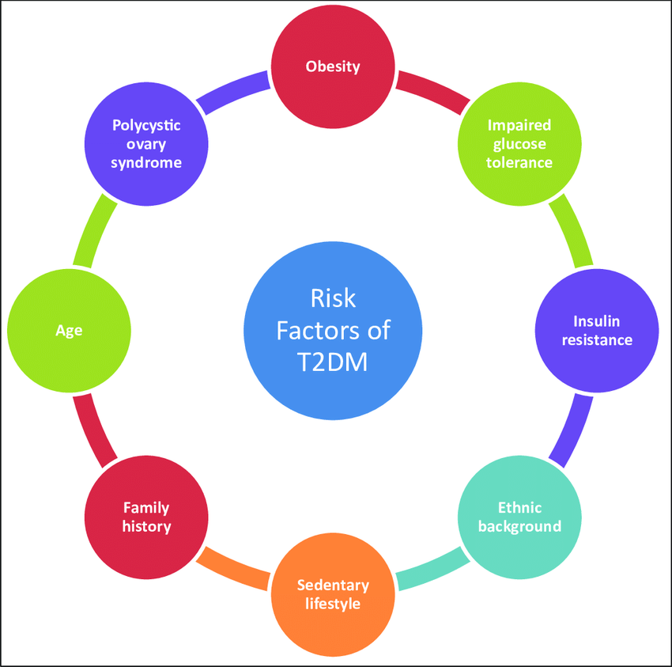
Various determinants and risk factors contribute to the high incidence rate of T2D in Hackney:
- : Obesity
Obesity is the most frequent risk factor of T2DM. On the one hand, the incidence of obesity among the general population of Hackney is 38 % higher than the national level of 28 % (NHS Digital, 2023) - obesity is directly correlated with insulin resistance, which is the cause of T2D. One can establish addiction to a poor diet and a poor lifestyle as the cause of obesity among the Hackney people. It is also because the outlets of the healthy foods are not readily available in the poorer districts.
2.Socioeconomic Status (SES):
The predisposing factors that precondition the rates of T2D among the low-income groups in Hackney include the inability to access healthy meals, inactivity, and the barriers to access to medical care (ONS, 2023). The fact that these groups have a high prevalence of both obesity and diabetes is attributed to the inadequacy to healthy food and exercise centres.
3.Ethnicity:
Some of the ethnicities include the black African-Caribbean and the South Asian, which are predisposed to T2D. The prevalence rate of T2D among South Asians is 3 times higher in Hackney, compared to the Whites (Hackney Health Needs Assessment, 2023). This can be attributed to the fact that it is provoked by the biological factors, predisposition to the risk through the lifestyle and socioeconomic determinants (Diabetes UK, 2023).
Health needs assessment and epidemiological Studies.
The predominantly large burden on minorities and income-deprived populations by T2D in Hackney is reported in several studies, which have assessed the prevalence of T2D in the community.
1.Prevalence:
The T2D among adults in Hackney rates 9.6 percent, as compared to the national average of 6.9 percent, indicating that the South Africans and black Africans are at a greater risk, and South Asians in Hackney are at three times higher risk than White people (Hackney Health Needs Assessment, 2023).
2.Health Needs:
Hackney Health Needs Assessment (2023) states that half of T2D patients have been diagnosed too late, when the disease progresses, which results in the emergence of complications, such as blindness and kidney failure. This leads to the relevance of screening and early intervention, particularly in high-risk communities.
Public Health Approaches and Strategies Used to Monitor Incidence
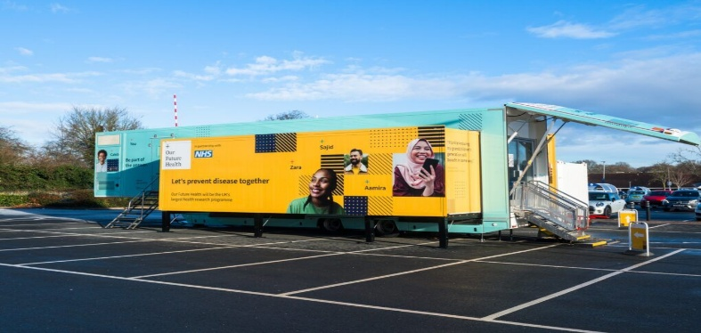
Hackney has several monitoring and surveillance systems that monitor and control the incidence of T2D:
1.GP Registers:
The GPs involved in Hackney maintain the patient records with the T2D registers, and this would allow the health givers to track the changes made on the patients and the gap and prevalence of diagnosis. EMIS (Electronic medical information systems) will enable the gathering of real-time data on diabetes care.
2.NHS Digital and Public Health England:
Structures Data collected by the NHS Digital and the National Diabetes Audit considers the prevalence of diabetes in the UK, the effectiveness of its treatment, and its complications. The local data obtained in Hackney is put against the national data to establish the success rates of local interventions (Moorthie et al., 2022).
3.Local Health Surveys:
The health behaviours, such as diet and physical activities, are direct factors that affect the risk of diabetes; surveys, such as the Hackney Public Health Survey, are conducted. The information can be applied to develop health interventions and campaigns based on the needs of Hackney (Raghupathi et al., 2025).
Type 2 Diabetes Public Health Impact/Consequences.
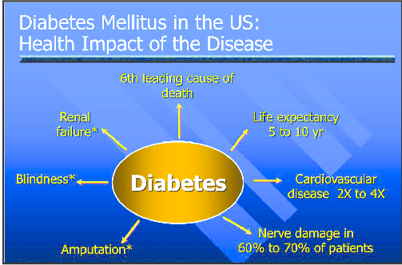
T2D has a high impact on Hackney both in the long term and the short term:
1.Short-term Consequences:
Possible effects of T2D are fatigue, blurred vision, infections, and, therefore, low standards of living, absenteeism at the workplace, and isolation. These complications include foot ulcers and retinopathy, among others, which explain why the high consumption of healthcare leads to high healthcare costs (Chen & Wang, 2021).
2.Long-term Consequences:
The cardiovascular disease, kidney failure, and amputations are the long-term complications. The economic cost involved because of T2D in the UK alone is more than 10 billion pounds every year, and the high rates assume a substantial portion in Hackney (NHS Digital, 2023). Long-term disability is also a characteristic of T2D and, as a result, adds another burden to the healthcare system, as it puts an extra strain on social care services (Regenold & Vindrola-Padros, 2021).
Health Intervention Program and Evaluation
An intervention program to address T2D in Hackney could include:
1.Community-based Interventions:
It is at the level of ethnic minority-oriented interventions that prevent T2D that can be implemented with the assistance of diabetes education. Such programs would be based on the alteration of the diet, sport, and regular check-ups. The participation and performance will be improved through the involvement of the local community centres and leaders.
2.Expanded Diabetes Care Access
The expansion of the use of the initiative on access to the NHS in managing diabetes in the primary healthcare setting would further imply that patients would have access to comprehensive care that would reduce the occurrence of complications and optimize the outcomes. There would be the nurses of diabetes and dietitians who would be present in the practices of GPs and would help to prepare the individualised plans of care.
3.Evaluation:
It is possible to evaluate these plans in terms of the rate of T2D to estimate the strategy's success. This regular audit of the NHS Digital and the opinion of the patients will improve the program (Moorthie et al., 2022).
The Epidemiological Approach has disadvantages and advantages
The epidemiological study offers an effective population-based insight into the T2D trend in Hackney, based on the GP data, NHS Digital data, and health surveys. However, it can also be affected by missing the self-reported information, meaning that it underestimates the burden of the disease and therefore also tends to underdiagnose ethnic minorities (Stefko et al., 2020).
Conclusion
In conclusion, T2D is a significant social health issue in Hackney, where the prevalence rate is elevated, and should be attributed to socioeconomic and ethnic imbalances. The possible impact of the illness on the social, economic, and health aspects is enormous. The necessity to minimize the burden of T2DM among the population is also of high concern since early diagnosis, prevention efforts, and trends of integrated care are crucial steps to be undertaken. Focusing on the most significant determinants, the surveillance enhancement, and some interventions, Hackney can work on the betterment of its health outcomes and the reduction of T2D among its residents.

Reference list
‌ Achieving gender equality and empowering women in the health and care workforce 2020, WHO.int, viewed 2 November 2025, https://www.who.int/teams/health-workforce/hwfequity.
‌ Closing the leadership gap 2021, World Health Organisation, viewed 2 November 2025, https://www.who.int/publications/i/item/9789240025905.
‌ Colvin, H (2023). General health by age, sex and deprivation, England and Wales, Ons.gov.uk, Office for National Statistics, viewed 2 November 2025, https://www.ons.gov.uk/peoplepopulationandcommunity/healthandsocialcare/healthandwellbeing/articles/generalhealthbyagesexanddeprivationenglandandwales/census2021.
‌ England, N (2023). NHS England» Gender pays gap report 2023 for NHS England, England.nhs.uk, viewed 2 November 2025, https://www.england.nhs.uk/long-read/gender-pay-gap-report-2023-for-nhs-england/.
‌ Group, HR 2024, Health inequalities by built-up area and ethnic group, England, Ons.gov.uk, Office for National Statistics, viewed 2 November 2025, https://www.ons.gov.uk/peoplepopulationandcommunity/healthandsocialcare/healthinequalities/bulletins/healthinequalitiesbybuiltupareaandethnicgroupengland/march2021tomay2023.
‌ Health inequalities - Office for National Statistics 2021, Ons.gov.uk, viewed 2 November 2025, https://www.ons.gov.uk/peoplepopulationandcommunity/healthandsocialcare/healthinequalities.
‌ Item 2021, Who.int, viewed 2 November 2025, https://www.who.int/news-room/questions-and-answers/item/gender-and-health.
‌ Kirkby, K, Bergen, N, Baptista, A, Schlotheuber, A & Hosseinpoor, AR 2023, ‘Data Resource Profile: World Health Organisation Health Inequality Data Repository’, International Journal of Epidemiology, vol. 52, Oxford University Press (OUP), no. 5, pp. e253-e262, viewed 2 November 2025, https://pmc.ncbi.nlm.nih.gov/articles/PMC10555845/.
‌ Published data - Office for National Statistics 2016, Ons.gov.uk, viewed 2 November 2025, https://www.ons.gov.uk/peoplepopulationandcommunity/healthandsocialcare/healthinequalities/datalist.
‌ Rea, M (2022). Health state life expectancies by national deprivation deciles, England. Office for National Statistics. Viewed 2 November 2025. https://www.ons.gov.uk/peoplepopulationandcommunity/healthandsocialcare/healthinequalities/bulletins/healthstatelifeexpectanciesbyindexofmultipledeprivationimd/2018to2020.
‌ Regenold, N., & Vindrola-Padros, C. (2021). ‘Gender Matters: A Gender Analysis of Healthcare Workers’ Experiences during the First COVID-19 Pandemic Peak in England’, Social Sciences, vol. 10, MDPI AG, no. 2, p. 43, viewed 2 November 2025, https://www.mdpi.com/2076-0760/10/2/43.
‌ Sowmiya Moorthie, Peacey, V, Evans, S, Phillips, V, Roman-Urrestarazu, A, Brayne, C & Lafortune, L (2022). ‘A Scoping Review of Approaches to Improving Quality of Data Relating to Health Inequalities’, International Journal of Environmental Research and Public Health, vol. 19, Multidisciplinary Digital Publishing Institute, no. 23, pp. 15874–15874, viewed 2 November 2025, https://www.mdpi.com/1660-4601/19/23/15874.
‌ Statistics on Health Inequalities in the United Kingdom 2025, Office for Statistics Regulation, viewed 2 November 2025, https://osr.statisticsauthority.gov.uk/publication/statistics-on-health-inequalities-in-the-united-kingdom/.
‌ Stefko, R., Gavurova, B., Viera Ivankova & Rigelsky, M (2020). ‘Gender Inequalities in Health and Their Effect on the Economic Prosperity Represented by the GDP of Selected Developed Countries—Empirical Study’, International Journal of Environmental Research and Public Health, vol. 17, Multidisciplinary Digital Publishing Institute, no. 10, pp. 3555–3555, viewed 2 November 2025, https://www.mdpi.com/1660-4601/17/10/3555.
‌ UK 2025, Health inequalities in health protection report 2025, GOV.UK, viewed 2 November 2025, https://www.gov.uk/government/publications/health-inequalities-in-health-protection-report/health-inequalities-in-health-protection-report-2025.
‌ Wellard, N (2022). Socioeconomic inequalities in avoidable mortality in England, Ons.gov.uk, Office for National Statistics, viewed 2 November 2025, https://www.ons.gov.uk/peoplepopulationandcommunity/birthsdeathsandmarriages/deaths/bulletins/socioeconomicinequalitiesinavoidablemortalityinengland/2020.
Annandale, E, Harvey, J, Cavers, D. & Dixon-Woods, M (2007). ‘Gender and access to healthcare in the UK: a critical interpretive synthesis of the literature’, Evidence & Policy: A Journal of Research, Debate and Practice, vol. 3, no. 4, pp. 463–486.
‌Bridger, E., Tufte-Hewett, A., & Comerford, D. A. (2023). ‘Perceived health inequalities: are the UK and US public aware of occupation-related health inequality, and do they wish to see it reduced?’, BMC Public Health, vol. 23, BioMed Central, no. 1, viewed 2 November 2025, https://bmcpublichealth.biomedcentral.com/articles/10.1186/s12889-023-17120-6.
Chang, AY, Hawkes, S, Buse, K & Zarulli, V (2025). ‘Is “gender equality in health” the right goal? Exploring issues of definition and measurement, BMJ Global Health, vol. 10, BMJ, no. 4, pp. e017900–e017900, viewed 2 November 2025, https://pmc.ncbi.nlm.nih.gov/articles/PMC12056647/.
‌Chen, D.-H. & Wang, Y-J (2021). ‘Inequality-Related Health and Social Factors and Their Impact on Well-Being during the COVID-19 Pandemic: Findings from a National Survey in the UK’, International Journal of Environmental Research and Public Health, vol. 18, MDPI AG, no. 3, p. 1014, viewed 2 November 2025, https://www.mdpi.com/1660-4601/18/3/1014.
‌Crespí-Lloréns, N, Hernández-Aguado, I, & Chilet-Rosell, E (2021). ‘Have Policies Tackled Gender Inequalities in Health? A Scoping Review’, International Journal of Environmental Research and Public Health, vol. 18, MDPI AG, no. 1, p. 327, viewed 2 November 2025, https://www.mdpi.com/1660-4601/18/1/327.
Diabetes UK (2020). Annual Diabetes Statistics Report.
‌Gavurova, B., Ivankova, V., Rigelsky, M, & Suler, P. (2020). ‘Gender health inequalities and economic productivity in OECD countries’, Economic Research-Ekonomska Istraživanja, vol. 34, Informa UK Limited, no. 1, pp. 2853–2872, viewed 2 November 2025, https://www.tandfonline.com/doi/epdf/10.1080/1331677X.2020.1845762.
Hackney Health Needs Assessment (2018). Addressing Health Inequalities in Hackney.
International Diabetes Federation (2019). Global Diabetes Atlas, 9th Edition.
‌Jeffrey, G. (2025). ‘Barriers to Women in Accessing Healthcare in the UK – A Review’, LSE Public Policy Review, vol. 3, no. 4, viewed 2 November 2025, https://ppr.lse.ac.uk/articles/10.31389/lseppr.122.
Matud, M. P., Bethencourt, J. M., del Pino, M. J., Hernández-Lorenzo, D. E., Fortes, D., & Ibáñez, I. (2024). Time Use, Health, and Well-Being across the Life Cycle: A Gender Analysis. Social Sciences, 13(6), 307. https://doi.org/10.3390/socsci13060307
‌McDermott, E, Nelson, R. & Weeks, H 2021, ‘The Politics of LGBT+ Health Inequality: Conclusions from a UK Scoping Review’, International Journal of Environmental Research and Public Health, vol. 18, Multidisciplinary Digital Publishing Institute, no. 2, pp. 826–826, viewed 2 November 2025, https://www.mdpi.com/1660-4601/18/2/826.
‌Moorthie, S, Peacey, V., Evans, S, Phillips, V., Roman-Urrestarazu, A., Brayne, C, & Lafortune, L. (2022). ‘A Scoping Review of Approaches to Improving Quality of Data Relating to Health Inequalities’, International Journal of Environmental Research and Public Health, vol. 19, MDPI AG, no. 23, p. 15874, viewed 2 November 2025, https://www.mdpi.com/1660-4601/19/23/15874.
NHS Digital (2023). Diabetes Prevalence in the UK. NHS Digital.
Public Health England (2019). Diabetes Health Needs Assessment: Hackney.
Qu, C (2025). ‘Female versus viral: Understanding the UK gender health inequalities during the Covid-19 pandemic using e-archives’, Social Science & Medicine, vol. 366, Elsevier BV, p. 117589, viewed 2 November 2025, https://www.sciencedirect.com/science/article/pii/S0277953624010438.
Raghupathi, W, Wu, S., & Raghupathi, V (2025). ‘Exploring the association between gender inequality and healthcare: A visualisation study’, Global Health Economics and Sustainability, vol. 3, AccScience Publishing, no. 2, p. 188, viewed 2 November 2025, https://accscience.com/journal/GHES/3/3/10.36922/ghes.5776.
‌The N 2024, ‘Addressing health inequalities in gender diverse people’, The Lancet Public Health, vol. 9, Elsevier BV, no. 2, pp. e68–e68, viewed 2 November 2025, https://www.thelancet.com/journals/lanpub/article/PIIS2468-2667%2824%2900006-9/fulltex.
Zeinab Khaledian, Tajvar, M, Amirhossein Takian, Mehdi Yaseri, Hajizadeh, M, & Alireza Olyaeemanesh (2025). ‘Addressing gender inequalities in health: a comprehensive framework for policy and practice’, Discover Social Science and Health, vol. 5, Springer Nature, no. 1, viewed 2 November 2025, https://link.springer.com/article/10.1007/s44155-025-00266-6.

