Student Name:  Andreea Florentina Simon  Student Number: 2025170 | Module: BMIH5005  Lecturer: Kathryn Roberts

RESEARCH PROJECT PROPOSAL

Table of Contents
Introduction 3
The rationale of the Research 3
Research Aim 4
Research Objectives 4
Research Questions 4
Discussion and Literature Review 4
Literature Review 4
Impact of employee engagement activities 5
Significance of employee engagement activities 6
Benefits of employee engagement activities 6
Providing the best possible recommendations for Hilton Hotel: 7
Adopting the leadership approach 7
Implementing the required reward system 7
Providing the platform for professional growth 7
Research Methodology 8
Evolution and Conclusion 9
Reference List 10

Introduction
The outline of the report evaluated the core perceptions towards considering the fact while elaborating on the perceptions of international hotel management along with its core operational activities. Employee engagement is determined as one of the critical points of consideration, allowing any organisation, irrespective of the nature of the business, to accomplish the long-term business objectives by fostering individual goals (Sun and Bunchapattanasakda, 2019).
Evidence from a wide range of sources suggested engaged employees care about their work and the company's performance; ensuring the right effort would create the ultimate point of difference. For that reason, employment engagement defines the function towards creating the best relationship with the organisation along with the employees fostering a good as well as an influential workplace culture where all the employees will feel motivated and dedicated towards the specific set of company values, aims and objectives (Arifin, Nirwanto and Manan, 2019). Therefore, in order to work as per the context of the current research operation, the study will specifically address the three critical components of employee engagement activities such as leadership, rewards and recognition, along with providing professional growth, creating the platform of discursions comprehensive and dynamic.

The rationale of the Research
The global pandemic created due to the sudden coronavirus outbreak provided one of the significant setbacks over all the industrial operations, considering how the entire hospitality sector experienced the significant setbacks (Craven et al., 2020). During the global pandemic,the selected hotel Hilton faced issues such as employee turnover resulting in a lack of employee engagement activities, reduced productivity level and hampering the organisational and operational activities. Over time, employee engagement has become one of the serious concerns for Hilton Hotels as the pattern of work changed over the time, where the HR managers reshaped the mode of business operation. Consequently, promoting employee engagement activities has become one of the critical concerns where the outline of the present research work will ensure the best application of using a wide range of theories driven by the contributions made by the current knowledge. On the other hand, it will prove to be crucial to ensure the best application of research methods providing the core as well as

the necessary aspects by using the best techniques required for identifying, selecting, processing and analysing information about the chosen topic of investigation.

Research Aim
The outline of the current investigation procedure focused on the critical attributes of employee engagement activities along with their impact on the hotel performance of Hilton accordingly.

Research Objectives
- To investigate the impact of employee engagement activities associated with the business operations of the hospitality sector.
- To determine the significance of employee engagement activities over the business operations of the hospitality sector.
- To analyse the benefits of having a good as well as a truly engaged workforce.
- To prove the best recommendations on how an effective workplace with engaged employees is managed accordingly.

Research Questions
- What is the impact of employee engagement activities in the workplace?
- What is the significance of having a truly engaged employment activity over the business operations?
- How do practical employee engagement activities create the necessary benefits within an organisation?
- What are the best recommendations that can be provided over the ways while exploring the current investigation procedure?

Discussion and Literature Review

Literature Review
The present section of the research procedure will investigate the effectiveness of applying a wide range of theoretical considerations driven by the contributions of current knowledge. The context will make sure about how the necessary evidence collected over the ways by executing the best form of secondary information contributed over the ways while reaching the result-oriented outcome. Therefore, based on the formulated research aims and

objectives, the current research procedure's literature specifying the core context of employee engagement activities with its impact on Hilton hotel would prove to be crucial for the study.

Impact of employee engagement activities
Employee engagement activities are one of the integrated aspects of HR operations. Promoting employment engagement activities and their significance will have the potential for the selected organisation to provide a one-stop solution for the identified issues (Fidyah and Setiawati, 2020). The perceptions of employee engagement activities improve the workplace culture aiming towards reducing the turnover ratio, ensuring the enhancement of productivity by fostering a good workplace culture by building effective customer relationships with higher profits, as opined by Arifin, Nirwanto and Manan (2019). Evidence suggested while exploring wide ranges of international business management, improving employee engagement in the workplace is not only about improving employee productivity, but also, at the same point of time, all the individual efforts converted accordingly in the same direction to accomplish the standard set of organisational goals and objectives (Sun, and Bunchapattanasakda, 2019). Employee engagement activities act as one of the trustworthy sources of employee motivation considering how the context will provide higher job satisfaction levels and motivate the employees to deliver results at their highest potential as per Sun and Bunchapattanasakda, (2019). On the other hand, the recovery stage soon after the hit of covid 19 forced managers of the Hilton hotel to think something out of the box in order to deliver the necessary results accordingly, aiming toward excelling in good workplace culture.
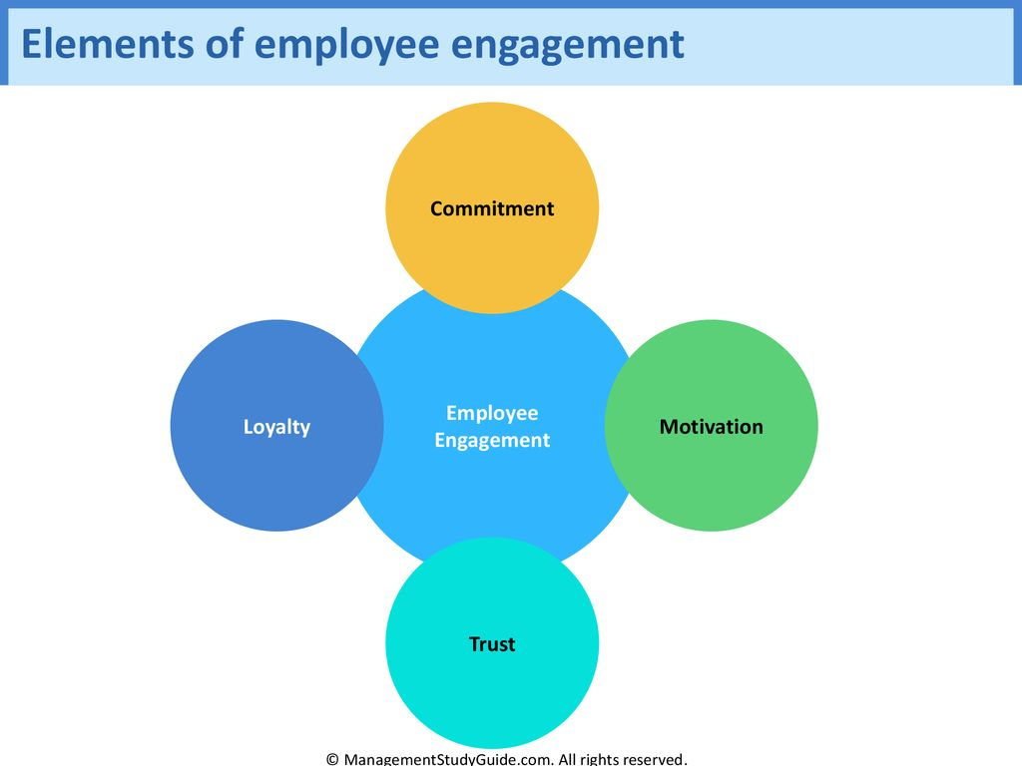
Figure 1: Employee Engagement Framework
(Source: Google Images)

Significance of employee engagement activities
The significance of employee engagement activities holds as one of the excellent positionings with the view towards elaborating the context about how the best delivered towards excelling customer satisfaction, which is one of the foremost things associated with the business operations of the hospitality industry (Fidyah and Setiawati, 2020). Therefore, the significance of excelling in the determined context of employee bounding reflected 21.25% more productivity in the workplace with minimising the context of employee turnover ratio as per Perchard (2018). Therefore, the benefits discussed in the ways illustrated as follows:
- Reducing the absenteeism and turnover ratio
- Enhancement of workplace productivity
- Leadership that is more effective
- Better customer satisfaction

Benefits of employee engagement activities
The benefits of employee engagement activities are one of the critical attributes challenging to replace as measured over the organisational context as per Khalid and Nawab (2018). The attributes of making employee engagement activities are considered one of the big wins for the managers where jobs become comfortable, employees are less stressed, and the team become more productive, resulting in higher customer satisfaction (MacDonald, Kelly and Christen, 2019). The same concept is applied over the ways while executing the determined

point of consideration associated with the business operations of the selected company in the report, i.e. Hilton Hotel. Therefore, the following part of the report will execute the best way about how the long-term goals, as well as the results, are accomplished to promote the necessary employee engagement activities accordingly.
- Higher employee engagement activities will indicate less burnout for the Hilton Hotel
- Practical employee engagement activities will foster a good workplace place
- Going more profound enhanced employment engagement activities will ensure Hilton Hotel less need for supervision along with reduced time spent on mentoring and coaching

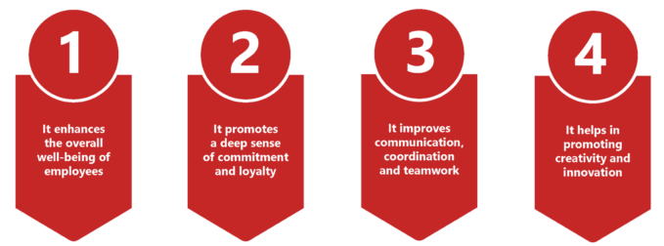
Figure 2: Benefits of having employee engagement activities
(Source: Google Images)

Providing the best possible recommendations for Hilton Hotel:

Adopting the leadership approach
The context will prove crucial in order to ensure the necessary leadership approach where the management of the selected organisation in the report will be able to countermeasure the identified issues (Al Khajeh, 2018). Therefore, recommended over ways adopting the fundamentals of transformational leadership style will promote the necessary employee engagement activities driven by the philopshiocal point of view of 4Is. Inspirational Motivation, Intellectual Stimulation, Idealised Influenced, and Individualised considerations are the components that foster transformational ways of managing a team (Khan andWajidi, 2019).

Implementing the required reward system
The employee reward system also holds as one of the critical points of consideration where making the best use of the determining aspects will act as one of the essential motivational

measures over the organisational aspects of Hilton Hotel. Ensuring a proper reward system will create a determined point of consideration, assessing the core attributes of fostering appropriate job effort with exploring the best performance matrix (Khalid and Nawab, 2018). Good reward system act as one of the critical functions of motivational measures where the performance level of the employees is examined by building the necessary point of understanding withy building proper engagement activities as per Khan and Wajidi, (2019).

Providing the platform for professional growth
Fostering the best professional growth will execute the critical point of consideration where both the professional and personal goals accomplished by the employees keep their time motivated with their work (Arifin, Nirwanto, and Manan, 2019). Therefore, the HR manager order to ensure a good workplace bonding among the employees required to take the necessary initiates for maintaining the optimum level of motivation where engraining employees all the time will be prioritised at the highest level (Lonhart, 2020).

Research Methodology
The research methodology will explore selecting the best approach to determine the best ways by effectively using tools and techniques to measure the validity and reliability of the study accordingly. Along with the same point of time, the proceedings as per the context of the current research operations will ensure identifying, selecting, processing, and analysing of the required information while evaluating the current topic (Ragab and Arisha 2018). As a result, a wide range of research methods is used over the ways by choosing the best mode of collecting data required for executing the current investigation procedure towards creating a dynamic and comprehensive platform.
The fundamentals of applying the concept of positivism research philosophy encouraged over the ways considering the fact of making the best use of factual knowledge gained through observation by marinating an objective manner as opined by Snyder (2019). As the reason the scope of formulating new theories was limited, the application of using the perceptions of deductive research methods will prove to be applied per the current context (Rinjit, 2020). Finally, while assessing the research design, explanatory research methods were selected as the nature of the present investigation procedure with its problem clearly defined accordingly.

Now coming with the mode of collecting data, both the primary and the secondary approaches are encouraged to select the best data obtained from a wide range of sources. Therefore, the scope of quantitative and quantitative methods of collecting data is present over the present research operation, where 30 employees and five managers (sample size for the research) from the Hilton hotel will be requested to share their valuable time along with their viewpoints on the research topic. Making the best use of the first-hand data will be crucial. A survey will be conducted to determine the quantitative approach and interviews to fulfil the qualitative attributes. Therefore, the fundamental Research will be subjected to the data protection act, where maintaining the confidentiality of the study by following a specific set of ethics will be crucial. Finally, analysing the collected data by making the best use of the statistical tools such as MS Excel for the quantitative approach with purposive sampling methods for the qualitative approach will allow the analyst to select the required data set out of several alternative options.

Evolution and Conclusion
The conclusion of the report summarised and analysed the critical points of consideration, making the best use of the literature along with the wide range of research methods used for conducting the current investigation procedure. Business exists in a dynamic condition where the context of exploring the perceptions of employee engagement activities holds as one of the ongoing proceedings. Therefore, making the best use of the literature will allow the HR team and the management of the Hilton Hotel to ensure the best employee engagement activities and the identified issues (discussed in the reasoning section) are addressed by taking the best possible measures. The methodological section of the report holds one of the crucial positionings where making the best use of the research methods with the contributions made by the theories (discussed in the literature review section) explained in the context of the identified research problem. Formulating an open-ended survey question was crucial where the objective of the research questionnaire was to gain the respondents' viewpoints. Finally, a proper time schedule maintained by the analyst to execute the research proceedings ensures the best time management aiming towards completing the operations on the mentioned time.

Reference List
Al Khajeh, E. H. (2018). Impact of leadership styles on organizational performance. Journal of Human Resources Management Research, 2018, 1-10. https://ibimapublishing.com/uploads/articles/JHRMR/2018/687849/687849-1.pdf
Arifin, Z., Nirwanto, N., and Manan, A. (2019). Improving the effect of work satisfaction on job performance through employee engagement. International Journal of Multi-Discipline Science (IJ-MDS), 2(1), 1-9. LJ201908071565151538635.pdf (unmer.ac.id)
Craven, M., Liu, L., Mysore, M., and Wilson, M. (2020). COVID-19: Implications for business. McKinsey and Company, 8. http://www.aedcr.com/sites/default/files/docs/mckinsey-full_article.pdf.pdf.pdf
Fidyah, D. N., and Setiawati, T. (2020). Influence of organizational culture and employee engagement on employee performance: job satisfaction as intervening variable. Review of Integrative Business and Economics Research, 9(4), 64-81. riber_9-4_05_s19-194_64-81.pdf (buscompress.com)
Khalid, K., andNawab, S. (2018). Employee participation and employee retention in view of compensation. SAGE Open, 8(4), 2158244018810067.Employee Participation and Employee Retention in View of Compensation (sagepub.com)
Khan, M. R., andWajidi, A. (2019). Role of leadership and team building in employee motivation at workplace. GMJACS, 9(1), 11-11. View of Role of Leadership and Team Building in Employee Motivation at Workplace (bahria.edu.pk)
Lonhart, M. C. (2020). Motivation Matters: Wellness in the workplace (Doctoral dissertation, University of Oregon). Final_Thesis-Lonhart_M.pdf (uoregon.edu)
MacDonald, P., Kelly, S., and Christen, S. (2019). A path model of workplace solidarity, satisfaction, burnout, and motivation. International Journal of Business Communication, 56(1), 31-49. A Path Model of Workplace Solidarity, Satisfaction, Burnout, and Motivation (sagepub.com)
Perchard, A. (2018). Workplace Cultures. Microsoft Word - Perchard_2018_WORKPLACE CULTURE MANUSCRIPT.docx (openrepository.com)
Ragab, M. A., and Arisha, A. (2018). Research methodology in business: A starter’s guide. Management and organizational studies, 5(1), 1-14. https://www.researchgate.net/profile/Mohamed-Ragab-22/publication/321769066_Research_Methodology_in_Business_A_Starter's_Guide/links/5a311456aca2724bf72185bf/Research-Methodology-in-Business-A-Starters-Guide.pdf
Rinjit, K. (2020). Research methodology. http://14.99.188.242:8080/jspui/bitstream/123456789/11658/1/Research%20Methodology%20A%20Step-by-Step%20Guide%20for%20Beginners%20by%20Ranjit%20Kumar%20%28z-lib.org%29.pdf
Singh, D. (2019). A literature review on employee retention with focus on recent trends. International Journal of Scientific Research in Science and Technology, 6(1), 425-431. 5095_lit_review_paper20190919-118800-dzni7v-with-cover-page-v2.pdf (d1wqtxts1xzle7.cloudfront.net)
Snyder, H. (2019). Literature review as a research methodology: An overview and guidelines. Journal of business research, 104, 333-339. https://reader.elsevier.com/reader/sd/pii/S0148296319304564?token=27348951DD4310050A9A40A2347170660C02D222620C2CE7B65A615C91B2E32D22A22B58B6310E2860EDC2451561AAC0andoriginRegion=eu-west-1andoriginCreation=20220620125732
Sun, L., and Bunchapattanasakda, C. (2019). Employee engagement: A literature review. International Journal of Human Resource Studies, 9(1), 63-80. Employee Engagement: A Literature Review (repec.org)

