Student Name: Cristina Larisa Negesc
Student ID: 1917996
Module code: BMSW6102
Assignment section: Task 1: Written submission
Lecturer’s name: Khaza Ahmed

Table of Contents
1 Introduction 3
2 Main Body 4
2.1 Innovative service idea 4
2.2 Products description, service process and Matrix Innovation 4
2.3 Emerging customer needs and target market 6
2.4 SWOT 6
2.5 Competitors 7
2.6 Sustainability 7
3 E-commerce 8
3.1 Platform 8
3.2 Smart Crockery Hire’s website 8
3.3 Financing, equipment and supplies 9
3.4 Staff 10
3.5 Payment service 11
4 Marketing 11
4.1 Advertising 11
4.2 Target customers and customer journey 12
4.3 Company Launch Event 12
5 Conclusion 13
References 13

1 Introduction
  - Purpose of the report
This project plan aims to create a competitive innovative service and products that addresses specific customers' emerging wants and needs. An eCommerce website store will enable the company to reach its customers, and the advertising marketing will be discussed.
  - Report structure
The objectives of this project plan are to introduce an innovative idea on the market which will be described, the Matrix innovation will be defined and applied, target market, customer needs, competitors, SWOT analysis and sustainability will be discussed. E-commerce will be discussed including platforms, website, financing and equipment, staff and payment services. The Marketing platforms, marketing techniques and the customer journey will be discussed. The report will end with a conclusion and references.

2 Main Body
Service innovation can be a powerful tool for building a company's long-term competitive advantage. Utilizing or adopting service models may assist firms in overcoming the challenges of expansion sustainability in competitive marketplaces as well as the challenge of commercialisation (Durst et al. 2015).

2.1 Innovative service idea
Nowadays, everything is smart; the phones, the houses, the devices, the cars and so on. However, the world hasn’t advanced in terms of traditional objects, as for example, the plate. Introducing a smart plate to the market and trying to change the customer behaviour will be hard, but not impossible. The developed innovative idea is to bring to the market the smart plate, its components and the service. The service and the products offered by the company aims to deliver outstanding and disruptive innovative service to its customers by hiring the smart plates. The innovative smart plates, the Wi-Fi devices and the App will provide an excellent service to the customers. The planning of an event has never been easier, and the aim of the company is to provide memories, not only the service.
The smart plates are connected through radio signal to the device attached under each table. The plates will transmit to the device the quantity of food eaten in real time, if the plate is empty or if the food hasn’t been touched for the past 10 minutes. The device will send this information in real time to the App and this will allow the event organiser and the waiters to know in real time which tables have to be cleared, the exact location of the plates and how much food has been consumed. This is not only an innovative service, but its products are innovative too, so in order to understand the service, a quick description on how the plates are made and the process is necessary.

2.2 Products description, service process and Matrix Innovation
  - Plates
The plates are made from Porcelain Dinnerware. Each plate is created as normal for starters, but the bottom of the plate is not attached until the microchip transmitter and the scale are fixed and connected in between the actual plate and the bottom of it. The pressure scale transmits in real time the weight of the food to the microchip. The microchip is a transmitter to the wireless device that will be placed under each table.
  - Table Wi-Fi device
The wireless device has limited action range which will not allow any other devices to interfere with it. This includes other smart plates on other tables. Each device will allow a limited number of plates to be connected and thanks to the microchip, each plate has a serial number. The device will transfer all the information needed to the App.
  - App
The App. will be installed in the main restaurant software, and each waiter tablet. The event manager and each waiter will see in real time which plates or tables can be cleared.
  - Matrix Innovation
Definition:
The Innovation Matrix can be used as a strategic tool to identify distinctive aspects of their product or service. In essence, this matrix aids a business in determining where it fits into various categories and what improvements it must do in order to be prepared for innovation (Borad, 2022).

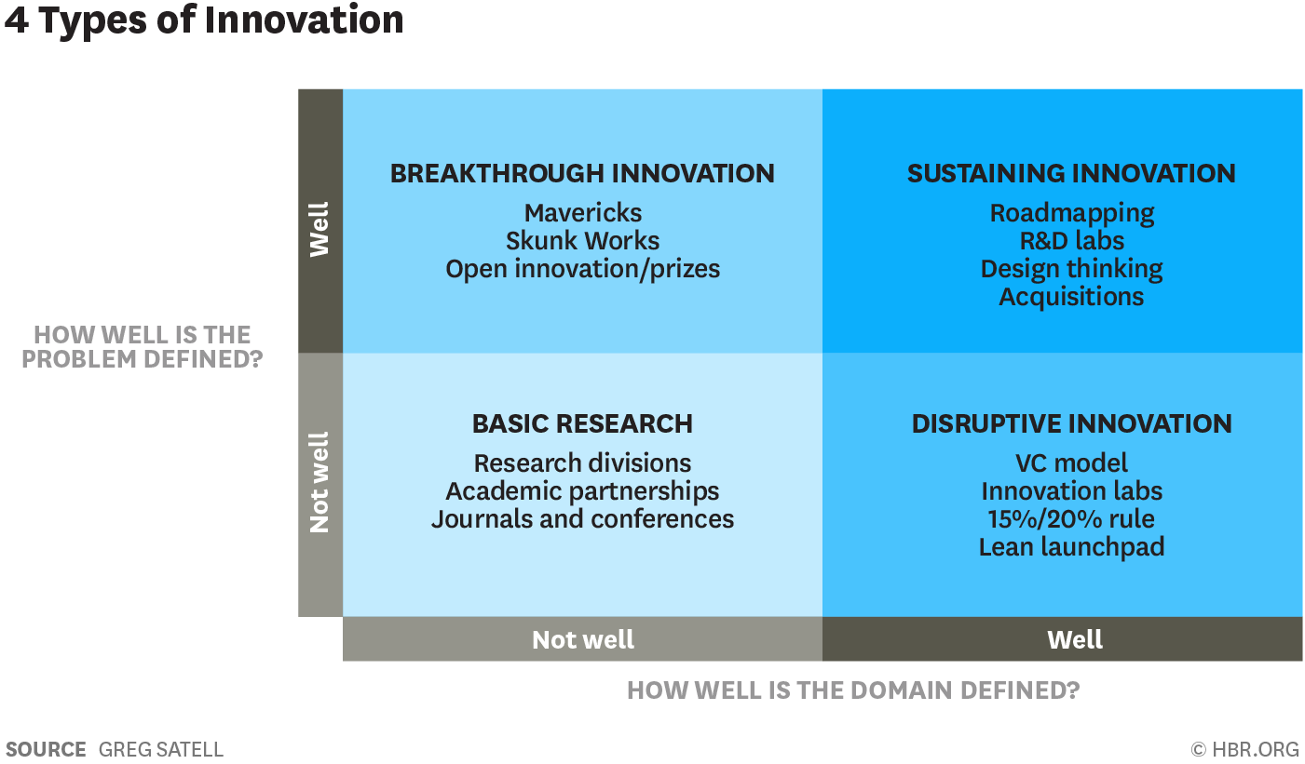
Figure 1 – Matrix Innovation

  - Matrix applied:
According to Kylliäinen, (2019), an idea, product, or service is said to be disruptively innovative if it either establishes an entirely new market sector or causes a disruption in the current industry. Smart Crockery hire thanks to its product will be placed into this category of the Matrix. It doesn’t establish a new market sector, but it is causing a disruption in the current market by innovating the traditional plate into the smart plate.

2.3 Emerging customer needs and target market
The target market is aimed at events, high end restaurants and caterers. Each of these 3 categories emerging needs involve their customer’s experience, time management, profit and publicity. The service and the products provided will fulfil all these needs. The customer experience will be improved and not feel rushed by the waiters going to the table often as they will be aware of each table situation in terms of eating, the time management of the event will succeed as everything will be better and easier organised with less surprises, including kitchen chiefs being able to achieve a more accurate and fair portion for each attendee, the profit will be bigger as fewer waiters will be able to manage larger number of tables and still proving excellent customer service, and in terms of publicity, their customers will love the customer service and the smart plates will attract more customers.

2.4 SWOT

S | W
Innovative service and products  Reliable supplier  Customer services  Investment in technology and innovation  Skilled employees | Customers  New business  Lack of reputation
O | T
New trends in the customer behaviour  Possible rapid economic development | Competition  Price

2.5 Competitors
Smart Crockery hire currently has no direct competitors in the United Kingdom market since it is the only company that rents smart plates. In terms of service, however, the company will face strong competition from existing companies that provide standard crockery. Moreover, although Smart Crockery hire intends to introduce traditional plates' replacement, the items are new to the market. Therefore, competition from traditional crockery merchants will continue to be extremely intense, particularly in terms of pricing and customer behaviour.

2.6 Sustainability
In order for the company to be and maintain the success will acquire, a sustaining innovation strategy is necessary for the long-term run. As soon as the products will start to be on the market, new competition will appear with the same or improved products, so a long-term plan to sustain the company competitive advantage is necessary. The first step into innovation sustainability will be product improvement. This includes different designs, different materials, and the introduction of new smart products which will facilitate the customer journey, as for example the smart cup, the smart glass and so on. The second important step into sustainability will be the investment in the company staff. This will include providing and adapting the training to the current staff regularly and hiring key employees which succeed in positions like development, innovation, environment sustainability, business innovation strategy and so on. The third step will involve the customer experience. The products and service provided will need to have exceptional customer support, where the customers will feel involved in the business, and their problems, complaints and requests will be sorted in no time.

3 E-commerce

3.1 Platform
Smart Crockery Hire will use one platform, in addition to the website, the Facebook page. This platform is very easy to use for the company and the customers. In addition, it has a high range of demographic individuals and is a very attractive platform which is used for both, business to business and direct to customer sales. The company’s goal will be the business-to-business sales. The Facebook page will be easily reached and will allow the company to promote their business and to sell their services. The content on the page is unlimited including customers reviews, prices, selling process and so on.

3.2 Smart Crockery Hire’s website
Regardless of the industry, the internet presence of a business can have a significant impact on its performance. Some businesses today are still unaware that the majority of their clients typically browse their website prior to completing a purchase. A good internet presence, specifically a website, will increase profits. The design of a website is crucial since the website's quality influences its performance. The appearance of a website is the primary factor influencing initial opinion; therefore the help of a website designer is necessary (Kaplan, 2020).
The website will contain 10 pages. The design will be simplistic but eye catching with the right amount of information on each page as follows:
- The “homepage” will contain a brief description of the service and products provided.
- The “about page” will contain a summary of the company, its employees with pictures and biographies and the reason the company’s service and products provided are different from the competitors.
- The “Services page” will explain in detail the service provided with pictures and videos, the advantages of using Smart Crockery hire and not a traditional crockery hire.
- The “products page” will have pictures of the different plates designs the customer can chose from, product and technical details, what the customer may expect when acquiring these products and why they should hire these products from Smart Crockery as opposed to the competition.
- The “FAQ page” will have the most commonly asked questions. These kinds of questions should also clear up any doubts a customer might have, making them feel safe enough to buy from Smart Crockery Hire.
- The “Reviews page” will contain positive reviews from customers including pictures and contact details where possible.
- The “Advertising and prices Page” will include relevant promo codes, sales, and bundle prices.
- The “Contact page” will include all the social media accounts, the relevant email addresses, phone numbers and contact forms.
- The last two pages will be “Privacy Policy page” and “Terms and conditions” page (Matt, 2022).

3.3 Financing, equipment and supplies
In terms of financing, in order to start the business around £100.000 will be required. The amount of money will come from savings and investors. The price for the products, equipment and supplies is as follows:
Cost breakdown
Item | Number of items | Price per item | Total
Products
Smart Plates including scale and microchip | 700 | £ 30.00 | £ 21,000.00
Wi-fi Devices tables | 70 | £ 10.00 | £ 700.00
Equipment
App development | 1 | £ 2,000.00 | £ 2,000.00
Website development | 1 | £ 3,000.00 | £ 3,000.00
Storage Renting space | 1 | £ 1,000.00 | £ 1,000.00
Van with allocated space for the plates | 2 | £ 25,000.00 | £ 50,000.00
Computers | 5 | £ 700.00 | £ 3,500.00
Dishwasher | 2 | £ 300.00 | £ 600.00
Printers | 2 | £ 200.00 | £ 400.00
Supplies
Batteries | 140 | £ 2.00 | £ 280.00
Printer ink | 10 | £ 15.00 | £ 150.00
Sanitaser | 5 | £ 2.00 | £ 10.00
Dishwasher detergents | 20 | £ 10.00 | £ 200.00
Sponges | 40 | £ 1.00 | £ 40.00
Office supplies |  |  | £ 10,000.00
Office stationery |  |  | £ 1,000.00
Total |  |  | £ 93,880.00

3.4 Staff
A successful business needs to employ high skills employees with outstanding customer service. However, as every start up, it will hire necessary employees and will expand its hiring process as soon as the business is functioning correctly and is starting to produce profit. Some of the staff necessary for the start-up, but not limited too will be:
- Product and Service manager: A product services manager oversees service and product growth, assuring quality and client satisfaction (Bektas, 2021).
- IT Specialist: Is the one who can be relied upon when things go wrong. From assisting internal staff members and keeping them productive to helping out external clients and fixing issues with computers, websites, or apps (Matzelle, 2020).
- Sales and Customer Service Manager: A customer service manager's main objective is to maintain profitable customers by enhancing their overall customer experience (Amaresan, 2021).
- Marketing Officer: Marketers define a company's services and products to the customers. A marketer should define the target market's interests and needs to the enterprise. A successful marketer increases a company's sales and profits (Doyle, 2020).
- Multi-skilled Operatives: Are the employees who will drive the van, deliver the goods, explaining the process, installing the app.

3.5 Payment service
The company will accept bank transfers, card payments through the website and cash payments. In order for the company to maintain a secure environment for its customers, it has to be PCI-DSS compliant. PCI Security Standards Council (SSC) provides complete standards and support resources to help enterprises safeguard the privacy of cardholder information at all circumstances. The PCI DSS is the council's pillar since it offers the basis for building a comprehensive card payment cybersecurity process involving protection, monitoring, and response to security breaches.

4 Marketing

4.1 Advertising
The Smart Crockery Hire website will be advertised on different social media platforms:
- Facebook is the most adaptable platform for all types of content. It's a way to engage with the customers and every kind of advertising information can be uploaded or shared.
- LinkedIn is helpful for discussing business developments or industry insights. LinkedIn is utilised to share interesting work-related information. It's an excellent location to exchange professional information, events or awards the company attends.
- YouTube is used by people all over the world to share videos. Clips can be shorter or longer, depending on what you want to say and who you want to reach. Podcasts with famous individuals is a good trend at the moment.
- TikTok is a new favourite for sharing short videos among audiences with short attention span (Fsb, 2022) .
In addition, the company will use paid search engines such as Google Ads and TV Ads. Different marketing techniques will be applied and for the first 10 businesses visiting the website will be given one event free trial to get the customer acquainted with the products and service.

4.2 Target customers and customer journey
  - Target customers
The target customers are event’s organisers, high end restaurants managers and caterers. They will be reached with different promotional and selling techniques including door to door, the power of social media and a launch event where most of the target customers will be invited.
  - Customer journey
The customer journey will start at the first click on the website where out of curiosity will want to see what the company provides. If it will be one of the firsts ten lucky clients, he will have a free event trial to get acquainted with the products and services. The customer will get in contact or vice versa and he will communicate the location, date, time and the products requested and any questions he may have. The operatives will deliver the plates to the requested location one day prior to the event and the App will be installed with proper training on how to use it. On the event day an IT specialist will install and program the Wi-Fi table devices and will assist the customer during the event resolving any issues and respond to any questions. The day after the event, the products will be collected by the company and the Sales and Customer Service manager will be in touch with the client covering the experience, the improvements that he may suggest and the feedback. A promotional code will be provided to the customer for the next purchase.

4.3 Company Launch Event
The event launch of the company will take place at a restaurant as a private event where most of the possible customers will be invited. It will be a dinner party where all the possible customers will feel comfortable and relaxed. The food will be served in the smart plates so they will be able to see in first hand the products, the service provided, and the benefits brought to the restaurant and staff. After dinner, the company’s managers and IT specialists will respond to any queries and will make a presentation on how the products work and why the service will benefit them. Once the presentation is over, all the invitees will carry one listening to music and having fun.

5 Conclusion
In conclusion, the disruptive innovative idea of Smart Crockery Hire will succeed if the project plan and its steps are taken into consideration. The sustainability for the company is very important and will keep the company on track if applied and reviewed frequently. The website and the correct marketing are very important tools for the company’s success, these should be reviewed and improved frequently by the relevant staff.

References
Amaresan, S. (2021) Hubspot. Available at: What Does a Customer Service Manager Do? (hubspot.com). (Accessed: 20 July 2022).
Bektas, A. (2021) Userguiding. Available at: What is Product Service Management? (userguiding.com). (Accessed: 18 July 2022).
Borad, S. (2022) Efinancemanagement. Available at: https Innovation Matrix | Meaning, Types and its Explanation | eFM (efinancemanagement.com). (Accessed: 23 July 2022).
Doyle, A. (2020) Thebalancecareers. Available at: Important Marketing Skills That Employers Value (thebalancecareers.com). (Accessed: 19 July 2022).
Durst, S. & Mention, A. & Poutanen, P. (2015) “Service innovation and its impact: What do we know about?”. Investigaciones Europeas De Dirección y Economía de la Empresa. DOI: 10.1016/j.iedee.2014.07.003.
Groot, J. (2021) DigitalGuardian Available at: What is PCI Compliance? | Digital Guardian. (Accessed: 20 July 2022).
Kaplan, K. (2020) Forbes. Available at: Why Every Business Needs A Website (forbes.com). (Accessed: 24 July 2022).
Kylliäinen, J. (2019) VIIma. Available at: Disruptive Innovation – What is It and How Does It Work? (viima.com). (Accessed: 20 July 2022).
Matt, A. (2022) Digital. Available at: 13 Must-Have Small Business Website Pages: Do You Have Them All? - Digital.com. (Accessed: 25 July 2022).
Matzelle, E. (2020) ComTIA. Available at: IT Specialist | IT Support and Help Desk | CompTIA. (Accessed: 22 July 2022).
Pisano, G. (2015) HBR. Available: You Need an Innovation Strategy (hbr.org). (Accessed: 23 July 2022).
Schooley, S. (2022) Businessnewsdaily. Available at: The First 8 People Your Startup Should Hire - businessnewsdaily.com. (Accessed: 17 July 2022).
Unknown. (2022) Thefederationofsmallbusinesses. Available at: Which social media platform is right for your business? | FSB, The Federation of Small Businesses. (Accessed: 25 July 2022).

