

LOCATION: london | LLEOLIAD: llundain
LEVEL 5 | LEFEL 5
EXAMINATION PERIOD | CYFNOD ARHOLIADAU
may 2016 | mai 2016

MODULE CODE: accc5002
LOCAL AREA NETWORKS
TIME: 2 HOURS

Local Area Networks
BSc Computer Networks (ACCC5002)

Practical Lab Assessment
Year 2/Level 5
May 2016

Name :

Student ID :

Date & Time :

This is an individual practical lab-test, held under examination conditions. You will be assigned three Switches and a Router; you should configure these devices based on the given specifications.

This paper is marked out of 100.

You will have 2 hours to complete this task.

TOPOLOGY DIAGRAM

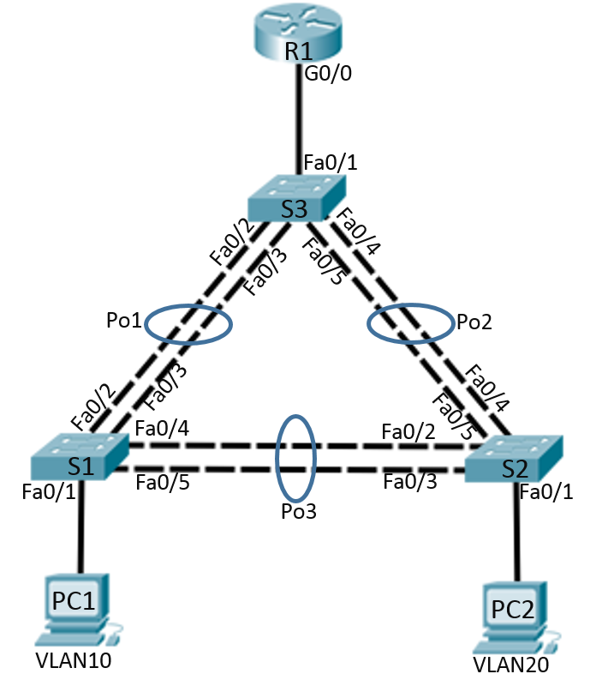

VLAN 10 – Students: 172.16.10.0/24
VLAN 20 – Staff: 172.16.20.0/24
VLAN 99 – Management: 172.16.99.0/24

Addressing Table (10 marks)

Device | Interface | IP Address | Subnet Mask | Default Gateway
R1 | Ge0/0.10 |  |  | N/A
R1 | Ge0/0.20 |  |  | N/A
R1 | Ge0/0.99 |  |  | N/A
S1 | VLAN99
S2 | VLAN99
S3 | VLAN99
PC1 | NIC
PC2 | NIC

Port Assignments

S1
Ports | Assignment | Network
Fa0/2 – 0/5 | 802.1q Trunks (Native VLAN 99) | 172.16.99.0
Fa0/1 | VLAN 10 (Students) | 172.16.10.0

S2
Ports | Assignment | Network
Fa0/2 – 0/5 | 802.1q Trunks (Native VLAN 99) | 172.16.99.0
Fa0/1 | VLAN 20 (Staff) | 172.16.20.0

S3
Ports | Assignment | Network
Fa0/1 – 0/5 | 802.1q Trunks (Native VLAN 99) | 172.16.99.0
Task 1: Prepare the Network (5 marks)
Step 1: Cable a network that is similar to the one in the topology diagram.
Step 2: Clear any existing configurations on the devices.
Task 2: Perform Basic Device Configurations (10 marks)
Configure the S1, S2, and S3 switches and R1 router according to the following guidelines:
- Configure the hostname.
- Disable DNS lookup.
- Configure an EXEC mode password.
- Configure a message-of-the-day banner.
- Configure a password for console connections.
- Configure synchronous logging.
- Configure a password for vty connections.
- Enable service password encryption.
Task 3: Router and Switch configuration instructions (55 marks)
- Configure S3 as a VTP server, and S1 & S2 as VTP clients in the example.com domain. Set the VTP password to ‘cisco’.
- Configure EtherChannel between the switches as per the topology diagram.
- Create VLANs 10, 20 & 99, and name as required.
- Assign ports to appropriate VLANs as shown in the Port Assignments table.
- Configure RSTP PVST+ on all switches.
- Configure S3 to be the primary root for all VLANs and S1 to be secondary.
- Configure PortFast and BPDU Guard on the interface connected to PC1 and PC2.
- Configure S1 as a DHCP server to provide IP addresses and default gateways to users on VLAN 10 & 20. Verify all PCs receive IP address details.
- Configure management IP addresses for all network switches in VLAN 99, and configure them for Telnet access.

- Configure router-on-a-stick inter-VLAN routing.
- Configure subinterfaces on R1 to operate on VLAN 10, 20, and 99 with the address from the Address table.
Task 4: After configuring each host computer, record the host network settings with the ipconfig /all command. (15 marks)

Host PC1 Network Configuration
Description
Physical Address
IP Address
Subnet Mask
Default Gateway

Host PC2 Network Configuration
Description
Physical Address
IP Address
Subnet Mask
Default Gateway

Host PC3 Network Configuration
Description
Physical Address
IP Address
Subnet Mask
Default Gateway

Task 5: Document the Configurations (5 marks)
All documentation for your solution should be submitted. Your name should be clearly printed on the documents.
At the end of the test a pen drive will be given to you, the configuration files for all routers should be copied to the media and handed in to your instructor. It is you responsibility that you copy the files correctly.
On each device, issue the following commands and capture the configurations. Save the file as devicename_surname_Pno.txt
show run
sh ip int brief
sh ip route
sh vlan
sh int trunk
sh spanning-tree
sh etherchannel summary
sh vtp status

