Marketing Plan of DFS in the Forthcoming Year --Based on an Environment Analysis


MAY 2020

MODULE NAME: marketing planning & practice (M6X00884)
Name: hongli shang
Student Number: 1904764

Table of Contents
Executive Summary 1
1.0 Introduction 2
1.1 Report Remit 2
1.2 Background Information of DFS 2
1.2.1 Main Products and Brands 2
1.2.2 Marketing Channels 2
1.2.3 Marketing Share and Main Competitors 3
1.3 Definitions of Major Concepts 3
1.3.1 The Definition of Marketing Mix 3
1.3.2 Explanation of SOSTAC model 4
2.0 Main Body 6
2.1 Situational Analysis 6
2.1.1 External Marketing Environment 6
2.1.2 Internal Organisational Environment 8
2.2 Objectives 9
2.3 Strategy 10
2.4 Tactics 10
2.5 Actions 13
2.6 Control 15
2.7 Limitation of the marketing plan 15
3.0 Conclusion 17
4.0 Recommendation 18
References 19

List of Figures
Figure 1-1 The Diagram Of 7Ps Model 4
Figure 1-2 The Diagram of SOSTAC Model 5
Figure 2-1 Sofasizer of Sofology 12

List of Tables
Table 2-1 The Summary of The Environmental Analysis of DFS 9
Table 3-1 The Summary of the Marketing Plan 17

Executive Summary
The purpose of the report aims to develop the marketing plan of next year for DFS under the framework of SOSTAC model based on a complete and systematic environmental analysis.
The first part introduced the organisation from its main products and brands, marketing channels, marketing share and main competitors. Moreover, two major models applied in the report: Marketing Mix and SOSTAC model were introduced.
In the second part, an outline market plan was introduced accompanied by the thorough analysis of internal and external environment under PEST and SWOT models. Externally, the contingent forestry legislation was disadvantageous considering wood was important for furniture industry; the positive performance of housing market and potential loosened fiscal policy formed advantageous economic factors. Moreover, the increasing purchasing power of young customers brought about the tendency of online shopping. Internally, large market share, complimentary brands and O2O business model were strengths of DFS while the fallen gross sale and synergy effects were its weaknesses.
Based on objectives of maintaining customers, improving synergy benefits and promoting sales, three strategies were considered: via diverse channels to flex the purchase, customising products and coordinating four brands. Specifically, seven tactics based on marketing mix were introduced: Engaging customers with the form of ‘DIY’; Differentiating pricing strategies based on customer segments; Enhancing the function of ‘Sofasizer’; Organising promotion activities on the theme of ‘love home’; Unifying order management and coordinating delivery; Helping customers to recycle old furniture; Designing catchy advertises and collaborating with renowned brands. Furthermore, reporting regularly, quantifying goals and collecting feedback could control the performance. However, there were three potential failure of the plan: budget limitation, privacy invasion and failure in coordination. Finally, recommendations of clinging to customers’ demand and developing digital platform were offered to enhance the performance.

Introduction

1.1 Report Remit
This report aims to come up with a complete and targeted plan for the furniture company, DFS, based on a thorough and systematic analysis of the environment it operates in. The market plan involves feasible objectives, strategy, specific tactics and actions, as well as the implementation and control under the framework of SOSTAC model.
Moreover, limitations and potential failure in terms of implementing the plan are also taken into consideration and correspondent recommendations are offered.

1.2 Background Information of DFS

1.2.1 Main Products and Brands
Established in 1969, DFS is one of the main incumbents in furniture industry in the UK (MarketLine, 2018). Through decades of growth, it has accumulated abundant experience and expertise in designing, manufacturing and marketing sofa and other upholstery products (MarketLine, 2018). There are four separate but complementary brands in DFS family: Dwell, Sofology, DFS and Sofa Workshop, which makes the organisation attractive to different customer segments.

1.2.2 Marketing Channels
Based on the UK, DFS dedicates in the domestic market at present although it also spreads its influence in the market of Spain, Ireland and the Netherlands (DFS, 2020). Corresponding to the social tendency, for example, young customers are becoming the dominant part of whole consumer groups, DFS adopts online format besides its offline showrooms (MarketLine, 2018). Relying on physical and online stores, it provides vertical integration service for customers which means it has ‘end-to-end control of whole customer journey from design all the way through to after sale servicing’ (DFS, 2019). Now, it owns 235 showrooms and 85% of its customers research its online shops as the start of their purchasing experience.

1.2.3 Marketing Share and Main Competitors
On the one hand, the pursuit of higher standard of living partly contributes to the prosperity of furniture industry. The UK accounts for exceeding 10% of the market value of European furniture sector (MarketLine, 2018). Specifically, the market value of upholstery was approximately ₤3.2 billion in 2019 and the market share of DFS group was 34%. In 2019, its whole revenue reached ₤996.2 million (DFS, 2019).
On the other hand, given the character of being close to people’s daily life, the competition in furniture sector is also intensive (MarketLine, 2018). The main competitors of DFS include Ikea, Kingfisher and Steinhoff. Compared with DFS, Ikea focuses more on international market as a global company. Moreover, Steinhoff and Kingfisher are diversified retailers rather than specialising in furniture sales, which is different from the DFS (MarketLine, 2018).

1.3 Definitions of Major Concepts

1.3.1 The Definition of Marketing Mix
As an integral part of marketing strategies, marketing mix is a traditional framework to optimise the resources and controllable factors of an organisation in order to fulfil market demands as well as organisational objectives (Giuseppe et al., 2016). The marketing-mix formula has undertaken a process of evolution since 1950s and its focus has changed as well. Among various formulas, the 4Ps model which was developed by McCarthy in 1960s is robust and versatile which refers to Product, Price, Place and Promotion (Giuseppe et al., 2016). Then, it was developed into 7Ps in 1990s through supplementing factors of Process, People and Physical Evidence (or Physical Environment) by Zeithaml and Bitner (Giuseppe et al., 2016). Figure 1-1 illustrates the diagram of 7Ps model.
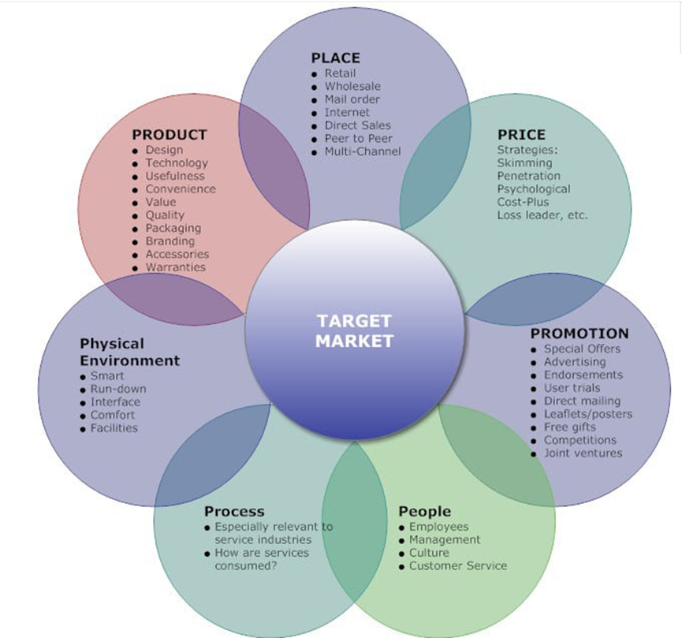
Figure 1-1 The Diagram Of 7Ps Model
Source: The Marketing Mix, 2020

It is believed that components that influence marketing conditions can be divided into two categories: controllable and uncontrollable factors. The former is the basis of marketing mix through which disadvantage parts of the latter could be minimised (Blut et al., 2018). Based on a profound research of marketing environment, not only does the well-organised marketing mix make it possible to enhance strengths of the organisation and diminish weaknesses, but also can improve flexibility facing emergency (Bekh, 2016).

1.3.2 Explanation of SOSTAC model
Developed by Smith in 1998, the SOSTAC model is an effective tool to express a complete marketing plan of the organisation. It comprises of six significant facets of a marketing plan which are situational analysis, objectives, strategy, tactics, actions and control. Figure 1-2 displays the diagram of SOSTAC model.
There is no doubt that an insightful marketing plan under SOSTAC framework can bring about a series of advantages (Dimitrescu et al., 2018). For example, clear objectives can encourage diverse departments of the organisation to work as an integration which is beneficial to fulfil the goal (Kristen, 2013). Moreover, with quantitative Key Performance Indicators (KPIs), it is more convenient to control so that the efficiency can be improved (Kristen, 2013).
However, the weakness of the model appears accompanied by disadvantages of a marketing plan (Dimitrescu et al., 2018). Being too dependent on an existing plan can stifle creativity and innovation. Worse yet, it makes the organisation sluggish facing environmental changes. A misleading plan will also turn out to be a disaster to the organisation (Dimitrescu et al., 2018).
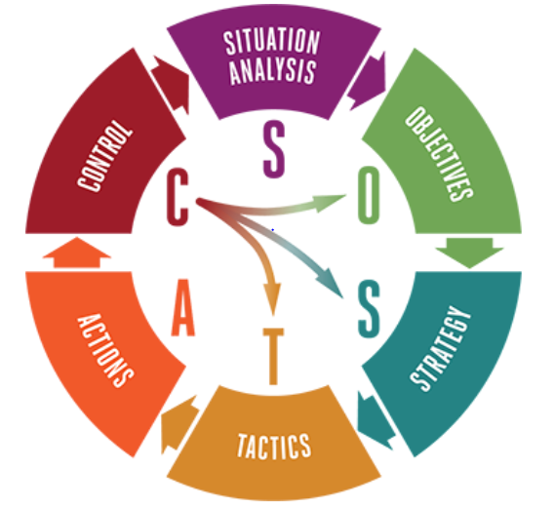
Figure 1-2 The Diagram of SOSTAC Model
Source: Antevenio, 2019

Main Body
In this part, a complete marketing plan is put forward under the framework of SOSTAC including the overall analysis of environment, targeted objectives and specific strategy, tactics and actions, as well as the control and monitor of the whole plan.

2.1 Situational Analysis
Situational analysis refers to have a clear understanding of both the situation of the organisation and its external environment. The former includes its strength, weakness and resource while the latter involves a series of uncontrollable factors (Kristen, 2013). Situational analysis is regarded as the premise of a well-organised marketing plan (Simpson and Radford, 2014). The following is the external and internal environmental analysis of DFS based on formulas of PEST and SWOT.

2.1.1 External Marketing Environment
First, the political situation is not advantageous for DFS. Environmental issues have been attached great importance around the world (Adhikari and Ozarska, 2018). Moreover, environmentally friendly methods of production are considered as sustainable. However, wood is an indispensable material in furniture industry (Adhikari and Ozarska, 2018). Considering the severity of deforestation in the UK (Virto et al., 2015), there have been a series of actions in terms of legislation which aims to protect forest (Gov. UK, 2018). For example, a tree felling license is required for everyone who is involved in falling trees. Moreover, the UK Forestry Standard has been implemented in order to regulate falling trees activities and protect forest resources in the UK (Forestry Commission, 2017). As a result, the cost tends to increase for furniture companies such as DFS or it has to find another effective way to manufacture their products.
When it comes to the economic factor, the world’s economies have been recovering gradually since the last financial crisis (Naisbitt et al. 2019). In the UK, the economy forecast indicates that economic condition will continue roughly as it is considering the existence of uncertain factors (The UK Economy: Forecast Summary, 2019). The overall economy situation has an apparent impact on consumer confidence, housing market and consumer credit (The UK Economy: Forecast Summary, 2019), which are key drivers in furniture industry. For example, home ownership rate in the UK declined to its lowest level since 1985 in 2017, reaching 63.4% (DFS, 2019). However, a recent survey indicates that exceeding 80% of people who are between 18 to 34 years old and do not own estates still want to own their homes (HBF and YouGov, 2016). Moreover, if the fiscal policy is loosened, it will stimulate the increase of consumer confidence and consumer credit (Aldridge, 2018). All of them could be considered as opportunities to DFS.
Furthermore, the social changes should not be ignored. On the one hand, the value of customers is becoming continuously significant (Azizi et al., 2017). With the increase of living standard, customers’ demand of furniture is becoming various. Customer orientation is a strategy that is accepted by numerous companies (Azizi et al., 2017). Therefore, clinging to customised products based on demands of customer is a method to achieve sustainable growth (Wang et al., 2017). On the other hand, young customers are becoming the dominant part among all customers. Compared with other consumers, they are less price sensitive but more concerned about the personality and cause behind the product (Páez et al., 2014). Therefore, DFS can witness a considerable growth if it seizes the opportunity of changes in terms of consumption habits.
Moreover, the technological factor can also affect the development of DFS. Meeting the consumption habits of young people, online shopping has becoming more and more popular (Lin et al., 2019). Correspondingly, the business model of O2O generates in order to satisfy different demands effectively. Via online stores, not only can the organisation promote products but also reduce a part of cost (Lin et al., 2019). Together with physical stores, it can attract more potential customers. DFS has already implemented such a model and made a progress (DFS, 2019).

2.1.2 Internal Organisational Environment
When it comes to strengths of DFS, the market share is advantageous. With a percentage of 34%, DFS is a main player in furniture industry in the UK (MarketLine, 2018). IKEA, known as a giant in the global furniture retailing industry, only enjoys a 9% market share in the UK (IKEA, 2019). A large market scale is advantageous for DFS to maintain its competitive edge.
Moreover, there are four brands in DFS group which are complementary (DFS, 2019). For example, Dwell focuses on stylish and modern furniture and targets on customers whose ages are between 35 to 55 while DFS aims at attracting average sofa purchasers. Sofa Workshop specialises in British-made furniture and its customers tend to be affluent and so does Sofology (DFS, 2019). This strength makes it possible for DFS to target most of the market.
Besides, O2O business model drives the growth of the group. For example, 85% of customers tend to visit its website before shopping in its showrooms (DFS, 2019). The well-designed website and 235 showrooms combine to provide customers with a satisfying shopping experience (MarketLine, 2018).
However, there are also weaknesses within the organisation. Initially, its gross sales fell by 6% for the six months to 29 December which is partly due to external uncertainty such as Brexit (MarketLine, 2020). The falling gross sales will restrain financial budgets of marketing to some extent. Next, that four brands operate separately is not beneficial to increase synergy benefits as well as improve management (DFS, 2019).
Table 2-1 is the summary of environmental analysis of DFS.

Table 2-1 The Summary of The Environmental Analysis of DFS
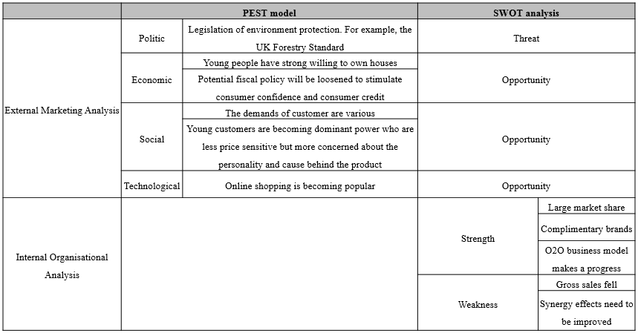

2.2 Objectives
Through the environmental analysis, the external consideration of fulfilling the various demands and the internal factors of improving synergy benefits and promoting sales combine to the basis of the marketing plan. The following are three specific marketing objectives of the marketing plan:
- Maintaining customers. Engaging customers and discovering the value of customers through promoting customised products and offering a reasonable discount (Fernandes and Remelhe, 2016). Managing a series of promotion activities with embedding company’s culture and positive social awareness. As a result, the market share of the organisation can be kept and even witness an increase (Fernandes and Remelhe, 2016).
- Improving synergy effects. Integrating existing retail resources of different brands in order to improve operating efficiency in delivery, information exchange and cost reduction whilst maintaining complimentary characters. Therefore, the demand of customer can be satisfied better, and the problem of high cost can be relieved (Lee et al., 2019).
- Increasing sales. By the end of next financial year, achieving an equivalent sale of the level before falling. If possible, even achieving a positive increase in sales.

2.3 Strategy
First, to maintain customers, the customer segments need to be clarified. The main customers of DFS range from average purchasers to affluent families (DFS, 2019) which means that it targets on the majority of the market. The marketing plan of next year will devote several parts of energy into attract more customers based on maintaining the original strategic direction. There are two strategies:
- Via diverse channels to make the purchase journey flexible. As noted above, e-commerce platform becomes popular with customers especially the young considering its flexible and convenient characters (Lin et al., 2019).
- To differentiate products through customising them. On the one hand, with customer value is discovered, the inspiration of products is guaranteed (Wang et al., 2017). On the other hand, forms as DIY can enhance fun character as well as customer experience (Wang et al., 2017).
Second, improving synergy effects require four brands act as a group which can be achieved through supply chain (Zhang et al., 2018). For example, leveraging its existing retail estates through introducing more Group brands. Moreover, sharing warehouses to improve the efficiency of stock management (Fichtinger et al., 2015). Therefore, the synergy effects such as reducing operating cost and improving service efficiency can be developed (Zhang et al., 2018).
As a result, there is a strong possibility that the sale growth can be achieved.

2.4 Tactics
Under the framework of marketing mix, 7Ps tactics of marketing plan in the forthcoming year are considered.
2.4.1 Product
Tactic: Maintaining present product mix and engaging customers with the form of ‘DIY’
When it comes to the product, for one thing, maintaining the situation that four brands operate separately targeting in different customer segments (MarketLine, 2018) is a part of marketing tactics in the forthcoming year in order to take full advantage of diverse creative elements to promote present product mix (DFS, 2019).
For another, products can differentiate from competitors by engaging customers (Fernandes and Remelhe, 2016). ‘DIY’ here is a generalised concept. Besides they can join the process of ‘manufacturing’ their furniture, for example, offering the chance to upholster an armchair in the factory, customers can even be involved in designing their unique furniture by communicating with company’s designers directly (Kish and Quilley, 2017).
2.4.2 Price
Tactic: Differentiating pricing strategies based on customer segments
When it comes to pricing tactics, there are several categories, such as penetration pricing, skimming pricing and neutral pricing which are suitable for different market goals and different enterprises (Feng et al., 2019). Considering the four brands have their own focuses respectively, differentiating their pricing strategies is effective to increase profits (Iveroth et al., 2013).
For brands that target on affluent customers such as Dwell, Sofology and Sofa Workshop, the brand effect allows them to maintain a relatively high price without losing those customers (Iveroth et al., 2013). Whilst, the customers of DFS tend to be average people for whom offering discounts or coupons seems to be more attractive (Iveroth et al., 2013).
2.4.3 Place
Tactic: Investing in platforms and enhancing the function of ‘Sofasizer’
Leveraging the latest technologies and the development of brand Sofology are what DFS expects to make more progress (DFS, 2019). Through well-invested platforms, it is possible to achieve omni-channel so that the seamless purchasing journey can be provided which allows customers to choose furniture online and experience it offline in order to gain a wonderful shopping experience (DFS, 2019).
To support that, enhancing the function of ‘Sofasizer’ is feasible. It is a tool in Sofology (see Figure 2-1) to help customers find the most suitable sofa through setting parameters such as size, colour and price (Sofology, 2020). Its function can be improved by intelligent recommendation based on customer purchase history (Liu et al., 2015). Therefore, it is more flexible for consumers to find what they want.
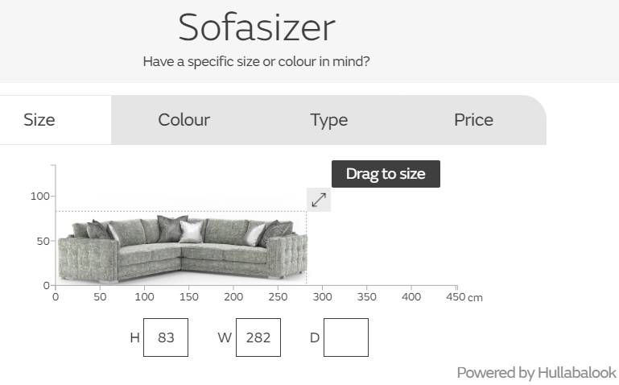
Figure 2-1 Sofasizer of Sofology
Source: Sofology, 2020

2.4.4 Promotion
Tactic: Organising promotion activities on the theme of ‘love home’
Under the background of quick pace of life, the purpose of the promotion activity is to convey an awareness of ‘caring more about your home as well as persons who are waiting for you to go home’ to customers. The content of activities includes pre-advertising, parent-child workshop and reasonable discounts.
On the one hand, this approach is more resonating with customers than only commercial promotions (Kim and Koo, 2015). On the other hand, if the response is positive, it can even be implemented annually which is beneficial to brand effects. Therefore, it allows DFS to increase its exposure and attractive more customers.
2.4.5 Process
Tactic: Unifying order management and coordinating delivery
The element of process aims to ensure a working business that is operating effectively (Giuseppe et al., 2016). One problem of DFS group is that there is a lack of effective communication among different groups (DFS, 2019). An idea is to utilise the Internet technology to establish a unified order platform to achieve reasonable allocation of logistics resources and improve delivery efficiency.
2.4.6 People
Tactic: Helping customers to recycle old furniture
When delivering new furniture to customers, the service of recycling old furniture in customers’ home can be considered. Not only can resources be reserved, but also customers can get some return. As for the old furniture, the scrap value can be realised through cooperating with charities, for example, British Heart Foundation, to recycle them responsibly (DFS, 2020).
2.4.7 Physical evidence
Tactic: Designing catchy advertises and collaborating with renowned brands to deepen public impression
A higher exposure to public sight is generally more convenient for customers to remember the brand (Bigat, 2012). Easy-to-remember advertising words is a cunning way to facilitate customers to have deep impression of the organisation (Bigat, 2012). Another way to achieve it is to build partnership with other well-known brand. For example, deepening the collaboration with Team GB which wins wide concern of the public (DFS, 2020).

2.5 Actions
To implement these tactics specifically, there are several necessary actions need to be noticed.
Action1 Clarifying the division of responsibilities of each department
Initially, allocating responsibility reasonably is imperative which is a guarantee of efficiency (Fröhlich and Grimm, 2016).
The finance department is responsible for preparing a budget for various activities on the agenda (Fröhlich and Grimm, 2016), including recycling old furniture from customers,‘Love Home’ promotion activities and maintaining online platforms.
The product department arranges issues of recycling used furniture, together with logistics department (Tettsoeva, 2018), such as how to evaluate the residual value of old furniture and the storage of them. Moreover, specific plan to engage customers into the creating process of their furniture needs to be considered by the product department.
The planning and promotion of the advertising case, as well as the arrangement of the site of ‘Love Home’ activities are managed by marketing department.
Finally, the technical department is responsible for communicating with external Internet agencies to develop and maintain online platforms, including improving functions and coordinating the construction of logistics platforms (Fröhlich and Grimm, 2016).
Action2 Making full use of internal resources and skills
For the specific implementation plan of the event, soliciting opinions from all parties to fully mobilize the creativity and enthusiasm of employees (Ogbeibu et al., 2018).
Specifically, for the ‘Love Home’ event, the location of the parent-child workshop can be selected in showrooms, encouraging child accompanied by their parents to accomplish an elaborate home accessory under the guidance of the company’s exceptional employees. But it is necessary to discuss and determine the number of participants that can be accommodated. Besides, the significance of establishing an online logistics management platform is to make full and reasonable use of the company's existing warehousing resources, but because it involves cooperation between different brands, necessary communication is feasible (Kastelic, 2016). Only by motivating all parties will the marketing plan for the coming year be more likely to succeed (Ogbeibu et al., 2018).
Action3 Resorting Internet companies to build platforms
If the proposal of building a logistics management platform is unanimous, cooperation with external Internet agencies is essential. The form of outsourcing enables DFS to realise the development and maintenance of the platform at a lower cost (Sohail, 2011); at the same time, the risk can be reduced under the framework of division of labour, and due to wield strengths respectively, efficiency is improved (Sohail, 2011).

2.6 Control
To measure and monitor the effect of various actions, there are several feasible approaches (Lamberti and Noci, 2010).
First, regular progress reporting meetings could be held to discuss the implementation of branch activities at various stages (Lamberti and Noci, 2010). Representatives from different departments report the progress and propose specific difficulties encountered in the implementation of the plan. Therefore, the best method to tackle them can be determined (Lamberti and Noci, 2010).
Second, preparing a control checklist, quantifying each target and planning the completion deadline (Haughey, 2014), so that the completion of the task at each time node is clear at a glance, therefore, the target meets the SMART standard which are specific, measurable, achievable, realistic and time bound (Haughey, 2014). For example, in the ‘Love Home’ promotion, the number of participants in parent-child workshops could be pre-judged, and specific targets also could be set for the sales growth achieved by the event.
Finally, customer feedback is also an important evaluation indicator (Wang et al., 2017). Understanding customer response through questionnaires and follow-up surveys to continuously adapt to external changes to make marketing plans more in line with market expectations.

2.7 Limitation of the marketing plan
- Budget limitation. To achieve the marketing plan, a considerable number of budgets is required, especially for the promotion activities and the plan of building logistics platform. Therefore, budget limitation is a potential failure (DFS, 2019).
- Privacy protection. Considering collecting the data of customers’ history purchase records is a part of marketing plan that aims to recommend the most suitable furniture to customers, privacy invasion is a sensitive issue (Christiansen,2011).
- Coordinating with different brands (Kastelic, 2016). Internally, the four brands operate respectively (DFS, 2019). Therefore, the attitudes towards the envisage of building logistics platform may differ. Externally, taking advantage of other renowned brands in order to increase the exposure to public sight may turn out to be a failure if the company does not come to terms with its partners.

Conclusion
To sum up, through the environmental analysis of DFS, the digital age and increasing purchasing power of young people externally, as well as the requirement of improving synergy effects and sales internally combine to the basis of the marketing plan in forthcoming year. Based on the framework of SOSTAC, a detailed marketing plan is put forward to enhance the performance, including specific objectives, strategies, tactics under the formula of 7Ps, actions and control. The Table 3-1 summarises the correlation among different parts of the marketing plan.

Table 3-1 The Summary of the Marketing Plan
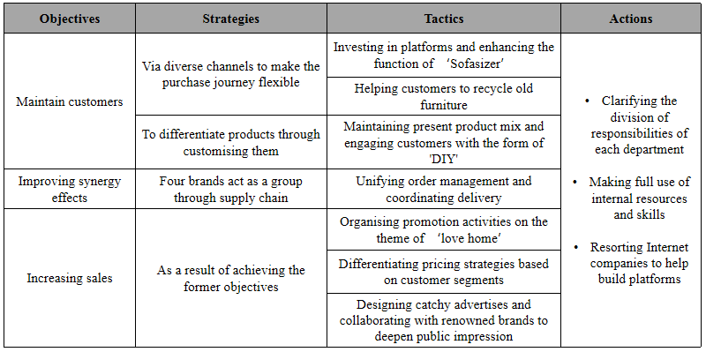
However, limitations of the marketing plan are also observed. The budget may not enough to support the whole plan. Given that the requirement of building online platform, privacy protection is another problem. Besides, communication among different brands may not be unanimous.

Recommendation
The following are several recommendations to improve the performance of the organisation.
Clinging to the demand of customers (Wang et al., 2017). As noted above, targeting most of the market with complimentary brands is an advantage of DFS (DFS, 2019). Therefore, focusing on the demand of customers is an effective way to make full use of that advantage which is beneficial for the organisation to unlock growth (Wang et al., 2017).
Taking advantage of digital platforms. In the digital age, Internet has been considered as a powerful tool in traditional industries (Annunziata and Biller, 2015). Via building Internet platforms, the organisation can communicate with customers smoother without the interruption of mediate process (Annunziata and Biller, 2015). Moreover, if the logistics management platform can be built in DFS, the delivery efficiency can be improved, and the cost can be reduced.

References
Adhikari, S. and Ozarska, B. (2018). Minimizing environmental impacts of timber products through the production process “From Sawmill to Final Products.” Environmental Systems Research, 7(1), pp.1–15.

Aldridge, S. (2018) ‘The Housing Market: Challenges and Policy Responses’, National Institute Economic Review, 245(1), pp. R5–R8.

Annunziata, M. and Biller, S. (2015). THE INDUSTRIAL INTERNET AND THE FUTURE OF WORK. Mechanical Engineering, 137(9), pp.30–35.

Azizi M., Dehghan S. A., Ziaie M., and Mohebi N. (2017). Identifying the customer satisfaction factors in furniture market. Economics, Management and Sustainability, 2(1), pp.6–18.

Bekh K. (2016). A COMPANY’S MARKETING MIX IN TERMS OF GLOCAL MARKETING. Baltic Journal of Economic Studies, 2(5), pp.10–15.

Bigat, E. (2012). Guerrilla Advertisement and Marketing. Procedia - Social and Behavioral Sciences, 51, pp.1022-1029.

Blut, M., Teller, C. and Floh, A. (2018). Testing Retail Marketing-Mix Effects on Patronage: A Meta-Analysis. Journal of Retailing, 94(2), pp.113–135.

Christiansen, L. (2011). Personal privacy and Internet marketing: An impossible conflict or a marriage made in heaven? Business Horizons, 54(6), pp.509–514.

DFS (2019). DFS Furniture plc Annual Report & Accounts 2019. Available at:
https://www.dfscorporate.co.uk/media/44848/DFS_AR19.pdf (Accessed: 14 March 2020).

DFS (2020). DFS Group at a glance. [Online] Available at: https://www.dfscorporate.co.uk/who-we-are/dfs-group-at-a-glance (Accessed: 14 March 2020).

Dimitrescu A., Babis C., Alecusan A. M., Chivu O., and Faier A. M. (2018). MANAGEMENT OF A MARKETING PLAN. Fiabilitate şi Durabilitate, 1(21), pp.279–285.

Dwell (2020). About us. [Online] Available at: https://dwell.co.uk/aboutus.php (Accessed: 14 March 2020).

Feng, S., Hu, X., Yang, A., Liu, J., and Ivorra, Benjamin. (2019). Pricing Strategy for New Products with Presales. Mathematical Problems in Engineering, 2019, 13.

Fernandes, T. and Remelhe, P. (2016). How to engage customers in co-creation: customers' motivations for collaborative innovation. Journal of Strategic Marketing, 24(3-4), pp.311–326.

Fichtinger, J., Ries, J., Grosse, E., and Baker, P. (2015). Assessing the environmental impact of integrated inventory and warehouse management. International Journal of Production Economics, 170(Part C), pp.717-729.

Forestry Commission (2017). The Forestry Standard- The governments’ approach
to sustainable forestry. Forestry Commission, Edinburgh. [Online] Available at:
https://assets.publishing.service.gov.uk/government/uploads/system/uploads/attachment_data/file/687147/The_UK_Forestry_Standard.pdf (Accessed: 16 March 2020).

Fröhlich E. and Grimm S. (2016). INTERNAL MARKETING: HOW TO INCREASE A DEPARTMENT’S REPUTATION WITHIN ITS COMPANY. Journal of Media Critiques, 2(8), pp.239–248.

Giuseppe F., Teresa C.M., Gerardino M. and Antonio F. (2016). The (r)evolution of wine marketing mix: From the 4Ps to the 4Es. Journal of Business Research, 69(5), pp.1550–1555.

Gov. UK (2018). Tree felling: overview. [Online] Available at: https://www.gov.uk/guidance/tree-felling-overview (Accessed: 16 March 2020).

Haughey D. (2014). A BRIEF HISTORY OF SMART GOALS. [Online] Available at: https://www.projectsmart.co.uk/brief-history-of-smart-goals.php (Accessed: 20 March 2020).

HBF and YouGov (2016). New survey shows home buyers financial worries – and the changing attitudes of young people. [Online] Available at: https://www.hbf.co.uk/news/new-survey-shows-home-buyers-financial-worries-and-the-changing-attitudes-of-young-people/ (Accessed: 16 March 2020).

IKEA (2019). IKEA UK ANNUAL SUMMARY. [Online] Available at: https://www.ikea.com/gb/en/files/pdf/88/d7/88d7ef71/ikea-uk.pdf (Accessed: 16 March 2020).

Iveroth, E., Westelius, A., Petri, C., Olve, N., Cöster, M., and Nilsson, F. (2013). How to differentiate by price: Proposal for a five-dimensional mode. European Management Journal, 31(2), pp.109-123.

Kim, H., & Koo, J. (2015). STAND-ALONE SALE OF A FREE GIFT: IS IT EFFECTIVE TO ACCENTUATE PROMOTION VALUE? Social Behavior and Personality, 43(10), pp.1593-1605.

Kish, K., and Quilley, S. (2017). DIY. Alternatives Journal, 43(1), 46-50,8.

Lamberti, L. and Noci, G. (2010). Marketing strategy and marketing performance measurement system: Exploring the relationship. European Management Journal, 28(2), pp.139–152.

Lee R., Lee J. and Garrett T. G. (2019). Synergy effects of innovation on firm performance. Journal of Business Research, 99, pp.507–515.

Lin, M., Wang, Z., Zhang, Z., and Cao, Y. (2019). Research on Consumers' Attitudes in China about Using Online-to-Offline Mode for Purchasing Wooden Furniture. Forest Products Journal, 69(2), pp.159-172.

Liu D., Xu W., Du W. and Wang F. (2015). How to Choose Appropriate Experts for Peer Review: An Intelligent Recommendation Method in a Big Data Context. Data Science Journal, 14(0), Data Science Journal, 2015(14).

Luke, K. (2013). 5 Steps to a New Marketing Plan. Journal of Financial Planning, 26(12), pp.20–21.

MarketLine (2018). Furniture & Floor Coverings in the United Kingdom. [Online] Available at:
https://advantage-marketline-com.ezproxy.uwtsd.ac.uk/Analysis/ViewasPDF/united-kingdom-furniture-floor-coverings-70275 (Accessed: 14 March 2020).

MarketLine (2020). DFS sales dip. [Online] Available at: https://advantage-marketline-com.ezproxy.uwtsd.ac.uk/News/dfs-sales-dip (Accessed: 16 March 2020).

Naisbitt, B., Boshoff, J., Hurst, I., Kara, A., Lenoel, C., Liadze, I., Mao X., Thamotheram C. and Whyte, K. (2019). The World Economy: World Overview. National Institute Economic Review, 250(1), pp.F38–F52.

Ogbeibu, S., Senadjki, A. and Gaskin, J. (2018). The moderating effect of benevolence on the impact of organisational culture on employee creativity. Journal of Business Research, 90, pp.334-346.

Páez, J., Veloso, M. and Payet, A. (2014). Los jóvenes ante la sono-esfera digital: medios, dispositivos y hábitos de consumo sonoro/Young people in the digital sonosphere: media digital, media devices and audio consumption habits. Comunicación y Sociedad, 27(1), pp.205–224.

Simpson, B. and Radford, S. (2014). Situational variables and sustainability in multi-attribute decision-making. European Journal of Marketing, 48(5/6), pp.1046–1069.

Sofology (2020) Sofasizer. [Online] Available at: https://www.sofology.co.uk/sofasizer (Accessed: 19 March 2020).

Sohail M. S. (2011). Sustaining competitiveness through information technology outsourcing. Competitiveness Review, 21(4), pp.369–381.

Tettsoeva E. M. (2018). Choice of cooperation model of the logistics department with other departments of an importing company. Управление, 6(1), pp.31–37.

The UK Economy: Forecast Summary (2019) National Institute Economic Review, 250(1), pp. F2–F2.

Virto, I., Imaz, M., Fernandez-Ugalde, O., Gartzia-Bengoetxea, N., Enrique, A., and Bescansa, P. (2015). Soil Degradation and Soil Quality in Western Europe: Current Situation and Future Perspectives. Sustainability, 7(1), pp.313-365.

Wang, L., He, J. and Xu, S., (2017). The Application of Industry 4.0 in Customized Furniture Manufacturing Industry. MATEC Web of Conferences, 100, pp.1-4.

Zhang D., Sun X., Liu Y., Zhou S., and Zhang H. (2018). The Effects of Integrative Leadership on the Enterprise Synergy Innovation Performance in a Supply Chain Cooperative Network. Sustainability, 10(7), 2342.

