Element 4 Personal Development Plan

Area for further development (provide further details) | Why? | How? | Who/Where? | When?
Improve confidence when reading stories or taking activities with larger groups | If I felt more confident I could then be more aware of all the children’s needs being met and make changes when appropriate also it would become more enjoyable which would then allow the children to also enjoy more as they pick up on feelings and attitudes. | Complete a mindfulness course.  complete the contact form and arrange consultation.  Ask for more opportunities to take part in, support activities eventually leading to a more leading role as confidence improves  Ask placement mentor for feedback following an observation on leading an activity | @Shiftmindfulness  online  setting  setting | Feb 2021  ongoing  March 2021  each month to see improvements
Continue to gain experience whilst doing my degree | To keep up to date with the procedures and to keep current with nursery day to day life and not be too out of practice  To improve my CV  To improve employment opportunities. | Volunteer one or two days a week once my youngest starts school  Discuss with Alison UWTSD placement co-ordinator about possible placement/ volunteer opportunities. | Healthy start nursery in merlins Bridge Haverfordwest.  Trinity St Davids- email | March 2021  ongoing  Jan 2021
Improve my organisational skills | To keep to deadlines and not get swamped with things I have to do with no time | Start a diary, keep all appointments logged and check reminders  set SMART targets  set specific times when I am to complete work  Reward myself when I achieve set targets to motivate me | I will get a new diary from The works, I will also start an electronic diary on my laptop and make time to check through it every day.  I will also use an alarm or reminders that deadlines are coming up | Jan 2021  ongoing
Become a healthier version of myself | To be as active as possible with the nursery children and my own children, to build on my confidence as being fitter would in turn help me to build my confidence. | Eating clean  Going for walks with the children  riding my bike on weekends  try and do my 10000 steps daily | Every day  walk as much as possible  start with healthy food shopping  Link to strava for motivation to plot steps etc  join a healthy eating group  set up a friends healthy eating group for motivation and to share tips  www.slimmingworld.co.uk | Jan 2021  ongoing
Improve my welsh language | To be able to converse with welsh speaking children and to help English speaking children to use more welsh during the day.  Improve employment opportunities | To start with I will do a free taster session online. Depending on how I get on with that I will go on to do the full course this will cost $15 and can be done online or at their swansea campus | Learnwelsh.cymru welsh government free taster sessions available online and then $15 to complete full course. | March 2021  I will complete this on a weekend in march

REFLECTION IN EARLY YEARS CHILDCARE
Reflection is defined as “a process of engaging the self in attentive , critical exploratory and interactive interactions with ones thoughts and actions and their underlying conceptual frame with a view to changing them and a view on the change itself. “Nguyen (2015)
Practitioners who consistently reflect on their practice and use this knowledge to gain an insight to their practice and therefore improve it will go on to become good critical thinkers and reflective practitioners produce good quality of care (Paige-Smith and Craft 2011).

SHOWING GOOD SKILLS AND VALUES
According to the common core of skills and knowledge for the children and young peoples workforce there are 6 area’s childcare professionals need to know about these are, Effective communication and engagement with children young people and families, safeguarding and promoting the welfare of the children, supporting transitions, child and young persons development, multi-agency and integrated working and information sharing (Children’s Workforce Development Council 2010)

SKILLS
* Communication
* patience
* Confidence
* Body language
* Flexibility
VALUES
* Non-Judgemental
* Anti-Discrimitory
* Ethically considerate
* Positive towards environment
* Active listener
* Good role model
THE IMPORTANCE OF SHOWING SKILLS AND VALUES
* To understand and observe children’s development and to be able to assess progress and make future plans.
* To be able to support children’s sense of identity in a positive way
* Identify additional learning needs
* All children are kept safe
* All children and their families are treated with respect and as equals

MODELS OF REFLECTION

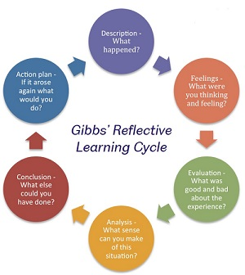
MODELS OF REFLECTION ARE TEMPLATES PRACTITIONERS CAN USE TO GUIDE THEM IN REFLECTION TO ENSURE IT IS DONE PROPERLY

GIBBS REFLECTIVE CYCLE
Gibbs (1988) reflective cycle is made up of 6 stages and is a reinvention of Kolbs (1984) cycle. Gibbs cycle is a process of learning from experiences considering and evaluating previous knowledge in light of these experiences and then incorporating this knew knowledge to inform future practice (Jasper and Rosser 2013) the cycle proposes the reflection to happen after the event, it is made up of a series of questions and allows the participant to learn upon experience.

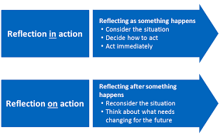
SCHON’S REFLECTIVE CYCLE
Schon interpreted Dewey’s conceptions of reflection into his work. Reflection in action or thinking on your feet is to change practice to suit the needs on the spot, to achieve this practitioners need to engage in knowing in action, practitioners will build up and draw on images ideas and actions (Farrell 2012). Reflection on action is to look back at a situation and reflect critically. Intentional reflective practice which is disciplined will lead to professional growth encouraging a more vigorous form of thinking to resolve a problem (Farrell 2012).

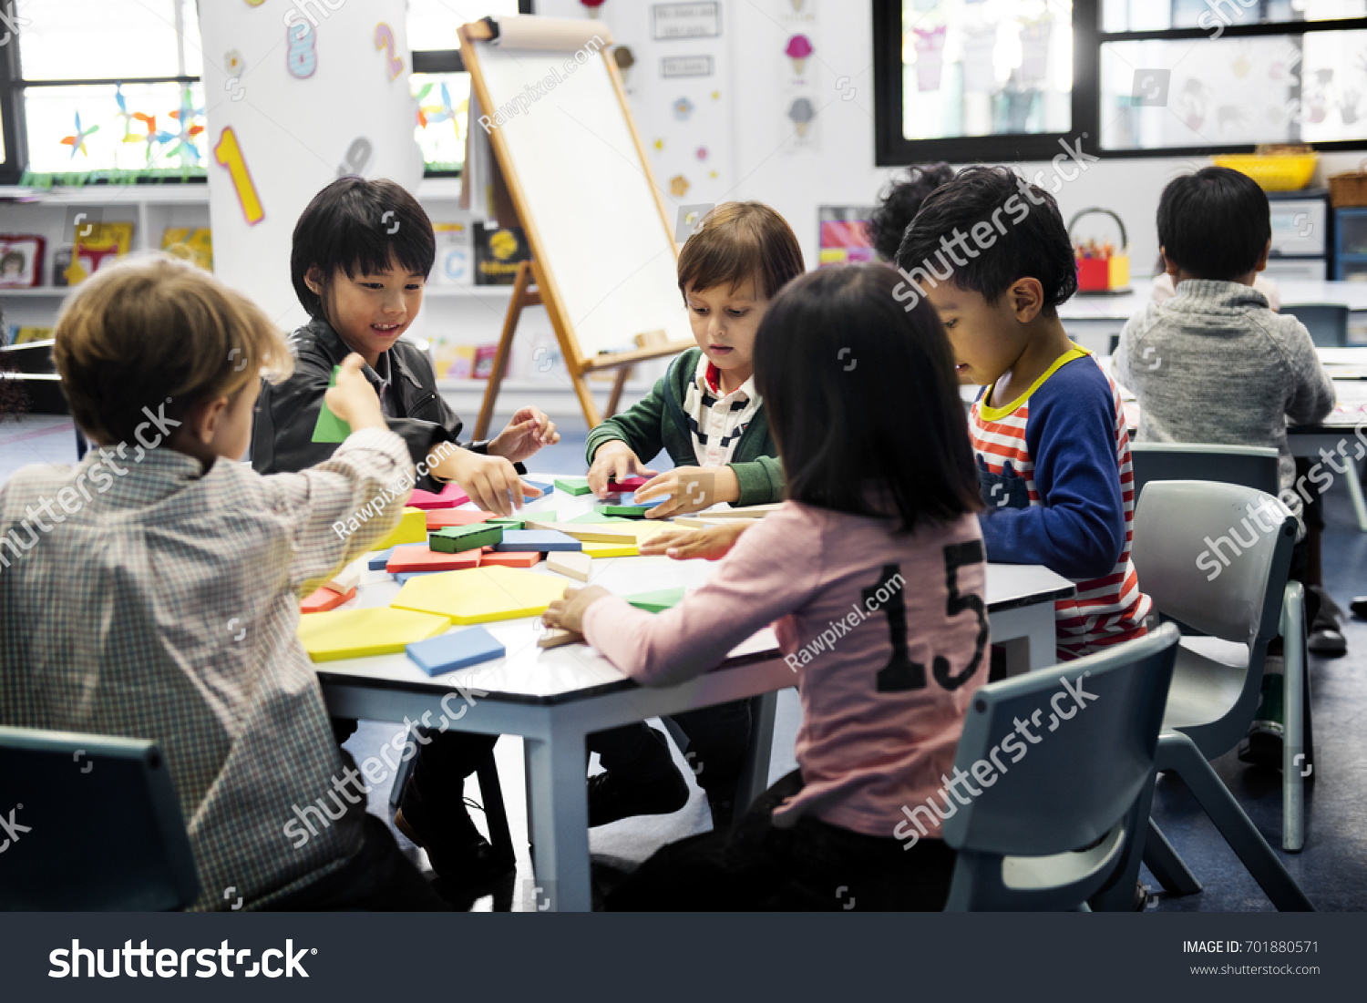
Being a Reflective Practitioner
According to Fortunati (2006) Early childhood workers need to be more attentive to creating possibilities than pursuing pre-defined goals. A reflective practitioner adapts easily and allows experiment, discussion, reflect and change focussing more on the opportunities and not the outcomes. According to Reggio Emilia- the concept of reflective practice is about meaning making, a continuous process of constructing theories about the world, testing them through dialogue and listening and then reconstructing these theories (Fortunati 2006).
ESTYN
Estyn are the education and training inspectorate for Wales, their mission is “to support education and training providers to develop a self improving and learning culture through advice, inspection and capacity building” with the vision of improving the quality of education for all children in wales through effective practice.
https:www.estyn.gov.wales
CIW
The care inspectorate Wales register, inspect and take action to improve the quality and safety of services for the well-being of the people in Wales. They are an independent regulator of the social care and childcare in Wales they have powers to review the way local authorities discharge their social service functions under the social services and well-being (Wales)Act 2014. They register and inspect providers of social care services in Wales under the Regulation and inspection of social care (Wales)Act 2016. and they also have the powers to register and/or inspect childminders and day care (including play) for children under 12.
Core Values
* Caring – being compassionate and approachable
* Fair – to be consistent, impartial and inclusive
* Integrity – to be honest and trustworthy
* Professional – to be skilled, knowledgeable and innovative
* Respect- to listen engage and value people
Https://careinspectorate.wales
Conclusion
In conclusion reflection is an important tool for early years childcare as it allows practitioners to develop and transform their practice to give the children the best quality of care that they can. It allows them to change with the times and look back enthusiastically to see where they can improve in their practice.
Evaluate the use of models of reflections as resources for effective reflective practice
(1000 words)
Reflective models are frameworks in which reflection can take place. There are different models to choose from and individuals may differ in preference as to which suits them best. They are used to guide personal and situational analysis and improvement (Jasper and Rosser 2013). This assignment aims to evaluate these models as a resource for effective reflective practice.
Being able to effectively reflect allows practitioners to enhance their professional development and improve their practice. Smith (2008) suggests that Reflective practice enables a deeper understanding of young children's learning and development.
According to the early years foundation stage a key element to the effective delivery of the stage is making observations and adapting practice this could be observing the children or reflecting on themselves (Elfer and Dearnley 2007).
Brodie (2013) who is an early years professional and trainer states “reflective practice as highlighted by the EYFS, is all about raising the quality of the practice and of the practitioners.
There are a variety of reflective models which assist in this reflective process and give a framework for practitioners to work around and experience meaningful reflections. They can be seen as carefully structured and crafted approaches (Finlay 2008).
Gibbs reflective model has a simple 6 step process to follow which is easy to understand and apply to practice. (ref) firstly you give a description of what happened, then you say how it made you feel then you evaluate what went well what did not go well. then you analyse what might have helped the situation you can explore options and do some research here then comes your conclusion where you can commit to take action and decide what would changes you would make. And lastly the Action plan where you can construct your action plan and agree a date to re-evaluate. These stages are easy to navigate through (Febriani 2020) and is easy for those who are new to reflection or inexperienced practitioners.
Practitioners may find this model a useful resource as it can be used to critically evaluate activities and practice and make changes and Improvements. When used efficiently the model will allow practitioners to become self aware and reflection will become a leading element within their practice and they will go on to produce efficient, transformational quality care.
A study by Febriani et al supports this as they found the model allowed for a deeper exploration of work and also that the better structure allowed for better quality of reflection.
The model allows you to improve over time based on your own experiences and you will gain a balanced and accurate view on your progress and make changes to suit your needs. However criticisms of this model could be that it is reactive rather than proactive, The questions maybe misunderstood which would lead to the reflection being performed correctly and not getting the desired outcome(Adeani and Febriani 2020).
In a study aimed examining how students implemented Gibbs reflective cycle in making reflections of literacy analysis the findings were that reflecting using Gibbs model caused awareness for the students regarding their skills they also stated that Gibbs model had clearly defined sections which defined it from other frameworks Adeani and Febriani (2020).
Schon’s reflective model suggests that there are two types of reflection one happens during an event reflection in action and one happens after the event reflection on action. Reflection in action involves thinking on your feet, thinking what to do next and reacting to the situation straight away. Reflection on action involves thinking about an experience thinking about what you would do differently next time and having the time to reflect. (Farrell 2020)
Schon (1987) states that critical reflection is made up of characteristics such as the ability to articulate a contextual awareness of ones own position through identifying the impact of ones own influence and background, to be able to identify your own values beliefs and assumptions and to be able to consider alternative perspectives from your own whilst evaluating (Nolan 2011). This reflective practice allows practitioners to develop an understanding of their own practice and to keep gaining new skills and approaches and deliver the best quality of care that they can.
In order to gain a positive outcome from reflective practice is dependant on a change in attitude or emotional state and a positive attitude towards learning in a particular area and an assertive confidence or priority change (Boud et al 1985).
Being able to effectively reflect allows practitioners to enhance their professional development and improve their practice.
Evidence from the longitudinal study of graduate leader training suggests that graduate leader's ability to reflect is improving provision and practice in the early year's settings and childcare centres (Hadfield et al.,2011).
However according to Ghaye and Lillyman (2000) for the practitioner to challenge their own practice they would then become vulnerable and according to Bolton (2001) this becomes especially true # when the issues lie along political or ethical and social grounds and this may leave the practitioner at a personal or professional risk ( Nolan 2011). Ghaye and Lillyman (2000) also suggest that such reflections may lead to disagreements in the workplace. Bolton (2001) goes on to say that situations such as these can be avoided if the reflection takes place in surroundings which are safe and supported and facilitated affectively in a structured learning environment.
Dearnley et al.(2007) explains how professional development can result in positive changes to early years work practices, however they also discuss how the findings of this study also highlighted the need to include reflective practice to result in long term sustainable changes- this supports the early years foundation stage as their main aim is to keep improving on quality care in early years childcare (Palaiologou 2016).
According to Dearnley et al (2007) “sustained effectiveness of the model is likely to be dependant on an ongoing culture of attention to the emotional experience of nursery staff within nursery umbrella organisations”.
A study conducted to evaluate a professional Development model in promoting pre-school teachers concluded that there was a significant merit and necessity of utilizing reflective practices during teachers training. The study was conducted over a school year and by the end of the intervention the results showed that the teachers involved in the study were providing a significantly higher quality of literacy and writing instruction in comparison to their peers, they also showed to be implementing new teaching practices with high fidelity Zhang and Cook (2019).
According to Zhang and Cook (2019) it is necessary to merge teachers reflective practice into a PD model in order to provide them with an effective and individualised classroom teaching support.
In conclusion reflection models can be a useful tool when used correctly. There is a need for time to be allocated for reflection, Reflection is an ongoing process and needs the specific attention in order to produce the best results.

Elfen 3 Log adfyfyriol – Element 3 Reflective log
Disgrifiad byr o’r gweithgaredd (dim mwy na 50 o eiriau
Brief description of the activity (no more than 50 words)
Jelly making involving making the jelly then adding items to the jelly (dinosaurs of their choice), leaving the jelly to set then finding the dinosaurs inside the jelly on a messy tray For this activity the children were aged between 3 and 4 and there were three groups of 5 children and one group of four girls and boys mixed.

Nod/Amcan y gweithgaredd Aim/Objective of the activity
The activity was a sensory activity and the aim was to allow the children to make use of their senses and explore and investigate, the activity was aimed to encourage this exploration as it used stimulating resources that provided the necessary sensory experiences throughout the activity I also supported the children’s language and social skills. and also to have fun,

Eich rôl chi Your role
My role was to lead the children through the activity, discussing each part of the activity with them asking questions keeping all children involved and engaged. I planned and prepared the activity and discussed it with my room leader, I brought the jelly and chose dinosaurs from the toy cupboard and washed them. I maintained and followed procedures and encouraged the use of language throughout.

Agweddau cadarnhaol – pam? Sut gellid datblygu’r rhain ymhellach?
Positive aspects – why? How could these be developed further?
Children were engaged, children were interested in the colours mixing and making new colours and excited to find the dinosaurs they had placed into the jelly. A positive aspect to using a food with a slimy texture is for children who are fussy with food because of the texture this allows them to touch and explore the feeling creating positive pathways in the brain to say this food is safe to engage with I could further develop this aspect by adding more textures such as rice or shaped pasta. To develop the exercise further I would use more colours of jelly and make jelly for the children to eat after the activity as the promise of this may stop them eating the activity jelly.

Agweddau heriol – pam? Cysylltwch a’ch arfer eich hunan. Challenging aspects – why? Link to your own practice.
Some challenging aspects were explaining the colours changing to the children in an age appropriate way as they were 3 and 4 year old I did this by keeping it as simple as possible and using terms which the children were familiar with if I were to do this activity again I would develop my confidence with scientific terms around this area , The children wanted to eat the jelly however due to hygiene rules this was not possible as they had their hands in it – next time I will provide extra jelly at the end of the session, making the jelly was a challenge as it is usually made with boiling water, so I did a trial run with warm water it took a little longer to dissolve but was a safer option. If I was to do the activity again I may do the jelly on a table with the children sitting a little further away for them to watch the process.

Pa wybodaeth wnaethoch chi arddangos?
What knowledge did you demonstrate?
Health and safety procedures were followed in line with the settings policies, good hygiene practice was followed all children and staff washed hands before and after and wore aprons to protect clothing, scientific knowledge was used when explaining the different colours were made by using which colours and explaining when the jelly had dissolved and when it became a solid again,

Pa sgiliau wnaethoch chi arddangos?
What skills did you demonstrate?
Having the Confidence to speak to all the children and keep control of the situation,
patience to hear each child and take all of their needs into consideration and to talk over everything at the children’s pace, being a reactive practitioner if the children were more interested in another aspect of the activity to abandon the initial plan and take the child led path, observation skills when ensuring each child is participating and has a chance to be heard and that all children are engaged and enjoying the activity, responsibility is shown when preparing for the activity as well as cleaning up and putting all equipment back where it came from and ensuring all the children were cleaned up and their clothes wiped down if needed also putting aprons on the children.

Pa werthoedd wnaethoch chi arddangos?
Which values did you demonstrate?
Sharing and turn taking when making the jelly and taking it in turns to find a dinosaur and say what they had found, looking and listening listening to the children’s thoughts and opinions on the texture and feel and the colours, kindness by always smiling giving good eye-contact and always giving the children time to speak in between, having a good understanding of the jelly making process and of the different colours mixing, by looking after the well-being of the children using good body language and ensuring each child’s needs are being met.

Beth allai cael ei wneud yn wahanol yn y dyfodol? Pam?
What could be done differently in future? Why?
The children could use individual jelly, The children would also be provided with pots of jelly to eat at the end. The jelly could be made the day before leaving the children with more time to play with the jelly. I would also use more textures and more colours when making the jelly To promote the children’s sensory skills further.

References,
A case study of the use of the six thinking hats to enhance the reflective practice of student teachers in Taiwan, Chin-Wen Chien (2020)
A reflective proffessional development intervention model of early writing instruction, Chenyi Zhang a j, Claire Cook journal of early childhood teacher education (2019), vol 40, no2 177-196
Developing professionalism through reflective practice and ongoing professional development, European Early Childhood Education Research Journal (2014) Josephine Bleach
Developing Reflective practice in early years Paige-Smith, Alice and Anna edas (2008) 2nd ED Open University Press (2011)
Exploring and evaluating levels of reflection in pre-service early childhood teachers. Andera Nolan, Jenny Sim Australian journal of early childhood vol 36 (2011)
Nurseries and emotional well-being evaluating and emotionally containing model of professional development Peter Elfer, Katy Dearnley Roehampton university London, uk (2007).
Observation assessment and planning in the early years Kathy Brodie (2013) Early Years (London/England) 2007-10-01 vol 27 (3) p267-279
Reflective Practice and its Role in Simulation Sissel Eikeland Husebo RN, CCN, MSC’S, PhD, Stephanie O Reagan, RN, MHSM, Debra Nestel PhD (2018) vol11 issue 8 pg 368-375
Reflecting on reflective practice: (re)visiting Dewey and Schon (2012) vol 3(1), p7-16 Tescol journal
The Common Core of Skills and Knowledge For Children and Young People’s Wokforce (2010) Children’s Workforce Development Council
The Early Year Foundation Stage theory and practice Ioanna Palaiologou 3rd ED (2016)
Using Gibbs reflective cycle in making reflections of literary analysis, ikin Syamsudin Adeani, R.Bunga Febriani, indonesian EFL journal (2020)
What is reflection? A conceptual analysis of major definitions and a proposal of five component definition and a model Quoc Dinh Nguyen (2015) DOI: 10.13140/RG.2.1.4147.5448
https://careinspectorate.wales
https://www.estyn.gov.wales

