Catalogue Entry

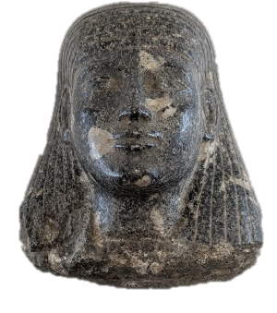Figure 1 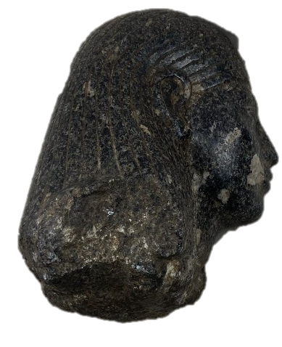Figure 2

Black Statue (Broken Bust)
Cyfarthfa Castle, Merthyr Tydfil CCM 276.004
Object Type: Statue (bust as broken off)
Material: granite or granodiorite
Period: Late Period
Provenance: unknown, collected by Major Harry Hartley Waite Southey, donated by Cyfarthfa Castle Museum
Culture: Ancient Egyptian
Dimensions: 19.1 cm x 17 cm x 14.5 cm
Object analysis by Olivia Hunt

Description
This head of an Egyptian elite, with his slightly off-centred wig tucked behind his ears, was once a part of a larger statue, not the bust it now is. The figure is entirely polished, and its features are detailed and carved into the stone making them incredibly distinct. The eyes are almond-shaped and elongated by an eyeliner carved into the stone. They are not quite equal in width: the left is 2.7 cm, and the right is 2.8 cm with a gap of 1.8 cm between them. From the front, the nose is small with flared nostrils: when viewed from the side the bridge to the tip is incredibly straight and notably small compared to other examples of ancient Egyptian statues. With only a small gap below the nose, the lips are full yet from the front are quite circular, and the chin is rounded and balanced proportionally to the other features. Both the brows and cheekbones are less noticeable, especially the brows which are only clear from the side view. Perhaps the most striking element is the wig, which begins low on the statue’s forehead and flows down the head to the shoulders, however, it is unknown where exactly the wig ends due to the head being broken at the neck and shoulders.
Despite the obvious damage and a few minor breakages, this statue is clearly durable due to its material, most likely a hard stone called granodiorite, which was quarried in Aswan, and is a dark grey to black colour. The Aswan quarry was active from the Old Kingdom to the Late Period, and along the Nile therefore meaning it was easy to move the stone around Egypt at the time. As a result of the material and the polishing, it is shiny and reflective.
As seen in other examples of ancient Egyptian and non-Egyptian artefacts, if damage occurs it is typically at the weakest parts, such as the nose or in this case the neck, where there are rough, uneven edges. This damage would have taken a great deal of force due to the robustness of granodiorite – it has a value of 6 on the Mohs Hardness Scale – perhaps as a result of an earthquake, which Egypt receives five a year on average. However, there is a probability of further damage being done intentionally as the shoulders are entirely cut off with smoother, clearer edges. This could have made it easier to transport the statue from where it was found to the United Kingdom and it was not an uncommon practice. Although the rest of the statue’s whereabouts is unknown, we cannot entirely know what type of statue it is – block, seated or standing; however, we can see from the flatness of the back of the head that it has perfect posture. This was done to show how the statues needed to see the world in front of them and conform to an ideal beauty standard.
CCM 376.004 was likely displayed in an ancient tomb before it was damaged and eventually ended up in the Cyfarthfa Castle collection. Statues akin to this one functioned as vessels for the Ka, the life force of a person that lived on after a person’s death, a statue such as CCM 276.004 is where the Ka would reside when it received nourishment either in tombs or temples, offerings were made by the living so the Ka could absorb the energy of these offerings. The Opening of the Mouth ritual was intend individuals, the deceased it was performed upon to regain human functions – for example giving the eyes and ears function again, or the ability to speak and eat; during the Old Kingdom this ritual was primarily enacted on statues, however, over time it developed to be on mummified individuals but statues still had a role especially if a body was not recovered or unusable.
The main features of this statue do not provide an obvious answer as to what time period it originates from. However, it seems most likely to be a Late Period (664—332 B.C.) piece in the style of Archaism – which occurred throughout Pharaonic Egypt and was most prominent in the Late Period. It was “conscious return to past styles and models” thus explaining the variety of features as the statue was inspired by a wide range of time periods. This phenomenon occurred in both royal and non-royal spheres, as this statue has no indications of royalty it can be assumed that it depicts a member of the high elite.
Bibliography
Ancient Egypt Online, The Ancient Egyptian Soul, 2017, https://ancientegyptonline.co.uk/soul/#:~:text=Ka%20(vital%20spark)&text=It%20was%20the%20double%20of,the%20image%20of%20a%20person.&text=The%20royal%20Ka%20had%20an,the%20image%20of%20his%20Ka. [accessed 22nd October 2025]

Global Egyptian Museum, Opening of the Mouth Ritual, https://www.globalegyptianmuseum.org/glossary.aspx?id=282 [accessed 22nd October 2025]

Harrel, James A., Ancient Egypt Hardstone Quarries, 2017, http://www.eeescience.utoledo.edu/faculty/harrell/egypt/quarries/Hardst_Quar.html [accessed 1st October 2025]

Kahl, Jochem, ‘Archaism’, UCLA Encyclopedia of Egyptology, (2012), https://escholarship.org/content/qt3tn7q1pf/qt3tn7q1pf.pdf [accessed 24th October 2025]

Latest Earthquakes, Egypt Earthquake Report, 2025, https://earthquakelist.org/egypt/#all-latest-earthquakes [accessed 22nd October 2025]

Nizar, Abu-Jaber, QuarryScapes: ancient stone quarry landscapes in the Eastern Mediterranean. Geological survey of Norway special publication. (Trondheim: Norges Geologiske Undersøkelse, 2009)

Robins, Gay, The Art of Ancient Egypt, (Cambridge, Massachusetts: Harvard University Press, 2000)

Tayloe, John H., Death and the Afterlife in Ancient Egypt, (London: British Museum Press, 2001)

World of Stones, Granodiorite Rock – All You Need to Know, 2023, https://worldofstonesusa.com/blogs/all/granodiorite-rock [accessed 13th October 2025]

Images:

Figure 1: Caddy, Apollo, [photograph] (2025)
Figure 2: Caddy, Apollo, [photograph] (2025)

James A. Harrel, Ancient Egypt Hardstone Quarries, 2017, http://www.eeescience.utoledo.edu/faculty/harrell/egypt/quarries/Hardst_Quar.html [accessed 1st October 2025]
Abu-Jaber, Nizar, ed. (2009). QuarryScapes: ancient stone quarry landscapes in the Eastern Mediterranean. Geological survey of Norway special publication. Trondheim: Norges Geologiske Undersøkelse
World of Stones, Granodiorite Rock – All You Need to Know, 2023, https://worldofstonesusa.com/blogs/all/granodiorite-rock [accessed 13th October 2025]
Latest Earthquakes, Egypt Earthquake Report, 2025, https://earthquakelist.org/egypt/#all-latest-earthquakes [accessed 22nd October 2025]
Gay Robins, The Art of Ancient Egypt, (Cambridge, Massachusetts: Harvard University Press, 2000), p. 19
Ancient Egypt Online, The Ancient Egyptian Soul, 2017, https://ancientegyptonline.co.uk/soul/#:~:text=Ka%20(vital%20spark)&text=It%20was%20the%20double%20of,the%20image%20of%20a%20person.&text=The%20royal%20Ka%20had%20an,the%20image%20of%20his%20Ka. [accessed 22nd October 2025]
John H. Taylor, Death and the Afterlife in Ancient Egypt, London: British Museum Press, (2001), p. 20
Ancient Egypt Online, 2017
Global Egyptian Museum, Opening of the Mouth Ritual, https://www.globalegyptianmuseum.org/glossary.aspx?id=282 [accessed 22nd October 2025]
Global Egyptian Museum
Jochem Kahl, ‘Archaism’, UCLA Encyclopedia of Egyptology, (2012), (p. 1), https://escholarship.org/content/qt3tn7q1pf/qt3tn7q1pf.pdf [accessed 24th October 2025]

