According to Baker and Pawlikowski, ‘a primary concern in the engineering of tall buildings is the effect of wind on the buildings’ structure’ (Baker and Pawlikowski, 2015). While this essay will report on two different structures, one of steel frame and one of concrete frame, it will link them by their common issue- wind load. The paper will discuss how Eiffel Tower’s ‘integrated approach to design, manufacture and erection processes’ enabled the construction of over 1000ft height (Peters, 1998), and will continue on to the success of ‘collaboration between the architects and engineers to vary the shape of the building along its height, thereby minimizing wind forces on the building’ (Baker and Pawlikowski, 2015).

EIFFEL TOWER

The Eiffel Tower, which is the steel structure discussed in this essay was chosen not only due to its popularity, but also uniqueness when it comes to intuitive concept and planning. Even though at the time of completion it reached impressive ‘312 m with 1665 steps’, the structure was erected in just over two years (Larsen, 2009). The tower was designed by Gustave Eiffel and completed in 1889 for the World’s Fair (Castellaro et al., 2017). It ‘is constructed of 7,300 tons of metal- mainly puddle iron, a type of wrought iron used for construction in the nineteenth century’ (Larsen, 2009).

The design, planning and construction of this building exceeded the boundaries of what was possible at the time, significantly enough that the Eiffel Tower remained the tallest structure up until 1930, with its final height of 324m (Castellaro et al., 2017). Its framework consists of mainly puddled iron structure that comprises of an increased carbon content, in comparison to the commonly used wrought iron, which allowed the possibility of an increase in size due to its higher tensile strength (Larsen, 2009). Gustave established ‘the modulus of elasticity of wrought iron by first drawing on the early scientific studies of Robert Hooke, Thomas Young, and others who formulated elasticity principles for metals’ (Barr, 1992). By experimentation he formulated the puddled iron and ‘devised a system of lattice-trussed piers with incurving edges that theoretically made it possible to construct towers of any height’ (Barr, 1992). His studies found that ‘steel's elasticity could produce an intolerable amount of sway in high winds’ and that ‘cast iron was brittle, lacked tensile strength, and was suitable, like stone, only in a compressive role for columns and arches’ (Barr, 1992).
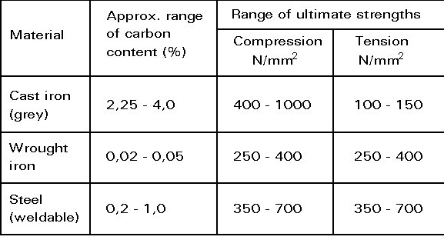
Fig 1. Carbon content and strength comparison

The processes used in the construction of the Eiffel Tower were as pioneering as the tower itself. The structure was so heavy that it had hydraulic jacks installed in each of the piers foundations to allow for settlement and adjustments to the tower [Fig. 2.](Barr, 1992). This permitted the use of a small team of workers to amend the tower by releasing sand from the hydraulic jack (Barr, 1992). Considering that the tower was assembled by 132 workers and included ‘more than 18,000 metal parts and 2.5 million rivets’, astute solutions were essential (Larsen, 2009). Finished pieces of iron such as ‘400 tons of girders and trusses’, which weight could not exceed three tons for structural flexibility and ease of assembly were transported each month (Barr, 1992). The components were delivered prefabricated, which further accommodated quick and efficient installation (Peters, 1998).

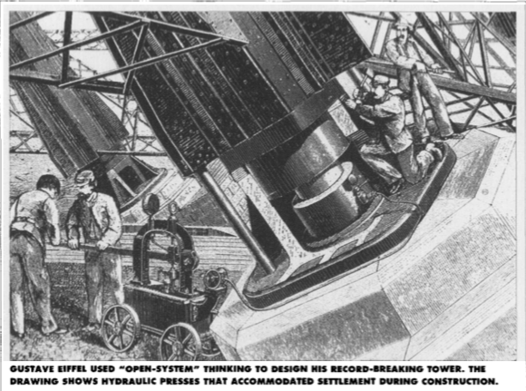
Fig 2. Drawing of hydraulic presses installed in foundations.
The construction of the foundations of the tower was crucial to the success of the project taking into account certain obstacles encountered by Eiffel. One of the paramount challenges in constructing the tower, was wind:
“What is the main obstacle I had to overcome in designing the tower? Its resistance to wind. And I submit that the curves of its four piers as produced by our calculations, rising from an enormous base and narrowing toward the top, will give a great impression of strength and beauty.”
(Weidman and Pinelis, 2004)
Therefore, this light and ‘unusual structure with a large stiffness and a small mass’ exposes relatively minor surface area to the wind, being capable of ‘escaping any intuitive forecast’ (Castellaro et al., 2017). Eiffel & Company understood that the wind load forces upon ‘the dense metalwork of the expansive first and second level observation decks’ hence presenting ‘a large resistance to the wind. (Weidman and Pinelis, 2004). Eiffel's second greatest difficulty was accounting for odd angles, which required separately designed non-repetitive elements (Barr, 1992). They resulted in creation of ‘curved weightbearing edges’, which formulated ‘irregular arcs and the trussing of the 29 panels varied gradually from bottom to top’ compounding ‘heights, inclinations, and profile coordinates given in table 1’ [Fig. 3.] (Weidman and Pinelis, 2004).
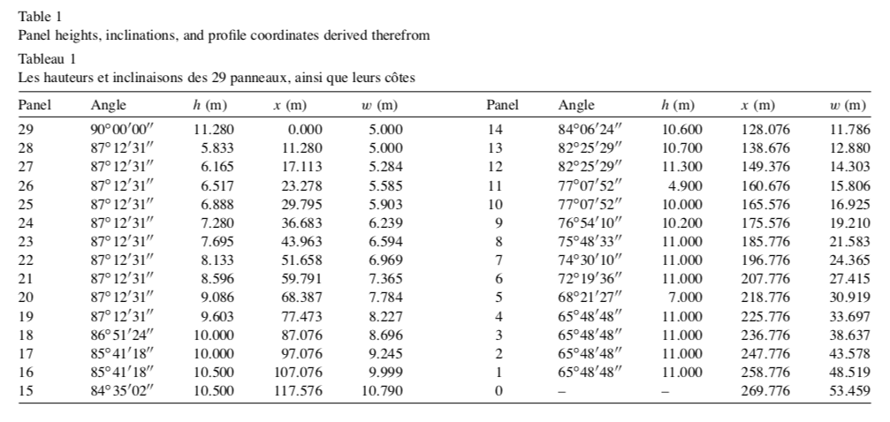
Fig 3. Data sheets of panels sizes of the Eiffel Tower.

As Wiedman underlines, however, ‘the Eiffel Tower was not designed according to a mathematical formula’ but ‘using graphical methods to construct a tower of sufficient strength to support its immense weight and empirical results garnered from past experience to account for wind loading’ (Weidman and Pinelis, 2004).
According to Thilmany, there were various theories attempting to explain the tower’s design. While ‘Chouard argued that Eiffel engineered his tower so that its weight would counterbalance the force of the wind’, another theory discussed the counterbalance between the wind pressure and the tension of the structure’s elements (Thilmany, 2005). Although the Chouard’s theory was backed by equations, they were questioned by Weidman who ‘searched historical records and found a 1885 letter from Eiffel to the French Civil Engineering Society’, in which ‘Eiffel wrote that he had indeed planned to use tension among the construction elements as a counterbalance to wind loads (Thilmany, 2005). It was then verified by Eiffel’s letters that “in reality the curve exterior of the tower reproduces, at a determined scale, the same curve of the moments produced by the wind” (Weidman and Pinelis, 2004).

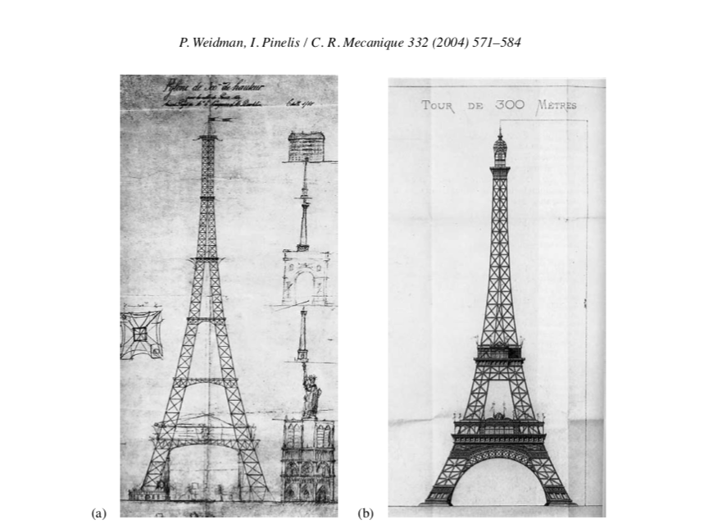

Fig 4. Eiffel tower original and final design

Similarly to the importance of planning for the construction of the tower, it is vital to mention about its sustainability at the site of the built. As ‘the non-structural masses of the tower are going to change several more times in the future’ due to lifts and antennas replacements, it is crucial to ‘monitor the ageing of the structure’ (Castellaro et al., 2017). Initially Eiffel Tower was a creation for The Universal Exposition of 1889, but it survived until today thanks to the extraordinary construction and meticulous preservation. Since its establishment, the Eiffel Tower has been painted every seven years and the processes accompanying its preservation have not changed until today (Larsen, 2009). The work is completed manually and includes sanding, cleaning, spot treating for corrosion, and applying ‘a coat of modern day, urethanc alkyd-based paint’ (Larsen, 2009). The adjustments consisted only in replacing lead-based pigments with ‘a zinc phosphate agent, which is resistant to factors contributing to corrosion, such as bird droppings and urban air pollution’ (Larsen, 2009). The works, also, provide an opportunity of the structure’s inspection, specifically on the possibly corroded metallic parts that may need replacement or covering with an anti-corrosion primer (Larsen, 2009).

Even though steel is susceptible to corrosion process, especially, without sufficient protection, it has various advantages such as price, availability, ease of fabrication and ease of recycling (Carter, 2012). All those factors contribute to its popularity. However, one needs to consider what is its impact on the environment. As steel and iron ‘are responsible for 31% of industrial CO2 emissions every year’ the need of waste disposal and meticulous planning of the required materials is hugely important (Hoskins, 2017).

While steel has a substantial impact on the environment, the second structure discussed in this essay has significantly more bearing. As Hoskins underlines it is vital to understand the energy that is needed for manufacturing, transport and dispose of building materials (Hoskins, 2017). He claims that ‘concrete is the second most consumed substance on Earth after water, and its production is responsible for 8.6% of global greenhouse gas emissions each year’ (Hoskins, 2017). Suresh Petkar approves that cement is ‘the highest CO2 producing material’, and its consumption ’has been mounting relatively high when compared to the consumption of steel throughout the world’ (Suresh Petkar, 2014). The concrete building embodied energy footprint grows from the moment of the concrete production, through its transportation to the site of build, until its final destination in a landfill (Suresh Petkar, 2014). Hence, the design of concrete structures needs to be focused on ‘future disassembly, that facilitates reuse and adaptation’ (Salama, 2017). This is why concrete technologies including Burj Khalifa’s ‘are very open to continuous development and improvements that make them more environmentally friendly’ (Salama, 2017).

BURJ KHALIFA

The concrete building that has been chosen for the second part of this essay is Burj Khalifa in Dubai. This was chosen as much like the Eiffel Tower as an iconic super structure that broke the record for the highest manmade structure. Both had to use forward-thinking techniques and engineering to overcome similar obstacles in their design such as the impact of the wind.

To achieve a building of this height they had to counter wind by differentiating the size of each wing (Skinner, 2010). Thanks to Y-shaped design and the faces of building becoming smaller with the height, and simultaneously reducing their weight, the vortices caused by the wind were never substantial enough to cause a sustained pressure on the building fabric (Skinner, 2010). A “buttressed core” system, which has been used to design Burj Khalifa ‘is a three-winged structure in which a strong hexagonal central core anchors three building wings’ (Baker and Pawlikowski, 2015). As ‘one of the wings at each tier “sets back” in a spiraling pattern’ the building makes an impression of even higher than in reality (Baker and Pawlikowski, 2015). Although the original project envisaged the setbacks to occur in counter-clockwise direction it had to be adjusted to clockwise direction after studying the wind loads data (Skinner, 2010).
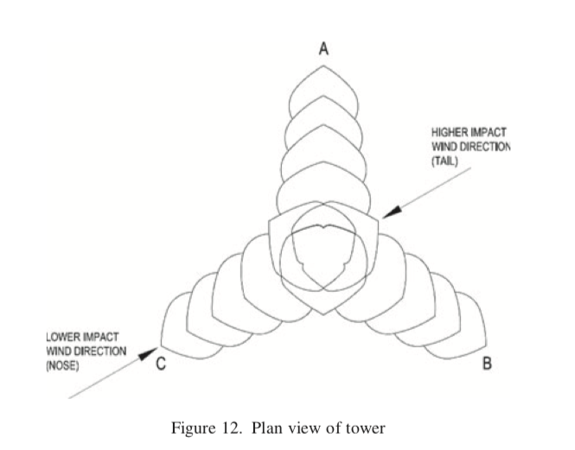
Fig 5. Example of wind direction impact of orientation of building.

The design accounted for six important wind directions, which are ‘parallel to the major axes of the wings—three directions where wind is blowing into the “nose” of each wing, and three directions where wind is blowing into the “tail” of each wing’ (Baker and Pawlikowski, 2015). Considering the strength of the most frequently occurring winds in Dubai the tower orientation has been chosen, altering the primary plan by rotating the building through 120° (Skinner, 2010).
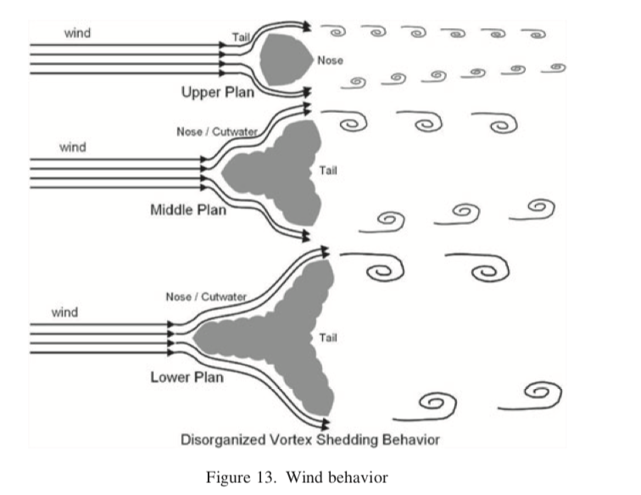
Fig 6. Wind behaviour on different levels.

The resistance to the wind was established through the gravitational load of the precise construction (Baker and Pawlikowski, 2015). According to Baker and Pawlikowski, Burj Khalifa acts as a one ‘giant concrete beam cantilevering out of the ground with the system working together as a single unit’ (Baker and Pawlikowski, 2015). For structure of such large mass to be stable, it requires substantial foundations to support it. This skyscraper inner core sits upon 196 1.5 m piles at 47.5m deep, with an outer core placed upon another 750 piles of 0.9m in diameter to depths of 30m (Skinner, 2010). Those piled foundations tie into the raft foundation bed 3.7m thick, which forms the base of the building (Skinner, 2010). The construction of the foundation was usually carried in 24-hour pours (Baker and Pawlikowski, 2015). The C50 concrete with a 40% fly ash content in the mix, to help retard the drying process taking into account the hot climate in the region (Baker and Pawlikowski, 2015). A high modulus and strong concrete was required for such big structure, as its stiffness ‘has significant benefits in terms of limiting movement, and high strength is necessary to reduce the cross-section of vertical elements’ (Aldred, 2010). According to their work on the matter Baker and Pawilikowski state that conctrete columns for the tower were specified in the range of C80 to C60 and required a minimum ‘Youngs Elastic Modulus of 43 800 N/mm2 at 90 days’ (Baker and Pawlikowski, 2015). The concrete mixing processes and testing would continue to play a significant role in how this building was constructed as ‘one of the most challenging construction issues was to provide a system and mix design that could support pumping the high-performance, high-modulus concrete over 600 m in a single stage’ (Baker and Pawlikowski, 2015).

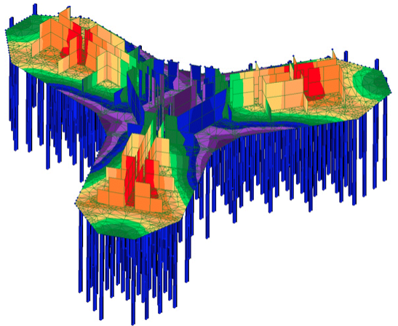
Fig 7. Model design of piled foundations.
The difficulties faced while pouring vast amounts of concrete up such high length cannot be underestimated. It is so because ‘concrete in the Middle East has a potential for blockage during pumping due temperature effects and delays’ (Aldred, 2010). Hence, to obtain the accurate temperature below 32°C ‘with high-performance concrete, and depending on the moisture content of the fine aggregate’ it became necessary to control the temperature variations (Aldred, 2010). It could even mean a substitution of water with ice ‘to limit the heat gain from the curing process’ (Baker and Pawlikowski, 2015). As Aldred professed, limiting ‘variation in rheology and concrete temperature through summer’ reduces the pumping problems (Aldred, 2010). Regardless of the major issues facing the structure’s assembly, they still manage to achieve a considerable speed in construction. This was accomplished in part by employing ‘prefabrication of reinforcing cages and advances in slip- and climb-form technology’ resulting in creation of large, complex reinforced-concrete structures ‘at rates of two to three levels per week’ (Aldred, 2010).

Both structures, however different, offer an insight to the engineering genius, which not only lies in designs of the buildings, but also in their climatic resistance and ease of assembly among all. While both frame materials used for construction of the buildings appeared to have a negative impact on the environment, they simultaneously challenge current engineers to come up with alternative solutions, of which examples we can see in the discussed structures.

Reference list

Aldred, J. (2010) ‘Burj Khalifa- a new high for high-performance concrete’ in Proceedings of the Institution of Civil Engineers, Vol. 163, Issue 2, pp. 66-73.

Baker, B. and J. Pawlikowski, (2015) ‘The Design and Construction of the World’s Tallest Building: The Burj Khalifa, Dubai’ in Structural Engineering International, Vol. 25, Issues 4, pp. 389- 394.

Barr, V. (1992) ‘Alexandre Gustave Eiffel: a towering engineering genius’ in Mechanical Engineering, Vol. 114, Issue 2, pp. 58-65.

Carter, T. (2012) ‘Iron across the ages’ in Materials World, Vol. 20, Issue 7, pp. 40-42

Castellaro, S., Perricone, L., Bartolomei, M. and Isani, S. (2017) ‘Dynamic Characteriztion of the Eiffel Tower’ in Procedia Engineering, Vol. 199, pp. 3332-3337.

Hoskins, D. (2017) ‘The solutions to climate change are already at our fingertips’ in Building Design & Construction. [Internet] Retrieved from ProQuest. [Accessed 4th January 2018] <https://search.proquest.com/docview/1947082279?accountid=14680&rfr_id=info%3Axri%2Fsid%3Aprimo>

Larsen, K. R. (2009) ‘Protecting the Eiffel Tower from the onset of corrosion’ in Materials Performance, Vol. 48 Issue 11, pp. 24-27.

Peters, T. F. (1998) ‘How creative engineers think’ in Civil Engineering, Vol. 68, Issue 3, pp. 48-51.

Salama, W. (2017) ‘Design of concrete buildings for disassembly: An explorative review’ in International Journal of Sustainable Built Environment, [Internet] [Accessed 7th January 2018] <http://www.sciencedirect.com/science/article/pii/S2212609016301741?via%3Dihub#f0005>

Skinner, S. (2010) ‘Raising the bar’ in International Construction, Vol. 49, Issue 7, pp. 23-28.

Suresh Petkar, S. (2014) ‘Environmental Impact Of Construction Materials And Practices’. Published by National Institute of Construction Management and research [Internet] Retrieved from: Research Gate. [Accessed 4th January 2018] <https://www.researchgate.net/publication/290427381_Environmental_Impact_Of_Construction_Materials_And_Practices>

Thilmany, J. (2005) ‘Deconstructing Eiffel’ in Mechanical Engineering, Vol. 127, Issue 2.

Weidman, P. and Pinelis, I (2004) ‘Model equations for the Eiffel Tower profile: historical perspective and new results’ in Mechanique, Vol. 332, Issue 7, pp. 571-584.

