Tomas Adam

1917610

Professional Career Development

Reflection on my learning and Role Play

LLOYD BEHARRY

January 2020

Contents
1.0 Introduction 3
2.0 Reflection 3
3.0 SWOT 3
4.0 Personal Career Plan 4
5.0 My learning 7
5.1 Organisation skills 7
5.1.1 Writing skills 7
5.1.2 Solving difficulties 7
5.1.3 Positivity 7
6.0 Conclusion 8
7.0 References 8
8.0 Appendices 9

Introduction

In this report, I will be writing a personal reflection on the role plays I have done with my partner, and on my career development planning. I will also be writing a Personal and Professional development plan for myself. This will be a plan for the next few years, on what I am intending to be doing. I will also have a SWOT analysis and the personal development plan will show anything I need to do to achieve my career goals. I have used the Honey and Mumford (1986) and Vark (1987) questionnaires. I will do a reflection on what I have learned and the skills I have gained during this course.

Reflection
Having an interview can be extremely stressful for the interviewee. It is very important for the interviewee to prepare for the interview in advance to ensure that the interviewee performs well. This is what I have done when preparing for my role play interview. I have researched all the questioned that I was being asked to ensure I give my best possible answer. Because the interview was based online, it was slightly different to a normal interview where you see the interviewer. On the other hand, being an interviewer is slightly easier. It is however also important to prepare the right question for the interviewee. Also, the stress level would have been different if the interview were held at the campus. This is because, we would have life audience instead of having audience virtually. If I was to do the interviews again, I would research more for my answers and ensure I remember everything I have to say of by heart. This is because the stress level may have not been as bad as a real interview however, the stress was there, and it had made me forget some things I had to say to the interviewer.

SWOT

SWOT stands for Strengths, Weaknesses, Opportunities, Threats. SWOT analysis is used to assess the four techniques either of yourself or your business. N, Parsons (2018) The following is my personal SWOT analysis:

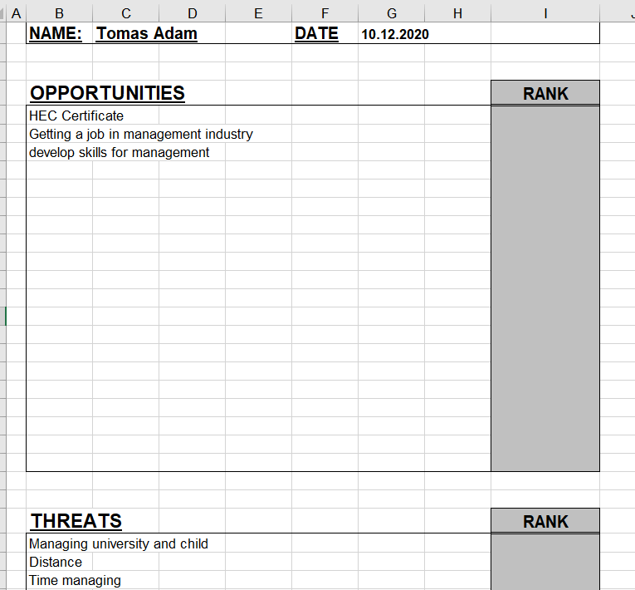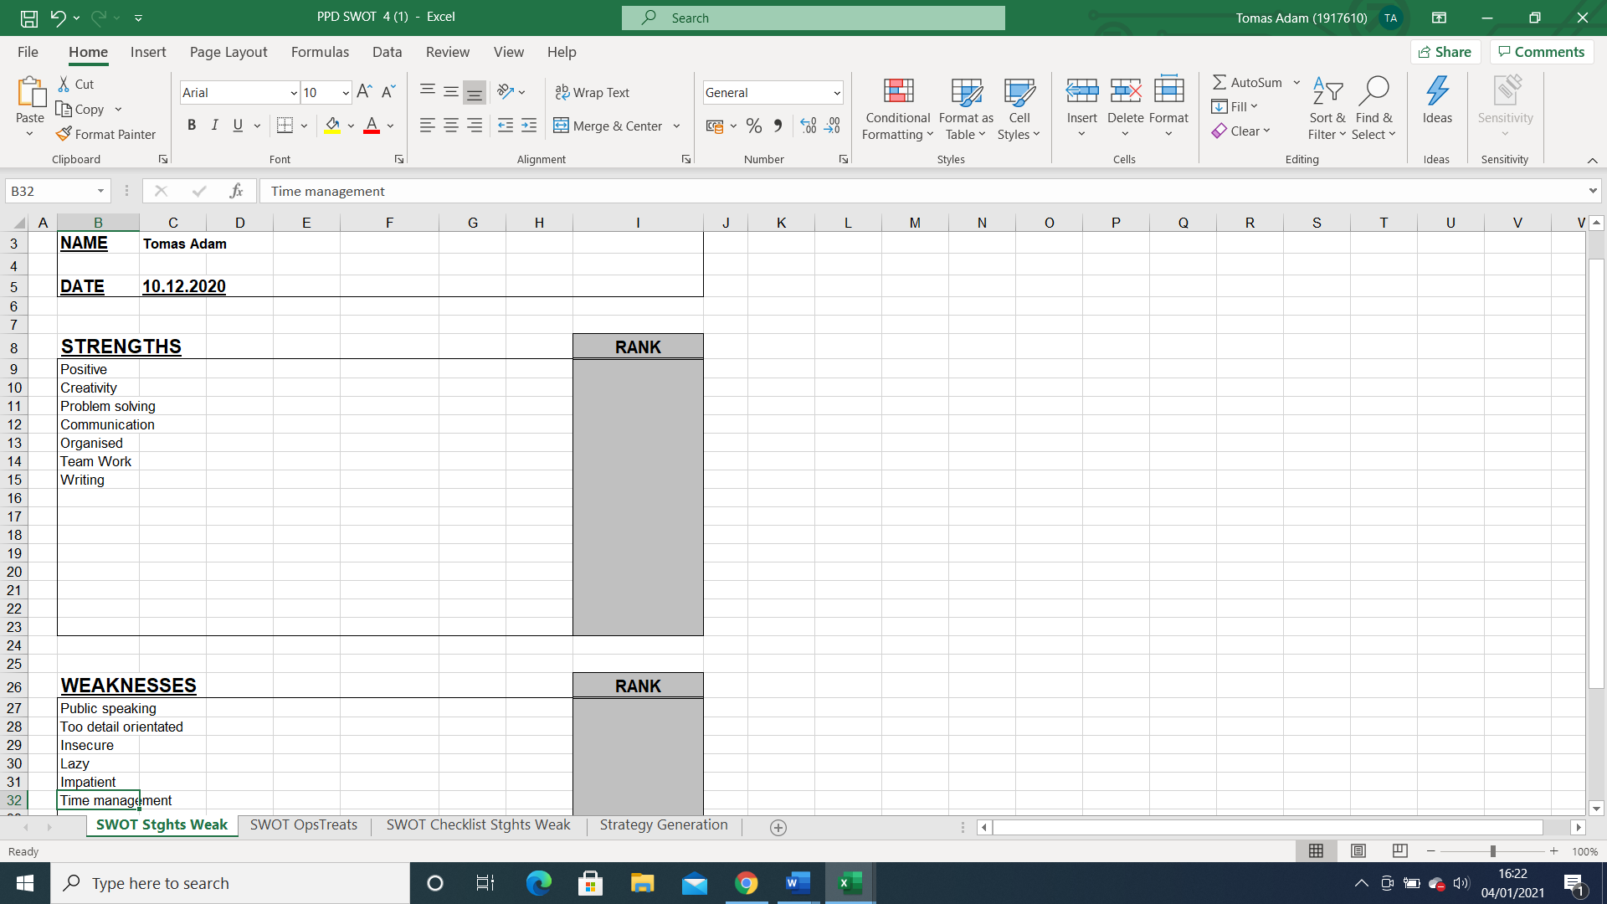

Personal Career Plan

Aim 1:
Finish degree

Aim 2:
Finding work as a manager

Aim 3:
Get management skills, knowledge and experience

Aim 4:
Open business

Aims | Actions | Date by which I should achieve my aims
Complete my degree | Attend lectures/finish assignments | 2023
Getting a job as a manager | Doing both university and unpaid work | 2022/2023
getting management skills and experience | Looking for work in the management field and taking the first opportunity | 2023/2027
Opening my business | I need to have all the legal work done and enough money | 2027/2028

Vark (1987)

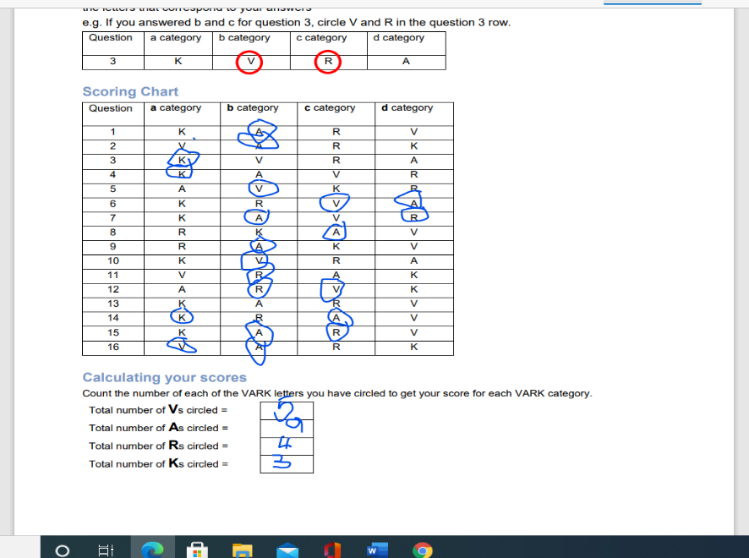
Honey and Mumford (1986)
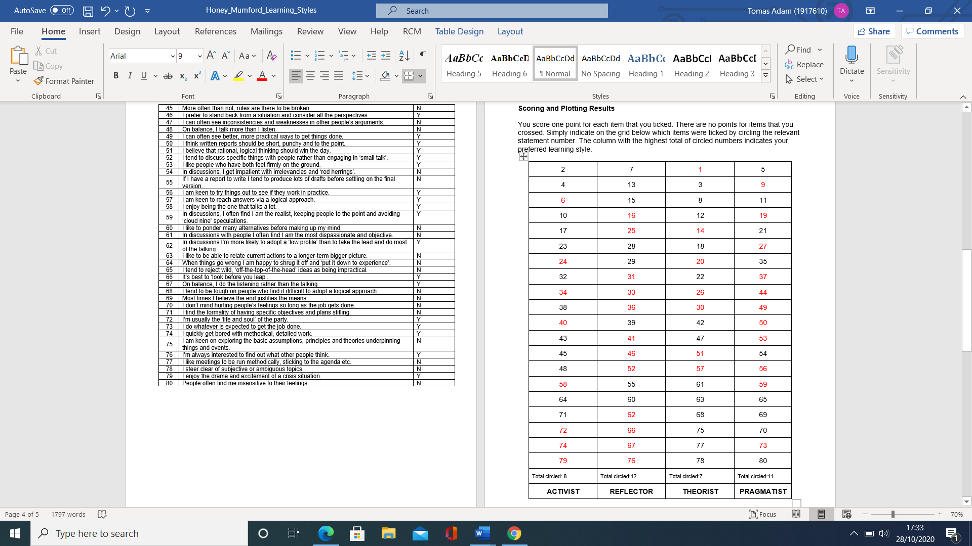

My goal is to achieve my dream of working in the mangement industry, I have created a plan which has the main aims I ned to achieve to work in the mangement industry. I have made a SWOT Analysis to help me be more selfaware. This is because the SWOT analysis will enable me to see the skills I have and the skills I do not have ut are needed to become a mangerBy creating a SWOT analsyis, it gives me a clear pictue of what oppurtunities are there for me and what threats there may be for me. I have used the learning styles questionnaires, I have chosen to use the Honey and Mumford (1986) and the Vark (1987) questionnaire to see what way I learn best and what sort of personality I am. The Vark (1987) questionnaire suggests that I am an ‘auditory’ learner. This means that I learn best by listening and debating. The Honey and Mumford (1986) questionnaire suggests that I am a ‘reflector’ and also a ‘pragmatists’. This means I am good at listening and observing and also that I am good at reflection on experience and also on analysing what and why has happened. According to Honey and Mumford (1986) reflectors are good at the ‘monitor’ role than any other role. These three steps are very important for my personal career development cycle. In order to achieve these steps, I need to make another step, this step is making mini mile stones which will ensure that I achieve my big goals. The goals that can be used as a mini milestone are goals such as completing my assigments and trying to speak in public. There is also another step to my personal career development which is doing the actions. This is actions such as going to usinversity and finding voluntery job to ensure I get experience needed for my dream management job. Recording the outcomes of my personal career development is the step six of the cycle. At the moment, I can eflect on tasks such as completing asseigments on time and attending university. The last step, step 7 is evaluating or reviewing which can onoly be completed once one or more gols are achieved. There may be complications when trying to complete my aim, these are issues such as: managing family and university, distance, and money. In order to resolve these issues I have to make sure that I do my assigments when my child is asleep or when my partner is not working, finding a nursery for my child for times when I am doing voluntery work and I would also need to create a professionak financial plan for myself and my family to esnure we save enough for my business. Taking a loan to start my business may be necessery.

My learning
I have gained skills during this course, that will help my in my career development. Skills such as being positive, problem solving, being organised, and writing skills.

5.1 Organisation skills

Organisation skills is a good skill to have when in education or in employment. This makes things much easier at university and at work because being organised means getting everything done quicker and not wasting any time for example searching for any products or materials needed to complete the assignment or the task at work. It can also improve the communication at work or university between the team. It also reduces the stress of having to much work to do and it also give you a sense of control. T, Fierbrandt (2020)

Writing skills
Writing skills is another very important skill to have both at university and at work. Excellent writing skills make your assignments much easier. Completing the assignments in this course so far, has bettered my writing skills which is extremely important in these days because written communication is almost used more than verbal communication both at work and university. R, Sethi (2020)

Solving difficulties

By nearly completing this course I have gained another important skill which is problem solving. This skill is important both at work and at university. Problem solving skills is a key skill that employers are always looking for as this skill shows other different skills you may have such s logic, determination, creativity, or resilience. The skills can also help you to climb the ladder of successes. L, Ashman (2019)

Positivity
A skill that I have gained throughout this year is staying positive. This skill is important to me because it prevents issues such as submitting an assignment late. Being positive and having an positive attitude towards learner and employment can ensure that you stay relaxed, focus, absorb any information you need to learn and remember things. Being positive also decreases the chances of stress which can increase resiliency. CareerGuide, (2019)

Conclusion
In conclusion a personal career development plan is needed to be made when trying to climb the ladder of success. For me to be good in both my education and employment I have created a personal carer development plan which has aims that I need to complete for me to get my dream job and opening my own business. I have also created SWOT Analysis which has helped me to understand what skills I have, what skills I need to work on, what opportunities are out there are, and what threats there is for me. I have also used theories to ensure I know what way I learn the best and what kind of personality I have. The theories I have used are Honey and Mumford (1986) and the Vark(1987) these are questionnaire that need to be answered in order to get your results.

7.0 References
Education Bhaskar. (2019). Why is Writing Important in Education- Why Writing Matters. [online] Available at: https://educationbhaskar.com/articles/importance-of-writing/9869/#:~:text=Why%20is%20writing%20important%3F (Accessed 01 Jan 2021).

ELN.IO (2016). Honey & Mumford Learner Types (1986) Online Quiz. [online] Www.eln.io. Available at: https://www.eln.io/blog/honey-mumford-learner-types-1986-questionnaire-online. (Accessed on 28 Dec.2020)

Eventus Recruitment. (2019). Professional Development Planning Cycle. [online] Available at: https://www.eventusrecruitmentgroup.com/blog/career-development/professional-development-planning-cycle/. (Accessed on 28 Dec. 2020)

Findanyanswer.com. (2020). Why is being organized important in school? [online] Available at: https://findanyanswer.com/why-is-being-organized-important-in-school (Accessed 22 Dec. 2020).

Graduateland. (2015). Why problem-solving skills are so important for your career. [online] Available at: https://graduateland.com/article/problem-solving-skills. (Accessed on 22 Dec. 2020).

Indeed Career Guide. (n.d.). Positive Thinking in the Workplace: Benefits and Tips. [online] Available at: https://www.indeed.com/career-advice/career-development/positive-thinking-in-your-career. (Accessed on 22 Dec. 2020)

Leap Like A Salmon. (2018). How personal and professional development go hand in hand… | Leap Like A Salmon. [online] Available at: https://www.leaplikeasalmon.com/how-personal-and-professional-development-go-hand-in-hand/. (Accessed on 24 Dec. 2020)

VARK - A Guide to Learning Styles. (n.d.). The VARK Modalities | VARK. [online] Available at: https://vark-learn.com/introduction-to-vark/the-vark-modalities/#:~:text=The%20acronym%20VARK%20stands%20for. (Accessed on 24 Dec. 2020)

8.0 Appendices

SWOT ANALYSIS

PDP PLAN

Aim 1:
Finish degree

Aim 2:
Finding work as a manager

Aim 3:
Get management skills, knowledge and experience

Aim 4:
Open business

Aims | Actions | Date by which I should achieve my aims
Complete my degree | Attend lectures/finish assignments | 2023
Getting a job as a manager | Doing both university and unpaid work | 2022/2023
getting management skills and experience | Looking for work in the management field and taking the first opportunity | 2023/2027
Opening my business | I need to have all the legal work done and enough money | 2027/2028

Vark (1987) questionnaire results

Honey and Mumford (1986) questionnaire results

