An individual reflective response to the Professional Teaching Experience

In this essay I will be reflecting on my first professional teaching experience and my targets throughout the experience relating to the QTS standards. During my Professional Teaching Experience, I aimed to develop in all areas of teaching. I recognise the importance of reflection in order to become better in the areas that I need to improve in, but also the areas where I have performed well.

Reflective practice is seen as a, “process of thinking through professional issues, problems of dilemmas, which do not have an obvious solution.” (Welsh Government, 2015) This expands on my point of improving in all areas and the areas that I may find difficult, by reflecting on those areas, I can then improve.

After my first week of observations I decided that I should target being able to develop my confidence in reading a story to small groups of children. I decided to use this target because they linked well to what I would be teaching in that week, after speaking to my class mentor. I also decided these targets because they linked to QTS standards.

The first target of developing my confidence in reading to a small group of children was mainly focusing on the QTS standard S3.3,

“begin to employ interactive teaching methods and collaborative group work.”

(Welsh Government 2009)

I developed this QTS standard by firstly starting the week by teaching a small group of eight children (see Appendix 1) and reading Oxford Reading Tree book, “Go Away, Floppy.” This helped me gain a lot of confidence in reading to the children and I learned a lot. This was when I started to learn about asking questions throughout the book in order to track pupil concentration and understanding. On the Thursday (8th March), it was World Book Day and our school celebrated it on the Friday. In my school, one teacher would dress up as a character from a book and read the book from which the character they are dressed up as is from (see Appendix 2). I watched two teachers read before I did. From this, I learned to put on an act for the children to keep them interested, as well as ask questions throughout the book. This lesson shows my development of confidence and my progress for this target, because at the start of the week I was reading for eight children in a small group and by the end of the week I was reading in front of the whole of reception, which was sixty children. I then progressed this target into my final week of the Professional Teaching Experience and read a book which led to singing and dancing, (see Appendix 3) which specifically links to the, “interactive teaching method” area of the chosen QTS standard. I decided to use singing and dancing as an addition to the reading lesson because throughout the Professional Teaching Experience, I have observed the teacher in the class singing in front and the children joining in and dancing. I also chose reading as one of my targets because Piaget deems reading as a key to a child’s cognitive development because you are developing your oral and written skills. Piaget also mentions that this is learned during the second stage of development, between the ages of two and seven, therefore, completing reading lessons during my time in reception was something that was very important to me because I wanted to see the children develop (The Classroom, June 2014). My next steps for these specific sessions would be for the children to write about something they enjoyed from that book in order to continue to develop their writing skills. This also links to Piaget in his Theory of Cognitive Development that children should develop their oral and written skills between the ages of two and seven.

My next chosen target was for me to help the children develop their literacy and numeracy skills through creative activities. I chose this target because it links to many different QTS standards, e.g. the standards about understanding a continuum in learners needs, (S2) because children need to be enjoying their learning otherwise they lose concentration and won’t learn; teaching the curriculum in the age range for which they are trained (S3.3). However, the main QTS standard from S3.3 that I wanted to meet with my target was to,

“begin to interest and motivate learners through their teaching.”

(Welsh Government, 2009)

I was motivated to use this QTS standard because I wanted make the learning fun and exciting. This links to Vygotsky, who says that by using the Zone of Proximal Development (ZPD), you can conclude that children learn quicker and more effectively during play because they are getting an experience of learning (Simple Psychology, 2014).

The first creative lesson I taught was about mixing colours and learning what primary colours be made into (see Appendix 4). I used skittles and milk in order to hook the children into the lesson and got the children to count the skittles, which developed their number skills. I then asked the children if they knew what colours changed to when two were mixed together. The original colours that we started with were the primary colours of blue, red and yellow. This developed their language skills and their confidence in speaking in front of a small group (LNF). I used toy cars so the children could draw over paper and this helped them enjoy mixing the colours together and the children then worked out for themselves what colours were made by combining two different colours.

The second creative lesson I taught was decided because we had Science, Technology, Engineering and Math (STEM) week in school and I had to create a lesson using a nursery rhyme (see Appendix 5). I decided to use, ‘Hey Diddle, Diddle’ and in my lesson I got the children to create a catapult using lollipop sticks and elastic bands. We labelled different planets that the children made themselves with numbers. So, the planet the children landed nearest they would add with their next score and they would add them together. This helped develop the childrens’ maths skills. I also asked the children if they had an idea of how to launch the cow further, this was to develop their creative skills, as well as their confidence in speaking in small groups. One child thought to add extra lollipop sticks to the catapult and we had a huge gap in results after we made that change. I also created this lesson based on reflecting from the previous creative lesson I did. This is because I wanted to create a lesson that everyone would enjoy, therefore with this lesson I added in the children drawing their own cow and moon themselves. This is so that the children who wouldn’t be as interested in launching the cow from a catapult, would be interested in the drawing and colouring part of it. I would have extended these lessons further by making the children write down or draw what they remember from the experiments, this would not only help develop their memory and creative skills, but would have also been a good assessment for learning (AFL) strategy for me to understand how much the children learned from the lesson. Vygotsky’s theory of creativity mentions that children should be able to develop their imagination, this is through a, “link between emotion and thought.” (Taylor & Francis Online, 2003) This shows that through children being creative, it helps them develop their imagination and consciousness, this is why I feel that creative drawing and writing is important to add into lessons and why I think I should have developed my lessons further into the children drawing or writing what they remember from the experiments.

Overall, I feel that through reflective practice throughout my Professional Teaching Experience I have been able to develop my teaching skills and be able to adapt lessons to meet certain children’s needs. I think this has helped me develop because, “We reflect in order to learn something, or we learn as a result of reflecting.” (Moon. J, 2004, p.80) I think that reflective practice is very important when trying to improve at something and by reflecting throughout the Professional Teaching Experience I have been able to develop my lessons in order for all children to enjoy and want to learn, not just certain personalities. Using different theorists like Piaget and Vygotsky has helped me progress and understand more that it is important to use certain aspects of teaching well in order to help a child develop fully and learn. I think one of my strongest areas is my ability to speak to the children and understand the resources they need in order to learn. My ability in being able to communicate to the children has helped a lot because I am able to build a relationship with the children, which will, “help maximise their learning potential” (S1.2) (Welsh Government, 2009). Therefore, I helped them learn because I was able to build a relationship with the children before teaching them. The main part of the Professional Teaching Experience I was nervous about was actually starting to teach the children. At the beginning, this showed and I seemed nervous and struggled to control the children, but after reflecting with my class mentor, I learned what I needed to do and when it came to teaching the next time, I was able to fully control the children, specifically using behaviour strategies, e.g. sitting successfully. The other main area that I improved in was my lesson plan writing. At the beginning of my Professional Teaching Experience, my class mentor gave me feedback saying that my first lesson plans were too detailed (see Appendix 1), however after I started spoke to my class mentor I made my lesson plans more to the point and with more approach to children of lower and higher ability.

Reference List
The Classroom. (8th June 2014) Learning Theories About Reading Development, Available at https://www.theclassroom.com/learning-theories-reading-development-7346958.html, “Accessed: 20/03/2019”

Jennifer A Moon. (2004) A Handbook of Reflective and Experimental Learning – Theory and Practice, 1st Edn, RoutledgeFalmer, London

SimplyPsychology. (29th January 2014) Lev Vygotsky, Available at https://www.simplypsychology.org/vygotsky.html, “Accessed: 20/03/2019”

Taylor & Francis Online. (22nd June 2011) Vygotsky’s Theory of Creativity, Available at https://www.tandfonline.com/doi/abs/10.1080/10400419.2003.9651416?journalCode=hcrj20, “Accessed: 20/03/2019”

Welsh Government. (3rd July 2009) Qualified Teacher Status Standards Wales 2009, Available at https://gweddill.gov.wales/legislation/subordinate/nonsi/educationwales/2009/3220099/?lang=en, “Accessed: 21/03/2019”

Welsh Government. (14th July 2015) Reflective practice, Available at https://learning.gov.wales/docs/learningwales/publications/150611-reflective-practice-booklet-en.pdf, “Accessed: 21/03/2019”

Appendix List
Appendix 1 – Reading Lesson Plan – Oxford Reading Tree
Appendix 2 – Reading Lesson Plan – World Book Day
Appendix 3 – Reading Lesson Plan – Involving dance
Appendix 4 – Creative Lesson Plan – Colour mixing
Appendix 5 – Creative Lesson Plan – Hey Diddle, Diddle

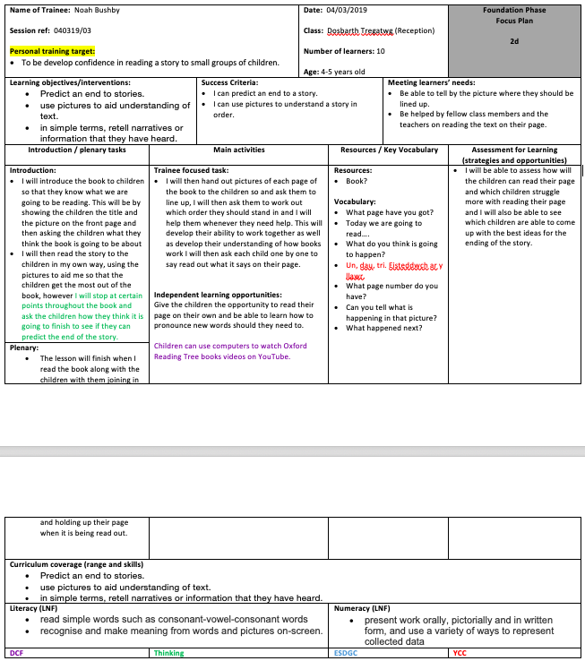
Appendix 1

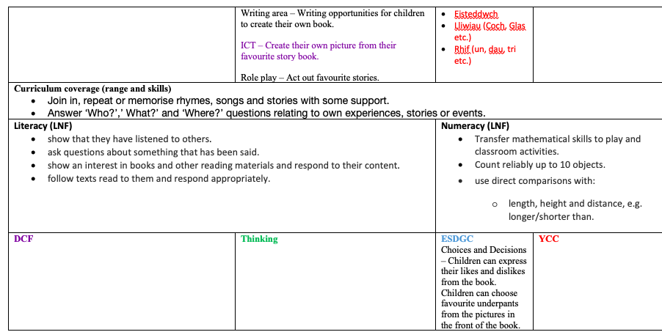
Appendix 2
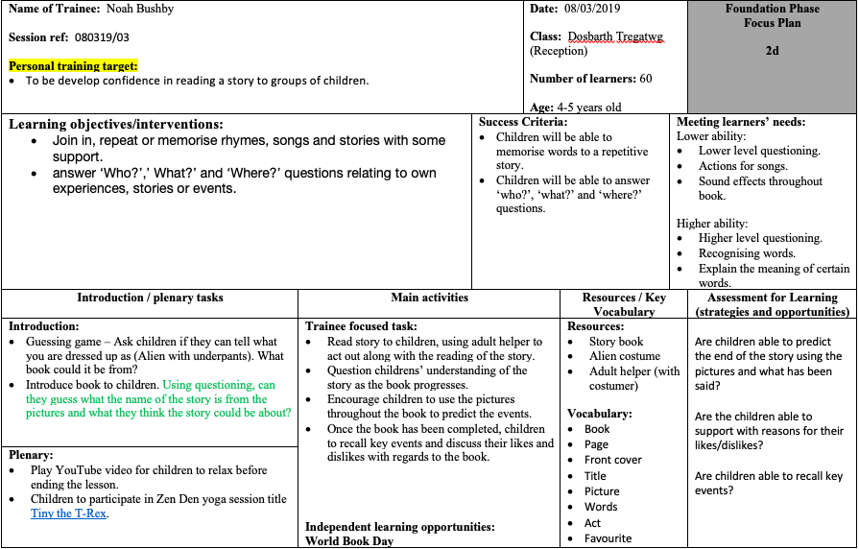

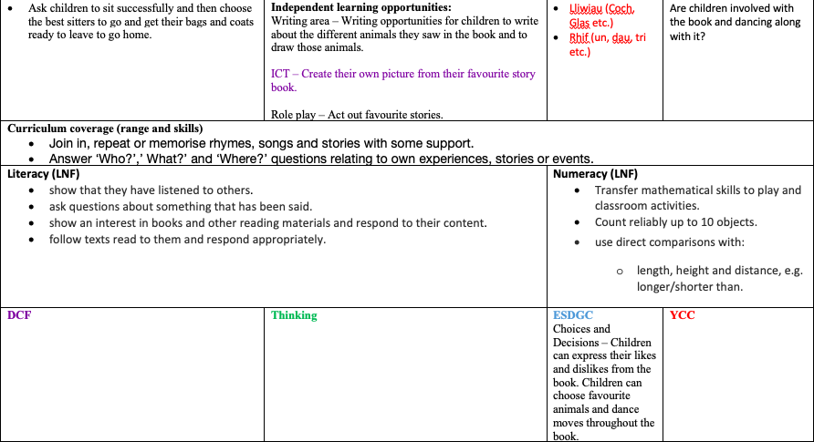
Appendix 3
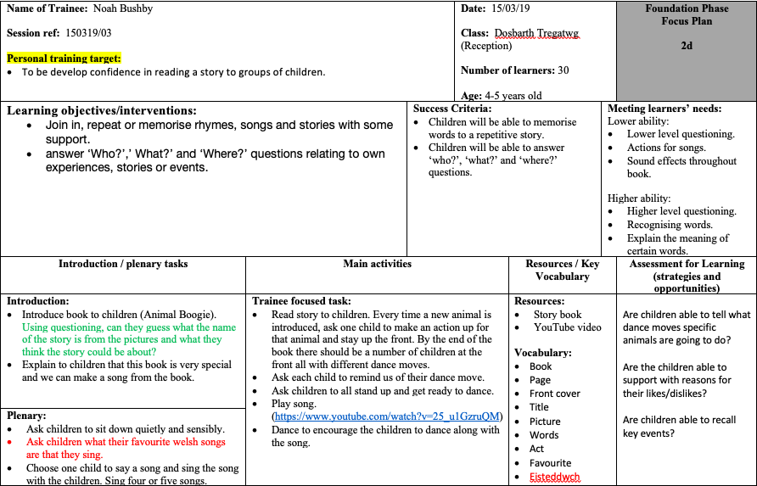

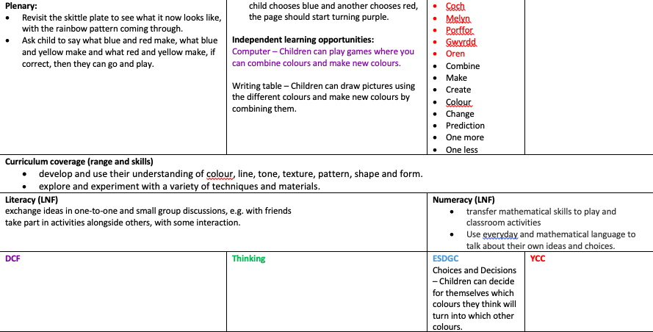
Appendix 4
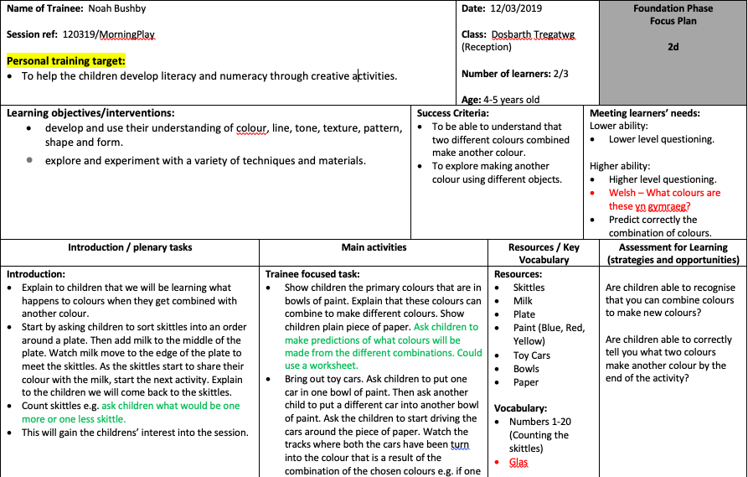

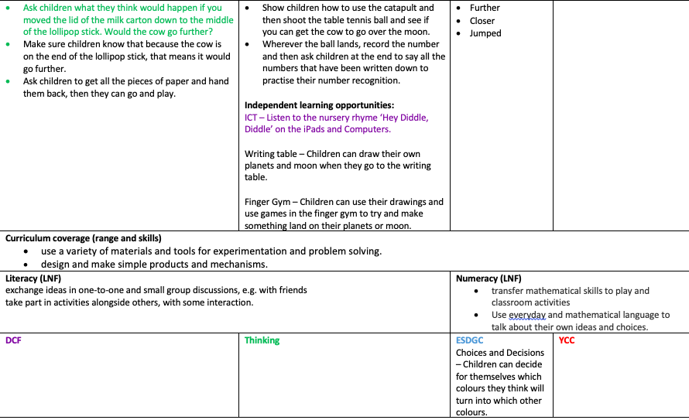
Appendix 5


