Max Greenland (2205366)

From Learning to Earning: future career planning
Preparing for Employment (BMLW 4008)

Contents
Contents 1
Introduction …………………………………………………………………………………………………… 2
CV ………………………………………………………………………………………………………………… 4
Covering letter ………………………………………………………………………………………………… 5
LinkedIn …………………………………………………………………………………………………………. 6

Success in the workplace
In the modern workplace, success is a multifaceted concept that goes beyond the achievement of goals. It can require a different attitude and way of working towards growth, both professionally and personally. Skills required for this professional growth can be developed from higher education, as many study skills can be utilised in a professional environment. Critical thinking, decision-making, and reflective practices, among other skills, that are worked on and perfected when at higher education are then highly sought-after abilities by future employers, as these students are already very comfortable when looking through high amounts of information and producing good quality work.
It is the goal of universities and other higher education platforms to ensure students have the necessary skills going forward in life, as when partaking in workshops, industry events and building networking skills students will “establish meaningful professional connections to help them be more successful in their careers” (Pushfar,2024)
To manage a successful team in a modern workplace, there are multiple techniques and goals that can help achieve the most effective environment. The most successful team managers are those who help each individual member of the team to grow (International Journal of Engineering and Management Sciences, 2018)
To truly have success in the workplace, one does not just need to reach a target or hit a professional goal. It encompasses a sense of purpose and fulfilment that can align with values and aspirations for the future.
As touched on, hitting personal goals can be excellent in helping to drive someone to become better and motivate their colleagues to become better. The hitting of goals can also be a step to the pursuit of excellence. The setting of high standards and striving for continuous improvement can help someone to learn new skills, perfect existing talents, and embrace future challenges with resilience and determination. Another cornerstone of success in the workplace is effective communication, as clear and open communication can help to facilitate collaboration with coworkers, making more effective work teams. Communication is important in personal growth as well, as receiving and providing feedback constructively is a skill that when used well can push coworkers and yourself to grow. Communication in the workplace can come from workplace friendships, or visa versa. These workplace friendships can lead to greater productivity, goal attainment and better job performance overall, as well as forming more cohesive work groups. (International Journal of Research and Development, 2013)
The strive for success in employment should not be solely for yourself, helping and motivating others to reach their full potential can vastly improve work output and the work environment. The leadership performance in the workplace has been cited as a critical success factor, even determining whether a project succeeds or fails. (International Journal of Productivity and Performance Management,2012)
Success in the workplace is a concept with varying methods and goals, that can encompass personal growth, professional achievements, and effectiveness. By embracing a different mindset of striving for excellence and perfection, aswell as fostering skills such as effective communication and being able to adapt to changes, individuals can navigate the various challenges of professional life with a strong confidence and resilience. Ultimately, this success in the workplace is not just focused on reaching the peak of someone's career but about the journey of continuous learning and growth.

CV

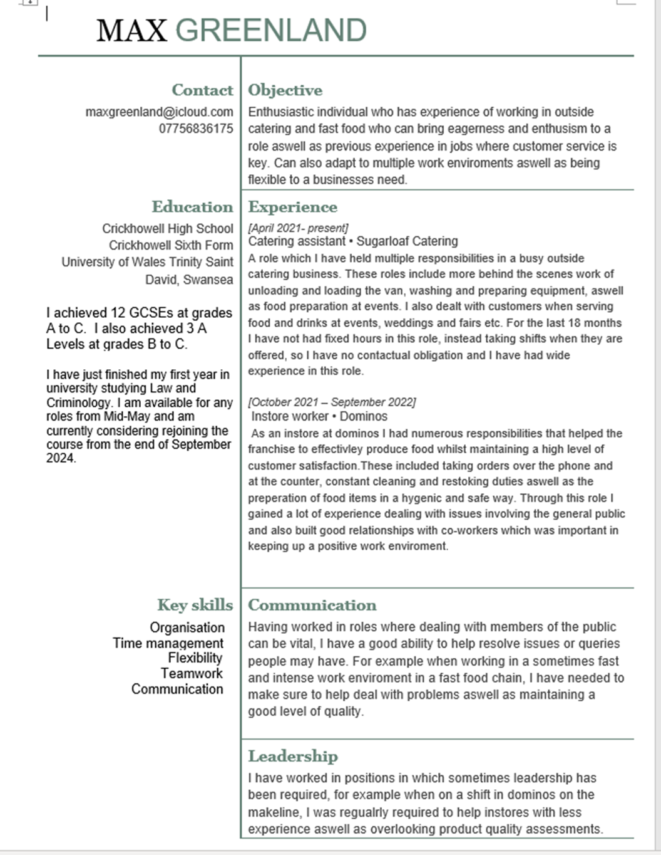

Covering letter

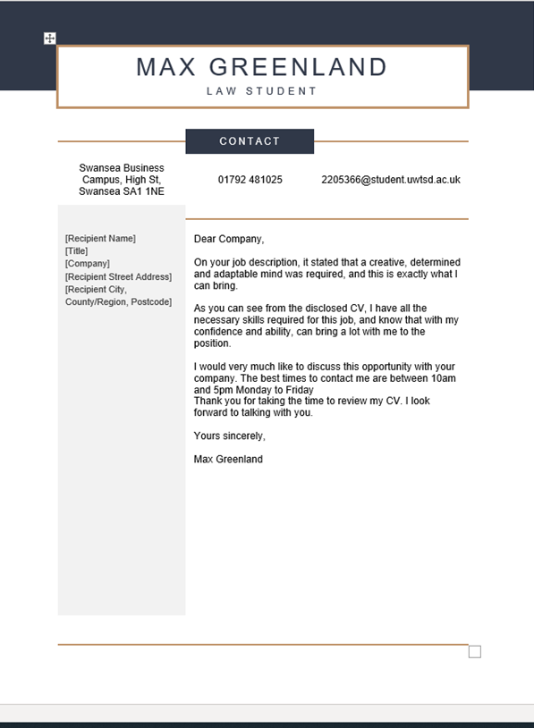

LinkedIn Profile



www.linkedin.com/in/max-greenland-b83918308

Reference list
Adil Namiq, F. (2018) Most Effective Management Style for Modern Workplace, International Journal of Engineering and Management Sciences, 3(3), pp. 402–411
Available at: https://ojs.lib.unideb.hu/IJEMS/article/view/5062
Accessed on: 10/05/2024
Gaur, M. and Ebrahimi, N., 2013. Understanding Workplace Relationships–With Special Reference to Superior-Subordinate Relationship–An Important Dimension Having Impact On The Success, Growth And Performance of the Employees And Organization. International Journal of Research and Development, 2(2), pp.7-12.
Available at: https://www.researchgate.net/profile/Mamta-Gaur-4/publication/358262639_Understanding_Workplace_Relationships_-With_Special_Reference_to_Superior-Subordinate_Relationship_-An_Important_Dimension_Having_Impact_On_The_Success_Growth_And_Performance_of_the_Employees_And_Orga/links/61f8e5ce1e98d168d7e2e109/Understanding-Workplace-Relationships-With-Special-Reference-to-Superior-Subordinate-Relationship-An-Important-Dimension-Having-Impact-On-The-Success-Growth-And-Performance-of-the-Employees-And-Org.pdf
Accessed on: 10/05/2024

Nixon, P., Harrington, M. and Parker, D., 2012. Leadership performance is significant to project success or failure: a critical analysis. International Journal of productivity and performance management, 61(2), pp.204-216.
Available at:
https://www.emerald.com/insight/content/doi/10.1108/17410401211194699/full/html
Accessed on: 10/05/2024

PushFar, 2024 7 Ways Universities Can Effectively Prepare Students for the Workplace
Available at: https://www.pushfar.com/article/7-ways-universities-can-effectively-prepare-students-for-the-workplace/#:~:text=Planning%20industry%20events%2C%20workshops%20on,will%20further%20support%20career%20growth.
Accessed on: 10/05/2024

