Module Number: LCMB7010
Module Name: Strategic Management
Title of the assignment: International Marketing
Name of student: Nabeel Ahmed Khan
Student Number: 2125539
Submission Date: 13-Jan-2023
Word Count: 6644 Words
Executive summary
International marketing is a very popular way to promote business and spread awareness about brands in international markets. Unilever is a British consumer goods company which has a strong customer base not only in the UK but also in many other countries like India. In this assignment, at first, the overview of the company is discussed along with its performance in the UK and India. It is followed by the importance of international marketing for companies and then a brief discussion about the external environmental factors that affect the marketing strategies of a company in different countries. The cultural differences between the countries are shown through the Hofstede cultural dimension model, and the other factors are shown through the PESTLE Analysis of the retail sector of the UK and India. Buyers are not merely those who purchase the majority of the company's goods; they are also those who remain loyal to the business and recommend it to individuals in their social circles, such as peers, friends, and coworkers. Any business enterprise that wants to succeed in business must figure out how to offer users a favourable picture of the firm and the things it produces. Therefore, it is crucial to analyse Unilever's global marketing strategy in the UK and India, two of its largest markets. The goal of this report is to pinpoint the variables influencing the goods of the two companies, which have roughly equivalent positions in the customer base, in order to develop a more thorough understanding and gain a competitive edge.

Table of contents
1. Introduction 3
2. Overview of Unilever 4
3. Significance of International Marketing 5
4. Contrasting external environmental factors 6
4.1 Cultural Differences 6
4.2 External environmental analysis 8
4.2.1 PESTLE Analysis of Indian Retail Market 8
4.2.2 PESTLE Analysis of UK Retail Market 10
5. Evaluating marketing strategies of Unilever 12
5.1 Evaluation of STP 12
5. 2 Marketing mix 17
5.3 Extended Marketing Mix 21
6. Conclusion 25
7. References 27
8. Appendices 31
Appendix 1: Graphs and Figures of PESTLE Analysis 31

1. Introduction
Marketing is the most important part of any business, as it can make or break a business. There is cutthroat competition between the companies, and any company that has good marketing strategies can attract customers effortlessly. In simple words, marketing is a way of promoting, advertising and selling products and services to customers. Marketing strategies should be framed in a way to grow the business and to grow the business. Marketing activities should also take place across borders. This type of marketing that is done across borders is called international marketing. International marketing increases the customer base of a company and also protects the company against economic downturns (Morgan et al. 2018). It consists of Exporting products, Licensing, contract manufacturing, Franchising, Joint ventures and Foreign direct investments. To expand the business on a global basis, companies need to follow some strategies like choosing the right global partners, adopting a proactive thinking method and a lean approach, creating a detailed strategy for the product or service provided and making proper reinvestment in the business. In this report, the marketing strategies of a company will be discussed in two different countries to give a clear understanding of the importance of the marketing tools like STP and marketing mix to expand the business in different countries too. The marketing tools help in focusing on marketing communications and providing the customers with what they need.
The company chosen for this report is Unilever which has good marketing strategies (Wachira and Kariuki, 2018). It is a multinational consumer goods company, and India and the United Kingdom are the top markets of the company. In this report, a clear comparison of the marketing strategies of the company for the two different countries will be discussed, along with a proper analysis of the environmental factors that affect the marketing of the products in both companies.

2. Overview of Unilever
Unilever is a multinational consumer goods company based in the United Kingdom. It is headquartered in London. It was founded in 1929 by the merger of Lever Brother, which was a soap-making company and Margarine Unie, which was a Mandarin-producing company. The company deals with various consumer products related to food items, home care and beauty and hygiene. The company is the largest producer of soap in the world. This company operates in 190 countries across the whole world and has great customer loyalty because of its marketing strategies. The company has research centers in the United Kingdom, China, India, The United States Of America and the Netherlands. These countries are also the largest market for Unilever products. In 2021 the company's operating profit in all the countries altogether increased to 8.7 billion euros from 8.3 billion in 2020. However, 2018 was the best year for the company, as it made an operating profit of more than 12 billion euros. That year, the company registered profits of more than 50 billion euros (Zou, 2021).
In the United Kingdom, the company generates an annual turnover of 2 billion euros, and the company spends 145 million euros while working with the suppliers of the company. Around 70% of the products that are produced by this company are sold in the country itself. Most of the households in the UK use the products of the company. However, in India, the company is known as Hindustan Unilever Limited (Raj and Aithal, 2018). It is a subsidiary of the British Company. The company was first set up in India in 1931. In 2022 the company’s annual turnover crossed 50000 crores in Indian Markets (Yadav and Yadav, 2019). The company deals with products from more than 50 brands in India. According to Unilever’s earnings, it is seen that India has strong growth for the company. This is only possible because of the innovation, double-digit pricing, and Positive volumes of the products.

3. Significance of International Marketing
International marketing refers to the business activities that enable the products and services of a company to reach customers across borders. International marketing helps the business to create a broader market in other countries too. But before getting into international business, companies need to know the advantages of including it in their business activities (Oviatt and McDougall, 2018). A lot of special skills and competence are needed in the international marketing of a business. However, there is a lot of competition in international marketing as the company needs to compete with both domestic and international competitors. International marketing also involves high risks or challenges like the political scenarios of the countries, cultural differences, change in trends or preferences of the customers or communication barriers. If any company depends on the domestic market only, then the growth of the company becomes limited. But if the company implements international marketing in its operations, then the company can expand the business overseas, which helps in increasing the customer base and the market share of the company. International marketing also helps the company in boosting its brand image in public. People always like to buy products that are available on a wide basis. International marketing helps companies to attract new customers and business partners. Working in international markets is highly beneficial for companies as it gives a lot of opportunities for networking. It also helps in connecting with new suppliers, vendors, employees, workforce and technologies that will benefit the company's market value. The Management of international operations includes operating the sales and marketing facilities of different countries, establishing manufacturing facilities in other countries and keeping track of the operations and practices of their competitors. Unilever follows cross-marketing strategies and collaborates with different companies to promote each other's products (Mitić, 2018). This helps in increasing brand awareness of the product and also in increasing sales in different markets.

4. Contrasting external environmental factors

4.1 Cultural Differences
The success of a business in any country depends upon certain factors. Every country has different cultural and political influences that affect the taste and preferences of the people of that country (Song et al. 2018). Companies need to produce and sell products according to the demand of the people of that country. There are many factors that affect the business of Unilever in both the countries India and The United Kingdom, but the biggest factor is the cultural differences between the countries. The cultural difference between both countries is explained in the Hofstede cultural dimension model, which will help in getting a clear understanding of the drivers of both cultures. It is a framework set for cross-cultural communication. It shows the effects of cultural differences on people and their behaviors (Hofstede, 2009).
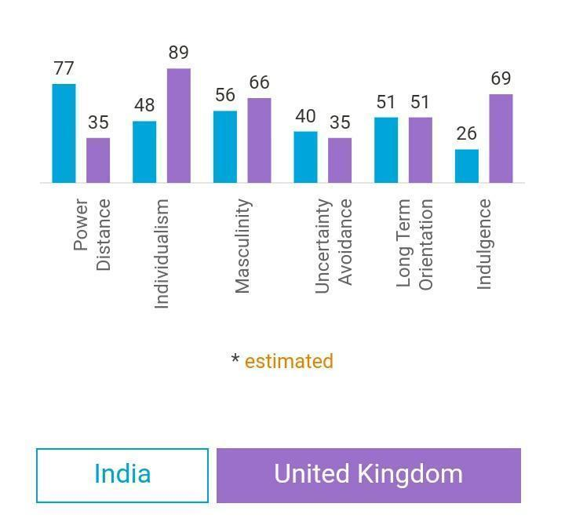
Figure 1: Comparison of countries
Source: (Hofstede Insights, 2021)

Factors | India vs the United Kingdom
Power Distance | It refers to the extent to which the powerless people of the country expect and accept that the power is distributed in an unequal manner. India leads in this dimension in comparison to the UK. In India, the state of hierarchy exists in society yet. However, the PD index of Britain is low as people in this country believe in equality and fair play.
Individualism | India believes in the collectivist approach where the people of the country take care of themselves and others too. However, the people of Britain believe in Individualism and only think about themselves and their benefits.
Macunality | The masculinity of society refers to a society where competition is important and winning is important, while a feminine society means a society where taking care of others is important and improving the quality of life is important. India has a highly masculine society, but the UK leads in this case.
Uncertainty Avoidance | It is a dimension where people of different cultures feel differently towards crises or unknown scenarios.  Indian culture is very accepting towards imperfections and has more tolerance, and the people of the UK also have a good approach towards not knowing what to do next.
Long-term orientation | India and the UK are the same in the case of maintaining links with the country's own past for dealing with present and future scenarios.
Indulgence | It is a dimension in which the people of the country control their desires, and India has a low score in this dimension and has high control over their desires. However, the United Kingdom has a high score in this dimension and less control over their desires.
Table 1: Cultural Analysis between the UK and India
Source: (By the Author)
From the above analysis, it is clear that there is a vast difference in the culture of both countries, which leads to the difference in the mentality of the people, and their tastes and preferences too. This is why the marketing strategies used by the company for the marketing of products in both countries have some differences too.

4.2 External environmental analysis

4.2.1 PESTLE Analysis of the Indian Retail Market
Factors | Description
Political | According to figure: 6/Appendix 1, the political stability index of India was -0.81 points in 2020, which was stable but a weak factor and had a disadvantage on the retail industry of the country (World Bank, 2018).
Economical | The sales of the market rose to 19% during the period of April to November 2022 (Szász et al. 2022). This shows that people are spending money buying products. This is highly beneficial for the Indian markets to get back to their form post-pandemic because the more people buy, the more it will help in the growth of the sector.
Social | The current population of India in the year 2023 is 1,428,627,663, which is a growth of 0.81% from the population in 2022 (MacroTrends, 2023). This is a big opportunity for the retail sector of India as a growth of population will lead to people buying more products related to household and personal use, which will increase the profit of companies contending in the retail sector of the country.
Technological | The company's retail sector benefits greatly from technological advancements. During and after the pandemic, the retail industry of the country survived because of the technological advancements too. People used online payments and online shopping facilities during the pandemic and are still utilizing them well. The advancement of technology is proving to be very beneficial for the country's retail market as providing products and services to customers has become easier.
Legal | There are many rules that apply to the goods and services in the retail industries and outlets throughout the country, like human rights laws, workplace safety and so on. Therefore, there is less possibility of fraud which is beneficial for the business, employees and its consumers. Customers like companies that follow ethics and work properly. Since the frauds are less, customer loyalty is more which is highly beneficial for the retail sectors.
Environmental | The retail sector of India is taking responsibility for protecting the environment. The companies take extra initiatives to reduce waste in their production and sales process of products. The companies avoid tests on animals. It is highly beneficial for companies as it improves brand reputation and customer loyalty, too, because customers also want to join and support companies that are socially responsible.
Table 2: PESTLE Analysis of India
Source: (By the Author)

4.2.2 PESTLE Analysis of the UK Retail Market
Factors | Description
Political | According to figure: 7/Appendix 1, the political Stability index of the United Kingdom is 0.54 points which is a good opportunity for the country's retail market as it will be easier for the companies of the retail market to practise safe trade practices throughout the nation (The World Bank, 2021).
Economical | In November 2022, the sales of the country's retail decreased to 5.8% from 5.9% in October of the same year (Atkinson and Aldrick, 2022). Therefore it can be comprehended that the retail market is going through a loss which is why the economic factor is a potential threat to the companies working in the retail sector.
Social | The current population of the United Kingdom is 68,784,502 as of January 11, 2023 which estimates an increase of 0.53 yearly percentage of change (WorldOmeter, 2023). This comprehends that as the population of the country increases, more and more people will rely on retail companies for household and personal items, which is an opportunity for the retail sector of the country as well as the contender companies of the sector.
Technological | The company’s retail sector benefits greatly from technological advancements. During and after the pandemic, the retail industry of the country survived because of technological advancements like home delivery of products through mobile and website orders.
Legal | There are many rules that apply to the goods and services in the retail industries and outlets throughout the country. The companies contending in the retail market have to follow laws like fair trade practices, Advertising Standards Authority (ASA), laws of employment safety and so on. This is an opportunity for the retail sector to avoid any bad situations with the customers and the employees.
Environmental | There are many pressures on businesses to promote and implement social responsibilities and to protect the environment. The companies take extra initiatives to reduce waste in their production and sales process of products. It is highly beneficial for companies contending in the retail market as it improves brand reputation.
Table 3: PESTLE Analysis of the UK
Source: (By the Author)

5. Evaluating the marketing strategies of Unilever

5.1 Evaluation of STP
Segmentation, targeting, and positioning are key concepts in modern marketing. Without it, marketing campaigns would lack personalization, be impersonal, and generally be unable to convert at a rate that most businesses would deem effective. STP is a three-step process that includes the analysis of segmentation, targeting and positioning (Romppanen, 2021). It helps in determining how to market products and which regions have the highest potential of making a profit. STP marketing works well because it concentrates on segmenting the core audience into separate groups, enabling a business to create extremely specialized marketing plans to connect with and connect with each consumer base. In fact, 59% of consumers claim that personalisation affects their choice to make a purchase, and another 44% claim that a customised customer journey would persuade them to use a company again (Tien, 2019). STP marketing is a little different from the strategies of advertising as it is more customers based. The reason is that it focuses on the customer's needs instead of just trying to sell the products. In other words, if a company's marketing initiatives are more tailored and targeted, they will be more lucrative. With the message's relevancy, the audience's capacity to relate to the story, or the copy's acuteness of the pain spots, the probability that the consumer would pay attention, take notice and whip out their money rises (Reza, 2020). Implementing the STP approach has several benefits, one of which is the reduction in marketing costs. A wide plan uses up a lot of advertising dollars, whereas laser-focused STP marketing puts utility and accuracy ahead of media costs. Below is the detailed STP Analysis of Unilever UK and Hindustan Unilever.
STP of Unilever UK
Segmentation
Segmentation means dividing the market into different parts and categories based on factors like geography, demographics, economy, etc. It is important for companies because it helps to concentrate on different types of customers and provide products which are useful for them. Since the factors of segmentation differ in different places, the segmentation of Unilever UK and Hindustan Unilever is also very different (Raj and Aithal, 2018).
Demographic  - Age - 10 to 70 (16 for food and beverage)  - Gender - all genders  - Income - high-income families.  - Occupation - all occupations. | Psycho-graphic  - Lifestyle - families with healthy lifestyles.  - Personality - health conscious.
Behavioral  - Occasion - all occasions.  - Attitude - People who spend money on cosmetics and healthcare products. | Geographic  - All regions of the UK.
Table 4: Segmentation of Unilever UK
Source: (By the Author)
Analysis
Due to the differences in cultural practices of the people, interests, and institutional arrangements of the targeted consumers, geographic segmentation proves to be highly advantageous for Unilever in the UK. If the cost of sending the products from one to the other has to be minimised, it can be a good point to start. The reason is that the final price of a product varies in different places because of different costs of transportation and packaging.
Targeting
Any business targeting strategy has a significant impact on its success. Due to its ability to sell its products in emerging areas, the firm has an advantage in the majority of global marketplaces. The company's engagement in the manufacture of diverse items may also be observed as a result of its growth, even within a single nation. These strategies help companies recognise the value of properly considered marketing strategies and the importance of variety in brand development. The main targeting strategy of Unilever is to gain a top position in the market across the UK (Widyastuti et al. 2019). The strategy mainly focuses on providing a variety of products and, at the same time, providing products that are specific to a region. The company uses this technique while developing new goods to market in various regions of the UK. This strategy is very difficult to follow because of the high spectrum of products. Still, the company follows it because it helps in reaching the most amount of potential customers. Unilever UK uses a cross-market approach so that they can effectively woo customers to be loyal to the company. To achieve this, Unilever subsidies the price of its products, which is frequently lower than that of competitors' companies.
Positioning
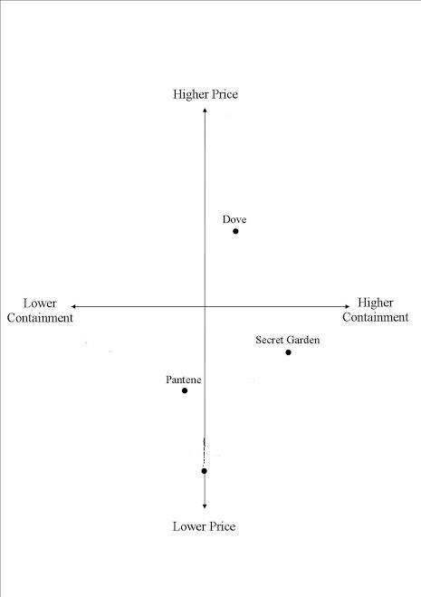
Figure 2: Positioning Map of household/personal items of Unilever UK
Source: (Made by the Author)

STP of Hindustan Unilever
Segmentation
Demographic  - Age - 10 to 70 (16 for food and beverage)  - Gender - all genders (mainly women)  - Income - low middle-income families.  - Occupation - all occupations. | Psychographic  - Lifestyle - families with healthy lifestyles.  - Personality - health conscious.
Behavioral  - Occasion - all occasions.  - Attitude - People who spend money on cosmetics and healthcare products. | Geographic  - All regions of India, especially the weaker sections of the society.
Table 5: Segmentation of HUL
Source: (By the Author)
Analysis
HUL takes advantage of a powerful distribution network that includes more than 3400 retailers and 16 million units (Fithry et al. 2021). They are able to sustain high volumes as a result of filling the shelves of the majority of retailers. The "Household and Personal Care" and food production channels are brought together through the new sales organization known as "One HUL," which unites all the units under the same objective of success (Mukul, 2020). HUL has consistently been successfully expanding at a pace higher than the rate of increase for the FMCG Sector, reiterating its position as a market leader in India. Segmentation is demonstrated well by Project Shakti. There are 627,000 villages in rural India, which presents a significant distribution difficulty for FMCG companies (As, 2020). HUL has developed a novel and effective project that allows rural women to sell HUL goods and, as a result, connect with village residents on an equal level. In addition to expanding the market reach, the effort raises brand recognition among the less advantaged sections of society.
Targeting
The operational strategy of FMCG firms like Hindustan Unilever plays a key role in marketing products with an increased market share, detailing and implementing the corporate methodology, aiding in the advancement of a key vision and putting a focus on broad company goals and objectives (Gayathri et al. 2021). This helps equip organizations with the skills and competencies to keep up and achieve pleasurable movement in the constantly changing business environment.
Positioning
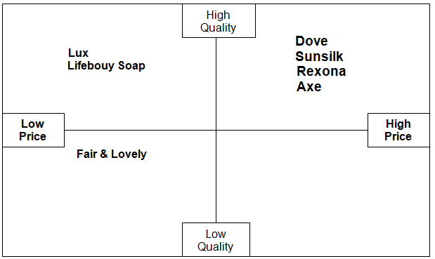
Figure 3: Positioning Map of household/personal items of HUL
Source: (Made by the Author)

5. 2 Marketing mix
The enhanced marketing mix includes three more elements in addition to the standard four Ps. Employees, processes, and physical services, which round out the marketing mix strategy, enable services marketing. If a business offers services rather than tangible items, marketers can use the extended marketing mix to complete a framework. Businesses need the right staff in order to produce services or products successfully. Once each element of the mix has been determined, firms are one step closer to having a functional and comprehensive marketing strategy.
Marketing mix of Hindustan Unilever Limited
Product - The majority of the products that Unilever manufactures include water purifiers, food and drinks, personal care, and other goods. In the tea industry, the corporation owns Lipton, in addition to Red Label, Taaza and Taj Mahal come under the brand named Brooke Bond. The brand named Bru is an HUL brand that has been established in the coffee market (Bhuiyan and Rahman, 2021). Under the Annapurna name, salt and atta are marketed. HUL provides a range of other products for care at home In addition to the well-known Comfort, Surf Excel, Rin and Wheel detergents. These are the principal brands that HUL oversees.
Place - In urban India, there are 6.3 million stores located, which are covered by roughly 2500 dispersal wholesalers, according to HUL Distribution. Rural India is home to 250 million individuals who consume 35 significant Indian brands (Arora and Agarwal, 2018). Unilever does not want to compromise on its quality which is the reason why people trust the brand. Along with this, they strive to provide the best quality and a fantastic customer experience. To sell food and drink, rice, fish products, hygiene and beauty products, and other goods to the alliances overseas, foreign brands primarily commit capital and labour. The supply chain is segmented so that Unilever can help the rural regions in using its products as well. The low cost, matched with the high quality of the products, helps them in fulfilling the high demand of the company. The price strategy is straightforward; for certain of its items, the pricing is kept consistent with rivals.
Pricing - Sales are significantly increased as a result of HUL's fair price approach in several countries. The business has long been known for its reasonably priced goods with a dynamic economy range that also targets the rural market (Shetty and Shreenidhi, 2018). It has an easy-to-understand pricing scheme. The bulk of regularly used things are of standard quality and are reasonably priced for middle-class Indian households. In order to control the competitive dynamics of the market, HUL uses a competitive pricing strategy. Due to this, the cost of comparable goods increases together with those of competitors while decreasing along with those of rivals.
Promotion - Promotion is important for every business in order to leave a lasting image among consumers. It helps the customers in buying a product by providing essential information regarding the product. HUL spends up to 18% of its annual budget on advertisements. Television advertising is the principal method of audience targeting (Paranjape, 2018). HUL has developed sustainable programmes to encourage and promote eco-friendly alternatives in rural areas as a target market. Additionally, there are other promotion strategies used with media like the press, social media, direct marketing, and many more.
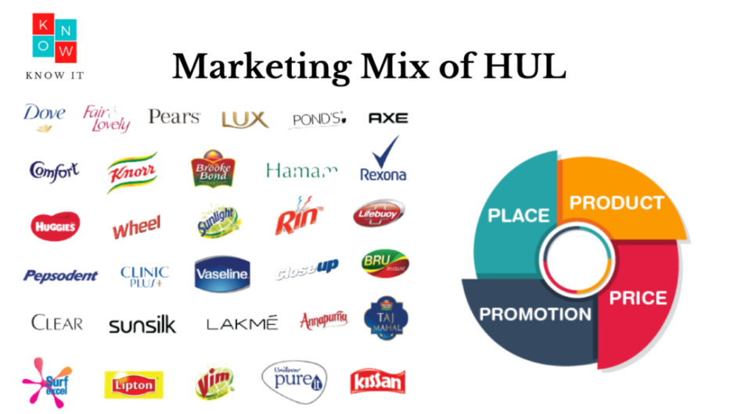
Figure 4: Main brands of HUL
Source: (It, 2022)

Marketing mix for Unilever UK
Product - HUl products are not the same as those from Unilever UK. Meals & drinks, personal care, and hygiene items make up the three main divisions. The company's portfolio consists of more than 400 brands in order to satisfy the wants of the customers in the three different product categories. By using a number of brands, the company may be able to fend off competition from a wide range of organisations, but if one brand suffers for any reason, many customers may find it difficult to distinguish it from other suppliers (Alon et al. 2020). In fact, a few of the goods are so well-known that a lot of people are familiar with them without knowing that Unilever is the owner. Most of these brands are distinct from those that are well-known in India. Some of these include PG Tips, Vaseline, Ben & Jerry's, Heinz Ketchup, Magnum, Dove, Comfort, Persil, Domestos, Lipton, Lynx, Hellmann's and Ben & Jerry's.
Place - The global FMCG (fast-moving consumer goods) business is quite cutthroat. Any business in this sector must thus take its rivals' actions into account. Numerous observers claim that Unilever typically adopts a rival's pricing strategy. This aids the business in aligning the cost of its goods with those charged by its rivals. Unlike HUL, Unilever UK offers products for various client segments, and its cost mirrors this. As a result, certain items have high prices to maintain their superior quality, while others have low prices. Unilever UK has chosen to price its products strategically below market average in order to appeal to clients with lower income areas of the UK, just like HUL.
Pricing - Unilever employs a variety of avenues for sales. For instance, its items are sold on e-commerce platforms as well as in groceries, cash & carry wholesalers, and supermarkets. All of these channels of distribution are essential for getting the company's items to its clients. Unilever goes so far it has used a lot of creativity in developing its distribution plan for the UK's rural consumers.
Promotion - Unilever employs a variety of marketing and advertising tactics. The promotion of HUL products is comparatively less expensive than that of Unilever UK. Over 7 billion euros are spent on promotional efforts by Unilever annually. It invested 168 million US dollars in 2017 alone on marketing the Dove brand. This demonstrates how Unilever makes significant and expensive promotional efforts. Additionally, Unilever employs sales promotion strategies like discounts and package deals. A few of its items are bundled together and offered at a reduced price. The social media footprint of Unilever is also enormous.

5.3 Extended Marketing Mix
Extended P’s of HUL
People - HUL uses employee performance evaluations to comprehend each person's skills, knowledge, and relative value to the company. The performances of the personnel in areas like sales, marketing and customer satisfaction that are relevant to the products are evaluated. Measuring employee and HUL performance is crucial because it allows us to monitor our progress toward the targeted objectives for various products (Salins et al. 2019). Furthermore, it aids in quality improvement. The enhancement of the employees' future performance is further considered while past employee performances are taken into consideration.
Processes - According to HUL, a goal-driven method and target are insufficient for winning in successive years. Hindustan Unilever strives to be future-ready by becoming completely digitised, more creative, and quick to react to the numerous changes affecting people's lives on a daily basis. And this is clearly evident in the work that HUL's brands are already undertaking. Through its #StopTheBeautyTest campaign, Dove has utilised real-life tales throughout its beauty and grooming products to question social standards. Additionally, Clinic Plus debuted a new initiative on Women's Day with the goal of empowering women to speak out against domestic abuse.
Physical evidence - HUL distributes its products with eye-catching colour labels that can be easily available for customers in the shops. So the company uses creative and catchy designs so that the products are seen differently by the people. As a consequence, such racks will be easier for customers to discover in busy shop spaces. Unilever also keeps updating its online platforms, like its website and social media platforms. HUL has started asking its customers for feedback on how to improve its product. Additionally, HUL has established its own retail stores where it provides a friendly environment for customers and encourages them to buy its products.

Extended P’s of Unilever UK
People - In terms of its workforce, Unilever's primary role is to make the routine tasks believed necessary to keep a business running smoothly. There are several duties associated with this role that the aforementioned personnel, particularly those involved in customer engagement, must carry out as effectively as they can in order to sustain a level of advancement that is essential to the business. Each employee of Unilever is directed in their actions toward upholding the established code of ethics and providing the necessary input, which contributes to higher levels of customer satisfaction, in order for development to be continuous and in line with the targets and the company's goals.
Processes - Shopping online is significantly different from exploring a shop and trying products on before making a purchase. Therefore Unilever also takes other quality aspects into account, which HUL also considers but not to such an extent because online sales of HUL are lesser in comparison. For Unilever UK, customer input is crucial, but it goes beyond how a product works, tastes, looks, or even feels on the body. All of these aspects are significant, but the organisation also looks into a lot of other topics related to eCommerce. Products arrive on schedule and are delivered without leaks, thanks to Unilever UK. The business meets customers' expectations by being upfront regarding pack sizes or ensuring that packing is undamaged when it arrives. Additionally, sustainability considerations are crucial.
Physical evidence - Logo and design are a part of physical evidence in marketing because people see the logo every time they buy a product from a particular company. The company's initial, an enormous blue "U," appears in the Unilever logo, which is a similarity to Hindustan Unilever Limited. Each symbol stands for a different link to the company. The new design, which replaces the previous one that has been in use since 1970, is made up of 25 symbols that have been meticulously interlaced with each other to form a U. Unilever employed a fluid creative approach in which they pondered about what and how Unilever does while simultaneously designing icons and the letter U. They worked with unique concepts and new designs.

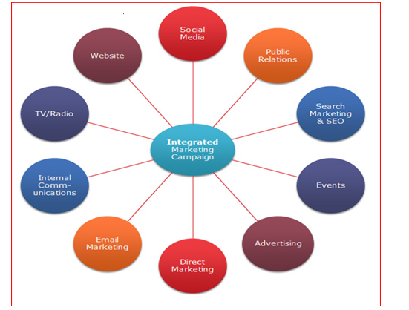
Figure 5: Marketing Campaign of Unilever UK
Source: (Locus, 2022)

When Unilever mixes its worldwide strategies with the local population, it uses one of the most effective business strategies to entice clients who are drawn to the products that are well-known on a global level while maintaining its local flavour. For instance, Hindustan Unilever Limited has maintained its position as one of the top companies that make personal and healthcare products. HUL's affinity for middle-class values and dated appearance contribute to its success in the Indian market. HUL's ideology has continued to evolve while being rooted in the goals and convictions of its clients. Unilever focuses on developing an edge over competitors in audience communication while promoting these brands without compromising their execution. For instance, the tagline "dirt is good '' for Surf Excel has been portrayed in several ways (Direction, 2020). The company aims to have a different approach to its sales of tea which could change the social attitudes of a tea connoisseur. Because of these creative marketing techniques, Unilever's products have maintained their consumer confidence despite being one of the oldest corporations. In 2020, Unilever UK celebrated the tenth anniversary of the Sustainable Living Plan. In addition to giving the world's 8 billion people access to sustainable living alternatives, the firm chose to fight social injustice and climate change. The company did not give up on these goals in the face of COVID-19. Unilever UK concentrated on potential industry-wide long-term developments.

6. Conclusion
From the above analysis, it can be concluded that all businesses need international marketing to promote them and increase their customer base. But international business can be tricky if not strategist properly. If the marketing strategies are not proper, then companies can face losses in other countries. Even though the company is the same, Unilever has different marketing strategies for the Indian market and the British Market. All these strategies are made by keeping the different factors in mind. Unilever has been in the market for 90 years, and it has succeeded in creating a good and strong customer base and market share in different countries. In India, Unilever focuses more on keeping the price low as India is an economically weak country in comparison to the United Kingdom. In India, the company sells a few low-quality products, too, so that people from all classes can afford them. However, in the UK, the main focus of the company is to give high-quality products to their customers. Price is not a factor in this country as it is an economically strong country. Speaking about segmentation, Hindustan Unilever has to consider a lot of factors in the process of marketing, like geographical and climate differences, gender, and the most important factor is the income level of the people. In spite of all these differences, the company manages to provide good quality products to the people because they strategies keeping the whole population in mind. This is why if a company wants to expand and grow itself, it should consider not only the domestic market but also the global market scenarios.

7. References
Alon, I., Jaffe, E., Prange, C. and Vianelli, D., 2020. Global Marketing: Strategy, Practice, and Cases. Routledge.
Alon, I., Jaffe, E., Prange, C. and Vianelli, D., 2020. Global Marketing: Strategy, Practice, and Cases. Routledge.
Arora, M. and Agarwal, A., 2018. Strategic Green Marketing and its Implication By Hindustan Unilever Limited. International Journal of Management and International Business Studies, 8(1), pp.23-38.
As, AJ, 2020. An Organization Study Report Of Hindustan Unilever Ltd.
Atkinson, A. and Aldrick, P. (2022) UK retail sales fall in November as inflation crisis deepens, Bloomberg.com. Bloomberg.
Bhuiyan, M. and Rahman, A., 2021. Marketing Strategy of Unilever Bangladesh Limited (Doctoral dissertation, Sonargaon University (SU)).
Direction, S., Sustainability certainty: Looking at organisations which have fully embraced sustainability, to impressive effect.
Fithry, A.N.I., Hariyanto, M.I.Z.P. and Utami, E.S., 2021. The Impact of Consumer Behaviour Megashift on Unilever's Product Strategy During COVID-19 Crisis. UNEJ e-Proceeding, pp.61-65.
Gayathri, S., Gandhimathi, S. and Gunasundari, S., 2021. A STUDY ON CONSUMER BUYING BEHAVIOUR TOWARDS HINDUSTAN UNILEVER LIMITED WITH REFERENCE TO COIMBATORE. EPRA International Journal of Research & Development (IJRD), 6(5), pp.1-1.
Hofstede Insights (2021) Compare countries, Hofstede Insights. Available at: https://www.hofstede-insights.com/fi/product/compare-countries/ (Accessed: January 11, 2023).
Iglesias, O., Mingione, M., Ind, N. and Markovic, S., 2023. How to build a conscientious corporate brand together with business partners: A case study of Unilever. Industrial Marketing Management, 109, pp.1-13.
It, TK (2022) Marketing strategy of hul, Know It. Available at: https://knowitall.in/marketing-strategy-of-hul/ (Accessed: January 11, 2023).
Jain, A. and Sharma, R., 2018. Flagship and Flanker Brands: Consumer Preference Study of Hindustan Unilever Limited and Procter & Gamble. IUP Journal of Brand Management, 15(3), pp.7-22.
Locus (2022) Unit 4 marketing principles assignment Unilever PLC: Locus help, Locus Assignments. Available at: https://www.locusassignments.com/solution/unit-4-marketing-principles-assignment-unilever-plc (Accessed: January 11, 2023).
Mitić, S., 2018. Cross-cultural characteristics of international marketing communications on website and social media. Marketing, 49(2), pp.69-82.
Morgan, N.A., Feng, H. and Whitler, K.A., 2018. Marketing capabilities in international marketing. Journal of International Marketing, 26(1), pp.61-95.
Mukul, R., 2020. A Study on Working Capital Case Study on Hindustan Unilever Limited.
Oviatt, B.M. and McDougall, P.P., 2018. Toward a theory of international new ventures. In International Entrepreneurship (pp. 31-57). Palgrave Macmillan, Cham.
Paranjape, S., 2018. Role of Digital Marketing for Developing Customer Loyalty. Sansmaran Research Journal, pp.1-7.
Raj, K. and Aithal, P.S., 2018. A ‘Desi’Multinational–A Case Study of Hindustan Unilever Limited. International Journal of Case Studies in Business, IT and Education (IJCSBE), 2(1), pp.1-12.
Raj, K. and Aithal, P.S., 2018. A ‘Desi’Multinational–A Case Study of Hindustan Unilever Limited. International Journal of Case Studies in Business, IT and Education (IJCSBE), 2(1), pp.1-12.
Reza, M.H., 2020. Marketing Strategy and Sustainable Plan of Unilever.
Reza, M.H. (2020) (PDF) market segmentation, targeting and positioning - researchgate. Available at: https://www.researchgate.net/publication/319085560_Market_Segmentation_Targeting_and_Positioning (Accessed: January 11, 2023).
Romppanen, J.M., 2021. Segmentation, Targeting & Positioning (STP).
Salins, M., Mendon, S. and Aithal, P.S., 2019. A Comprehensive Analysis of Top Indian Cosmetic Company: LAKME. International Journal of Case Studies in Business, IT, and Education (IJCSBE), 3(2), pp.79-90.
Shetty, T.S. and Shreenidhi, B.S., 2018. A Case Study on Corporate Social Responsibility Initiatives with Special Reference to Hindustan Unilever Limited. Anveshana, 8(2), pp.59-76.
Song, R., Moon, S., Chen, H.A. and Houston, M.B., 2018. When marketing strategy meets culture: The role of culture in product evaluations. Journal of the Academy of Marketing Science, 46(3), pp.384-402.
Szász, L., Bálint, C., Csíki, O., Nagy, B.Z., Rácz, B.G., Csala, D. and Harris, L.C., 2022. The impact of COVID-19 on the evolution of online retail: The pandemic as a window of opportunity. Journal of Retailing and Consumer Services, 69, p.103089.
The World Bank (2021) Data | Databank - World Bank.
Tien, N.H., 2019. Comparative analysis of multidomestic strategy of P&G and Unilever Corporation. International journal of foreign trade and international business, 1(1), pp.5-8.
Wachira, N.M. and Kariuki, P.K., 2018. Integrated marketing communication and performance of Unilever Kenya Limited (Doctoral dissertation, KENYATTA UNIVERSITY).
Widyastuti, S., Said, M., Siswono, S. and Firmansyah, D.A., 2019. Customer trust through green corporate image, green marketing strategy, and social responsibility: A case study.
World Bank, 2018. India Development Update, March 2018: India's Growth Story. World Bank.
Yadav, R. and Yadav, R., 2019. Profitability trends in Hindustan Unilever limited-a study. International Journal of Research in Social Sciences, 9(12), pp.316-323.
Zou, S., 2021, August. Analysis on the Recovery of MNEs from the Financial Crisis: A Case Study of Unilever. In 1st International Symposium on Innovative Management and Economics (ISIME 2021) (pp. 121-128). Atlantis Press.
Hofstede, G., 2009. Geert Hofstede cultural dimensions.
MacroTrends (2023) India population growth rate 1950-2023, MacroTrends. Available at: https://www.macrotrends.net/countries/IND/india/population-growth-rate (Accessed: January 11, 2023).
WordOmeter (2023) UK population (live), Worldometer. Available at: https://www.worldometers.info/world-population/uk-population/ (Accessed: January 11, 2023).

8. Appendices

Appendix 1: Graphs and Figures of PESTLE Analysis

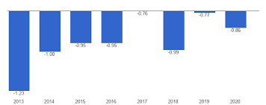

Figure 6: Political Stability Index of the India
Source: (The World Bank, 2021)

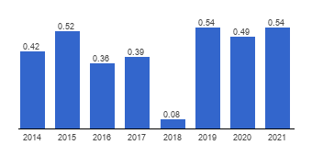
Figure 7: Political Stability Index of the United Kingdom
Source: (The World Bank, 2021)

