
MARKETING MANAGEMENT – ASSESSMENT 1
Case Study of Vauxhall Motors


Student Name: Wafa Wajeeh Nasser
Student Number: 1703942
Module Title: MBA General Management
Module Code: LCMB7001
Assignment Title: Marketing Management (A1)
Name of Supervisor: Tushara Balendran
UWTSD
Table of Contents
1. Introduction 3
2. Communication 6
2.1. The Shannon and Weaver’s Macro Model 6
2.2. IMC 7
3. Recommendations of New Promotional Strategies for Vauxhall Motors 8
3.1. Online promotions 9
3.2. Off-line promotions 9
3.3. Keller’s Branding Equity Model 10
3.4. Advantages and Disadvantages of Keller’s Brand Model 12
4. The Customer Journey 13
4.3. The Customer Touch Points and Customer Journey Map 14
5. Total Engaging Model 15
6. Conclusion 15
7. Recommendations 16
8. References 18

Introduction
Vauxhall Motors is one of the U.K.'s vehicle maker. It is claimed by G.M. (General Motors) and is similarly the organization of the exceptionally effective Opel. During the 1st World War Vauxhall had indirect 2,000 staff vehicles for the British Army, and as did the Crossley Car Company – the significant benefit of having been in persistent vehicle creation since 1914, reconversion appeared to introduce not many issues which encouraged extensive hopefulness for future possibilities (Cole, 2020). In this report, the marketing management of Vauxhall Motors is explained and analyzed in a thorough manner that facilitates to understand its current position in terms of marketing and the factors which can be further improved for the purpose of increasing the overall brand image of the company.
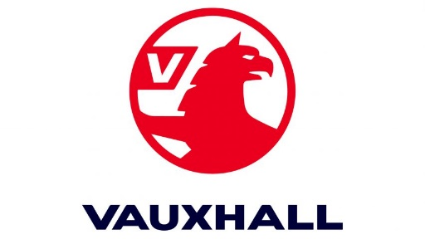
Figure 1: Logo of Vauxhall Motors
Source: https://www.vauxhall.co.uk/
A long way from such expectations being acknowledged in any case, the organization started to sink profoundly into financial issues emerged in 1921, and by the center 1920s the company's proceeded with presence of under danger (Coomber, 2017). There are various purposes behind this, including poor administrative approaches which were showed in over development toward the end of the War, the resumption of serious dashing during a period of such financial distress, and the creation of some unacceptable kind of models, Vauxhall was in good company to experience the ill effects of such deformities, some of which had been essential for an example of overcoming adversity in the pre-war years (Dowlah, 2018).


Figure 2: Marketing of Vauxhall Motors through official website
Source: https://www.vauxhall.co.uk/
The essential reasons lay in the impacts of the post-war issues, and the major change in the engine vehicle market during the 1920's, drove by the huge makers like Ford, Morris, and Austin. Of these the adjustment in the vehicle market was by a wide margin the most significant, and this advancement was not to be completely perceived until well into the decade. Such advancements were hence not obvious to vehicle makers in the seasonally difficult market that won in the quick post-war years. On edge to capitalize on the blast of a vehicle starved market, numerous new firms entered the business and those in presence arranged broad development programs somewhere in the range of 1918 and 1921 (Dowlah, 2018). Vauxhall's capital was expanded by £200,000 in 1920 to £600,000, an extra I.5 sections of land of floor space was added. This dramatically increased the size of the Vauxhall works of 1914. Kimpton Road, which overhauled the works, was metal and 320 laborers' homes were based on a site close by.
Finance was given, by bank Overdrafts to the estimation of £246,000 in 1919 and by the issue of £300,000 on momentary notes, repayable in 1925, Perhaps the most impulsive of Vauxhall's moves was to put £90,000 in S.F.Edge's A.C.Cars Ltd., which was to go in to liquidation alongside various different firms during the 1920's. The outcome of the blast conditions included high vehicle costs which were brought about by the fast expansion in lab our and material expenses (Tiverios, 2020). Vauxhall stayed beneficial all through the 1990s, however the measure of benefits varied significantly. Strengthening is the way toward empowering or approving people or representatives to think, act and control work and settle on choices self-governing (Fæste et al., 2021). Currently, Vauxhall Motors has highlighted a wide range of promotional strategies, advancement, and improvement of new items for its customers (Jacobs, 2019). In addition, the organization has focused on vehicle security and building one group to accomplish authority on the lookout. Also, for keeping up its upper hands, the organization has fulfillment of its clients, representatives and its sellers, financial backers, and providers, among others. The vision and mission of Vauxhall Motors are to grow its business activity around the world by considering its guiding principle of trustworthiness, respectability just as polished methodology. In such manner, it is distinguished that the organization sends out a bigger extent of vehicles 80% out by and large creation in the worldwide market (Paul, 2018).
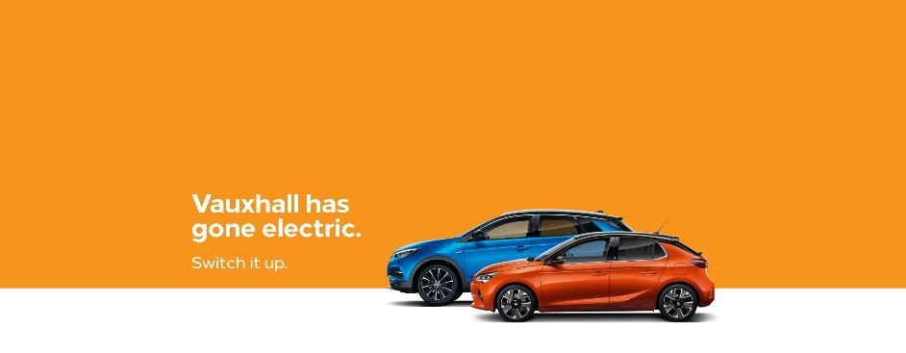
Figure 3: Promotional Strategy of Vauxhall Motors
Source: https://www.vauxhall.co.uk/
Lately, Vauxhall Motors has been attempting to build up another amazing bike in the commercial center, with the point of catching the bikes broadly and universally (Jones and Richardson, 2017). The organization has distinguished that the bike market is one of the developing business sectors across the globe throughout the most recent decade (Kaziba, 2020). For this purpose, the promotional strategies that are considered to be undertaken by the company includes both online and offline or physical strategies by means of which the marketing objectives can be achieved in an effective manner.

2. Communication
Communication is considered to be a vital aspect in the area of marketing. It can be defined as the exchange and imparting of the information by means of writing, speaking, and using any other medium to fulfil the purpose. The effective business communication tends to enable the marketers to define the benefits of the product and respond in an efficient manner to the objections or queries that may be faced by the customers (Jones and Richardson, 2017). By means of communication, marketing departments tend to persuade a wide range of public to purchase the products that are offered by the company. In case of Vauxhall motors, the communication strategies are widely utilized by the company as it tends to communicate with its customers both online and in the physical showrooms and they also introduce their products by giving thorough details.

2.1. The Shannon and Weaver's Macro Model
The influential and well-known model of communication which is utilized in marketing is developed by Claude Shannon and Warren Weaver. The Shannon-Weaver's model of communication is shown in the figure 4 below. It is considered to be a transmission model in which there are five elements which includes an information source that tends to produce a message, a transmitter that encodes any message into the signals, then there is a channel to which the signals are adapted for the purpose of transmission, a receiver is another element that reconstructs the messages obtained from the signal and finally there is a destination where the message arrives. This model is mainly utilized for the purpose of explaining the communication aspect in the marketing with the target audience (Taylor, 2017). In case of Vauxhall Motors, it is considered to be widely important that the communication strategies are utilized to convey a proper message to the clients so that the clients can be acknowledged regarding the services and products that the company has to offer. If the unique selling point of the company and its main ideas are delivered to the clients in a proper manner, then the customer range and value of the brand can be increased in an effective manner. However, there is also a sixth element i.e., noise, it is known to be a dysfunctional factor and can be stated as a rumor or an obstacle due to which the proper information is refrained to be delivered to the customers or target audience respectively (Taylor, 2017). In context of Vauxhall Motors, the company requires to strategically analyze all of its channels i.e., both online and offline channels that are utilized for the purpose of marketing so that it can enhance its efficiency and achieve the marketing objectives in a successful manner (Jacobs, 2019).


Figure 4: The Shannon and Weaver's Model of Communication
Source: (Taylor, 2017)

2.2. IMC
The integrated marketing communications or IMC is considered to be such an approach that is utilized by the companies in order to create a seamless and unified brand experience with its customer range across the various channels (Sezerliev, 2019). The integrated marketing communications and its related elements and aspects are presented in the figure 5 below. In case of Vauxhall Motors, for example, it has been observed that the organization utilizes a wide range of channels in a successful manner but in order to gain competitive advantage there is a lot that is required to be done. It is important for Vauxhall motors to be more focused on the digital media and utilize it effectively as it can help in boosting the sales. By writing interactive blogs regarding the different brands, the company can also create a strong image of the brand.
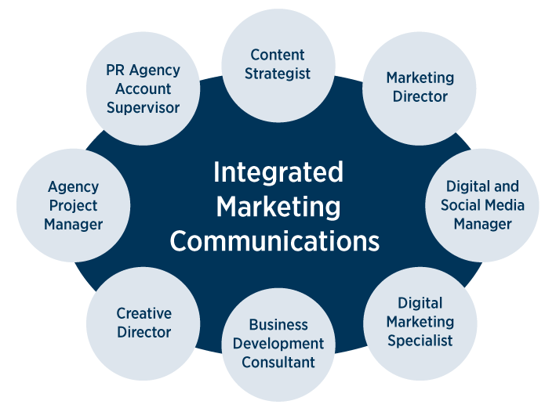
Figure 5: Integrated Marketing Communications
Source: (Sezerliev, 2019)
The marketing efforts are utilized to be shifted from the mass advertisement to the niche marketing, the organizations have increasingly utilized IMC for the purpose of developing effective cost-effective campaigns which can deliver the customer value (Sezerliev, 2019). On the other hand, the communication tools which are utilized in IMC mainly include the digital and traditional media such as the webinars, blogs, SEO, television, radio, magazines, and billboards.

Recommendations of New Promotional Strategies for Vauxhall Motors
Although Vauxhall Motors has been utilizing IMC and other promotional strategies for the purpose of maintaining its marketing position but there are also new promotional strategies which are required to be utilized by Vauxhall Motors so that it can create a vast impact on the customer range and reach a higher level of audience. There are both online and offline promotional strategies that can be utilized by the company.

3.1. Online promotions
Social media marketing is one the most powerful method to carry out business of various sizes to reach the customers and prospects. It is one of the most convenient marketing methods. The customers are already in the manner of interacting with the wide range of brands through the commonly used social media platforms such as Twitter, Facebook, Instagram, and Pinterest. For example, Vauxhall Motors has been utilizing Twitter for its online promotions but it's not utilizing all the platforms effectively. The organization is required to carry out the social media marketing and incorporate it in its marketing plan to bring remarkable success in the business and create brand advocates that are devoted and also bring sales and driving leads.
On the other hand, another online promotional strategy that can be utilized by Vauxhall Motors is content marketing. It is known to be a strategic marketing approach that tends to focus upon creation and distribution of the relevant, valuable, and consistent content for the purpose of attracting and retaining a defined audience. For example, the Vauxhall Motors can utilize it to enhance the knowledge of the customers and can also change the way in which the customers perceive the brand image.

3.2. Off-line promotions
Offline promotions are also a manner of marketing that can help to gain much audience. For Vauxhall motors, the Trade show marketing can prove to be effective as it tends to refer to such exhibition where the organizations showcase the wide range of products that they offer and provide the customers with the opportunity to test their services and products. On the other hand, the speaking engagements is also an offline promotional strategy with advantageous results. For Vauxhall Motors, this phenomenon can increase the visibility of the company and can also increase the level of its sales. It gives the chance to the company to plan out its engagement with the target audience and use this chance to build trust and establish credibility of the company.

3.3. Keller's Branding Equity Model
Branding can be defined as a marketing practice that helps create a symbol, design, or name that identifies and differentiates one product from another (Keller and Brexendorf, 2019). On the other hand, Brand Equity tends to refer to the level of swaying a brand name that is embedded in the minds of customers and the brand value that an organization perceives that is well thought of and identifiable (Keller and Brexendorf, 2019). In figure 6 below, the brand equity and its related elements are shown, including brand attribution, brand awareness, brand loyalty, and the perceived quality.
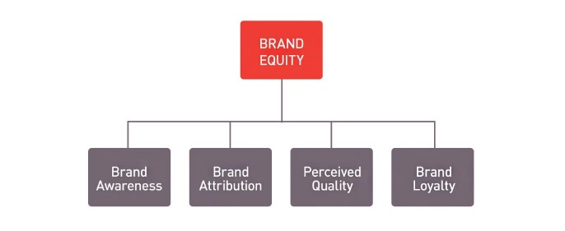
Figure 6: Brand Equity
Source: (Keller and Brexendorf, 2019)
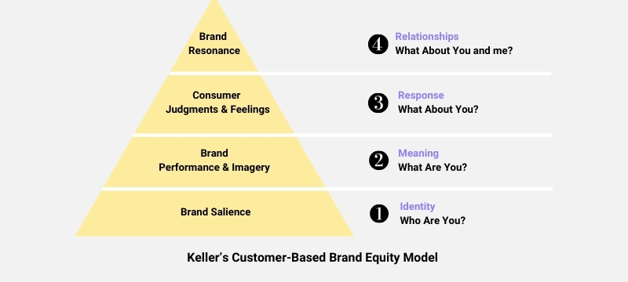
Figure 7: Keller's Customer-Based Brand Equity Model
Source: (Keller and Brexendorf, 2019)
Keller's brand equity model is a customer-based model that is utilized to recognize its overall value and brand image and analyze where it stands in the perspective of the customers.
Brand salience - (Identity) who are you?
Vauxhall Motors is one of the most recognized and highly valued companies in the U.K. The current positioning strategy of the company is to offer high-quality cars that are cost-effective and tends to promote them by means of using different channels to reach the target audience (Keller and Brexendorf, 2019). The brand image that the company has developed by using its positioning strategy is quite strong as it offers quality and luxury products as well that have a high level of technology incorporated, such as electric cars, which has helped the company to gain a competitive advantage.
Performance and Imagery (meaning) what are you?
The brand meaning includes more than the price and quality of the brand as it also involves customer loyalty and the overall value of the brand (Keller and Brexendorf, 2019). The performance and imagery level of the pyramid shows what the organization has to offer and how it is different from the others. Differentiation is the main aspect of marketing as this is something that makes the brand stand out from others. In the case of Vauxhall motors, the company tends to utilize the unique selling point strategy by means of which it introduces technology-based cars that have modified engines and promises to introduce many differentiated products in the future that keeps the customers interested and invested in the brand because it meets the demands of the customers by giving them the technology they desire. In terms of imagery, it is the customer perception regarding the brand image.
For example, the customers have high expectations and a positive perception of Vauxhall motors due to its significant innovations. Following is presented a perceptual map for the Vauxhall motors. The perceptual mapping mainly utilizes the input of the customers to understand the brand accordingly, along with the product and service from the perspective of the customer.

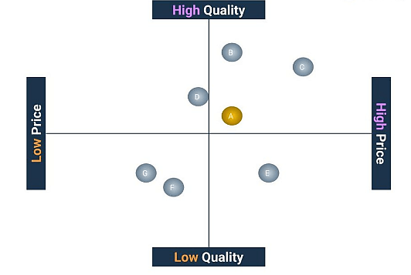
Figure 8: Perceptual Map for Vauxhall Motors
Response (what about you?)
The customers of Vauxhall expect technology and innovation, and the company tends to comply with their wishes. This constant motivation keeps the company invested in innovation (Keller and Brexendorf, 2019). The judgment of the customers helps in increasing the performance of the brand along with its quality. Also, the feelings and emotional content of customers also help the company to evaluate its performance.
Resonance, building relationships: Vauxhall Motors has been trying to build a community where it can serve to acknowledge the needs of the customers as well as the environment by introducing eco-friendly products. Whereas the more company and customers get connected, it increases the more loyalty (Keller and Brexendorf, 2019).

Advantages and Disadvantages of Keller's Brand Model
The benefits of using Keller's brand model are that it helps in analyzing the position upon which the company stands in terms of its marketing and creating a brand image. It helps in evaluating the aspects that are required to be improved upon to enhance the marketing of the company. On the other hand, the disadvantages of using the model include that it does not reflect upon enhancing the customer behavior or dealing with customer experience.

4. The Customer Journey
The customer journey includes the stages that are described in figure 9 below. It includes Awareness, Consideration, Decision, Retention, and Advocacy.
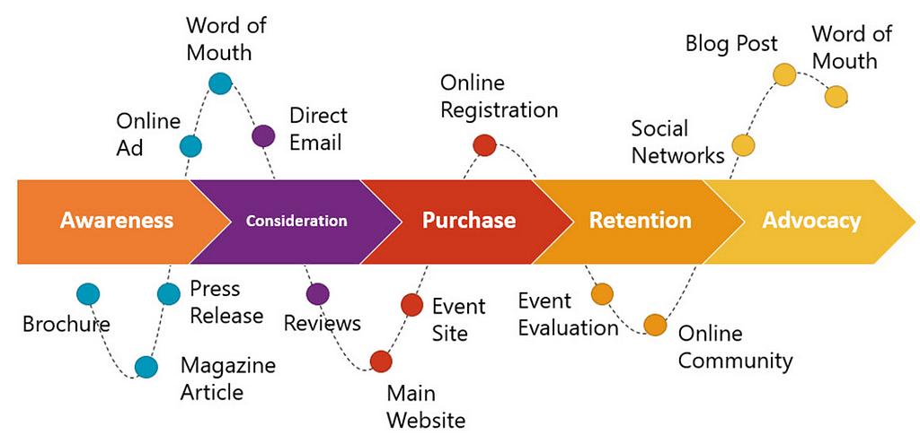
Figure 9: The Customer Journey
Source: (Grewal and Roggeveen, 2020)
Awareness: Vauxhall Motors creates enough awareness by being prominent on different channels, so the target audience is reached, and the customers acknowledge their existence.
Evaluation and consideration: after awareness of the brand, the customer would verify if there were required or desired products in the company (Herhausen et al., 2019). As Vauxhall has a deep understanding of the customers, it tends to create whatever the customer needs to satisfy the needs and retains its potential customers.
Decision: the decision is undertaken after surveying the product, and Vauxhall Motors gives opportunities to test the vehicle of choice before buying to fulfill the customer's needs.
Retention: Vauxhall Motors creates loyalty and emotional connection by staying intact with the customers throughout the buying journey and then promises to make the best deal.
Advocacy: by effectively making the customer satisfied with the services, Vauxhall Motors, in that case, carries out feedbacks and requests further information and perception regarding the brand so that it can improve its performance and word can spread out.

4.3. The Customer Touch Points and Customer Journey Map
The customer touchpoints used by Vauxhall motors, both digital and physical, are presented in the figure 10.
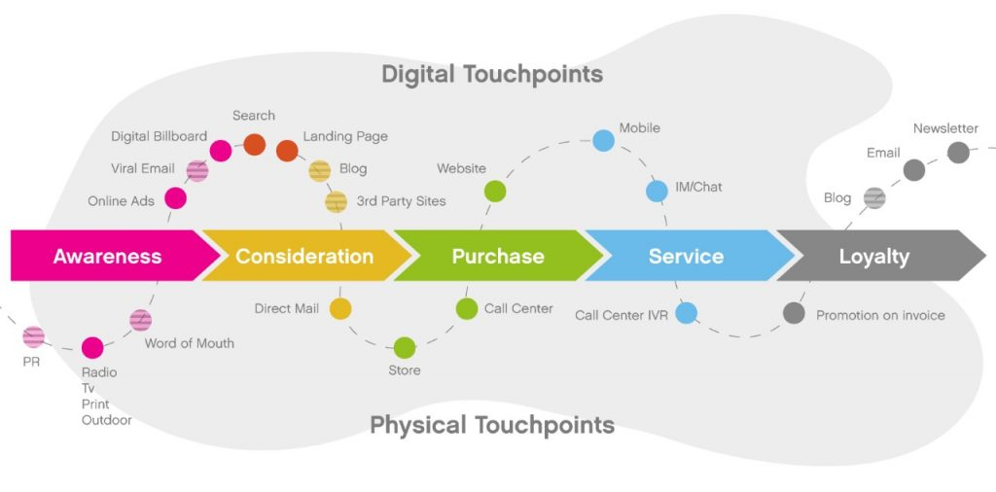

Figure 10: Digital and Physical Touch points of the Customers.
The company uses online and offline strategies to target the audience. It includes the advertisements, word of mouth and mainly the social media marketing. The touch points that are used at pre-purchase mainly include traditional media elements such as mail, website, deals, offers, coupons or direct promotion (Grewal and Roggeveen, 2020). The pre-purchase stage is the one where the customer comes in contact with the brand. The purchase stage also utilizes touch points that are used by the customers including store placement, sales agent, and even packaging which tends to represent the product in a presentable manner. These aspects tend to capture the attention of the customer. In case of the post-purchase touch points in customer experience are used after the sale of product or service and enhances the customer experience and brand loyalty (Grewal and Roggeveen, 2020). The post-purchase touch points mainly include the customer satisfaction surveys, loyalty programs for customers, and other aspects that tend to enhance the brand trust and loyalty.
The customer journey mapping of Vauxhall shows the visual story of the customers and their interaction with the brand. In this exercise, mainly the businesses are helped by means of being in the shoes of customers and understanding their point of view. The business is viewed from the perspective of the customer which then increases the productivity and efficiency of the business respectively. In the customer journey of the Vauxhall motors it is represented that how the company has achieved the awareness, research, evaluation, purchase, payment and services aspects for the customer. The company has achieved successfully the marketing process that helped in attracting the customer in the first place.

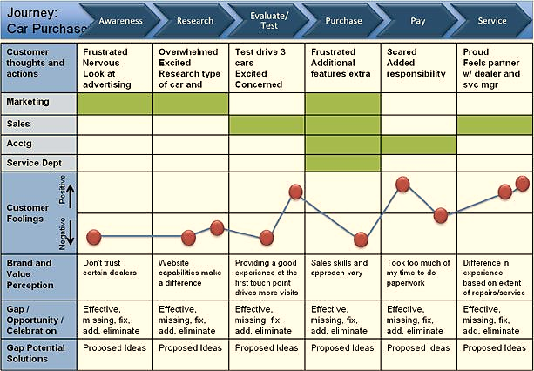
Figure 11: Customer Journey Map (Vauxhall Motors)
The weaknesses of the Vauxhall's customer journey map include that the customers that attract the brand doesn't tend to trust the certain dealers that affect the point of sale and website capabilities also tend to make a difference as the Vauxhall website has lesser content than the other automobile companies. The strengths of the Vauxhall's customer journey map is that it represents that each of the stage has been accomplished in an effective manner whereas the test driver factor is one of the most important one as it is essential for the customer to go through this stage to attain satisfaction and further develop connection with the brand.

5. Total Engaging Model
The total engagement model is mainly recognized for its chief role in gaining the customer satisfaction in a balanced manner. It puts everything together which helps in making an effective system. By using this model, the Vauxhall Motors can gain excess to customer satisfaction and can lead the market. All of the activities are focused in this model which includes services, product, advertisement and internal culture.

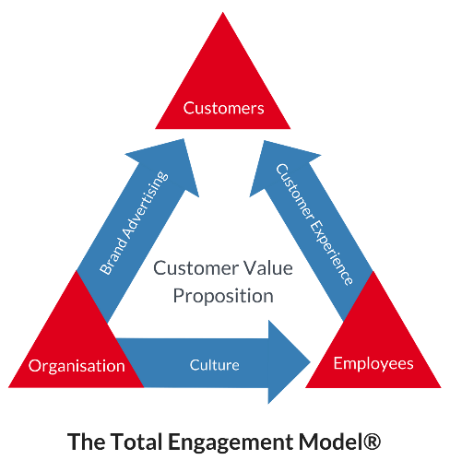
Figure 11: Total Engagement Model
Source: (Sun and Bin, 2018)
The main advantage of the total engagement model is that it facilitates how to design and also operationalize a plan of growth by increment of customer engagement (Sun and Bin, 2018).

6. Conclusion
In conclusion, Vauxhall engines are the one of the U.K. s most seasoned and driving organizations. Canada based engine organization Magna which has took over Vauxhall has communicated the work cut of five thousand to twelve thousand numbers in October 2009 (BBC news). The news may influence the working productivity of the representatives causing struggle between the administration and laborers. The organization needs to guarantee the employer stability and for that real prerequisite of labor ought to be designated. The initiative characteristics of the supervisors ought to be upgraded through appropriate preparing by specialists. The correspondence, character improvement, cooperation are the significant components for achievement of any organization which can be conveyed to representatives through workshops, preparing and bunch conversations. The representatives ought to be made mindful in regard to the organization approaches and objectives to ensure that they work to meet the assumptions for the organization. It is fundamental the administration ought to guarantee that the workers would know about innovation through legitimate preparing. The creative assembling and innovative limit and not failing to remember the public picture of Opel/Vauxhall will in general harm because of Cost-Cutting, Plant Closures, infringement of dealing and bi-parallel arrangements and so forth The Opel/Vauxhall is dealing with issues in haggling with the worker's guild chiefs in Europe for shutting down their unit in Antwerp.

7. Recommendations
In this section, the recommendations are provided to state that what areas and aspects can be improved in the Vauxhall Motors Marketing management. There are a few promoting techniques like item/administration advancement, advertising venture, client experience and so forth which have assisted the brand with developing. Advertising system assists organizations with accomplishing business objectives and targets, and Marketing is the broadly utilized element to characterize the procedures.
Promotion and Advertising Strategy: Vauxhall can utilize 360-degree advertising to advance its image of brand. Vauxhall should take part in car exhibitions to show its items and offers official statement of its new dispatches to make popularity among the objective section. Vauxhall has supported different football clubs and football group. It has likewise been a backer of public football crews in U.K. (Fæste et al., 2021). Soccer being perhaps the most mainstream sports in U.K., supporting clubs has given the brand essential openness to the focused-on crowd. Vauxhall must attempt to wander in sports portion consistently and all the while, has supported hustling groups to build its image impression.
Pricing Strategy: Vauxhall must follow the techniques of significant strategies in case of pricing and in its advertising mix by cutting down the costs of its vehicles to win faithful clients. They have re-designed activities to give low costs as well as to offer wanted benefit of less expenses. Vauxhall's vehicle costs rely upon the objective buyer, similar to its product offering of Adam vehicles comes in three variation Adam fundamental, Adam rocks and Adam S with Adam essential model filling in as base cost and an extra increase is there on Adam rocks and Adam S (LeClair, 2018). The organization permits clients to alter their vehicles like browsing diverse accessible tones and frill and consequently conveys discretionary component evaluating for its vehicles. It is important that Vauxhall must improve its client relations by means of increasing its engagement.

8. References
- Turner, P.G., 2019. What Delimits Equitable Relief from Forfeiture?
- Tiverios, N.A., 2020. The forfeiture of contractual rights. The Cambridge Law Journal, 79(1), pp.17-20. (Turner, 2019) (Tiverios, 2020)
- Coomber, I., 2017. Vauxhall: Britain's Oldest Car Maker. Fonthill Media.
- Odom, K., 2017. General Motors Strategic Audit.
- Paul, J., 2018. Toward a'masstige'theory and strategy for marketing. European Journal of International Management, 12(5-6), pp.722-745.
- Jacobs, A.J., 2019. General Motors in Belgium. In The Automotive Industry and European Integration (pp. 89-119). Palgrave Macmillan, Cham.
- Candelo, E., 2019. Marketing Innovations in the Automotive Industry: Meeting the Challenges of the Digital Age. Springer.
- Kaziba, K., 2020. Achieving Effective Integrated Marketing Communications through a Dealer Network System. A comparative case study of the United Kingdom and Uganda's New Car Market (Doctoral dissertation, Cardiff Metropolitan University).
- Jones, D.B. and Richardson, A.J., 2017. Origins of sports car marketing: early 20th Century British cycle-cars. Journal of Historical Research in Marketing.
- Anbinder, J., 2018. Selling the World: Public Relations and the Global Expansion of General Motors, 1922–1940. Business History Review, 92(3), pp.483-507.
- LeClair, D.R., 2018. General Motors: Globalization, Disruption, and Sustainability. In Business despite Borders (pp. 165-177). Palgrave Macmillan, Cham.
- Fetzer, T., 2017. Reversing gear: trade union responses to economic crises at Opel (1974–1985). Business History, 59(1), pp.141-157.
- Fæste, L., Löfgrén, I., Reeves, M. and Kengelbach, J., 2021. How Bold CEOs Succeed at M&A Turnarounds. In Mastering the Science of Organizational Change (pp. 139-144). De Gruyter.
- Dowlah, C., 2018. Global Value Chains in Automobiles. In Transformations of Global Prosperity (pp. 199-229). Palgrave Macmillan, Cham.
- Cole, A., 2020. Fundamental valuation of the General Motors Company: assessing the value in the midst of a pandemic (Master's thesis).

- Sezerliev, S., 2019. Contemporary PR: Communication Perspectives and Challenges in the Context of IMC, Branding and New Consumers.
- Taylor, C.R., 2017. How to avoid marketing disasters: back to the basic communications model, but with some updates illustrating the importance of e-word-of-mouth research.
- Keller, K.L. and Brexendorf, T.O., 2019. Measuring brand equity. Handbuch Markenführung, pp.1409-1439.
- Grewal, D. and Roggeveen, A.L., 2020. Understanding retail experiences and customer journey management. Journal of Retailing, 96(1), pp.3-8.
- Herhausen, D., Kleinlercher, K., Verhoef, P.C., Emrich, O. and Rudolph, T., 2019. Loyalty formation for different customer journey segments. Journal of Retailing, 95(3), pp.9-29.
- Sun, G. and Bin, S., 2018. Construction of learning behavioral engagement model for MOOCs platform based on data analysis. Educational Sciences: Theory & Practice, 18(5).

