Introducing the modern workplace | LCBB4003
Title: The Role of Structure & Culture in the Performance of Morrison’s

1805644
Laura Basa

Introduction
Organisational performance is supported by factors like the structure, culture, people and values of the people. The report includes the leadership strategies of management that plays an important role in controlling the above-mentioned factors. Moreover, the key function of the leaders has been discussed to communicate and motivate people in the organization by setting goals and objectives. Moreover, the cultural dimensions of Hofstede have been discussed here by comparing the two branches of the selected company giving numerical differences. (Brooks, 2015). Lastly, the behavioural approach to management and their behaviour, attitude, perception performance and values have been illustrated in detail.

Background

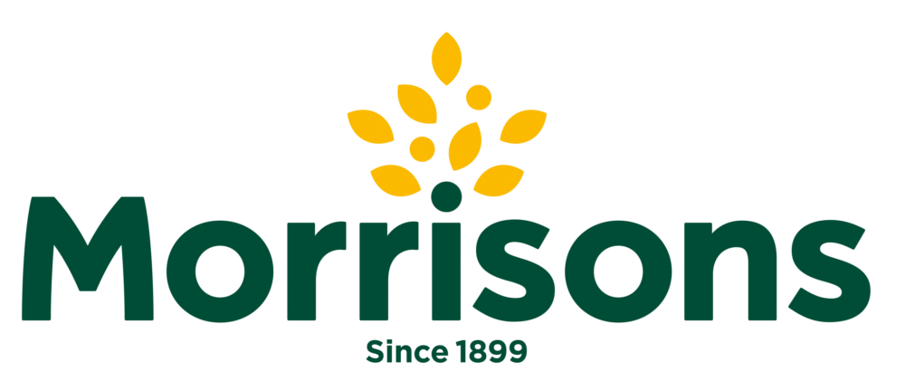
For presenting the work as a more practical and relevant one, Morrison’s has been selected. Morrison’s is a grocery and general merchandise company headquartered in England. It was established in 1899 in the UK by William Morrison. It is being operated through its 498 shops and 110,000 employees. Their sales in the year of 2018 stood at £17,262 million. They also have an online delivery system in most of the countries under operation. The company is listed in major share markets including the London Stock Exchange (Groceries.morrisons.com, 2019).

Morrison’s Structure:
Morrison’s is an UK-based grocery and general merchandise company operated in England. The company follows a hierarchical organisational structure making the organisation more bureaucratic and less democratic in nature (Evans, 1997). Based on research conducted by Fatehi in 1996, this structure can also be categorised as a functional structure. Their structure is also a responsive one. It has a multi-faceted structure which can respond to the adverse environment. The structure ensures that the positions, duties and responsibilities within the organisation are distributed at different levels ensuring that the work will be done more smoothly and efficiently (Fatehi, 1996). Officials having a higher-level position in the organisational pyramid have high authority and responsibilities. The organisational structure of Morrison’s is that it consists of five executive committees each of them reports to the Morrison’s board. Each committee of 11 members is led by the Group Chief Executive. The structure is highly hierarchal making it less flexible but task-oriented. Everyone in the organization knows their assigned roles and each of them is clearly aware of spam of control.
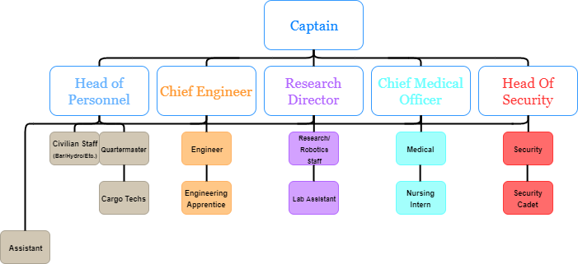
CEO

Figure: Corporate governance structure and span of control of Morrison’s Source: (Evans, 1997)
The board of directors is comprised of ten members. A major restructuring in the structure of Morrison’s in the year of 2014-15 brought a lot of changes. This chain of command includes the shift in the roles and position includes the Chairmanship of the board was assigned to John Allan with Dave Lewis as the group chief executive; Allan Stewart as the Chief Financial Officer and Deanna Oppenheimer as the Senior Independent Director. The above-mentioned structure was/is followed in the headquarter of the company from where all the stores around the UK are controlled and executed. They have another structural form for running their store level operation. Often their structure is criticised as they follow a four-layer structure in the stores (Groceries.morrisons.com, 2019). High in layers, the structure often creates unnecessary bureaucratic complexity with a negative effect on coordination and collaboration among the managers and their subordinates. They should reduce their layer to create a more flexible and creative work culture.
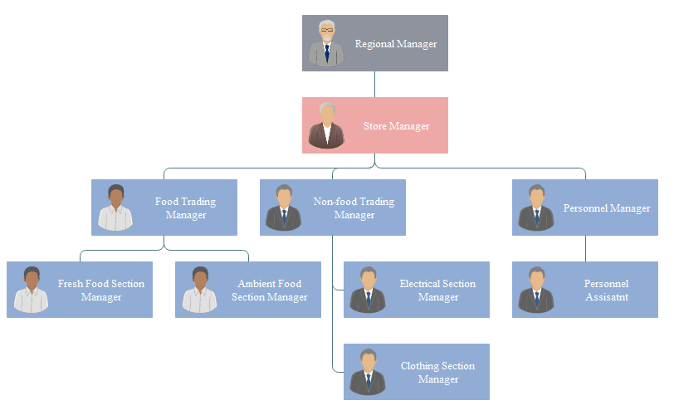
Figure: Chain of command in stores of Morrison’s Source: (Evans, 1997)
The organisational structure forms the basis for the organisational culture in Morrison’s. This high in layer structure assigns everyone with specific roles that are linked with others which makes the functioning more formal, determines specific jobs and positions of the employees and limits the power and responsibilities of the employees. In 2011, one of their stores in the borough of Tower Hamlet was accused of selling Pork as it is strictly prohibited in Islam. They immediately stopped selling pork in any Muslim majority boroughs in the UK (Groceries.morrisons.com, 2019). Their learning ability from mistakes is commendable. Such a transnational structure helped them share their learnings across the UK. Their national responsive operation contributes to building an integrated operation.

Morrison’s product and geographical position:
Morrison provides different types of delicious fresh food and groceries. These are some foods that can be ordered through online and all of these foods are appealing.

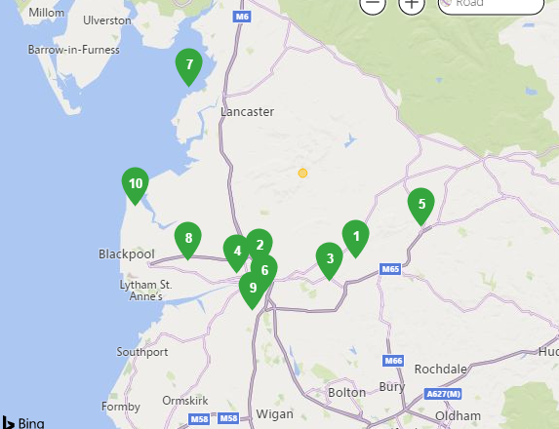
However, there are different stores of Morrison’s in United Kingdom and as a result, the foods and groceries are delivered very rapidly with less time and cost. The business has expanded worldwide and with its different stores in different location, it is providing customer oriented service.

Morrison’s Cultural dimensions:
Culture, in an organisational context, is the combination of the code of conducts, the attitude among the employees, norms and values held by the employees and the way the individuals within the organisation thinks (Brown, 2017). Hofstede's cultural dimension can be used to analyse the cultural factors of the different region where Morrison’s has operations and how they affect and shape the values and behaviour of the employees. The theory analysed the factors on some dimensions which include individualism-collectivism; uncertainty avoidance; power distance and masculinity-femininity (Hofstede, 1991). Morrison’s used the theory in managing cross-cultural psychology, management of national business and communication (Gopal, 2016). Among these dimensions, the power distance dimension was most relevant to the structure of the company. Structure laid the basis of organisational culture for Morrison’s. On a scale of low to high power distance Morrison’s uses a high power distance. The cultural dimension of the Hofstede’s model for the UK and USA branch of Morrison is compared below: (1=low or 0=high)
Hofstede’s cultural dimensions | UK | USA
Power Distance | 1 | 0
Collectivism vs Individualism | 1 | 1
Masculinity Versus Femininity. | 1 | 1
Uncertainty Avoidance Index | 1 | 0
Long- Versus Short-Term Orientation | 1 | 1
Indulgence Versus Restraint. | 0 | 1
Total | 5 | 4
So, UK branch has higher score compared to USA branch of Morrison (Groceries.morrisons.com, 2019)
It has been possible as their structure was hierarchical where the position of employees in the hierarchy naturally determines the high power gap in USA. Personnel Manager exercises power and authority over the Personnel Assistant. The employees who are at the higher organisational hierarchy enjoys some sort of autocratic leadership over their subordinates in UK. But such type of autocratic leadership style and culture has limited the flexibility limiting the scope of creativity. Employees in the Morrison’s USA branch enjoy less freedom in terms of decision making. They are not allowed to act going out of the order of the top management. Even if the idea generated by lower-level management was better. All the employees are assigned specific roles and tasks. They are expected to follow them without justification for and against it. The stiffness of the schedule of tasks leads to poor communication across the layers of management resulting in lack of team spirit (Brown, 2017). But Morrison’s UK branch is a company which just sells the products there is the little scope of the employees to show creativity. What can be a creative way to perform a task is determined by the top management based on some cross-cultural and cross border research (Hofstede, 1991). The management then communicates those instructions to their subordinates sometimes with the arrangement of some training programs (Gopal, 2016). But in the end, all of the activities and actions adopted by top management have made the organisation successful. The culture of the organisation where every employee is treated equally irrespective of their caste, colour, religion, gender or origin is one of the core determinants of the success of the company. Though the organization has a hierarchical structure any thoughts from the employees are welcomed and are considered in the research programs conducted by top management. They take the opinions from the employees from the lower hierarchy who have direct communication with the customers (Gopal, 2016). This culture of taking opinion from lower management as an input for the research conducted by higher management has helped the organisation come up with sustainable solutions to problems as compared to the organisation who randomly follows the opinion of the lower-level management.

Values created in Morrison’s territory:
An organisation is an entity with a group of people who has a particular shared purpose. The managers of Morrison’s believe that organisation becomes successful when the structure of it can shape a strong culture with people who are motivated enough to achieve the goals and objectives. The management of the overall things has nature in terms of functioning and the processes that are followed. The nature of management functions and processes include being social, continuous, universal, iterative and composite. Being social means that the functions should be well accepted by the people as they will make everything happen. Without their cooperation, nothing will happen. The processes and functions are continuous as long as the organisation exists. Discontinuity means functional disruption and process collapse and ultimately failure of the organization. The nature of management is universal. The basic things in managing an organisation remain the same irrespective of the size, region and purpose of the organisation. The nature of management functions and processes is that they are contained within one another and all of them can be the sub-functions of the rest of the function. Finally, All the functions and processes are composite and integrated (Rama Sastri, 2017). There is no strict sequence. Leadership skills of management are one of the key factors for success (Mobley, Wang and Li, 2017). It helps the employees keep motivated and work hard for the achievement of the organisational goals and objectives. Morrison’s has achieved great success with their leadership roles.

Roles and skills of leaders:
Their leaders played different roles in the success of the company which include inspiring trust, creating a vision, executing strategy and coaching potential. The leaders in Morrison’s helped to inspire trust among the employees. The trust toward the management increased the motivation for working in alignment with the organizational goals. In creating the clarification of the desired state the team is heading towards the leaders of Morrison’s were successful. Leadership skills were helpful in executing the strategy. The managers of Morrison’s keep their strategy implementation as their first priority and find the most sustainable one. Extracting the true potential of the employees is another important role a good manager plays. Besides understanding the roles the leaders play it is also necessary to have an idea over the factors on which the effective leadership is dependent upon (Moe, 2016). The effective leadership is determined by strategic thinking, communication skills, collaborative styles and professional standards. Good leaders understand the structure, culture and behaviour of people in the organisation and are focused on the vision the company is heading. They need to communicate all the goals, objectives and strategies to achieve them to the subordinates. Morrison’s is clear in communicating its mission, vision and values to the employees. For example, the management in 2014 decided that they will go online besides their offline stores. They communicated this message and prepared all the relevant teams within one month of the declaration and eventually their online order receiving and delivering them to customers started to run smoothly. Effective leaders take decision with a combined judgement of the ethical behaviour, team cooperation, commitment toward success and respect for diversity.

Morrison’s Human capital management:
People in the organisation is the key elements of success. All the resources are amassed, arranged and lead towards success by the people of the organisation. To manage the individuals the management needs to get an idea about the diverse behavioural types of the people. Management can ensure it by following some behavioural approach to management. Behaviour is shaped by the culture and values that are shared by the people within the organisation. They are other factors like national culture and national exposure. The behavioural approach is concerned with human behaviour, psychological aspect and social issues in an organisational perspective. The behaviour of employees affects team performance and efficiency. One of the key findings that the management of Morrison’s skipped is that individuals preferred being a consultant to being ordered. The performance of the company could have been better in a sense if they followed a flatter rather than a hierarchical organisational structure.

Behavioural approaches of management:
There are some other important elements of the behavioural approaches to management which include Individual Behaviour; Informal Leadership; participation and motivation by self-control and self-development (Moore, 2016). The management of Morrison’s is always careful about individual behaviour. They observe the response of individual behaviour most importantly. Their research team keep finding ways to keep the employees motivated. Despite being a hierarchically structured organisation they also have introduced informal communication by facilitating the interpersonal communication among the employees irrespective of their level in the hierarchy (Swainston, 2017). Morrison’s has built a coffee zone in each and every store to facilitate this. Their employees are now more personally connected to each other. That makes the employees feel like they are with their friends not in the workplace.

Factors contributing to Morrison’s performance:
The researcher in Morrison’s believes that employees are naturally attracted to learn new things and to develop themselves. So they try to lead them by creating more enthusiasm for knowledge and learning new skills.
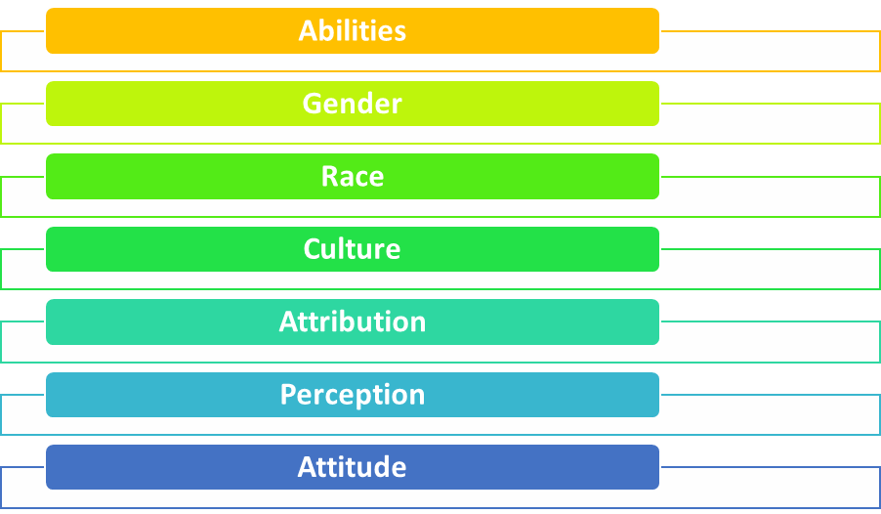

Figure: Factors affecting the differences in individual behaviour
Source: (Snygg and Combs, 2015)
Moreover, there are some factors that affect individual behaviour in the organisation. The factors include Abilities, Gender, Race and culture, Attribution, Perception and Attitude. All of these factors shape individual behaviour (Brooks, 2015). For example, a person with above-average or good abilities will have some ambitious expectations from the organisation especially when it comes to promotion. No employees in Morrison’s is facing discrimination based on gender but there is some natural or evolutionary fact that all the tasks are not suitable and appropriate for men and women equally. In Morrison’s heavy works are done by men and works that are light but need great care like decoration are done by women. The perception and attitude towards the goals and objectives of the organisation also shape the behaviour of the people of the organisation (Snygg and Combs, 2015).

Conclusion
An organisation is an entity with a group of people who has a particular shared purpose. People in the organisation is the key elements of success. The structure shows the spam of control with the hierarchy of the command and the cultural dimensions of Hofstede have performed actively in the territory of Morrison. However, the resources are amassed, arranged and lead towards success by the people of the organisation (Evans, 1997). So they should be given great importance. But being a hierarchically structured firm, it is not always possible to give the employees complete freedom. And most of the time the people in the organisation is ordered rather than consulted. The leadership style and management functions and processes have helped them become a successful company.

References
Brooks, I. (2015). Organisational behaviour. Harlow: Financial Times Prentice Hall.
Brown, A. (2017). Organisational culture. 3rd ed. London: Financial Times.
Evans, M. (1997). Organisational structure. 3rd ed. Darwin: Northern Territory Library.
Gopal, N. (2016). Business communication. New Delhi: New Age International.
Groceries.morrisons.com. (2019). Morrisons | Online Shopping | Food, Drink & More To Your Door. [online] Available at https://groceries.morrisons.com/webshop/startWebshop.do [Accessed 24 Jul. 2019].
Mobley, W., Wang, Y. and Li, M. (2017). Advances in global leadership. Bingley: JAI Press.
Moe, E. (2016). Governance, Growth and Global Leadership. London: Taylor and Francis.
Moore, L. (2016). Organisational leadership. Geelong, Vic.: Deakin University.
Rama Sastri, J. (2017). The managerial function. 4th ed. Bombay: Place of publication not identified.
Snygg, D. and Combs, A. (2015). Individual behaviour. New York: Harper.
Swainston, T. (2017). Behaviour management. London: Network Continuum.
Fatehi, K., (1996). International management: A cross-cultural and functional perspective. Prentice Hall.
Hofstede, G. (1991). Hofstede's culture dimensions: An independent validation using Rokeach's value survey. Journal of cross-cultural psychology, 15(4), pp.417-433.

