

Student name Sobia Naveed
Student number 2316438
Module code BMHP5014
Module title Changemaker : Creativity and Value . Creation

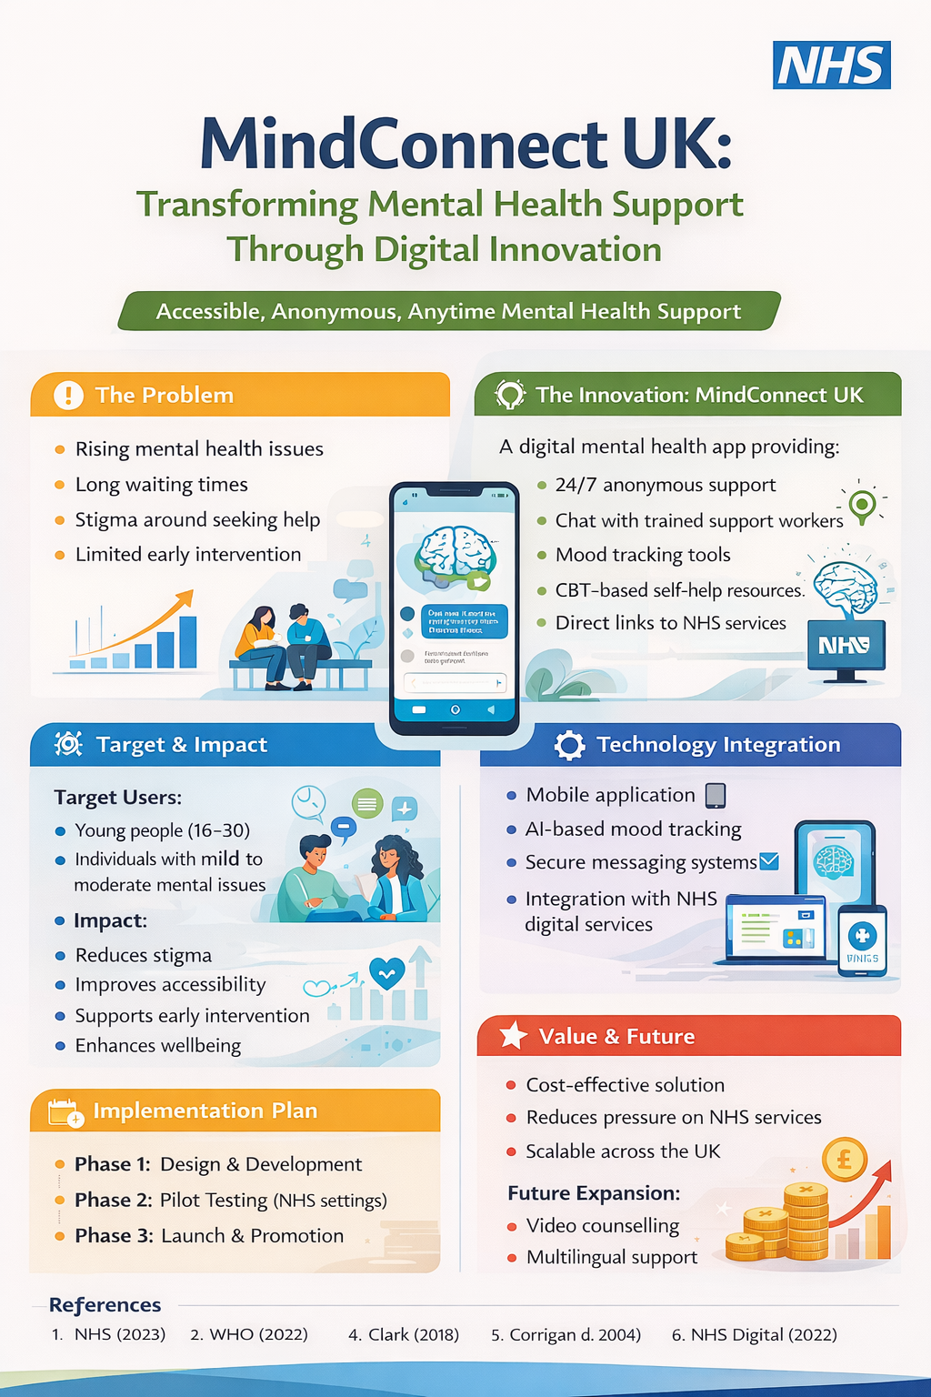
WRITTEN PITCH
I am proposing an innovative digital solution to address a critical and growing challenge within the UK healthcare system: limited access to timely mental health support. Mental health conditions such as anxiety and depression are increasingly prevalent across the population, placing significant pressure on services provided by the National Health Service. Despite ongoing efforts to improve care, many individuals continue to face barriers such as long waiting times, stigma, and limited flexibility in accessing services. These issues often result in delayed treatment, worsening conditions, and increased long-term demand on healthcare systems. To address this problem, I have developed an innovation called Mind connect UK, a digital mental health support application designed to provide immediate, accessible, and user-center care.
Mind connect UK is a mobile-based platform that offers 24/7 support for individuals experiencing mental health challenges. The application includes a range of integrated features such as anonymous chat with trained mental health support workers, mood tracking tools, and self-help resources based on cognitive behavioral therapy (CBT). These features are designed to empower users to take an active role in managing their mental health while also providing a clear pathway to professional support when required. By combining evidence-based approaches with digital accessibility, the app offers a modern solution to traditional service limitations.
One of the key strengths of this innovation is its accessibility. A significant number of individuals are reluctant to seek help due to the stigma associated with mental health conditions or fear of being judged. Mind connect UK addresses this barrier by offering anonymous support, allowing users to engage with services in a safe and private environment. Furthermore, the use of mobile technology ensures that support is available anytime and anywhere, making it particularly beneficial for young people, students, and working individuals who may struggle to attend in-person appointments. This flexibility aligns with the increasing demand for digital healthcare solutions and reflects changing user expectations in modern society.
The expected impact of Mind connect UK is substantial. Firstly, it promotes early intervention by enabling individuals to seek support at the earliest stages of mental distress. Early intervention is widely recognized as a key factor in improving mental health outcomes and preventing conditions from becoming more severe. Secondly, the app reduces pressure on existing NHS services by offering an alternative pathway for individuals with mild to moderate conditions, allowing clinical resources to be prioritized for more complex cases. Additionally, the app contributes to improved mental wellbeing, increased productivity, and enhanced quality of life, creating both social and economic value.
The implementation of this innovation involves a structured and phased approach. The first stage focuses on the design and development of the application, including user interface design, integration of key features, and ensuring accessibility for diverse user groups. This stage would involve collaboration between software developers, healthcare professionals, and user experience designers. The second stage involves pilot testing within selected NHS settings or community health services. This allows for the evaluation of effectiveness, identification of potential improvements, and collection of user feedback. The final stage is the full-scale launch of the application, supported by awareness campaigns, partnerships with healthcare organizations, and integration with existing NHS digital platforms.
A clear implementation timeline can be outlined as follows: the design and development phase would take approximately six months, followed by a three-month pilot testing phase, and finally a nationwide launch within 12 months. This structured approach ensures that the innovation is thoroughly tested and refined before full implementation.
Key stakeholders in this project include the National Health Service, mental health professionals, policymakers, technology developers, and service users. Collaboration between these stakeholders is essential to ensure that the application meets clinical standards, aligns with national healthcare strategies, and effectively addresses user needs. Partnerships with organizations such as Mind can also enhance outreach and engagement, particularly among vulnerable populations.
In terms of regulatory considerations, the app must comply with legal and ethical requirements, including data protection regulations such as GDPR. Ensuring the confidentiality and security of user data is essential in building trust and encouraging engagement. Additionally, the app must align with guidelines set by organizations such as National Institute for Health and Care Excellence to ensure that the content and interventions provided are evidence-based and clinically appropriate.
From a value perspective, Mind connect UK aligns closely with current NHS priorities, including the expansion of digital healthcare services and the promotion of patient-center care. The app offers a cost-effective solution by reducing reliance on in-person consultations and improving efficiency in service delivery. By supporting early intervention and self-management, it also contributes to long-term cost savings within the healthcare system.
However, potential barriers must be acknowledged. Digital exclusion remains a concern, as some individuals may lack access to smartphones or digital literacy skills. To address this, the app could be supported by community-based initiatives that provide guidance and access to digital tools. Data privacy concerns are another potential challenge, which can be mitigated through robust cybersecurity measures and transparent communication with users.
Looking towards the future, Mind connect UK has significant potential for expansion and adaptation. Additional features such as video counselling, multilingual support, and integration with wearable health devices could further enhance its effectiveness. The app could also be adapted for use in other areas of health and social care, supporting a wider range of conditions and populations.
In conclusion, Mind connect UK represents a practical, innovative, and scalable solution to current mental health challenges in the UK. By combining creativity, technology, and patient-center care, it has the potential to transform how mental health services are delivered. I strongly encourage stakeholders to support the development and implementation of this innovation to improve access to care, reduce stigma, and enhance overall wellbeing across the population
Wills, Frank. Beck’s Cognitive Therapy : Distinctive Features. London, Routledge, 2021.

Reference List
- NHS . “NHS.” NHS, 2023, www.nhs.uk.
- Burns, Dianne. Foundations of Adult Nursing. SAGE Publications Limited, 29 Nov. 2024.
- Hudson, Christopher G. Research Handbook on Mental Health Policy. Edward Elgar Publishing, 18 Nov. 2022.
- Lily-Jo. Talking to Children about Mental Health. SPCK, 19 Jan. 2023.
- Milne, Derek L, and Robert P Reiser. Resolving Critical Issues in Clinical Supervision. John Wiley & Sons, 13 Feb. 2023.
- Series, Lucy. Deprivation of Liberty in the Shadows of the Institution. Policy Press, 29 Mar. 2022.
- Shah Fahad, et al. Challenges and Solutions of Climate Impact on Agriculture. Elsevier, 8 Oct. 2024.
- Woolf, Alison. Better Mental Health in Schools. Taylor & Francis, 20 Sept. 2022.
- World Health Organization. World Mental Health Report. World Health Organization, 16 June 2022.
- Yiannis Kyratsis, et al. Digital Health Adoption: Looking beyond the Role of Technology. Frontiers Media SA, 10 Apr. 2023.

