Comparison of Digital Modulation Methods
Ashleigh Elder P141924
January 12th 2018

Contents

- Introduction

- Background Theory
  - Modulation and Demodulation
  - Additive Gaussian White Noise
  - Forward Error Correction

- Materials and Methods

- Discussion and Results
5.1 Conclusion

- Bibliography
6.1 References
6.2 Research

1 Introduction
The aim of this report is to critically compare the performance of amplitude, phase and frequency shift keying (ASK PSK and FSK respectively) in the presence of additive gaussian white noise (AGWN) to demonstrate an understanding of the subject matter and show proficient use of system level simulation software. ASK, PSK and FSK are three of the main forms of digital modulation that are used to “eliminate transmission noise and offer improved robustness to signal interference…”[1] therefore this report aims to describe, test and compare each method of digital modulation with and without the AGWN.

2 Background Theory
2.1 Modulation and Demodulation
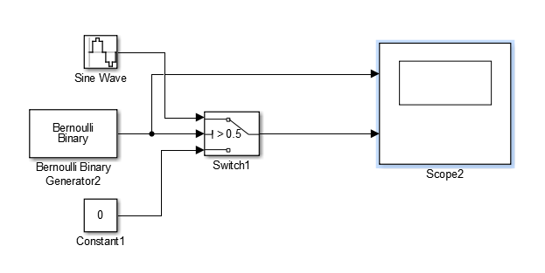
Digital Modulation uses “discreet signals to modulate a carrier wave.”[1] to be demodulated at receiving end. The modulation process combines a given binary signal with a carrier sine wave turning the digital signal into an analogue one in order to transmit the original signal. There are several methods of modulation but this report shall only compare three of the main methods; ASK PSK and FSK.
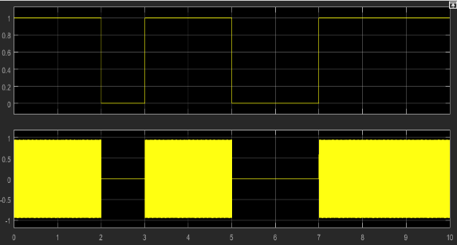
Amplitude Shift Keying causes the carrier wave to switch between two or more discreet levels in accordance with the binary input data it does this by combining the carrier wave with the binary signal being divided into eleven pulses of equal duration to represent each individual bit.
Fig 1.
This means that only one wave gets added to the signal in ASK modulation as opposed to PSK and FSK where two waves are added and can be achieved with the use of a simple switch switching between the carrier wave and 0.
Fig 2.

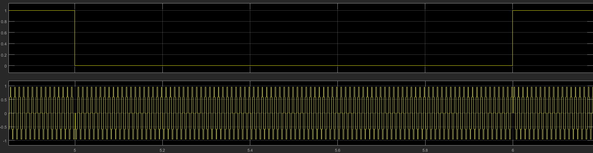
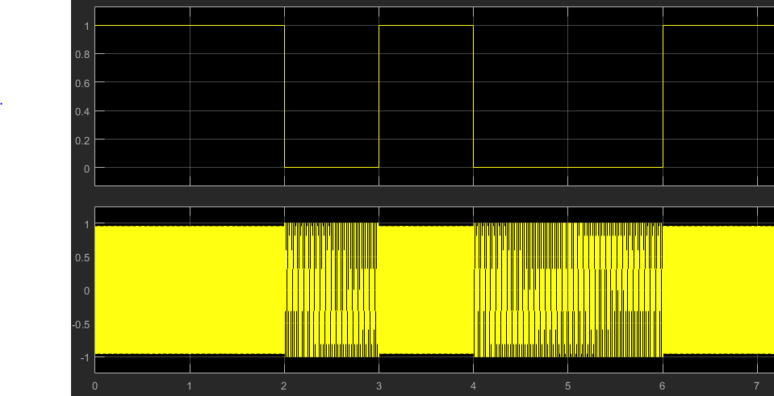
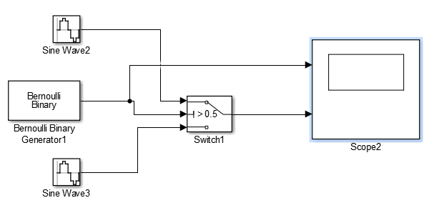
Phase Shift Keying causes the carrier wave to change phase between two discreet values at the beginning of each pulse with one representing a binary 1 and another representing a binary 0. This requires the use of two identical carrier waves out of phase with one another to use interchangeably again via a simple switch.
Fig 5.
Fig 4.
Fig 3.

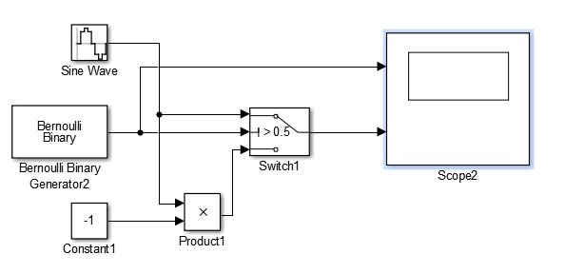
Frequency Shift Keying causes the carrier wave to change frequency between tow discreet values in order to represent a binary 0 and binary 1. FSK modulation can be simulated with a simple switch that switches between two different carrier signals at different frequencies in order to use interchangeably as the binary input signal pulses switch.
Fig 6.
Modulation is the total opposite of demodulation as demodulation combines the modulated signal with an exact copy of the original and filters it with a lowpass filter to make the signal smoother. This signal is then put through several mathematical functions to return the original signal. Generally separate electronic circuits would be used to demodulate the signal but this is being replicated via the use of mathematical functions.[2]
2.2 Additive Gaussian White Noise
Additive Gaussian White Noise is unwanted white noise that has been added to the source signal, white noise is noise that has equal power density at all frequencies and can come from several sources including static and thermal signals although for the purposes of this report an AGWN process shall be added to the simulated modulators. Gaussian means that the Additive White Noise is in the time domain of 0 and is identically distributed across all frequencies. This white noise needs filtering out of our source signal and this can be achieved via a low pass filter and can be minimised with certain forms of forward error correction.[3]
2.3 Forward Error Correction
As the modulated signal picks up noise and the signal weakens over longer distances some of the arriving signal can become corrupted and pick up errors. Forward Error Correction adds redundant information to the original binary signal in the form of parity bits that get decoded along with the original data and this detects and corrects any incorrect data.
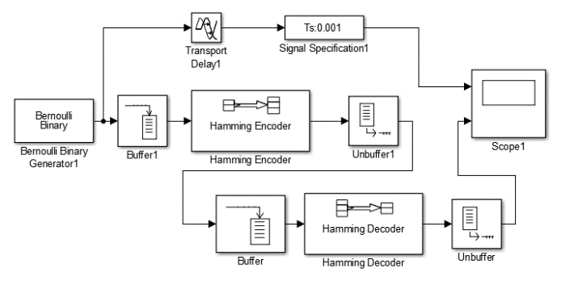
An example of a forward error correcting process is Hamming code which tries adds a number of parity bits ensuring the signal has an even number of bits if this is incorrect the process attempts to correct the code and discover the error. The simulation for this can be seen in (fig 7) although it was impossible to test this in matlab due to issues with Simulink.

3 Materials and Methods
In order to simulate the three separate digital modulators Matlab’s Simulink was used with data on error rate detection being taken from these simulations for use in comparing the different methods. To do this the modulators shall be combined with AGWN noise and filtered at different levels of decibels with the results being recorded and an error rate graph produced using Microsoft Excel to better understand the success of each method at filtering noise and maintaining the original given signal.
Simulink was also used to simulate the hamming code error correction method although the simulation was unable to be tested properly due to issues with Simulink.

4 Discussion and Results
For each simulation a Bernoulli binary generator shall be used to create the source signal and it shall be added to a carrier wave of 2*pi*100 at an amplitude of 1 and sample time of 1/1000. The PSK modulator shall also include a carrier wave with its phase multiplied by -1 and the FSK modulator shall include a carrier wave at a frequency of 2*pi*50.
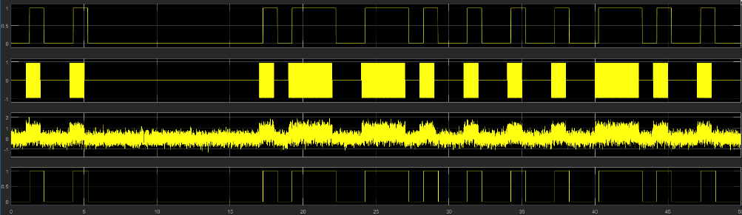
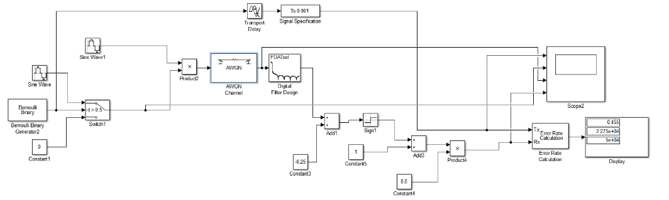
The screenshots above (fig 7)(fig 8) display the ASK digital modulator with AGWN the scope has been set to display the original binary signal (created using a Bernoulli binary generator) and displays the signal first being ASK modulated with AGWN being added and then the whole signal getting filtered to give the original binary output at the output of the demodulator. This AWGN channel has been set at a SNR of 10dB therefore this shows the ASK modulator is successfully filtering it without any noticeable issues.
Fig 8.
Fig 7.

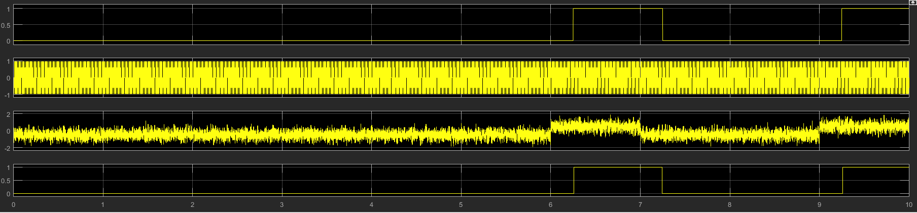
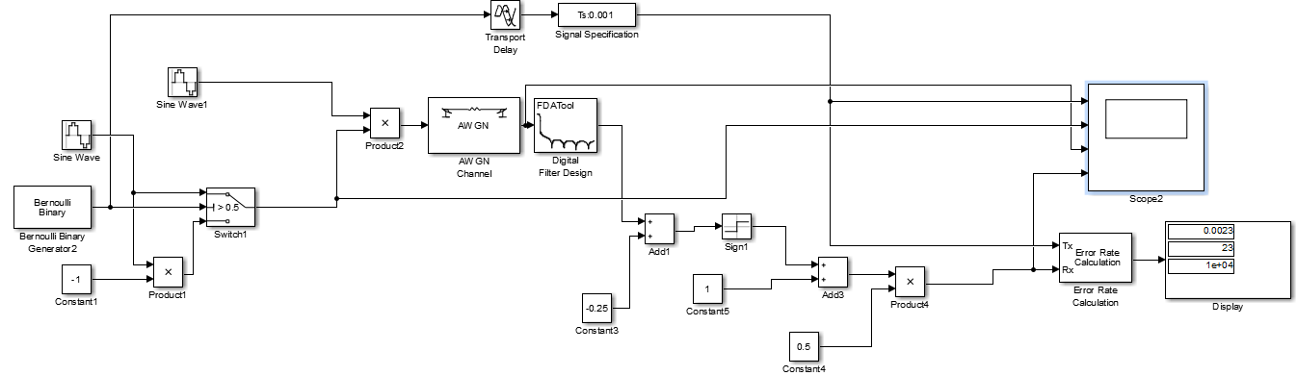
The screenshots below (fig 9) (fig 10) demonstrate the PSK digital modulator again with AGWN and the display is showing the signal at the same parts as the ASK filter, the original signal, the PSK modulated signal, AWGN and then the demodulated filtered signal. At this point as the AWGN is only on 10dB is also successfully demonstrates the PSK modulator doing it’s job and successfully filtering noise without any noticeable issues.
Fig 9.
Fig 9.
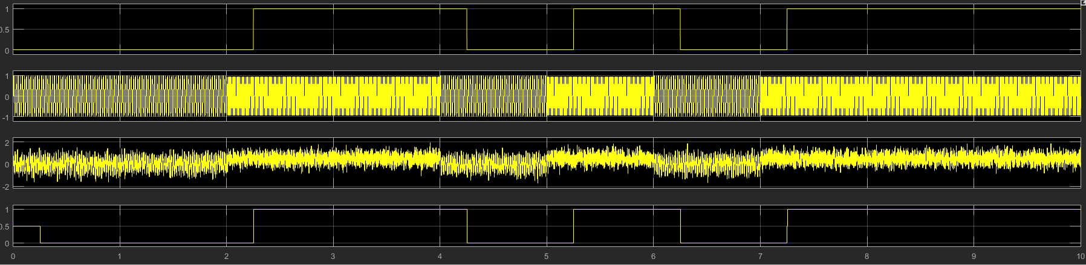
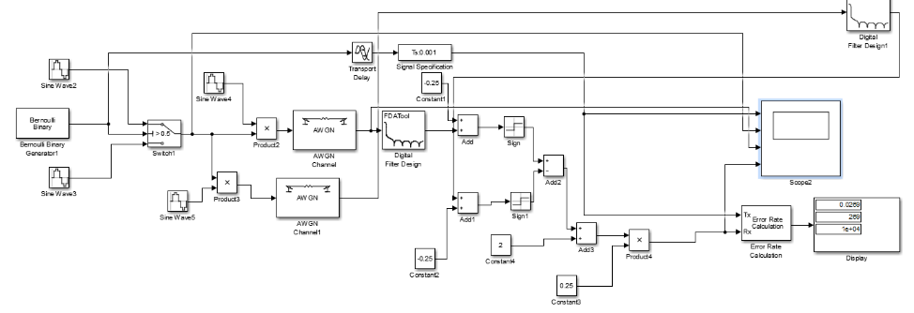
Finally left (fig 11)(fig12) displayed is the simulation and results at the signals beginning, when modulated using FSK modulation and with AGWN before getting to the final filtered signal. The graph for the ouput shows the FSK digital modulation working correctly to remove AWGN and return the original signal.

Each of these processes have had the resulting error rate recorded and compared with each other at varying sound noise resolutions (SNR) in the graph below. Using this information it shows that the most effective form of digital modulation tested seems to be PSK although this could have proven to be different if any lower resolutions were used if the task was to be completed again. The graph also shows that the form of digital modulation that is worst at dealing with AGWN is the FSK modulator with a error rate consistently higher than the other two. This graph also shows that none of the above forms of digital modulation are particularly effective at filtering AGWN after a certain point. Although without noise present ASK modulation seems to do better according the the results on the bit error rate table.
 | Error rate (%)
SNR(dB) | ASK | PSK | FSK
-20 | 45.5 | 39 | 88.8
-17.5 | 42.6 | 37.2 | 85.4
-15 | 40 | 34.8 | 81.3
-12.5 | 37.8 | 33.3 | 75.3
-10 | 33.4 | 21.3 | 67.4
-7.5 | 29.2 | 18.2 | 58.5
-5 | 22.6 | 12.7 | 46.8
-2.5 | 17.6 | 9.3 | 34.8
0 | 9.7 | 4.8 | 21.6
2.5 | 4.1 | 2.7 | 10.4
5 | 1.5 | 0.5 | 3.8
7.5 | 0.5 | 0.3 | 2.8
10 | 0.1 | 0.3 | 2.7
In order to address the problems digital modulation has at filtering out AGWN various forms of forward error correction can be used but as afore mentioned testing could not go underway on the forward error correction hamming code simulation as Simulink had issues running said simulation.

4.1 Conclusion
In conclusion none of the forms of digital modulation tested are particularly useful in the real world after a certain amount of noise corrupts the signal although without noise ASK seems to be the better option but this gradually shifts in favour of PSK as more noise is added. In order to deal with the problems of noise in digital signal modulators forward error correction methods could be used although more testing is needed on the subject.

- Bibliography

5.1References
[1] M. Borkowski, “Digital Δ-Σ Modulation.” http://www.comfortaudio.com/faq/dm/, 2008.
[2] “Demodulation _ Amplitude Modulation AM _ Electronics Notes.” https://www.electronics-notes.com/articles/radio/modulation/amplitude-modulation-am-demodulation-detection.php, 2018
[3] Guassian Waves.com, “Simulation and Analysis of White Noise in Matlab GaussianWaves.”. https://www.gaussianwaves.com/2013/11/simulation-and-analysis-of-white-noise-in-matlab/. 2018

5.2 Research
D. P. X. Shafiul Alam, “Introduction to Data Communications,” p. 15, 2009.
N. Vlajic, “Analog Transmission of Digital Data (PPT),” Comput. Syst. Eng., 2010.
Wireless Pi, “Additive white Gaussiannoise.” wirelesspi.com, 2018 .
Electronics Post, “Explain the need for modulation in a communication system – Electronics Post.” https://electronicspost.com/explain-the-need-for-modulation-in-a-communication-system/, 2018
Carter,Mancini, Bruce,Ron (2009). Op Amps for Everyone. Texas Instruments. pp. 10–11. ISBN 0080949487.
Video: https://www.youtube.com/watch?v=cNuGvsNyg-Y&feature=youtu.be

