
Programme: Master of Business Administration
Module Code: LCMB7024
Module: Marketing Management
Lecturer: Dr Laila Maazouz (London)
Assignment Title: Assessment component 2: Marketing Portfolio
Student Name: Sorbane Das Toma
Student ID: 2437417
Word Count: 2586

Table of Contents
Introduction 3
Element 1: STDP Strategy 3
1.1 Segmentation Strategy 3
1.2 Targeting Strategy 4
1.3 Differentiation Strategy 5
1.4 Positioning Strategy 5
Element 2: Marketing Mix (4Ps) 7
2.1 Product Strategy 7
2.2 Price Strategy 8
2.3 Place Strategy 8
2.4 Promotion Strategy 9
Element 3: Marketing Strategy Pitch 11
Element 4: Reflection 12
References 14

Introduction
The UK beauty and personal care sector is under pressure to balance commercial expansion and environmental accountability especially with regard to plastic waste and packaging intensity. Although the consumer awareness of sustainability is increasing, the sector still heavily relies on single-use plastic, and there is a large discrepancy between the ethical mindset and the buying behaviour (Ellen MacArthur Foundation, 2023). This assignment suggests a zero-waste refill concept LUSH ReFill Bar, which is a part of LUSH UK high-street stores, which offers refillable shampoos, conditioners, and body washes in reusable aluminium bottles. The report engages in a critical analysis of the strategic rationality of this concept based on the Segmentation, Targeting, Differentiation, and Positioning (STDP) conceptual framework. The analysis uses the current marketing theory alongside the UK industry data, therefore, assessing the ability of LUSH ReFill Bar to improve its competitive efficiency as it transforms to meet the shifting consumer needs in terms of sustainability, affordability, and accessibility.

Element 1: STDP Strategy

1.1 Segmentation Strategy
Through market segmentation, enterprises can recognize consumer groups with unique requirements, values, and behaviors, moving beyond mass marketing (Armstrong et al., 2020). LUSH ReFill Bar segments because UK beauty consumers are not universal but want sustainability.
Variables used for segmentation
- Demographic: income, age, and life stage.
- Psychographic: Environmental, moral, and ethical values for conservation.
- Behavioral: Brand loyalty, zero-waste consumption, and willingness to replenish.
- Geographic: UK urban and non-urban places.
Younger consumers (18-35) are more likely to associate personal identification with ethical consumption and will be overrepresented in refill and zero-waste retail formats (Laville, 2025). Demographical considerations alone cannot predict sustainable behavior. Psychographic segmentation is tactical. LUSH appeals to vegan, cruelty-free, pro-environmentalists who oppose corporate greenwashing (White et al., 2019).
Behavioral segmentation further narrows the market to consumers who actively seek refills, join recycling or reuse programs, and buy again. WRAP (2023) says refills are more popular when customers see them as convenient, economical, and environmentally friendly. Geographic segmentation will focus on urban UK centres, where LUSH stores are most concentrated and sustainability rules are most integrated into daily consumption. This multi-layered segmentation approach ensures strategic precision without overgeneralization.

1.2 Targeting Strategy
According to the segmentation analysis, LUSH ReFill Bar follows concentrated (focused) targeting approach, with such a focus as urban and eco-conscious millennials (18-35). This choice is a selectivity and not an exclusion because not all consumers in the UK are equally willing to become refillers.
Target segment characteristics:
- High environmental concern
- Close connection with ethical brands.
- Ambition to change ways to become sustainable.
- Frequent customers of the high-street beauty stores.
Young UK customers are more likely to try refillable beauty items than older consumers, especially with established brands, according to Mintel (2023). By targeting this demographic, LUSH may leverage brand credibility and lower sustainable consumption behaviour obstacles.
Strategic focus may slow short-term volume growth. Nevertheless, Jahari et al. (2022) propose that focused targeting can enhance the long-term profitability through the rise in customer lifetime value and brand advertising. The targeting method promotes long-term growth rather than transactional growth because ethical consumers are more loyal and word-of-mouth. This target market category overlaps strongly with LUSH clients, reducing market entrance risk and ensuring strategic fit.

1.3 Differentiation Strategy
Differentiation involves provision of attributes which have sense to consumers and attributes that competitors find hard to imitate (Porter, 2008). LUSH ReFill Bar stands out as one of the companies that focus on sustainability overall, as opposed to single green characteristics.
Differentiation dimensions:
- Container: aluminium reusable refillable bottles.
- Ethics of the product: 100% vegan, cruelty-free.
- Business model: embedded principles of a circular economy.
Although other competitors like Boots and The Body Shop launched limited refill programs, they usually co-exist with the traditional product line that is heavy in terms of plastic and diminishes perceived effort (Laville, 2025). Conversely, the refill system fits the decades-old anti-packing and anti-ethics sourcing stance of LUSH, increasing perceived legitimacy.
According to the Ellen MacArthur Foundation (2023), it is more likely that consumers are more impressed by brands that exhibit systemic transformation, as opposed to incremental improvement. The LUSH ReFill Bar can have a real effect on the environment by cutting down on packaging waste by up to 80% over single-use alternatives (Statista, 2024) instead of merely being a sign of symbolism sustainability. This degree of differentiation also reinforces competitive insulation, in addition to establishing ethical brand equity of LUSH.

1.4 Positioning Strategy
Brand positioning entails consumer perception of a brand relative to the other brands (Ries et al., 2001). LUSH ReFill Bar wants to be the UK's most ethical and accessible refill beauty station with high sustainability and high-street brand reach. uch positioning could be interpreted based on the sustainability and accessibility of the market. One of the reasons in the UK beauty market is that large retailers, such as Boots, are available but not engaged with any refill or zero-waste systems, and smaller eco-beauty companies are sustainable but less visible and convenient (Nordigarden et al., 2025). LUSH ReFill Bar will provide a cyclical refill strategy as part of its chain of statewide shops in a strategic high-sustainability, high-accessibility location.
High Sustainability Commitment

- Niche Zero-Waste Stores
(e.g. independent refill shops)
- LUSH ReFill Bar

- The Body Shop
Limited availability
High-street presence

- Boots

- Superdrug

Low Sustainability Commitment

Figure 1: Perpetual Position Map of Lush Refill Bar
(Source: Self-developed)

This positioning is strategic because it responds to convenience as one of the primary obstacles to sustainable consumption. WRAP (2023) found that UK customers are more likely to use refill systems in familiar surroundings. This position requires operational consistency and open communication to maintain ethical validity and avoid greenwashing assumptions. Overall, the positioning supports LUSH brand principles and long-term uniqueness.

Element 2: Marketing Mix (4Ps)
Since LUSH ReFill Bar is a product-based sustainability innovation that is integrated into a pre-established retail setting, 4Ps framework (Product, Price, Place, and Promotion) offers a suitable and rigorous framework to study the product. The components of the marketing mix are being critically analyzed to indicate how they reinforce the brand segmentation, targeting, differentiation, and positioning strategy in reaction to the structural issues in the UK beauty market.

2.1 Product Strategy
LUSH ReFill Bar goes beyond functional hair and body care to include the product strategy of production ethics, packaging reduction and recycling consumption. Modern marketing theory underlines that products are more and more valuable in the form of symbolic and experience qualities, especially in ethically based markets (Armstrong et al., 2020). Here, refillable conditioners, conditioners, and body washes are the modes of sustainability and not just hygienic solutions.
The major product differentiation of LUSH ReFill Bar is its zero-waste refill service that uses aluminium reusable bottles instead of single-use plastic. This is in line with the principles of a circular economy, which gives more focus to reuse and waste prevention and not just on recycling (PWC, 2024). Significantly, the refill program does not sacrifice the LUSH-established quality of the product such as 100% vegan formulations and cruelty-free testing, which supports brand authenticity. It has been argued that ethical consistency in product attributes enhances consumer trust and decreases scepticism with sustainability claims (White et al., 2019).
Competitively, besides the retailers which created refill options to a lesser extent (e. g. Boots, The Body Shop), these activities are typically accompanied by product assortment that are largely intensive in plastic consumption, undermining the perceived effort (The Body Shop, 2024). In contrast, LUSH ReFill Bar has made refilling an essential part of its product architecture, which supports all its differentiation and place its high-sustainability, positioning. But operational complexity and hygiene assurance are the critical risks that need to be addressed in order to maintain product credibility.

2.2 Price Strategy
Pricing is an important factor in creating a sense of fairness, accessibility and value especially in the context of sustainable consumption. LUSH ReFill Bar should use a cost-parity or slightly cheaper refill price strategy than regular packaged options, in order to eliminate price as an adoption barrier. According to Armstrong et al. (2020), some consumers are ready to pay a higher price on ethical products, but, they say, any change in behaviour is better in case sustainable products are priced competitively.
The UK evidence supports using this approach. According to Statista (2024), the commitment of refill is significantly high when consumers feel there is a financial benefit or at least being cost-neutral in comparison to single-use packaging. LUSH strengthens the behavioural incentive to reuse by making refills less expensive than first-time purchases of bottles, and it appeases the sensitivity to price of its target market, students and young professionals.
Importantly, the pricing method helps LUSH to be ethical and affordable. High premium prices would compromise the access and limit the adoption of refills to niche customers. Nevertheless, product competitiveness can cause a squeeze in margins, particularly at elevated initial infrastructure expenses. This trade-off is based on the strategic decision to focus on long-term loyalty and repeat purchase behaviour rather than maximisation of short-term profits in line with the concept of relationship marketing (Peattie and Crane, 2005).

2.3 Place Strategy
The place strategy is capitalizing on the flagship presence of LUSH in the UK high-street retail sector, integrating ReFill Bars into the existing stores. The choice of distribution is a strategic focus, as the accessibility is an influential factor in the sustainable consumption behaviours (Rouch, 2021). LUSH normalises the refill behaviour in the mainstream retail contexts, instead of the specialist zero-waste stores that can only appeal to very committed customers.
The strategy is very consistent with the targeting strategy of the brand, which is focused on urban and eco-conscious people who already shop at LUSH stores. According to Mintel (2023), the purchase of beauty products depends on convenience and familiarity, especially when it comes to buying common items, including shampoo and body wash. Through placing the refill stations in high-profile areas within the store, LUSH eliminates friction in behavioural change and makes sustainability a part of the everyday shopping behaviour.
Critically, in-store refill model also supports the concept of experiential engagement since consumers can touch the process of refilling. Scalability, however, might not be able to match the store size, layout variations, and operational training demands. Regardless of these obstacles, the place strategy indeed aids the high-accessibility positioning of LUSH and distinguishes it amongst mass retailers as well as niche eco-stores.

2.4 Promotion Strategy
LUSH ReFill Bar promotion is based mostly on ethical communication, education, and behavioural nudging as opposed to conventional price-based advertising. According to the marketing communications theory, sustainability messages are most successful when they focus on the practical effect and do not include any wild offers (Peattie, 2010). In this regard, the promotional strategy of LUSH is based on open communication about waste reduction, refill bonuses, and environmentality.
Explanations of the environmental benefits of refilling (reduced plastic waste and reduced carbon footprint) are explained in-store, through staff advocacy, and online. PWC (2024) notes that consumer education is vital in empowering the participation in the circular economy, especially in areas that need behaviour change. Loyalty incentives and refill discounts also help to strengthen the repeat behaviour without compromising the ethical validity.
LUSH has a stronger promotional strength than its rivals because its message is backed by long-established activist brand voice adds credibility to the message. But effectiveness in promotions requires consistency between claims and practice. Any failure of operations like stock shortage or vague hygiene standards would undermine trust and positioning. On the whole, the promotional plan contributes to the differentiation of LUSH ReFill Bar by making refilling a responsibility and a convenient routine.

Element 3: Marketing Strategy Pitch
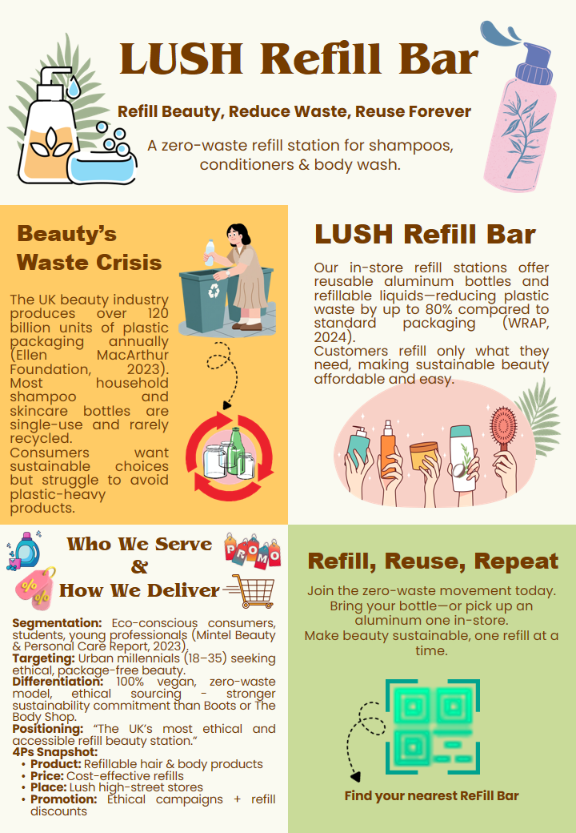
"Good afternoon everyone. Today I am thrilled to present Lush ReFill Bar, a new zero-waste beauty product that should minimize plastic waste and help every person live a sustainable lifestyle.
The beauty sector produces in excess of 120 billion plastic packages annually, and the majority of these are ordinary products of shampoo and skincare bottles (Ellen MacArthur Foundation, 2023). A lot of customers desire to lead a more environmentally-conscious lifestyle, yet they lack easy choices in the shops. LUSH ReFill Bar will address this issue by providing in-store refill bars to shampoos, conditioners, and body wash. Customers are allowed to use their own bottle or purchase a reusable aluminum bottle and refill it repeatedly. This removes up to 80 percent plastic waste and makes it affordable.
Our most important consumers are eco-conscious students, young professionals, and urban shoppers who do not need to spend more in order to have ethical beauty. LUSH is superior to Boots and The Body Shop due to the availability of a 100 percent vegan and zero-waste model with ethically sourced ingredients.
With LUSH ReFill Bar, we turn beauty sustainable, simple and accessible - one refill at a time. Thank you."

Element 4: Reflection
The creation of the LUSH ReFill Bar idea and the marketing plan behind it was an excellent exercise to test the theoretical marketing models on a modern sustainability issue in the UK beauty industry. Learning how to go beyond descriptive application of models like STDP and the marketing mix to a more critical assessment of how strategic decisions interrelate with consumer behaviour, operating constraints, and ethical credibility was seen as one of the most important learning outcomes. Specifically, the examination of segmentation and targeting revealed that the group of sustainability oriented consumers cannot be considered a uniform group; the intention to use refill behaviour significantly depends on convenience, price sensitivity, and belief in brand authenticity.
One of the main skills I gained in this process was the ability to perform a strategic analysis, particularly in making trade-offs between ethical ambition and commercial viability. An example to support this is that the distribution and pricing choices that needed to be done critically to position LUSH ReFill Bar as highly sustainable and widely accessible were crucial, instead of depending on the sustainability, which would convert it into a widely used tool. This strengthened the idea that sustainable marketing should deal with behavioural obstacles, rather than environmental intent, a theme that has been a persistent theme in the current sustainability literature (White et al., 2019).
The creation of the strategic poster and pitch also improved the visual communication and synthesis abilities. Breaking down intricate strategic analysis into a small, visually consistent format necessitated the importance of prioritisation of key messages, as well as more explicit formulation of value propositions. This practice revealed a personal bias of paying more attention to the information density and less to the clarity at the beginning. The feedback and the refining process helped me to develop my communication skills in the elaborating of the strategy more convincingly particularly in congruing problem-solution story with STDP and marketing mix.
However, the project also showed that improvement could be made. More quantifiable market data, e.g. consumer willingness-to-pay or store level feasibility data would strengthen future analyses. In addition, as much as ethical positioning was well thought upon, further inquiry about the dangers of the operation such as hygienic control and staff education on offering refill systems, would make the plan more realistic. In future projects, I would be more inter-disciplinary as I would integrate operational and financial perspectives into the marketing theory.
Overall, this assignment has improved my understanding of brand strategy based on sustainability and reinforced the importance of credibility, consistency and consumer-centricity in ethical marketing. The gained learning is applicable directly to the future occupations when strategic decision-making in socially responsible and competitive business environments is required.

References
Armstrong, G., Denize, S., Volkov, M., Adam, S., Kotler, P., Ang, S., Love, A., Doherty, S. and van Esch, P. (2020). Principles of Marketing. 8th ed. Melbourne, Vic: Pearson Australia.
Ellen MacArthur Foundation (2023). The Global Commitment 2023. www.ellenmacarthurfoundation.org.
Jahari, S.A., Hass, A., Idris, I.B. and Joseph, M. (2022). An integrated framework examining sustainable green behavior among young consumers. Journal of Consumer Marketing, 39(4). doi:https://doi.org/10.1108/jcm-04-2021-4593.
Laville, S. (2025). Reuse and Return Schemes Could Help Eliminate Plastic Pollution in 15 years, Says Report. The Guardian.
Mintel (2023). 2023 Global Beauty & Personal Care Trends | Mintel. www.mintel.com.
Nordigården, D., Feber, D., Grünewald, F., Pley, M. and Seidner, M. (2025). Sustainability in packaging 2025: Inside the minds of global consumers. McKinsey & Company.
Peattie, K. (2010). Green Consumption: Behavior and Norms. Annual Review of Environment and Resources, [online] 35(1), pp.195–228. doi:https://doi.org/10.1146/annurev-environ-032609-094328.
Peattie, K. and Crane, A. (2005). Green marketing: legend, myth, farce or prophesy? Qualitative Market Research: An International Journal, 8(4), pp.357–370.
Porter, M.E., (2008). Competitive advantage: Creating and sustaining superior performance. simon and schuster.
PWC (2024). Consumers willing to pay 9.7% sustainability premium, even as cost-of-living and inflationary concerns weigh: PwC 2024 voice of the consumer survey. PwC.
Ries, A., Trout, J. and Kotler, P., (2001). Positioning: The battle for your mind (Vol. 2). New York: McGraw-Hill.
Rouch, D.A. (2021). Fashion and Clothing textiles: How to Reduce the Environmental and Social Impacts. ResearchGate.
Statista (2024). Cosmetics - United Kingdom | Statista Market Forecast. Statista.
The Body Shop (2024). Our Refill Scheme. The Body Shop.
White, K., Habib, R. and Hardisty, D.J. (2019). How to SHIFT Consumer Behaviors to Be More Sustainable: a Literature Review and Guiding Framework. Journal of Marketing, [online] 83(3), pp.22–49. doi:https://doi.org/10.1177/0022242919825649.
WRAP (2023). Mainstreaming Reusable and Refillable Packaging in the UK. WRAP.

