DS 1 Template

My Screenshots/Photos
- Please add 4–6 screenshots or photos of your digital life.
- You can use your phone or laptop.
- For each screenshot, write one or two sentences explaining what it shows.

Screenshot/photo 1

Using Microsoft outlook, it allows me to manage my personal information, and emails schedule my calendar for crucial events like birthdays, appointments, store and managing my personal contacts.

Screenshot/Photo 2
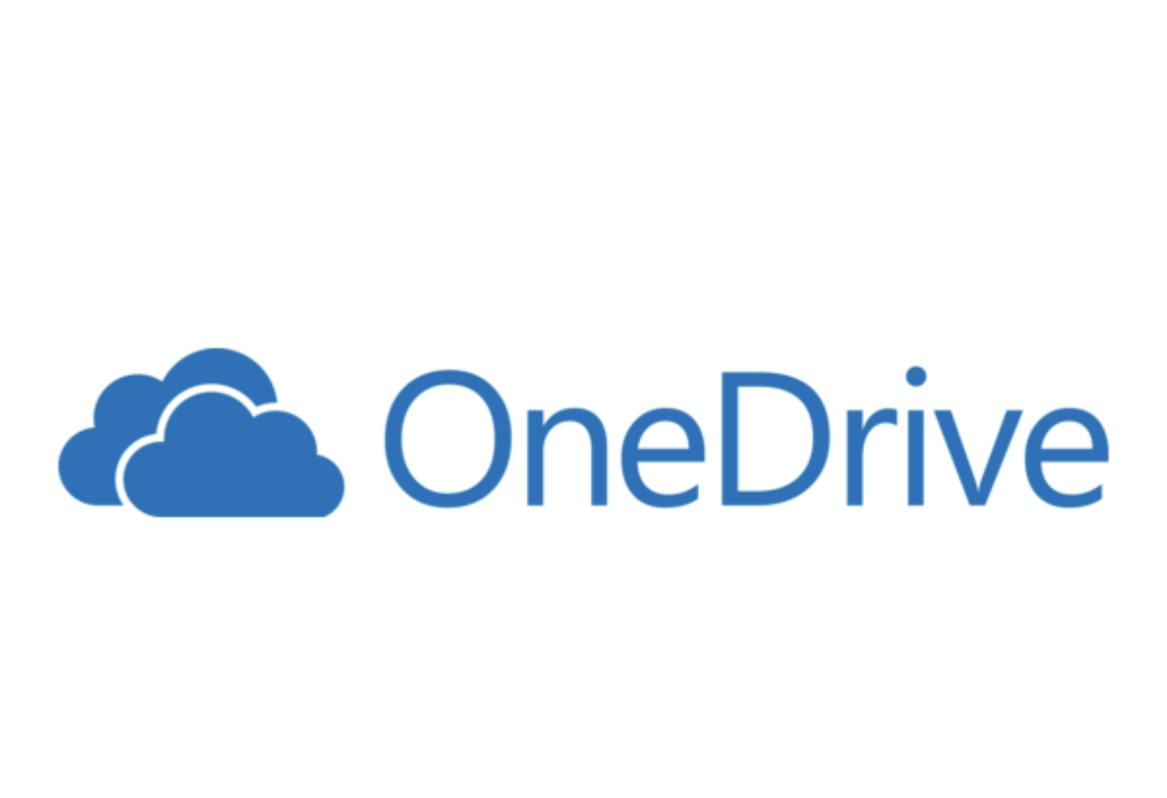
Using Microsoft one-drive allows me to create folders. Backup and store my organised files so it is nice and tidy also makes it easy to find.

Screenshot/Photo 3

Microsoft word I use it every day for my assignments, creating my cv and to edit written documents.

Screenshot/Photo 4

Using zoom allows me to set up online meetings and conferences like job interviews.

Screenshot/Photo 5

During my digital class I’ve learned how to set up my profile on LinkedIn for my professional career development and employment.

Screenshot/Photo 6

Messenger allows me to send messages video calls and share photos and media with family and friends and create group chats.

My Short Reflection
- Write 5–8 simple sentences about your digital life.
- You can use the sentence starters below if helpful.
I use digital tools for this very reason. Centralise data access, shared digital collaborations, flexible accessibility, streamlined workflow, consistency and transparency.
I want to improve my skills so that I can stay relevant and informed at a professional workplace using digital tools.
In today world with ai it is important to stay up to date I’m hoping that this module will help me improve my skills using digital tools so I can have a full understanding of how to use it at a professional level. It is very important for me to achieve this skills if I want to be successful in my career.

Sentence starters
- I use digital tools to …
- I feel confident when I …
- I want to improve …
- I often use these tools: …
- I sometimes feel nervous about …
- I hope this module will help me …
- Digital skills are important for me because …
You can write more if you want.

Submission Checklist
Before you submit, please check:
​​​ ☐ I added 4–6 screenshots
☐ I wrote short sentences for each screenshot
☐ I wrote my short reflection
☐ My work is my own
☐ My file opens correctly
​​☐ My file opens correctly

