Module Title – Introduction to Health and Social Care
Module Code – LCHS4003
Assignment Title – Portfolio
Student Name – Katelen Summerfield
Student Number – 2434537
Lecturer’s Name – Mumtaz Goolam

What is community antenatal midwifery?  A community antenatal midwifery is a service that provide support for expecting mothers within their homes or in certain facilities such as hospitals, community family unit hubs and GP practice. Theses can provide scans, regular checks if required on a case-to-case risk also antenatal classes to help expecting mothers to understand every part of being pregnant all the way to how labor could be like.  What’s the background of the service?  Information for: Royal College of Midwives (RCM). (2025) |  |  |  |  | Equity for black and other ethnic groups:  Black and ethnic groups are at more of a risk then white women during pergantice, if the services don’t put in the right inerventions in place for theses groups of woman they will have more poor outcomes. Its 4 times the likeyhood that a black woman to die in carring and give brith and for asian woman its twice as likey, also the mortality rates are still higher for thoes groups not just for the mother but for the baby as well. (The Care Quality Commission (CQC). 2022)  Here is a readmission per 1,000 briths by theise groups for january 2018 to december 2020.  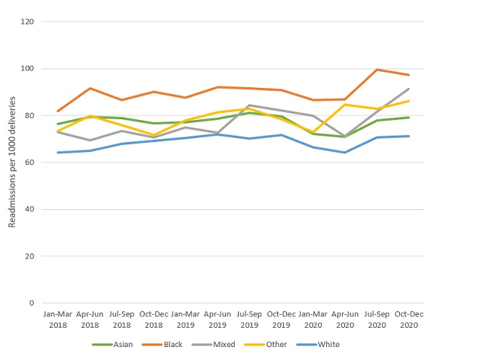  (CQC. 2022)
What two challenges does it face today?  Staff leaving the service:  The Royal collage of midwives (RCM). (2025), investigated a yearly report form the Nursing and Midwifery Council (NMC) on the numbers of newly and currently that are registered and those that have left the register in March 2025. For the registered last year there has been uptake of 5.8% but 46% leave as they are getting old or another most reason why is that of ill health, mental or physical health by 13%. This makes it hard for the service to manage workload effectively and care being missed due to not having enough staff to go around. |  |  | Community antenatal midwifery service  Why are they important?  Its important to have this service because when you’re a first-time mother, they have lots of questions but also their worry a lot as you never had a baby before, and these services can talk presser off an already stressful time as the body is changing and their hormones are all over the place. Also, they may not have great support at home.

References list

Care Quality Commission (CQC). 2023, Safety, equity and engagement in maternity services. Available at: https://www.cqc.org.uk/publications/themes-care/safety-equity-engagement-maternity-services. (Accessed: 23 October 2025).

Royal College of Midwives (RCM). 2025, History of Midwifery. Available at: https://rcm.org.uk/who-we-are/. (Accessed: 26 October 2025).

Royal College of Midwives (RCM). 2025, Latest NMC report reveals concerning snapshot of why midwives are leaving the register. Available at: https://rcm.org.uk/blog/2025/06/latest-nmc-report-reveals-concerning-snapshot-of-why-midwives-are-leaving-the-register (Accessed: 23 October 2025).

The history of the NHS

Introduction

This essay is going to discuss the origins of the National Health Service (NHS) and what is the NHS is, then explore the historical factors that started the NHS. This essay will also give a brief understanding on how the NHS is currently structured and its function.

Origins

- Historical Context:
Prior to the concept of the NHS the healthcare in Britain was divided, here are 4 key issues that brought the idea of the NHS to light.
- Inequality
This means depended on what class people was in for e.g., the poor population couldn’t afford health insurance and the high cost of health care at the time, relaying on charity’s funded hospitals and local healthcare that was poorly funded, overcrowded. As for the richer population had the funds for privet healthcare which didn’t have these issues. (Campbell, J. (2002)
- No universal access system
Which created people to see this more as lucky if they could have it and wasn’t a right to have as if they lived in a part of the country that lack infrastructure for available healthcare made it harder to access proper health care if needed to see medical professionals. (Edgerton, D. (2007)
- Private healthcare
Because of it, only being easily accessible for the wealthy population in hospitals and other healthcare places had small waiting times, when no-profit organizations had lack of recuses and didn’t have regular care. (British Medical Association (n.d.) and Edgerton, D. (2007)
- WW2 and Great depression
The impact of these in Britain showed that the current system before the NHS wasn’t functioning, this then developed the national unity for a power of a joint action to push for a more improved system. (Campbell, J. (2002)

- Key Influences:
Here are some of the key influences of starting the NHS is that the economy was tuff for on the population of the UK because years of 1920s and 1930 with the great depression making it very for families especially those of the lower class not being able to have the day-to-day necessities and that involves healthcare. Jurying this time, it gives people insight of the current problems in the with public health as there was an increase of campaigns for more equality in the rich and poor population. This then made the labour parity aimed for a social reform and to help build for a government paid healthcare system and free universal access healthcare. Also, the influenced a change was Aneurin Bevan who was the minister of health before the war with the idea of the NHS. (Campbell, J. (2002), Edgerton, D. (2007)

- Establishment:
The NHS was first implemented in 1948 by Aneurin Bevan Minister for Health and the Labour party after the WW2, the government also introduced some called The Welfare State this mean that they are responsible for the people of the UK, this meant form the day your born all the way to when you die that they will support the people of Britain. So having a free health care that is accessible to everyone is part of the welfare state system among free schooling, improved living. BBC Bitesize. (2019).

Current NHS

- Organizational:
The current minsters of health and social care that look over the NHS are The Rt Hon Wes Streeting, Karin Smyth, Stephen Kinnock, Baroness Merron, Ashley Dalton, Dr Zubir Ahmed. These people help maintained the different parts of the health care.
- Funding:
The way that the NHS is paid for is though national insurance that come out of everyone’s paycheck every month unless you are homeless, on Universal credit, not working or retired. The mount you pay is based on what the individuals earn a month. This still means it free to anyone that uses it.
- Challenges:
Some of what the NHS faces are that since Covid-19 pandemic happened it coursed a backlog on appointments as the whole country was on lockdown also the lack of staff as the population and immigration the county there is not enough staff in the services, this makes longer waiting times in like emergency services, also creates heavy workload and burn out.

Conclusion

All in all, this essay explored what led up to the NHS to be created and by who, when it was created. It also discussed the welfare state, then went into how the current NHS is who organizes is it, how its funded and what some of the challenges it faces today but remains a patient centered care and free-to-the-point-of-use.

Reference list

BBC Bitesize. (2019). Labour Reforms - The Welfare State 1945-1951 - Revision 1 - National 5 History - BBC Bitesize. [online] Available at: https://www.bbc.co.uk/bitesize/guides/zt4hvcw/revision/1. (Accessed: 26 October 2025).

British Medical Association (n.d.) Historical Archives. Available at: https://www.bma.org.uk (Accessed: 18 October 2025).

Campbell, J. (2002) Aneurin Bevan: A Biography. London: Penguin Books.

Edgerton, D. (2007) The NHS: A History. London: Profile Books.

