
Name: Edward Walden
Student Number: 2203426
Module: Engineering Management
Module Code: ACHA5012
Assignment Title: Project Planning
Date of Submission: 17th November 2024

Introduction
The level 5 group project for myself and the other people within my group is to make a series of upgrades the Honda NSF250, ideally making and implementing these upgrades in time for the 2025 competitive season. The primary reason as to why these upgrades are important is because the Honda NSF250 is being entered into a more competitive racing class than it competed in earlier in 2024, meaning we need these upgrades to ensure that the bike is not only faster in and of itself, but also able to compete with the higher powered motorcycles it will be put up against.

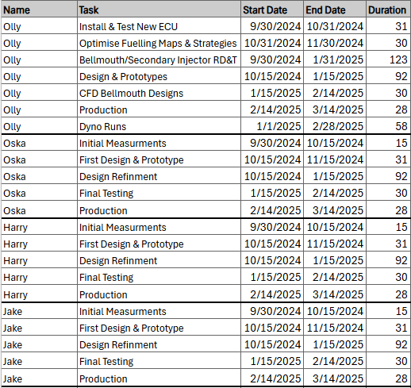
Group Roles

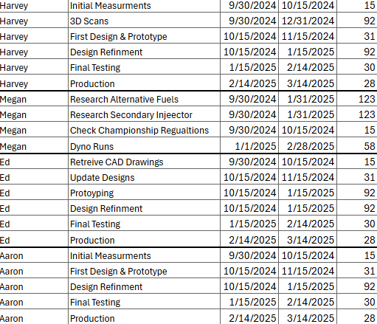

The table above shows each team members roles and responsibilities within the group project, alongside each tasks predicted start and end date as well as how long we believe each task should take. These figures are not concrete however, as the individual will not know how long each task will take them until they actually get around to doing them.
Each role/responsibility for the different parts of the group project was chosen in order to best match each person’s individual skillset and personality traits. The method we used to decide this was using ‘Belbin’s’ model, which outlines nine distinct roles that individuals will typically take on when placed in a team environment.
These roles, along with their strengths and weaknesses have been outlined in the table below:
Role | Definition | Strengths | Weaknesses
Plant | The creative innovator who comes up with ideas and solutions | Imaginative, innovative, able to think outside the box to solve difficult problems | Can be overly focused on ideas and may overlook details or practicality elements
Resource Investigator | The networker, who explored opportunities and brings in external information and resources | Extroverted, enthusiastic, and skilled at discovering new ideas and building connections | May lose interest once the initial excitement dissipates, causing them to sometimes fail when trying to follow through on ideas
Co-ordinator | The leader, who organises and directs the team, ensuring everyone is focused and working together | Confident, good and delegating, and able to bring out the best in others | Can be seen by other team members as manipulative or controlling, particularly if they try to dominate decision making aspects within the team
Shaper | The individual who challenges the team, pushing them to overcome obstacles and keep pushing forward with the project | Dynamic, challenging and thrives under pressure | Can be easily frustrated and may clash with the others when things aren’t progressing as quickly as the rest of the team would like
Monitor Evaluator | The analyst who critically evaluates ideas and strategies to make sure they are feasible | Logical, objective, and good at making informed decisions | May come across as overly critical or detached, focusing more on analysis than action
Teamworker | The supporting role who works to resolve team conflicts and ensure smooth collaboration | Co-operative, empathetic and good at building relationships | Can be indecisive and may avoid their own conflicts, potentially sacrificing clarity for group cohesion
Implementer | The organiser who turns ideas into practical plans and ensures that tasks are carried out efficiently | Practical, reliable, and disciplined in implementing different strategies | Can be inflexible or resistant to new ideas, preferring to stick to their own/established methods
Completer Finisher | The perfectionist who ensures that all tasks within the project are completed to the best standard they can, as well as making sure they are completed on time | Detail-orientated, ensures nothing important is overlooked in the team | Can be overbearing when trying to make sure everything is perfect, which can end up delaying progress of tasks within the team.
Specialist | The expert who is able to provide knowledge and assistance in a specific area | Highly skilled, focused and offers valuable technical expertise | Can become overly focused on their area of expertise and may not contribute as much to broader less skilled team tasks

The best suited traits for my task of redesigning the airbox for the Honda NSF250 would, first, be Plant, as this tasks requires a high level of creativity to not only redesign the airbox, but also make sure that the improvements that the team wants are applied to the new airbox.
Additionally, Resource Investigator would also be quite a useful trait to have for this specific task, as outside sources, for example, it would be worth reaching out to other engineers who may have done similar projects in the past, but also it would be useful to have specialists in fields like fabrication to help with this task, as the group may not have any experience in some of the more practical parts of this task.
Finally, an important trait to have would be the Implementer trait, as the task of redesigning the airbox requires multiple prototypes to be modelled, fabricated and also tested to ensure that they are in fact better than the original airbox.

List of Tasks:
1. Initial Design Phase
Tasks Involved:
- Analyse Current Airbox Design: Examine the existing airbox for performance issues (airflow, space constraints, mounting points, etc.).
Time Estimate: 4 hours
Duration: 1 day
- Define Design Objectives: Set specific goals such as airflow optimization, reduced weight, improved throttle response, and compatibility with the intake and exhaust system.
Time Estimate: 6 hours
Duration: 1 day
- CAD Modelling: Create a 3D model of the new airbox using CAD software (e.g., SolidWorks, AutoCAD, CATIA).
Time Estimate: 16 hours
Duration: 3 days
- Review and Refine Design: Conduct internal design reviews, possibly with the engineering team or using CFD (Computational Fluid Dynamics) simulation to assess airflow performance.
Time Estimate: 8 hours
Duration: 1 day
Total for Design Phase: 34 hours (5 days)

2. Prototyping Phase
Tasks Involved:
- Prepare 3D Printed Prototype (Optional): Use 3D printing for a first iteration of the airbox design to evaluate fitment and initial airflow testing.
Time Estimate: 10 hours
Duration: 2 days
- Refine Prototype Design: After reviewing the 3D printed prototype, refine any areas that need adjustment in the design (mounting points, dimensions, etc.).
Time Estimate: 8 hours
Duration: 1 day
- Prepare for CNC Milling/Fabrication: Generate CNC machine-ready files from the CAD model for the airbox components.
Time Estimate: 8 hours
Duration: 1 day
Total for Prototyping Phase: 26 hours (4 days)

3. Fabrication Phase
Tasks Involved:
- Material Sourcing: Identify and order materials for the airbox (e.g., carbon fibre, plastic, aluminium, rubber gaskets).
Time Estimate: 4 hours
Duration: 1 day
Bill of Materials:
  - Carbon Fiber Sheets: $200 (1-2 weeks lead time)
  - Aluminium Sheets: $150 (1 week lead time)
  - Plastic Resin (ABS, Polycarbonate, or Nylon): $100 (2-3 weeks lead time)
  - Rubber Gaskets: $30 (2-3 days lead time)
  - Fasteners (Stainless Steel Bolts, Nuts, Washers): $20 (3-5 days lead time)
  - Epoxy Resin (for bonding carbon fibre parts): $50 (2-3 days lead time)
- CNC Milling/Lathe Operations: Machining of airbox parts, including precision cuts and holes for intake and mounting points.
Time Estimate: 20 hours
Duration: 3 days
- Composite Layup (if applicable): Lay-up carbon fibre or fiberglass for parts that require lightweight and strong material. This includes curing time.
Time Estimate: 16 hours
Duration: 3 days (including curing time)
- Assembly: Assemble the fabricated parts, install gaskets, mounts, and perform fitting checks on the bike to ensure compatibility.
Time Estimate: 10 hours
Duration: 1-2 days
Total for Fabrication Phase: 56 hours (10-11 days)

4. Testing and Tuning Phase
Tasks Involved:
- Fitment Testing: Install the airbox on the bike and check for proper fitment, clearance, and sealing. Adjust as necessary.
Time Estimate: 6 hours
Duration: 1 day
- Airflow Testing: Conduct airflow tests, either with a flow bench or using in-situ testing methods (e.g., pressure probes, sensors) to measure performance gains.
Time Estimate: 8 hours
Duration: 1-2 days
- Tuning and Adjustments: Based on test results, make any necessary design adjustments (e.g., enlarging inlet/outlet openings, optimizing internal volume, or altering mounting points).
Time Estimate: 6 hours
Duration: 1 day
- Final Assembly and Quality Check: Ensure the final airbox is clean, sealed, and all fasteners are tight and secure. Perform final visual and functional inspections.
Time Estimate: 4 hours
Duration: 1 day
Total for Testing and Tuning Phase: 24 hours (4-5 days)

Specialist Equipment Required:
- CAD Software (SolidWorks, CATIA, Fusion 360)
- CFD Software (ANSYS Fluent, OpenFOAM)
- 3D Printer (FDM or SLA)
- CNC Milling and Lathe Machines
- CNC Router
- Composite Layup Equipment (Autoclave, vacuum bagging)
- Mold Making Tools (Silicone or fiberglass molds)
- Injection Moulding Machine (for high-volume production)
- Laser Cutter or Waterjet Cutter
- Torque Wrenches and Precision Tools (Calipers, Micrometres)
- Flow Bench
- Digital Pressure Sensors and Data Loggers
- Engine Dynamometer (for testing engine performance)
- Smoke Testing Machine (for leak detection)
- Flow Meters or Anemometers
- Thermal Cameras or Temperature Sensors
- Vibration Testing Equipment
- Finishing Tools (Belt Sanders, Die Grinders, Heat Gun)

Preliminary Bill of Materials (BOM) with Estimated Costs:
Item | Quantity | Unit Cost | Total Cost | Lead Time
Carbon Fiber Sheets | 2 sheets | £79/sheet | £158 | 1-2 weeks
Aluminium Sheets | 2 sheets | £59/sheet | £118 | 1 week
Plastic Resin (ABS/Polycarbonate) | 1 kg | £79/kg | £79 | 2-3 weeks
Rubber Gaskets | 3-5 units | £5/unit | £15-25 | 2-3 days
Epoxy Resin (for bonding) | 1 litre | £39/litre | £39 | 2-3 days
Stainless Steel Fasteners | Assorted | £16 | £16 | 3-5 days
Miscellaneous (tools, consumables) | N/A | £39 | £39 | N/A
Estimated Total BOM Cost: £475
Lead Time for Materials: 2-3 weeks (varies depending on specific suppliers)

Overall Project Timeline:
- Design Phase: 5 days
- Prototyping Phase: 4 days
- Fabrication Phase: 10-11 days
- Testing and Tuning Phase: 4-5 days
Total Estimated Time: 23-25 days

Team Milestones
Throughout the group project there are certain milestones we are aiming to achieve which will demonstrate not only our progress but also our ability to actually fulfil the tasks we have undertaken.
The first milestone the team aimed for was getting measurements and making initial assessments at the start of the project, the goal if which is to get accurate measurements for component sizes and mounting points which will inform designs and modifications.
A second primary milestone we aim to achieve will be having the Honda NSF250 fully operational with all the new and improved components installed. The goal of this milestone is ensure the compatibility of the new parts with the rest of the motorcycle, which we will do by completing an initial engine operation where the NSF250 will be ran and observed to make sure nothing is out of place or interfering with the engines ability to run.
Another important milestone the team aims to achieve is Pre-Season Testing. This is important as it will be the first time the NSF250 is out on track with all the new components installed, which means it will be the first time the team is able to actually see firsthand if the new parts are an improvement in the areas they wanted to improve, but also, it will show the team the improvement in overall performance of the NSF250.

Gateway Objective
One primary objective as part of redesigning the airbox is to improve engine performance and output, and this is theoretically done by increasing airflow into the throttle body which will increase throttle response coming out of the engine and will therefore increase overall performance. The ideal improvement will be to increase power output by around 2-3% at peak RPM which will be tested via means of dyno testing and flow bench testing. The main improvement to the airbox will be to increase its volume, as this will increase air pressure inside the airbox, which means that when the throttle is made open, the air will move into the throttle body with not only more volume but more velocity. The improvement on just this change alone will only be an increase of around 1-2BHP over the engines original output, however with the NSF250 being raced in a more competitive class for the 2025 racing season, this small upgrade in speed and power, alongside the upgrades provided by the rest of the team, will ideally make the NSF250 a strong competitor.

Areas of Concern
The first area of concern with this task is that the airbox's main job is to make sure that clean, fast air enters the engine with the least amount of resistance and turbulence possible. Flow constraints caused by poorly built intake runners, air filter locations, or intake ducting can result in less than ideal airflow and, ultimately, worse engine efficiency. Efficiency, power production, and throttle response may all be impacted by this, especially in high rev or racing situations.
There are multiple ways that this issue can be resolved. The main method would be to incorporate the air intake and filter better into the airbox, adjusting where it can and will go will change the airflow, different placements can be tested using CFD (Computational Fluid Dynamics) which will also help to optimize the airflow through the airbox and into the throttle body, ideally ensuring there are no sharp or sudden turns that the airflow has to navigate.
The second area of concern is that the airbox has to fit in perfectly with the NSF250's design since, like the majority of racing motorcycles, it has a small frame. The demand for higher performance features, including larger intakes, better airflow, and more components (like sensors or temperature regulation), must be balanced with space limits. The redesign of the airbox must also take into consideration the impact on overall handling and weight distribution, vibration resistance, and ease of access for servicing and maintenance.
The way we intend to resolve this issue is by actually relocating the NSF250’s fuel tank to be closer to the sub frame, this means that not only is there more room at the front of the bike for the air box, but the added space from the relocation of the fuel tank means that it could be possible in the future for the airbox to be fully integrated into the fuel tank cover, as that extra space could be used to increase the airbox volume which may give the bike better performance.

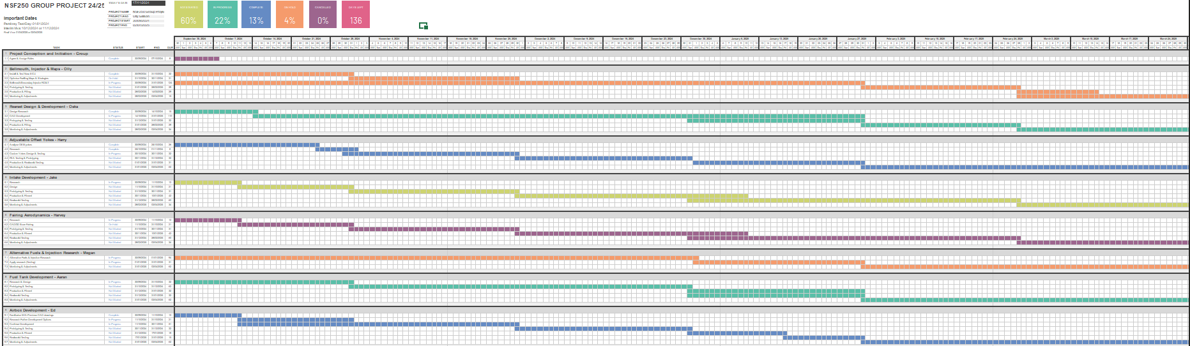
Gantt Chart and Milestones
The Gantt chart above details the whole group tasks, as well as showing week by week which tasks they intend to work on, providing an estimated timeframe for how long each of their tasks will take. Additionally, the table of milestones shows what the group is aiming to achieve over the time of upgrading the parts for the NSF250 including the final presentations the group will be making.


