Research Title:
A report submitted in fulfilment of the requirements for Modul BMSW4003, University of Wales Trinity Saint David, London

Abstract:

The COVID-19 pandemic and related emergency measures for Restrictions on the spread of the virus in England led to the cessation of all forms of university education. The learning process was reorganised and conducted from a distance in a virtual learning environment. A significant degree of freedom was given to teachers to define the models, forms, methods, and tools for organising the teaching and learning processes according to the student’s specific context and needs.
The main purpose of this study is to evaluate the impact of virtual learning in an electronic environment conducted in the period June-August 2021 on the effectiveness of high education on a course at the University of Wales Trinity St. David, London.

Rationale:

The crisis allowed some positive changes in the educational system. Some of them happened quickly, and the system employees were adapting rapidly to the new situation and continue to work responsibly in the name of education. E-learning platforms support the learning process by including tools for its organisation, management and overall administration, including learning materials, communication between participants and various tracking tools. E-learning in its various forms (e-distance, blended, mobile, etc.) is a relatively new opportunity to maintain and improve professional competencies, which has recently become increasingly popular.
A virtual learning environment optimises learner’s development; learners can acquire and expand their professional knowledge, skills, and competencies without being detached from their official, personal, and family commitments. In this sense, they support professional development and are the basis for innovative lifelong learning. The use of modern information and communication technologies is crucial for creating an innovative educational environment that can be easily adapted to the specific context of on-the-job training so that learning is accessible and convenient for employees and is combined in the best possible way. In this sense, VLE creates favourable opportunities to overcome many limitations of traditional face-to-face training.
Objectives:

Given the real risk of further waves of COVID-19, the institution must have clear plans, resources, and preparation for a smooth and timely transition to distance learning. It is essential to react as presently for the Moodle platform to be fully used and adjusted for all participants in the educational process.

This report aims to update data on the impact of the virtual environment so that informed decisions can be made about student’s difficulties.

Literature Review:
Moodle ™ means modular object-oriented dynamic learning environment. Founded and developed by Martin Dugiamas in 2002, Moodle проекти is designed to provide teachers, administrators and learners with an open, stable, secure and open platform for creating and providing personalised learning environments. Moodle ™ supports the training needs of a wide range of institutions and companies around the world. (https://ethinkeducation.com/what-is-moodle-guide/)
Today, Moodle ™ is the most widely used learning management system globally, with over 100,000 registered implementations worldwide, supporting over 150 million learners.
Due to its flexibility and scalability, Moodle ™ is adapted for use in education and many other community systems.
Open source platforms give trainees full access to the code on their Moodle site, giving them the freedom to customise the look and feel of their site and include branded content, innovative plugins, third-party tools and best practices. For e-learning in their learning strategy to create a personalised learning solution tailored to their specific learning needs.
Available for Apple iOS and Android-based devices, Moodle ™ Mobile allows learners to access course content; upload images, videos and other files; receiving notifications; send messages to classmates and teachers.
Moodle provider delivers additional security and ensures maximum uptime and data protection. In addition, backups are done regularly and are available when needed.

Methodology:
Due to the lack of specific tools for objective measurement of academic results (knowledge and skills) that can be attributed to the educational VLE, resulting from the termination of the present learning process at the university were used feedback based on self-assessment tools from students. The specific elements of the resource provision, the processes, and the results at the three levels form the framework model for assessing the impact of distance learning in an electronic environment, presented in Table 1.
The research methodology integrates the so-called Schulman’s Learning Table (Schulman, 2002), according to which student’s engagement serves as a “proxy” for learning, understanding, and identity, which in principle cannot be measured directly. According to Schulman’s theory, engagement is a fundamental goal of education. The logical chain on which his model is built is as follows: learning begins with the engagement of students, which in turn leads to the accumulation of knowledge and understanding.
Table 1. Framework model for assessing the impact of Virtual Learning Environment (VLE) – Moodle
Impact of Virtual Learning Environment (VLE) – Moodle

resource | process | effectiveness

That study used various data attributes such as quantitative, qualitative and social attributes to study the Impact of Virtual Learning Environment (VLE) – Moodle on student’s learning experience at the University of Wales Trinity Saint David London Campus. The study used primary and secondary data.
Primary data were collected through an online questionnaire Appendix 1 adopted from context-based literature.
Respondents to the questionnaire were asked to indicate their willingness to participate within two weeks, from 25 July to 8 August 2021. Twenty-five is the number of students in the research course. Sixteen participants took part in the survey, such as one of the participants were discarded, which was incompleted data. One of the most common methods for handling missing data, known as complete Managing missing data 191 case analysis, removes any case with missing data and conducts the analysis only on units that have complete data for all the variables under consideration (Graham, 2009). Advanced Research Methods for Applied Psychology (2018).pdf
The survey was anonymised, thus ensuring data protection and student confidentiality, and questions were addressed ethically. The data used in this study were collected voluntarily. A problem-oriented approach was applied to formulate the questions. “As your research progresses, a much clearer idea of what sources are relevant will emerge, and more questions will occur to you as your knowledge of the subject deepens (Tosh 2010 “ The analyse of documentary evidence 127page.
An online questionnaire was considered the optimum instrument for data collection to facilitate wide participation and efficient collection and analysis of quantitative data. The option is to gain some qualitative insights through close-ended questions. The questionnaire was designed using Microsoft Forms and disseminated via the mailing list and various other social media platforms such as WhatsApp and Teams.
The final questionnaire included ten close-ended questions. The questionnaire is provided in Appendix 1.
For analysis, the data from the questionnaire were downloaded from Google Forms in the form of an Excel spreadsheet. The approach adopted (based on Creswell’s eight steps (2003) for coding topics and the guidance of Miles and Huberman (1994)) was first to identify topics related to individual issues. It allowed me to see which topics were repeated the most and whether some cases were more evident in specific contexts. This thematic analysis was performed in Excel using keyword search, reading to identify, and counting functions.

Primary data

Primary Data Analysis:

Fifteen students took part in the online survey in July-August 2021 during distance learning at the University of Wales Trinity Saint David, campus London. The researching report is on the Impact of the virtual learning environment (VLE) – Moodle.

The structure of the survey considers content questions that collect data on:
- providing resources to students, including access to digital devices, the Internet and appropriate electronic educational resources;
- organisation of the learning process in the conditions of training;
- motivation, emotional-cognitive and behavioural student’s commitment to the learning process;
- to the respective satisfaction of the students with the distance learning.
The question consists of separate sections (groups of questions) for each of the listed thematic areas. Several scales have been formed that can verify an in-depth analysis of individual factors that have had the most profound impact on learning by allocating and assessing students for the effectiveness of the learning process.

Resources

Resource provision and creation of a safe electronic environment
This part of the report analyses the survey data, showing how students have electronic resources (access to electronic devices, the Internet and educational resources) suitable for their education at home. I will also monitor how effective they are using electronic devices, and thus electronic educational resources, in all subjects studied at the university.
All students stated that they have their smartphone, but 32% have difficulty providing the required device for online learning, which they can use for educational purposes. Also, 26% of students have problems accessing the Internet, which denies them from studying and participating in online lessons without technical issues and interruptions( Chart 2).
The data shows that the resource provision and use of electronic devices for educational purposes are relatively limited.
Chart 1. What device do you have for learning?
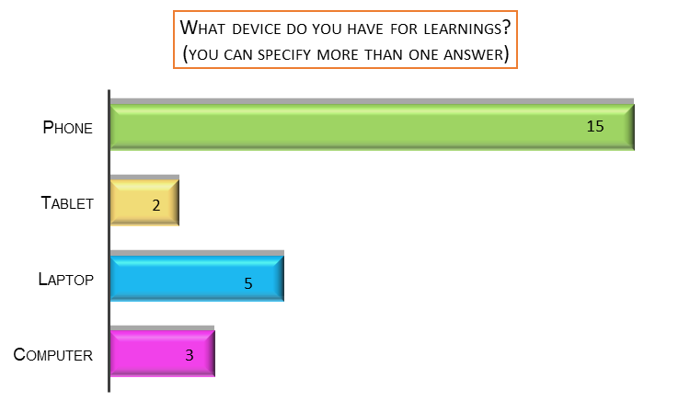

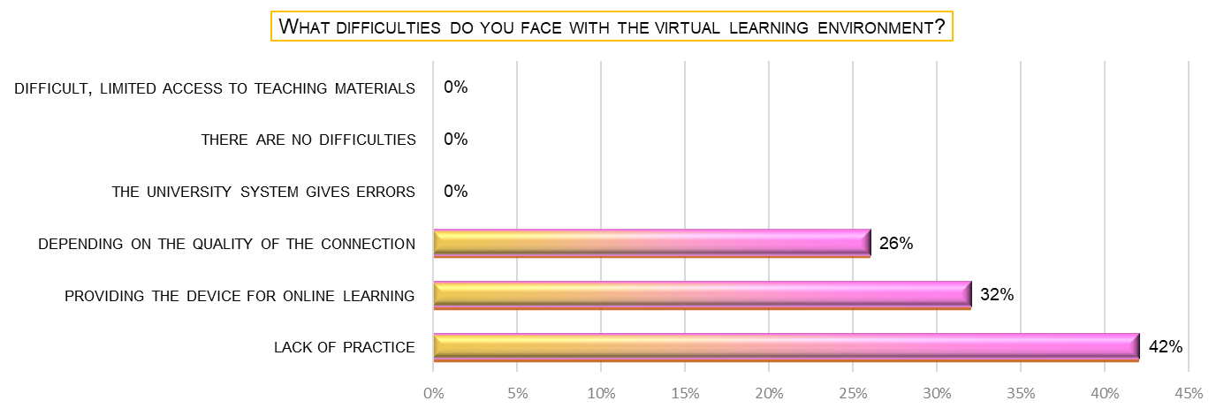
Chart 2. What difficulties do you face with the virtual learning environment?

Processes
The virtual learning process in an electronic environment has not been interrupted for system reasons (Chart 2). 100% of students participate for the first time in virtual learning in an electronic learning environment. Therefore, it is normal for 42% to answer that the lack of practice is the main reason for their difficulties (Chart 2).

Chart 3. Have you used this VLE before?
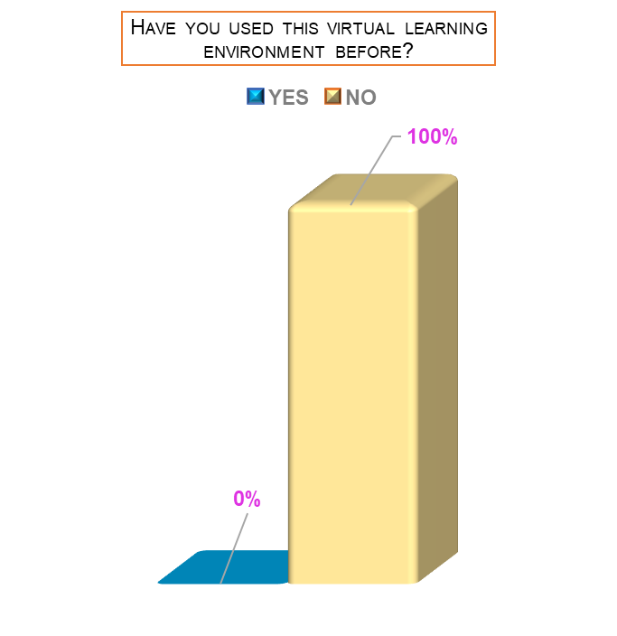
Less than half of the students - 42%, indicating that they used a VLE - Moodle for learning purposes less than 30 minutes per week in the 2020-2021 academic year. The remaining responses were distributed as shown in Chart 4.
Chart 4. On average, how much time per week do you use Moodle for personal training?
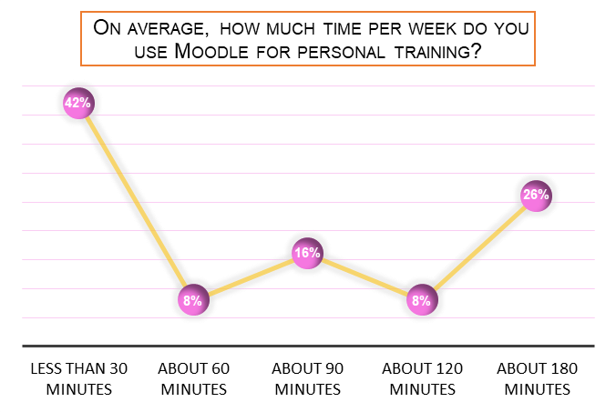

Effectiveness of the platform in terms of virtual learning
In order to study the efficacy of Moodle, questions focused on the platform’s content were included in the research toolkit. The study aims to analyse virtual learning processes and effectiveness; student’s responses to such aspects of the learning process reflect their overall impression.
On Chart 5, the most used applications are Module about 40% and Library 30% compared to the data. The 0% of use for Titanium and Email were considering with lack of tasks at this moment. The average 3,066 is the difficulty finding information from the scale from 1 to 5 (Chart 6).
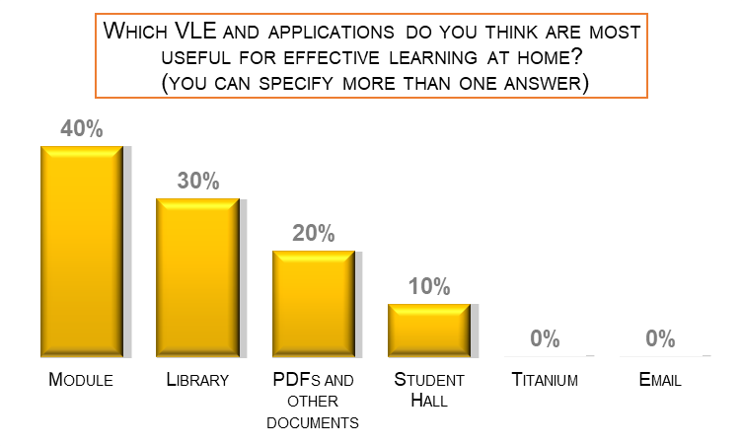
Chart 5. Which VLE and applications do you think are most useful for effective learning at home?

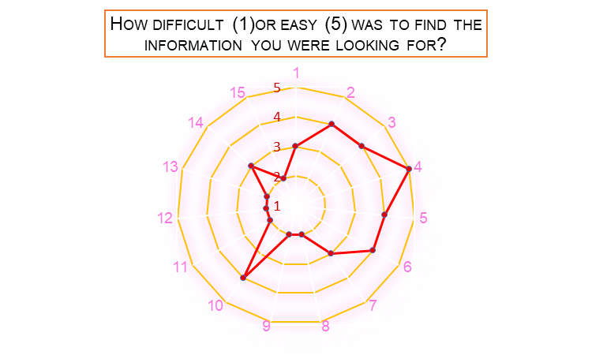
Chart 6. How difficult (1)or easy (5) was finding the information you were looking for it?
Average 3,066

The following Chart 7 presents the proportion of students who chose the Yes / No option related to the listed characteristics for VLE. All learners like course content, and Moodle does not cause stress even though they face it for the first time VLE. Moreover, 73% of students demonstrate a Neutral level of satisfaction (Chart 8).
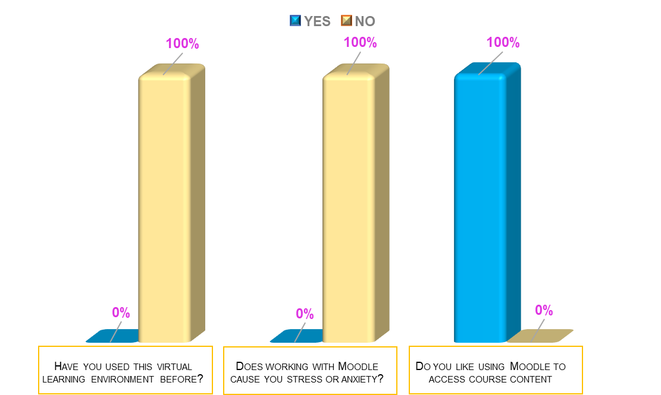
Chart 7. Have you used this virtual learning environment before? Does working with Moodle cause you stress or anxiety? Do you like using Moodle to access course content?

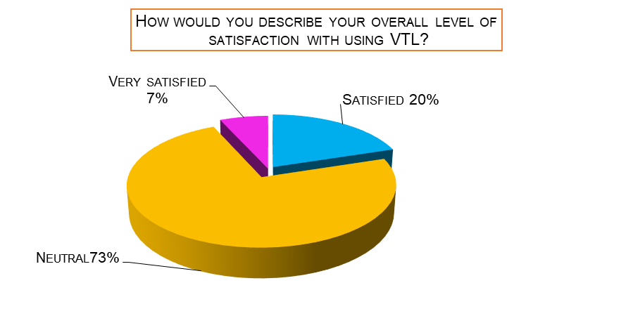
Chart 8. How would you describe your overall level of satisfaction with using the virtual?
The data shows that for most students, VLE has led to a significant change in the way of learning and the organisation of the university day, without this substantial causing difficulties.
Overall, it was easy for students to learn after introducing VLE; they have adapted to the changed learning conditions. Students are more likely to be satisfied with the way the learning process has gone and consider they have had the opportunity to learn thoroughly.

Secondary data
Research of published material on the topic was gathered and analysed as a secondary data collection tool. The value of the two researcher’s presence was used to verify the value of the primary data and achieve a complete interpretation of the data. This approach is defined by Cornish et al. (2014) as a process in which “there is a joint focus and dialogue between two or more researchers on a shared data set in order to achieve a coherent interpretation file:///C:/Users/maria/Desktop/%D0%94%D0%B8%D0%B3%D0%B8%D1%82%D0%B0%D0%BB%D0%BD%D0%B8%20%D1%83%D0%BC%D0%B5%D0%BD%D0%B8%D1%8F/kaka%20Lili/BALEAPReportCovidandEAPMay2021.pdf

Corresponding to most reports in Google Scholar, websites and online magazines, the lack of e-devices make it difficult and limited for students in e-learning. One more challenge is access to the Internet and the availability of a quality Internet connection are key conditions for conducting distance learning in an electronic environment, for asynchronous teaching and learning process, and for maintaining active relationships between teachers and students and between students themselves.

The conduction on secondary data confirmed that the functionality and plugin capabilities of the Moodle™ offer an engaging and effective e-Learning experience for students of all ages. Moodle™ allows for unique learning methods such as competency-based education, mobile learning, accessible guidebooks and interactive online classrooms. The platform seems to be easy and does not stress the students. Form the same site

Conclusion/Recommendation:

Currently, we have a small but significant percentage of the population who have limited access to devices and connectivity, and are therefore socially disadvantaged and unable to develop the skills that come from frequent (and even habitual) use of technology for communication that many people now take for granted. We also have issues with literacy at its most basic level.
Digital Literacy Unpacked, edited by Katharine Reedy, and Jo Parker, Facet Publishing, 2017. ProQuest Ebook Central, http://ebookcentral.proquest.com/lib/trinity/detail.action?docID=5490897.
Created from trinity on 2021-09-01 14:48:30.
Reedy, K, & Parker, J (eds) 2017, Digital Literacy Unpacked, Facet Publishing, London. Available from: ProQuest Ebook Central. [1 September 2021].
This document aims to create knowledge about the factors that influence the acceptance and use of the Virtual Learning Environment (VLE) among students at the University of Wales Trinity Saint David, London. The study concludes that the facilitating state and user experience positively influence students perceived usefulness of VLE. On the other hand, perceived usefulness and subjective norms do not affect the perceived effectiveness of VLE. Similarly, perceived ease of use is positively influenced by self-efficacy, user experience, and personal criteria, but the facilitating state does not affect this. Supported by much literature, the study also notes that perceived ease of use has a powerful effect on the perceived usefulness of VLE.
Similarly, both the perceived ease of use and the perceived utility of VLE have a positive effect on the behavioural intention to use VLE to a similar extent. Behavioural intent to use VLE also has a positive impact on the actual use of the system. As a result of the analysis of the mean and frequency, the study concluded that students usually have a high degree of intention to use VLE. From a management perspective, the findings show that it is imperative to ensure that the VLE system is easy to use and valuable, as these variables are essential for students’ intention to use VLE. It is also observed that the perceived utility is significantly affected by only two external variables.
Therefore, a future study may be conducted to identify variables that affect the perceived usefulness of VLE. The study also recommends that VLE system administrators and teachers ensure that VLE-related expectations and needs of students are taken into account, as user experience proves to be an essential indicator of the perceived usefulness of VLE.

If you want to understand what science is, you should look in the first instance, not at its theories or its findings, and certainly not at what its apologists say about it; you should look at what the practitioners of it do. – Clifford Greertz (1973, p.5) https://books.google.co.uk/books?id=Hr11DwAAQBAJ&lpg=PP1&ots=Xj-wuNDBsE&dq=thematic%20analysis%20secondary%20data&lr&hl=bg&pg=PA1#v=onepage&q=thematic%20analysis%20secondary%20data&f=false Applied Thematic Analysis
Greg Guest, Kathleen M. MacQueen, Emily E. Namey SAGE Publications, 9.11.2011 г. - 320 страници

