Assignment 2: Marriott International

Name: Martin Cristian Miklosi
Student Number: 1815981
Module Title: Management for the Hotel Industry BMIH5007
Lecturer: Dale Clark

EXECUTIVE SUMMARY

The purpose of this report shows how important it is to analyse a company's success in the hospitality industry, and this research aims to do just that through an analysis of financial parameters. The evaluation focuses on the company's non-financial performance, which serves as a preliminary to evaluating the company's financial performance.
There are two distinct but equally valuable applications for the study of financial ratios. Can be used to look at how your business is doing now compared to how it was doing last quarter or even several years ago. As a result, you may be able to better pinpoint the issues that need attention. Better still, it can alert you to issues that you can prevent. May also use these ratios to evaluate how well the business is doing in comparison to others in its industry.

Table of content

Executive Summary 1
Introduction 3
Financial Analysis Trends 4
Profitability 4
Liquidity 4
Gearing 4
Knowledge from Ratio Analysis 4
Benefits and Limitations of Ratio Analysis 4
Conclusion (average of 10% of word count) 5
Bibliography 6

INTRODUCTION

Marriott International, Inc. (Marriott) is a hotel and restaurant chain that provides various hospitality-related services. A number of upscale, premium, and elite hotel, residential, and timeshare brands are among those it manages, franchises, and licences. In addition to daily expenditures made with co-branded credit cards, members can earn points by staying at hotels and resorts, including all-inclusive resorts and premium home rental.
The primary function of financial statements is to reveal an institution's performance, assets, liabilities, and cash flow. The income statement reveals key details regarding a company's profitability. What's more, it indicates the scale of sales, as well as the character of the various classes of expenses, based on the method of collecting the relevant data. A company's financial data is useful for making assessments of its current performance, as well as its performance relative to prior years, competitors, and from the perspective of various stakeholders. There are many uses for financial records, but one of the most common is performance evaluation. Successful hotel management relies heavily on accurate financial statements. Hotel's financial health can be determined from a variety of financial statements, each of which displays somewhat different data.

Financial analysis – Figure 1
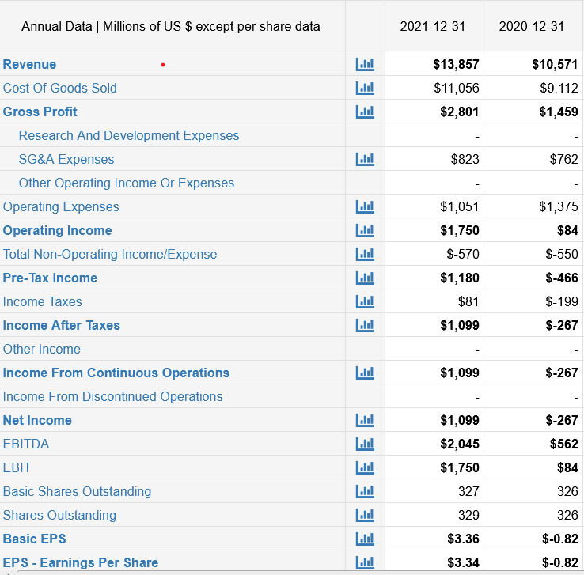

Figure 2

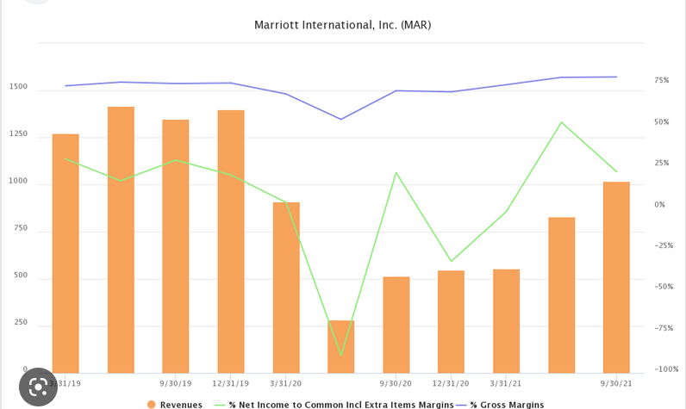

Financial analysis trend

Companies evaluate their financial health and progress using profitability ratios and other financial metrics. Throughout the course of the fiscal year, a firm can examine its finances using ratios to determine when and where it is financially successful, as well as how it can increase earnings going forward.
Marriot gross profit was decline wit 54.65% in 2020 but was increase in 2021 with 91,98 %, demonstrate that the coronavirus had a limited impact on company. On assets the increase shows a proportion of 3,45 % and decline of 1,4% in 2020. Despite their difficulties, Marriot was able to successfully navigate the pandemic and turn a profit.

LIQUIDITY
The liquidity ratio measures a company's short-term debt repayment capacity and is a sort of financial measurement. This ratio is useful for figuring out whether or not a business can pay its short-term debts with its available cash on hand.

GEARING
The term "gearing ratio" refers to a broad category of financial ratios that measure the relationship between the firm's equity (or capital) and its debt. The gearing ratio is one of the most common tools for assessing a company's financial health, as gearing is a measure of financial leverage.

KNOWLEDGE OF RATIO ANALYSIS

In order to assess the effectiveness of a company's profit-driven activities over a specific time frame, financial and economic ratios are calculated. If a ratio is to be meaningful, it must be compared to an established baseline. It's possible that the average ratio in a certain industry is the least valuable kind of "standard ratio." While similar hospitality firms with similar operations are a good source for developing industry standards, they may be dispersed across a vast geographical area.
Ratios are the cornerstone of operational benchmarking because they provide data with context by standardizing it and ensuring its comparability. There is no right or wrong ratio when it comes to analysing the data but understanding the strengths and limitations of each type is key to interpreting the numbers and drawing conclusions from them. By consistently tracking their chosen ratios against a relevant competitive set, hoteliers can find opportunities to increase revenue, control costs and, ultimately, optimize the bottom line. A major benefit of ratio analysis is that it promotes a methodical strategy for examining efficiency and effectiveness.

BENEFITS AND LIMITATIONS OF RATIO ANALISYS

An organization's financial statements must be prepared and then analysed. Ratio Analysis is one method that may be used to examine and evaluate a company's financial health. The stakeholder is then able to have a deeper understanding of the financial situation of the organisation and make more informed decisions. A company's financial statements can be reduced to a few figures using financial ratio analysis, which provides insight into the company's profitability and financial status. The net effect of a company's revenue after deducting all expenses is captured by the net profit margin. This method involves drawing inferences about a company's profitability without having to examine the income statement. Financial ratios provide a standardized method with which to compare companies and industries. Using ratios puts all companies on a relatively equal playing field in the eyes of analysts; companies are judged on their performance rather than their size, sales volume, or market share. Beyond simple numerical values, ratios offer important information about a firm, such as its ability to turn a profit, secure capital, develop through sales rather than debt, and more. With the use of ratios, we may see patterns in specific industries and establish norms against which the efficiency of all participants can be evaluated. Companies of all sizes can benefit from using industry benchmarks to establish organisational strategy and clearly evaluate performance against competitors and the market as a whole.
Investors and analysts are able to more effectively evaluate and explain the strengths and weaknesses of specific companies or industries when they use a common language and have a solid understanding of ratios. When used for the purpose of investing, fundamental analysis refers to the process of establishing the relative strength of several companies by comparing their respective financial ratios. When drawing out business plans or pitch decks for lenders and investors, entrepreneurs can benefit from using ratios as a guide. Business owners can use industry trends as a starting point for setting time-bound performance targets in terms of certain ratios that will provide investors a glimpse into the potential of the new company.
Both analysts and investors should be aware of the major limitations of ratio analysis. Financial statement accounting data is used to calculate ratios. However, accounting numbers can have their own flaws, be approximated, vary depending on how they're actually used, or even be manipulated. Therefore, it is not recommended to draw solid conclusions based on ratios. Even between businesses in the same sector, there may be difficulties in making meaningful comparisons due to differences in accounting practises surrounding such issues as depreciation, asset life estimation, amortisation of intangibles, preliminary expenses, and the classification of extraordinary events. Accounting ratios may have less value than they otherwise would be due to inflation. Financial statements and accounting figures based on historical costs do not reflect current value figures due to inflation, especially in the case of assets purchased at different dates by the various firms.
While accounting ratios can be useful, they should only be used after other factors, such as the state of the economy, the state of the industry, the position of individual firms within the industry, the nature of the firm's operations, the size of the firm, and the variety of its products, have been considered. Accounting ratios' value is affected by both the computing methods and the resulting data. Despite appearing to be the same on the surface, accounting ratios can be confusing due to the wide variety of methodologies used to determine the numerator and denominator.

Conclusion

A market trend simply reflects the prevailing movement of prices over time. There are no rules for determining how long a trend should be observed for, albeit the longer it has persisted in one direction, the more weight it is given. Revenue for Marriott International, Inc., a global hotel chain, was roughly $13.86 billion in 2021, up from $10.57 billion in 2020. In 2020, the company's revenue plummeted to $10.57 billion due to the widespread spread of the coronavirus (COVID-19).
In conclusion 2021 was financially a good years for Marriot International, they overall profit was higher than in 2020 even if they faced challenges with the pandemic, they managed to budget well.
The company reported $3.19 in adjusted diluted earnings per share (EPS) for the entire year, which is a significant increase over the projected earnings of $0.18 per share in 2020.

References list:

Forbes (2019). Forbes. Forbes. [online] Available at: https://www.forbes.com [Accessed 2 Dec.2022]

CFI (2019). Financial Modeling Courses & Training - Financial Analyst Certification. [online] Corporate Finance Institute. Available at: https://corporatefinanceinstitute.com [Accessed 3 Dec.2022]

Hospitality Net (2019). Hospitality Net – Home. [online] Hospitality Net. Available at: https://www.hospitalitynet.org. [Accessed 2 Dec.2022]

AccountingTools (2019). AccountingTools. [online] AccountingTools. Available at: https://www.accountingtools.com. [Accessed 4 Dec. 2022]

https://www.facebook.com/bbc (2019). BBC - Home. [online] BBC Homepage. Available at: https://www.bbc.co.uk [Accessed 2Dec.2022]

Indeed (2021). Job Search | Indeed. [online] uk.indeed.com. Available at: https://uk.indeed.com. [Accessed 4 dec. 2022]

Investopedia (2022). Sharper Insight. Smarter Investing. [online] Investopedia. Available at: https://www.investopedia.com/. [Accessed 3Dec.2022]

Macrotrends (2010). Macrotrends | The Long Term Perspective on Markets. [online] Macrotrends.net. Available at: https://www.macrotrends.net.[ Accessed 1 Dec.2022]

www.google.com. (n.d.). marriott 2020-2021 - Google Search. [online] Available at: https://www.google.com/search?q=marriott+2020-2021 [Accessed 2 Dec. 2022].

