

Name: Mason Tobias

Student ID:2506377

Lecture: Besty Jose

Module: Professional Development within Health and Social Care

Module Code : LCHS4009

Assignement Title : Personal Development Portfolio

Submitted on : 23/07/2026

Table of Contents
- Cover page………………….1
- Table of contents……………..2
- Job Advertisement…………….3
- Introduction………………….4
- Task 1 – Curriculum Vitae (CV)……………...5
- Task 2 – Personal Statement…………………7
- Task 3a – SWOT Analysis…………………………...10
- Task 3b – Personal Development Plan (PDP)……...12
- Task 4 – Gibbs Reflective Cycle………………………14
- References………………………………………………...18

Job Advertisement

Position: Children’s Residential Social Care Worker

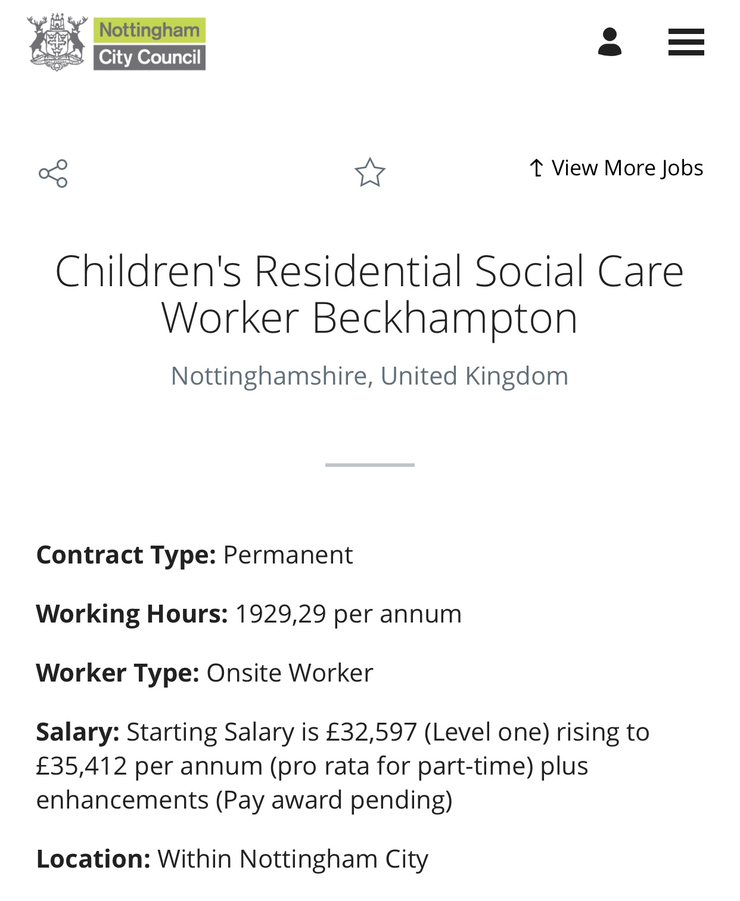

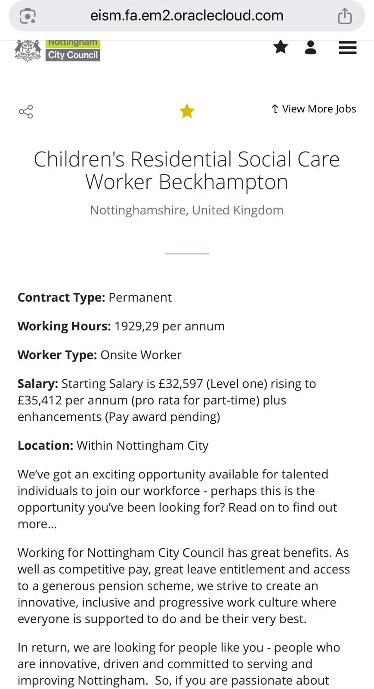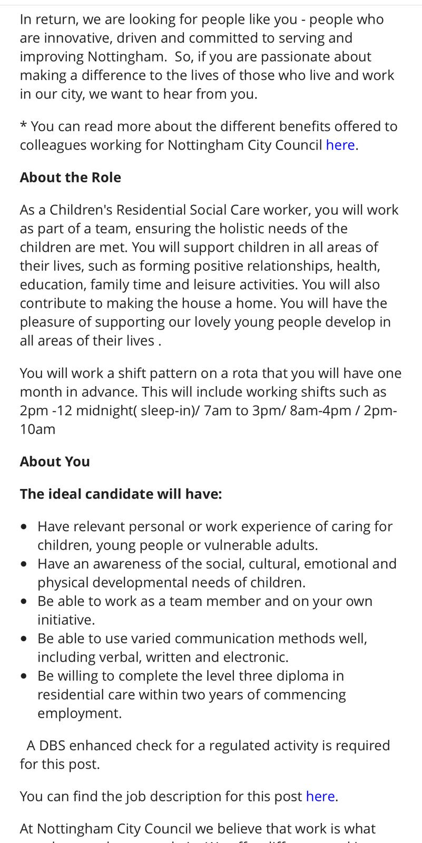
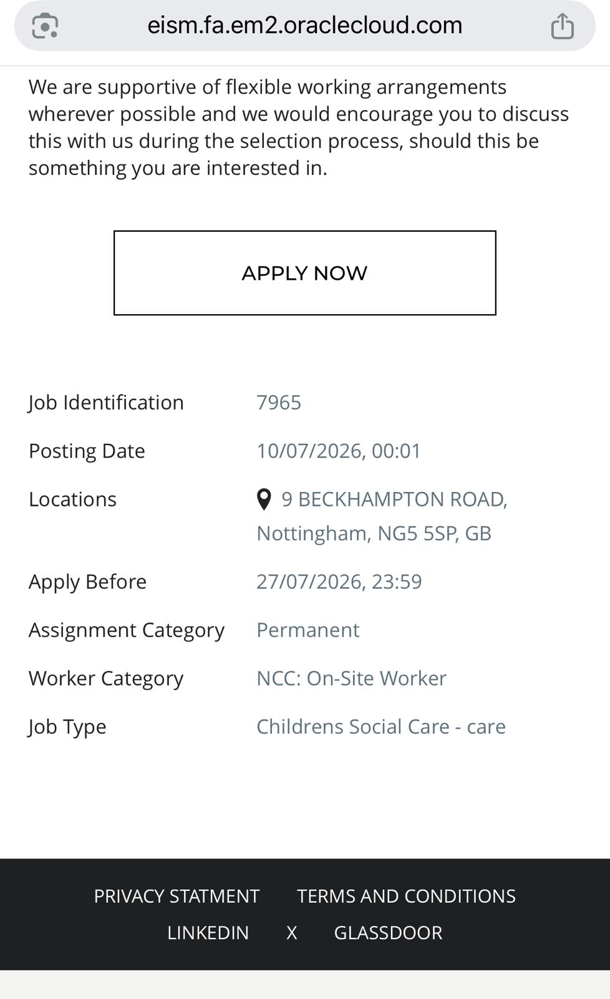

Introduction

This professional development portfolio has been developed to support an application for the role of Children’s Residential Social Care Worker with Nottingham City Council Children’s Services. The role aligns with my career ambition of supporting children and young people who may experience vulnerability, disadvantage, or challenging life circumstances. Children’s residential care workers have an important responsibility in promoting children’s safety, emotional wellbeing, development, and independence through relationship-based and person-centred support (Department for Education, 2015).
I have developed a strong interest in health and social care through both academic study and practical experience. I have approximately ten years' experience working with adults, children and young people across community and clinical settings with several organisations. These experiences have strengthened my communication skills, empathy, teamwork abilities and understanding of supporting individuals with diverse needs.
I am currently studying Level 4 Health and Social Care at university and working towards progression to Level 5. My academic development has enhanced my understanding of safeguarding, equality, professional values, and person-centred approaches. These values closely match the expectations of a Children’s Residential Social Care Worker, where staff are required to provide safe, nurturing, and inclusive environments for children in care (Nottingham City Council, 2026).

Task 1 – Professional Curriculum Vitae

Name: Mason Tobias
Address: 32 Oxclose Lane, NG5 6GA, Nottingham, United Kingdom.
Phone: 07848794777
Email: 2506377@student.uwtsd.ac.uk

Professional Profile
Compassionate professional Support Worker with over 10 years of experience supporting children, young people, adults with mental health needs, autistic individuals, and older adults. Skilled in safeguarding, medication administration, person-centred care, communication and multidisciplinary working. Currently studying Level 4 Health and Social Care at UWTSD Birmingham Campus and enrolled on Level 5 from September 2026. Seeking the Children's Residential Social Care Worker role with Nottingham City Council.

Key Skills
Safeguarding; Trauma-informed care; Person-centred care; Medication administration; Mental health support; Autism support; Behaviour support; Risk assessment; Record keeping; Teamwork.
Communication; Equality and diversity.

Employment History
Support Worker – Fast Supporting Service Ltd (March 2022–Present)
• Person-centred care Approach Training
• Medication administration
• Support with appointments, shopping, and education
• Safeguarding Training Assistant Coordinator
• Maintaining Accurate records

Support Worker – Green staff Medical Ltd (March 2016–April 2022)
• Medication administration
• Activities coordination
• Responsible Adult for young people in police custody and court
• Supported children, young people, mental health, autism, and older adults

Education
University of Wales Trinity Saint David (UWTSD), Birmingham Campus
Level 4 Health and Social Care (Expected September 2026)
Level 5 Health and Social Care (Starts September 2026)

Training
Mandatory Combined Care Certificate; First Aid; Basic Life Support; Immediate Life Support.
Trauma-Informed Care; Safety Intervention Training; Safeguarding; Medication administration.

References
All relevant references are available upon request, please.

Task 2 – Personal Statement-Application for the Position of Children’s Residential Social Care Worker
I am applying for the position of Children’s Residential Social Care Worker with Nottingham City Council because I am enthusiastic about supporting vulnerable children and young people to achieve positive outcomes and reach their full potential. Throughout my career as a Support Worker, I have developed the knowledge, practical experience and professional values needed to provide safe, compassionate, and person-centred care. I believe my experience, combined with my commitment to continuous professional development, makes me a strong candidate for this role.
Over the past ten years, I have worked as a Support Worker for Green Staff Medical Ltd and Fast Supporting Service Ltd, supporting children, young people, adults with mental health conditions, autistic individuals, and older adults. My responsibilities have included administering medication, coordinating meaningful activities, supporting individuals in attending healthcare appointments, assisting with education, and promoting independence through person-centred care. I have also acted as a responsible adult for young people attending police custody and court, which required professionalism, confidentiality, and the ability to remain calm in challenging situations. These experiences have strengthened my communication, safeguarding and critical thinking skills while enabling me to build positive relationships based on trust, empathy, and respect (Skills for Care, 2024).
One of my greatest strengths is my ability to provide compassionate, trauma-informed care while recognising the unique needs of every child and young person. Nottingham City Council’s Children’s Residential Service places significant emphasis on promoting children’s physical, emotional, educational, and psychological wellbeing. I fully support this approach because I believe children who have experienced trauma require consistent, nurturing relationships that encourage resilience, confidence, and emotional development (Department for Education, 2023). My experience working with vulnerable individuals has taught me the importance of supporting professional boundaries while creating supportive environments where children feel safe, valued, and respected.
I am currently studying Level 4 Health and Social Care at the University of Wales Trinity Saint David (UWTSD), Birmingham Campus, and I expect to complete my qualification in September 2026. I have also enrolled in Level 5 Health and Social Care, demonstrating my commitment to lifelong learning and continuous professional development. My academic studies have strengthened my understanding of safeguarding legislation, equality, diversity, person-centred care, ethical practice, and reflective learning. I understand that effective residential childcare practice must comply with the Children Act 1989, Care Act 2014, Working Together to Safeguard Children guidance and the Children’s Homes Regulations, ensuring that children remain safe while receiving high-quality care (Children Act, 1989; Care Act, 2014; Department for Education, 2023).
I have completed extensive professional training, including the Mandatory Care Certificate, First Aid, Basic Life Support, Immediate Life Support, Trauma-Informed Care, Safety Intervention Training and Safeguarding. These qualifications have enhanced my ability to identify risks, respond appropriately to emergencies, and promote the welfare of vulnerable individuals. I recognise that safeguarding is everyone’s responsibility and that effective partnership working with families, social workers, healthcare professionals, and education providers is essential for achieving positive outcomes for children (Social Work England, 2023).
My personal qualities include resilience, patience, adaptability, honesty, and excellent communication skills. I work effectively both independently and as part of a multidisciplinary team and remain calm when managing challenging situations. I also understand the importance of maintaining accurate records, protecting confidentiality, and respecting equality, diversity, and inclusion within all aspects of practice (Equality Act, 2010).
I am particularly attracted to Nottingham City Council because of its commitment to trauma-informed practice, continuous professional development, and high-quality residential childcare services. The opportunity to complete the Level 3 Diploma for Residential Childcare while working within an experienced multidisciplinary team aligns perfectly with my career aspirations. My long-term goal is to progress into a senior residential childcare position where I can contribute to service improvement, mentor colleagues and continue supporting vulnerable children to achieve positive life outcomes.
I believe my professional experience, academic commitment, and passion for supporting vulnerable children make me well suited to the role of Children’s Residential Social Care Worker. I am enthusiastic about contributing to Nottingham City Council’s vision of providing safe, nurturing and child-centred care while continuing to develop my knowledge and skills as a reflective and compassionate practitioner.

Task 3a – Personal SWOT Analysis
This SWOT analysis is my own and focuses on my strengths and weaknesses, opportunities and threats regarding the role of a Children's Residential Social Care Worker (Zoschke et al., 2023).

Table 1: Personal SWOT Analysis

STRENGTHS | WEAKNESSES
- *10 years of experience working with adults, children and youth in community and clinical settings.  * I am compassionate, reliable, and committed to promoting dignity, respect, and wellbeing, which reflects key professional values within social care practice (Social Work England, 2023).  *Maintains a calm under pressure, patient and resilient attitude when dealing with challenging behaviour.  - *Good verbal, written and electronic communication abilities.  - *Currently working towards Level 4 Diploma in Health and Social Care and will progress to Level 5.  - *Genuine commitment to safeguarding and the wellbeing of vulnerable people, which involves developing trust, particularly important when supporting children who may have experienced trauma or instability (Department for Education, 2015).  - *Flexible and ready to work shift patterns such as sleep-in.  - *Great team worker with a professional approach.  - *Great problem-solving skills  - *I am an empathetic individual  - * I have great reflection skills | - *Limited experience with statutory documentation (e.g. Significant Events, Notifiable Events)  - *Time management constraints  *Develop confidence in applying complex children’s social care policies and local authority procedures to support effective practice.  *Improve my specialist knowledge of children’s residential care legislation, safeguarding procedures, and care planning processes.  - *Improve my organisational skills
OPPORTUNITIES | THREATS
- *Regular and structured induction, supervision and mentoring by the Home Manager and senior staff  - *Continuing university studies (Level 4/5) reinforce theoretical knowledge to be able to put it into practice  - *A clear progression pathway (e.g. Senior worker, deputy/registered manager) for skilled residential care staff.  - *Multi-agency training and networking opportunities with social workers, education and health partners.  - *I have access to funding for my Training. | - *The emotional load of residential care can be a real risk for stress and compassion fatigue over time (Skills for Care, 2024).  *Stress from balancing work, study and life, particularly when working night shifts.  - *Pressures from the wider sector (e.g., staffing shortages, funding changes, policy reform).  *Changes in legislation, policies and service expectations require continuous professional development and adaptability.  *Managing challenging behaviour and safeguarding concerns may require ongoing training and guidance to ensure safe and effective practice

Task 3b – Personal Development Plan (PDP)
A Personal Development Plan supports professionals to identify goals, develop skills and monitor progress. Continuous professional development is important within health and social care to maintain safe and effective practice (Health and Care Professions Council, 2023).

Table 2: Personal Development Plan
SMART Goal | Actions | Timescale | Monitoring & Evaluation
Complete the Level 3 Diploma for Residential Childcare within two years. | Attend all training sessions, complete assignments, apply learning in practice and take part in supervision. | 24 months | Successful completion of the qualification, tutor feedback, and manager appraisal.
Develop advanced trauma-informed practice skills. | Attend CPD courses, complete online safeguarding and trauma-informed care training, read current research, and reflect on practice. | 12 months | Training certificates, reflective diary, supervision feedback, and increased confidence supporting children affected by trauma.
Improve leadership, report writing, and professional communication skills. | Shadow senior staff, attend leadership workshops, author reflective reports, and seek regular feedback from supervisors. | 24 months | Annual appraisal, improved report quality, increased responsibilities, and positive manager feedback.

Summary of Personal Development Priorities
My main development priorities are to strengthen my specialist knowledge of children’s social care, increase confidence in professional documentation and gain further experience working directly with children in care. By achieving these goals, I will become better prepared to provide safe, effective, and compassionate support within a residential care environment. Regular supervision, reflection, and training will help me evaluate my progress and maintain professional standards (Social Work England, 2023).

Task 4 of 4 - Critical Reflection Using Gibbs’ Reflective Cycle (1988)
Gibbs’ Reflective Cycle (1988) provides a structured framework for analysing experiences through six stages: description, feelings, evaluation, analysis, conclusion, and action plan. Reflection is an important part of professional development because it enables individuals to identify strengths, recognise areas for improvement and enhance future practice (Schön, 1983).
As part of my LCHS4009 Component 1 assessment, I delivered a presentation based on the role of a Residential Care Home Manager. The presentation explored the purpose of residential care, the role of the residential care manager and the importance of safeguarding children and vulnerable adults. I also discussed person-centred care, promoting independence, multidisciplinary working and the legislation that underpins residential care practice, including the Children Act 1989, the Care Act 2014 and Working Together to Safeguard Children guidance (Children Act, 1989; Care Act, 2014; Department for Education, 2023). To support my presentation, I used academic books, government publications, and professional guidance to ensure that the information presented was evidence-based and relevant to current practice (Skills for Care, 2024).
Before completing the presentation, I felt a mixture of confidence and nervousness. I was confident because my earlier experience in health and social care helped me understand the topic area, but I also felt anxious about presenting academic information clearly. I wanted to demonstrate my knowledge while maintaining a professional standard.
After receiving feedback, I felt positive because my lecturer recognised the effort I had made in researching and preparing the presentation. However, I also understood that improving my use of in-text citations was a key area for development. Initially, I focused more on creating a complete reference list rather than ensuring that every key statement was directly supported by a citation within the presentation (Gibbs, 1988).
The presentation had several successful aspects. I demonstrated preparation, organisation, and the ability to communicate information effectively. The use of reliable academic sources strengthened the quality of my work and showed my commitment to evidence-based practice. These skills are important within health and social care because professionals must use accurate information when making decisions and supporting individuals (Skills for Care, 2024).
However, the main weakness was that some information was not supported with enough in-text citations. Although I included references at the end, I did not always clearly show which sources supported specific points. Harvard referencing requires both in-text citations and a complete reference list to acknowledge the work of other authors and maintain academic integrity (Pears and Shields, 2022).
The feedback has helped me understand that academic quality depends not only on finding proper sources but also on effectively integrating evidence throughout written and spoken work. In health and social care, evidence-based practice requires professionals to combine knowledge from research, professional guidance, and practical experience (NICE, 2022).
Improving my citation skills will also support my future career development. As a Children’s Residential Social Care Worker, I will need to maintain accurate records, contribute to reports, and use legislation and guidance to support decision-making. The ability to reference information clearly is therefore relevant both academically and professionally.
My earlier experience working with adults, children and young people has helped me develop communication skills and confidence. However, this reflection has shown me that professional development requires continuous learning, including improving academic writing and evidence use.
Overall, the presentation was a positive learning experience. I successfully demonstrated research skills, organisation, and communication abilities, which were recognised through positive lecturer feedback. The main area for improvement is developing stronger use of in-text citations to ensure that evidence is clearly linked to academic claims.
This experience has increased my awareness of the importance of attention to detail and reflective learning. I will apply this feedback to future assignments and professional practice.
In future presentations and written assignments, I will ensure that every critical point supported by evidence includes a correct UK Harvard in-text citation. I will use Cite Them Right and my university’s referencing guidance to check that all citations correspond accurately with the reference list (Pears and Shields, 2022; Cite Them Right, 2024). I will also proofread my work carefully before submission and seek feedback from tutors whenever possible. In addition, I will continue developing my presentation and academic writing skills by taking part in workshops, engaging in reflective practice, and applying feedback constructively. These actions will strengthen my academic performance and prepare me for professional practice within children’s residential social care (Skills for Care, 2024; Social Work England, 2023).

References
Children Act 1989 (1989) Children Act 1989. London: The Stationery Office. Available at: https://www.legislation.gov.uk/ukpga/1989/41 (Accessed: 15 July 2026).
Department for Education (2015) Guide to the Children’s Homes Regulations including the Quality Standards. London: Department for Education. Available at: https://www.gov.uk/government/publications/childrens-homes-regulations-and-quality-standards (Accessed: 15 July 2026).
Equality Act 2010 (2010) Equality Act 2010. London: The Stationery Office. Available at: https://www.legislation.gov.uk/ukpga/2010/15 (Accessed: 15 July 2026).
Gibbs, G. (1988) Learning by Doing: A Guide to Teaching and Learning Methods. Oxford: Oxford Polytechnic.
Health and Care Professions Council (HCPC) (2023) Standards of conduct, performance, and ethics. London: HCPC. Available at: https://www.hcpc-uk.org/standards/standards-of-conduct-performance-and-ethics/ (Accessed: 15 July 2026).
National Institute for Health and Care Excellence (NICE) (2022) Evidence standards framework for digital health technologies. London: NICE. Available at: https://www.nice.org.uk/corporate/ecd7 (Accessed: 15 July 2026).
National Institute for Health and Care Excellence (NICE) (2023) Children’s attachment: attachment in children and young people who are adopted from care, in care or at high risk of going into care. London: NICE. Available at: https://www.nice.org.uk/guidance/ng26 (Accessed: 15 July 2026).
Nottingham City Council (2026) Children’s Residential Social Care Worker Job Advertisement and Job Description. Nottingham: Nottingham City Council.
Pears, R., and Shields, G. (2022) Cite Them Right: The Essential Referencing Guide. 12th edn. London: Bloomsbury Academic.
Schön, D.A. (1983) The Reflective Practitioner: How Professionals Think in Action. New York: Basic Books.
Skills for Care (2024) The state of the adult social care sector and workforce in England. Leeds: Skills for Care. Available at: https://www.skillsforcare.org.uk (Accessed: 15 July 2026).
Social Work England (2023) Professional Standards. Sheffield: Social Work England. Available at: https://www.socialworkengland.org.uk/standards/professional-standards/ (Accessed: 15 July 2026).
Zoschke, I.N., Betancur, A., Ehsan, S., TenHaken, J.D., Rahman, J.R., King-Tezino, K., Kramer-Najjar, M., Bravo, C.A. and Wilkerson, J.M. (2023). SWOT Analysis and Recommendations for Community Health Workers and Stakeholders Responding to COVID-19 Health Inequities. Health Promotion Practice, 25(6), pp.971–984. doi:10.1177/15248399231201131.

