Student Name: Angel Stoyanov

Student ID: 2106796

Writing Module: Effective Team Working and Communication

Module Code: BMSW4002

Assignment Title: Component 1 Report Effective Teamworking for Team Success

Lecturer Name: Mr Akash Puranik

REPORT

To: Manager of Vodafone UK Abdul
From: Expert Angel Stoyanov
Date: 06th of March 2022
Subject: Abdul team effectiveness

- Introduction

- Abstract

  - How can Abdul develop an effective team and what theoretical model can be used
  - What are the types of roles that are needed to create an effective team
  - What type of impact can effective teamworking have on team success
  - What are the barriers to effective teamworking identified in Abdul scenario

- Conclusions

- Recommendations

- References

- Introduction

Task Description
As part of the course, I have been given a task to write a report on Abdul scenario. Abdul has been assigned to a new project for Vodafone UK.
Abdul’s team of 18 employees has been working for over two months now but have not yet met as a team due to COVID restrictions.
Abdul contacted each member of the team to discuss their roles and responsibilities. However, recently he received several calls from community groups complaining about the poor level of communication from the project community liaison leads.
.
Each member of his team, failed to complete the project tasks according to deadline and seems unconcerned about others on the team. When someone asks for help, no one supports or responds to the email communications.
Also, one of his project staff failed to attend an important meeting that was arranged with the local MP and community groups.

According to above scenario I have wrote a report explaining the ways and how the Abdul’s team can improve and become effective.

2.1 How can Abdul develop an effective team and what theoretical model can be used

What is a team? Group of people is it a team? According to Kozlowski and Bell (2003) teams are people “who exist to execute organizationally related tasks, share determined goals, interact socially, exhibit task interdependencies, maintain and control boundaries, and are embedded in an organizational context that influences exchanges with other units in the broader entity’’ and have an important part in our personal and professional live. Teams exist to complete specific task that are bounded to common and valued goal. In order to do this people must create interact one another, dynamically, interdependently, adaptively, have allocating roles, diversity, clear purpose, climate of trust, adequate resources, team efficacy, appropriate size. (Kozlowski & Bell, 2003).
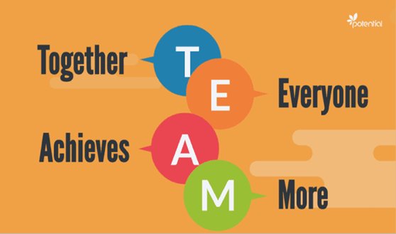 Fig.1 Team success formula
One of the most significant models of team developing belongs to Bruce W. Tuckman first published in 1965, who became the most principally referred to and widely in team organisation (Miller, 2003).
It proved that describing new ways of people working together, helping each other and understand what they are here for in the development process by demostraiting a common language and what Reckards and Moger called “simple means of discussing and exploring team dynamics” (Reckards & Moger, 2000).
According to Tuckman’s model there are five deferent stages of team formation known as forming, storming, norming, performing and adjourning
.
Tuckman (1965) Psychological bulletin
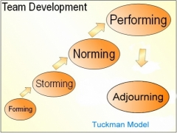

Fig. 2 Tuckman’s model stages

The first stage forming identify group members who becomes orientational to the task, create rules, test the permissible limits to determine what type of behaviours are acceptable, create relationships between each other.
Storming stage represent time of group conflict and chaos. Team members may become unsettled in their roles because they do not like the way of decision making or planning and refuse to move forward achieving the common goal.
Norming stage is a period when the team restore stability, develop close relationships, cohesiveness and start demonstrating more effective structure by accepting each other as a whole team.
During the performing stage members understand and perform their roles effectively, optimal strategies has been builded and becomes a mechanism for problem solving and maximum productivity. According to Bonebright (2010) successful task completion becomes the focus of the group.
Following Tuckman’s model, it was discovered that the termination of the team was a needful addition (Seck & Helton, 2014). In adjourning stage, the members come to their end making self-evaluation and analysis of the outcome on what they have done.
Furthermore, another theory model belongs to the expert (Wheelan, 1999), which is very similar to Tuckman’s. Again, the team development goes through stages and is mainly connected with relationship dimensions of the group work. Wheelan stages includes: 1- Dependency and inclusion; 2- Countertendency and fight; 3- Trust and structure; 4- Work and productivity

Maund, A. et al. (2017)
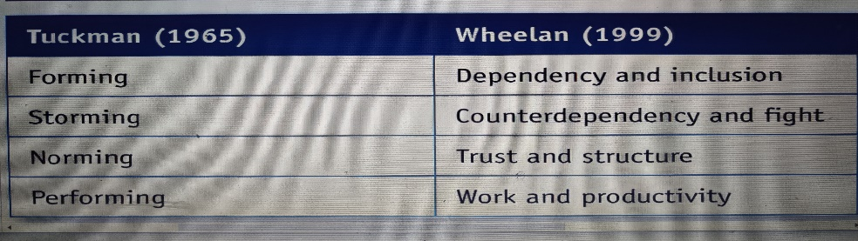
Fig. 3 Similarity between Tuckman and Wheelan’s models
Wheelan (1999) 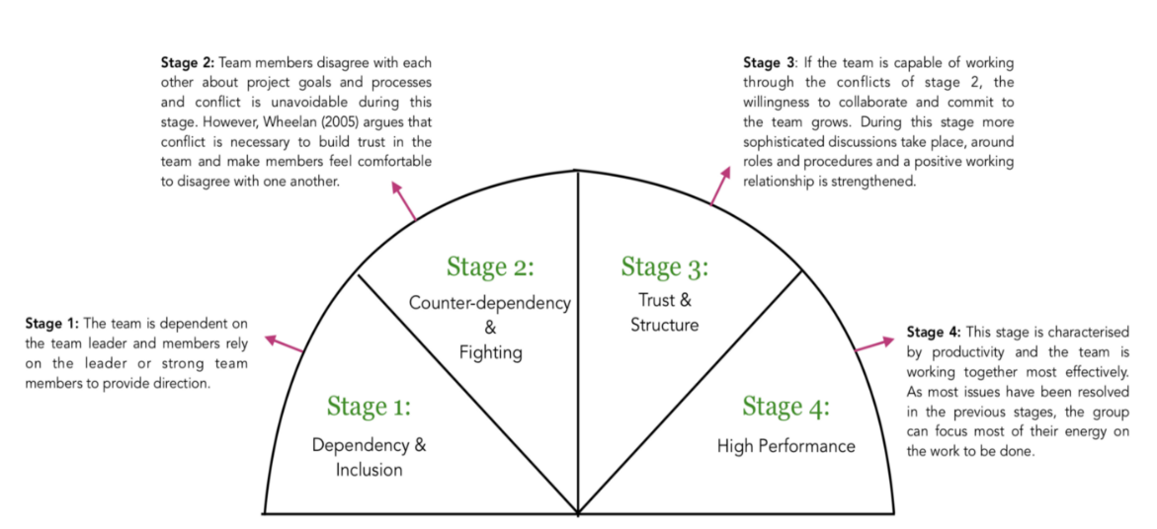
Fig.4 Stages definition
According to another research, Gersick’s (1988) model, team development goes through phases and not stages. The first phase that Gersick describe is stability, that is settled by the end of the first meeting. The first meeting is significantly important in creating appropriate direction, culture and climate. At the end of the first phase the members goes in midpoint- instability and transition before coming back to stability-second phase. In this phase the team develop to high performance with clear direction, structure and intending to achieve their collective goals. While the Tuckman’s and Wheelan’s models describe the relationships, Gersick’s model is more connected with task dimension.
Gersick’s (1988) Online source
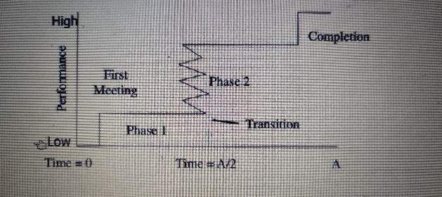
Fig.5 Gersick’s model phases

2.2 What are the types of roles that are needed to create an effective team

What Abdul need to create an effective team? Of course, great team is based on hiring the most skilled and experience people, but that not always work out, as each person has different personalities that may attract conflicts.
Conflicts between the team members lead to their failure and to avoid that the leader must identify the skills set of each person to get most of it. Research states that one of necessary part of effective team management is hence control and balanced power (Eisenhardt, et al., 1997). According to deep research of what make an effective team, Belbin (1981) has published a theory of team roles, that suggest nine types of different personality that can be found in any team, failing under three categories depending on their focus- action, thinking and people-oriented roles.
1. Action-oriented category- shaper, implementer and completer finisher role.
Shaper role is member who has the ability to push and drives everyone towards achieving goal. Shapers always have high energy, dynamic and remains positive to whatever the challenge they face and ensure that the deadline tasks are met to bring positive outlook.
Implementers have the skills to be well organised, disciplined and efficiently turns ideas into action to push the team moving forward. However, they are less flexible and adjustable to respond to new possibilities.
Completer finisher takes part of both roles (shaper and implementer) and focus their painstaking to the end of the project reaching their goals at high standard with low errors. Therefore, not surprisingly completers are called “perfectionists”.
2.Thinking oriented role- Plant, Monitor Evaluator and Specialist
According to Belbin’s theory plant role is the most creative personality type. They are free thinkers, who provide best solution to a problem by their unusual new ideas, where a project must move on to the achieving goal.
Monitor Evaluator is strategic role. People prefer to approach logically about the project in the long term, stays positive on the project that they work on and reserved individual which is good in stressful situations.
Specialist role is focused on the project not just to be done, but to be great. They can provide deep knowledge and to be very professional, sending their team to project continue or to the next level of its stage. The lack of this role is narrow front thinking and excessively technicality information.
3.People oriented roles- Coordinator, Team Worker and Resource Investigator
Coordinator is a natural team leader. They are focused on managing the people in the team not on the task, feel confident, mature, keeps calm in particular situations and have talent to identify the people right position.
Team workers are sociable, flexible, responsive and diplomatic, able to communicate well with everyone and aid with someone who is struggling.
Resource Investigators like to look at opportunities from different angles, investigate all the available options before step to decision, making contracts related to project progress. Sometimes may lose interest if a project task moves away from initial flaming.

Belbin M. (2010) Team roles at work
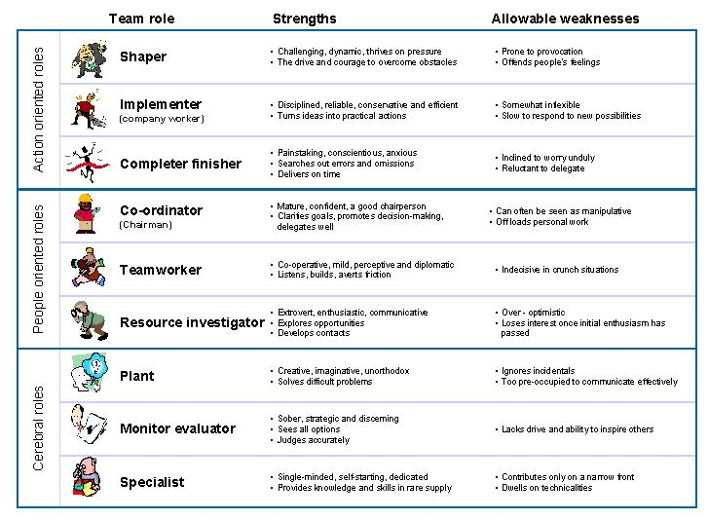
Fig.6 Belbin’s team roles Strengths and Weaknesses

2.3 What type of impact can effective teamworking have on team success
Research of effective team has been described by Coyle (2018) identifying the secrets of developing team success – Build Safety, Share Vulnerability, Establish Purpose.
Build safety includes overcommunicate listening which means using eye and body language to show each other that you are interested in what people say and mean. Also note if you are wrong in early stage and if there is any negative feedback from team member respond in sensible way.
Share Vulnerability- Always tell the truth to your team, ask kindly questions and how you can help with. Any bad news must be discussed face to face to make people feel safe and supported.
Establish purpose is the skill to manage how to name and rank your priorities, be more and more familiar, paint them on the wall in order to follow the target given, as team members not supposed to know them or remember and not last how members treat each other.
Further investigation of importance of impact states that in team success must be considered the size of team members, development and productivity. The size of the team is critical point of increasing or decreasing the effectiveness of productivity and development, as small groups (3,4-6 members) are impressively more productive and developmentally, than larger team size (7,10-11 or more). According to Bogart and Lundgren (1974) findings, when size increase, reflect on decreasing of solidarity and intimity, members become more competitive, disputable, less consolidated and unsatisfactorily (Steiner,1972).
Group development of team success has been investigated by experts Wheelan, et al., (1993) and established in several stages. In the first stage preponderate dependency and inclusion, where the members concern about safety, inclusion issues and await for leader’s directions. Second stage is characterised to period of counterdependency and conflict- members disagree about end goal and procedure. Third stage predominates trust and structure, where teammates pulls together and create positive relationships. During fourth stage the team reach its capacity at high level of productivity and effectiveness. This is where the group productivity starts, when the team functionality is at the highest stage.
Another theory found that important impact of effectiveness is team diversity, as play part in views as source of inter group bias, understanding the information and decision making (Van Knippenberg & Schippers,2007).
There are many who suggest team success depends also on appropriate group decision making. Group decision making is successful when everyone is involved to find out a solution by good communication to reach the collective solution (Collins & Guetzkow,1964).

Online source Slidetodoc, DMSA
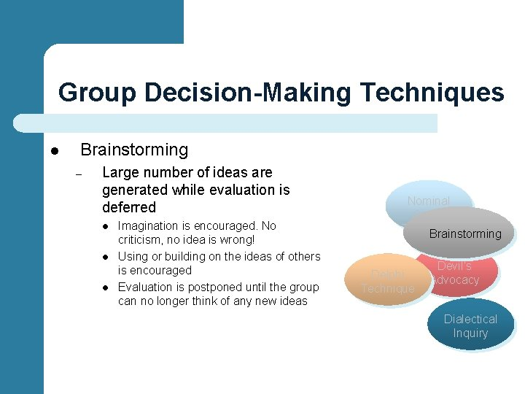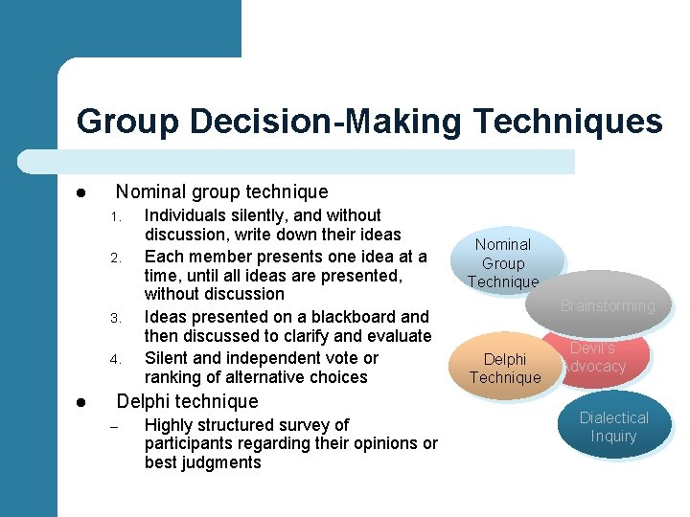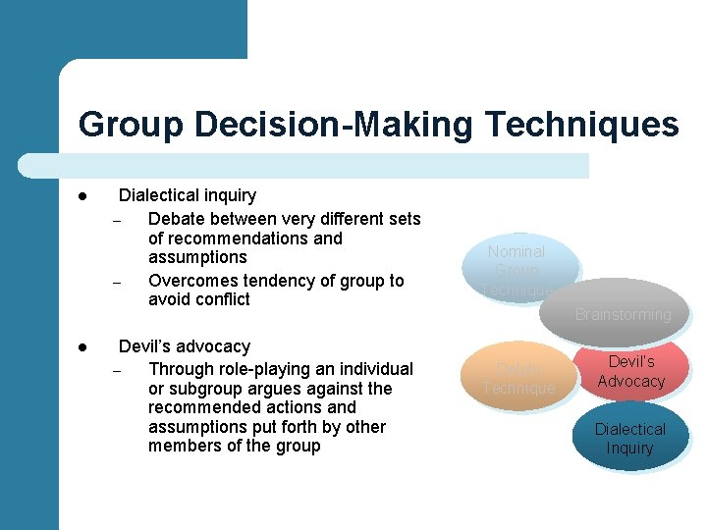
Fig.7 Group decision Techniques define

2.4 What are the barriers to effective teamworking identified in Abdul scenario
In this scenario Abdul has allowed many mistakes that made his team failure, but the fact is that working in team sometimes can be quite frustrating. The first barrier that stops Abdul’s team from success is oversized team. Amount of 18 people are very difficult to be coordinated and that is why team become inefficient.
Second barrier share vision- Online meeting could be arranged, but they never met each other to communicate and discus roles and responsibilities.
Third lack- Poor communication due to poorly performing and structuring group, poor leadership.
Fourth barrier of effectiveness- Abdul team break down Belbin shaper role failing to complete task within deadline.
Fifth is lack of commitment- Staff failed to attend important meeting, that make others feel frustrating who doing their job.
Following my report of models of team success Abdul need urgently to act and restart everything from the beginning.

3.Consclusions

Teamwork developing and leadership always been fundamental part of operational practise and with improved understanding of performance we might be able to analyse professionally skills more effectively and deeply. There are many facts of investigations, theories, models and techniques that can improve ability for team performance and success, but of course require practise. By developing our own skills, we can better our outcome, start learning from each other and receive positive behaviour between the whole team. Nowadays the performance is maximized thanks to the global development of teams as whole and individuals, which is required to maintain effective working environment.

4. Recommendations

Based on what I have learned I would recommend that individuals and leaders must:
-Continue communicate and communicate each other in two ways street.
- Crystallise setting goal and roles early on.
- Create teamwork reward program.
- Know who does what?
- Have a clear organizational structure.
- Identify problems when appear.
- Talk less, act and listen more.
- Ask members for feedback to monitor progress or failing.
- Hire wisely.
- Create team traditions and meet in different locations.
- Mix it up with appropriate roles.
- Work as machine, make decisions as a whole team.

- References

- Abudi, G. (2010). The five stages of project team development. Available at: www.pmhut.com/the-five-stages-of-project-team-development. (Accessed 22 February 2022)
- Avery, C., Murphy, E. and Walker, M. (2001) Teamwork is an individual skill getting your work done when sharing responsibility. 1st ed. San Francisco, CA: Berrett-Koehler Publishers
- Belbin, M. (2010) Team roles at work. 2nd ed. London: Routledge.
- Driskell, T., Salas, E. and Driskell, J. (2018) ‘Teams in extreme environments: Alterations in team development and teamwork’, Human resource management review, 28(4), pp. 434–449. Available at: https://onlinelibrary.wiley.com/doi/10.1111/j.1936-4490.2003.tb00698.x (Accessed 22 February 2022)
- Gersick, C.J.G. (1988) ‘Time and Transition in Work Teams: Toward a New Model of Group Development’, Academy of Management journal, 31(1), pp. 9–41
- Heyck-Merlin, M. (2016) The together leader: get organized for your success--and sanity! First edition. San Francisco, CA: Jossey-Bass.
- Miller, D. (2003). The stages of group development: A retrospective study of dynamic team processes. Canadian Journal of Administrative Sciences 20(2), pp. 121–43.
- Parker, G. (1990) Team players and teamwork: The new competitive business strategy. San Francisco: Jossey-Bass
- Parker, G. (2008) Team players and teamwork: new strategies for developing successful collaboration. 2nd ed. San Francisco, CA: Jossey-Bass.
- Tuckman, B. and Jensen, M. (1977) ‘Stages of Small-Group Development Revisited’, Group & Organization Studies, 2(4), pp. 419–427. Available at: https://journals.sagepub.com/doi/10.1177/105960117700200404 (Accessed 22 February 2022)
- Wheelan, S. (2003) An initial exploration of the internal dynamics of leadership teams. Consulting Psychology Journal: Practice and Research 55(3), pp. 179–88.
- Wheelan, S. (2009) ‘Group Size, Group Development, and Group Productivity’, Small group research, 40(2), pp. 247–262.

