Community Needs Assessment: Newport Higher Education Campus
Introduction.
What is a community?
Communities can usually be defined as a geographic location, where those who reside in the area will have similar norms and shared interests like religion, identities, values and beliefs. These residents will usually be in cities, villages and towns or in a virtual communication platform, for example social media sites and different blogging sites. Although communities tend to include residents in close proximation of each other, the size of a geographical location is insignificant if the characters and interests of the residents expand further than their village or city.
Introduction to Newport.
Newport is the third largest city in Wales, with a city population of 145,700. The residents of Newport have a large population of working-class people, with a large percentage of support for the Labour Party (Nomis, 2017).
The city continues to grow economically with regeneration programmes and investments creating business opportunities and transforming the city and international profile to new highs. In 2017, a new £100 million International Convention Centre began its work at the Celtic Manor Resort, which with gather a £70 million economic benefit to Newport. The city gathered investments to provide employment and leisure opportunities, with a retail and leisure park, Friars Walk opening. Also, a £1 Billion investment Opportunity to transform Llanwern Steelworks into a community that will provide 4,000 new homes and 6,000 new jobs in the next 20 years (Newport City Council, 2018)
Education in Newport
Newport homes a University of South Wales campus and Coleg Gwent, as well at the adult education centre, Brynglas House. There are nine Comprehensive schools, including Newport High School, with one of them being independent, Rougemont School, all governed by Newport Local Education Authority.
University of South Wales, Newport.
Overlooking the River Usk, the Newport Campus of the University of South Wales provides a diverse Education atmosphere for those studying Business, Education, among other subjects. The university has continuously worked to become one of the major educational institutes in the United Kingdom, proudly teaching students from over 120 countries in the world. The building is a state-of-the-art institute that promotes sustainability and urban regeneration for Newport.
Issues that Newport’s University of South Wales Campus Faces.
One of the key issues that Newport’s Higher Education Community faces is the decline in Welsh Students applying to go to University. A reason that this decline could have occurred was the Government decision to completely cut the universal tuition fee grants of £5,100 that all students were entitled to. Obviously, the need for students to be earning income is higher than the need for a higher education. From 2018 the Government declared that students from low income homes will now be subjected to means tested applications to determine how much of a grant they are entitled to, if they are full time students.
Universities in Wales face application issues, as the number of 18-year olds applying for universities in Wales decrease each year. The increasing competition from apprenticeships and vocational qualifications raise concerns as students are choosing other options, with money concerns (Wightwick, 2018)
Students have voiced their concern, declaring that the cost of living is a barrier to being able to attend higher education. The prices of rent, bills and transport as well as being able to afford resources that are expected to have for their courses all have a negative impact on their mental health (Ellett, 2018)
Data shows that young Welsh people are more likely to attend University outside of their home countries, compared to those from England and Scotland (Appendix A). With no financial incentive to stay in Wales, students are being more and more influenced to travel outside of Wales to gain their higher education qualifications (BBC News, 2018).
The most recent Maintenance Grant scheme shows how there is no incentive for students to attend university in Wales, as the amount of money students are entitled to all depend on their household income.
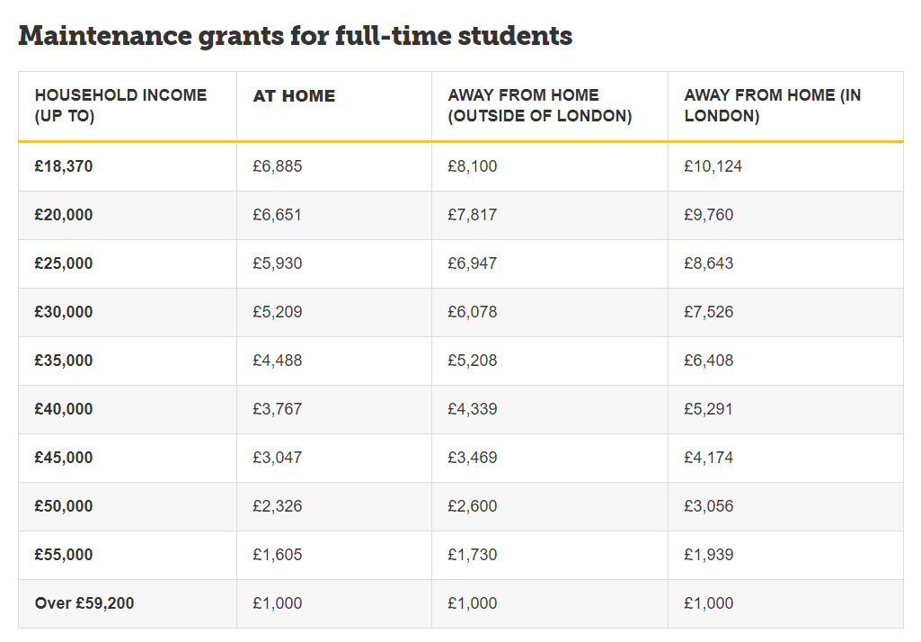(Wightwick, 2017)
Data and Statistics
In Newport, for those who are economically active, there are over 400 adults out of employment. Wales has a prominent issue with unemployment rates, as they have risen every year, and Newport is no exception from this male unemployment levels, like the rest of Wales, are higher than female unemployment levels. The number of people above the age of 16 and claiming benefits has risen to 3,590 with only 775 of those people being over the age of 50. With consideration of the 880 of those people (some over the age of 50) with disabilities, there is still clear room for improvement for the unemployment levels for those in Newport (Nomis, 2018). There are 6,800 people in Newport with no qualifications. However, there are 80,000 people with an NVQ Level 1 and Above (Nomis, 2017).
In 2017 the number of university applicants from Wales fell 7%, which is the steepest drop from any of the nations in the United Kingdom. The number of students coming to Wales to study from other locations of the UK and Europe has also declined by 8% (Wightwick, 2017).
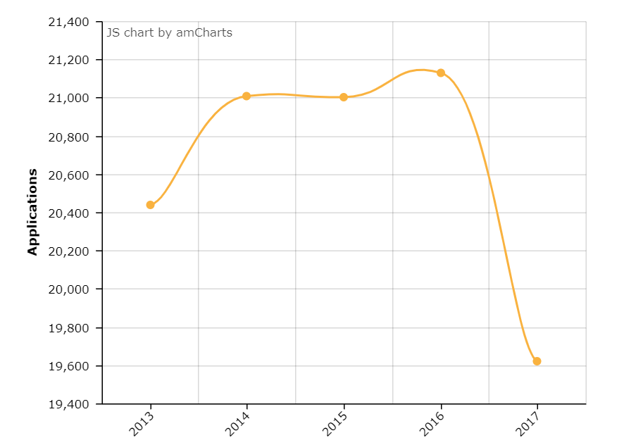(Wightwick, 2017)

Figures show that Wales had the lowest percentage of 18-year old’s applying for University, there are many reasons why the decline of applications of 18-year olds has occurred, including funding issues and debt concerns (Wightwick, 2017).
The financial burden of going to university often outweighs the potential of the possible outcomes, 14% of young people in England and Wales are not likely to attend Higher Education, according to the Sutton Trust survey (Pells, 2017).
Assessing the Needs
Newport, having not one, but two Higher Education Institutes, can enhance the chances of employment by using different strategies that promote the need for education. The University can be used in a variety of different ways to help those seeking employment gather educational qualifications and opportunities, as well as those in employment looking to further their career goals.
There is a need for Welsh Higher Education Students to consider applying and attending universities in Wales, like The University of South Wales’s Newport Campus, rather than attending universities in England and across the United Kingdom. The decreasing number of students applying in Newport, has left a sense of worry from the Newport community (Hughes, 2018).
Newport needs to assess the strategies to support their student’s financial concerns and needs. They need to directly be helping students manage money but also offer additional financial support. As the Government will not be funding the maintenance needs of Welsh Students then the University of South Wales and Newport Council need to be working together to ensure that potential students are aware what Newport has to offer, as well as offering financial aid. Students also need to be made aware of the extra funding and bursaries that they are entitled to, to help manage their finances more effectively (Rowe, 2018).
Newport and the University of South Wales should be encouraging more young people to not only attend university but specifically attend university in Wales. As the University of South Wales are failing to meet the normative needs, an action plan must be in place to show potential students of the qualifications and opportunities they can get through attending their university. They must also be displaying how the university and the Government can support their time at university, financially and academically.
With the investments that have been put into Newport with the retail park like Friars Walk, Newport City need those investments to have been worth-while. Other than the people of Newport shopping and eating at the Park, the need for students to utilize the Retail Park is also crucial to ensure the continuing success of the retail park (Owen, 2018).
The unemployment levels in Newport need to be active reducing and bringing more students into Newport will help create jobs and opportunities for the city. Bringing in more students not only boosts Wales and Newport’s economy, but benefits the sustainability of Newport and their public services.
Brexit has made it more difficult for students from the EU to attend University in Wales, but not impossible (Fazackerley, 2019). To help this Newport also needs to be promoting encouraging students from outside of the UK to come to South Wales to study.

References
BBC News (2018). Ucas: Welsh university course acceptances down 5.7%. BBC News. [online] Available at: https://www.bbc.co.uk/news/uk-wales-46547004 [Accessed 3 Apr. 2019].
Ellet, P. (2018). Students struggling to juggle university living costs – Which? News. [online] Which? News. Available at: https://www.which.co.uk/news/2018/07/students-struggling-to-juggle-university-living-costs/ [Accessed 3 Apr. 2019].
Fazackerley, A. (2019). 'The sooner you go home the better': is this the UK's message to international students?. The Guardian. [online] Available at: https://www.theguardian.com/education/2019/feb/05/the-sooner-you-go-home-the-better-is-this-the-uks-message-to-international-students [Accessed 4 Apr. 2019].
Hughes, M. (2018). The slow death of Newport's once-thriving university and the chilling effect it is having on the city. Wales Online. [online] Available at: https://www.walesonline.co.uk/news/slow-death-newports-once-thriving-14777816 [Accessed 4 Apr. 2019].
Newport City Council (2018). Newport: A City on the Rise. [online] Newport.gov.uk. Available at: http://www.newport.gov.uk/en/About-Newport/CityontheRise/Newport-A-City-on-the-Rise.aspx [Accessed 13 Jan. 2019].
Nomis (2018). Labour Market Profile - Newport. [online] Nomis. Available at: https://www.nomisweb.co.uk/reports/lmp/la/1946157404/printable.aspx [Accessed 12 Jan. 2019].
Owen, R. (2018). TALKING POINT: Friars Walk three years on - what you said. South Wales Angus. [online] Available at: https://www.southwalesargus.co.uk/news/17230006.talking-point-friars-walk-three-years-on-what-you-said/ [Accessed 4 Apr. 2019].
Pells, R. (2017). Number of young people planning to go to university falls to lowest level in eight years. The Independent. [online] Available at: https://www.independent.co.uk/news/education/education-news/number-of-young-people-planning-to-go-university-falls-lowest-level-eight-years-students-tuition-a7884901.html [Accessed 13 Jan. 2019].
Rowe, B. (2018). What types of extra funding are available to help you at university? - Which?. [online] University.which.co.uk. Available at: https://university.which.co.uk/advice/student-finance/what-types-of-extra-funding-are-available-to-help-you-at-university [Accessed 4 Apr. 2019].
Wightwick, A. (2017). Fewer people in Wales are applying to go to university after generous grants for all were scrapped. Wales Online. [online] Available at: https://www.walesonline.co.uk/news/education/fewer-people-wales-applying-go-12548013 [Accessed 13 Jan. 2019].
Whitewick, A. (2018). Fewer applicants, job losses and financial problems: What's going wrong at Wales' universities?. Wales Online. [online] Available at: https://www.walesonline.co.uk/news/education/fewer-applicants-job-losses-financial-15579317 [Accessed 3 Apr. 2019].

Appendecies
Appendix A



