

BA BUSINESS MANAGEMENT

Introducing the Modern Workplace
LCBB4003
Assignment 2 – Individual Reflection

Lecturer: Sadeque Shaikh
Student: Lilia Triboi(ID 2027089)

SUBMITTED ON: 01.04.2023

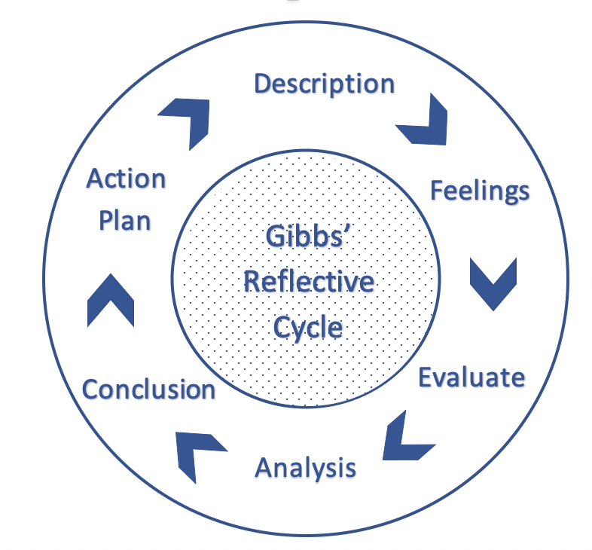

INTRODUCTION
In this report I aim to reflect on my experience of working in a studying team with which I want to create a project for our “Introduction to Modern Workplace” module. To be able to reflect on this short journey I have decided to use one of the most known reflection models for working in a group or team, called “Gibbs’ Reflective Cycle”. This model is a theoretical approach of reflection that was developed by Gibbs in 1998 and which is based on a six-stage approach. As is broken in so many stages, this model encourages individuals to reflect on their behavior and avoid going for early conclusions without exploring the issues and challenges encountered from different points of view. (Cambridge Assessment, 2023).
DESCRIPTION
Firstly, our team was formed once people started asking each other if they want to join the group for studying and working. We have unanimously voted for the same person to become our team leader; next step was to learn what tasks we have and what is it expected from us. Our team leader suggested that we should each choose our preferred task and after we started establishing what should each of us bring to the table. We were a team of five people and as soon as we found some free time, we started discussing the theme that we want to work on, what is our company of choice and what sources we should use to obtain the correct information for writing our part of the assignment.
Once everyone was happy with their choice of task, we established what was the deadline and we started working on our project.
FEELINGS
The team was small and although we were just 5, conversations filled with ideas and opinions were running constantly. I was left disappointed when I knew that people cannot get together to discuss the project further and that the only way of communicating was through Teams or via email. I have a fear of speaking in public which often times stops me from speaking in public and I grew gradually frustrated with the fact that the project required public speaking and my stress was not acknowledged by anyone in the group. My team leader seemed to be busy with other issues related to the project and did not paid much attention to my concerns. This situation was worrying me a lot and I felt a bit unhappy with how the teamwork was going.
EVALUATION
In the beginning, things were a little bit chaotic, no one seemed to be listening to anyone, too many jokes were made, team members were not listening to each other, and our Team conversations seemed pointless and useless. Once we all decided that we should listen to each person and allow everyone to finish what they have to say, things have started to take a turn for the better. Communication flown easily and I became happier to work with my team which enabled me to come with my own contributions for the project – I was able to suggest ideas of what the Power Point presentation should contain, how should we structure the information we found so we can present it with efficiency to our audience. Once the team was balanced and everyone knew what they had to do, it was much easier to work with my colleagues.
ANALYSIS
Our work and communication improved considerably once we had some rules in place to keep order, to encourage active listening and to offer respect to each member of the team. I’d say that Gibbs’ Reflection Model has helped me understand why we have been facing challenges in our work project – my feelings have been overwhelming making me gradually more worried and my part was affected and implicitly my performance within the work team. Reflecting on my attitude I should have pulled aside my team leader and explain how I felt in that moment and ask for guidance. Now when I am more comfortable with what I have to do and I can look back at the situation, I think that ideally, I shouldn’t have let my feeling upset me and isolate me from the group. Eventually I have learned about the power of effective communication and ensured that I will continue to communicate with my team all throughout this whole experience.

CONCLUSION
I think it’s safe to conclude that although we have worked together as a team in the past and we know our strengths and weaknesses, our experience was nothing short of events which have had an impact on our work and collaboration. Lacking structure meant that some of has had no idea how to start their work; not having time to meet up and discuss about our work was as well a key influence in our overall project. Gradually everyone became more comfortable, our team leader included, and we became efficient in communicating what we want, what we lack and what is making us stressed or frustrated. I could do better in recognizing what upsets me and finding means of turning the negative into positive in a way that is not affecting my work. To be able to handle this situation in a better manner, I would have to work on my communication skills and on being clearer with what I want to say.
ACTION PLAN
If in the future I will be required to work in a team, I would want to implement everything that I have learned during this experience with my team; I will try to adapt my actions so I can have a positive experience when working withing a group or in a team. Communication is key and making it effective is the most important part when working with other people and looking for developing successful projects either for higher education, work or just for your own community.

REFERENCES

Education, C. A. I., 2023. Getting started with Reflective Practice. [Online]
Available at: https://www.cambridge-community.org.uk/professional-development/gswrp/index.html
[Accessed 18 03 2023].

