  Component One:  What are the key skills required when working in the housekeeping team? 750 words (+/- 10%)  Contribution to Overall Module Assessment: 25% | Student No: | 2206244
 | Module Title: | Hotel Placement – Operating Hotel Facilities
 | Module Code: | BMIH4006
 | Lecturer: | Lola Villard
Working in hospitality industry offers a lot of jobs in different departments. In each on them you need a series of skills to be successful and to gain guests loyalty.
“ The housekeeping department is an integral part of all the areas which a lodging operation is divided.” ( Casado, 2012, p.12)
Skills can be divided in two main categories, hard skills the ones that requires a diploma, a certificate, a course or training from where you can learn something and soft skills, the ones you are born with or you develop during your work experience and you can improve them during your life.
Housekeeping it is an operational department in the hotel and can have a variety of jobs depending on the size of the hotel and the services provided, such as room attendants, cloak room attendant, gardener, washers, floor supervisor, laundry, housekeeping supervisor and executive housekeeper.( Bridger, 2018, p.65)
I started my student placement working in housekeeping department for 3 weeks and it was more that I was expecting. I met a lot of people who showed me different jobs and I realise how much work has to be done to ensure guest’s comfort.
Soft skills that a good housekeeper needs are: attention to details, communication skills, organizational skills, honesty, responsible, hardworking, time management, teamwork and others.
Also some hard skills can be useful for a housekeeper, such as carpet cleaner, window treatment cleaner, mopping, dusting, health and safety certificate and even computer skills because as a supervisor you have to fill in some tables and it is useful to be computer literacy. ( G. Raghubalan, 2015, p.294)
During my days spend at the hotel I experienced different cleaning activities and I have done a lot of work in the rooms and on the communal areas as well and I can definitely say that it is a hard work and you need resistance and a lot of power to work.
I was really impressed by the way my supervisor showed me how to put sheets on bed. She was so fast, she knew exactly what she has to do from the moment she opened the hotel room. She was really good organised and she had all the wipes, cleaning products and tools ready to clean the room as fast as possible, but to do this in a very professional way.
In each room that you clean if the guest stays more than 1 night you just visit to take the trash, put new bags, check the toilet paper, towels and hygiene products and rearrange the pillows and sheets on beds.
If the guest are leaving and the room has to be ready for a new guest, than you have to do a lot, vacuum the room, clean the bathroom, change the bed sheets and all the towels, clean the dust, clean the mirrors, TV, phone, door handles and add any extras that guest asked for. ( Hotelowner, 2018)
I can give some examples that I consider very important skills for a housekeeping person from my short experience in this field. One of them in my opinion is being organised as if you know very clear what you have to do and where to find everything you need, where to put dirty stuff, from where to get clean ones, what products to use and where you have them in your trolley, cleaning is going faster and you don’t loose time looking for products or thinking what else do you have to do.
Another skill very important is attention to detail. It is a big difference from cleaning a room and cleaning a room properly. As a housekeeping person you have to check the room after you clean it and be sure that everything it is in order, no products left in the room that shouldn’t be there, no dust, no object put wrong or missing objects. You need to be fast but efficient, you have to do your job properly but you have to manage your time, you need to move fast and to be strong enough to move the beds and other furniture. Also, if you meet a guest you have to smile and have a nice and professional attitude.
For a housekeeping person it is important also to have soft skills like honesty, adaptability, cooperation and loyalty.

Word Count | 720

Component Two:
Contribution to Overall Module Assessment: 25%
In this scenario – You have just been promoted to team leader for a floor within the hotel. A guest complains that on their arrival, their room had not been properly cleaned. Create an action plan and answer the following questions.

Problem | Why did it happen? | What are you going to do? | How will you prevent this from happening in the future? | What measures would you introduce to improve team effectiveness?
Dusty TV screen | The renovation of the hotel can produce more dust than normally. | We are going to clean the TV screen daily and use better products to keep dust away. | We are going in upgrade the hoovers so they produce less dust when are used. | Weekly I will ask some of the crew members to focus on dust, so after cleaning all the rooms, they will clean better the TV.
Hair found in bathtub | Accidentally the housekeeping person lost a hair while she was cleaning the bathroom and she didn’t notice. | I will ask the housekeepers to wear a hair protection during cleaning the bathrooms. | Try to be more careful and the team leader will check all the rooms after cleaning and before guests arrival. | I am planning to achieve better cleaning products in order to clean faster and with better results.
Dirty mirror, small signs of wipe or hands. | Because they are hard to clean and very easy to keep stains if not using the right products and wipes. | Use specific products and wipes for each surface. | Clean more often and check the aspect of the mirrors more often. | Use wipes on different colours to easily know which one is suitable for each kind of surface.
Small paper/ trash found on the drawer of the bedside. | Because it was too small and the housekeeping person couldn’t manage to take it off. | From now on use the hoover inside the drawer to take off all the dust and small papers. | Like mentioned using the hoover and a wet wipe to clean the drawer better. | Cordless small hoover to be provided with accessories provided for narrow spaces.
Stained pillow or blanket | Because they are used by a lot of guests and they are sheets changed very often. | I am planning to achieve some pillow protector to cover the pillows and to replace them more often for better comfort of hotel’s guests. | Each housekeeper will make weekly reports after cleaning the room with all the issues and the aspects of the pillows and blankets. | Make an evidence of each room with all the pillows and blankets what type they are, how many and the achievement date.

Component Three:
Contribution to Overall Module Assessment: 50%
Your task is to create and prepare a presentation following the detailed scenario provided below.

As the floor housekeeping manager and given the recent guest complaints you need to put together a basic training presentation for your colleagues within the housekeeping team to get the best out of them, ensure that brand standard is being achieved and that Health and Safety procedures are also being followed.

Hello colleagues and thank you for joining the housekeeping training presentation. I had a meeting with the hotel manager and together we have discussed those aspects after receiving a list with guests complains. Today we will talk about the importance of maintaining brand standards and following Health and Safety procedures, we’ll see the list of complains, then some training methods and we’ll finish with some new products and equipment.

Training Notes:
We will start our presentation with the importance of brand standards. As you all know the significance of brand standards is to create consistent guest experience. Customers have more and more expectations and we have to anticipate their wishes so they get loyal to our brand.

Training Notes:
Next, we are going to talk about Health and safety procedures, Regular Cleaning and Sanitization: Implement a rigorous cleaning schedule for all areas of the hotel, including guest rooms, public areas, and back-of-house areas. Pay special attention to high-touch surfaces such as doorknobs, elevator buttons, and handrails. Use appropriate cleaning products and disinfectants to maintain a hygienic environment. Proper Handling and Storage of Chemicals: Ensure that all cleaning chemicals and supplies are stored securely and labeled correctly. Train staff on the proper handling and use of these chemicals to prevent accidents and ensure their safety.

Training Notes:
Now, I would like to kindly ask you to have a look on the table on the screen and try to see if when you are doing your regular housekeeping activity you tick those issues mentioned by some of our guests. Some of them are just specified by a few, but others are mentioned by most of them that had complains. Of course we have a lot of happy guests, but our purpose is to get better and better and try to diminuate the number of unhappy guests.

Training Notes:
Those are the methods that we are going to put in application for our housekeeping department regarding our training. The methods are: Ergonomics and safety training, comprehensive orientation, hands-on demonstrations, standard operating procedures, role playing and simulations.
Training Notes:

Specific training sessions to cover health and safety procedures, including proper handling of cleaning chemicals, safe use of equipment, and emergency response protocols. Practical demonstrations and simulations can be useful in conveying these concepts effectively.

Training Notes:
Regarding continuous training, housekeeping personnel will receive ongoing training to stay updated on new cleaning techniques, equipment, and industry trends. Regular refresher courses and opportunities for skill enhancement and professional development.
Regularly assess trainees' progress through quizzes, practical assessments, and feedback sessions.

Training Notes:
Next, we are going to talk about cleaning techniques and efficiency by dividing into 3 topics: effective cleaning techniques: for exemple proper dusting, vacuuming and sanitizing practices, then time saving methods, by using better cleaning products, use of the same routine for each room so in this way you keep thing in order and never miss something, and to have prepared all the necessary products for each room. Finally, the good and correct using of products and equipments.

Training Notes:
We are intending to achieve new trolleys, new cleaning products and to put employees on training for qualifications like window cleaner, professional carpet cleaner and we are open to suggestions .Training will be part of your working hours, so you don’t have to stress about the payment. We need qualified people working for our hotel so we can get more guests and better reviews.

Training Notes:
At the end I would like to thank you all for being part of our housekeeping team and we all appreciate your hard work. On the near future we will try to make things go easier for all of you and we hope to have a big attendance on our training program because only having the same purpose we can succeed together.

Training Notes:

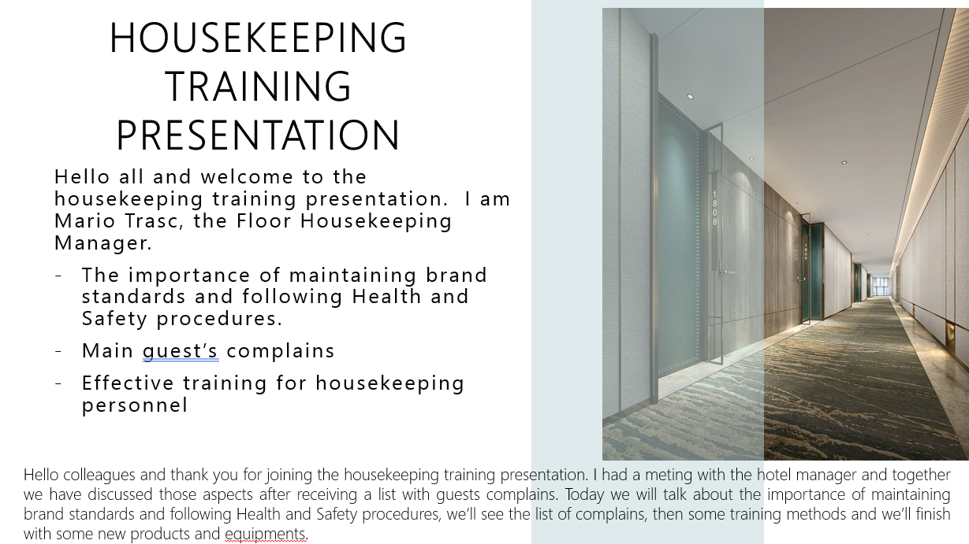

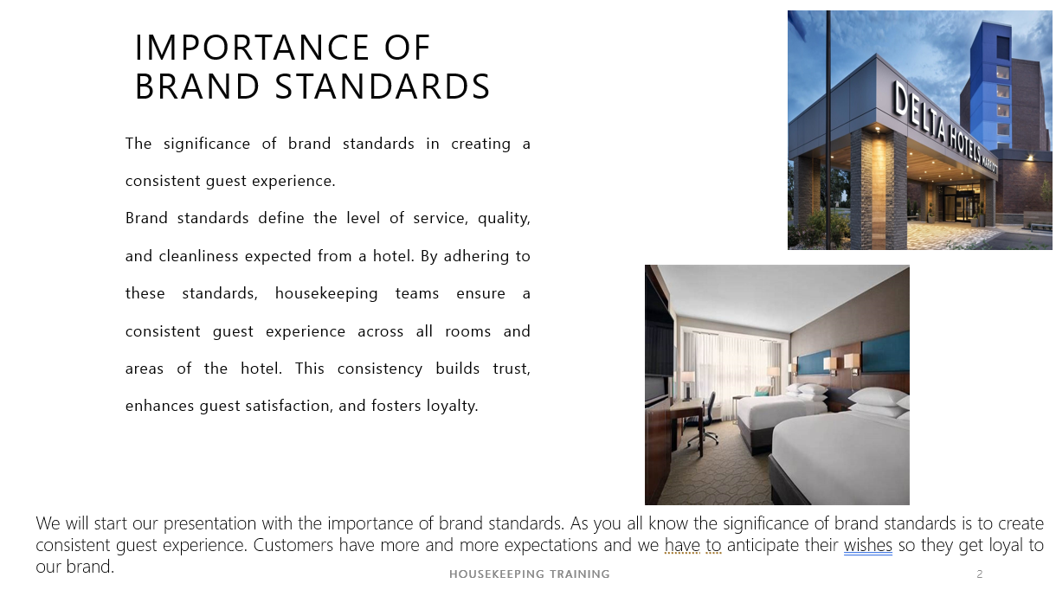

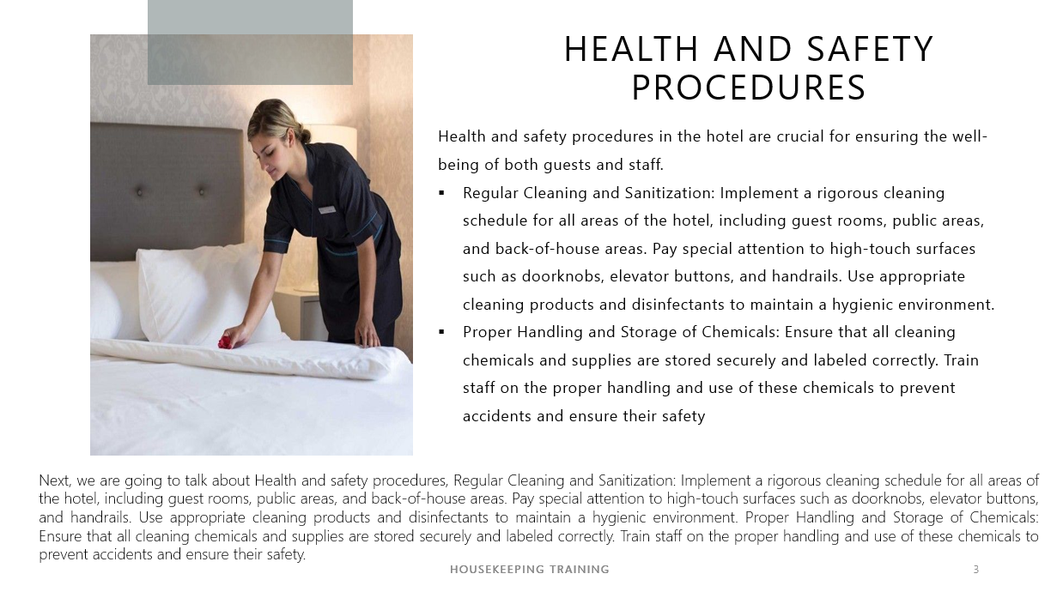

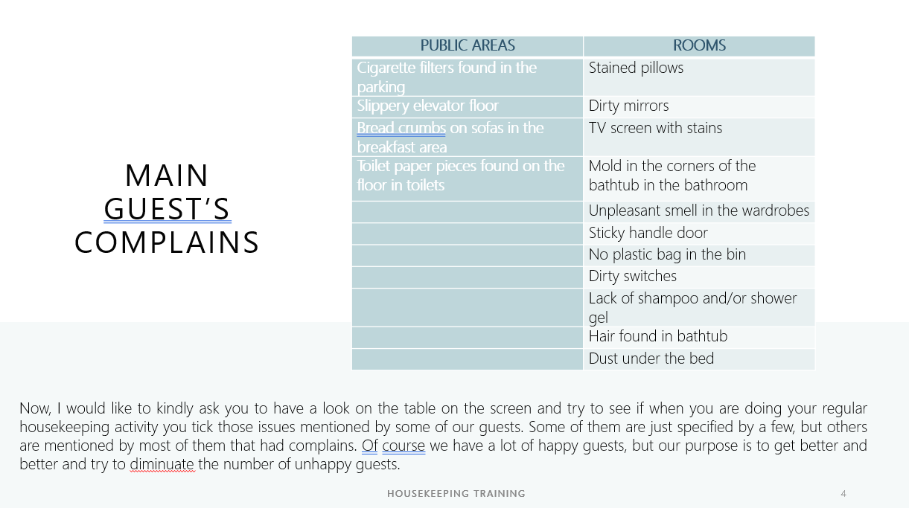

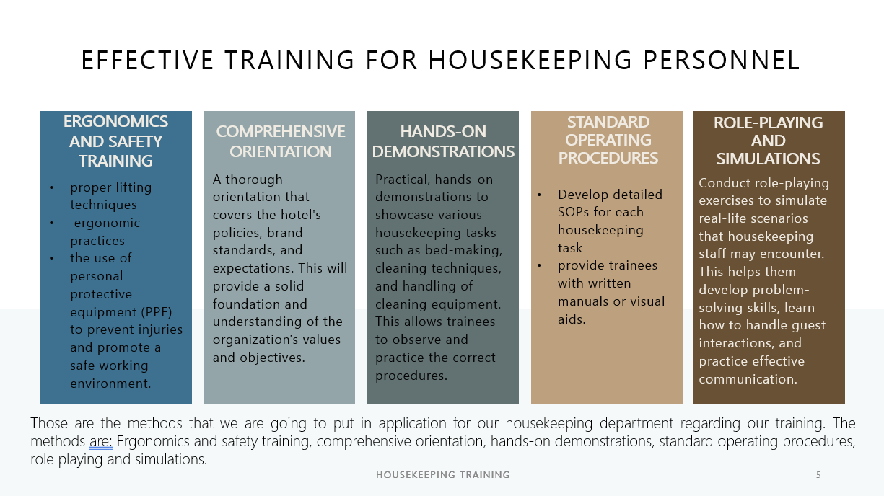

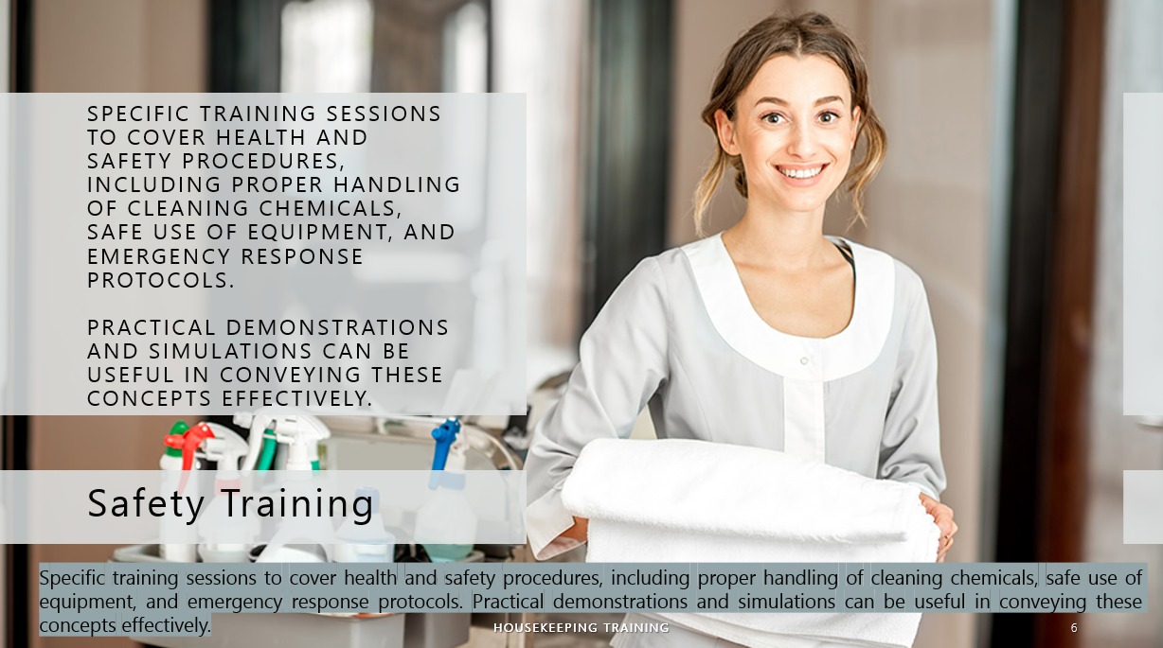

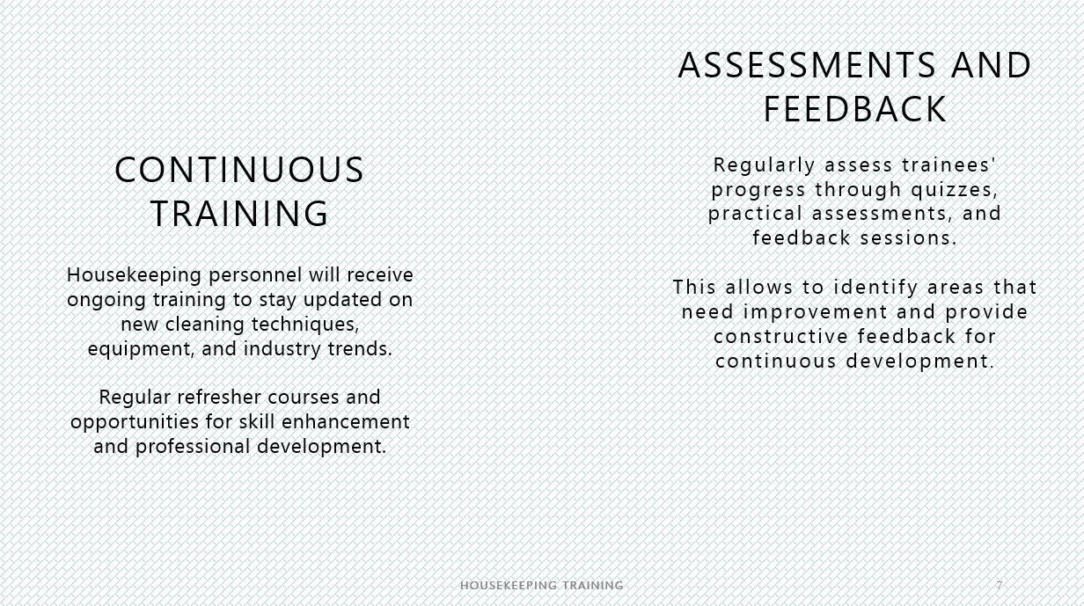

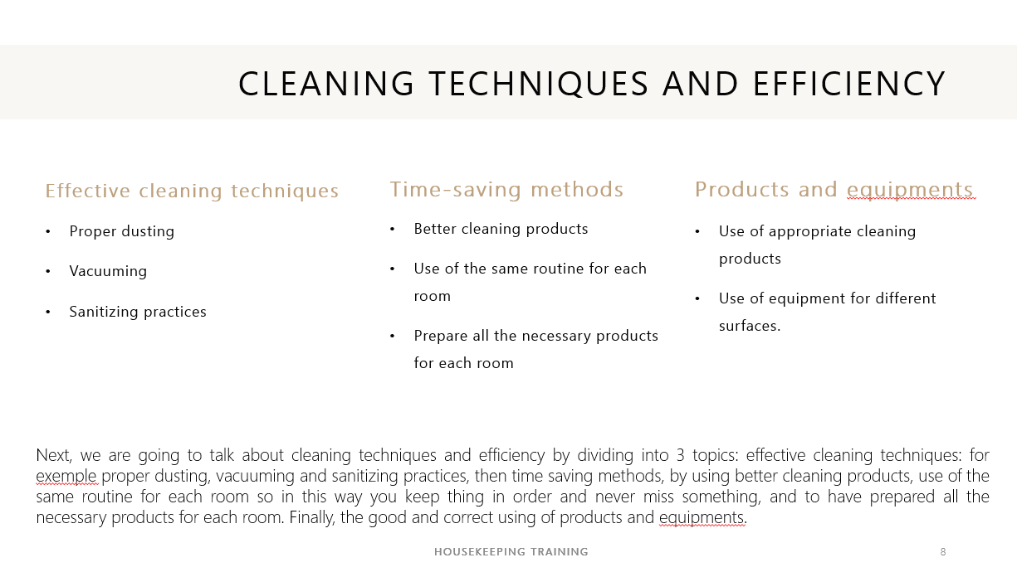

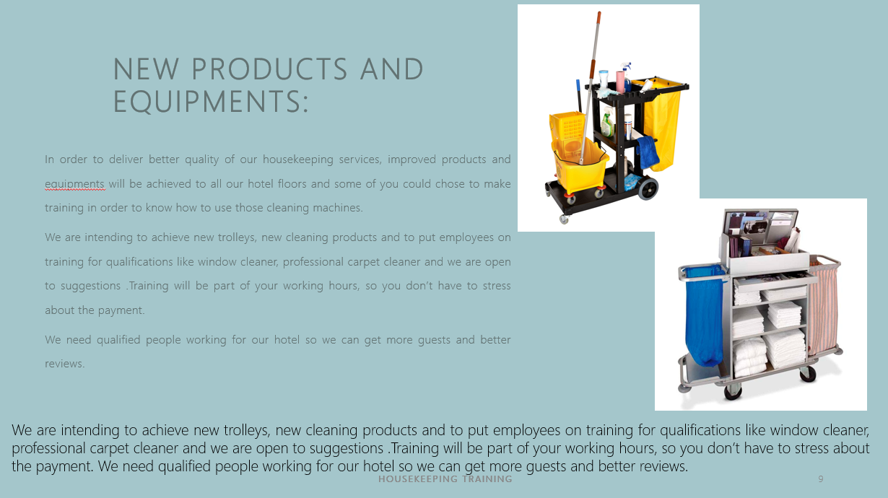

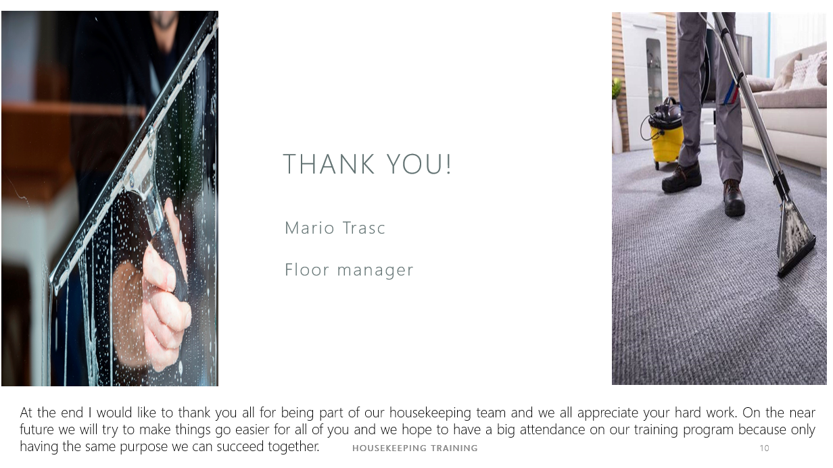

References

Component One:
Bridger, E. (2018) Employee engagement: a practical introduction. 2nd ed. HR Fundamentals. London: CIPD and Kogan Page.
Casado, M. (2012) Housekeeping Management. London: Wiley.
Hotelowner (2018) The importance of a good housekeeping. Available at: The importance of good housekeeping | Article | Hotel Owner ( Accessed on 26th of May 2023)
Jones, T. (2010) Professional Management of Housekeeping Operations. London: Wiley.
Raghubalan, G. and Raghubalan, S. (2016) Hotel Housekeeping - Operations And Management. 3rd ed. India: Oxford University Press.

Component Three:
Bridger, E. (2018) Employee engagement: a practical introduction. 2nd ed. HR Fundamentals. London: CIPD and Kogan Page.
Casado, M. (2012) Housekeeping Management. London: Wiley.
Cottrell, S. (2019) The Study Skills Handbook. 5th ed. London: Red Globe Press
Hotelogix (2022) The importance of training housekeeping staff ar your hotel. Available at: The Importance of Training Housekeeping Staff at Your Hotel - Hotelogix ( Accessed on 29th of May 2023)
Hotelowner ( 2023) How to keep staff training records up to date at your hotel. Available at: How to keep staff training records up to date at your hotel | Article | Hotel Owner ( Accessed on 5th of June 2023)
Jones, T. (2010) Professional Management of Housekeeping Operations. London: Wiley.
Marriott (2023) Policies and position statements. Available at: Policies and Position Statements | Marriott International Serve360 - csr-marriott ( Accessed on 7th of June 2023)
Mullins, L. and Dossor, P. (2013) Hospitality Management and Organisational Behaviour. 5th ed. Harlow: Pearson.
Raghubalan, G. and Raghubalan, S. (2016) Hotel Housekeeping - Operations And Management. 3rd ed. India: Oxford University Press.
Wood, R. (2013) Key Concepts in Hospitality Management, Sage, London

